FREQUENCY SPECTRUM MANAGEMENT PANEL (FSMP)

Eleventh Working Group meeting

Web Meeting, 1 – 12 March 2021

Agenda Item 5: Development of (planned) Material for ITU-R Studies on:
d) WRC-23 AI1.9 Wideband HF

Liaison Statement from ITU-R WP3L
on
WRC-23 Agenda Item 1.9

(Presented by the Secretary)

SUMMARY
Attached is a liaison statement from ITU-R WP3L on WRC-23 Agenda Item 1.9.

Action: FSMP WG/11 is invited to review the attached liaison statement and take action as appropriate.

______________

Radiocommunication Study Groups | 
Source: Document 3L/25, 3L/TEMP/15
Subject: WRC-23 agenda item 1.9

 | 27 August 2020
Working Party 3L
REPLY LIAISOn STATEMENT to working partY 5B
(COPIED TO Working Parties 5A, 5C, 6A and ICAO for information)
WRC-23 agenda item 1.9
Review of Appendix 27 of the Radio Regulations to accommodate
digital aeronautical HF technologies
Working Party (WP) 3L wishes to thank WP 5B for the request for advice on the radio propagation models that may be relevant to compatibility studies for the introduction of new digital aeronautical wideband HF systems for the AM(R)S between 2 850 and 22 000 kHz.
The propagation of radio waves in the HF band is complicated, principally due to the dynamic behaviour of the ionosphere. Ionospheric radio wave propagation varies significantly over the day, from season-to-season, over solar cycle and with geomagnetic conditions.
Anomalies and statistical behaviours of the ionosphere can have numerous effects on radio communications. Ionospheric propagation effects can be subtle and potentially wide ranging. The Annex, Propagation Considerations, appears here to clarify and expand on the most important propagation aspects that may arise in WP 5B’s studies. The annex particularly focuses on ionospheric phenomena that may influence wanted and unwanted propagation paths.
In preparing this reply, WP 3L finds that the characteristics and topologies of the new digital systems, that operate in the HF range, are critical to providing accurate and relevant advice to WP 5B. Consequently, WP 3L has taken the liberty to imagine potential coupling scenarios. Without specifics of the propagation links under study, WP 3L will rely on these assumptions which result in identifying dominant coupling between AM(R)S and victim (potentially interfered station) as line-of-sight, ground wave and/or ionospheric propagation.
The most relevant propagation models and coverage calculations are available in the ITU-R Recommendations listed below:
P.368 - Ground-wave propagation curves for frequencies between 10 kHz and 30 MHz
P.371 - Choice of indices for long-term ionospheric predictions
P.372 - Radio noise
P.373 - Definitions of maximum and minimum transmission frequencies
P.533 - Method for the prediction of the performance of HF circuits
P.534 - Method for calculating sporadic-E field strength
P.581 - The concept of "worst month"
P.845 - HF field-strength measurement
Additionally, more background information can be found in the ITU Handbooks “The ionosphere and its effects on radio wave propagation”.
https://www.itu.int/dms_pub/itu-r/opb/hdb/R-HDB-32-1998-PDF-E.pdf
and "Ground Wave Propagation”., https://www.itu.int/dms_pub/itu-r/opb/hdb/R-HDB-59-2014-PDF-E.pdf .
WP 3L looks forward to the continued collaboration and receiving feedback, if any, from WP 5B in order to enable WP 3L to provide further information upon request.

Status: For information and action, if any.
Deadline: 30 April 2021
Contacts: Angelo Canavitsas | E-mail: canavitsas@petrobras.com.br
Ben Witvliet | E-mail: ben.witvliet@agentschaptelecom.nl

ANNEX
Propagation Considerations
- Ionospheric radio wave propagation
In several scenarios, ionospheric radio wave propagation will be the dominant propagation mechanism in the frequency range 2 850 to 22 000 kHz. Refracted waves by the ionosphere may be received at distances up to 3 500 km. Multiple reflections between ionosphere and the Earth (‘multi-hop propagation’) may even cover the entire globe. Additional reflections and greater path length increase the path loss, therefore single-hop paths have a lower path loss.
Ionospheric refraction is frequency dependent. Vertically emitted radio waves are reflected only when their frequency is less than the critical frequency (peak plasma frequency) of the E- or F-region. But radio waves emitted at lower grazing angles are still reflected at frequencies that are 4-5 times higher. As a result, the radio wave propagation at the lower end of the frequency range of interest differs significantly from propagation in the middle or at the higher end of the frequency range.
Ionospheric radio wave propagation varies significantly over the day. One of the main drivers of the electron density production in the ionosphere is the radiation of the sun. Consequently, the electron density in the ionosphere, responsible for the refraction of radio waves, shows a strong diurnal variation and also changes with the seasons. Due to the 11-year cycle of the sun, the electron density worldwide follows a more or less sinusoidal variation with the same period.
Furthermore, the electron density distribution is not equal across the globe. The high-latitude ionosphere differs significantly from the mid-latitude and low-latitude regions.
- Different scenarios and associated HF propagation models
The propagation models cannot be selected unless the interference scenarios are known. However, an answer to WP 5B’s question can be formulated by sketching different variations of the relative location of AM(R)S and victim, and the associated propagation mechanisms. These scenarios are not exhaustive. If WP 5B defines other scenarios that are not described here, WP 3L will be glad to provide additional advice on them.
Figures 1, 2, 3 and 4 depict several different scenarios, with increasing separation distance. The associated propagation models will be discussed.

Figure 1
Close-range scenarios, all frequencies. LOS = line-of-sight; GW = ground wave.

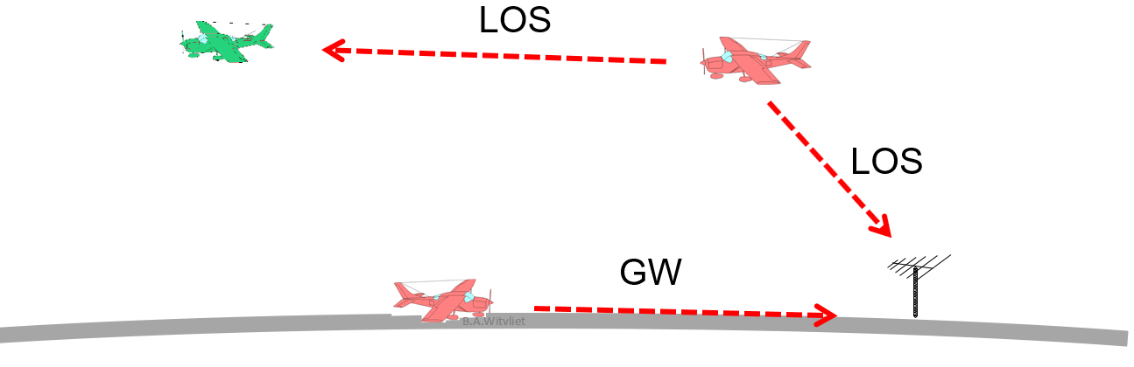

Figure 2
Short-range scenario up to 400 km. NVIS = Near Vertical Incidence Skywave.
Frequency 2 is much higher than frequency 1. Heights are not to scale.

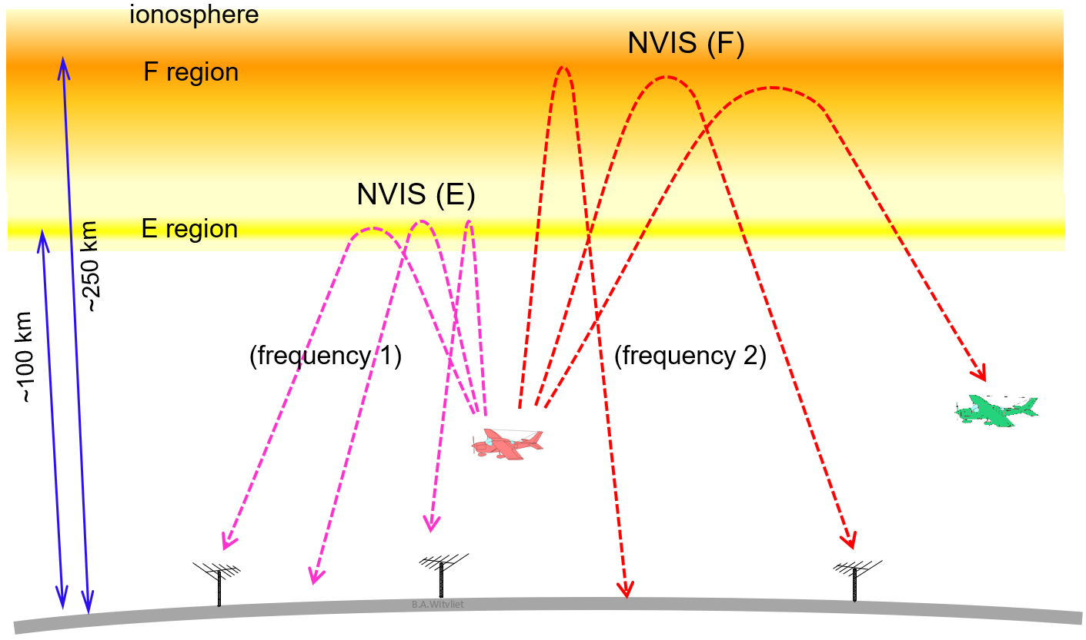

Figure 3
Single-hop mid-range scenarios, up to 3,500 km (F-region) or 2,000 km (E-region).
1F = single hop propagation via the F-region. Es = Sporadic E. Heights are not to scale.
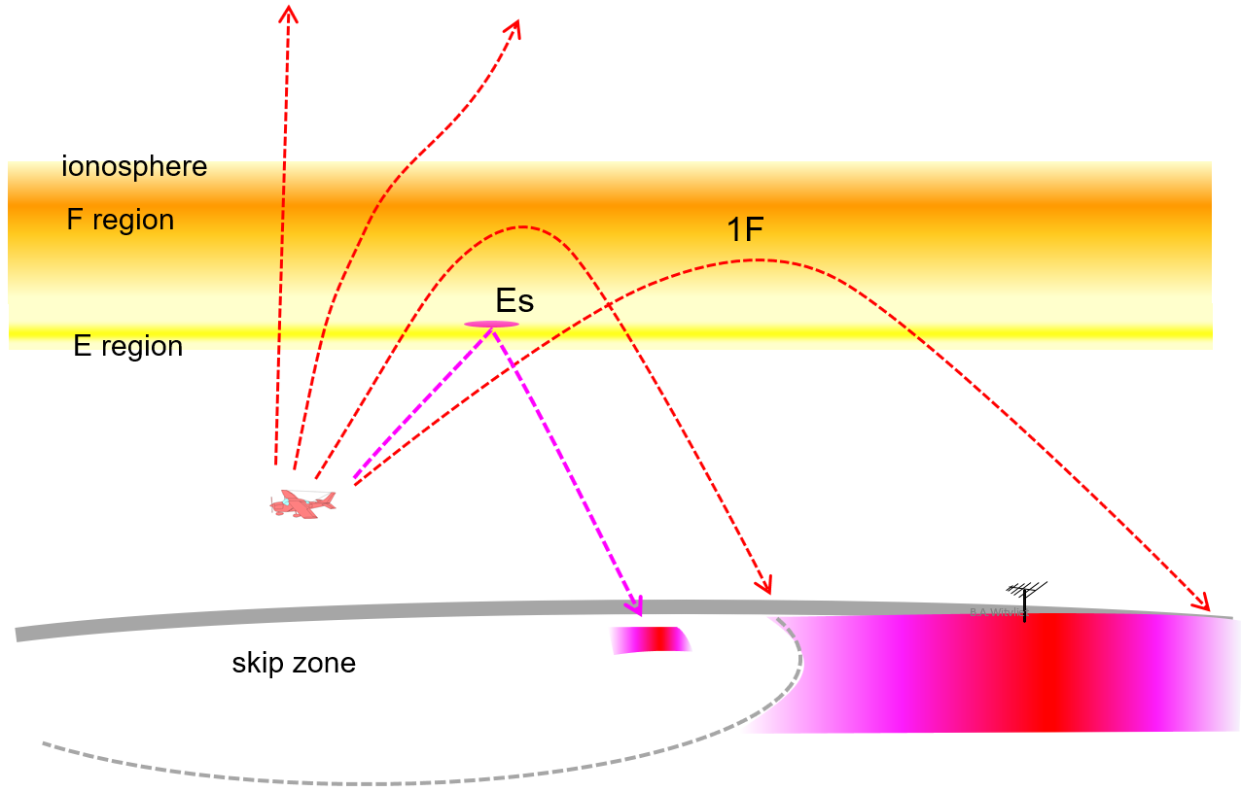

Figure 4
Example of a multi-hop scenario for long-range ionospheric propagation.
2F = two hops via the F-region; 3F = three hops via the F-region. Heights not to scale.

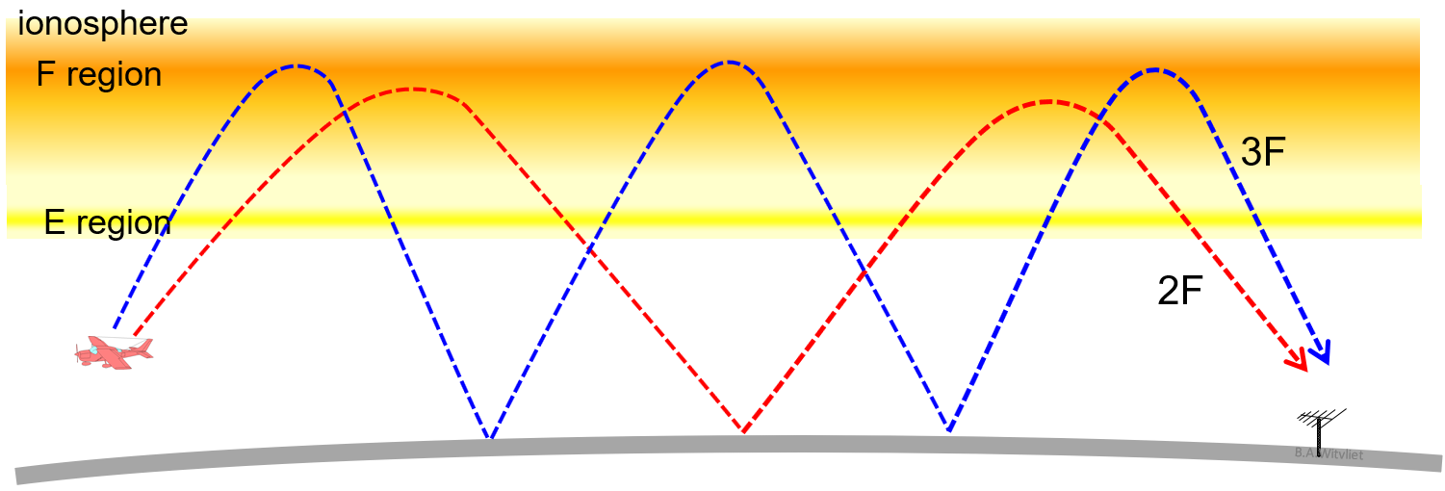

- Line-of-sight propagation (LOS)
When both the AM(R)S and the victim are airborne and within sight of each other, the dominant propagation mechanism is ‘free space propagation’ and the Friis theorem applies. This is depicted in Figure 1. Path loss can be calculated using Recommendation ITU-R P.525-4 “Calculation of free space attenuation,” formula 3. The same is true when the AM(R)S is within sight of a terrestrial victim.
- Ground wave propagation (GW)
When both the AM(R)S and the victim are on the ground, ground wave propagation will provide a coupling path between them. This is also depicted in Figure 1. The associated path loss can be calculated using Recommendation ITU-R 368-9 “Ground-wave propagation curves for frequencies between 10 kHz and 30 MHz” and associated “GRWAVE” software.
- Near vertical incidence skywave (NVIS) propagation
When the transmit frequency is below the critical frequency of the E- or F-region of the ionosphere, even vertically emitted radio waves will be reflected back to Earth. Due to the important height of the F-region (200-250 km), a continuous area around the AM(R)S is covered. The signal strength is homogenous in the entire area. This is depicted in Figure 2. NVIS path loss is low.
Near the AM(R)S, both the ground wave and the NVIS skywave will be received. At very short distances the ground wave is dominant. As the ground wave attenuation increases rapidly with frequency, the sky wave path will become dominant at a certain distance from the victim.
Whether the AM(R)S and/or victim are airborne or on the ground does not alter the propagation properties. The path loss and probability can be calculated using Recommendation ITU-R 533-14 “Method for the prediction of the performance of HF circuits” and related software. Some of the required input parameters can be found in Recommendation ITU-R P.371-8 “Choice of indices for long-term ionospheric predictions.”
- Single-hop mid-range propagation (1E, 1F)
Single-hop E-region propagation (1E) will cover distances up to approx. 2 000 km. Single-hop F-region propagation (1F) will reach at least 3 500 km. This is depicted in Figure 3. Similar to NVIS, the calculation of path loss and probability of single-hop E- and F-region propagation can be done with Recommendation ITU-R P.533. The difference with NVIS propagation is the existence of a skip zone, a large zone around the AM(R)S in which its signal is not received.
- Sporadic E-region reflection
Sporadically, thin patches of high electron density are formed in the E-region. Their electron density is significantly higher than the background E-region. Due to their lower altitude, the associated range is much shorter than the F-region reflections on the same frequency. This is depicted in Figure 3. Path loss is very low. Its occurrence is random and sporadic. Methods to calculate the probability and signal strength of Sporadic-E propagation are described in Recommendation ITU-R P.534-5 “Method for calculating sporadic-E field strength”.
- Multi-hop long-range propagation (e.g. 3F)
Multi-hop propagation will cover very long distances, up to the antipodes. Several propagation modes may exist simultaneously. When the path loss of two paths is comparable, their interference will cause deep periodic fading. An example is depicted in Figure 4.

- Radio noise
At HF, the ambient electromagnetic noise level (‘radio noise’) is relatively high. That implies that in many cases reception is ‘radio noise-limited’ and not exclusively ‘path loss limited’. The background radio noise level as a function of frequency is described by Recommendation ITU-R P.372-14, sections Parts I and II (natural noise) and VI (man-made noise). This radio noise is defined for an omnidirectional antenna. When beamforming is used, the received radio noise is proportionally lower reduced with respect of these levels.
- Other effects of ionospheric propagation
Radio wave propagation through a plasma (the ionosphere) not only causes path loss; it also causes Doppler shift, time dispersion and multi-path fading. These propagation effects are not covered in Recommendation ITU-R P.533, but they can be found in Recommendation ITU-R F.1487-0, which is maintained by Study Group 5.
_______________

