FREQUENCY SPECTRUM MANAGEMENT PANEL (FSMP)

Tenth Working Group meeting

Virtual Meeting, 17 – 26 August 2020

Agenda Item 3 : Radio Altimeter and Wireless Aircraft Intra-Communications (WAIC) issues

5G emissions and Radio Altimeters in the frequency band 4200 – 4400 MHz

(Presented by Alexandre GUIGNOT)

SUMMARY
Last June 2020, ICAO secretary brought to the attention of FSMP members, a Liaison Statement informing ECC about the issue of potential interference to aeronautical Radio Altimeters operating in the 4200 - 4400 MHz frequency band, caused by IMT systems currently operating or planned to operate in the frequency band 3400 - 3800 MHz in Europe.
A consolidated version was taken forward to ECC. DGAC, on behalf of the ICAO secretary presented this liaison statement.
This working paper will inform the group about the outcome of this discussion.
In particular, ICAO was invited to present a new contribution with the IMT subgroup of CEPT (PT1). In this view, DGAC prepared a contribution in Annex and invite FSMP members to review it.

- INTRODUCTION
Last June 2020, ICAO secretary brought to the attention of FSMP members, a Liaison Statement informing ECC about the issue of potential interference to aeronautical Radio Altimeters operating in the 4200 - 4400 MHz frequency band, caused by IMT systems currently operating or planned to operate in the frequency band 3400 - 3800 MHz in Europe.
The main issue is the fact that there is no specific limit of unwanted emissions from IMT base stations within the frequency band 4200-4400 MHz. The only available information is contained within the European Commission implementing Decision (EU) 2019/235 of 24 January 2019 on amending Decision 2008/411/EC as regards an update of relevant technical conditions applicable to the 3 400 - 3 800 MHz frequency band defines the baseline power limits below 3400 MHz and above 3800 MHz.
In the absence of other information, this Decision suggests that within the frequency band 4200 - 4400 MHz the EIRP limit per antenna is defined as -2dBm/5MHz (-9dBm/MHz) for non-active antennas systems (non-AAS) and the total radiated power (TRP) limit per cell is defined as -14dBm/5MHz (-21dBm/MHz) for active antenna systems (AAS). When using AAS with an assumed maximum antenna gain of 26 dBi, the EIRP limit would reach +5 dBm/MHz.
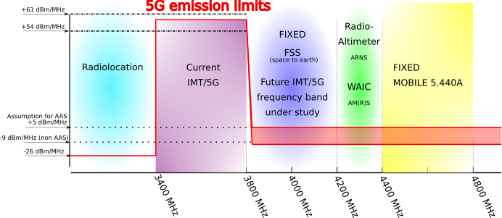
Preliminary studies using the operational and technical characteristics contained in ITU-R Recommendation M.2059 show that with the out-of-band emission limits above being applied:
- For an AAS, a separation distance of more than 27 km is required (applying a 6dB safety margin, for informational purposes: more than 13 km without any safety margin being applied); and
- For a non-AAS, more than 5.5 km (applying a 6dB safety margin, for informational purposes: more than 2.7 km without any safety margin being applied).
One will find in Annex the original text sent to ECC.
- Outcome of the discussion during ECC plenary
  - The ECC plenary was held on June 29th to July 3rd 2020. The information document (ECC(20)INFO 06) was presented by DGAC on behalf of ICAO (unable to attend the meeting due to the national bank holiday in Canada) on July 1st.
  - During this discussion, we received the comment that there will be a need to know all the characteristics of the Radioaltimeters. However, we believe that the recommendation ITU-R M.2059 already covers this point.
  - The discussion also focused on the ECC/DEC/(11)06. But it didn’t help, as more likely, this ECC decision is based on the European Commission implementing Decision (EU) 2019/235.
  - An administration pointed out the lack of information from IMT community, in particular the effective bandwidth value will help to know whether unwanted emissions falling within the frequency band 4.2-4.4 GHz are part of the spurious domain or not.
  - Finally, the group decided to bring the question to PT1. This group will assess whether there is an issue or not. On this matter, ICAO was invited to contribute to the next ECC PT1 meeting that will be held on September 1st to the 3rd 2020.
  - The final minutes of the ECC meeting reported the following:
Document ECC(20)INFO 06 from ICAO was introduced by France. This highlighted concerns about potential interference from 5G MFCN unwanted emissions to Radio Altimeters in the frequency band 4200 – 4400 MHz. It was generally considered that this issue should be looked at in ECC PT1 to see if any action is needed.
It was noted that ICAO was not able to find all the information about channel bandwidth of MFCN systems in 3400-3800 MHz and has assumed that the limit in block edge mask in ECC Decision (11)06 and Decision (EU) 2019/235 applies in the 4200 – 4400 MHz band. Participants noted that depending on the channel bandwidth of the MFCN system, the lower spurious emission limits in ERC Recommendation 74-01 may apply. It was also noted that it could be useful for ICAO to provide further information on radio altimeter characteristics and usage scenarios.
ICAO were invited to contribute to the next ECC PT1 on this issue; ECC PT1 should then consider if there is an issue and report back to ECC. It was suggested that it could be beneficial to update the ECC(20)INFO 06 with complete information.
- Contribution proposal at ECC PT1
  - As ECC PT1 will have to determine, whether there is an issue or not, we believe that the ICAO contribution should focus on the definition of the relevant scenario and the protection criteria applicable for the protection of the radioaltimeters (ITU-R M.2059).
  - The contribution that one can find in Annex 2 was written with this aim.
- ACTION BY THE MEETING
The meeting is invited to:
- note and review the contents of this working paper;
- Review the ICAO contribution for ECC PT1.
— END —
ANNEX 1: Original LS to ECC
ANNEX 2: Contribution Proposal to ECC PT1

