 |  | ECC PT1(20)xyz
ECC PT1 #66
Web meeting, 1-3 and 9-11 September 2020
Date issued: | TBD
Source: | ICAO
Subject: | 5G emissions and Radio Altimeters in the frequency band 4200 – 4400 MHz
Group membership required to read? (Y/N)
N
Summary:
During the last ECC meeting, ICAO raised its concerns about the issue of potential interference to aeronautical Radio Altimeters operating in the 4200 - 4400 MHz frequency band, caused by IMT systems currently operating or planned to operate in the frequency band 3400 - 3800 MHz. This issue is raising concerns within aviation due to the possible large impact which could occur to the operation of aeronautical Radio Altimeters, systems which provide a function critical to the safety of aircraft.
One can read in the ECC minutes:
Document ECC(20)INFO 06 from ICAO was introduced by France. This highlighted concerns about potential interference from 5G MFCN unwanted emissions to Radio Altimeters in the frequency band 4200 – 4400 MHz. It was generally considered that this issue should be looked at in ECC PT1 to see if any action is needed.
It was noted that ICAO was not able to find all the information about channel bandwidth of MFCN systems in 3400-3800 MHz and has assumed that the limit in block edge mask in ECC Decision (11)06 and Decision (EU) 2019/235 applies in the 4200 – 4400 MHz band. Participants noted that depending on the channel bandwidth of the MFCN system, the lower spurious emission limits in ERC Recommendation 74-01 may apply. It was also noted that it could be useful for ICAO to provide further information on radio altimeter characteristics and usage scenarios.
ICAO was invited to contribute to the next ECC PT1 on this issue; ECC PT1 should then consider if there is an issue and report back to ECC. It was suggested that it could be beneficial to update the ECC(20)INFO 06 with complete information.
In accordance with the guidance of ECC, ICAO would like to bring to the attention of ECC PT1 the following material:
- Information on radio altimeter characteristics and its application (based on the ITU-R M.2059),
- Usage scenarios to consider for assessing the impact of 5G unwanted emissions to the Radioaltimeters operating in the frequency band 4200-4400 MHz.

Proposal:
invites Group to
Assess the impact of 5G unwanted emissions to the Radioaltimeters operating in the frequency band 4200-4400 MHz.

Background:
None

Introduction
During the last ECC meeting, ICAO informed ECC about the issue of potential interference to aeronautical Radio Altimeters operating in the 4200 - 4400 MHz frequency band, caused by IMT systems currently operating or planned to operate in the frequency band 3400 - 3800 MHz in Europe.
The main issue is the fact that there is no specific limit of unwanted emissions from IMT base stations within the frequency band 4200-4400 MHz. The only available information is contained within the European Commission implementing Decision (EU) 2019/235 of 24 January 2019 on amending Decision 2008/411/EC as regards an update of relevant technical conditions applicable to the 3 400 - 3 800 MHz frequency band defines the baseline power limits below 3400 MHz and above 3800 MHz.
In the absence of other information, this Decision suggests that within the frequency band 4200 - 4400 MHz the EIRP limit per antenna is defined as -2dBm/5MHz (-9dBm/MHz) for non-active antennas systems (non-AAS) and the total radiated power (TRP) limit per cell is defined as -14dBm/5MHz (-21dBm/MHz) for active antenna systems (AAS). When using AAS with an assumed maximum antenna gain of 26 dBi, the EIRP limit would reach +5 dBm/MHz.
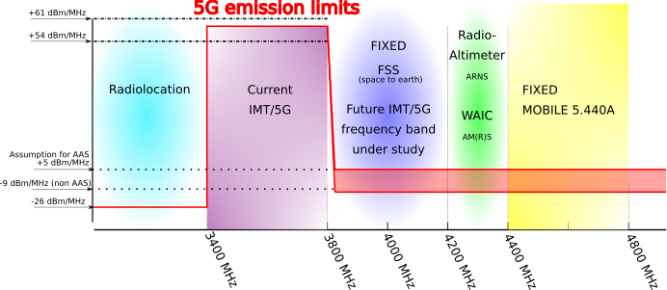
Preliminary studies using the operational and technical characteristics contained in ITU-R Recommendation M.2059 show that with the out-of-band emission limits above being applied:
- For an AAS, a separation distance of more than 27 km is required (applying a 6dB safety margin, for informational purposes: more than 13 km without any safety margin being applied); and
- For a non-AAS, more than 5.5 km (applying a 6dB safety margin, for informational purposes: more than 2.7 km without any safety margin being applied).
One will find below the original liaison statement sent to ECC.
In response to this liaison statement, ICAO was invited to contribute to the next ECC PT1 on this issue; ECC PT1 should then consider if there is an issue and report back to ECC. It was suggested that it could be beneficial to update the ECC(20)INFO 06 with complete information. This document can be considered as the update.

Information on radio altimeter characteristics (based on ITU-R M.2059)
All technical characteristics for radioaltimeters operating within the frequency band 4200-4400 MHz could be find within the Recommendation ITU-R M.2059. In particular the Table 1 & and Table 2 give the technical parameters of each Radioaltimeters type.
Radioaltimeters are operating within the frequency band 4200-4400 MHz under the aeronautical radionavigation service (ARNS).
The basic function of a radio altimeter is to provide accurate height measurements above the Earth surface with a high degree of accuracy and integrity during the approach, landing, and climb phases of aircraft operation representing a wide variety of reflectivity. Such information is used for many purposes and the high degree of accuracy and integrity of those measurements must be achieved regardless of the Earth surface, such as during final approach and flare guidance in the last stages of automated approach to land. It is also used to determine the particular altitude in which the aircraft can safely land and as an input to the terrain awareness warning system (TAWS), which gives a “pull up” warning at a predetermined altitude and closure rate; and as an input to the collision avoidance equipment and weather radar (predictive wind shear system), auto-throttle (navigation), and flight controls (autopilot). Radio altimeter systems are designed to operate for the entire life of the aircraft in which they are installed. The installed life can exceed 30 years, resulting in a wide range of equipment age, performance and tolerance.
It is important to note that there are two types of radar waveform modulation methods for Radioaltimers:
- Continuous wave of LFMCW (Linear Frequency Modulation Continuous Wave) or FMCW Radioaltimers (Frequency Modulated Carrier Wave);
- And pulsed modulation.

FMCW Radioaltimeters
FMCW radio altimeters operate by a Tx/Rx working in conjunction with separate transmit/receive antennas. Operation requires a signal from the transmit antenna to be directed to the ground. When the signal hits the ground it is reflected back to the receive antenna. The system then performs a time calculation to determine the distance between the aircraft and ground, as the altitude of the aircraft is proportional to the time required for the transmitted signal to make the round trip.
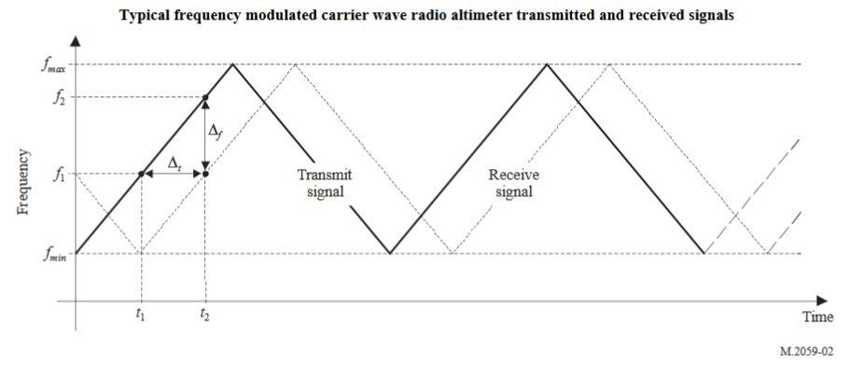
It is important to note that FMCW Radioaltimeters have not a fixed frequency. One can find the chirp bandwidth of each FMCW radioaltimeters type.

Pulsed RadioAltimeters
The pulsed-type radio altimeter uses a pulse of radio-frequency energy transmitted towards the earth to measure the absolute height above the terrain immediately underneath the aircraft. The time difference between the transmitted pulse and the received pulse is measured. Where the velocity of propagations of electrometric energy is known and is a constant, the time is proportional to the height of the aircraft.
One can note that pulsed Radioaltimeters are emitting at a fixed frequency (generally 4300 MHz). However the emission bandwidth could vary (see for example D4 from ITU-R M.2059).

Antenna Patern for RADIOALTIMETERS
There is no antenna pattern defined within the recommendation ITU-R M.2059. However, within the ITU-R Report M.2319, the antenna pattern is well defined.
ICAO recommends using the antenna pattern formula available in the Report ITU-R M.2319 (§A-3.1.1) when performing compatibility studies:
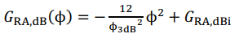.
One can note that this formula is only valid for Φ<90°.

Interference threshold to be considered for RadioAltimeters

Protection CRITERIA
This ITU recommendation gives three primary electromagnetic interference coupling mechanisms between radio altimeters and interfering signals from other transmitters which are receiver overload, desensitization, and false altitude generation.
Any compatibility analysis between radio altimeters and other systems must utilize protection criteria for the maximum acceptable degradation for a radio altimeter.
Those three criteria are defined as followed:
- Receiver front-end overload where the value depends on each radio altimeters type
- Receiver desensitization which is the common I/N protection criteria of -6dB,
- And the False altitude reports which is defined by -143 dBm/100 Hz (–143 dBm considering 100 Hz detector bandwidth following the instantaneous altimeter LO frequency).
As we will focus only within the frequency band 4200-4400 MHz, only the false altitude reports and the receiver desensitization are applicable.

Receiver desensitization
According to ITU-R Recommendation M.2059 Receiver Desensitization I_{T,RF} at the receiver input is given by:
Where:
I_{T,IF} = Interference power threshold
$≥N-I/N\text{ dB}$
N $=-114dBm/MHz+10\log{(}B_{R,IF})+N_{F}$
B_{R,IF}: = IF bandwidth of the radio altimeter (MHz)
N_{F}: =Noise figure at receiver input (dB)
I/N = Interference to noise ratio (assumed to be -6 dB)
R_{S} $=\frac{2B_{R,IF}}{B_{S}}$
B_{S} = Chirp Bandwidth (MHz)
One can note that Rs is only applicable for FMCW radioaltimeters.
It has to be noted, that the interference power threshold (I_{T,RF}) is considered within the all chirp bandwidth.

FalsE altitude report
ITU-R M.2059 defines the false altitude criteria as -143 dBm/100 Hz or -103 dBm/MHz for all FMCW radio altimeters only. It is given by:
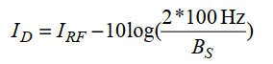
Where a 100 Hz detection bandwidth is considered representative:
- ID: Interference power at the detector,
- BS: Chirp bandwidth.
If the magnitude of the spectral components caused by the interference signal rises above the detection threshold of the altimeter (IT,FA), then they may falsely be regarded as valid altitudes by the altimeter and there will be no means to exclude them from the altitude calculation. In practice, ID (the interference power at the detector) would cause false target spectral components within the FMCW receiver signal processing chain if it exceeds the protection threshold IT,FA
IT,FA = –143 dBm considering 100 Hz detector bandwidth following the instantaneous altimeter LO frequency.

Application of the ITU-R M.2059 for the interference threshold
Type of Radioaltimeter | A1 | A2 | A3 | A4 | A5 | A6 | D1 | D2 | D3 | D4
Antenna Gain (dBi) | 10 | 10 | 10 | 13 | 11 | 11 | 11 | 10 | 11 | 13
Feeder Loss (dB) | 6 | 6 | 2 | 6 | 6 | 6 | 6 | 0 | 2 | 0
Protection Criteria (I/N) (dB) | -6 | -6 | -6 | -6 | -6 | -6 | -6 | -6 | -6 | -6
Receiving Bandwidth (MHz) | 2 | 0,25 | 2 | 9,2 | 6 | 16 | 0,31 | 1,95 | 2 | 30
Noise Figure (dB) | 10 | 6 | 6 | 10 | 10 | 10 | 8 | 9 | 8 | 10
Chirp Bandwidth (MHz) | 104 | 132,8 | 133 | - | - | - | 150 | 176,8 | 133 | -
RS (dB) | -14,15 | -24,24 | -15,22 | 0,00 | 0,00 | 0,00 | -23,84 | -16,56 | -15,22 | 0,00
Interference Threshold (I/N) at the receiver P_{R}(dBm/MHz) | -112,94 | -116,94 | -116,94 | -109,93 | -109,93 | -109,93 | -114,94 | -113,94 | -114,94 | -109,93
False Altitude criteria (dBm/MHz) | -103,00 | -103,00 | -103,00 | - | - | - | -103,00 | -103,00 | -103,00 | -

Application of the Safety margin
Radioaltimeters is used for safety aeronautical application (non-precision instrument approach aid). ICAO (DOC 9718) defines an aeronautical safety margin and recommends including it into any study as followed:
“Aeronautical safety applications are required to have continued operation through worst case interference, so all factors which contribute to harmful interference should be considered in analyses involving those applications. An aviation safety margin is included in order to address the risk that some such factors cannot be foreseen (for example impacts of differing modulation schemes). This margin is applied to the system protection criteria to increase the operational assurances to the required level. Traditionally for aviation systems/scenarios an aviation safety margin of 6–10 dB is applied. Until established on the basis of further study on a case-by-case basis, an aviation safety margin of not less than 6 dB should be applied.”
Regarding the issue, ICAO recommends to use the aeronautical safety margin when assessing the impact of unwanted 5G emissions into the RadioAltimeter.

Parameters for IMT operating within the frequency band 3400-3800 MHz
ICAO is requestiong the parameters applicable for IMT operating within the frequency band 3400-3800 MHz and the out-of band domain (in particular within the frequency band 4200-4400 MHz) for its own current and future studies.

Relevant scenario to consider
Roll off plane: TBD,
Free space propagation model.

Base Station Scenario
TBD

Terminal SCENARIO
TBD

Annexes: (if any)

Local Oscillator

