 |  |  |  | Doc. ECC(20)XXX
 | 53rd ECC Plenary Meeting
 | Web meeting, 29 June – 3 July 2020
 | Date issued: |  | 24_06_2020
 | Source: |  | International Civil Aviation Organization (ICAO)
 | Subject: |  | Liaison Statement to ECC on 5G emissions and Radio Altimeters in the frequency band 4200 – 4400 MHz
To: |  | Mr. Chris Woolford, ECC Chairman  E-mail: chris.woolford@ofcom.org.uk
Cc: |  | Mr. Andreas Geiss  E-mail: andreas.geiss@ec.europa.eu
Dear Mr. Woolford,
ICAO would like to bring to your attention the issue of potential interference to aeronautical Radio Altimeters operating in the 4200 - 4400 MHz frequency band, caused by IMT systems currently operating or planned to operate in the frequency band 3400 - 3800 MHz. This issue is raising concerns within aviation due to the possible large impact which could occur to the operation of aeronautical Radio Altimeters, systems which provide a function critical to the safety of aircraft.
As you are aware, the European Commission implementing Decision (EU) 2019/235 of 24 January 2019 on amending Decision 2008/411/EC as regards an update of relevant technical conditions applicable to the 3 400 - 3 800 MHz frequency band defines the baseline power limits below 3400 MHz and above 3800 MHz. In the absence of other information, this Decision suggests that within the frequency band 4200 - 4400 MHz the EIRP limit per antenna is defined as -2dBm/5MHz (-9dBm/MHz) for non-active antennas systems (non-AAS) and the total radiated power (TRP) limit per cell is defined as -14dBm/5MHz (-21dBm/MHz) for active antenna systems (AAS). When using AAS with an assumed maximum antenna gain of 26 dBi, the EIRP limit would reach +5 dBm/MHz.
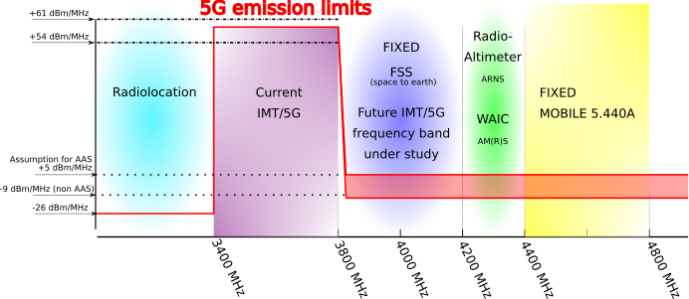
Illustration of some specific applications operating within the C-Band, around the 3600 - 4200 MHz frequency band and associated baseline power limits for IMT AAS systems (as enforced by EC Decision 2019/235)
Taking into consideration the above, the aviation community has strong concerns with regard to the increase of the wide band noise level in the frequency band 4200 – 4400 MHz, as may result from the aggregated effect of both the 5 dBm/MHz power from AAS and the -9 dBm/MHz power from non-AAS. ICAO would like to point out that the Radio Altimeters are an essential component of aeronautical safety-of-life systems, used during all phases of flight, including precision approach, landing, ground proximity and collision avoidance systems. Any interference to the Radio Altimeters will have a large impact on the continued safety of aircraft operations, particularly during the approach and landing phases (in the vicinity of airports and at airports).
Preliminary studies using the operational and technical characteristics contained in ITU-R Recommendation M.2059 show that with the out-of-band emission limits above being applied:
- For an AAS, a separation distance of more than 27 km is required (applying a 6dB safety margin, for informational purposes: more than 13 km without any safety margin being applied); and
- for a non-AAS, more than 5.5 km (applying a 6dB safety margin, for informational purposes: more than 2.7 km without any safety margin being applied).
ICAO thanks ECC for the consideration of the above and looks forward to the continued exchange with ECC on this matter, collaborating as appropriate in order to further refine understanding of the potential interference mechanisms to Radio Altimeters. With this work, ICAO believes that the safe operation of Radio Altimeters operating in the frequency band 4200-4400 MHz can be safeguarded.
Best regards,
Loftur Jonasson
ICAO FSMP Secretary
E-mail: LJonasson@icao.int

ATTACHMENT

