FREQUENCY SPECTRUM MANAGEMENT PANEL (FSMP)

Tenth Working Group Meeting

Montréal, Canada, 17-26 August 2020

Agenda Item 7c: Wideband HF communications (WRC-23 AI 1.9)

TECHNICAL CONSIDERATIONS FOR THE WIDEBAND HF OVERLAY CONCEPT FOR AGENDA ITEM 1.9 WRC-23

(Presented by Sai Kalyanaraman, Collins Aerospace)

SUMMARY
This paper provides technical considerations in support of WRC-23 Agenda Item 1.9 concerning Wide Band HF (WBHF) aeronautical communications. Feedback is sought from the FSMP on the material presented to this meeting, and on how WBHF can be implemented within existing Appendix 27 HF spectrum.

- INTRODUCTION
  - While HF Radio communications has been the primary long-range communication system for safe, efficient air travel over long range routes beyond the range of ground-based VHF radios, modern technology now provides alternate solutions, namely aeronautical mobile-satellite (R) service (AMS(R)S) satellite communications (SATCOM), which are now authorized by regulatory authorities for use in long-range aeronautical communications. Terrestrial and space-based systems work well together in a complementary and synergistic fashion to offer better performance, reliability and availability than either system alone. Having both space-based and terrestrial means of long-range communication, termed “link diversity,” mitigates single point of failure concerns associated with vulnerabilities and failure modes which differ for each system (e.g., solar events, rain fade, jamming, hardware failures, etc.).

  - A next generation wideband HF radio system is being developed to address the limitations of today’s HF radio communications systems (i.e. intelligibility of analog voice communications and limited throughput of data over HFDL). To support a WBHF system, Appendix 27 of the ITU Radio Regulations (RR) will need to be modified to accommodate technical and regulatory elements to permit an overlay of WBHF channels on the current Appendix 27 allotment plan.

  - At the Eighth Working Group Meeting of the FSMP, Working Paper 29 introduced a concept of a modernized wide-band AM(R)S system intended to use HF spectrum as defined and governed by Appendix 27 of the RR. Subsequently, WRC-19 adopted a WRC-23 future agenda item to update Appendix 27 to accommodate WBHF. The objective is to allow – as an overlay on the existing Appendix 27 allotment plan – use of multiple contiguous 3 kHz channel assignments as a single, wideband channel, and to allow for advanced modulations that would provide greater throughput of information (higher data rates) and maintain a robust, link-diverse communications architecture.

- AVIATION INDUSTRY IMPLEMENTATION
  - The SARPS and relevant airborne receiver standards updates for WBHF will be addressed through the relevant ICAO panel and RTCA/EuroCAE special committees. This item will also be introduced at the next DCIWG (Data Communication Infrastructure Working Group) with a request that a project team be setup towards ICAO SARPS update activities in support of WBHF. Relevant WBHF validation data will be provided in support of the ICAO SARPS development effort. Analysis of technical compatibility between the WBHF system and the current legacy use of airborne HF will be addressed through the SARPS development process. Once the SARPS process is underway, RTCA/EuroCAE will be contacted in order to initiate an Airborne HF radio MOPS development effort. In parallel with the WRC effort, a launch customer will be identified to initiate regional rollout and test preliminary ground station capability in support of WBHF. Channels assigned under special agreements for the initial service are planned for use in the interim until the WRC effort is concluded.
  - Alternate WBHF approaches of other radio and system designers are expected to co-exist alongside the contiguous channel WBHF approach described here, as long as the new entrants meet the out-of-band airborne HF spectral requirements and ensure compatibility with existing uses of HF.
  - As a point of reference, Table 1 shows data speeds that can be achieved with advanced modulation waveforms on contiguous channels utilized as a wide-band channel.

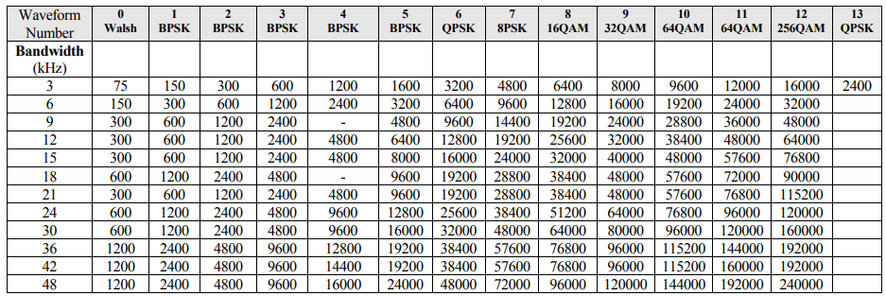
Table 1- Modulation used to obtain each data rate.
- TECHNICAL ASPECTS OF THE WIDEBAND HF SYSTEM OVERLAY CONCEPT
  - The WBHF system will utilize the existing 2.8 to 22 MHz AM(R)S HF aeronautical frequency bands, so no additional spectrum will need to be allocated, and new modulation waveforms will fall under the same J2D emission designator as legacy HFDL. Since the WBHF signal will also comply with the legacy HFDL spectral mask regarding adjacent channel power (see figures below), it will coexist with legacy HF voice and HFDL, as well as existing adjacent band services in the HF spectrum. Table 2 provides sample technical characteristics of a WBHF system.

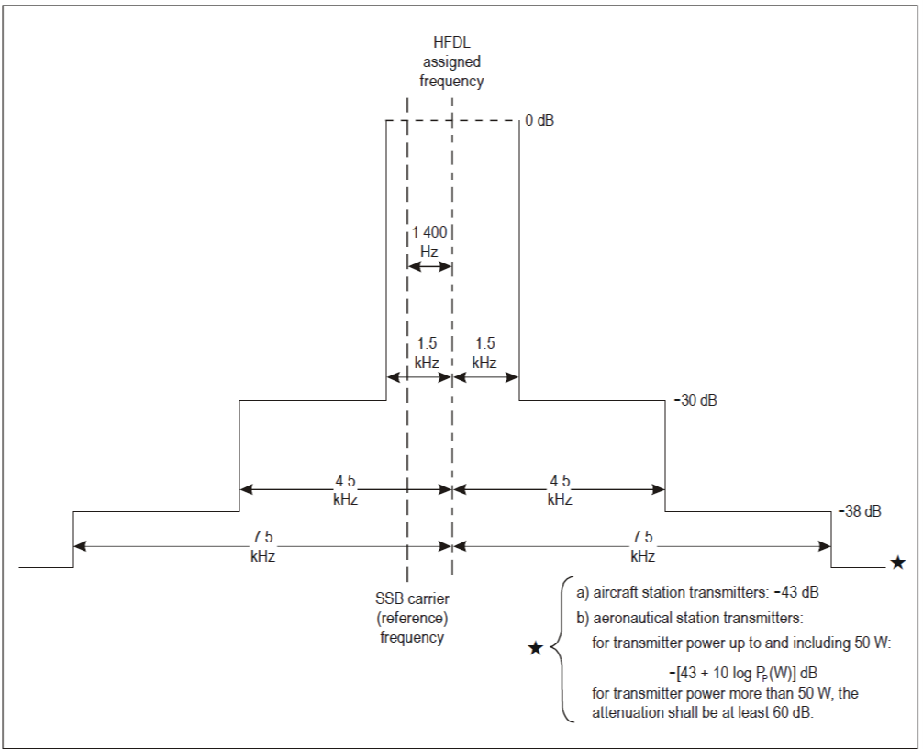
Figure 1- ICAO Annex 10 Volume III (Figure 11-1) Required spectrum limits (in terms of peak power) for HFDL aircraft and ground station transmitters
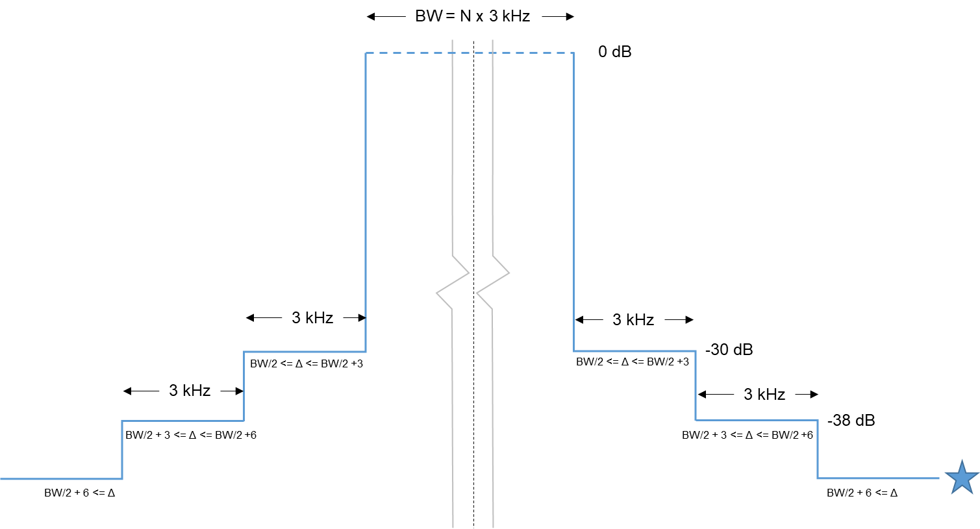
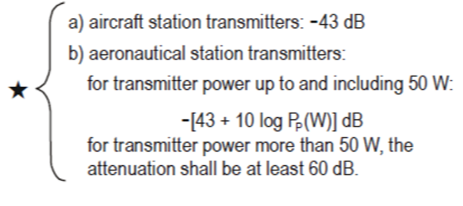
Figure 2- Proposed Wideband HF Spectral Mask. Note: N is the number of bonded contiguous channels
Note: Assigned frequency is offset by BW/2 - 100 Hz above SSB carrier reference frequency, as with legacy HFDL.

Figure 3 – Current Spectral Emission mask Table (27/74)

Figure 4 – Proposed Wideband HF Spectral Emission Mask Table

Parameter | Ground Station | Aircraft Station | Units
Channel Bandwidths | 3,6,9,12,15,18,21,24,27,  30,33,36,39,42,45,48 | 3,6,9,12,15,18,21,24,27,  30,33,36,39,42,45,48 | kHz
Emission Type | SSB | SSB
Duplex Type | Half-Duplex, Full Duplex, and Broadcast | Half-Duplex, and Broadcast
Waveform Type | Walsh, BPSK, QPSK, 8PSK, 16QAM,32 QAM, 64QAM, 256 QAM | Walsh, BPSK, QPSK, 8PSK, 16QAM,32 QAM, 64QAM, 256 QAM
Power Spectral Density | 6 kW/3 kHz | 400 W/3 KHz
HF Propagation | Skywave | Skywave

Table 2 - Technical Characteristics

  - Existing Appendix 27 rules are based on 3 kHz channels where channels are assigned, and a spectral mask defined by the carrier frequency and/or the assigned frequency such that the spectrum emission limits are specified for the assigned and first, second and third adjacent 3 kHz bandwidth channels. To accommodate WBHF, Appendix 27 will need to allow for a spectral mask definition to accommodate multiple contiguous channels configured as a single wideband channel, defined around the center frequency and bandwidth of the wideband channel (see Figure 1). Wideband HF will meet the same spectrum emission limits with respect to adjacent channels as the existing 3 kHz allotments, which will ease compatibility analysis.
  - The proposed protection criteria would remain the same 15 dB Desired-to-Undesired (D/U) ratio per 3 kHz channel for Data on Data, Data on Voice, and Voice on Data. Thus, considering wideband channels, the protection ratio would be 15 dB D/U per 3 kHz.
  - The proposed power spectral density (W/kHz) would not exceed the existing HFDL and HF Voice frequencies authorized in Appendix 27. This would be 6 kW/3kHz for the Aeronautical Station and 400 W/3 kHz for the Aircraft station. When a larger bandwidth is used, the total peak envelope power may increase, but the power spectral density would not exceed the current levels seen in a given 3 kHz bandwidth. Thus, there would be the same (or lesser) amount of energy on the existing 3 kHz channels.
  - Considering the operational usage, WBHF will be operated in similar locations and in the same manner as the existing HFDL system. HF is typically used in areas that lack VHF coverage, such as Oceanic and Remote areas.

- SUMMARY
4.1 It was intended for the information contained above to be reviewed at the ICAO Communications Panel in October 2020, generating an ICAO job card, and then forwarding the relevant technical information to ITU-R WP 5B. However, with the recent ICAO CP delay until May 2021, it is likely such info would not be available in time for ITU-R WP 5B until November 2021 or possibly later. To avoid possible delay of the technical work in 5B, it is proposed that the below included liaison statement be sent to the ITU-R from this FSMP meeting to provide initial guidance from ICAO about what is being done and ensure the ITU-R is aware of ICAO’s role in such work.
- ACTION BY THE MEETING
The meeting is invited to:
    - Review this working paper and the discussed parameters
    - Support the proposed activities and direction to support WRC-23 Agenda Item 1.9.
    - Send the attached liaison statement to ITU-R WP 5B with details of the system parameters.

— END —

ATTACMENT A – LIAISON STAEMENT TO ITU-R

DRAFT LIAISON STATEMENT TO WORKING PARTY 5B

Preparation for WRC-23 agenda item 1.9

Review of Appendix 27 of the Radio Regulations to accommodate digital aeronautical HF technologies

ICAO thanks ITU-R WP 5B (WP 5B) for its liaison statement (Doc XXX) on Agenda Item 1.9.

ICAO provides the below preliminary Wideband HF (WBHF) systems technical characteristics to be used for the work under WRC-19 Agenda Item 1.9. These characteristics should be representative of the future WBHF systems that will be submitted into ICAO’s own Standards and Recommended Practices (SARPs) process. However, this process has been formally delayed by COVID-19 until 2021, and therefore the below preliminary information is intended to provide the ITU-R with a starting point in the development of its work towards completing WRC-23 Agenda Item 1.9. If these characteristics should change, or if additional characteristics are identified, ICAO will inform WP 5B.

Considerations in the design of wideband HF systems using contiguous 3 kHz channels:
- The WBHF signal will comply with the legacy HFDL spectral mask regarding adjacent channel power as defined in ITU-R Rec M.1458-0 (see table 1 and figure 1 below). Therefore, it will coexist without conflict with legacy HF voice and HFDL, as well as existing systems in adjacent HF allocations to AM(R)S bands.
- The WBHF channels will be defined around the reference frequency and bandwidth of the wideband channel (see Wideband Spectral Mask diagram). Reference frequency and assigned frequency of individual 3 kHz channels comprising a bonded wideband utilization would remain unchanged.
- The WBHF modulation waveforms will fall under the same J2D emission designator as the existing HF Datalink (HFDL) as defined in ITU-R Rec M.1458-0.
Table 1: Proposed Wideband HF Spectral Emission Mask Table
Figure 1 - Proposed Wideband HF Spectral Mask. Note: N is the number of bonded contiguous channels
Note: Assigned frequency is offset by BW/2 - 100 Hz above SSB carrier reference frequency, as with legacy HFDL.

Please see 27/25 and 27/28
Please see 27/60 for authorized power per 3 kHz channel. (6 kW for Aeronautical station and 400 W for aircraft)

