FREQUENCY SPECTRUM MANGEMENT PANEL (FSMP)

Sixth Working Group Meeting

Mexico City, Mexico, 8 – 15 February 2018

Agenda Item 7..: Any other business

Safety Management in Spectrum

(Presented by John Mettrop)

SUMMARY
This paper considers the impact that change & safety management will have on spectrum management, the challenges it presents and the issues that will need to be resolved.

- INTRODUCTION
  - In 2013 ICAO adopted Annex 19 to the Convention on International Civil Aviation and the Safety Management Manual (Doc 9859) formalising what had been deemed best practice in a number of States and continuing the process of continual improvement.
  - In 2017 the European Commsion adopted implementation regulation (EU) 2017/373 laying down common requirements for providers of air traffic management (ATM)/air traffic services and other ATM management network functions and their oversight which for the first time included safety management.
- DISCUSSION
  - Safety management as described in Annex 19 to the Convention on International Civil Aviation, the Safety Management Manual and (EU) 2017/373 is more about the management of change. All three documents start from a premise that the current ATM system is “safe” and that any change that is introduced should either maintain or hopefully improve that level of safety thus ensuring a continual cycle of improvement. Where a change effectively lowers the level of safety of the ATM system then that can only be justified by demonstrating that the socio-economic benefits outweigh the loss in safety. However the level of safety must be maintained at a level that is above that declared in the State Safety Programme.
  - At the highest level a State has to establish a State Safety Programme which will identify the acceptable level of safety performance against which the performance of the ATM system within a country is measured. These are then cascaded down to the individual organisations that provide the ATM system and the systems that constitute that ATM system which are in turned managed through a safety management system the requirements for which are laid down in the ICAO Safety Management Manual. It should be noted that where there is a systemic risk then this can be identified and addressed as part of the State Safety Programme
  - Starting from the assumption that the current ATM system is safe and will remain safe unless acted upon by an external force then any change that may affect that system needs to be identified and before it is implemented it needs to be assessed as to the impact on the current system. The focus being on the total risk of an individual change and does so relatively i.e. the safety goal for every change is to leave the system at least as safe as it was before the change. However, provision is made for a change to lower safety provided that the temporary reduction in safety will be offset by future improvements in safety for temporary situations or in the case where there is a permanent reduction in safety there are other socio-economic benefits.
  - In the European legislation it identifies that it those who have a “view of safety” (e.g. aircraft manufacturers, air traffic service providers, aircraft operators & airport operators) are those who can write the safety case. Those who provide services to support those with a “view of safety” but are subject to aeronautical regulation rather than writing safety cases provide safety support cases and those who are not subject to aeronautical regulation operate either under a service level agreement or a contract. A service provider will use safety support case(s), service level agreement(s) or contract(s) to justify the safety case. (see Annex for a visual representation)
  - How does this affect Spectrum management? Well a change in spectrum use either within or adjacent to a frequency band used by aviation has the potential to affect the continued safe operation of an ATM system. Therefore, it needs to be investigated to assess whether there is an impact and if so what that impact might be. If the re is no impact then no further action is required however if there is a potential impact then aviation will need to engage in the relevant spectrum management process to support the protection of the current and known future aeronautical systems at the current level of safety.
  - Should the spectrum management decide against the advice of aviation to proceed with a proposed change then aviation will have to work with the relevant elements of the spectrum management process to ensure that the minimum level of safety as articulated through the State Safetgy Programme is maintained. This will require the implementation of suitable mitigation techniques which may require one or a combination of the following on a temporary or permanent basis: -
- Planning rules
- Equipment/standards modification including remediation of existing equipment
- Changes in operational procedures
- Re-routing of traffic
- Reduction in capacity
- Closure of services
  - The options chosen will depend on the confidence in the ability for the relevant parties to ensure adherence to the agreement at a level that will allow the production of a safety support case and given that any third parties are unlikely to be subject to aeronautical regulation that may well require some form of contract or service level agreement with those parties.
  - Finally the situation will have to be continually reviewed and remedial action taken if there is evidence that safety is being or could be compromised.
- ISSUES
  - The following issues have been identified that will need to be addressed
- Assumption of aviation controlling the process: The current safety management process assumes that aviation has control of the various elements of the process but in spectrum management that is not the case as aviation is a participant rather than the regulator
- Minimum acceptable level of safety: How to define the minimum acceptable level of safety that should be used given that the current aeronautical regulations indicate that the value can be set by individual States and therefore can vary.
- How to justify the level of safety chosen: Given that the value for the acceptable level of safety can vary between States how do you justify the value(s) chosen. One possibility might be to use the State safety data.
- How to make the minimum acceptable level of safety understandable in radio terms: How to translate the minimum acceptable level of safety into standards radio parameters such as availability, reliability and continuity.
- How to impose an aeronautical process: How do you impose what is an aeronautical safety process on the spectrum management process that is not under the control of aviation?
- Legal responsibility: Who has legal responsibility for ensuring that any agreements are adhered to within agreed limits or is this part of the State level safety risk and hence underwritten by the State
- Non-compliance: What happens if the radio regulators and the non-aviation spectrum usersrefuse to comply with aeronautical safety requirements and therefore aviation undertakes an expensive process to develop safety case(s) and yet there will be a hole in the case due to the absence of supporting evidence for the non-aeronautical system.
- ACTION BY THE MEETING
  - The meeting is invited to:
- Note the document and agree that safety management needs to be integrated into the aeronautical spectrum management process;
- Discuss the ideas presented in the paper and whether there are other issues that need to be addressed.
- Discuss how to address the issues identified.

Annex
Air Transport System – View of Safety
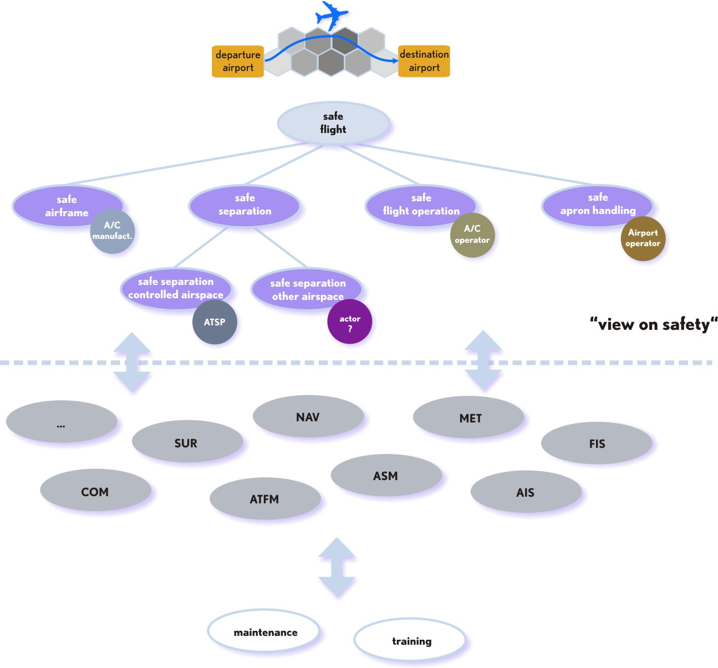
Safety Assessment
Safety Support Assessment
“View of safety”
“No view of safety”

Safety & Safety Support Case Relationships
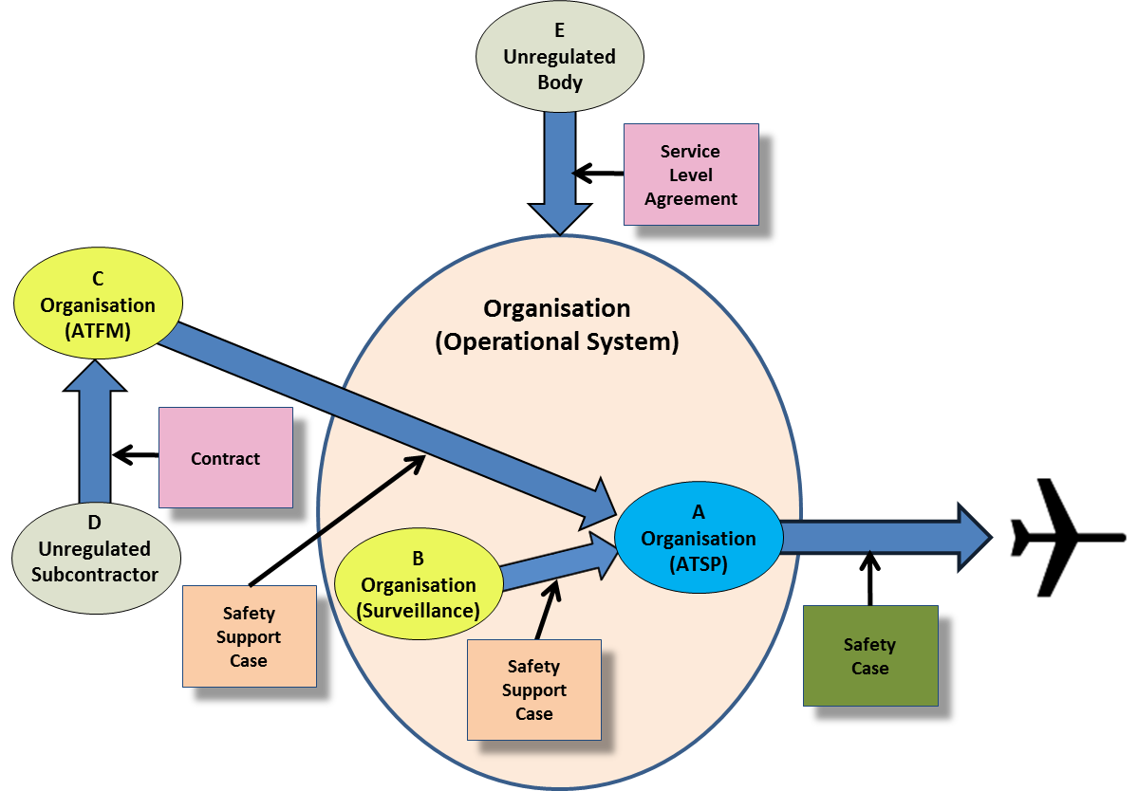

— END —

http://eur-lex.europa.eu/legal-content/EN/TXT/?uri=CELEX%3A32017R0373
Acceptable level of Safety Performance: The minimum level of safety performance of civil aviation in a State, as defined in its State safety programme, or of a service provider, as defined in its safety management system expressed in terms of safety performance targets and safety performance indicators.

