INFORMATION ON THE VULNERABILITY OF GNSS TO INTERFERENCE FROM JAMMING

(presented by John Taylor)

SUMMARY
This paper presents information from the recent Munich Satellite Navigation Summit that discussed the vulnerabilities of GNSS from the increasing use of jamming devices and that consensus was reached on the need for a terrestrial back-up to GNSS.

- INTRODUCTION
  - In the last few decades aviation has become very reliant on GNSS for precision navigation and a variety of other critical functions onboard aircraft for the timing and sequencing of avionics equipment during flight. More recently, in the last 10 years, the understanding that interference to GNSS services was such that it was perceived as a rare event, however today that perception and understanding has changed to a very high probability of interference and that action is needed to preserve the functionality of GNSS.
  - Last month the Resilient Navigation and Timing Foundation hosted a conference in Munich having the topic to discuss to need for a backup to GNSS. The conference was attended by experts from many States.
  - Representatives from the European Commission (EC) and the European GNSS Agency (GSA) noted the growing problem of GNSS jamming devices that were operating on the continent, and that the EC had collected the electronic signatures of more than 100,000 jamming devices operating in Europe.
  - It was highlighted that spoofing is becoming easier, cheaper and occurring more often. The ever increasing threat to aviation from spoofing and jamming events will have an impact on flight operations and also safety. Jamming devices are sophisticated enough to impact all GNSS frequencies simultaneously.
  - The panellists discussed the need for a backup to GNSS, and it was noted that a single backup would be insufficient, moreover that multiple backup systems would be required and that a very comprehensive plan was needed. The EC is considering a Radionavigation Plan to progress this further.
  - The conference was appraised that the U.S. Congress recently reinforced the need for a complimentary and backup system for GPS and that the government was developing plans for this, and that it was long overdue to have a backup system.
  - In the end, the panellists were asked to describe the desirable characteristics of systems to complement, backup, or augment GNSS. The summarized characteristics is below:

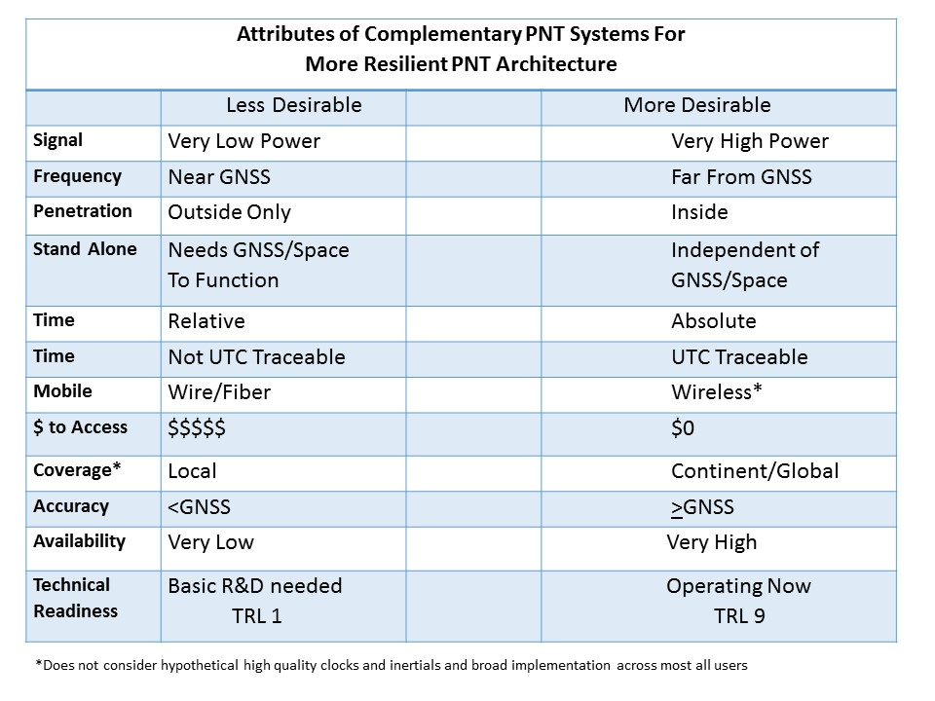
Action by the Meeting
- The meeting is invited to note the information from the RNTF Conference
- That backup systems to GNSS will need to be developed
- The critical importance and availability of terrestrial navigation systems used by the aviation transportation industry, that must be protected from interference and disruption

