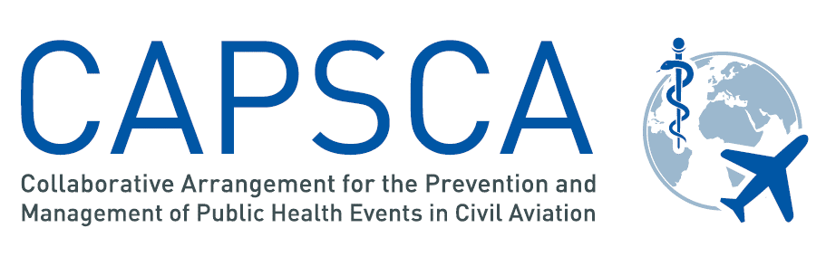

CAPSCA Member States (18 March 2025):

- Asia/ Pacific Region

- Afghanistan
- ​Bangladesh
- Brunei Darussalam
- Cambodia
- China
- Hong Kong SAR (China)
- Macao SAR (China)
- India
- Indonesia
- Lao People's Democratic Republic
- Malaysia
- Maldives
- Mongolia
- Myanmar
- Nepal
- ​New Zealand
- Pakistan
- Papua New Guinea
- Philippines
- Republic of Korea
- Singapore
- Solomon Islands
- ​Sri Lanka
- Thailand
- Timor Leste
- ​Tonga
- ​Viet Nam

- ESAF Region

- Angola
- ​Botswana
- Burundi
- ​Eswatini
- Ethiopia
- Kenya
- Lesotho
- Mozambique
- ​Namibia
- Rwanda
- Seychelles
- Somalia
- ​South Africa
- ​South Sudan
- United Republic of Tanzania
- Uganda
- Zambia
- Zimbabwe

- EUR/NAT Region

- Albania
- Algeria
- Andorra
- Armenia
- Azerbaijan
- Austria
- Belarus
- Belgium
- Bosnia and Herzegovina
- Cyprus
- Czechia
- Finland
- France
- Germany
- ​Georgia
- Greece
- Hungary
- Iceland
- Ireland
- Israel
- Italy
- Kazakhstan
- Kyrgyzstan
- Latvia
- Lithuania
- Luxembourg
- Malta
- Republic of Moldova
- Montenegro
- Morocco
- Netherlands
- North Macedonia
- Poland
- Portugal
- Romania
- Serbia
- Slovakia
- Slovenia
- Spain
- Sweden
- Switzerland
- Tajikistan​
- Tunisia
- ​Turkey
- United Kingdom
- Uzbekistan

- MID Region

- Bahrain
- ​Egypt
- Iran (Islamic Republic of)
- Iraq
- Jordan
- Kuwait
- ​Lebanon
- Libya
- Oman
- Qatar
- Sudan
- Syria Arab Republic
- Saudi Arabia
- United Arab Emirates
- Yemen

- NACC Region

- ​Bahamas
- ​Barbados
- Belize
- Canada
- Costa Rica
- Cuba
- Dominican Republic
- El Salvador
- Grenada
- Guatemala
- Haiti
- Honduras
- Jamaica
- Mexico
- Nicaragua​
- Saint Kitts and Nevis
- Saint Vincent and the Grenadines
- ​Trinidad and Tobago
- United States

Territories:

- Aruba (Netherlands)
- Curaçao (Netherlands)
- Bermuda (UK)
- Cayman Islands (UK)
- Turks and Caicos Islands (UK)

- SAM Region

- Argentina
- Bolivia (Plurinational State of)
- Brazil
- ​Chile
- ​Colombia
- Ecuador
- Guyana
- Panama
- Paraguay
- Peru
- ​Suriname
- Uruguay
- ​Venezuela (Bolivarian Republic of)

- WACAF Region

- ​Benin
- Burkina Faso
- Cabo Verde
- Cameroon
- Chad
- Central African Republic
- Côte d'Ivoire
- Democratic Republic of the Congo
- Equatorial Guinea
- Gabon
- Ghana
- Gambia
- Guinea
- Guinea Bissau
- Liberia
- Mauritania
- ​Mali
- Niger
- ​Nigeria
- ​Congo
- ​São Tomé e Príncipe
- Senegal
- ​Sierra Leone
- Togo

