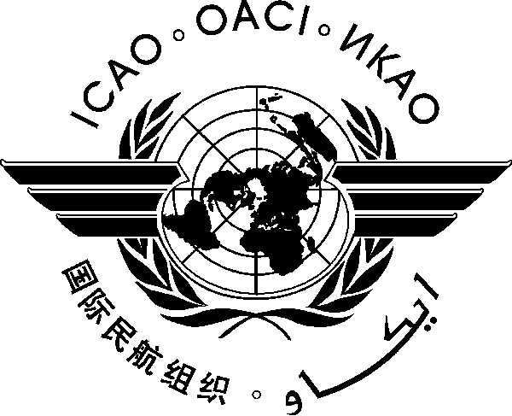
INTERNATIONAL CIVIL AVIATION ORGANIZATION

3rd AFI AVIATION SAFETY SYMPOSIUM
(Tuesday, 28 June 2016, Malabo, Equatorial Guinea)

Progress towards the Improvement of aviation safety in the AFI region: Implementation/Monitoring/Follow-up

PROGRESS TOWARDS THE ATTAINMENT OF ABUJA SAFETY TARGETS, MONITORING AND FOLLOW-UP ACTIVITIES

(Presented by the AFCAC)

SUMMARY
This Working Paper presents the progress made on in the implementation of the Abuja Safety Targets and activities undertaken by AFCAC and AFI States to meet the Safety Targets set by the Abuja Declaration and endorsed by the Heads of State of the African Union.

REFERENCE(S):
- 25th AFCAC Plenary Report
- Final Report of the Second Meeting of the Regional Aviation Safety Group for Africa-Indian Ocean (RASG-AFI/2)
- Report of the 16th AFI Plan SC Meeting
- Report of the16th AFCAC Technical Committee Meeting

Related ICAO Strategic Objective(s): The working paper relates to the Safety Strategic Objective of ICAO.

- INTRODUCTION

  - The Secretariat of AFCAC was directed by the 25th AFCAC Plenary to establish a new questionnaire for the follow-up and monitoring of the implementation of the Abuja Safety Targets.

  - The campaign for the collection of data was based on a new questionnaire developed in cooperation with ICAO and oriented to the Abuja Safety Targets. A total of 10 explicit questions to be answered or responded to by AFI States to determine the status of implementation of the Abuja Safety Targets were asked.

  - The new questionnaire on the collection of data which is attached as an appendix to this Working Paper was based on two (2) broad criteria namely:

- Reducing the accident rate in the AFI Region to within world average, and
- Implementing effective and independent regulatory oversight.

  - In accordance with Conclusion 3/11 of RASG-AFI/3, forty-four (44) AFI States have designated Focal Points to facilitate coordination with AFCAC on safety matters and the monitoring of the implementation of Abuja Safety Targets. The AFI States that are yet to designate Focal Points are: Comoros, Eritrea, Djibouti, and Madagascar.

  - The Designated Focal Points have started to coordinate with AFCAC and a significant improvement has been noted in the collection of data. In this regard, AFCAC will continue to develop strategic solutions with the Focal Points in order to compile comprehensive data from all AFI States.

  - The mechanism for the follow-up and monitoring of the status of implementation of the Abuja Safety Targets also includes the collection of data from other sources such as ICAO, IATA, ACI, etc.

- STATUS OF IMPLEMENTATION OF THE ABUJA SAFETY TARGETS

  - As of May 2016, the status of the implementation of the Abuja Safety Targets is as follows:

Nr | Abuja Safety Targets | Assessments | Achievements
1 | Reduce Runway related accidents and serious incidents by 50% by end of 2015 | Runway Related Accidents & serious incidents had a rate of 6.8 accidents per million sectors in 2012 and 2.8 by end of 2015.  (Source: IATA) | Safety Target met.  The positive trend should be maintained by AFI States.  As of December 2015. Twelve (12) Runway Safety Teams have been established at 12 international airports within AFI Region.
2 | Reduce Controlled Flight Into Terrain (CFIT) related accidents and serious incidents by 50% by end of 2015 | CFIT related Accidents & serious Incidents had a rate of 1.2 per million sectors in 2012 and went down to 0 in 2015.  (Source: IATA) | Safety Target met  The positive trend should be maintained by AFI States with Fleet modernization by AFI operators, implementation of PBN procedures (APV) by AFI States; and establishment and/or maintenance of CCO/CDO).
3 | Reduce LOC-I related accidents and serious incidents by 50% by the end of 2015 | LOC-I related accidents & serious incidents had a rate of 2.25 per million sectors in 2012 and went down to 0.80 by end of 2015.  (Source: IATA) | Safety Target met  The positive trend should be maintained.  ICAO and Stakeholders to continue their assistance to AFI States in organising more workshops on LOC-I
4 | States to establish and strengthen autonomous Civil Aviation Authorities by end of 2013 | From responses to the questionnaire received, the AFI States indicated that a Primary Act empowered their CAA to be an autonomous entity.  Malawi indicated that the Process is on-going. | Comprehensive data on status of CAAs not available.  The twenty-two (22) CAAs of States that have attained the 60% EI Target, among the forty eight (48) AFI States, have effective autonomy.
5 | Resolve ALL identified Significant Safety Concerns [existing ones by July 2013 and new ones within 12 months] | As of April 2016, 4 States with 4 SSCs namely Djibouti, Angola, Malawi and Eritrea are outstanding :  Djibouti and Eritrea remain priority States for AFCAC AFI-CIS missions. | Safety Target not met  Angola has made significant progress and has indicated willingness to receive an ICVM to verify the effective resolution of its identified SSC.  A follow-up AFI-CIS mission will be conducted in Malawi from 16 to 29 May 2016. The AFI-CIS Inspectors will assist the Malawi CAA to address specific PQs for the implementation of its Corrective Action Plan
6 | Implementation of State specific ICAO Plans of Action by July 2013 | Thirty-Two (32 ) States have accepted ICAO Plans of Action and are at different stages of implementation  (Source: ICAO) | The Abuja Safety Targets are fully incorporated into the Plans of Action.  Most States with ICAO Plans of Action have registered significant progress in the level of safety oversight.
7 | Progressively increase the Effective Implementation (EI) score of ICAO’s USOAP results to no less than 60% (35% or 19 of all African States by end of 2013, and 70% or 38 of all African States by end of 2015 and 100% or 54 of all African States by end of 2017) | As of April 2016, Twenty-two (22) States have attained EI ≥ 60% and Fourteen (14) AFI States have EI ≤ 30%.  AFI Average USOAP Overall EI = 45.43%  EI Global Average = 62.87%  (Source: ICAO) | Safety Target not met  Number of States with EI of 60% or greater has increased significantly from Fifteen (15) in 2014 to Twenty-two (22) at 2015 end.  The efforts of ICAO and AFCAC will need to be intensified to accelerate the implementation of the CAPs
8 | Implement State Safety Programs (SSP) and ensure that all Service Providers implement a Safety Management System (SMS) by end of 2015 | Eleven (11) States have initiated implementation of SSP and the highest attained is level 2.  However, none of the forty eight (48) States has attained level 4 implementation of SSP  (Source: ICAO) | Safety Target not met  Comprehensive data on status of SSP/SMS implementation not available. The implementation of SSP remains a serious challenge, as no State indicated the realization of full implementation of SSP. However, some AFI States indicated that some of their operators have implemented SMS
9 | Certify all international aerodromes by end of 2015 | As of December, 2015 Forty eight (48) International  Aerodromes were certified, 21.39% of the total number of 229 international airports within AFI.  .  (Source: ACI Africa, based on available information) | Safety Target Not Met.  From the responses to the questionnaire, aerodrome certification is still a serious challenge for AFI States. However, almost all AFI States indicated that the process of certification of international aerodrome is in progress;  The expansion of the AFI Plan to cover AGA and ANS will foster the implementation of aerodrome certification;  States will definitely need more assistance on this issue
10 | Require all African airlines to obtain an IATA Operational Safety Audit (IOSA) certification by end of 2015 | By the end of 2015, eleven (11) airlines from eleven (11) States were added to the IOSA Registry.  The progress is very slow as only 11 more airlines have been added to the IOSA registry since 2012. The total number of AFI airlines on the IOSA Registry as of December 31, 2015 was thirty (30)  (Source : IATA) | No comprehensive data available on the status of IOSA as a State regulatory requirement  - Only Equatorial Guinea, Ghana and Mozambique indicated incorporation of IOSA certification requirement into their National Regulations;  - Many Airlines may be ready for IOSA certification even in States that have not yet incorporated IOSA certification in their Regulations

- END -

