SMS GAP ANALYSIS CHECKLIST AND IMPLEMENTATION PLAN
Ref: ICAO Safety Management Implementation Website (September 2021)

The following complements Amendment 1 to Annex 19 – Safety Management, and the 4th edition of the Safety Management Manual (SMM) (ICAO Doc 9859).

1. Initial Gap Analysis Checklist (Table 1)

1.1 The initial gap analysis checklist in Table 1 can be used as a template to conduct the first step of an SMS gap analysis. This format with its overall “Yes/No/Partial” responses will provide an initial indication of the broad scope of gaps and hence overall workload to be expected. The questionnaire may be adjusted to suit the needs of the organization and the nature of the product or service provided. This initial information should be useful to senior management in anticipating the scale of the SMS implementation effort and hence the resources to be provided. This initial checklist would need to be followed up by an appropriate implementation plan as per Tables 2 and 3.

1.2. A “Yes” answer indicates that the organization meets or exceeds the expectation of the question concerned. A “No” answer indicates a substantial gap in the existing system with respect to the question’s expectation. A “Partial” answer indicates that further enhancement or development work is required to an existing process in order to meet the question’s expectations.

Table 1. Gap analysis checklist
No. | Aspect to be analysed or question to be answered | SMM 4th edition reference | State regulations reference | Answer | Status of implementation
Component 1 — SAFETY POLICY AND OBJECTIVES
Element 1.1 — Management commitment
1.1-1 | Is there a safety policy in place? | 9.3.1 |  | Yes  No  Partial
1.1-2 | Does the safety policy reflect senior management’s commitment regarding safety management? | 9.3.1  9.3.2  9.3.3 |  | Yes  No  Partial
1.1-3 | Is the safety policy appropriate to the size, nature and complexity of the organization? | 9.3.1  9.3.4.3 |  | Yes  No  Partial
1.1-4 | Is the safety policy relevant to aviation safety? |  |  | Yes  No  Partial
1.1-5 | Is the safety policy signed by the accountable executive? | 9.3.4.1 |  | Yes  No  Partial
1.1-6 | Is the safety policy communicated, with visible endorsement, throughout the [Organization]? | 9.3.4.2 |  | Yes  No  Partial
1.1-7 | Is the safety policy periodically reviewed to ensure it remains relevant and appropriate to the [Organization]? | 9.3.4.6 |  | Yes  No  Partial
1.1-8 | Are there relevant safety objectives in place? | 9.3.4.7 |  | Yes  No  Partial
1.1-9 | Are the safety objectives periodically reviewed to ensure them remain current? | 9.3.4.8 |  | Yes  No  Partial
Element 1.2 — Safety accountability and responsibilities
1.2-1 | Has [Organization] identified an accountable executive who, irrespective of other functions, shall have ultimate accountability, on behalf of the [Organization], for the implementation and maintenance of an effective SMS? | 9.3.5.3  9.3.5.4 |  | Yes  No  Partial
1.2-2 | Does the accountable executive have full control of the financial and human resources required for the operations authorized to be conducted under the operations certificate? | 9.3.5.1 |  | Yes  No  Partial
1.2-3 | Does the Accountable Executive have final authority over all aviation activities of his organization? | 9.3.5.1  9.3.5.8 b) |  | Yes  No  Partial
1.2-4 | Has [Organization] identified and documented the safety accountabilities of management as well as operational personnel, with respect to the SMS? | 9.3.5.11  9.3.5.12 |  | Yes  No  Partial
1.2-5 | Is there a safety committee or review board for the purpose of reviewing SMS and safety performance? | 9.3.6.7  9.3.6.8 |  | Yes  No  Partial
1.2-6 | Is the safety committee chaired by the accountable executive or by an appropriately assigned deputy, duly substantiated in the SMS manual? | 9.3.6.8 |  | Yes  No  Partial
1.2-7 | Does the safety committee include relevant operational or departmental heads as applicable? | 9.3.6.8 |  | Yes  No  Partial
1.2-8 | Are there safety action groups that work in conjunction with the safety committee (especially for large/complex organizations)? | 9.3.6.9 |  | Yes  No  Partial
Element 1.3 — Appointment of key safety personnel
1.3-1 | Has [Organization] appointed a qualified person to manage and oversee the day-to-day operation of the SMS? | 9.3.6.1 |  | Yes  No  Partial
1.3-2 | Does the qualified person have direct access or reporting to the accountable executive concerning the implementation and operation of the SMS? | 9.3.6.1 |  | Yes  No  Partial
1.3-3 | Does the manager responsible for administering the SMS hold other responsibilities that may conflict or impair his role as SMS manager? | 9.3.6.3 |  | Yes  No  Partial
Element 1.4 — Coordination of emergency response planning
1.4-1 | If required to establish an emergency response planning (ERP), does [Organization] coordinate its ERP with the relevant external entities with which it must interface during the provision of its products and services? | 9.3.7.2 |  | Yes  No  Partial
1.4-2 | Does the ERP address foreseeable emergencies as identified through the SMS and include mitigating actions, processes and controls to effectively manage aviation-related emergencies, where applicable? | 9.7.3.1 |  | Yes  No  Partial
1.4.3 | Dose [Organization] exercise the coordination of ERP as part of the periodic testing of its ERP, where applicable? | 9.7.3.3 |  | Yes  No  Partial
Element 1.5 — SMS documentation
1.5-1 | Is there a top-level SMS summary or exposition document which is approved by the accountable manager and accepted by the CAA?  [5.3.36 to 5.3.38] | 9.3.6.2 e)  9.3.8.2 |  | Yes  No  Partial
1.5-2 | Does the SMS documentation address the organization’s SMS and its associated components and elements? | 9.3.8.1  9.3.8.3 |  | Yes  No  Partial
1.5-3 | Is [Organization] SMS framework in alignment with the regulatory SMS framework? | 9.3.8.3 b) |  | Yes  No  Partial
1.5-4 | Does [Organization] maintain a record of relevant supporting documentation pertinent to the implementation and operation of the SMS? | 9.3.8.4 |  | Yes  No  Partial
1.5-5 | Does [Organization] have an SMS implementation plan to establish its SMS implementation process, including specific tasks and their relevant implementation milestones? | 9.7.7.1  9.7.7.2 |  | Yes  No  Partial
1.5-6 | Does the SMS implementation plan address the coordination between the service provider’s SMS and the SMS of external organizations where applicable? | 9.7.7.3 |  | Yes  No  Partial
1.5-7 | Is the SMS implementation plan developed in consultation with the accountable executive and other senior managers? | 9.7.7.3 |  | Yes  No  Partial
1.5-8 | Is the SMS implementation plan monitored regularly and updated as necessary? | 9.7.7.4 |  | Yes  No  Partial
Component 2 — SAFETY RISK MANAGEMENT
Element 2.1 — Hazard identification
2.1-1 | Is there a formal process to identify all possible hazards that could impact aviation safety in all areas of operation and activities, with consideration of interfaces both within and external to [Organization]? | 2.5.2  9.4.4 |  | Yes  No  Partial
2.1-2 | Is the hazard identification based on a combination of reactive and proactive methods using both internal and external sources utilized for hazard? | 9.4.4.1  9.4.4.2  9.4.4.13  9.4.5 |  | Yes  No  Partial
2.1-3 | Is there a mandatory safety reporting system used? | 9.4.4.3 |  | Yes  No  Partial
2.1-4 | Is there a voluntary reporting system with appropriate protections being provided to encourage people to report additional information that is not subject to mandatory reporting system? | 9.4.4.4 |  | Yes  No  Partial
2.1-5 | Are personal at all levels and across all disciplines are encouraged to identify and report hazards and other safety issues through the safety reporting systems within [Organization]? | 9.4.4.6 |  | Yes  No  Partial
2.1-6 | Is service provider safety investigation part of its SMS supporting hazard identification? | 9.4.5 |  | Yes  No  Partial
2.1-7 | Are the identified hazards and their potential consequences documented to be used for safety risk assessment processes? | 9.4.4.11 |  | Yes  No  Partial
Element 2.2 — Safety risk assessment and mitigation
2.2-1 | Has [Organization] developed a safety risk assessment model and procedures for the assessment of safety risks associated with identified hazards? | 2.5.3  2.5.4  2.5.5  2.5.6  9.4.6.1 |  | Yes  No  Partial
2.2-2 | Does the safety risk assessment process use whatever safety data and safety information that is available for the analysis and assessment of safety risks associated with identified hazards? | 9.4.6.4  9.4.6.5 |  | Yes  No  Partial
2.2-3 | Does [Organization] have a process to prioritize its safety risk assessments? | 9.4.6.6  9.4.6.7 |  | Yes  No  Partial
2.2-4 | Does [Organization] have procedures to implement appropriate safety risk controls? | 2.5.7  2.5.9  9.4.6.8 |  | Yes  No  Partial
2.2-5 | Are there means to monitor and validate the effectiveness of the implemented safety risk control under operational conditions? | 2.5.7.5  9.4.6.9 |  | Yes  No  Partial
2.2-6 | Are the safety risk management activities and their outputs documented? | 2.5.8  9.4.6.10 |  | Yes  No  Partial
Component 3 — SAFETY ASSURANCE
Element 3.1 — Safety performance monitoring and measurement
3.1-1 | Are there means established to monitor and verify the safety performance of the organization, such internal audits and the establishment and monitoring of safety performance indicators? | 9.5.1  9.5.2  9.5.3  9.5.4 |  | Yes  No  Partial
3.1-2 | Is there a process established for safety performance management? | 4.1.1  4.1.2  4.1.3  9.5.4.11 |  | Yes  No  Partial
3.1-3 | Are there safety performance indicators established to measure and monitor the safety performance of the organization and the performance of its SMS? | 4.3.1  4.3.2  9.5.4.13 |  | Yes  No  Partial
3.1-4 | Are the safety performance indicators relevant to the organization’s safety objectives? | 4.3.2.5  9.5.4.14 a)  9.5.4.17 |  | Yes  No  Partial
3.1-5 | Do the safety performance indicators include quantitative monitoring of high-consequence safety outcomes (e.g. accident and serious incident rates),lower-consequence events (e.g. rate of non-compliance, deviations) and process performance (e.g. training, system improvements and report processing)? | 9.5.4.12 |  | Yes  No  Partial
3.1-6 | Is there appropriate usage of corresponding safety performance targets to work together with safety performance indicators? | 4.3.3  4.3.5  9.5.4.15  9.5.4.18 |  | Yes  No  Partial
3.1-7 | Are safety performance indicators and their associated safety performance targets developed in consultation with, and subject to, the civil aviation authority’s agreement? | 8.4.7.14  8.4.7.15  9.5.4.20 |  | Yes  No  Partial
3.1-8 | Is there a procedure for corrective or follow-up action to be taken based on the results of monitored and measured SPIs? | 4.4.7 |  | Yes  No  Partial
3.1-9 | Are the safety objectives, safety performance indicators and the associated safety performance targets periodically reviewed? | 4.4.4  4.5 |  | Yes  No  Partial
Element 3.2 — The management of change
3.2-1 | When facing changes, does [Organization] identify hazards and assess and control the associate risks using its existing hazard identification or safety risk management procedures? | 9.5.5.2 |  | Yes  No  Partial
3.2-2 | Does [Organization] regularly review its system description to determine its continued validity, as it might experience regular or even continuous changes, large or small? | 9.5.5.1  9.5.5.4 |  | Yes  No  Partial
3.2-3 | Has [Organization] defined the trigger for its formal change management process? | 9.5.5.5 |  | Yes  No  Partial
3.2-4 | Is there a process developed for change management to identify and manage the safety risks that may arise from changes which could affect the level of safety risk of the organization? | 9.5.5.3  9.5.5.7 |  | Yes  No  Partial
Element 3.3 — Continuous improvement of the SMS
3.3-1 | Is there a procedure for periodic internal audit/assessment of the effectiveness of the service provider’s SMS, using a variety of methods to determine its effectiveness? | 9.5.6.1  9.5.6.2  9.5.6.3 |  | Yes  No  Partial
3.3-2 | Does the internal audit function of the service provider include the evaluation of all of the safety management functions throughout its organization? | 9.5.6.2 |  | Yes  No  Partial
Component 4 — SAFETY PROMOTION
Element 4.1 — Training and education
4.1-1 | Is there a programme to provide SMS training/familiarization to personnel involved in the implementation or operation of the SMS? | 9.6.4.1 to  9.6.4.9 |  | Yes  No  Partial
4.1-2 | Has the accountable executive undergone appropriate SMS familiarization, briefing or training? | 9.6.4.1 to  9.6.4.9 |  | Yes  No  Partial
4.1-3 | Are personnel involved in conducting risk mitigation provided with appropriate risk management training or familiarization? | 9.6.4.1 to  9.6.4.9 |  | Yes  No  Partial
4.1-4 | Is there evidence of organization-wide SMS education or awareness efforts? | 9.6.4.1 to  9.6.4.9 |  | Yes  No  Partial
Element 4.2 — Safety communication
4.2-1 | Does [Organization] participate in sharing safety information with relevant external industry product and service providers or organizations, including the relevant aviation regulatory organizations? | 9.6.5.1 to  9.6.5.4 |  | Yes  No  Partial
4.2-2 | Is there evidence of a safety (SMS) publication, circular or channel for communicating safety (SMS) matters to employees? | 9.6.5.1 to  9.6.5.4 |  | Yes  No  Partial
4.2-3 | Are [Organization] SMS manual and related guidance material accessible or disseminated to all relevant personnel? | 9.6.5.1 to  9.6.5.4 |  | Yes  No  Partial

2. Detailed SMS Gap Analysis and Implementation Tasks (Table 2)

The initial gap analysis checklist in Table 1 should then be followed up by using the detailed “SMS gap analysis and implementation task identification plan” in Table 2. Once completed, Table 2 will provide follow-up analysis on details of the gaps and help translate these into actual required tasks and subtasks in the specific context of the organization’s processes and procedures. Each task will then accordingly be assigned to appropriate individuals or groups for action. It is important that correlation of individual element/task development with their descriptive placeholders in the SMS document be provided for in Table 2 in order to trigger progressive updating of the draft SMS document as each element is implemented or enhanced. (Initial element write-ups in SMS documents tend to be anticipatory rather than declaratory.)

3. Actions/Tasks Implementation Schedule (Table 3)

Table 3 will show the milestones (start-end dates) scheduled for each task/action. For a phased implementation approach, these tasks/actions will need to be sorted according to the phase allocation of their related elements. Table 3 can be a separate consolidation of all outstanding actions/tasks or, if preferred, be a continuation of Table 2 in the form of a spreadsheet. Where it is anticipated that the actual number of tasks/actions and their milestones are sufficiently voluminous and complex so as to require utilizing a project management software to manage them, this may be done by using software such as MS project/Gantt chart as appropriate. Table 4 is an illustration of a Gantt chart.

Table 2. Example SMS gap analysis and implementation task identification plan

Question Ref # | Gap analysis question | Answer (Yes/No/Partial) | Description of gap | Action/task required  to fill the gap | Assigned task group/person | SMS document reference | Status of action/task (Open/WIP/Closed)
1.1-1 | Is there a safety policy in place? | Partial | The existing safety policy addresses OSHE only. | a) enhance the existing safety policy to include aviation SMS objectives and policies or develop a separate aviation safety policy;  b) have the safety policy approved and signed by the accountable executive. | Task  Group 1 | Chapter 1, Section 1.3. | Open
etc.

Table 3. Example SMS implementation schedule

Action/task required  to fill the gap | SMS document ref. | Assigned task group/  person | Status of action/ task | Schedule/timeline
 |  |  |  | 1Q  22 | 2Q  22 | 3Q  22 | 4Q  22 | 1Q  23 | 2Q  23 | 3Q  23 | 4Q  23 | 1Q  23 | 2Q  23 | 3Q  23 | 4Q  24 | etc.
1.1-1 a) Enhance the existing safety policy to include aviation SMS objectives and policies or develop a separate aviation safety policy. | Chapter 1, Section 1.3. | Task Group 1 | Open
1.1-1 b) Require the safety policy to be approved and signed by the accountable executive.
etc.

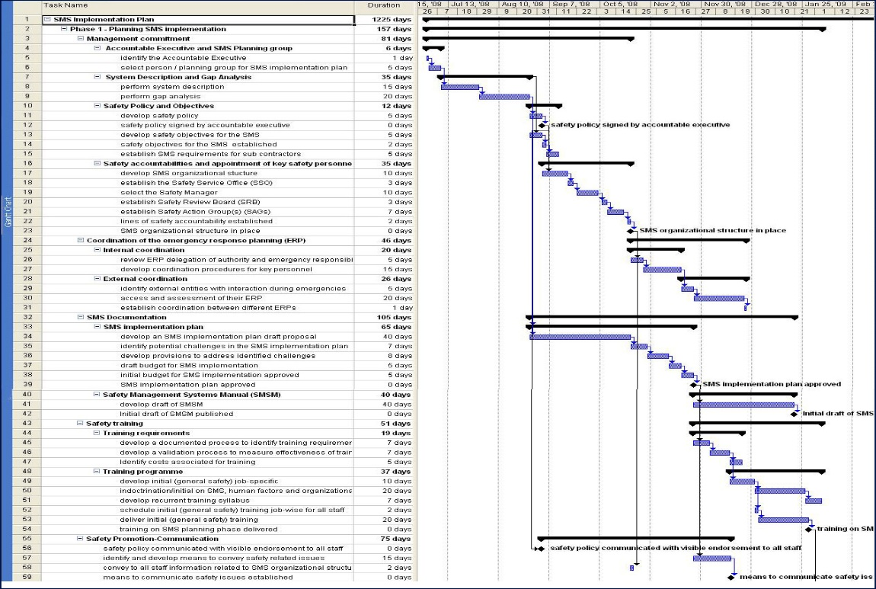
Table 4. Sample SMS implementation schedule (Gantt chart)

- END OF DOCUMENT -

