Sharing and Exchange of Safety Intelligence in Colombia
– A first approach –

Description

The sharing and exchange system that Colombia has in place.

The main Colombian system for collecting safety data and sharing information is the “framework” called IRIS (for Integrador de Reportes e Información de Seguridad). This has a place on the Aerocivil’s website (www.aerocivil.gov.co).

Its scope is an integrated mechanism to collect data and visualize safety information coming from sources such as mandatory and voluntary reports from the industry, as well as accidents investigation reports, information that can be used by the aeronautical community and the Aeronautical Authority to support safety analysis.

This framework was projected as part of Colombian SSP (called PEGASO for Programa Estatal para la Gestión de Autoridad en Seguridad Operacional).

Background

IRIS was launched in October 2016 (please see the screenshot, here below). At the beginning, the first form to collect MOR data was issued on excel format and visualizations were produced on excel and PowerPoint. Also, some data had been collected on different forms, not standardized and they were collected by different areas in Aerocivil.
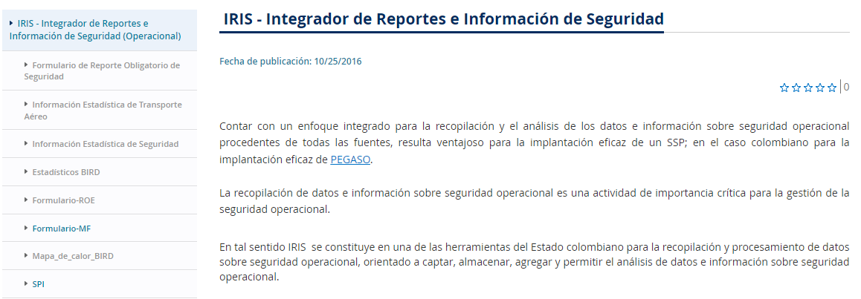

Mechanisms have been evolving and today several forms are presented online in a more standardized way, data is saved on Oracle databases, and visualizations are prepared with PowerBI taking data, mainly from those Oracle databases.

Why to establish the sharing network

Since 2013, when first edition of Annex 19 was issued, it was noticed that SSP required safety data and information, and aimed States to prepare mechanisms to identify hazards, analyze risks, make promotion and, in fact, data for implementing almost every component of the SSP.

The best way to convince some to do something is to be the example. So, in order to aim the industry (not only to regulate), it was also necessary that the State (Authority) was the example. In fact, some organizations require the Authority to lead the tasks to be accomplished to implement effective SMSs.

Some features of IRIS

The system is prepared to collect data and information as well as to share information, always protecting sources and sensitive data.

Collection:

On the web site (https://www.aerocivil.gov.co/autoridad-de-la-aviacion-civil/iris-integrador-de-reportes-e-informacion-de-seguridad-operacional), the aeronautical community finds online forms to complete with data and information related to Mandatory and Voluntary Occurrence Reports, Bird strikes -form based on ICAO Bird Strike Information System (IBIS)-, Airworthiness malfunction, among others.

These forms are supported by circulars (issued also on the web), so the standards and guidelines can be consulted by the community.

It is noticed that during the former years (since 2015 up to around the end of 2019), MOR data was collected through parametrized excel forms, also published on the web, but they required much more work to purge possible wrong data. Anyway, data was organized to be uploaded to Oracle data tables when this resource was made available.

At the present, Data collected from the forms goes directly to Oracle databases. Data quality is reviewed periodically. When necessary, in case of any detected data error (mistakes when data was typed), the sender is contacted by email to make clear the possible wrong data. Nevertheless, most of the fields on the form can be selected from lists (based on main data tables), but sometimes dates can be wrong selected or badly typed.

Sharing:

On the same IRIS framework, Colombia has issued some dashboards generated from data collected from the forms (used to collect data). Data is taken directly from oracle databases. Dashboards were created and published with PowerBI, and they are updated daily, through scripts defined to do so with data compiled along the day.

On our way to share intelligence

Up to the present, Colombia shares information derived from the reports received from industry. This information would be the foundation to share intelligence in the future which should be the result of data analysis, evaluation and comparation of trends and relationships as well as finding out root causes.

It is necessary to prepare the scenario to support well-informed decisions and effective actions but also to enable advanced analysis, e.g. predictive analysis. Typically, dashboards contemplate events identified by taxonomies, geolocation of events and taxonomies are presented, reporting by type of service providers, behavior in the time (seasonality). In some cases, ratios are also calculated and presented on the dashboards. Also, the behavior of SPIs is shown by sub-sector. Visualizations do not show names of organizations or data from people. Raw data is not shared.

We consider that, up to date, Colombia does not share intelligence, yet. To share intelligence, we think that safety information should be used as a source to prepare safety analysis and publish the resulting reports, but this information still is not being used in that way.

It is important to remark that Colombian Authority has worked on safety data quality but in a very manual manner. Nevertheless, we don’t have fully implemented data governance policies and procedures, yet. Neither the information is used to make decisions. In this sense, it does not seem possible to speak about safety intelligence, at this moment.

Some other irrelevant information about IRIS.

Webpage is not the “sole” mechanism used to collect and share information. Another way to collect safety information is the email. There is an institutional mailbox, “Seguridad Operacional” seguridadoperacional@aerocivil.gov.co devoted to receive safety information, such as agreed SPIs, sent by organizations on a yearly basis, on excel forms (this excel is well explained through a circular published on the web https://www.aerocivil.gov.co/autoridad-de-la-aviacion-civil/biblioteca-tecnica/Circulares%20Informativas/219-MAUT-1.0-22-005%20CI%20Definicion%20de%20Indicadores%20de%20rendimiento%20en%20Materia%20de%20Seguridad%20Operacional-OFP-s.pdf. This excel can be downloaded by the industry, clicking on https://www.aerocivil.gov.co/autoridad-de-la-aviacion-civil/biblioteca-tecnica/Formatos/219-MAUT-1.0-12-002%20FO%20Herramienta%20definici%C3%B3n%20de%20SPIs%20-%20MOD-XXXX-NIT-SPI-mes-a%C3%B1o.xlsx, as it is mentioned in the circular.

Colombia also shares information throughout annual reports. Up to date, two reports have been issued which are published on https://www.aerocivil.gov.co/autoridad-de-la-aviacion-civil/seguridad-operacional.

For better coverage when sharing safety information, the Authority collects the contact emails of each service provider’s staff, including SMS and Accountable managers, as well as emails of aeronautical personnel when they carry out any procedure before the aeronautical authority (certification, licensing, and so on).

This CAAuses the institutional mailbox (seguridadoperacional@aerocivil.gov.co) to share information. Through collected emails, new information or publications, changes related to Safety documents, procedures, guidelines, or some other information is also communicated. It is important to mention that when emails are sent, the email addresses are sent as hidden to protect contact information.

Stakeholders

Roles in IRIS

IRIS is run by the Authority Planification Group (the Group I lead), which is part of the Safety Authority Secretariat. Data is collected on database's workspace assigned specifically to this Authority Planification Group.

Note: IT area must apply backup procedures to all oracle databases, including this workspace.

Stakeholders involved in / impacted by IRIS.

In general terms, the illustration below summarizes the participation of those considered as IRIS’ stakeholders:
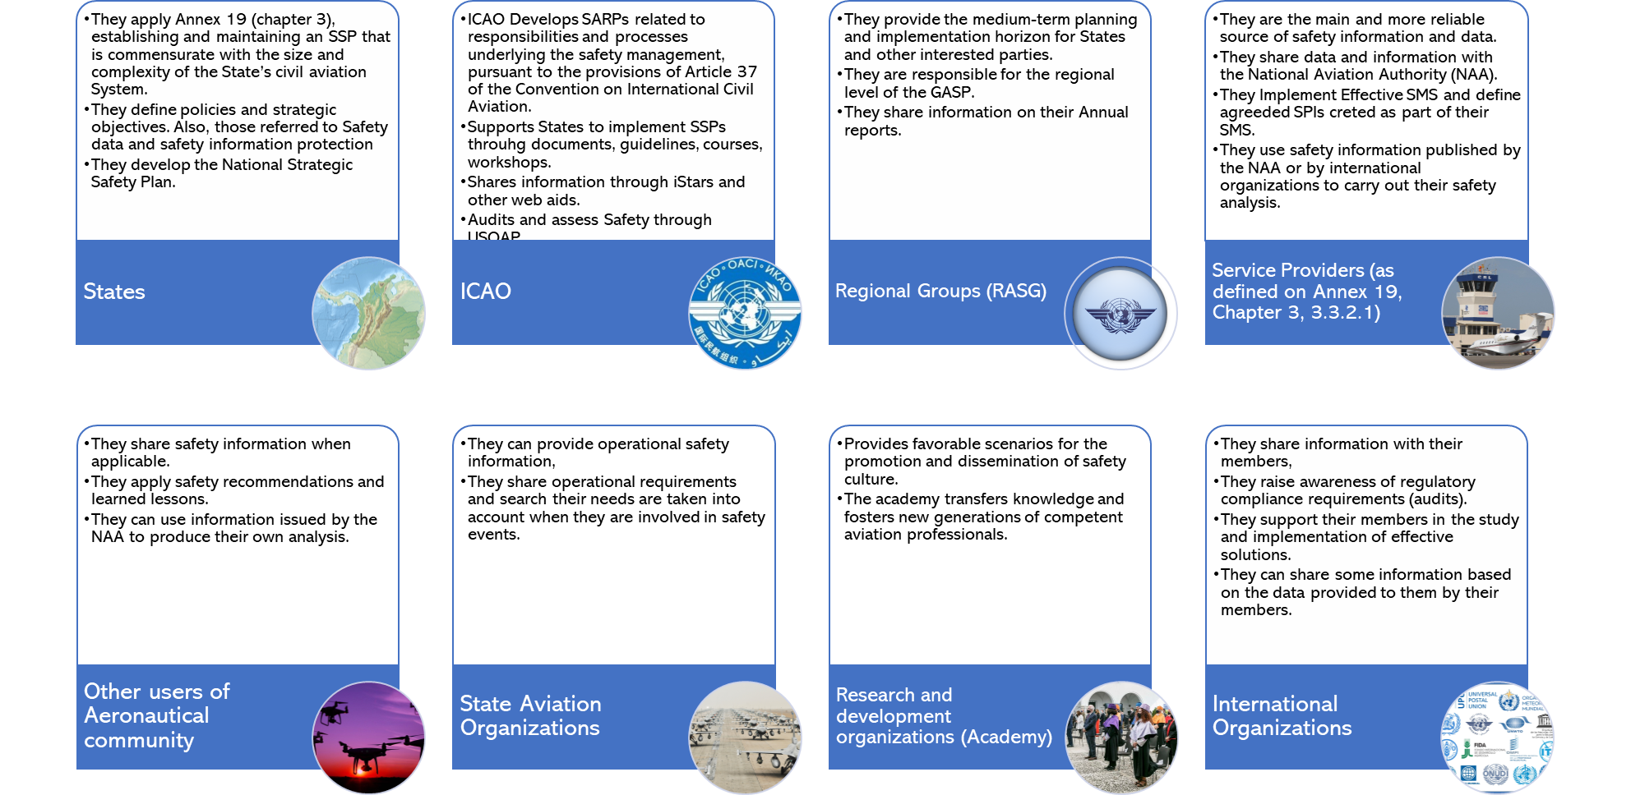

The “participation” of each stakeholder as depicted into the former illustration is:
- States
    - They apply Annex 19 (chapter 3), establishing and maintaining an SSP that is commensurate with the size and complexity of the State’s civil aviation System.
    - They define policies and strategic objectives. Also, those referred to Safety data and safety information protection.
    - They develop the National Strategic Safety Plan. They need data and information.

- ICAO
    - ICAO Develops SARPs related to responsibilities and processes underlying the safety management, pursuant to the provisions of Article 37 of the Convention on International Civil Aviation.
    - Supports States to implement SSPs through documents, guidelines, courses, workshops.
    - Shares information through iStars and other web aids.
    - Audits and assess Safety through USOAP.
    - Assess Safety through USOAP.

- Regional Groups (RASG)
    - They provide the medium-term planning and implementation horizon for States and other interested parties.
    - They are responsible for the regional level of the GASP.
    - They share information on their annual reports.

- Service Providers (as defined on Annex 19, Chapter 3, 3.3.2.1)
    - They are the main and more reliable source of safety information and data.
    - They share data and information with the National Aviation Authority (NAA).
    - They Implement Effective SMS and define agreed SPIs created as part of their SMS.
    - They use safety information published by the NAA or by international organizations to carry out their safety analysis.

- Other users of Aeronautical community
    - They share safety information when applicable.
    - They apply safety recommendations and lessons learned.
    - They can use information issued by the NAA to produce their own analysis.

- State Aviation Organizations
    - They can provide operational safety information,
    - They share operational requirements and search their needs are considered when they are involved in safety events.

- Research and development organizations (Academy)
    - Provides favorable scenarios for the promotion and dissemination of safety culture.
    - The academy transfers knowledge and fosters new generations of competent aviation professionals.

- International Organizations
    - They share information with their members,
    - They raise awareness of regulatory compliance requirements (audits).
    - They support their members in the study and implementation of effective solutions.
    - They can share some information based on the data provided to them by their members.

Intended users are all the aeronautical community. This community can be segregated on those who send data and information to the Colombian CAA and those who can use shared information issued by this CAA. In that sense, users are:

User of tools (forms) where safety data and information are collected:
- Service Providers in Colombia (Regulated by RAC 219), included foreign operators who flight to/from Colombia,
- Other users who want to send voluntary reports.

Users to whom information is shared (on dashboards):
- Other States: National Aviation Authorities,
- Service Providers in Colombia Regulated by RAC 219, included foreign operators,
- Other users of Aeronautical Community. Other users can be UAS operators, ground handling organizations, and so on,
- State Aviation Organizations (e.g. Military and Police Organizations),
- Research and development organizations (Academy): Universities, Technical Schools, among others,
- International Organizations: IATA, IFALPA, ACI, and so on.
- Internal intended users are the personnel who is part of the Colombian Authority:
    - Safety Inspectors and
    - directive staff who in the future can make decisions regarding safety.

As depicted in the previous item b), users are internal and external and can be national or foreign people interested in having safety information.

Access to IRIS

It is stablished (in circulars published on the web) that the people who can fill in the reports have to be:
- SMS managers MOR
- Airworthiness responsible Malfunction reports, or
- Officer of Aviary and Fauna matters BIRD

There must be at least an SMS manager in each organization.

Nevertheless, at the present, everybody can have access not only to dashboards but also to report forms. We expect to evolve into more controlled reporting tools.

Meanwhile, this is why it is often necessary to “clean up” or “purge” the data that is included through forms. In some cases, we have identified data that is not reliable, coming from unidentified users (they must include their email when filling in the form). So, we can compare those emails with the list of registered emails of the people defined by service provider organizations to report (as listed above).

As there is not any enroll process implemented, yet, it is seen that the “open” access has been a good tool for some users who want to obtain information for their own analysis, studies, projects, courses as well as some governmental organizations like Ministry of TICs, Ministry of Transport, National Statistics Agency (DANE for Departamento Administrativo Nacional de Estadística), among others.

Nevertheless, due to lack of granting access procedures and lack of control to access to reports forms, sometimes the workload is bigger because it is necessary to verify data quality more often.

Inputs, Processes and Outputs

Here below are detailed inputs (formats, interfaces, frequency) to IRIS:

Inputs:

Master data tables – these tables are created on oracle and contain data related to:

- Aircrafts: contains data like registry, ICAO Type Designator, MTOW, owner’s ID, manufacturing date, manufacturer, model, among others

- Service providers: Organization’s ID, name of the organization, service provided, and so on,

- Aerodromes: ICAO Code, Name, Airport type, Owner/Operator’s ID, Location, Coordinates, and so on.

- Personnel (organization’s staff): Name and email for Accountable, SMS manager, Operations responsible, Maintenance responsible, Quality Control manager, among others.

- Occurrences: Taxonomy, events.

Accident/serious incidents data: this data is collected by querying ECCAIRS which is the tool used by the Accident/Incident Investigation Area (AIG). About Accident/incident recommendations, they are taken from official final reports created for each event by the AIG and issued on the website. All this data is uploaded to oracle data tables.

Mandatory reports: These reports can be reported through on-line forms developed using “.html” and “.net”, so the responsible of each kind of occurrence in the organizations can fill in parametrized fields. Forms send data directly to oracle databases. Those forms are prepared to collect data from:
- Mandatory occurrence reports (MOR),
- Bird collision reports (created applying IBIS parameters),
- Airworthiness malfunction reports,
- HAZMAT reports.

Ramp Inspection reports: Up to date, Colombia does not have any automatic tool to support certification nor inspection activities. Nevertheless, when it was decided to generate mandatory reports, it was also possible to produce an online form to collect ramp inspections. It is the only automatic tool issued to be used by inspectors, and it is very helpful to collect the related information. From this data, the authority also has internal dashboards automatically updated.

SPIs: They are sent by service providers who applying the Circular 219-MAUT-1.0-22-005 – referred to SPIs definition. The circular complements the SMS Regulation (RAC 219), lists agreed Indicators with each sub-sector (type of service provider), and it is a guideline on how to define and send updated SPIs to the National Aviation Authority. Each service provider must present an excel file (yearly, by the end of march): The file was prepared to include data and information, produce graphs and alerts. One sheet must be completed for each indicator.

The screenshot presented here below shows the excel form devoted to present SPIs by service providers who are regulated on RAC 219 to implement SMS. The excel was an adaptation of the tool formerly exposed by ICAO on the web site, as the "SPIs kit". The referred excel file can be downloaded by any organization from https://www.aerocivil.gov.co/autoridad-de-la-aviacion-civil/biblioteca-tecnica/Formatos/219-Herramienta%20definici%C3%B3n%20de%20SPIs%20-%20MOD-XXXX-NIT-SPI-mes-a%C3%B1o.xlsx and the explanatory Circular is found on https://www.aerocivil.gov.co/autoridad-de-la-aviacion-civil/biblioteca-tecnica/Circulares%20Informativas/219-MAUT-1.0-22-005%20CI%20Definicion%20de%20Indicadores%20de%20rendimiento%20en%20Materia%20de%20Seguridad%20Operacional.pdf :

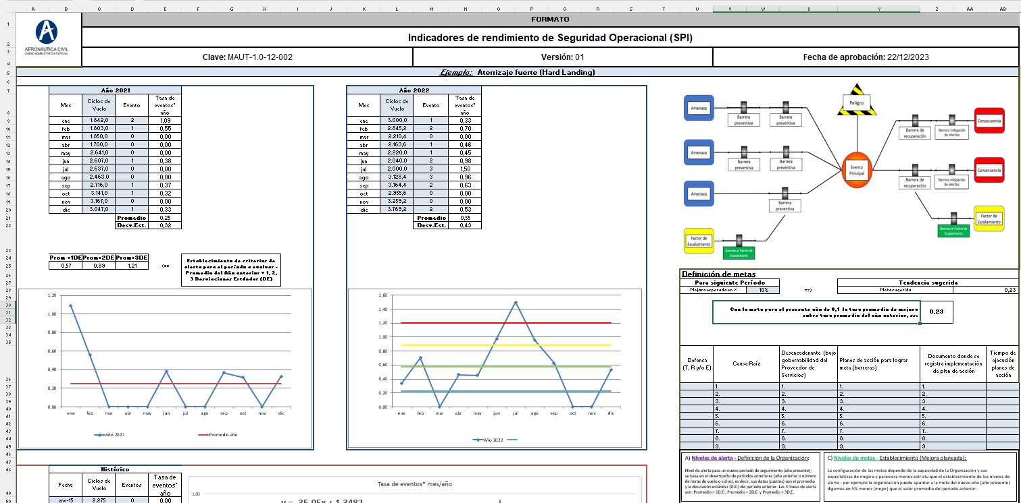

Regarding data collected from SPIs, the NAA, in the Authority Planning Group, applies a procedure to standardize the compilation, review and analysis of safety performance indicators (SPI) submitted by each service provider.

The procedure starts from the reception of the electronic documents (excel files) with the SPI delivered by the service provider organizations and covers the validation of compliance with the criteria established in the Information Circular “Definition of Safety Performance Indicators (SPI)”. The data is consolidated with the objective of generating dashboards that allow analyzing the behaviors and trends of the indicators.

The following graph shows a brief schema of the process applied to mandatory reports which automatically update dashboards:

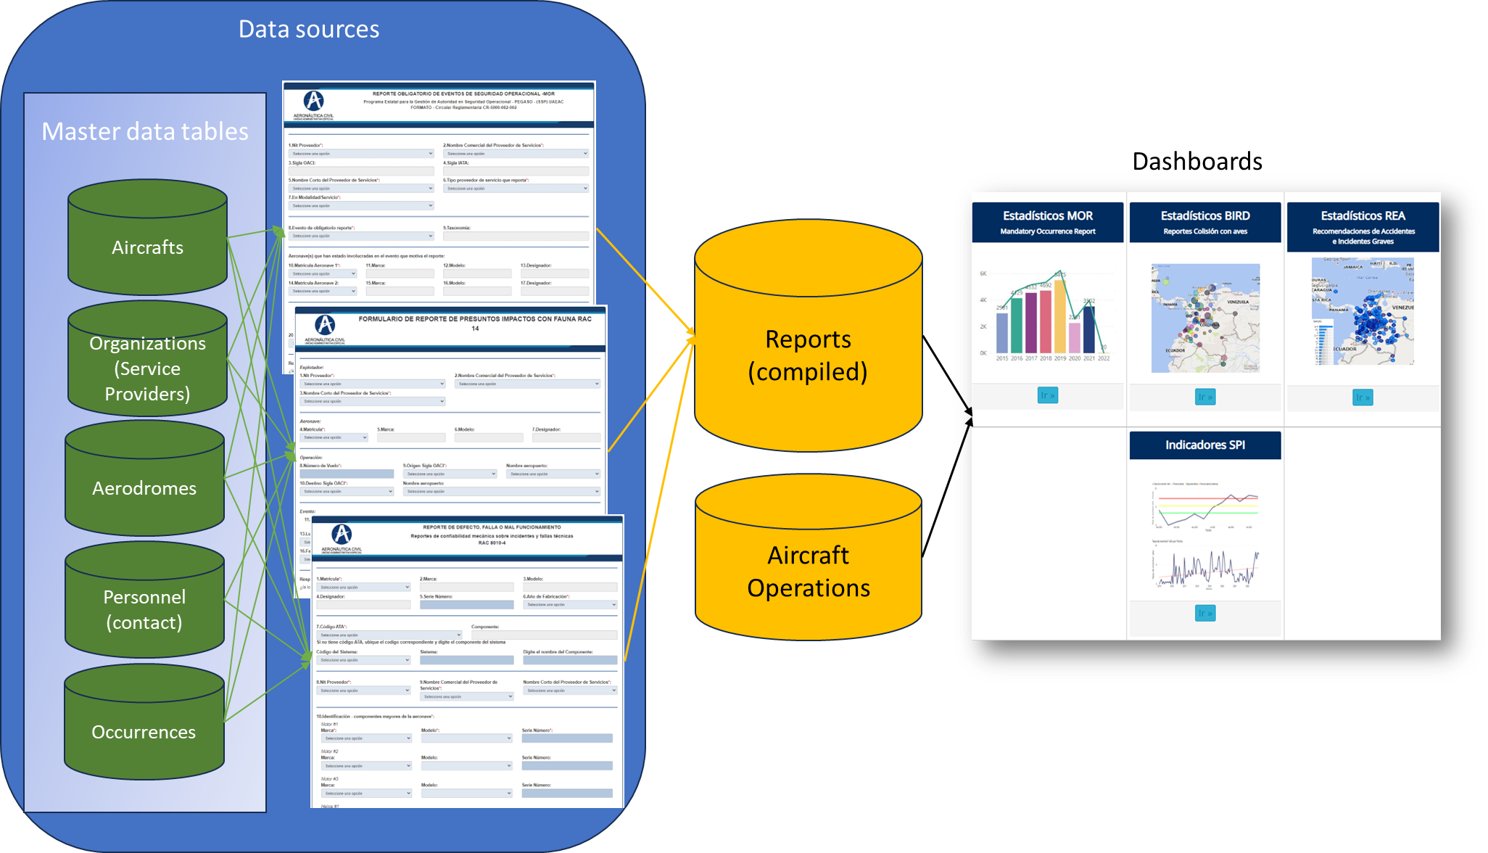

Another input used to produce dashboards is data coming from aircraft operations registered by Air Traffic Services (ATS). This data is accessible to this Authority even though it is necessary to apply some download, quality assurance and upload processes.

Note: Up to date, Colombia doesn’t have any software or tool to gather information obtained during inspections or any other activity developed by the National Aviation Authority. We are working on this issue to contract software capable of supporting the authority’s tasks.

Using standardized taxonomy (ADREP)

All our tools (online forms and dashboards) use ADREP taxonomy for the occurrences, taken from the CICTT. Also, we have created a couple of taxonomies for occurrences not described by CICTT but necessary for our environment. Those taxonomies for occurrences are described in the Directive MOR.

Some other taxonomies are also standardized, like phases of flight, engine make/model/sub model, and aircraft make/model/series (for Airworthiness malfunction reports), categorization of some elements related to aerodrome events and air navigation systems to associate some characteristics or locations into the aerodrome or navigation aid systems with the occurrences.

Frequency

In the table below the frequency of updating data processes is detailed for each input:

Input | Updating frequency
Aircrafts | Every time there's a new aircraft operating in Colombia
Service providers | Every time a new organization is approved
Aerodromes | Every time a new aerodrome is approved
Personnel (organization’s staff) | Every time the organization changes staff personnel
Occurrences | When required (very few times)
Accident/serious incidents data | Quarterly
Mandatory occurrence reports (MOR) | Service providers (through SMS managers) are required to fill in the online form every time an event listed on the MOR Directive occurs, 5 working days as late.
Bird collision reports | Service providers (through responsible of wild issues) are required to fill in the online form, every time a collision or near-collision occurs, 5 working days as late.
Airworthiness malfunction reports | Service providers (through responsible maintenance in AMOs or aircraft operators) are required to fill in the online form every time a failure or malfunction event occurs, 2 working days as late.
HAZMAT reports | Service providers (through responsible of operations) are required to fill in the online form, every time a hazmat event occurs, 5 working days as late.
SPIs | Every year, at the end of the first quarter of the year.

Processing and analysis of data

As the first step, data must be cleaned. To do this, this the Colombian Civil Aviation Authority applies the internal procedure “MAUT-1.0-06-002 Procedimiento Compilación de datos de Seguridad Operacional”, which includes some tips related to data quality.

Some dashboards created internally (not public) have been useful to identify certain behaviors or special characteristics, such as the age of pilots who are involved on accidents or historical data to understand patterns and tendencies.

Now, related to compiled data and once it is cleaned, there is no process on data more than the analysis done which is mainly generating dashboards with descriptive statistics.

We are aware that there are other kinds of data analytics. Anyway, to reach following or more advanced type of analytics we wanted to start in the “beginner level” (descriptive) to move forward predictive, prescriptive, and diagnostic.

In the future, when we reach a better progress, applying data governance policies and procedures, data quality, and density of data acquired, we will be able to evolve, which is one of our dreams.

Dashboards generated as part of IRIS framework.

Using Power BI, we have had the possibility to offer dashboards with bar and pie graphics, time series. Some dashboards contain seasonality, and some calculations are done to produce ratios, e.g., with SPIs.

Through the public dashboards, we have been able to identify and share the behavior of reporting culture across the time and by type of service provider, quantity of events, the occurrence which are the more present, location (georeferenced) where those occurrences appear and phase of flight in which they are more frequent, ratios by taxonomy. Also, identification of birds, species and their classification, criticality matrix, and so on.

In relation with accidents data, there are dashboards that show the relationship between accidentality and aircraft designators, events classified with taxonomy, recommendations issued to each accident. Even, it is possible to search text into the recommendations, so the users can identify easily what proactively they can do.

With internal (no public) dashboards, we have been able to calculate some indicators referred to accident ratios, incident ratios classified by type of service provider, weight of aircrafts, among others.

Outputs

The outputs of processing safety collected data can be seen on dashboards explained along this document, which are on our website (https://www.aerocivil.gov.co/autoridad-de-la-aviacion-civil/iris-integrador-de-reportes-e-informacion-de-seguridad-operacional/informaci%C3%B3n-estad%C3%ADstica-de-seguridad) are permanently available to any user who wants to see into our IRIS web framework. Dashboards are updated automatically every day at 01:00am with all the reports that have been included by the industry.

As part of collecting safety data, it has been necessary to type inspections carried out by inspectors, but that are on paper. With this manually typed data on excel files, some PowerBI dashboards have been developed for internal use in the Authority. The dashboards have been shared with chiefs of inspection areas, but it seems they are not frequently used, perhaps, because of lack of training or culture to use this kind of technologies.

It is important to notice that Colombia does not have developed “safety Intelligence” yet, having into account that only gathering and producing descriptive statistics is not enough to talk properly about this concept.

Incentivizing reporting culture.

It is important to classify and parametrize, as much as possible, common characteristics existing in the different sub-systems and environment involved (airspaces, aerodromes, air aids, etc.), to better identify hazards, locations where occurrences happen, human performance issues and obtain as possible more precise data, which also bring us to share information to be understood by all the aviation community.

Consequently, this understanding can produce a better report culture, better root cause analysis, better identification of barriers, as part of the SMS and SSP activities. Tools easy to use and understand complemented con respecting protecting sources and sensitive data invite industry not only to accomplish with regulation but also to report easier and in a relaxing way.

Opportunities and Challenges

- What opportunities and challenges have you identified in managing the system?

Challenges
- We don’t have “data governance” even when the TIC Ministry has issued legislation and guidance about it.
- Aerocivil has too many distributed databases. Each information system that has historically been acquired (contracted or developed in-house) has its own group of tables.
- Most of those Databases don’t “talk” among them.
- Terrible data quality (duplicated – multiplicated –, not updated, not reliable, not complete, etc.)
- All basic data must be “cleaned” before being uploaded to oracle to make IRIS work.
- Lack of “manpower” and knowledge about data quality.
- Lack of electronic solutions to implement all the tasks that must be carried out by the authority, like certification or surveillance. So, inspections are on paper (eventually, they are found as electronic scanned files).
- It is recognized that Inspections data is a very important source of safety data. Now, we need to gather data coming from inspections, but it is necessary to "type" inspections (today, on excel files). To do so, we would need more people to “transcript” on tables what we have on inspections.
- Some other important data, as historic operations, must be imported from other systems and some of them must be maintained on excel.
- ECCAIRS has a lot of data for each event, but not always this data is either complete or standardized. Again, it is necessary to “clean” or complete data to use it.

Opportunities

IRIS as the framework created to collect and share safety information is mostly known by the industry. It contains:

    - Online forms to MOR, BIRD, Malfunction, Hazmat (data goes directly to oracle)
    - Dashboards (on PowerBI) are produced from collected data.

- Improving industry point of view:
    - They trust that we are doing “something” with the information that they report.
    - Some of them use information to use on their own analysis.
    - When a new organization is working on the “certification” process, sometimes they use those tendencies for their own proposes.
    - Foreign operators are contributing also with reports and safety data.
- Internally in Aerocivil, sometimes those tools have been useful for training events, which is well used as promotion scenarios and safety culture fostering. Training prepared for governmental institutions, using safety dashboards has been also another good achievement.
- In the future, depending on the evolution of our system, we are planning on sharing information to each organization (service provider), based on their own data. This is, we want to create some other dashboards to permit the organizations seeing their personalized dashboards and analyisis applied to their own data, protecting information.
- During the next couple of years, we expect having a new software (technological solution) to support authority activities. So, we will be able to obtain data from this new software.

Trust and confidence motivate users to report.

We can think that Industry in Colombia trusts that they are not going to be “punished” or even surveyed when they report a mandatory occurrence. This is because the management of data and reports is being done by only one person in the Group of Authority Planification. Nevertheless, it doesn’t exist any legislative protection referring to safety data or its sources. Anyway, when it appears any doubt, Colombia accepts compliance with and exposes the Chicago Convention and, with it, compliance with ICAO Annex 19, Chapter 5.

Typically, every quarter of the year, from the Institucional mailbox of the authority (seguridadoperacional@aerocivil.gov.co) are sent emails to the contacts of the industry, containing news about recent documents (procedures, guidelines) produced, new dashboards, or even, emails are sent with videoclips created in Skybrary, very useful and well received.

Also, we used to have a Colombian CST, where the Aviation Authority congregated the national aviation industry. Unfortunately, the confinement due to the COVID-19 pandemic generated difficulties to restart the meetings.

Potential participants are also encouraged to join.

The main objective of our developments is the Colombian aviation industry, precisely the industry regulated by RAC 219 referred to Safety Management applicable to those service providers depicted on Annex 19, listed in Chapter 3, 3.3.2.1. The way to aim these service providers to share information is the regulation, but also circulars and guidelines, emails, meetings referred to safety management matters.

Even it is recognized that it is important to have legislation to protect data, information, and sources, it is not easily achievable, so it is necessary to warranty the industry that the Authority respects the Chicago Convention.

IRIS: the goddess of the rainbow from Greek mythology, is often portrayed as a messenger for the gods. She is described as a fleet-footed figure who could travel on a rainbow bridge between Earth and heaven.
At the beginning, IRIS was planned to collect safety data, but today Colombia has also issued forms to collect data referred to Security.
CAA: Civil Aviation Authority. In some cases, the term NAA (National Aviation Authority) is also used.
RAC: Reglamentos Aeronáuticos de Colombia (Colombian Aeronautical Regulation)
RAC 219 contains SMS implementation regulation.
ATS, as service provider, is part of Aerocivil organizational structure.

