Safety Culture Discussion Cards - Complete Collection

http://www.skybrary.aero/index.php/Safety_Culture_Discussion_Cards_-_Complete_Collection
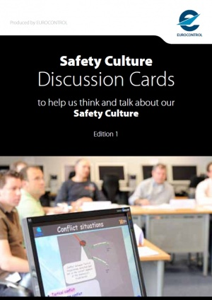
  Article Information
  Category: | Safety Culture | 
  Content source: | SKYbrary
  Content control: | EUROCONTROL | 
Cover card for Safety Culture Discussion Cards
The EUROCONTROL Safety Culture Discussion Cards are a practical resource to aid real discussion about safety culture by any person or team within the ANSP, including staff and managers in air traffic operations (e.g. air traffic controllers, aeronautical information services personnel), maintenance staff, specialist staff and support staff (e.g. safety, quality, projects, human resources, legal, etc). The cards use the same concepts as the survey methodology, though everyday language is used to make the cards completely accessible. The cards can be used without the need for external support.

You can download the whole set of cards in a PDF file by selecting one of the following versions:
English - low res
English - low res with 'Download at SKYbrary' ribbon
English - high res (without cropmarks)
English - high res (with cropmarks)
French / Français - low res
French / Français - high res
Spanish / Español - low res
Spanish / Español - low res with 'Download at SKYbrary' ribbon
Spanish / Español - high res (with cropmarks)
Spanish / Español - high res with 'Download at SKYbrary' ribbon (with cropmarks)
Portuguese / Portugál - low res
Portuguese / Portugál - high res
Portuguese / Portugál - high res (with cropmarks)
Hungarian / Magyar - high res
Hungarian / Magyar - high res (with cropmarks)
Finnish / Finn - low res
Finnish / Finn - high res
Finnish / Finnish - high res (with cropmarks)

