ICAO WORKSHOP ON
NATIONAL AVIATION SAFETY PLAN DEVELOPMENT

Handout 2:
Facilitated Exercise I: Develop a List of Prioritized National Safety Issues (Part 2)

Context
Using the information provided on StateX (in this handout), complete the tasks below.
Time allocated: 1h30
Documentation / References
- Standardized Framework for the Identification of Organizational (ORG) Challenges
- Doc 10131, Chapter 2, Sections 2.3 to 2.5
Your tasks
- Using the Standardized Framework for the Identification of ORG Challenges, and your subject matter expertise, conduct an evaluation of StateX based on the information provided in Appendix A;
- Based on the results of the evaluation, compile a list of identified hazards and safety deficiencies;
- Discuss as a group and select the top hazards and safety deficiencies at the State level, which comprise the State’s ORG challenges;
- Based on the discussion, draft a list of prioritized national safety issues and include the reason for selecting each issue (as an ORG Challenge); and
- Complete the form in the Appendix B.

— — — — — — — —
APPENDIX A
INFORMATION ON STATEX

Last year, StateX had approximately 15,300 scheduled commercial departures. During the past 5 years, departures have increased on average by 6.6 % per year. StateX has 1 international airport listed in the ICAO Regional Air Navigation Plan with approximately 10,000 departures last year. On average, 35% of all departures in StateX are international. 45% of international departures last year were performed by operators from StateX. The majority were conducted by STATEX AIRWAYS, the national airline. Currently, StateX’s Performance-based Navigation (PBN) implementation is at 50%. StateX has not promulgated regulations detailing the requirements for the certification of aerodromes, including criteria to determine if an aerodrome should be certified. StateX’s topography includes mountainous terrain and valleys. Due to its climate, fog is prevalent, particularly in the vicinity of the international airport.

StateX has no Significant Safety Concerns (SSCs).

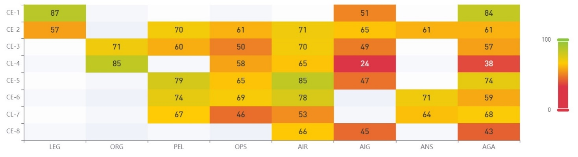
The 5 lowest scoring Priority Protocol Questions, or PPQs, (in terms of Effective Implementation (EI) score) by Audit Area (AA) and Critical Element (CE) combination, based on the State’s “Heat Map” are as depicted below:

Based on this “Heat Map”, by AA and CE combination, these 5 PPQs were identified as “not satisfactory” for StateX:
- PQ 6.125 Has the investigation authority developed periodic training plans detailing and prioritizing the type of training to be provided during the established period; and appropriately implemented the training programme?
- PQ 8.055 Is the training programme (for aerodrome inspectors) appropriately implemented?
- PQ 8.413 Has the aerodrome regulatory authority developed and implemented a process to take actions, including enforcement, if deficiencies found during surveillance activities are not rectified within a reasonable time by the aerodrome operator?
- PQ 6.507 Has the State established an accident and incident database, in a standardized format, to facilitate the effective analysis of information on actual or potential safety deficiencies and to determine any preventive actions required?
- PQ 4.359 Does the organization/individual responsible for the transport of dangerous goods by air carry out regular and random inspections of all entities, except air operators, involved in the transport of dangerous goods by air to confirm compliance with Annex 18 – Safe Transport of Dangerous Goods by Air, and the Technical Instructions (TI or Doc 9284)?

With regards to the Civil Aviation Organization and State System & Functions (ORG/CE-3), using information generated by the Universal Safety Oversight Audit Programme (USOAP) activities, via the ICAO Online Framework (OLF), StateX has a “not satisfactory” rating for the following PQs:
- PQ 2.051 (PPQ) Has the State established and implemented a mechanism to ensure that each safety oversight authority has sufficient financial resources to meet its national and international obligations?
- PQ 2.053 (not PPQ) Has the State established a mechanism to ensure that each safety oversight authority has sufficient personnel to meet its national and international obligations?
- PQ 2.103 (not PPQ) Is each safety oversight entity/investigation authority able to attract, recruit and retain sufficiently qualified/experienced technical personnel?

With regards to State safety programme (SSP) implementation, StateX started a gap analysis and completed approximately a third of it.

StateX has not completed the SSP self-assessment available on the OLF.

STATEX AIRWAYS has voluntarily implemented a safety management system (SMS); none of the aerodromes in StateX have an SMS.

StateX has one airline (STATEX AIRWAYS) certified through the IATA Operational Safety Audit (IOSA) programme, out of all its air operators.

The current edition of the Global Aviation Safety Plan (GASP) lists the following Global Organizational (ORG) Challenges:
- Lack of sufficient financial resources for the safety oversight authority to meet its national and international obligations
- Lack of qualified technical personnel, primarily aircraft accident investigators and aerodrome inspectors
- Lack of a regulatory process to address the resolution of safety issues, primarily related to aerodrome operations
- Low level of SSP implementation at the global level
- Deficiencies in safety data and safety information collection, analysis and exchange, to support safety management activities

The current edition of the Regional Aviation Safety Plan (RASP), for the region in which StateX is situated, lists the following Regional ORG Challenges:
- Lack of resources & expertise
- Human factors & competence of personnel
- Cybersecurity
- Poor development of aircraft accident and incident investigation structure

— — — — — — — —
APPENDIX B
LIST OF PRIORITIZED NATIONAL SAFETY ISSUES (ORG CHALLENGES)
ORG Challenges | Justification

— END —

