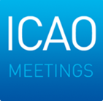
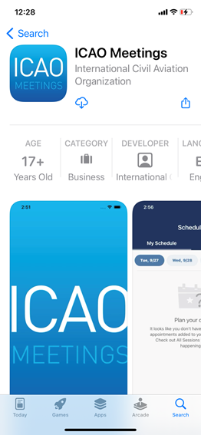
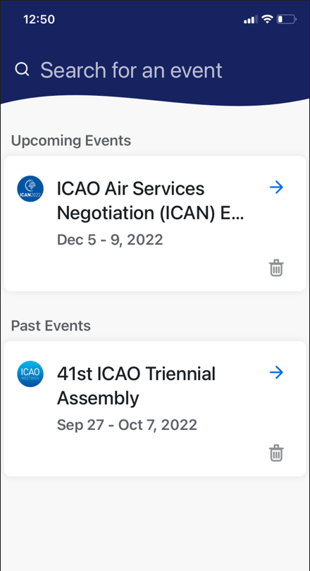
If your mobile device is not compatible, you’ll need to use the web version of the app found here: https://cvent.me/2k8xA5

Mobile App
Downloading the App
The ICAN Event is contained within the ICAO Meetings App.
If you have already downloaded the ICAO Meetings App previously, you do not need to download it again – skip to Step 3.
It does NOT allow you to:
- Stream the Opening and Closing Ceremonies (streaming is available on the Web version)
- Post photos or comments
The App ALLOWS you to:
- View the programme and your schedule
- Search and message other attendees
- Schedule and join meetings
- View your check-in QR code
- And much more!
- Go to your app store.
Access the App Store on iOS devices and the Play Store on Android.
- Install the app.
Search for ICAO meetings. Once you find it,
tap either Get, Install or 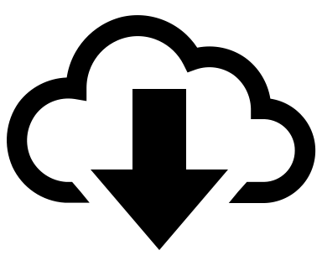.

After installing, a new icon will appear on the home screen.

3. Find your event in the ICAO Meetings App.
Search for the ICAN 2023, then tap Download or  to open it.

4. Login to your event.
The ICAO Meetings app gives you the full event experience from your phone or tablet similar to the web experience. To login and use the features, follow the same steps detailed in the Attendee Guide.

