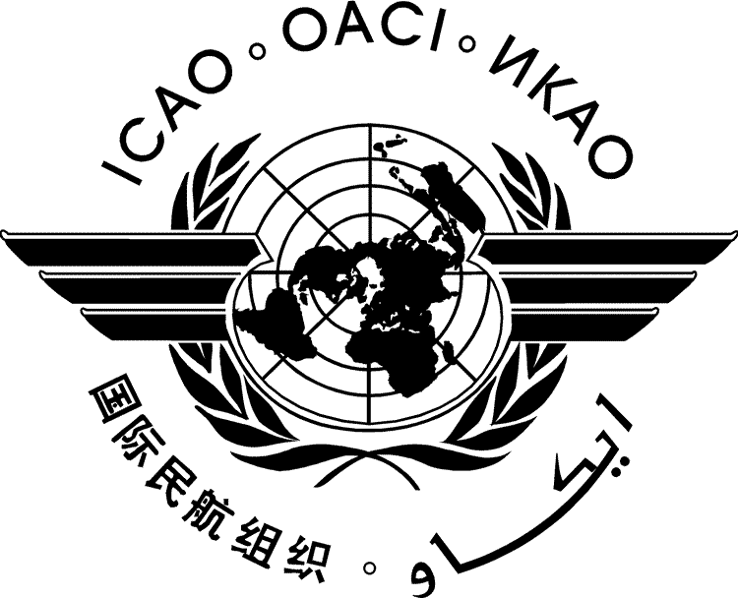 | International Civil Aviation Organization  WORKING PAPER
  FALP/14-WP/xx
  ../.. /..
FACILITATION PANEL (FALP)

FOURTEENTH MEETING

Montréal, 20 to 24 April 2026

Agenda Item | 1: | Recent Facilitation developments in ICAO
Agenda Item | 2: | Recent Facilitation-related developments in the United Nations and other international organizations
Agenda Item | 3: | Amendments to Annex 9 — Facilitation
Agenda Item | 4: | Reports of the Facilitation Panel’s Working Groups
Agenda Item | 5: | New Strategic Goal for 2026-2028 Business Plan - “No Country Left Behind”
Agenda Item | 6: | Other Facilitation matters

TITLE OF PAPER

(Presented by …..)

SUMMARY

Action by the FAL Panel:

- INTRODUCTION

- DISCUSSION

- RECOMMENDATIONS

— — — — — — — —

FALP/14-WP/
Appendix A

APPENDIX A

TITLE

— — — — — — — —

FALP/14-WP/
Appendix B

APPENDIX B

TITLE

— END —

