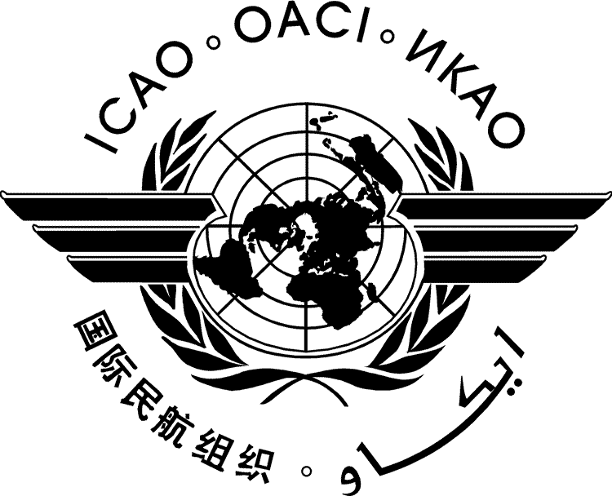 | International Civil Aviation Organization  WORKING PAPER
  LC/40-IP/xx
  ../../26
  (Information Paper)
  Arabic, Chinese, English, French, Russian and Spanish only
LEGAL COMMITTEE – 40TH SESSION
(Montréal, 26 – 30 October 2026)

Agenda Item | 1: | Adoption of the Agenda
Agenda Item | 2 | Consideration of the General Work Programme of the Legal Committee  - Processes and procedures for States to fulfil their obligations under Article 12 of the Chicago Convention;  - Review of the Role of the International Explosives Technical Commission under the Convention on the Marking of Plastic Explosives for the Purpose of Detection;  - International legal aspects of unmanned (pilotless) aircraft operations and integration into civil aviation;  - Promotion of the ratification of international air law instruments;  - Acts or offences of concern to the international aviation community, including cyber threats, that may not be adequately covered by existing air law instruments;  - Study of international legal issues relating to global satellite systems and services supporting international air navigation services;  - International carriage by air and data protection laws; and  - Legal review of the analysis completed by the Air Transport Regulation Panel of the Application of Article 15 of the Chicago Convention.
Agenda Item | 3 | Review of the General Work Programme of the Legal Committee
Agenda Item | 4 | Election of the Vice Chairpersons of the Committee
Agenda Item | 5 | Date, place and agenda of the 41st Session of the Legal Committee
Agenda Item | 6 | Any other business
Agenda Item | 7 | Report on work done at the Session

TITLE

(Presented by …)

- INTRODUCTION
  - ...
  - …
- DISCUSSION
  - …
  - …
- CONCLUSION

— END —

Language versions provided by State/Organization

