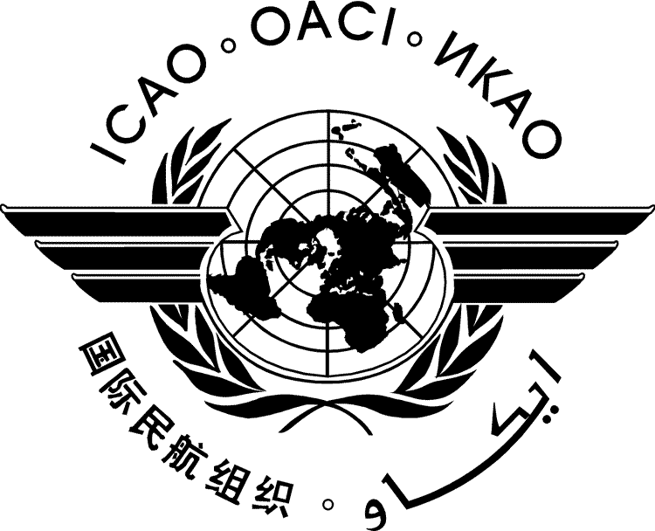 | International Civil Aviation Organization  WORKING PAPER
  ATConf/7-WP/xxxx
  ../../26
  (Information Paper)
  Arabic, Chinese, English, French,
  Russian and Spanish only
SEVENTH WORLDWIDE AIR TRANSPORT CONFERENCE
(ATCONF/7)

Montréal, HQ, 16 to 20 November 2026

Agenda Item | 1: | Overview of developments in the field of air transport
 | 1.1: | Developments and progress since the Sixth Worldwide Air Transport Conference (ATConf/6)
 | 1.2: | Air transport in ICAO’s long term strategic plan: Accelerating aviation towards 2050
Agenda Item | 2: | Fostering aviation growth and air connectivity through investments in infrastructure, human capital and partnerships
 | 2.1: | Integrating civil aviation into national development and investment plans
 | 2.2: | Investment for the development and modernization of civil aviation infrastructure
Agenda Item | 3: | Strengthening regulatory and institutional frameworks
 | 3.1: | Strengthening regulatory oversight and evolving institutional frameworks
 | 3.2: | Enhancing air connectivity through progressive economic and regulatory aviation frameworks for international air transport
 | 3.3: | Strengthening emergency planning mechanism and consumer protection for a resilient aviation system
 | 3.4: | Levies on international air transport
Agenda Item | 4: | Emerging technologies, new business models and other associated aspects
 | 4.1: | Economic regulatory frameworks on emerging technologies
 | 4.2: | Support and economic opportunities of access to aviation cleaner energies
 | 4.3: | Leveraging air transport data and the digital ecosystem for seamless, secure and resilient operations

TITLE

(Presented by …)

EXECUTIVE SUMMARY
This paper presents…

- INTRODUCTION
  - ...
  - …
- DISCUSSION
  - …
  - …
  - …
  - …
  - …
- conclusion
  - …

— END —

Language versions provided by State/Organization

