Baltic Sea ad-hoc Civil Military Expert Group – Strategic level focal points, version 24.10.2017
Country/  Organisation |  | Focal point | Organisation | Civil/  Military | email | phone | Remarks
Denmark |  | Claus Gerlen | Danish Transport Authority | Civil | clge@tbst.dk | +45 4178 0054
Denmark |  | Per Coulet | Danish Defence | Military | coulet@mil.dk | +45 2523 9190
Denmark |  | Lise Kronborg | Naviair | Civil | lkr@naviair.dk | +45 2321 8462
Estonia | 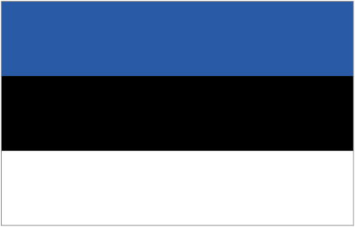 | Mikk Habakuk | Estonian Air Force | Military | mikk.habakuk@mil.ee
Estonia |  | Üllar Salumäe | EANS | Civil | ullar.salumae@eans.ee | +372 505 9129
Estonia |  | Tiina Ester | Estonian CAA | Civil | tiina.ester@ecaa.ee | +372 610 3592
Finland |  | Kari Siekkinen | Finnish Transport Safety Agency | Civil | kari.siekkinen@trafi.fi | +358 40 070 9392
Finland |  | Kai Väisänen | Finnish Transport Safety Agency | Civil | kai.vaisanen@trafi.fi | +358 40 501 5099
Finland |  | Pasi Nikama | Air Navigation Services Finland | Civil | pasi.nikama@ansfinland.fi | +358 40 848 2904
Germany |  | Andreas Krebber | DFS / BMVI Germany | Civil | andreas.krebber@dfs.de | +49 172 695 2077
Latvia | 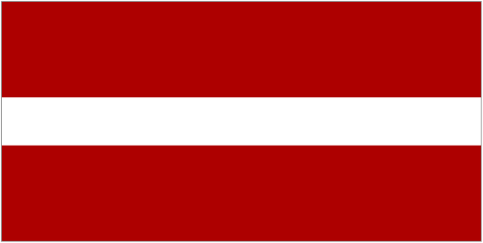 | Erika Neimane | Latvian Civil Aviation Agency | Civil | Erika.neimane@caa.gov.lv | +371 6783 0953
Latvia |  | Eizens Jekabsons | Latvian Civil Aviation Agency | Civil | eizens.jekabsons@caa.gov.lv | +371 6750 7913
Latvia |  | Yury Bazulev | LGS | Civil | renate.rulle@lgs.lv
Latvia |  | Alvis Vilks | LGS | Civil | renate.rulle@lgs.lv
Latvia |  | Alfred Mikelson | LGS | Civil | renate.rulle@lgs.lv
Latvia |  | Agris Jansons | Ministry of Defence / Military Aviation Authority |  | janis.marsavs@midd.gov.lv
Lithuania |  | Vilius Veitas | Ministry of Transport and Communications | Civil | vilius.veitas@sumin.lt | +370 5239 3846
Lithuania |  | Juozas Januškevičius | Lithuanian Air Force | Military | juozas.januskevicius@mil.lt | +370 3730 7639
Lithuania |  | Alvydas Šumskas | CAA | Civil | a.sumskas@caa.lt | +370 5273 9259
Lithuania |  | Loreta Kasparaitė | CAA | Civil | l.kasparaite@caa.lt | +370 5237 9051
Lithuania |  | Virginijus Žikas | VĮ “Oro navigacija” | Civil | zikas.v@ans.lt | +370 7069 4582
Poland | 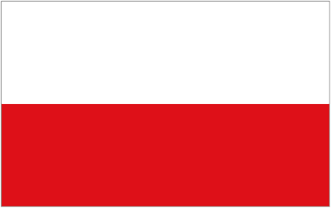 | Slawomir Trejda | Military Air Traffic Service Office (MATSO) of the Polish Armed Forces | Military | s.trejda@ron.mil.pl | +48 261 821 024
Poland |  | Dariusz Wojtasik | CAA | Civil | dwojtasik@ulc.gov.pl | +48 604 835 628  Cell +48 604 835 628
Poland |  | Jacek Wawrzenczyk | PANSA | Civil | j.wawrzenczyk@pansa.pl | +48 609 604  150
Poland |  | Marek Winiarski | PANSA | Civil | marek.winiarski@pansa.pl | +48 603 412 329
Russian Federation | 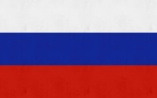 | Oleg Povkh | Aviation Flight Control of Russia |  | ncuo_ckkpa_1@mil.ru
Russian Federation |  | Vladimir Karpov | State ATM Corporation | Civil | karpov@matfmc.ru | +7 495 601 08 00
Russian Federation |  | Vladimir Pustovarov | Federal Air Transport Agency | Civil | pustovarov_va@scaa.ru
Russian Federation |  | Tatiana Streltsova | State ATM Corporation | Civil | streltsova@matfmc.ru
Russian Federation |  | Andrey Toroshchin | Aviation Flight Control of Russia |  | toroav@mail.ru
Russian Federation |  | Dmitrii Dergachev |  |  | ncuo_ckkpa_1@mil.ru
Russian Federation |  | Stanislav Krutko | Ministry of Defence
Russian Federation |  | Alexander Kuznetsov | North-West Air Navigation branch of State ATM Corporation | Civil
Sweden | 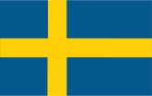 | Lars-Eric Blad | Transportstyrelsen | Civil | Lars-Eric.Blad@transportstyrelsen.se | +46 705 241 268
Sweden |  | Anders Jernberg | LFV | Civil | anders.jernberg@lfv.se | +46 708 192 392
Sweden |  | Ann Gyldén | Swedish Armed Forces | Military | ann.gylden@mil.se | +46 708 395 934
ICAO | 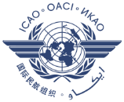 | Sven Halle |  | Civil | shalle@paris.icao.int | +33 146 418 524
EASA |  | Denis Koehl |  | Civil | denis.koehl@easa.europa.eu | Mob. +49 160 9342 9344  Commercial: +49 221 89990 22 28
NATO | 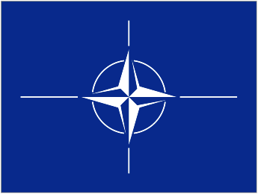 | Giorgio Cioni |  |  | cioni.giorgio@hq.nato.int | +32 2 707 3974
NATO |  | Paul James |  |  | james.paul@hq.nato.int | +32 2 707 3901
NATO |  | Michael Braun | CAOC Uedem |  | Michael.braun@caocu.nato.int | +49 160 9342 9344
Eurocontrol |  | Michael Steinfurth |  | Civil | Michael.steinfurth@eurocontrol.int | +32 499 942  445
Eurocontrol |  | Mariana Anguelova |  | Civil | mariana.anguelova@eurocontrol.int | +32 473 359 392
Eurocontrol |  | Catalin Lepadatu |  | Civil | catalin.lepadatu@eurocontrol.int
Eurocontrol |  | Andy Woollin |  | Civil | andy.woollin@eurocontrol.int |  | Focal point for flight plan processing
Eurocontrol |  | Olivier Mrowicki |  | Civil | olivier.mrowicki@eurocontrol.int |  | Civ-mil expert from the Network Manager

--END--

