APPENDIX T TO EANPG/59-RASG-EUR/06 REPORT
EUROPEAN (EUR) AIR NAVIGATION PLAN

VOLUME III

TO BE ENDORSED BY EANPG/59

16 OCTOBER 2017

Key to mark-up:
Green highlight = content to be reviewed and updated by relevant experts

TABLE OF CONTENTS

PART 0 – Introduction 0-1
PART I - General Planning Aspects (GEN) I-1
Table GEN III-1 – Implementation Indicator(s) for each ASBU Block 0 Module I-3
Appendix A – Sample Template for Air Navigation Report Form (ANRF)
Appendix B – Main Planning Table Template
PART II – Air Navigation System/ASBU Implementation II-1
Figure GEN III-1 – Analysis and Implementation Workflow II-2
Figure ANS-ASBU III-EUR-1 – 2016 ASBU Monitoring Reporting of ICAO EUR States II-3
Table ASBU-III-EUR-1 – EUR Region Implementation Status of Block 0 Module Elements II-5
Table ASBU- EUR-B0-AMET II-13 - II-16
Tables ASBU- EUR-B0-DATM 3-1, 3-2, 3-3, 3-4-1, 3-4-2, 3-4-3 II-17 – II-30
Table ASBU-III-EUR-2 – EUR Region Implementation Status of Block 1 Module Elements II-31
Table ASBU-III-EUR-3 – EUR Region Implementation Status of Block 2 Module Elements II-35
Table ASBU-III-EUR-4 – EUR Region Implementation Status of Block 3 Module Elements II-36
PART III - Air Navigation System/Regional Aviation System Improvement (RASI) Implementation III-1

___________________

EUR ANP, VOLUME III

PART 0 – INTRODUCTION

1. INTRODUCTION
  - The background to the publication of ANPs in three volumes is explained in the Introduction in Volume I. The procedure for amendment of Volume III is also described in Volume I. Volume III contains dynamic/flexible plan elements related to the implementation of the air navigation system and its modernization in line with the ICAO Aviation System Block Upgrades (ASBUs) and associated technology roadmaps described in the Global Air Navigation Plan (GANP).
  - The information contained in Volume III is related mainly to:
- Planning: objectives set, priorities and targets planned at regional or sub-regional levels;
- Implementation monitoring and reporting: monitoring of the progress of implementation towards targets planned. This information should be used as the basis for reporting purposes (i.e.: global and regional air navigation reports and performance dashboards); and/or
- Guidance: providing regional guidance material for the implementation of specific system/procedures in a harmonized manner.
  - The management of Volume III is the responsibility of the European Air Navigation Planning Group (EANPG).
  - Volume III should be used as a tool for monitoring and reporting the status of implementation of the elements planned here above, through the use of tables/databases and/or references to online monitoring tools, as endorsed by EANPG. The status of implementation is updated on a regular basis as endorsed by the EANPG.

2. AVIATION SYSTEM BLOCK UPGRADES (ASBUs), MODULES AND ROADMAPS
2.1 The ASBU Modules and Roadmaps form a key component to the GANP, noting that they will continue to evolve as more work is done on refining and updating their content and in subsequent development of related provisions, support material and training.

2.2 Although the GANP has a worldwide perspective, it is not intended that all Block Upgrade Modules are required to be applied in every State, sub-region and/or region. Many of the Block Upgrade Modules contained in the GANP are specialized packages that should be applied only where the specific operational requirement exists or corresponding benefits can be realistically projected. Accordingly, the Block Upgrade methodology establishes an important flexibility in the implementation of its various Modules depending on a region, sub-region and/or State’s specific operational requirements. Guided by the GANP, ICAO EUR regional, sub-regional and State planning should identify Modules which best provide the needed operational improvements.
____________________

EUR ANP, VOLUME III

PART I - GENERAL PLANNING ASPECTS (GEN)

- PLANNING METHODOLOGY
  - Guided by the GANP, the regional planning process starts by identifying the homogeneous ATM areas, major traffic flows and international aerodromes. An analysis of this data leads to the identification of opportunities for performance improvement. Modules from the Aviation System Block Upgrades (ASBUs) are evaluated to identify which of those modules best provide the needed operational improvements. Depending on the complexity of the module, additional planning steps may need to be undertaken including financing and training needs. Finally, regional plans would be developed for the deployment of modules by drawing on supporting technology requirements. This is an iterative planning process which may require repeating several steps until a final plan with specific regional targets is in place. This planning methodology requires full involvement of States, service providers, airspace users and other stakeholders, thus ensuring commitment by all for implementation.
  - Block 0 features Modules characterized by technologies and capabilities which have already been developed and implemented in many parts of the world today. It therefore features a near-term availability milestone, or Initial Operating Capability (IOC), of 2013 for high density based on regional, sub-regional and State operational need. Blocks 1 through 3 are characterized by both existing and projected performance area solutions, with availability milestones beginning in 2018, 2023 and 2028 respectively.

- REVIEW AND EVALUATION OF AIR NAVIGATION PLANNING
2.1 The progress and effectiveness against the priorities set out in the regional air navigation plans should be annually reported, using a consistent reporting format, to ICAO.
2.2 Performance monitoring requires a measurement strategy. Data collection, processing, storage and reporting activities supporting the identified global/regional performance metrics are fundamental to the success of performance-based approaches.
2.3 The air navigation planning and implementation performance framework prescribes reporting, monitoring, analysis and review activities being conducted on a cyclical, annual basis. An Air Navigation Reporting Form (ANRF) reflecting selected key performance areas as defined in the Manual on Global Performance of the Air Navigation System (ICAO Doc 9883) has been developed for each ASBU Module. The ANRF is a customized tool which is recommended for the application of setting planning targets, monitoring implementation, and identifying challenges, measuring implementation/performance and reporting. If necessary, other reporting formats that provide more details may be used but should contain as a minimum the elements described in the ANRF template. A sample of the ANRF is provided in Appendix A. A sample Template of a planning table which may be used to show the elements planned in an ICAO region is provided in Appendix B.

- REPORTING AND MONITORING RESULTS
  - Reporting and monitoring results will be analyzed by the PIRGs, States and ICAO Secretariat to steer the air navigation improvements, take corrective actions and review the allocated objectives, priorities and targets if needed. The results will also be used by ICAO and aviation partner stakeholders to develop the annual Global Air Navigation Report. The report results will provide an opportunity for the international civil aviation community to compare progress across different ICAO regions in the establishment of air navigation infrastructure and performance-based procedures.
  - The reports will also provide the ICAO Council with detailed annual results on the basis of which tactical adjustments will be made to the performance framework work programme, as well as triennial policy adjustments to the GANP and the Block Upgrade Modules.
  - Table GEN III-1 contains a minimum set of Implementation Indicator(s) for each of the eighteen ASBU Block 0 Modules necessary for the monitoring of these Modules (if identified as a priority for implementation at regional or sub-regional level). These indicators are intended to enable comparison between ICAO Regions with respect to ASBU Block 0 Modules and will apply only to commonly selected ASBU Modules. All regions/PIRGs reserve the right to select the ASBU Modules relevant to their needs and to endorse additional indicators, as deemed necessary. No reporting is required for ASBU Block 0 Modules that have not been selected.
Note: The priority for implementation as well as the applicability area of each selected ASBU Block 0 Module is to be defined by the EANPG. This should be reflected in Part II – Air Navigation System Implementation.

____________________

TABLE GEN III-1 – IMPLEMENTATION INDICATOR(S) FOR EACH ASBU BLOCK 0 MODULE

Explanation of the Table
1 Block 0 Module Code
2 Block 0 Module Title
3 High level Implementation Indicator
4 Remarks

Module Code | Module Title | Implementation Indicator | Remarks
1 | 2 | 3 | 4
B0-APTA | Optimization of Approach Procedures including vertical guidance | % of international aerodromes having at least one runway end provided with APV Baro-VNAV or LPV procedures
B0-WAKE | Increased Runway Throughput through Optimized Wake Turbulence Separation | % of applicable international aerodromes having implemented increased runway throughput through optimized wake turbulence separation | - Not to be considered for the first reporting cycles due to lack of maturity.  - List of ADs to be established through regional air navigation agreement.
B0-RSEQ | Improve Traffic flow through Runway Sequencing (AMAN/DMAN) | % of applicable international aerodromes having implemented AMAN / DMAN | - Not to be considered for the first reporting cycles due to lack of maturity.  - List of ADs to be established through regional air navigation agreement.
B0-SURF | Safety and Efficiency of Surface Operations (A-SMGCS Level 1-2) | % of applicable international aerodromes having implemented A-SMGCS Level 2 | List of ADs to be established through regional air navigation agreement.
B0-ACDM | Improved Airport Operations through Airport-CDM | % of applicable international aerodromes having implemented improved airport operations through airport-CDM | List of ADs to be established through regional air navigation agreement.
B0-FICE | Increased Interoperability, Efficiency and Capacity through Ground-Ground Integration | % of FIRs within which all applicable ACCs have implemented at least one interface to use AIDC / OLDI with neighbouring ACCs
B0-DATM | Service Improvement through Digital Aeronautical Information Management | - % of States having implemented an AIXM based AIS database  - % of States having implemented QMS
B0-AMET | Meteorological information supporting enhanced operational efficiency and safety | - % of States having implemented SADIS FTP  - % of States hosting a VAAC having implemented VAA/VAG  - % of States hosting a VO having implemented VONA  - % of States having implemented QMS | - 91% as of 25 Sep 2017  - 100% as of 23 Sep 2016  - 100% as of 23 Sep 2016  - 98% as of 25 Sep 2017  Note: Information received through the METG mechanism.
B0-FRTO | Improved Operations through Enhanced En-Route Trajectories | % of FIRs in which FUA is implemented
B0-NOPS | Improved Flow Performance through Planning based on a Network-Wide view | % of FIRs within which all ACCs utilize ATFM systems
B0-ASUR | Initial capability for ground surveillance | % of FIRs where ADS-B OUT and/or MLAT are implemented for the provision of surveillance services in identified areas.
B0-ASEP | Air Traffic Situational Awareness (ATSA) | % of States having implemented air traffic situational awareness | - Not to be considered for the first reporting cycles due to lack of maturity.
B0-OPFL | Improved access to optimum flight levels through climb/descent procedures using ADS-B | % of FIRs having implemented in-trail procedures | - Not to be considered for the first reporting cycles due to lack of maturity.
B0-ACAS | ACAS Improvements | % of States requiring carriage of ACAS (with TCAS 7.1 evolution)
B0-SNET | Increased Effectiveness of Ground-Based Safety Nets | % of States having implemented ground-based safety-nets (STCA, APW, MSAW, etc.)
B0-CDO | Improved Flexibility and Efficiency in Descent Profiles (CDO) | - % of international aerodromes / TMAs with PBN STAR implemented  - % of international aerodromes/TMA where CDO is implemented
B0-TBO | Improved Safety and Efficiency through the initial application of Data Link En-Route | % of FIRs utilising data link en-route in applicable airspace
B0-CCO | Improved Flexibility and Efficiency Departure Profiles - Continuous Climb Operations (CCO) | - % of international aerodromes / TMAs with PBN SID implemented  - % of international aerodromes/TMA where CCO is implemented | The implementation of CCOs and CDOs are top priorities from the GANP and should be addressed jointly

_____________________

Appendix A

SAMPLE TEMPLATE

- AIR NAVIGATION REPORT FORM (ANRF)
(This template demonstrates how ANRF to be used.
The data inserted here refers to ASBU B0-05/CDO as an example only)

Regional and National planning for ASBU Modules

- REGIONAL/NATIONAL PERFORMANCE OBJECTIVE – B0-05/CDO:
Improved Flexibility and Efficiency in Descent Profiles

Performance Improvement Area 4:
Efficient Flight Path – Through Trajectory-based Operations
3. ASBU B0-05/CDO: Impact on Main Key Performance Areas (KPA)
SAMPLE | Access & Equity |  | Capacity |  |  | Efficiency |  | Environment |  | Safety
Applicable | N |  | N |  |  | Y |  | Y |  | Y
4. ASBU B0-05/CDO: Planning Targets and Implementation Progress
5. Elements |  |  |  |  | 6. Targets and implementation progress  (Ground and Air)
1. CDO
2. PBN STARs
7. ASBU B0-05/CDO: Implementation Challenges
Elements |  | Implementation Area
 |  | Ground  system Implementation |  | Avionics Implementation |  |  | Procedures Availability |  | Operational  Approvals
1. CDO
2. PBN STARs

8. Performance Monitoring and Measurement
8A. ASBU B0-05/CDO: Implementation Monitoring
Elements | Performance Indicators/Supporting Metrics
1. CDO | Indicator: Percentage of international aerodromes/TMAs with CDO implemented  Supporting metric: Number of international aerodromes/TMAs with CDO implemented
2. PBN STARs | Indicator: Percentage of international aerodromes/TMAs with PBN STARs implemented  Supporting metric: Number of international aerodromes/TMAs with PBN STARs implemented

8. Performance Monitoring and Measurement
8 B. ASBU B0-05/CDO: Performance Monitoring
Key Performance Areas  (Out of eleven KPAs, for the present until experienced gained, only five have been selected for reporting through ANRF)  SAMPLE | Where applicable, indicate qualitative Benefits,
Access & Equity | Not applicable
Capacity | Not applicable
Efficiency | Cost savings through reduced fuel burn. Reduction in the number of required radio transmissions.
Environment | Reduced emissions as a result of reduced fuel burn
Safety | More consistent flight paths and stabilized approach paths. Reduction in the incidence of controlled flight into terrain (CFIT).
9. Identification of performance metrics: It is not necessary that every module contributes to all of the five KPAs. Consequently, a limited number of metrics per type of KPA, serving as an example to measure the module(s)’ implementation benefits, without trying to apportion these benefits between module, have been identified on page 5. For the family of ASBU modules selected for air navigation implementation, States/Region to choose the applicable performance (benefit) metrics from the list available on page 5. This approach would facilitate States in collecting data for the chosen performance metrics. States/Region, however, could add new metrics for different KPAs based on maturity of the system and ability to collect relevant data.

_______________________
AIR NAVIGATION REPORT FORM
HOW TO USE - EXPLANATORY NOTES

- Air Navigation Report Form (ANRF): This form is nothing but the revised version of Performance Framework Form that was being used by Planning and Implementation Regional Groups (PIRGs)/States until now. The ANRF is a customized tool for Aviation System Block Upgrades (ASBU) Modules which is recommended for application for setting planning targets, monitoring implementation, identifying challenges, measuring implementation/performance and reporting. Also, the PIRGs and States could use this report format for any other air navigation improvement programmes such as Search and Rescue. If necessary, other reporting formats that provide more details may be used but should contain as a minimum the elements described in this ANRF template. The results will be analysed by ICAO and aviation partners and utilized in the Regional Performance Dashboards and the Annual Air Navigation Report. The conclusions from the Air Navigation Report will serve as the basis for future policy adjustments, aiding safety practicality, affordability and global harmonization, amongst other concerns.

- Regional/National Performance objective: In the ASBU methodology, the performance objective will be the title of the ASBU module itself. Furthermore, indicate alongside corresponding Performance Improvement area (PIA).

- Impact on Main Key Performance Areas: Key to the achievement of a globally interoperable ATM system is a clear statement of the expectations/benefits to the ATM community. The expectations/benefits are referred to eleven Key Performance Areas (KPAs) and are interrelated and cannot be considered in isolation since all are necessary for the achievement of the objectives established for the system as a whole. It should be noted that while safety is the highest priority, the eleven KPAs shown below are in alphabetical order as they would appear in English. They are access/equity; capacity; cost effectiveness; efficiency; environment; flexibility; global interoperability; participation of ATM community; predictability; safety; and security. However, out of these eleven KPAs, for the present, only five have been selected for reporting through ANRF, which are Access & Equity, Capacity, Efficiency, Environment and Safety. The KPAs applicable to respective ASBU module are to be identified by marking Y (Yes) or N (No). The impact assessment could be extended to more than five KPAs mentioned above if maturity of the national system allows and the process is available within the State to collect the data.

- Planning Targets and Implementation Progress: This section indicates planning targets and status of progress in the implementation of different elements of the ASBU Module for both air and ground segments.

- Elements related to ASBU module: Under this section list elements that are needed to implement the respective ASBU Module. Furthermore, should there be elements that are not reflected in the ASBU Module (example: In ASBU B0-80/ACDM, Aerodrome certification and data link applications D-VOLMET, D-ATIS, D-FIS are not included; Similarly in ASBU B0-30/DAIM, note that WGS-84 and eTOD are not included) but at the same time if they are closely linked to the module, ANRF should specify those elements. As a part of guidance to PIRGs/States, every Regional ANP will have the complete list of all 18 Modules of ASBU Block 0 along with corresponding elements, equipage required on the ground and in the air as well as metrics specific to both implementation and performance (benefits).

- Targets and implementation progress (Ground and Air): Planned implementation date (month/year) and the current status/responsibility for each element are to be reported in this section. Please provide as much details as possible and should cover both avionics and ground systems. This ANRF being high level document, develop necessary detailed action plan separately for each element/equipage.

- Implementation challenges: Any challenges/problems that are foreseen for the implementation of elements of the Module are to be reported in this section. The purpose of the section is to identify in advance any issues that will delay the implementation and if so, corrective action is to be initiated by the concerned person/entity. The four areas, under which implementation issues, if any, for the ASBU Module to be identified, are as follows:

- Ground System Implementation:
- Avionics Implementation:
- Procedures Availability:
- Operational Approvals:

Should be there no challenges to be resolved for the implementation of ASBU Module, indicate as “NIL”.

- Performance Monitoring and Measurement: Performance monitoring and measurement is done through the collection of data for the supporting metrics. In other words, metrics are quantitative measure of system performance – how well the system is functioning. The metrics fulfil three functions. They form a basis for assessing and monitoring the provision of ATM services, they define what ATM services user value and they can provide common criteria for cost benefit analysis for air navigation systems development. The Metrics are of two types:

- Implementation Monitoring: Under this section, the indicator supported by the data collected for the metric reflects the status of implementation of elements of the Module. For example- Percentage of international aerodromes with CDO implemented. This indicator requires data for the metric “number of international aerodromes with CDO”.

- Performance Monitoring: The metric in this section allows to asses benefits accrued as a result of implementation of the module. The benefits or expectations, also known as Key Performance Areas (KPAs), are interrelated and cannot be considered in isolation since all are necessary for the achievement of the objectives established for the system as a whole. It should be noted that while safety is the highest priority, the eleven KPAs shown below are in alphabetical order as they would appear in English. They are access/equity; capacity; cost effectiveness; efficiency; environment; flexibility; global interoperability; participation of ATM community; predictability; safety; and security. However, out of these eleven KPAs, for the present until experienced gained, only five have been selected for reporting through ANRF, which are Access & Equity, Capacity, Efficiency, Environment and Safety. Where applicable, mention qualitative benefits under this section.

- Identification of performance metrics: It is not necessary that every module contributes to all of the five KPAs. Consequently, a limited number of metrics per type of KPA, serving as an example to measure the module(s)’ implementation benefits, without trying to apportion these benefits between module, have been identified on page 6. For the family of ASBU modules selected for air navigation implementation, States/Region to choose the applicable performance (benefit) metrics from the list available on page 6. This approach would facilitate States in collecting data for the chosen performance metrics. States/Region, however, could add new metrics for different KPAs based on maturity of the system and ability to collect relevant data.

______________________

Appendix B - Main Planning Table Template

 | Objectives |  |  |  |  | Priorities and targets |  |  | Reference
Block | ASBU modules and elements  Enablers | Performance Improvement Area | Applicable or not in [Region]  (Yes/No) | Regional planning elements | Enablers | Priority  allocated  in [Region] | Target(s) in [Region] | Indicator(s)  / Metric(s) | Supporting  Planning Document  (ANRF, other)
 |  | SAMPLE

EUR ANP, VOLUME III

PART II – AIR NAVIGATION SYSTEM/ASBU IMPLEMENTATION

1. INTRODUCTION
  - The GANP and the ASBU concept and documents were developed to provide the framework and strategic direction for a global and harmonized aviation system. They provide strategic direction and define measurable operational improvements and include key civil aviation policy principles to assist ICAO Regions and States with the preparation and implementation of their air navigation plans.
1.2 The planning and implementation of required elements of selected ASBU Modules in the ICAO EUR Region should be undertaken within the framework of the EANPG with the participation and support of all stakeholders, including regulatory personnel so as to ensure global interoperability and harmonization of the aviation system.
1.3 The ASBU implementation monitoring report will be presented to the EANPG on an annual basis and can be, after EANPG endorsement, issued as a companion document to Volume III.
1.4 Figure GEN III-1 depicts the workflow for analysing and implementing ASBU Module elements. This same method can be applied with respect to Regional Aviation System Improvements or national aviation system improvements.
1.5 The significance of each step in the workflow as it pertains to regional planning is as follows:
- Analysis Not Started – The requirement to implement this ASBU Module element has not yet been assessed by any State in the Region
- Analysis In Progress – A Need Analysis as to whether or not this ASBU Module element is required is in progress by at least one State in the Region
- N/A – The Region has decided not to implement this ASBU Module element
- Need - One or more States in the Region have determined the ASBU Module element is required, but none have begun planning for the implementation
- Planning – Implementation of this ASBU Module element is planned, but not started
- Developing – Implementation of this ASBU Module element is in the development phase, but not yet operational
- Partially Implemented – Implementation of this ASBU Module element is partially completed and/or operational in at least one area of the Region
- Implemented - Implementation of this ASBU Module element has been completed and/or is fully operational in all areas of the Region where the need was identified

1.6 The analysis and implementation status determined in accordance with the above is reflected in the applicable ANRFs and in the ASBU Implementation Status Tables (Tables ASBU III-EUR-1 and 2).

Figure GEN III-1 – Analysis and Implementation Workflow
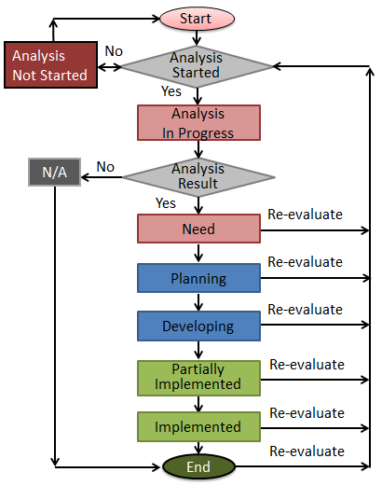

2. MONITORING OF ASBU MODULES IMPLEMENTATION
2.1 The monitoring of the regional implementation progress should be done by the EANPG for all planned elements. Due to the level of effort required, development of, and monitoring of, performance metrics/indicators should only be done for highest priority implementations.
2.2 The EANPG has determined the mechanisms and tools for the monitoring and collection of necessary data at regional levels.
3. ASBU MODULES MONITORING MECHANISM IN THE EUR REGION
3.1 At EANPG/55 (25-28 November 2013), it was agreed that, in order to enable monitoring and reporting of the current priorities, a cooperative mechanism would be put in place between ICAO and EUROCONTROL. This mechanism would encompass the utilisation of the EUROCONTROL ESSIP/LSSIP process complemented by a specific ICAO EUR ASBU questionnaire. As a first step, this cooperative regional mechanism would address the initial high priority modules.
3.2 The EUROCONTROL ESSIP/LSSIP process is a robust mechanism to support Single European Sky (SES) and SESAR deployment planning and reporting. The process sits at the crossroads of multiple performance improvement initiatives synergising the planning and monitoring activities of all stakeholders involved: State civil and military authorities, air navigation service providers and airport operators, all categories of airspace users. This cyclic process comprises three main components (see figure below):
1. Deployment planning: ESSIP Plan
2. Deployment reporting and monitoring at local (LSSIP documents) level
3. Deployment reporting and monitoring at European level: ESSIP Report
3.3 The ESSIP Plan contains the detailed implementation objectives and Stakeholder Lines of Action (SLoA) to be achieved within coordinated time scales. Its target audience includes planning staff from the various stakeholders participating in ESSIP, both at European and National level. It is produced every year.
3.4 The ESSIP Report assesses the level of success in the implementation progress of ESSIP objectives at ECAC level for the benefit of all aviation stakeholders. For each of the objectives it highlights critical issues, main reasons for delays, (positive) progress and it proposes remedial actions at network level. It is based on information gathered from the Local Single Sky ImPlementation (LSSIP) documents and closes the loop between the monitoring and planning phases of the ESSIP/LSSIP yearly cycle. Understanding what happened during the reporting period puts into perspective the investments and actions to real benefits and enables to steer implementation.
3.5 The 2016 ASBU monitoring report addresses the deployment status, with reference date December 2016, for most ASBU Block 0 Modules. It is separated in two different paragraphs those Block 0 modules that were considered Priority and the other Block 0 Modules with less priority as approved by EANPG/55 and confirmed by EANPG/58. The report is based on the information submitted by 41 States participating in the ESSIP/LSSIP mechanism and 11 other States of the ICAO EUR Region, outside that reporting mechanism, that reported their monitoring information using a questionnaire fully aligned with the ESSIP objectives and developed specifically for that. It must be highlighted that this report includes the progress/status of implementation of ASBU Block 0 modules (reference period 2016) for all 55 States that are accredited to the ICAO EUR Region. It must also be noted that Monaco, San Marino and Andorra are not addressed separately in this report, neither in related statistics, as they are included in other States for monitoring purposes. Therefore there are 52 Member States addressed in the following chapters.
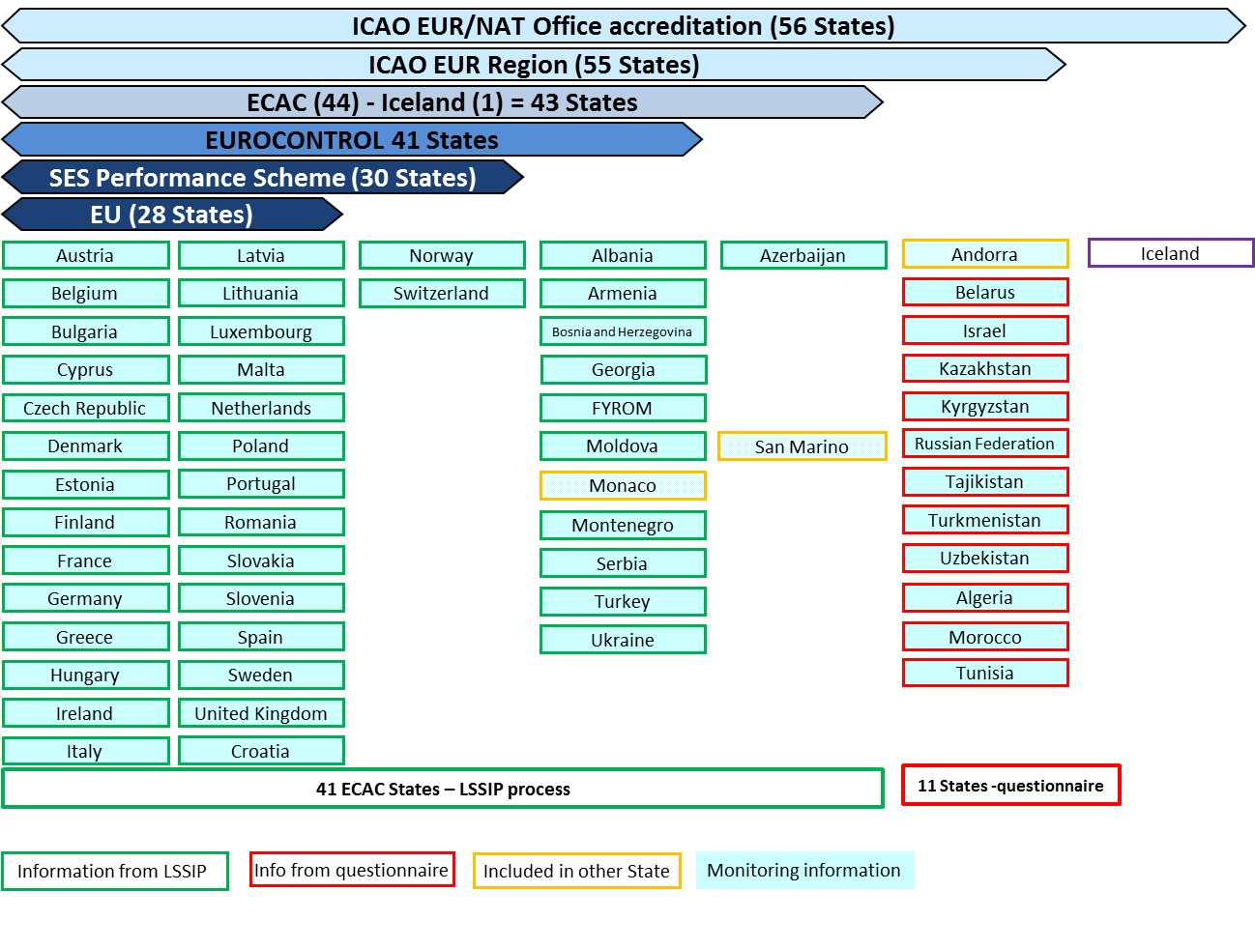
FIGURE ANS-ASBU III-EUR-1 – 2016 ASBU MONITORING REPORTING OF ICAO EUR STATES
3.6 Table ASBU-III-EUR-1 provides a high-level view of the implementation status of ASBU Module 0 in the ICAO EUR Region. (Note: The number of identified elements is still under development.) For the explanation of the analysis and implementation status, refer to Figure GEN III-1 and paragraph 1.5 in Volume III, Part II.
3.7 Detailed information on mapping of the ASBU Block 0 Modules against individual ESSIP objectives and the implementation of Block 0 Modules in the EUR Region can be found in Tables ASBU-III-EUR-1-2-1 and 1-2-2.
3.8 Additional information on implementation for B0-AMET can be found in Table ASBU- EUR-B0-AMET.
3.9 Additional information on implementation for B0-DATM can be found in Tables ASBU- EUR-B0-DATM 3-1, 3-2, 3-3, 3-4.
____________________

Table ASBU-III-EUR-1 – EUR Region Implementation Status of Block 0 Module Elements

FURTHER WORK REQUIRED

Block 0 Modules | Module Elements | Need Analysis of Module Elements |  |  |  | Implementation Status  (if Element is needed) |  |  |  | Remarks
Block 0 Modules | Module Elements | Not Started | In Progress | Need | N/A | Planning | Developing | Partially Implemented | Implemented
Performance Improvement Area 1: Airport Operations
APTA | 1. (Derived from 4.1.1) Design and publish PBN Approach Procedures with vertical guidance (LPV, LNAV/VNAV minima, using SBAS and Baro VNAV) |  |  |  |  |  |  | X |  | If this means design and publish than we are okay…..
 | 2. (Derived from 4.1.1) PBN Approach Procedures without vertical guidance (LP, LNAV minima; using SBAS) |  |  |  |  |  |  |  |  | Not part of APTA
 | 3. (Derived from 1.3.2) Design and publish GBAS Landing System (GLS) Approach procedures |  |  |  |  |  |  | X |  | If this means design and publish than we are okay…..
 | Publish in AIPs all coordinates data in WGS-84 in accordance with ICAO Annex 15 requirements |  |  |  |  |  |  | X
WAKE | 1. (Defined: Element 1) New PANS-ATM wake turbulence categories and separation minima
 | 2. (Derived from Element 2) Dependent diagonal paired approach procedures for parallel runways with centrelines spaced less than 760 meters (2,500 feet) apart
 | 3. (Derived from Element 3) Wake independent departure and arrival procedures for parallel runways with centrelines spaced less than 760 meters (2,500 feet) apart
 | 4. (Derived from Element 3) Wake turbulence mitigation for departures procedures for parallel runways with centrelines spaced less than 760 meters (2,500 feet) apart
 | 5. (Identified by the United States) 6 wake turbulence categories and separation minima
SURF | 1. (Derived from Element 1) Install A-SMGCS with at least one cooperative surface surveillance system |  |  |  |  |  |  | X
 | 2. (Derived from Element 1) Including ADS-B APT as an element of A-SMGCS
 | 3. (Derived from Element 2) A-SMGCS alerting with flight identification information
 | 4. (Derive from 1.4.1) Airport vehicles equipped with transponders
 | Publish A-SMGCS Level 1 or Level 2 procedures (including transponder operating procedures) in national aeronautical information publications |  |  |  |  |  |  | X
 | Implement approved A-SMGCS operational procedures at airports equipped with A-SMGCS and mandate the carriage of required equipment |  |  |  |  |  |  | X
ACDM | 1. (Derived from 1.2.1 and 1.2.2) Airport CDM procedures |  |  |  |  |  |  | X
 | 2. (Derived from 1.2.1 and 1.2.2) Airport CDM tools |  |  |  |  |  |  | X
 | 3. (Derived from 3.1 & 7.2.1) Collaborative departure queue management
 | Define and implement local Air Navigation Service (ANS) procedures for information sharing through Letters of Agreement (LoAs) and/or Memorandum of Understanding (MoU) |  |  |  |  |  |  | X
 | Define and implement local procedures for turnaround processes |  |  |  |  |  |  | X
 | Define and implement variable taxi-time and pre-departure sequencing procedure |  |  |  |  |  |  | X
 | Define and implement procedures for CDM in adverse conditions, including the de-icing |  |  |  |  |  |  | X
RSEQ | 1. (Derived from Element 1) AMAN via controlled time of arrival to a reference fix
 | 2. (Derived from Element 1) AMAN via controlled time of arrival at the aerodrome
 | 3. (Defined: Element 2) Departure management |  |  |  |  |  |  | X |  | How can elements 2 and 3 be defined when there is no definition of element 1
 | 4. (Derived from Element 2) Departure flow management
 | 5. (Defined: Element 3) Point merge |  |  |  |  |  |  | X |  | Point Merge is more a procedure than a system
 | Implement basic AMAN functions/tools, initial basic AMAN procedures and adapt the TMA organisation to accommodate use of basic AMAN |  |  |  |  |  |  | X
 | Implement, in En-Route operations, information exchange mechanisms, tools and procedures in support of Basic AMAN operations |  |  |  |  |  |  | X
Performance Improvement Area 2: Globally Interoperable Systems and Data
FICE | 1. (Derived from 1.1.4) AIDC to provide initial flight data to adjacent ATSUs |  |  |  |  |  |  | X
 | 2. (Derived from 1.1.5) AIDC to update previously coordinated flight data
 | 3. (Derived from 1.1.5) AIDC for control transfer |  |  |  |  |  |  |  |  | ??? Russian Federation may use AIDC for COTR with Anchorage
 | 4. (Derived from 1.1.6) AIDC to transfer CPDLC logon information to the Next Data Authority
 | Implementation of ground-ground automated co-ordination processes, such as: Notification; Initial Coordination; Revision of Coordination, etc |  |  |  |  |  |  | X
 | Upgrade and put into service ATC system to support the basic procedures (specifically PAC and COD |  |  |  |  |  |  | X
 | Upgrade and put into service communication systems to support information exchange via FMTP between FDPS(s) for the purpose of notification, coordination and transfer of the flights between ATC units |  |  |  |  |  |  | X
DATM | 1. (Derived from 1.1.1) Aeronautical Information Exchange Model (AIXM) |  |  |  |  |  |  | X
 | 2. (Derived from 3.1.3) eAIP |  |  |  |  |  |  | X
 | 3. (Derived from 7.1) Digital NOTAM
 | 4. (Identified by NACC) eTOD |  |  |  |  |  |  | X
 | 5. (Identified by NAT) WGS-84 |  |  |  |  |  |  | X
 | 6. (Identified by NAT) QMS for AIM |  |  |  |  |  |  | X
 | Ensure quality of aeronautical data and aeronautical information (implement QMS, implement data quality requirements, implement the common dataset and digital exchange formats, establish formal arrangements) |  |  |  |  |  |  | X
 | Implement the integrated briefing functionality |  |  |  |  |  |  | X
AMET | 1. (Defined: Element 1) WAFS |  |  |  |  |  |  | X
 | 2. (Defined: Element 2) IAVW |  |  |  |  |  |  |  | X
 | 3. (Defined: Element 3) TCAC forecasts |  |  |  | X
 | 4. (Defined: Element 4) Aerodrome warnings | X
 | 5. (Defined: Element 5) Wind shear warnings and alerts | X
 | 6. (Defined: Element 6) SIGMET |  | X
 | 7. (Defined: Element 6) Other OPMET information (METAR, SPECI and/or TAF) |  | X
Performance Improvement Area 3: Optimum Capacity and Flexible Flights
FRTO | 1: (Derived from Element 1) CDM incorporated into airspace planning |  |  |  |  |  |  | X
 | 2: (Defined: Element 2) Flexible Use of Airspace (FUA) |  |  |  |  |  |  | X
 | 3. (Defined: Element 3) Flexible route system |  |  |  |  |  |  | X
 | 4: (Derived from Element 3) CPDLC used to request and receive re-route clearances
 | Implementation of advanced airspace management (implement rolling ASM/ATFCM process, optimise flexible airspace structure design and availability, improve accuracy of airspace booking, implement an improved Notification Process supporting the Rolling ASM/ATFCM process, deploy automated ASM support systems) |  |  |  |  |  |  | X
 | Improved Operations through enhanced En-Route Trajectories |  |  |  |  |  |  | X
NOPS | 1. (Derived from 1.1.1) ATFM |  |  |  |  |  |  | X
 | Implement enhanced tactical flow management services, supply the ETFMS (Enhanced Tactical Flow Management System) with basic/standard Correlated Position Data, send/receive and process ATFM data to/from the ATFMUs |  |  |  |  |  |  | X
ASUR | 1. (Defined: Element 1) ADS-B |  |  |  |  |  |  | X
 | 2. (Defined: Element 2) Multilateration (MLAT) |  |  |  |  |  |  | X
 | Surveillance Performance and Interoperability, initial capability for ground surveillance, carriage and operation of Mode S, carriage and operation of ADS-B out, safety oversight for the surveillance chain, ensure interoperability of surveillance data |  |  |  |  |  |  | X
ASEP | 1. (Defined: Element 1) ATSA-AIRB
 | 2. (Defined: Element 2) ATSA-VSA
OPFL | 1. (Derived from 1.3.1) ITP using ADS-B
ACAS | 1. (Derived from 1.3.2) ACAS II (TCAS version 7.1) |  |  |  |  |  |  | X |  | From ICAO Annex 10 equipment carriage requirement
 | 2. (Derived from 1.3.7 a) Auto Pilot/Flight Director (AP.FD) TCAS |  |  |  |  |  |  |  |  | Not part of ASBU module
 | 3. (Derived from 1.3.7 b) TCAS Alert Prevention (TCAP) |  |  |  |  |  |  |  |  | Not part of ASBU modele
 | Deliver operational approval for ACAS II version 7.1 equipped aircraft and obtain airworthiness certification for ACAS II version 7.1 equipped aircraft |  |  |  |  |  |  | X
 | Establish ACAS II (TCAS II version 7.1) performance monitoring |  |  |  |  |  |  | X
SNET | 1. (Defined: Element 1) Short Term Conflict Alert implementation (STCA) |  |  |  |  |  |  | X
 | 2. (Defined: Element 2) Area Proximity Warning (APW) |  |  |  |  |  |  | X
 | 3. (Defined: Element 3) Minimum Safe Altitude Warning (MSAW) |  |  |  |  |  |  | X
 | 4. (Identified by NAT) Medium Term Conflict Alert (MTCA) |  |  |  |  |  |  | X |  | In Europe it would be MTCD
 | For each Saftey Net function, the description of the functionality level is linked to the EUROCONTROL Safety Net Specs (B0 functionality is defined as level 2). The implemented function must be accompanied by safety assessment and training /licencing aspect must be adressed |  |  |  |  |  |  | X
Performance Improvement Area 4: Efficient Flight Paths
CDO | 1. (Derived from Element 1) Procedure changes to facilitate CDO |  |  |  |  |  |  | X
 | 2. (Derived from Element 1) Route changes to facilitate CDO |  |  |  |  |  |  | X
 | 3. (Derived from Element 2) PBN STARs |  |  |  |  |  |  | X
 | Coordinate activities and implement rules and procedures for the application of CDO techniques whenever practicable in Approach Control Service in close cooperation with aircraft operators,  Support CDO measures, implement monitoring of performance and feedback to ANSP and users,  Include CDO techniques in the aircrew training manual |  |  |  |  |  |  | X
TBO | 1. (Defined: Element 1) ADS-C over oceanic and remote areas
 | 2. (Defined: Element 2) Continental CPDLC
 | Initial application of Air –Ground Data Link Services in En-Route airspace above FL 285 with ATN/VDL-2 |  |  |  |  |  | X
CCO | 1. (Defined: Element 1) Procedure changes to facilitate CCO |  |  |  |  |  |  | X
 | 2. (Defined: Element 1) Route changes to facilitate CCO |  |  |  |  |  |  | X
 | 3. (Defined: Element 2) PBN SIDs |  |  |  |  |  |  | X
 | Coordinate activities and implement rules and procedures for the application of CCO techniques whenever practicable in Approach Control Service in close cooperation with aircraft operators,  Support CCO measures, implement monitoring of performance and feedback to ANSP and users,  Include CCO techniques in the aircrew training manual |  |  |  |  |  |  | X
Totals | All Elements: 62

___________________

TABLE ASBU-III-EUR-1-2-1 - MAPPING OF ASBU BLOCK 0 EUR PRIORITY MODULES WITH ESSIP OBJECTIVES
TABLE ASBU-III-EUR-1-2-2 - MAPPING OF REMAINING ASBU BLOCK 0 MODULES WITH ESSIP OBJECTIVES

____________________

Table ASBU- EUR-B0 – AMET: Meteorological information supporting enhanced operational efficiency and safety

Description and purpose

Global, regional and local meteorological information:
- forecasts provided by world area forecast centres (WAFC), volcanic ash advisory centres (VAAC) and tropical cyclone advisory centres (TCAC);
- aerodrome warnings to give concise information of meteorological conditions that could adversely affect all aircraft at an aerodrome including wind shear; and
- SIGMETs to provide information on occurrence or expected occurrence of specific en-route weather phenomena which may affect the safety of aircraft operations and other operational meteorological (OPMET) information, including METAR/SPECI and TAF, to provide routine and special observations and forecasts of meteorological conditions occurring or expected to occur at the aerodrome.

This module includes elements which should be viewed as a subset of all available meteorological information that can be used to support enhanced operational efficiency and safety.

Main performance impact:
KPA- 01 – Access and Equity | KPA-02 – Capacity | KPA-04 – Efficiency | KPA-05 – Environment | KPA-10 – Safety
N | Y | Y | Y | Y

Applicability consideration:
Applicable to traffic flow planning, and to all aircraft operations in all domains and flight phases, regardless of level of aircraft equipage.

Elements | Applicability | Performance Indicators/Supporting Metrics | Targets
SADIS FTP | All States | Indicator: % of States having implemented SADIS FTP  Supporting metric: number of States having implemented SADIS FTP | 100% by Dec. 2018
QMS | All States | Indicator: % of States having implemented QMS for MET  Supporting metric: number of States having implemented QMS for MET | 100% by Dec. 2018
VAAC | France, United Kingdom | Indicator: % of VAACs in or serving the EUR Region that provide Annex 3 volcanic ash products (Volcanic Ash Advisories (VAA) and Volcanic Ash Advisories in Graphic Form (VAG))  Supporting metric: number of States hosting a VAAC having implemented VAA/VAG | 100% by Dec 2016
VONA | Italy, Russian Federation, Spain | Indicator: % of Volcano Observatories in the EUR Region that provide volcano observatory notice for aviation (VONA) as per the Handbook on the International Airways Watch (IAVW) (Doc 9766)  Supporting metric: number of States with Volcano Observatory having implemented VONA | 100% by Dec 2016

Elements will include METAR and TAF availability and timeliness as well as SIGMET availability by the end of 2018.

__________________

B0-AMET Status of implementation in the EUR Region
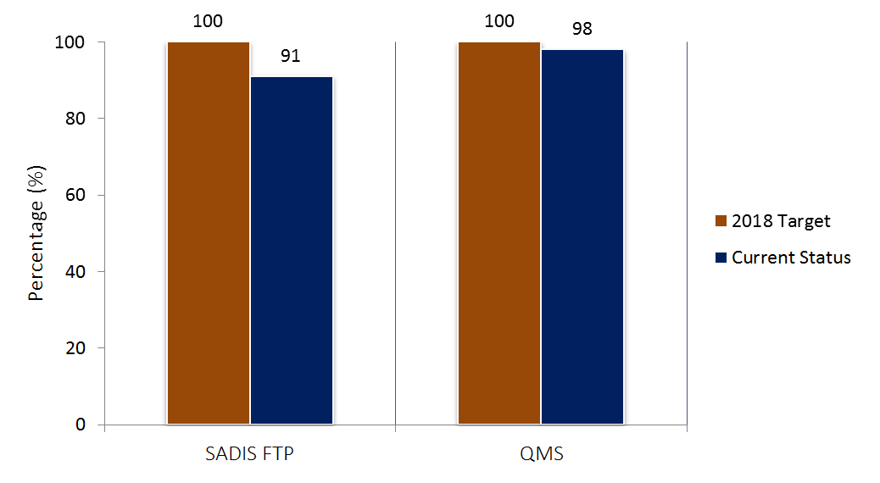 |  |  | 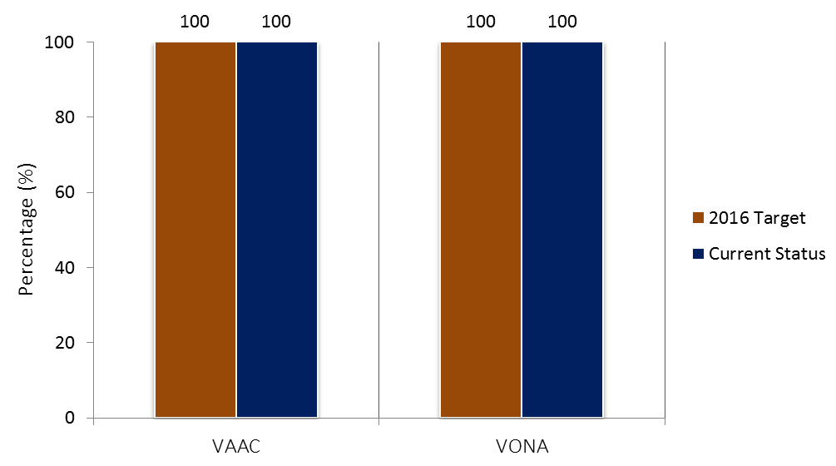
B0-AMET Status of implementation in the EUR Region
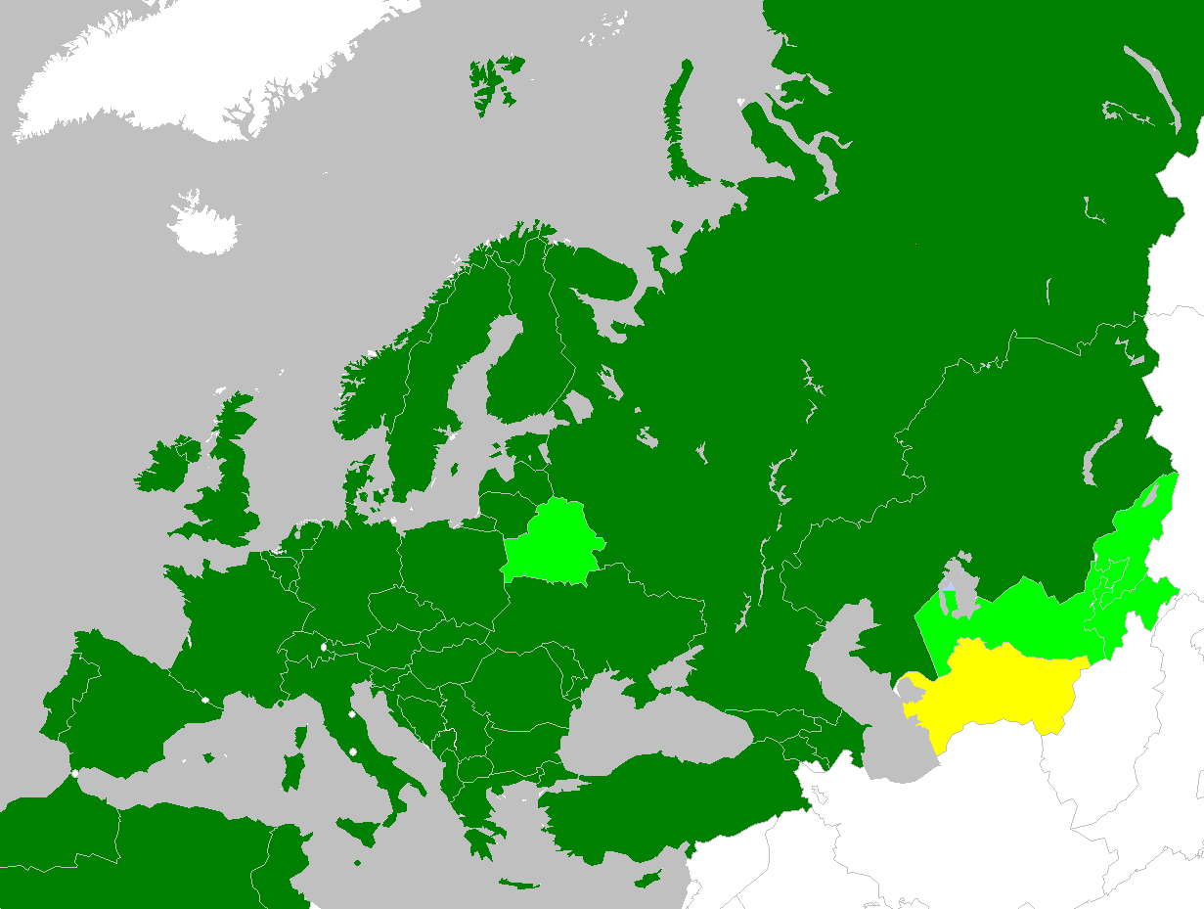 |  | Legend  - Completed  - Partially Completed (50%+)  - Partially Completed/Late (50%-)  - Not Started/Not Implemented  - Not Applicable  - Missing Data  The progress for B0-AMET is acceptable (with approximately 94% implementation).  Note: These high-level implementation elements are not applicable to Andorra, Morocco and San Marino.

Module | Elements | Albania | Algeria | Armenia | Austria | Azerbaijan | Belarus | Belgium | Bosnia and Herzegovina | Bulgaria | Croatia | Cyprus | Czech Republic | Denmark | Estonia | Finland
B0-AMET | SADIS FTP
B0-AMET | QMS
B0-AMET | VAAC
B0-AMET | VONA

Module | Elements | France | Georgia | Germany | Greece | Hungary | Ireland | Israel | Italy | Kazakhstan | Kyrgyzstan | Latvia | Lithuania | Luxembourg | Malta | Montenegro
B0-AMET | SADIS FTP
B0-AMET | QMS
B0-AMET | VAAC
B0-AMET | VONA

Module | Elements | Morocco | Netherlands | Norway | Poland | Portugal | Republic of Moldova | Romania | Russian Federation | Serbia | Slovakia | Slovenia | Spain | Sweden | Switzerland | Tajikistan
B0-AMET | SADIS FTP
B0-AMET | QMS
B0-AMET | VAAC
B0-AMET | VONA

Module | Elements | FYROM | Tunisia | Turkey | Turkmenistan | Ukraine | United Kingdom | Uzbekistan
B0-AMET | SADIS FTP
B0-AMET | QMS
B0-AMET | VAAC
B0-AMET | VONA

B0-DATM: Service Improvement through Digital Aeronautical Information Management

Table ASBU-EUR-B0-DATM 3-1

Provision of AIS/AIM products and services based on the Integrated Aeronautical Information Database (IAID)

EXPLANATION OF THE TABLE

Column:
- Name of the State or territory for which the provision of AIS/AIM products and services based on the IAID is required.
- Requirement for the implementation and designation of the authoritative IAID, shown by:
FI – Fully Implemented
PI – Partially Implemented
NI – Not Implemented
Note 1 — The IAID of a State is a single access point for one or more databases (AIS, Terrain, Obstacles, AMDB, etc.).
Note 2 — Information providing detail of “PI” should be given in the Remarks column (the implemented components of the IAID).
Note 3 — The information related to the designation of the authoritative IAID should be published in the AIP (GEN 3.1)
- Requirement for an IAID driven eAIP production, shown by:
FI – Fully Implemented (eAIP: Text, Tables and Charts)
NI – Not Implemented
Note 4 — AIP production includes, production of AIP, AIP Amendments and AIP Supplements
- Requirement for an IAID driven NOTAM production, shown by:
FC – Fully Compliant
NC – Not compliant
- Requirement for an IAID driven SNOWTAM production, shown by:
FC – Fully Compliant
NC – Not compliant
- Requirement for an IAID driven PIB production, shown by:
FC – Fully compliant
NC – Not compliant
- Requirement for Charting systems to be interoperable with the IAID, shown by:
FC – Fully compliant
PC – Partially compliant
NC – Not compliant
- Requirement for Procedure design systems to be interoperable with the IAID, shown by:
FI – Fully Implemented
PI – Partially Implemented
NI – Not Implemented
Note 5 — full implementation includes the use of the IAID for the design of the procedures and for the storage of the encoded procedures in the IAID
- Requirement for ATS systems to be interoperable with the IAID, shown by:
FI – Fully Implemented
PI – Partially Implemented
NI – Not Implemented
- Action Plan — short description of the State’s Action Plan with regard to the provision of AIM products and services based on the IAID, especially for items with a “PC”, “PI”, “NC” or “NI” status, including planned date(s) of full compliance, as appropriate.
- Remarks — additional information, including detail of “PC”, “NC”, “PI” and “NI”, as appropriate.

State | IAID | eAIP | NOTAM | SNOWTAM | PIB | Charting | Procedure Design | ATS | Action Plan | Remarks
1 | 2 | 3 | 4 | 5 | 6 | 7 | 8 | 9 | 10 | 11
ALBANIA | PI | FI | FC | NC | FC | PC | NI | NI |  | AIXM 5.1 in progress
ALGERIA
ArMENIA | FI | FI | FC | FC | FC | PC | NI | PI | 7,8,9: 2018 | AIXM FC (EAD)
AUSTRIA | PI | PI | FC | FC | FC | PC | PI | NI | 2017
AZERBAIJAN | FI | FI | FC | FC | FC | FC | PI | FI |  | AIXM 5.1 FC
BELARUS | FI | FI | FC | FC | FC | PC | PI | NI | 2,7,8: 2017 | AIXM PC
BELGIUM | FI | NI | FC | FC | FC | FC | PI | NI | 3: end 2017
BOSNIA and HERZEGOVINA
BULGARIA | PI | NI | NC | NC | NC | NC | NC |  | AIM system 2018 | AIXM 4.5 (EAD) not linked to other modules
CROATIA
CYPRUS | FI | FI | FI | NI | FI | FI | FI |  |  | EAD
CZECH REPUBPLIC | PI | NI | FI | FI | FI | PI | FI | PI | Q4 2017 | New IAID for static data in progress
DENMARK
ESTONIA | PI | FI | FC | FC | FC | PC | PI | NI |  | AIXM 5.1 FC
FINLAND | NI
FRANCE | PI | FI | NC | NC | NC | PC | PI | NI | AIXM 5 : 2021-2023 | AIXM 4.5
GEORGIA | FI | FI | FC | FC | FC | FC | FI | NI |  | EAD
GERMANY | PI | PI | NC | NC | NC | PC | PI | NI | ADQ implementation project | ADQ impl. project delayed due to technological immaturity. Additional compliance is expected to be achieved as the project progresses.
GREECE
HUNGARY | FI | FI | FC | FC | FC | FC | FI | NI
IRELAND
ISRAEL
ITALY
KAZAKHSTAN | FI | FI | FC | NC | FC | FC | FI | NI
KYRGYZSTAN | PI | NI | FC | FC | FC | NC | NI | NI |  | EAD
LATVIA | FI | FI | FC | FC | FC | PC | FI | PI | Full IAID with AIXM 5.1 Jun 2017 | AIXM 4.5 (5.1 in progress)
LITHUANIA | FI | FI | FC | FC | FC | PC | PI | NI | AIXM: 2016-2017 | AIXM 5.1 in progress
LUXEMBOURG | FI | NI | FC | NC | FC | FC | PI | NI | 3: 2017 | Joint AIP (Belgium/ Luxemburg fully migrated EAD)
MALTA
MONTENEGRO
MOROCCO | NI | NI | NC | NC | NC | NC | NI | NI | 2018
NETHERLANDS
NORWAY | PI | FI | FC | FC | FC | FC | FI | NI |  | IAID: not impl for AMDB
POLAND
PORTUGAL | PI | FI | FC | FC | FC | FC | NI | NI | AIXM 5.1: 2018 | 8 & 9: Tool not interoperable
REPUBLIC OF MOLDOVA | PI | FI | FC | FC | FC | FC | FI | NI | 2: 2019  7, 9: 2018 | AIXM
ROMANIA | NI | NI | NC | NC | NC | NC | NI | NI | 3,4,5,6,7,9: 2019 | EAD in use.
RUSSIAN FEDERATION | NI | NI | NC | NC | NC | NC | NI | NI | 2021 | AIXM NC
SERBIA
SLOVAKIA | PI | FI | FC | FC | FC | PC | PI | NI | 2018
SLOVENIA
SPAIN | PI | NI | NC | NC | NC | PC | NI | NI | Ongoing project for all items | IAID not fully completed
SWEDEN | FI | FI | FC | FC | FC | FC |  |  |  | AIXM 5.1
SWITZERLAND | PI | NI | FC | FC | FC | PC | PI | NI | 2, 3, 4, 7, 8, 9: Under review in the context of the ADQ IR implementation | 2:Implemented components of IAID: AIS database  7, 8: Not fully interoperable with IAID.
TAJIKISTAN | NI | NI | NC | NC | NC | NC | NI | NI
FYROM
TUNISIA
TURKEY | FI | PI | FC | FC | FC | FC | FI | FI | 2: 2017 | EAD
TURKMENISTAN | NI | NI | NC | NC | NC | NC | NI | NI
UKRAINE | PI | FI | NC | NC | NC | NC | NI | NI | 2017-2018 Integrated AIM system will cover all items | 2: AIP production only
UNITED KINGDOM | FI | FI | FC | FC | FC | FC | FI | FI |  | AIXM 4.5 system being upgraded to (EU) No.73/2010 AIXM 5.1 compliant AIS system
UZBEKISTAN | NI | NI | NC | NC | NC | NC | NI | NI |  | AIXM NC

---------------------

Table ASBU-EUR-B0-DATM-3-2

Aeronautical Data Quality

EXPLANATION OF THE TABLE

Column:

- Name of the State or territory.
- Compliance with the requirement for implementation of QMS for Aeronautical Information Services including safety and security objectives, shown by:
FC – Fully compliant
PC – Partially compliant
NC – Not compliant
- Compliance with the requirement for the establishment of formal arrangements with approved data originators concerning aeronautical data quality, shown by:
FC – Fully compliant
PC – Partially compliant
NC – Not compliant
- Implementation of digital data exchange with originators, shown by:
FI – Implemented
PI – Partially Implemented
NI – Not implemented
Note 1 — Information providing detail of “PI” and “NI” should be given in the Remarks column (percentage of implementation).
- Compliance with the requirement for metadata, shown by:
FC – Fully compliant
PC – Partially compliant
NC – Not compliant
- Compliance with the requirements related to aeronautical data quality monitoring (accuracy, resolution, timeliness, completeness), shown by:
FC – Fully compliant
NC – Not compliant
- Compliance with the requirements related to aeronautical data integrity monitoring, shown by:
FC – Fully compliant
NC – Not compliant
- Compliance with the requirements related to the AIRAC adherence monitoring, shown by:
FC – Fully compliant
NC – Not compliant
- Action Plan — short description of the State’s Action Plan with regard to aeronautical data quality requirements implementation, especially for items with a “PC”, “PI”, “NC” or “NI” status, including planned date(s) of full compliance, as appropriate.
- Remarks — additional information, including detail of “PC”, “NC”, “PI” and “NI”, as appropriate.

State | QMS | Establishment of formal agreements | Digital data exchange with originators | Metadata | Data quality monitoring | Data integrity monitoring | AIRAC adherence monitoring | Action Plan | Remarks
1 | 2 | 3 | 4 | 5 | 6 | 7 | 8 | 9 | 10
ALBANIA | FC | FC | PI | FC | FC | FC | FC
ALGERIA | FC |  |  |  |  |  | FC
ArMENIA | FC | PC | NI | FC | FC | FC | FC | 2018
AUSTRIA | FC | PC | PI | PC | PC | PC | FC | 2017
AZERBAIJAN | FC | FC | PI | FC | FC | FC | FC | 2018
BELARUS | FC | FC | NI | NC | NC | NC | FC | 2017
BELGIUM | FC | PC | NI | NC | FC | FC | FC | 3, 4 and 5: 2017
BOSNIA and HERZEGOVINA | NC |  |  |  |  |  | FC
BULGARIA | FC | FC | NI | PC | PC | FC | FC
CROATIA | FC |  |  |  |  |  | FC
CYPRUS | FC | PC | FI | PC | FC | FC | FC |  | 80% implemented
CZECH REPUBPLIC | FC | PC | NI | NC | FC | NC | FC | Q4 2017 | 3: 25% (under implementation)  4-7: Q4 2017
DENMARK | FC |  |  |  |  |  | FC
ESTONIA | FC | PC | PI | NC | FC | NC | FC | Q4 2017
FINLAND | FC | PC | PI | NC |  |  | FC
FRANCE | FC | PC | PI | NC | PC | PC | FC |  | 3 : 85% implemented.  4 :20% implemented
GEORGIA | FC | PC | NI | FC | FC | NC | FC | 3: 2017; 6,7:2018
GERMANY | FC | PC | PI | PC | PC | PC | FC | ADQ impl. project | (see above)
GREECE | NC |  |  |  |  |  | FC
HUNGARY | FC | PC | FI | FC | FC | FC | FC | 3:2018 | 3: 20% under implementation
IRELAND | FC |  |  |  |  |  | FC
ISRAEL | FC |  |  |  |  |  | FC
ITALY | FC |  |  |  |  |  | FC
KAZAKHSTAN | FC | FC | PI | FC | FC | NC | FC |  | 4: 25%
KYRGYZSTAN | PC | NC | NI | NC | NC | NC | FC | 2: 2017
LATVIA | FC | FC | FI | FC | FC | FC | FC
LITHUANIA | FC | FI | PI | PC | PC | PC | FC
LUXEMBOURG | FC | NC | NI | NC | FC | FC | FC | Action Plan under development
MALTA | FC |  |  |  |  |  | FC
MONTENEGRO | FC |  |  |  |  |  | FC
MOROCCO | FC | PC | NI | NC | NC | NC | FC | 2018
NETHERLANDS | FC |  |  |  |  |  | FC
NORWAY | FC | FC | FI | FC | FC | FC | FC
POLAND | FC |  |  |  |  |  | FC
PORTUGAL | FC | PC | PI | NC | FC | NC | FC | 4: Internal Y; external 50%  5: 2017/18  7: WFM 2017
REPUBLIC OF MOLDOVA | FC | FC | PI | FC | FC | FC | FC
ROMANIA | FC | FC | NI | NC | FC | FC | FC | 4: 2019 | 4: Available data exchange by email with CRC32Q verification tool.
RUSSIAN FEDERATION | FC | NC | NI | NC | FC | FC | FC
SERBIA | FC |  |  |  |  |  | FC
SLOVAKIA | FC | FC | PI | PC | FC | NC | FC | 2019
SLOVENIA | FC |  |  |  |  |  | FC
SPAIN | FC | FC | PI | PC | FC | FC | FC | Ongoing for digital data and full metadata exchange
SWEDEN | FC | FC | FI | PC | FC | FC | FC
SWITZERLAND | FC | PC | PI | NC | NC | NC | FC | 3, 4, 5, 6, 7: Under review in the context of the ADQ IR implementation. | 3: Formal arrangements with relevant originators have been prepared but still have to be aligned with the ADQ IR.  4: 10 % of implementation.
TAJIKISTAN | NC | NC | NI | NC | NC | NC | FC
FYROM | FC |  |  |  |  |  | FC
TUNISIA | FC |  |  |  |  |  | FC
TURKEY | FC | NC | NI | PC | PC | FC | FC | 3: 2018
TURKMENISTAN | NC | NC | NI | NC | NC | NC | FC
UKRAINE | FC | NC | NI | NC | FC | FC | FC | 3: 2017  4: 2018 | 5, 6, 7: By EAD
UNITED KINGDOM | FC |  |  |  |  |  | FC
UZBEKISTAN | FC | NC | NI | NC | NC | NC | FC

----------------

Table ASBU-EUR-B0-DATM-3-3

World Geodetic System-1984 (WGS-84)

EXPLANATION OF THE TABLE

Column:

- Name of the State or territory for which implementation of WGS-84 is required.
- Compliance with the requirements for implementation of WGS-84 for FIR and Enroute points, shown by:
FC – Fully compliant
PC – Partially compliant
NC – Not compliant
- Compliance with the requirements for implementation of WGS-84 for Terminal Areas (arrival, departure and instrument approach procedures), shown by:
FC – Fully compliant
PC – Partially compliant
NC – Not compliant
- Compliance with the requirements for implementation of WGS-84 for Aerodrome, shown by:
FC – Fully compliant
PC – Partially compliant
NC – Not compliant
- Compliance with the requirements for implementation of Geoid Undulation, shown by:
FC – Fully compliant
PC – Partially compliant
NC – Not compliant
- Action Plan — short description of the State’s Action Plan with regard to WGS-84 implementation, especially for items with a “PC”, “PI”, “NC” or “NI” status, including planned date(s) of full compliance, as appropriate.
- Remarks — additional information, including detail of “PC” and “NC”, as appropriate.

State | FIR/ENR | Terminal | AD | GUND | Action Plan | Remarks
1 | 2 | 3 | 4 | 5 | 6 | 7
ALBANIA | FC | FC | FC | FC
ALGERIA | FC | FC | FC | FC
ArMENIA | FC | FC | FC | FC
AUSTRIA | FC | FC | FC | FC
AZERBAIJAN | FC | FC | FC | FC
BELARUS | FC | FC | FC | FC
BELGIUM | FC | FC | FC | FC
BOSNIA and HERZEGOVINA | FC | FC | FC | FC
BULGARIA | FC | FC | FC | FC
CROATIA | FC | FC | FC | FC
CYPRUS | FC | FC | FC | FC
CZECH REPUBPLIC | FC | FC | FC | FC
DENMARK | FC | FC | FC | FC
ESTONIA | FC | FC | FC | FC
FINLAND | FC | FC | FC | FC
FRANCE | FC | FC | FC | FC
GEORGIA | FC | FC | FC | FC
GERMANY | FC | FC | FC | FC
GREECE | FC | FC | FC | FC
HUNGARY | FC | FC | FC | FC
IRELAND | FC | FC | FC | FC
ISRAEL | FC | FC | FC | FC
ITALY | FC | FC | FC | FC
KAZAKHSTAN | FC | FC | FC | FC
KYRGYZSTAN | FC | FC | FC | FC
LATVIA | FC | FC | FC | FC
LITHUANIA | FC | FC | FC | FC
LUXEMBOURG | FC | FC | FC | FC
MALTA | FC | FC | FC | FC
MONTENEGRO | FC | FC | FC | FC
MOROCCO | FC | FC | FC | FC
NETHERLANDS | FC | FC | FC | FC
NORWAY | FC | FC | FC | FC
POLAND | FC | FC | FC | FC
PORTUGAL | FC | FC | FC | FC
REPUBLIC OF MOLDOVA | FC | FC | FC | FC
ROMANIA | FC | FC | FC | FC
RUSSIAN FEDERATION | FC | FC | FC | FC
SERBIA | FC | FC | FC | FC
SLOVAKIA | FC | FC | FC | FC
SLOVENIA | FC | FC | FC | FC
SPAIN | FC | FC | FC | FC
SWEDEN | FC | FC | FC | FC
SWITZERLAND | FC | FC | FC | FC
TAJIKISTAN | NC | NC | NC | NC
FYROM | FC | FC | FC | FC
TUNISIA | FC | FC | FC | FC
TURKEY | FC | FC | FC | FC
TURKMENISTAN | NC | NC | NC | NC | 2018
UKRAINE | FC | FC | FC | FC
UNITED KINGDOM | FC | FC | FC | FC
UZBEKISTAN | FC | NC | NC | NC | 2018

-------------------

Table ASBU-EUR-B0-DATM-3-4

Provision of the required Terrain and Obstacle data sets

EXPLANATION OF THE TABLE
Column
1 | Name of the State or territory for which the Terrain and Obstacle data sets are required.
2 | Compliance with requirement for the provision of Terrain data sets for Area 1, shown by:  FC – Fully Compliant  PC – Partially Compliant  NC – Not Compliant
3 | Compliance with requirement for the provision of Terrain data sets for Area 2a, including the take-off flight path area (Annex 15, 10.1.5b refers) and the area bounded by the lateral extent of the aerodrome obstacle limitation surfaces (Annex 15, 10.1.5c refers), shown by:  FC – Fully Compliant  PC – Partially Compliant  NC – Not Compliant
4 | Compliance with requirement for the provision of Terrain data sets for Area 4, shown by:  FC – Fully Compliant  PC – Partially Compliant  NC – Not Compliant  N/A – Not Applicable  Note 1 — The requirement is applicable only for international aerodrome(s) CAT II/III.
5 | Compliance with requirement for the provision of Obstacle data sets for Area 1, shown by:  FC – Fully Compliant  PC – Partially Compliant  NC – Not Compliant
6 | Compliance with requirement for the provision of Obstacle data sets for Area 2a, including the objects in the take-off flight path area which project above a plane surface having a 1.2 per cent slope and having a common origin with the take-off flight path area (Annex 15, 10.1.6b refers) and the penetrations of the aerodrome obstacle limitation surfaces (Annex 15, 10.1.6c refers), shown by:  FC – Fully Compliant  PC – Partially Compliant  NC – Not Compliant
7 | Compliance with requirement for the provision of Obstacle data sets for Area 4, shown by:  FC – Fully Compliant  PC – Partially Compliant  NC – Not Compliant  N/A – Not Applicable  Note 2 — The requirement is applicable only for international aerodrome(s) CAT II/III.
8 | Action plan — short description of the State’s Action Plan with regard to compliance with the requirements for provision of the required Terrain and Obstacle data sets, especially for items with a “PC” or “NC” status.
9 | Remarks— additional information, including detail of “PC” or “NC”, as appropriate.

State | Terrain data sets |  |  | Obstacle data sets |  |  | Action Plan | Remarks
State | Area 1 | Area 2a | Area 4 | Area 1 | Area 2a | Area 4 | Action Plan | Remarks
1 | 2 | 3 | 4 | 5 | 6 | 7 | 8 | 9
ALBANIA | FC | FC | FC | PC | FC | FC |  | 5: Lack out of Tirana TMA
ALGERIA | NC | NC | NC | NC | NC | NC
ArMENIA | FC | FC | FC | FC | FC | FC |  | 4,7: UDYZ
AUSTRIA |  |  | NC | NC |  | NC
AZERBAIJAN | NC | NC | NC | PC | NC | NC
BELARUS | FC | NC | NC | FC | PC | NC | 2017
BELGIUM | FC | NC | NC | FC | NC | NC
BOSNIA and HERZEGOVINA | FC | NC | FC | NC | NC | FC
BULGARIA | NC | NC | NC | NC | NC | NC
CROATIA | NC | NC | NC | NC | NC | NC
CYPRUS | FC | NC | FC | FC | NC | FC
CZECH REPUBPLIC | FC | NC | NC | FC | NC | NC | Q4 2017 | New IAID for static data incl. TOD is under implementation
DENMARK | FC | NC | NC | NC | NC | NC
ESTONIA | FC | FC | N/A | PC | PC | N/A
FINLAND | NC | NC | NC | FC | PC | NC |  | 5: Electronic list of obstacles
FRANCE | FC | FC | PC | FC | FC | PC |  | 4,7:LFBO,LFST,LFPG,LFBD,LFLL,LFPO
GEORGIA | NC | NC | N/A | NC | NC | N/A | 2019
GERMANY | FC | NC | NC | FC | NC | NC
GREECE | NC | NC | NC | NC | NC | NC
HUNGARY | NC | NC | NC | FC | PC | FC |  | 6: LHBP, LHUD available
IRELAND | FC |  | NC | NC |  | NC
ISRAEL | NC | NC | N/A | NC | NC | N/A | 5: 2018
ITALY | NC |  | NC | NC |  | NC
KAZAKHSTAN | NC | NC | NC | FC | FC | FC | 2018
KYRGYZSTAN | NC | NC | NC | NC | NC | NC
LATVIA | FC | FC | FC | FC | FC | FC |  | 4, 7: EVRA RWY18/36
LITHUANIA | FC | FC | FC | FC | PC | PC
LUXEMBOURG | NC | NC | NC | NC | NC | NC | 2017 | In progress
MALTA | NC |  | NC | NC |  | NC
MONTENEGRO | FC |  |  | NC
MOROCCO | NC | NC | NC | NC | NC | NC | 2017-2023
NETHERLANDS | NC |  | NC | NC |  | NC
NORWAY | FC | FC | FC | FC | FC | FC
POLAND | NC |  | NC | FC |  | NC
PORTUGAL | FC | NC | NC | FC | PC | NC | 4, 7: 2017 | 4, 7: LPPT, LPPR, LPFR
REPUBLIC OF MOLDOVA | FC | FC | FC | FC | FC | FC
ROMANIA | NC | NC | NC | NC | NC | NC | 2020
RUSSIAN FEDERATION | PC | PC | PC | FC | PC | FC | 2021
SERBIA | FC |  | NC | NC |  | NC
SLOVAKIA | FC | FC | FC | FC | NC | PC |  | 4,7: LZIB, LZKZ
SLOVENIA | NC |  | NC | NC |  | NC
SPAIN | FC | NC | PC | FC | FC | PC | Ongoing area 2 terrain | Missing some area 4 terrain & obstacle data; in progress
SWEDEN | FC | NC | NC | NC | PC | PC |  | Project on-going
SWITZERLAND | PC | PC | PC | PC | NC | NC | 2-7: First step: adaptation of national law by mid-2018 in order to implement the "Obstacle Concept Switzerland" | 2, 3, 4: Terrain data available in a different format – detailed information is published in the AIP under GEN 1.7 / GEN 3.1
TAJIKISTAN | NC | NC | NC | NC | NC | NC
FYROM |  |  |  | NC
TUNISIA | NC | NC | N/A | NC | NC | N/A
TURKEY | FC | FC | FC | FC | FC | FC
TURKMENISTAN | NC | NC | NC | NC | NC | NC
UKRAINE | FC | PC | PC | FC | PC | PC |  | 4, 7: UKHH
UNITED KINGDOM | NC |  | NC | FC |  | NC |  | 5: Electronic list of obstacles AVBL
UZBEKISTAN | NC | NC | NC | NC | NC | NC

--------------------

Table ASBU-III-EUR-2 – EUR Region Implementation Status of Block 1 Module Elements

FURTHER WORK REQUIRED

Block 1 Modules | Module Elements | Need Analysis of Module Elements |  |  |  | Implementation Status (if Element is required) |  |  |  | Remarks
Block 1 Modules | Module Elements | Not Started | In Progress | Need | N/A | Planning | Developing | Partially Implemented | Implemented | Remarks
Performance Improvement Area 1: Airport Operations
ACDM | 1. (Derived from 1.3.1 a) Airport Operations Plan (AOP) which encompasses local airport information and information that is shared with the ATM system/ATM network manager
ACDM | 2. (Derived from 1.3.1 b) Airport performance framework integrated into AOP
ACDM | 3. (Derived from 1.3.1 b) Airport performance framework aligned with regional/national performance framework(s)
ACDM | 4. (Derived from 1.3.1 c) Decision making support to facilitate communication and coordination between airport stakeholders for joint planning
ACDM | 5. (Derived from 1.3.1 d) Accessible information on airport resource availability and planned aircraft operations for use by airport operators and ATM system/network managers
ACDM | 6. (Derived from 1.3.1 e) Real time monitoring and alerting to activate collaborative airside/landside airport operations to respond to specific conditions, such as specified meteorological conditions/events
APTA | 1. (Derived from 1.3.1) CAT II PBN approach procedures
APTA | 2. (Derived from 1.3.1) CAT III PBN approach procedures
APTA | 3. (Derived from 1.3.1) CAT II GLS approach procedures
APTA | 4. (Derived from 1.3.1) CAT III GLS approach procedures
APTA | 5. (Derived from 1.3.1) PBN STARs directly integrated to approaches with vertical guidance
RATS | 1. (Derived from Element 1) Provision of tower control (TWR) or aerodrome flight information service (AFIS) for single aerodrome(s) by remotely located air traffic controllers (ATCO) or aerodrome flight information service officers (AFISO)
RATS | 2. (Derived from Element 2) Provision of TWR or AFIS for multiple aerodromes by a single ATCO or AFISO
RATS | 3. (Defined: Element 3) Remote provision of ATS for contingency situations
RSEQ | 1. (Derived from Element 1 and 4.1.1) Surface management of runway demand and sequencing aircraft on the ground to support departure operations based on precise surface movement tracking
RSEQ | 2. (Derived from Element 2) Integration of departure sequencing and surface management
RSEQ | 3. (Derived from Element 3) Arrival metering extended across FIR boundaries
RSEQ | 4. (Derived from Element 4) Assignment of RNAV/RNP routes linked to controlled time of arrival at metering fixes
SURF | 1. (Derived from 1.4.1) Basic surface situation awareness (SURF) through display of other aerodrome traffic to aircraft via ADS-B or TIS-B
SURF | 2. (Derived from 1.4.2) SURF with Indications and Alerts (SURF-IA) for aircraft
SURF | 3. (Derived from 1.4.3 & 1.4.4) SURF for airport vehicles
SURF | 4. (Derived from 1.4.4) SURF-IA for airport vehicles
SURF | 5. (Defined: Element 2) Enhanced vision systems for taxi operations
WAKE | 1. (Derived from Element 1 and 3.1.1) PANS-ATM aircraft leader/follower pair-wise wake turbulence separation minima
WAKE | 2. (Derived from Element 2 and 3.2.1) Wake Turbulence Mitigation for Arrivals (WTMA) on parallel runways with runway centre lines spaced less than 760 m (2 500 feet) apart or on a single runway through variable application of wake turbulence separation dependant on the crosswinds present along the approach corridor
WAKE | 3. (Derived from Element 3) Wake Turbulence Mitigation for Departures (WTMD) on parallel runways with runway centre lines spaced less than 760 m (2 500 feet) through reduction of separation between departures when runway crosswinds are of sufficient strength and persistence
Performance Improvement Area 2: Globally Interoperable Systems and Data
AMET | 1. (Derived from Element 1 and 1.3.2) Producing meteorological information elements that can be ingested by automated decision support tools
AMET | 2. (Derived from Element 2) Automated processing of meteorological information to derive predicted effects on airspace capacity
AMET | 3. (Derived from Element 2) Automated processing of meteorological information to derive predicted effects on aerodrome capacity
AMET | 4. (Derived from Element 3) Comparison of predicted meteorological airspace capacity constraints to projected demand
AMET | 5. (Derived from Element 3) Comparison of predicted meteorological aerodrome capacity constraints to projected demand
AMET | 6. (Derived from Element 4) Meteorological information integrated decision support that creates ranked mitigation strategies
DATM | 1. (Derived from 1.1.1) Implementation of digital information management using WXXM for meteorological information
DATM | 2. (Derived from 1.1.1) Implementation of digital information management using FIXM for flight and flow information
DATM | 3. (Derived from 1.1.1) Implementation of digital information management for aircraft performance-related data
FICE | 1. (Derived from 1.3.5 a) Ability for ATS to receive early flight intention information
FICE | 2. (Derived from 1.3.5 b) Ability for AOC and ATS to exchange 4D trajectory information
FICE | 3. (Derived from 1.3.5 c) Implementation of a flight and flow information format using internet protocol and XML.
FICE | 4. (Derived from 1.3.5 d) Allocation and use of globally unique flight identifiers (GUFI)
FICE | 5. (Derived from 1.3.5 e) Ability for ATS to receive FF-ICE information elements
SWIM | 1. (Derived from 1.1.5 a) Implement structure/protocols for sharing information within communities of interest
SWIM | 2. (Derived from 8.1) PANS-AIM
Performance Improvement Area 3: Optimum Capacity and Flexible Flights
ASEP | 1. (Derived from 1.1.1, 1.1.2 and 1.3.1) Implementation of procedures for aircraft to be cleared to maintain a specified distance from a preceding aircraft from top of descent to the initial or final approach fix
ASEP | 2. (Derived from 1.1.1, 1.1.2 and 1.3.1) Implementation of procedures for aircraft to be cleared to maintain a specified time interval between it and a preceding aircraft from top of descent to the initial or final approach fix
FRTO | 1. (Derived from Element 1) Free routing, including within defined airspace and/or at defined times and/or within defined flows.
FRTO | 2. (Derived from Element 2 (1.4.3 b)) Maintaining same PBN route spacing between straight and turning segments
FRTO | 3. (Derived from Element 2 (1.4.3 c)) Publishing PBN holding procedures
FRTO | 4. (Defined: Element 3) Dynamic sectorization
NOPS | 1. (Derived from Element 1) Improving ATFM algorithms and techniques
NOPS | 2. (Derived from Element 1) Integrating ATFM and Airspace Organization and Management (AOM) in the design of alternative route options for ATFM
NOPS | 3. (Derived from Element 2) Using trajectory projections as soon as possible after departure to update ATFM requirements and perform additional ATFM smoothing for single flows
NOPS | 4. (Derived from Element 2) Using trajectory projections as soon as possible after departure to update ATFM requirements and perform additional ATFM smoothing for converging flows
NOPS | 5. (Derived from Element 3) Initial User Driven Prioritization Process (UDPP) whereby operators affected by ATFM measures can collaborate with each other and ATFM to devise alternative measures that serve ATFM requirements while at the same time taking account of operators’ priorities
SNET | 1. (Derived from 1.3.1) Implementation of Approach Path Monitor (APM), which generates timely alerts to ATCOs if aircraft are in unsafe proximity to obstacles or terrain during final approach
SNET | 2. (Derived from 1.3.2) Implementation of accurate approach path model in APM which minimizes nuisance alerts
Performance Improvement Area 4: Efficient Flight Paths
CDO | 1. (Derived from 1.2.1 and 1.3.1) CDO procedures defined as vertical paths to be followed within specified tolerances
RPAS | 1. (Derived from 1.3.1 a) Streamlined process for RPA access to non-segregated airspace
RPAS | 2. (Derived from 1.3.1 b) Defined airworthiness certification for RPA
RPAS | 3. (Derived from 1.3.1 c) Defined operator certification for RPA operators
RPAS | 4. (Derived from 1.3.1 d) Defined communication performance requirements for Command and Control (C2) links and for ATC communications
RPAS | 5. (Derived from 1.3.1 e) Defined remote pilot licencing requirements
RPAS | 6. (Derived from 1.3.1 f) Defined detect and avoid technology performance requirements
TBO | 1. (Derived from 1.3.1) Ability to download trajectory information via air/ground data link
TBO | 2. (Derived from 1.3.1) Ability to exchange complex route clearances via ground/ground data link from one ANSP to another
TBO | 3. (Derived from 1.3.1) Ability to exchange complex route clearances via ground/ground data link across multiple airspace boundaries
TBO | 4. (Derived from Element 1) Initial 4D operations by specifying Required Time of Arrival (RTA)
TBO | 5. (Defined: Element 2) Data Link Operational Terminal Information Service (D-OTIS)
TBO | 6. (Derived from Element 3) Departure clearances via data link (DCL)
TBO | 7. (Defined: Element 4) Data Link Taxi (D-TAXI)
Totals | All Elements: 68

___________________

Table ASBU-III-EUR-3 – EUR Region Implementation Status of Block 2 Module Elements
Note: The table will be filled later.

Block 2 Modules | Module Elements | Need Analysis of Module Elements |  |  |  | Implementation Status (if Element is required)
Block 2 Modules | Module Elements | Not Started | In Progress | Need | N/A | Planning | Developing | Partially Implemented | Implemented
Performance Improvement Area 1: Airport Operations
WAKE | TBD
SURF | TBD
RSEQ
Performance Improvement Area 2: Globally Interoperable Systems and Data
FICE | TBD
SWIM | TBD
Performance Improvement Area 3: Optimum Capacity and Flexible Flights
NOPS
ASEP
ACAS
Performance Improvement Area 4: Efficient Flight Paths
CDO
RPAS

Block 2  Modules | Elements | Not Started | Need Analysis |  |  | Implementation Status (if Needed)
Block 2  Modules | Elements | Not Started | In  process | Need | N/A | Plan-  ning | Develop-ing | Partially Imple-mented | Imple-mented
RSEQ
SURF
WAKE
FICE
SWIM
ASEP
NOPS
ACAS
CDO
RPAS
Summary Counts |  | 0 | 0 | 0 | 0 | 0 | 0 | 0 | 0

___________________

Table ASBU-III-EUR-4 – EUR Region Implementation Status of Block 3 Module Elements
Note: The table will be filled later.

Block 3 Modules | Module Elements | Need Analysis of Module Elements |  |  |  | Implementation Status (if Element is required)
Block 3 Modules | Module Elements | Not Started | In Progress | Need | N/A | Planning | Developing | Partially Implemented | Implemented
Performance Improvement Area 1: Airport Operations
RSEQ
Performance Improvement Area 2: Globally Interoperable Systems and Data
FICE | TBD
AMET | TBD
Performance Improvement Area 3: Optimum Capacity and Flexible Flights
NOPS
Performance Improvement Area 4: Efficient Flight Paths
TBO
RPAS

Block 3  Modules | Elements | Not Started | Need Analysis |  |  | Implementation Status (if Needed)
Block 3  Modules | Elements | Not Started | In  process | Need | N/A | Plan-  ning | Develop-ing | Partially Imple-mented | Imple-mented
RSEQ
AMET
FICE
FRTO
RPAS
SNET
CDO
RPAS
Summary Counts |  | 0 | 0 | 0 | 0 | 0 | 0 | 0 | 0

___________________

EUR ANP, VOLUME III

PART III - AIR NAVIGATION SYSTEM/REGIONAL AVIATION SYSTEM IMPROVEMENT (RASI) IMPLEMENTATION

- INTRODUCTION
1.1 Part III indicates the implementation status of planned improvements to the EUR Region aviation system which are not covered in Part II. (e.g. additional functionalities exceeding Block 0 requirements such as detailed in the European ATM Master Plan, etc.)
1.2 To be developed…

- END -

Companion Document
ASBU Implementation Monitoring Report, ICAO EUR States, Reference Period 2016

Full details are shown in ASBU Implementation Monitoring Report, ICAO EUR States, Reference Period 2016.

