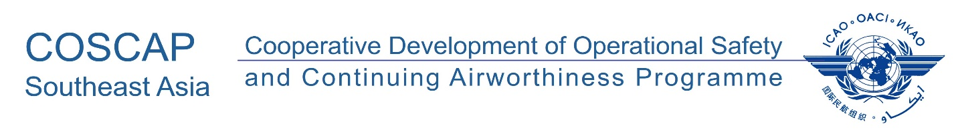

The 24th South East Asia Regional Aviation Safety Team (SEARAST/24) and
National Coordinators Meeting
26 March 2026, 09:00-16:00 hrs., ICAO APAC RO, Bangkok, Thailand (Hybrid)

ON SITE

ON LINE

PARTICIPANTS REGISTRATION FORM
State
Name | Title | Surname (Capitals) | First name | Middle name
Position / Title
Organization
Department / Division
Telephone
(office)
Telephone
(mobile)
E-mail
(office)
E-mail
(alternate)
Any Special Need
Meal Choice
(subject to availability)

Please send completed form(s) by 20 March 2026 to:

COSCAP-SEA Programme, Administrative Assistant
E-mail: sjuntarapratin@icao.int

