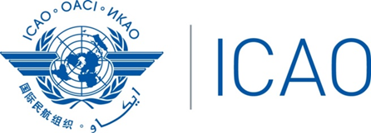 | International Civil Aviation Organization  Workshop on Transposition of Annex 14 SARPs  into National Aerodrome Standards and the  Sixth Meeting of the Asia/Pacific Aerodrome Design and Operations Task Force (AP-ADO/TF/6)  Langkawi, Malaysia, 17 - 21 February 2025

REGISTRATION FORM

PLEASE TYPE

1. | Name in full :
  Mr. | Mrs. | Ms. | Dr. | Capt.
 |  |  | (as should appear in the official listing)
2. | Title or Official Position:
3. | State/Organization:
4. | Mailing Address:
5. | Telephone Number:
 | E-mail:

Note: Meeting materials will only be available in soft copy (electronic) to participants. Please download meeting materials from the ICAO Asia/Pacific website (http://www.icao.int/apac) prior to the meeting.

Date ..………….........................………….... Signature .………….................................................…
After completing, please send to: ICAO Regional Office Fax: 66 (2) 537 8199 or E-mail: apac@icao.int

