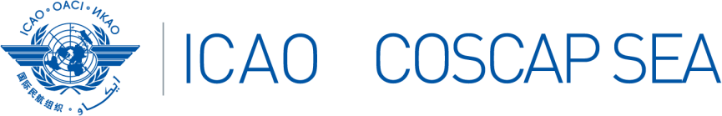

The 23rd South East Asia Regional Aviation Safety Team (SEARAST/23) and
National Coordinators Meeting
21 – 22 January 2025, 09:00-16:00 hrs., ICAO APAC RO, Bangkok, Thailand.

PARTICIPANTS REGISTRATION FORM
State
Name | Title | Surname (capitals) | First name | Middle name
Position / Title
Organization
Department / Division
Telephone
(office)
Telephone
(mobile)
E-mail
(office)
E-mail
(alternate)

Please send completed form(s) by 10 January 2025 to:

COSCAP-SEA, Administrative Assistant
E-mail: sjuntarapratin@icao.int

