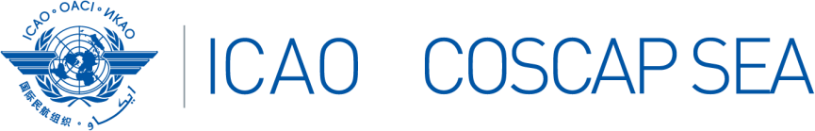

COSCAP Southeast Asia Programme AIS to AIM Transition Course
30 June – 4 July 2025, ICAO APAC RO, Bangkok, Thailand.

PARTICIPANTS REGISTRATION FORM
State
Name | Title | Surname (Capitals) | First name | Middle name
Position / Title
Organization
Department / Division
Telephone
(office)
Telephone
(mobile)
E-mail
(office)
E-mail
(alternate)
Any Special Need
Meal Choice
(subject to availability)

Please send completed form(s) by 20 June 2025 to:

COSCAP-SEA, Administrative Assistant
E-mail: sjuntarapratin@icao.int

