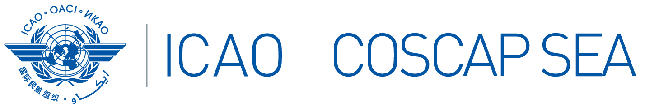

Interim South East Asia Regional Aviation Safety Team (SEARAST) and National Coordinators Meeting
27 March 2024, 09:30-13:30 hrs., Bangkok Time, on Zoom

PARTICIPANT REGISTRATION FORM

State
Name | Title | Surname (capitals) | First name | Middle name
Position / Title
Organization
Department / Division
Telephone (office)
Telephone
(mobile)
E-mail
(office)
E-mail
(alternate)

Please send completed form(s) by 5 March 2024 to:
ICAO COSCAP SEA Administrative Assistant
E mail: sjuntarapratin@icao.int

