Courtesy Shuttle Bus Services to the Meeting Venue
- 2 Routes:
- Airport Ring (tentative departure time in the morning, subject to actual traffic conditions)
0805 | 0815 | 0825 | 0835
0830 | 0840 | 0850 | 0900
0930 | 0940 | 0950 | 1000

- Tung Chung Ring (tentative departure time in the morning, subject to actual traffic conditions)
0805 | 0815 | 0825 | 0835
0830 | 0840 | 0850 | 0900
0930 | 0940 | 0950 | 1000

Note: Due to the restriction of loading area, the guests of The Silveri should board at Novotel Citygate or Tung Chung Station.

Courtesy Shuttle Bus Services from the Meeting Venue

- 2 Routes:
- Airport Ring (tentative departure time, subject to actual meeting arrangement)
13 Dec 2023 (tentative)
1300 | 1310 | 1320 | 1330
1415 | 1425 | 1435 | 1445

- Tung Chung Ring (tentative departure time, subject to actual meeting arrangement)
13 Dec 2023 (tentative)
1300 | 1310 | 1320 | 1330
1415 | 1425 | 1435 | 1445

Note: Due to the restriction of loading area, the guests of The Silveri should board at Novotel Citygate or Tung Chung Station.

- Info to be posted to website direct

Pick-up and drop-off point:

The shuttle bus will stop at the pick-up and drop-off area of the hotels or near Tung Chung MTR Station Exit A as shown in the photo. An [“APANPIRG” or “RASG”] signage will be displayed on the windscreen of the shuttle bus.
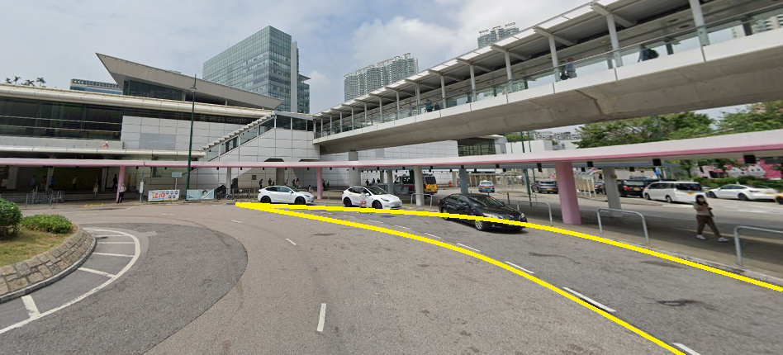
Tung Chung MTR Station
Exit A
Pick-up and
Drop-off Bay

For planning purpose, please inform us the name of your hotel through the reply form preferably not later than 30 November 2023. (reply date TBC)

Pick-up and
Drop-off Bay
Pick-up and drop-off area of Tung Chung MTR Station near Exit A

