AD 2 AERODROMES

PKRS – EWOK / MCGARTH

AD 2.1 AERODROME LOCATION INDICATOR AND NAME

PKRS – EWOK / MCGARTH

AD 2.2 AERODROME GEOGRAPHICAL AND ADMINISTRATIVE DATA

1 | ARP coordinates and site at AD | 635906N 0223620W  Runway Intersection
2 | Direction and distance from (city) | 10 mile to the NE
3 | Elevation / Reference Temperature | 169 ft / 11.1 ºC (July)
4 | Geoid Undulation | 217 FT
5 | MAG VAR/Annual Change | 15.1W
6 | AD Operator | POLAR HOLDING  1 King Triton Drive  Ewok
7 | Types of Traffic Permitted (IFR/VFR) | IFR/VFR
8 | Remarks | 1. Airport for use by national and international civil air transport with all types of aircraft.  2. Upon request, contact the flow manager aircraft on channel 130.480 call sign "Airport One" (not monitored H24).  3. Changes in the availability of the runway and taxiway infrastructure at the airport will be promulgated by NOTAM.

AD 2.3 OPERATIONAL HOURS

1 | AD Operator | H24
2 | Customs and Immigration | H24
3 | Health and Sanitation | H24
4 | AIS Briefing Office | H24 Self Briefing
5 | ATS Reporting Office (ARO) | H24
6 | MET Briefing Office | H24
7 | ATS | H24
8 | Fueling | H24
9 | Handling | H24
10 | Security | H24
11 | De-Icing | H24
12 | Remarks | NIL

AD 2.4 HANDLING SERVICES AND FACILITIES

1 | Cargo-handling facilities | All modern facilities
2 | Fuel/oil types | Jet A1/All kinds.
3 | Fuelling facilities/capacity | Jet A1 unlimited.
4 | De-icing facilities | De-icing equipment AVBL
5 | Hangar space for visiting aircraft | O/R, limited.
6 | Repair facilities for visiting aircraft | Major repairs to all types of aircraft. Spares AVBL.
7 | Remarks | Oxygen and related servicing unlimited.

AD 2.5 PASSENGER FACILITIES

1 | Hotels | At AD: 2 hotels (322 beds). In the close vicinity of the airport: 3 hotels (1274 beds).
2 | Restaurants | At AD, near vicinity and in the city: unlimited.
3 | Transportation | Train, buses, taxis and rental cars.
4 | Medical facilities | First aid treatment. Two motor ambulances. Hospitals at city
5 | Bank and post office | AVBL
6 | Tourist office | AVBL
7 | Remarks | NIL

AD 2.6 RESCUE AND FIRE FIGHTING SERVICES

1 | AD category for fire fighting | CAT 10
2 | Rescue equipment | 9 crash trucks equipped with 780 liters of foam (level B) and 250 kg of dry chemical powder, 1 rescue vehicle, and 1 truck with rescue equipment; allocated to 3 fire stations.
3 | Capability for removal of disabled aircraft | Coordinated by airport authority in consultation with outside partners
4 | Remarks | NIL

AD 2.7 SEASONAL AVAILABILITY – CLEARING

1 | Types of clearing equipment | 14 snow sweep combinations with ploughs, 4 snow blowers, 4 de-icing cars, 6 ramp ploughs, 4 compact-sweepers.
2 | Clearance priorities | RWY, TWY and apron simultaneously.
3 | Remarks | 1. Responsible authority: airport authority.  2. Methods of snow removal: snow ploughs and sweeping machines.  3. Snow measuring: observation by own experienced staff.  4. Measuring of estimated surface friction: Friction Tester and/or using motor craft by the flow manager aircraft.  5. Determining the values of the estimated surface friction:  a. When using the Friction Tester:  Measured coefficient Est. surface friction  0.40 and above Good  0.39 to 0.36 Medium to good  0.35 to 0.30 Medium  0.29 to 0.26 Medium to poor  0.25 and below Poor  b. In other cases: decision of the flow manager aircraft.  6. Information concerning improvement of estimated surface friction: at the discretion of the flow manager aircraft.  7. Details concerning up-to-date information to users: SNOWTAM via the international NOTAM office

AD 2.8 APRONS, TAXIWAYS AND CHECK LOCATIONS/POSITIONS DATA

1 | Apron surface and strength | Apron 1 ASP PCN 50 F/A/X/T  Apron 2 ASP PCN 50 F/A/X/T  Apron 3 ASP PCN 50 F/A/X/T
2 | Taxiway width, surface and strength | TWY N 1-3 30 M PCN 60/F/A/W/T TWY N 4 23 M PCN 50/F/A/W/T TWY K 1 30 M PCN 36/F/B/W/T TWY K 2 30 M PCN 32/F/A/W/T TWY K 3-4 30 M PCN 43/F/A/X/T  TWY D 1 15 M PCN 78/F/B/W/T TWY C 3 23 M PCN 58/F/A/W/T TWY S 1-4 30 M PCN 65/F/A/W/T TWY E 1-4 23 M PCN 68/F/B/W/T TWY G 1 23 M PCN 50/F/A/W/T TWY G 2 23 M PCN 53/R/A/W/T TWY A 1 23 M PCN 80/F/A/X/T
3 | Altimeter checkpoint location and elevation | Terminal apron, elevation 131 FT
4 | VOR checkpoints | NIL
5 | INS checkpoints | NIL
6 | Remarks

AD 2.9 SURFACE MOVEMENT GUIDANCE AND CONTROL SYSTEM AND MARKINGS

1 | Use of aircraft stand ID signs, TWY guide lines and visual docking/parking guidance system at aircraft stands | Provided
2 | RWY and TWY markings and LGT | RWY Markings: Thresholds, RWY designation, aiming point and TDZ, RWY centerlines and RWY holding positions.  RWY Lights: THR, TDZ, RWY centerline, EDGE, END and RWY guard lights  TWY Markings: Centerlines, intermediate holding positions, taxi side stripe markings, apron safety lines and aircraft stands  TWY Lights: Edge lights on taxiways and aprons and apron flood  lights
3 | Stop bars | No
4 | Remarks | Beware of fish and other objects floating on movement surface

AD 2.10 AERODROME OBSTACLES

OBST type | OBST position | ELEV / HGT | Markings | Remarks
Mast | 635906.09N 0224354.08W | 158 / – FT | LGTD | NIL
Mast | 635103.26N 0222706.56W | 668 / – FT | LGTD | NIL
Mast | 635101.04N 0222801.20W | 1065 / – FT | LGTD | NIL
Mast | 635150.25N 0222619.23W | 779 / – FT | NIL | NIL

AD 2.11 METEOROLOGICAL INFORMATION PROVIDED
1 | Associated MET office | De Bilt
2 | Hours of service  MET office outside hours | H24  -
3 | Office responsible for TAF preparation Periods of validity | De Bilt  30 HR
4 | Trend forecast  Interval of issuance | TREND  Every 30 minutes for international METAR, maximum 30 minutes for local display and broadcast on ATIS.
5 | Briefing/consultation provided | Briefing on request from MWO-De Bilt by telephone after self-briefing
6 | Flight documentation  Language(s) used | Reports, forecasts, charts.  English
7 | Charts and other information available for briefing or consultation | S, P, W, T
8 | Supplementary equipment available for providing information | WXR, APT
9 | ATS units provided with information | Atlantis ACC and FIC
10 | Additional information (limitation of service, etc.) | Charge for tel. briefings and consultations is $0.50/min

AD 2.12 RUNWAY PHYSICAL CHARACTERISTICS

Designations RWY NR | TRUE BRG | Dimensions of RWY (M) | Strength (PCN) & surface of RWY and SWY | THR coordinates RWY end coordinates THR geoid undulation | THR elevation & highest elevation of TDZ of precision APP RWY
01 | 000.02 | 10020 X 197 | PCN 73 F/A/W/T  ASPH | 635752.12N 0223619.63E  —  GUND 217 FT | THR 135 FT TDZ 159 FT
19 | 180.02 | 10020 X 197 | PCN 73 F/A/W/T  ASPH | 635930.76N 0223619.56W  —  GUND 217 FT | THR 161 FT TDZ 162 FT
10 | 089.97 | 10555 X 197 | PCN 73 F/A/W/T  ASPH | 635906.14N 0223918.02W  —  GUND 217 FT | THR 109 FT TDZ 125 FT
28 | 270.02 | 10055 X 197 | PCN 73 F/A/W/T  ASPH | 635906.15N 0223532.61W  —  GUND 217 FT | THR 168 FT TDZ 169 FT

AD 2.13 DECLARED DISTANCES

RWY Designator | TORA | TODA | ASDA | LDA | Remarks
01 | 10020 | 10510 | 10020 | 10020 | NIL
19 | 10020 | 10510 | 10020 | 10020 | NIL
10 | 10055 | 10900 | 10055 | 10055 | NIL
28 | 10055 | 10900 | 10055 | 10055 | NIL

AD 2.14 APPROACH AND RUNWAY LIGHTING

RWY Designator | APCH LGT type LEN INTST | THR LGT color WBAR | VASIS (MEHT) PAPI | TDZ LGT LEN | RWY Centre Line LGT Length, spacing, color | RWY End LGT color | Remarks
01 | RWY THR ID Lights | GRN — | PAPI 3.0° | — | Color coded | RED | NIL
19 | LIH W CL 2953’  LIH R Sidebars 900’  LIH W Crossbars 490’  985’ Seq. fl.CL | GRN — | PAPI 3.0° | 2953’ | Color coded | RED | NIL
10 | LIH W CL 2953’  LIH R Sidebars 900’ LIH W Crossbars 490’  985’ Seq. fl.CL | GRN — | PAPI 3.0° | 2953’ | Color coded | RED | NIL
28 | LIH W CL 985’ and W Crossbar | GRN — | PAPI 3.0° | — | Color coded | RED | NIL

AD 2.15 OTHER LIGHTING, SECONDARY POWER SUPPLY

1 | ABN/IBN location, characteristics | ABN FLG G and W - on water tank. The beacon will be secured if winds exceed 75 knots.
2 | WDI location and LGT | Yes. LGTD WDI by thresholds and mid runway
3 | TWY edge and center line lighting | No
4 | Secondary power supply / switch-over time | Secondary power, switchover time 15 seconds - CAT II, 0.0  sec.
5 | Remarks | NIL

AD 2.17 ATS AIRSPACE

SEE ENR 2

AD 2.18 ATS COMMUNICATION FACILITIES
Service designation | Call sign | Frequency | Hours of Operation | Remarks
APP | Approach | 119.300 MHZ | H24 | Approach Control
APP | Approach | 377.200 MHZ | H24 | Approach Control
APP | Approach | 119.150 MHZ | H24 | Final Controller
APP |  | 121.500 MHZ | H24 | Emergency
TWR | Tower | 118.300 MHZ | H24 | Tower Control
TWR | Tower | 257.800 MHZ | H24 | Tower Control
GND | Ground | 121.900 MHZ | H24 | Ground Control
GND | Ground | 359.800 MHZ | H24 | Ground Control
GND |  | 121.500 MHZ | H24 | Emergency
GND |  | 243.000 MHZ | H24 | Emergency

AD 2.19 RADIO NAVIGATION AND LANDING AIDS
Type of aid | ID | Frequency | Hours of Operation | Antenna coordinates | Elevation of DME
NDB | KF | 392.00 KHZ | H24 | 635906.1N 0224353.8W
VORTAC | KFV | 112.800 MHZ CH 75X | H24 | 635858.4N 0223654.5W | 200 FT
ILS 11 (CAT II)  LOC  (14° W 2016) | IKF | 109.500 MHZ | H24 | 635906.2N 0223501.5W
GP 11 | IKF | 332.600 MHZ | H24 | 635911.1N 0223854.0W
DME | IKF | 109.500 MHZ CH 32X | H24 | 635910.8N 0223853.8W | 100 FT
ILS 19 (CAT II)  LOC  (14° W 2016) | IKO | 110.300 MHZ | H24 | 635747.3N 0223619.6W
GP 19 | IKO | 335.000 MHZ | H24 | 635920.9N 0223608.4W
DME | IKO | 110.300 MHZ CH 40X | H24 | 635920.9N 0223608.4W
ILS 29 (CAT I) LOC  (14° W 2016) | IKW | 108.500 MHZ | H24 | 635906.1N 0223942.2W
GP 29 | IKW | 329.900 MHZ | H24 | 635910.1N  0223556.6W
DME | IKW | 108.500 MHZ CH 22X | H24 | 635910.1N 0223556.6W
ILS 01 (CAT I) LOC  (14° W 2016) | IKN | 111.300 MHZ | H24 | 635936.0N 0223619.6W
GP 01 | IKN | 332.300 MHZ | H24 | 635801.5N 0223612.4W
DME | IKN | 111.300 MHZ CH 50Y | H24 | 635801.5N 0223612.4W

AD2.24 Charts Related to Aerodrome

Aerodrome Chart - ICAO
ILS or LOC Z RWY 28
RNAV GNSS RWY 28

Aerodrome Chart - ICAO
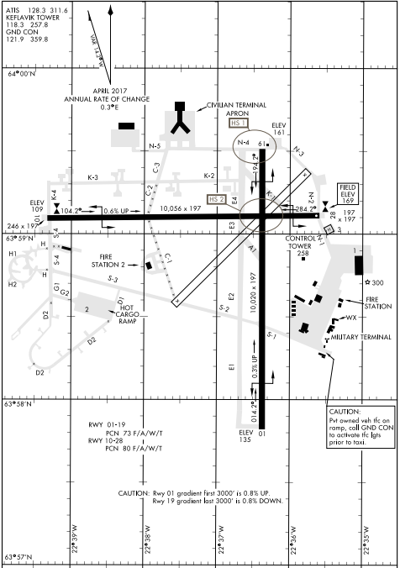

ILC or LOC RWY 28
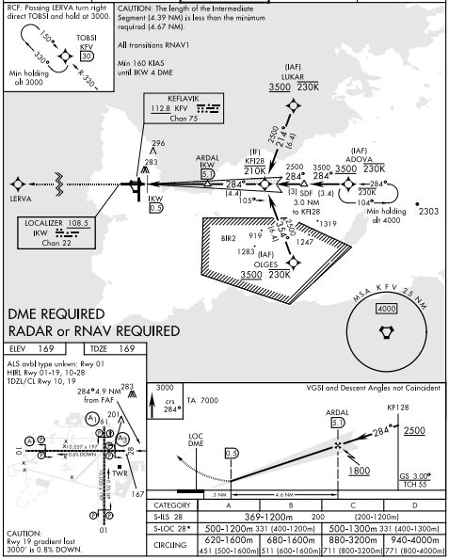

RNAV GNSS RWY 28
