PROPOSAL FOR OVERSIGHT ACTIVITY
Title |  | Monitoring Atlantis discovered noncompliance items
Activity Type  Definitions in Work Instructions. |  | Audit ☐ |  | Assessment ☐ |  | Combo _____  Part audit/part assessment |  |  | SEI _____  Special emphasis item  SERFI _____  Special emphasis request for information
 |  | Initial ______ |  | Replication ____  Modified Replication _____ |  | Follow-up: _____  Addresses a compliance issue or condition noted in an observation. |  |  | Facility-specific: _____
 |  | On-site _____ |  | Desk _____
Category |  | ☐ATC ☐Tech Ops ☐AIS ☐QA ☐QC ☐Other__________________
Submitter(s) / Branch(s)
Thesis Statement |  | This is the expectation for safety when controls and/or mitigations are effective.  Example: Credentialing and Control Tower Operator Certifications Programs reduces risk to the NAS by ensuring qualified personnel are providing control guidance.
Problem Hypothesis |  | This is your prediction about what risk is introduced into the system based on your research of the topic.  Example: Inconsistent application of the guidance could result in unqualified personnel, introducing risk into ATC operations.
Purpose Statement  (Focus of the Activity) |  | What controls will the activity focus on to collect data?  Example, This proposed activity will examine Atlantis management process controls and management controls for access to the credentialing system.
Background |  | Include any relevant results from your research on this topic and should include information that you used to determine Severity and Likelihood, and any adjustments to RAV. Format as bullets, not as paragraphs of text.  Past activities, include any that directly relate to the topic, e.g., audits, compliance items, etc. with brief summary conclusions for each. If no activities, include that also.  Related activities, include any that indirectly relate to the topic, e.g., audits, compliance items, etc. with brief summary conclusions for each.  Example: DSK-FY12-002: Controllers failing to vector aircraft to final with the appropriate final intercept angles and distances; failures to utilize appropriate verbiage with control actions related to final (i.e. vectors across). COMP-FY12-09 Corrective Action Plan for PKRS completed, closed.  Other information  What else that you want the reviewers to know about the topic.
NAS Equipment |  | Include info about any systems related to or included with this activity, e.g., impact due to single point of failure, common cause failure, maintenance, etc.? If so, describe rationale to include (or exclude). Consider: Loss of Function (The service is no longer provided.) or Malfunction (The service is being provided inaccurately or with diminished integrity. ), Service, Functionality, Failure Condition/Hazard, Environment / System State, Effect (From SMS 4.0, Table 3.5: NAS Equipment)
Description of Proposed Activity (Use if applicable but these are not required.)
Methodology Considerations |  | Include any special aspects, e.g. of the data collection, analysis, etc. that you want the reviewers to know. Format as bullets, not paragraphs of text. If no special aspects, leave blank.
Limitations |  | Include any special limitations of the activity that you want the reviewers to know. Format as bullets, not paragraphs of text. If no special limitations, leave blank.
Recommendations |  | Include any recommendations for the activity that you want the reviewers to know. Format as bullets, not paragraphs of text. If no recommendations, leave blank.
Facilities |  | Recommend data collection sites, if able. Also include why each is selected. Identify facilities using historic trends, if applicable, and include that rationale here also.
Control #1
Order # | Example: 7110.65
Chapter | Example: 5 |  | Section |  | Example: 9 |  | Para | Example: b
Text | Include the text of the relevant management control. Do NOT copy/paste long passages directly from the Order in this section.
Control #2 (as needed)
Order # | Example: 7110.65
Chapter | Example: 5 |  | Section |  | Example: 9 |  | Para | Example: b
Text | Include the text of the relevant management control. Do NOT copy/paste long passages directly from the Order in this section.
Control #3 (as needed)
Order # | Example: 7110.65
Chapter | Example: 5 |  | Section |  | Example: 9 |  | Para | Example: b
Text | Include the text of the relevant management control. Do NOT copy/paste long passages directly from the Order in this section.

RAV Assessment Informs decisions about the appropriate level of resources to be assigned.
Use Atlantis RAV Calculator matrix to complete (appended with definitions).
- Explain rationale for Severity Index rating: |  | Explain here.
- Explain rationale for Likelihood Index rating: |  | Explain here.
Severity Index: ____ |  | Likelihood Index: ____ | c.. RAV Prime Value _________ from Atlantis RAV Calculator (matrix)
Adjustments to RAV Prime | Add if topic pertains to separation minima. |  | + .25 | Yes ___ No ___
Adjustments to RAV Prime | Add if topic is a repeat noncompliance.  “Repeat” is referring to a repeat compliance observation. |  | + .25 | Yes ___ No ___
Adjustments to RAV Prime | Add if topic is of special interest, e.g., to NTSB, OIG, GAO, Congress, Executives. |  | + .50 | Yes ___ No ___
Adjustments to RAV Prime | Add if there a single-point failure or common cause failure. |  | + .50 | Yes ___ No ___
 | d. Total Adjustments
 | e. Adjusted RAV Value:

Management Review and Comment - including rationale for any changes made to any RAV value.
Branch Manager | Comment:
Branch Manager | Approved? Yes No If no, proposal sent to: ____________
Audit Topic Branch Manager Review Team | Comment:
Audit Topic Branch Manager Review Team | Approved? Yes No If no, proposal sent to: ____________
Executives | Comment:
Executives | Approved? Yes No If no, proposal sent to: ____________

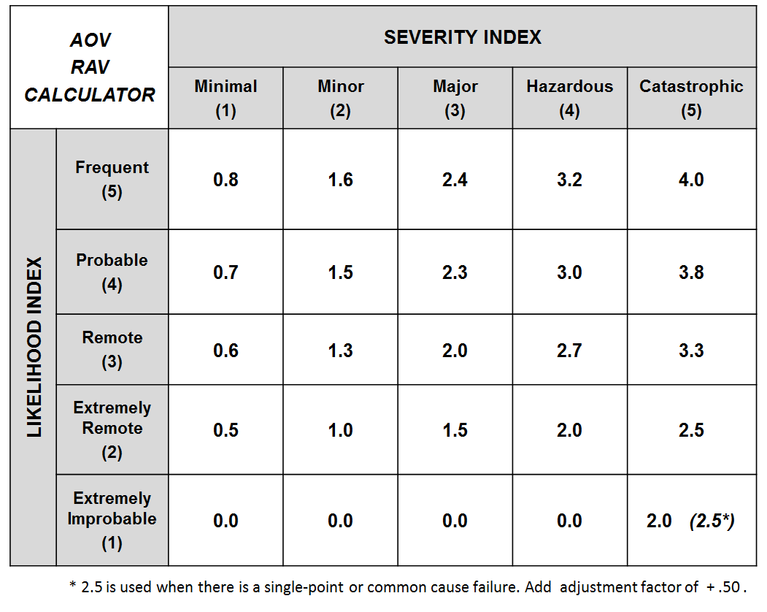
Severity - ATC Services Hazard Classification. From SMS Manual July 2017 table 3.3.
See table for NAS Equipment (with table 3.4), Unmanned Aircraft Systems, Flying Public, Flight Crew.
Catastrophic (5) | Ground or mid-air collision; Controlled flight into terrain or obstacles.
Hazardous (4) | Four indicators fail; CAT A runway incursion.
Major (3) | Three indicators fail; CAT B runway incursion.
Minor (2) | Two or fewer indicators fail; CAT C runway incursion.
Minimal (1) | Minimal reduction in ATC services; CAT D runway incursion; Proximity Event (PE), Operational Deviation (OD) or Measure of Compliance (MoC) greater than or equal to 66%.

Likelihood is a prediction how often a hazard’s effect (or outcome) is expected to occur. Use Likelihood to estimate future risk (how often a given effect is expected to occur). From SMS Manual July 2017 4.0 Table 3.5
Frequent (5) | (x) ≥ 1 per 1000
Probable (4) | 1 per 1000 > (x) ≥ 1 per 100,000
Remote (3) | 1 per 100,000 > (x) ≥ 1 per 10,000,000
Extremely Remote (2) | 1 per 10,000,000 > (x) ≥ 1 per 1,000,000,000
Extremely Improbable (1) | 1 per 1,000,000,000 > (x) ≥ 1 per 1014

