PROPOSAL FOR OVERSIGHT ACTIVITY
Title |  | Monitoring Atlantis discovered noncompliance items
Activity Type  Definitions in Work Instructions. |  | Audit ☒ |  | Assessment ☐ |  | Combo _____  Part audit/part assessment |  |  | SEI _____  Special emphasis item  SERFI _____  Special emphasis request for information
 |  | Initial ___X___ |  | Replication ____  Modified Replication _____ |  | Follow-up: _____  Addresses a compliance issue or condition noted in an observation. |  |  | Facility-specific: _____
 |  | On-site ___X__ |  | Desk _____
Category |  | ☐ATC ☐Tech Ops ☒AIS ☐QA ☐QC ☐Other__________________
Submitter(s) / Branch(s) |  | Bob Neptune / Safety Oversight Office
Thesis Statement |  | Data Quality ensures safety of Air Navigation in the Navigation Environment.
Problem Hypothesis |  | Incorrect Digital data / information in navigation environment can cause aircraft approach and departure anomalies.
Purpose Statement  (Focus of the Activity) |  | Inspect Quality Controls related to the collection, processing, and dissemination of air navigation data and information.
Background |  | Situation has occurred where an aircraft, unable to perform missed approach procedure, causing a failure to align with the runway surface which caused runways to be closed to all other traffic.  Past activities, No previous audits have occurred.  Related activities, include any that indirectly relate to the topic, e.g., audits, compliance items, etc. with brief summary conclusions for each.  Other information  .
NAS Equipment |  | Central AIS / AIM database and related management process, procedures, and records.
Description of Proposed Activity (Use if applicable but these are not required.)
Methodology Considerations |  | Observe the following:  - Data Collection Processes  - Verification and Validation Processes  - Dissemination Processes
Limitations
Recommendations
Facilities |  | Data collection sites
Control #1
Order # | ICAO Annex 15
Chapter | 2 |  | Section |  | 2.1 |  | Para | 2.1.4
Text | Each Contracting State shall ensure that the aeronautical data and aeronautical information provided are of required quality in accordance with 3.2.
Control #2 (as needed)
Order # | ICAO Annex 15
Chapter | 3 |  | Section |  | 3.2 |  | Para | 3.2.1 through 3.2.7
Text | Reference ICAO Annex 15
Control #3 (as needed)
Order #
Chapter |  |  | Section |  |  |  | Para
Text

RAV Assessment Informs decisions about the appropriate level of resources to be assigned.
Use Atlantis RAV Calculator matrix to complete (appended with definitions).
- Explain rationale for Severity Index rating: |  | This situation occurred at PKRS, primary runway.
- Explain rationale for Likelihood Index rating: |  | Unless data quality is not improved, there is reason to suspect reoccurrence is probable.
Severity Index: __4__ |  | Likelihood Index: _4___ | c.. RAV Prime Value _____3.0__ from Atlantis RAV Calculator (matrix)
Adjustments to RAV Prime | Add if topic pertains to separation minima. |  | + .25 | Yes __X_ No ___
Adjustments to RAV Prime | Add if topic is a repeat noncompliance.  “Repeat” is referring to a repeat compliance observation. |  | + .25 | Yes ___ No _X__
Adjustments to RAV Prime | Add if topic is of special interest, e.g., to NTSB, OIG, GAO, Congress, Executives. |  | + .50 | Yes ___ No __X_
Adjustments to RAV Prime | Add if there a single-point failure or common cause failure. |  | + .50 | Yes _X__ No ___
 | d. Total Adjustments |  | 0.75
 | e. Adjusted RAV Value: |  | 3.75

Management Review and Comment - including rationale for any changes made to any RAV value.
Branch Manager | Comment:
Branch Manager | Approved? Yes No If no, proposal sent to: ____________
Audit Topic Branch Manager Review Team | Comment:
Audit Topic Branch Manager Review Team | Approved? Yes No If no, proposal sent to: ____________
Executives | Comment:
Executives | Approved? Yes No If no, proposal sent to: ____________

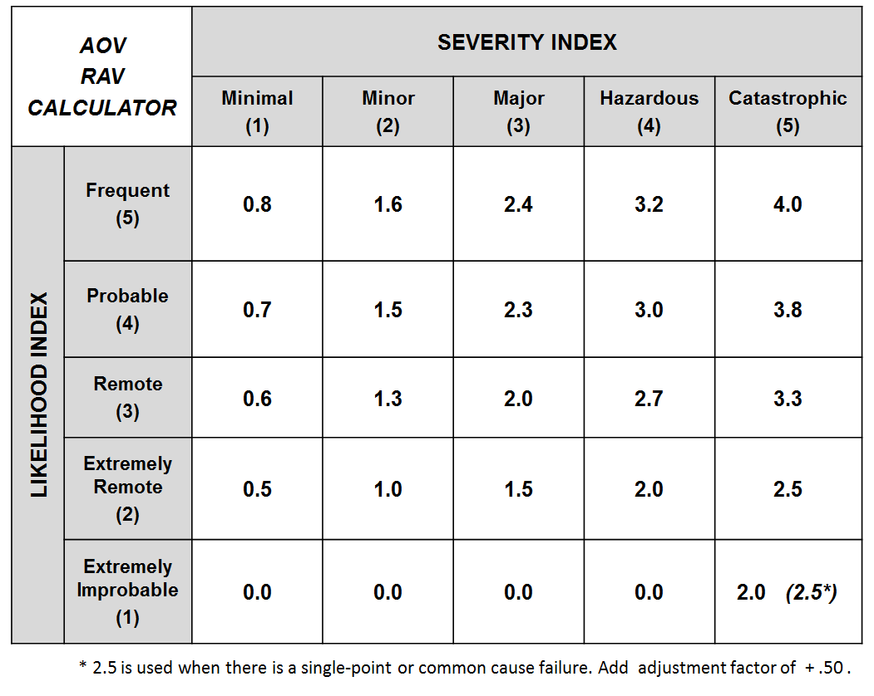
Severity - ATC Services Hazard Classification. From SMS Manual July 2017 table 3.3.
See table for NAS Equipment (with table 3.4), Unmanned Aircraft Systems, Flying Public, Flight Crew.
Catastrophic (5) | Ground or mid-air collision; Controlled flight into terrain or obstacles.
Hazardous (4) | Four indicators fail; CAT A runway incursion.
Major (3) | Three indicators fail; CAT B runway incursion.
Minor (2) | Two or fewer indicators fail; CAT C runway incursion.
Minimal (1) | Minimal reduction in ATC services; CAT D runway incursion; Proximity Event (PE), Operational Deviation (OD) or Measure of Compliance (MoC) greater than or equal to 66%.

Likelihood is a prediction how often a hazard’s effect (or outcome) is expected to occur. Use Likelihood to estimate future risk (how often a given effect is expected to occur). From SMS Manual July 2017 4.0 Table 3.5
Frequent (5) | (x) ≥ 1 per 1000
Probable (4) | 1 per 1000 > (x) ≥ 1 per 100,000
Remote (3) | 1 per 100,000 > (x) ≥ 1 per 10,000,000
Extremely Remote (2) | 1 per 10,000,000 > (x) ≥ 1 per 1,000,000,000
Extremely Improbable (1) | 1 per 1,000,000,000 > (x) ≥ 1 per 1014

