DECLARATION BY THE ORGANIZATIONS OF THE UNITED NATIONS SYSTEM ON THE DEVELOPMENT OF HARMONIZED UNMANNED AVIATION FRAMEWORKS IN SUPPORT OF THEIR RESPECTIVE MANDATES, MISSIONS AND OBJECTIVES

Whereas the deployment of unmanned aircraft systems (UAS), including remotely piloted aircraft systems, presents an opportunity for the organizations of the United Nations system to enhance their operational capabilities in support of their respective mandates, missions and objectives, including in the context of humanitarian assistance, disaster relief and rule of law;
Whereas there are varying levels of development and implementation of UAS strategies, policies, regulations, standards, recommended practices and guidelines (hereinafter “UAS Frameworks”);
Whereas increased coordination and harmonization regarding UAS Frameworks may assist the organizations of the United Nations system in the implementation of their respective mandates, missions and objectives; and
Whereas the organizations of the United Nations system listed in the annex to this declaration would wish to coordinate their efforts related to the development, harmonization and implementation of UAS Frameworks;
The organizations of the United Nations system listed in the annex to this declaration subject to, and in accordance with, their respective regulatory and legal frameworks, mandates, missions and objectives, hereby:
  - acknowledge the importance of facilitating the development and implementation of UAS Frameworks to facilitate the safe and efficient utilization of UAS by the organizations of the United Nations system;
  - recognize that collaborative and coordinated efforts by the organizations of the United Nations system are important to addressing the challenges and risks associated with the operation of UAS;
  - recognize that active participation, engagement, and the sharing of expertise by the organizations of the United Nations system in a coordinated and collaborative manner can contribute to the advancement of safe, efficient, and responsible UAS operations in support of their respective mandates, missions and objectives;
  - recognize the role of United Nations Aviation Technical Advisory Group (“UNATAG”) in advising the organizations of the United Nations system on aviation operational and safety matters and reviewing and amending the United Nations common aviation standards and procedures for relevance and consistency with international safety standards and operational requirements in accordance with its terms of reference;
  - agree that UNATAG will update the UN aviation standards for peacekeeping and humanitarian air transport operations to include relevant UAS Frameworks;
  - agree to:
- continue to develop their respective UAS Frameworks with the view to facilitating safe and efficient conduct of UAS operations;
- as far as practicable, support and coordinate their efforts related to the development, harmonization and implementation of UAS Frameworks, including with regard to safety of UAS operations, and will engage in collaborative efforts with organizations of the United Nations system in this respect;
- establish a coordination forum as the strategic coordination mechanism for UAS Frameworks for the organizations of the United Nations system, and support and participate in the work and activities of the forum; and
- coordinate with respect to mechanisms to exchange knowledge, best practices and lessons learned, and develop training programs to enhance the safety, efficiency, and effectiveness of the UAS operations.
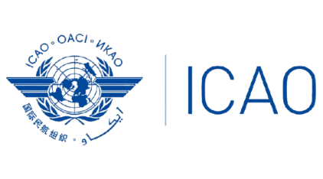
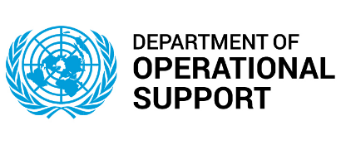
Endorsed by:
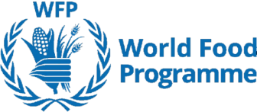

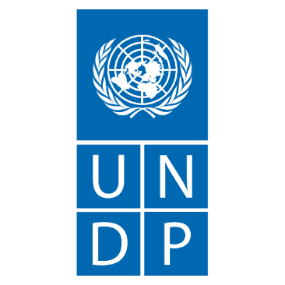




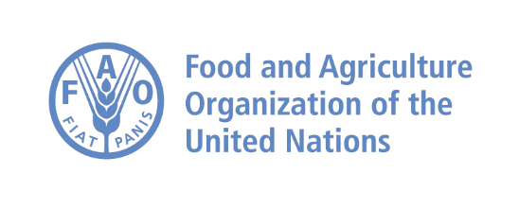
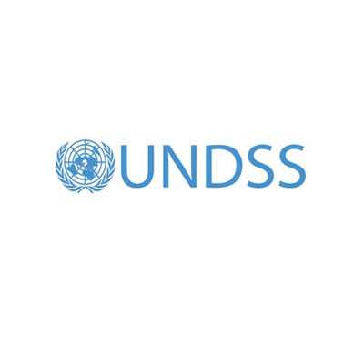

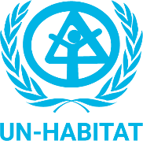

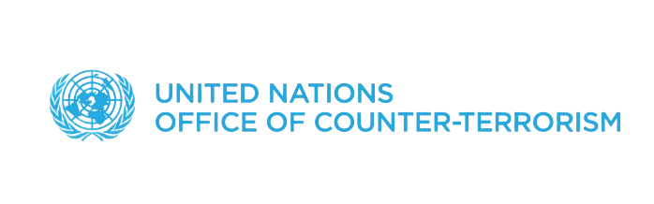

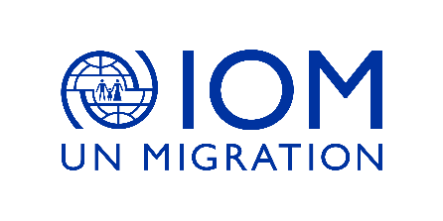
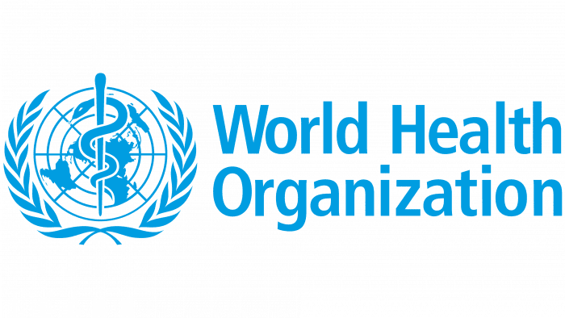
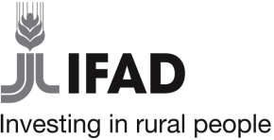

— — — — — — — —

ANNEX

List of the organizations of the United Nations system that have accepted the Declaration on the development of harmonized unmanned aviation frameworks in support of their respective mandates, missions and objectives since 30 April 2025

UN Secretariat Departments and Offices
Department of Operational Support (DOS)
Department of Safety and Security (DSS)
Office of the Coordination of Humanitarian Affairs (OCHA)
Office of Counter-Terrorism (OCT)
United Nations Office on Drugs and Crime (UNODC)

Funds and Programmes
United Nations Development Programme (UNDP)
United Nations Human Settlements Programme (UN-Habitat)
World Food Programme (WFP)

Specialized Agencies
Food and Agriculture Organization (FAO)
International Civil Aviation Organization (ICAO)
International Fund for Agricultural Development (IFAD)
International Telecommunication Union (ITU)
Universal Postal Union (UPU)
World Health Organization (WHO)

Other Entities and Bodies

— — — — — — — —

Related Organizations
International Organization for Migration (IOM)

Regional Commissions

— — — — — — — —

— END —

