SGN1-12 WP1212

Implementation of Voice over
Internet Protocol (VoIP) for Air Traffic Management (ATM) Applications

Reference Guide for ACP, Subgroup N1

Version 1.0

Prepared by Leon Sayadian
FAA/ATO-P/SE

November 2006
TABLE OF CONTENTS
1.0 Introduction 5
1.1 Purpose 5
1.2 Scope 5
2.0 VoIP Overview 5
2.1 VoIP Implementation 6
2.1.1 Application Layer 8
2.1.2 Transport Layer 8
2.1.3 Network Layer 9
2.1.4 Link Layer 12
2.1.5 Physical Layer 12
2.1.6 Echo cancellation 12
2.1.7 Telephone Naming and Addressing 12
2.1.8 Quality Measurement 12
2.2 Quality of Services 12
2.3 Gateway 13
2.4 Gatekeeper 13
3.0 VoIP Architecture Characteristics 13
3.1 Assumptions 13
3.2 Voice over IP Components 13
3.3 Performance Parameters for VoIP Applications 13
3.4 Availability 14
3.5 Delay 14
Appendix A - Real-Time Multimedia Protocols 15

APPENDIX B - CODECs for VoIP CHNOLOGY ..…………..……………………………………16
Appendix C - Multimedia Protocols: H.323 and SIP 22
Appendix D - Compression of IPv4 and IPv6 30
Appendix E - VoIP Security 34
Appendix F- Numbering and Addressing 43
Appendix G - VoIP Components 51
Appendix H - Bandwidth and Performance 54
Appendix I - QoS Criteria 60
Appendix K - Gateway/Gatekeeper 65
References 67
Lexicon 73

List of Figures

Figure -1…………………………………………………………………………..…………...06
Figure -2…………………………………………………………………………………..…...09
Figure -3……………………………………………………………………………….………08
Figure -4……………………………………………………………………………………….10
Figure -B-1.………………………………………………………...………………………….17
Figure -C-………………………………………………………..….....................................21
Figure -C-2………………………………………………………………………………….…22
Figure -C-3…………………………………………………………………………………….28
Figure -IPv4 & IPv6..………………………………………………………………………....30
Figure -E-1…………………………………………………………………………………….36
Figure -E-2a & 2b……….…………………………………………………………………....37
Figure -E-3…………………………………………………………………………………….38
Figure -E-4a &4b…………..……………………………………………………………….…39
Figure -E-5…………………………………………………………………………………….40
Figure -E-6…………………………………………………………………………………….41
Figure -F-1…………………………………………………………………………………….44
Figure -F-2…………………………………………………………………………………….45
Figure -F-3 & 4….........……………………………………………………………….….….46
Figure -F-5, 6 & 7….…………………………………………………………………………47
Figure -G-1…………………………………………………………………………...……....52
Figure -I-1……………………………………………………………………………….…….59
Figure -I-2………………………………………………………………………………….….61
Figure -I-3………………………………………………………………………….………….62
Figure -I-4……………………………………………………………………………..………63
Figure -K-1………………………………………………………………………………...….64
Figure -K-2…………….………………………...……………………………………......….65

List of Tables

Table -B-1…………………………………………………………………………………….17
Table - B-2…………………………………………………………………………..……….20
Table - IPv4 & IPv6.....……………………………………………………………..……….31
Table - F-3……………………………………………………………………………………48
Table - H-1 &2…………………………………………………………………….…………54
Table - H-3 ……………………………………………………………………..……………56

1.0 Introduction

The current ATM voice switching systems provide air traffic controllers with the capability to establish Air-Ground (A-G) and Ground-Ground (G-G) voice communications. The current G-G infrastructure uses analog lines and legacy signaling to communicate between air traffic facilities. Such legacy technologies are becoming obsolete, inefficient and costly to maintain. ICAO/ATN WG N and EUROCAE WG-67 is addressing the modernization of the ATM voice infrastructure by developing specifications and requirements for implementing mature, scalable, and cost-effective VoIP technology [75].

1.1 Purpose

The purpose of this document is to provide G-G architecture, standards, protocols and guidance for the implementation of VoIP for ATM communications. The content herein describes fundamental concepts for the evolution of this infrastructure from its discrete legacy sub-systems into an integrated service-oriented network.

1.2 Scope

This document focuses on implementing VoIP and IP telephony for ATM G-G voice systems. A-G implementations are not discussed in this document.

2.0 VoIP Overview

The legacy G-G voice system infrastructure is based upon costly, low capacity, congested point-to-point circuitry, which invoke legacy signaling protocols that are difficult to maintain. Communication service providers are migrating towards newer technologies [e.g., Transmission Control Protocol (TCP), User Datagram Protocol (UDP), and IP version 4 and 6 (IPv4&6)], enabling scalable, available, and cost-effective G-G multimedia communications among ATM facilities.

The porting of voice and signaling via TCP/UDP and IP protocol stacks will leverage shared media [e.g., Internet, Intranet, Local Area Networks (LAN), and Wide Area Networks (WAN)] for these payloads. Voice is digitized, compressed, and converted into packets, where they are merged with data and signaling packet traffic over the network. Signaling protocols [1 and 65] are used to set up/tear down calls, and convey information for locating users and negotiating capabilities. This digital approach provides a transition path from the traditional circuit-switched technology of the public or Private Switched Telephone Network (PSTN).

2.1 VoIP Implementation

Recommended standards and protocols will be described below for implementing digital voice technology in the application (including session and presentation), transport, network, link, and physical layers of the OSI model, as shown in Figure 1. Applicability of these standards is based upon their maturity and complexity, fulfillment of the ATM mission need, and product availability. Additional standards information may be found in the attached Appendices.

Provisioning of VoIP entails consideration of the following issues:

- Standards and protocols
- Integrated Networking with PSTN, as shown Figure 2
- Interface to PSTN via MEGACO, as shown Figure 3
- Packet technology and products (e.g., Gateway {GW}, Router {Rtr}, Multipoint Control Unit {MCU}, terminals, ground-based radios, telephone, switches, multiplexers, and servers), as shown Figures 4
- Network management architecture and policy
- Guaranteed Quality of Service (QoS) for prioritization of traffic classes (see section 2.2)
- Signal compression
- Security technology
- Multimedia communication
- Interoperability
- Scalability

H.323/
H.460.x
H.235
H.450.x
T.120
(RTP)

T.130
(AVC)
H.225
Q.931
H.225
RAS

H.245
SIP
TCP/UDP
IPv6
FR, ATM, MAC
Physical Interfaces T1/E1
LAN/WAN/PSTN
Users
Users
Figure 1 - VoIP Architecture & Layers
User Interface
OSI Layers
Layer 7, 6, and 5
Layer 4
Layer 3
Layer 2
Layer 1
Adapter

2.1.1 Application Layer
- H.323 series [1] is an umbrella recommendation for multimedia communications over packet based networks (e.g., Internet and Intranet). It includes the standards listed below:
  - H.225.0 Call setup/Registration Admission Status (RAS) [2] (defined in Appendix A), Q.931 [25]
  - H.245 Call control [4]
  - H.246 Interlocking of H-Series multimedia terminal [5]
  - H.235 Security [3 and 32]
  - H.248.1 v3 Megaco [6]
  - H.320, H.321, and H.324 for ISDN, ATM and PSTN communications [9]
  - H.332 Coupled Conferences [10]
  - H.450.1-12 Generic functional protocol for the support supplementary services [e.g., call (transfer, forwarding, hold, park, and waiting)] [11]
  - H.460.1-15 Generic Extensibility Framework (GEF) [99]
● Session Initiation Protocol (SIP) [65, 66, 67 and 69] is a simple signaling protocol for application layer control of VoIP implementations
  - SIP-T (Telephony) [71]
  - Session Description Protocol (SDP), which describes the session for Session Access Protocol (SAP), SIP [45, 60, 68 and 70]
  - Session Announcement Protocol (SAP) , used for multicast session managers to distribute a multicast session description to a large group of recipients [76]
  - T.125 – Multipoint communication service protocole [89]
  - ECMA – 312, 3rd Edition (ATS QSIG) [31]
- Simple Network Management (SNMP) or SNMPv3 [79]
- RTP (Real Time Protocol) [88] Payload for DTMF Digits, Telephony Tones/Signaling
- RSVP (Resource reSerVation Protocol) [42] (defined in Appendix A)
- RTSP (Real Time Streaming Protocol) [44] (defined in Appendix A)
  - T.120, RTP (Real-Time Transport Protocol) [26 and 98]
  - RTCP (Real Time Control Protocol) [73] (defined in Appendix A)
  - SRTP (Secure Real Time Protocol) [74] (defined in Appendix A)
  - ZRTP (Zimmerman Real Time Protocol) [105] (defined in Appendix A)
- T.130, Audio Visual Control [27]
- Call Processing [59]
- Codecs: G.114, G.711, G.711 Annex B [91], G.723.1, G.726, G.728, G.729A [13, 15, 16, 17, 18, 19], and iLBC [101 and 102]. For detailed information on these codecs, see Appendix B.

Appendix C includes a comparison of H.323 and SIP capabilities.

2.1.2 Transport Layer
- TCP, UDP [37 and 38]
- Security: Transport Layer Security (TLS) [43]. For details, see Appendix E.

2.1.3 Network Layer
- IPv4, IPv6, Differentiated Services (DiffServ)/Explicit Congestion Notification (ECN), Internet Control Management Protocol version 6 (ICMPv6) [36, 53, 52 and 54]
- IP Virtual Private Network (VPN) [58]
- IP access to telephony for SIP and SDP [60]
- A Framework for Telephony Routing over IP [61]
- QoS for IP-based services and performance parameters [29, 30 and 63]. For detailed information, see Appendix I.
- Security: IP Security (IPSec) [47, 48, 49, 50, 51 and 90]. For detailed information, see Appendix E.
- Border Gateway Protocol version 4 (BGP-4) [41]
- Expedited Forwarding Per-Hop Behavior (PHB) [64]
- Transport IP over Asynchronous Transfer Mode [28]
- Integrated Services Digital Network (ISDN) user-network interface specification for basic call control [25]
- Open Shortest Path First (OSPF) [46]
- Assured Forwarding PHB Group [57]
- Naming and addressing [Section 2.1.7]

A comparison of IPv4 and IPv6 features is included in Appendix D.
Figure 2 - Integrated Networking
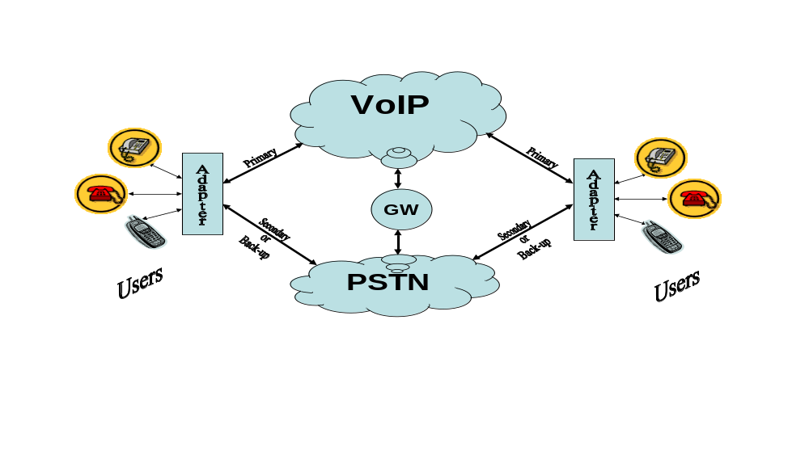
SIP
IP
Network
IP
Network
IP
Network
IP
Network
IP
Network
PSTN
IP
Network
PSTN
MEGACO
Gateway
Figure 3 -
VoIP
Interface to PSTN via MEGACO

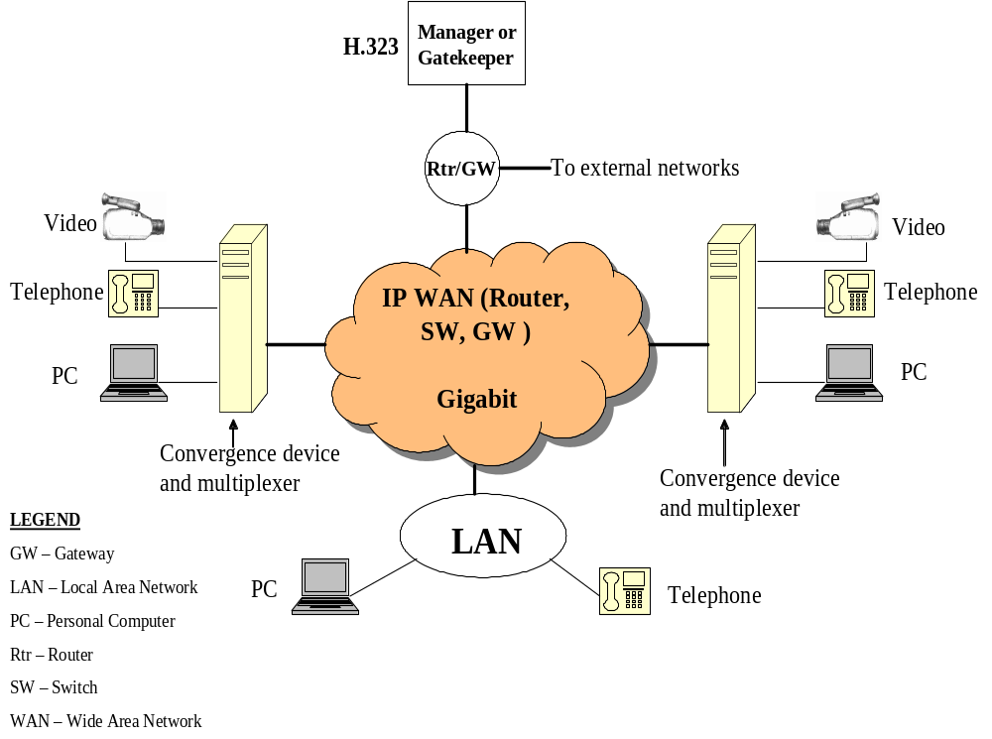

Figure 4 - Converged VoIP Network

2.1.4 Link Layer
- LAN [33, 34 and 35], Frame Relay (FR) [24], ATM [39 and 40], Multi-Protocol Label Switching (MPLS) [62 and 106], ISDN [23], ATS-QSIG [31]
- PISN (Private Integrated Services Network) for Air Traffic Services [31]
- Link Control Protocol (LCP) for multi-protocol data-grams over Point to Point Protocol (PPP) infrastructures [55]

2.1.5 Physical Layer
- T1, T3, E1, FDDI, SONET
- ITU V.x series (e.g., V.35, V.34, V.24, V.11)

2.1.6 Echo cancellation
- ITU G.165 and ITU G.168 [14]
- ITU G.131 [94]

2.1.7 Telephone Naming and Addressing
- Public Numbering ITU-T E.164 [85 and 86]
- Private network addressing ECMA-155 [87]
- Notation for national/international telephone numbers ITU-T E.123 [93]
- Identification plan for land mobile station ITU-T E.212 [83]
- Definition Relating to National/International Numbering Plan T.160 [84]
- Electronic Numbering (ENUM) [78, 80, 81 and 97]
- EUROCONTROL Report on ATS Ground Voice Network Numbering Plan [104]
- ICAO Recommended Voice Addressing Plan [82]
- Assignment procedures for international signaling print code [95 and 96]

Detailed information is contained in Appendix F.

2.1.8 Quality Measurement
- ITU-T P.800 [20], ITU-T P.861 [21], ITU-T P.862 [22]
- ITU-T G.107 [12]

2.2 Quality of Services
An important consideration is the implementation of mechanisms to ensure that diverse ATM message types are conveyed as per their appropriate priority, with sufficient quality. QoS tools may be used to ensure that voice communications are delivered with precedence over other messaging. Key QoS requirements are described in Appendix I.

2.3 Gateway
Gateway enables external control and management of data communication equipment operating at the edge of multi-service packet networks, such as Media Gateway Control Protocol (MGCP) [77] and Gateway Control Protocol (GCP) [6 and 72]. Appendix K defines additional information.

2.4 Gatekeeper
Gatekeeper provides call-control services for H.323 endpoints, such as address translation and bandwidth management, as defined within the RAS recommendation [1 and 2]. See detail in
Appendix K.

3.0 VoIP Architecture Characteristics

3.1 Assumptions

The following assumptions are a pre-requisite for defining the voice switching infrastructure:

- A robust IP infrastructure exists that supports ATM requirements (e.g. availability, performance, Quality of Services (QoS), security) at ATM facilities
- Interfaces are available to the Private Switched Telephone Network (PSTN) for backup and load sharing
- The IP infrastructure is compatible with the legacy end systems (e.g., voice switches, circuits, signaling protocols)
- Member states manage the portion of the network within their domain
- Provisions are available for fixed wireless links (e.g., satellite)
- ATS-QSIG signaling is integrated within the voice communications network for international interfaces
- Sufficient implementation of redundancy

Voice over IP Components

VoIP components are defined in Appendix G.

Performance Parameters for VoIP Applications

To achieve the desired level of performance for ATM VoIP communications, the following criteria must be addressed:
- Jitter
- Impact of packet and frame size
- Packet delay and loss
- Bandwidth allocation based on QoS
- Voice compression
- Echo cancellation
- Interoperability
Appendix B, I and H contains detailed information.

Availability

Availability and reliability are critical parameters of an ATM VoIP network. EUROCAE-67 requirements for G-G voice services stipulate availability at no less than 99.999%.

3.5 Delay

Packet delay or latency must not exceed the maximum tolerable level for a VoIP conversation (100 - 150 ms). Jitter, which is the variation of latency over time, must be below acceptable values, and the jitter buffer must be carefully designed for this purpose see Appendix I. Packet loss can erode voice quality, so techniques such as Packet Loss Concealment and Packet Loss Recovery may be implemented to mitigate this concern.

Appendices and references provided in this document describe detailed information, parameters, and guidance materials on these topics.

Appendix A - Real-Time Multimedia Protocols

RSVP is used by a host to request specific qualities of service from the network for particular application data streams or flows. It is also used by routers to deliver QoS requests to all nodes along the path(s) of the flows, and to establish and maintain state to provide the requested service. RSVP requests will generally result in the allocation of bandwidth for specified traffic flows at each node along the communications path.

RTP provides end-to-end delivery services for data with real-time characteristics, such as interactive audio and video. These services include payload type identification, sequence numbering, time-stamping and delivery monitoring. Applications typically run RTP on top of UDP to make use of its multiplexing and checksum services; both protocols contribute parts of the transport protocol functionality.

RTCP is based on the periodic transmission of control packets to all participants in the session, using the same distribution mechanism as the voice packets. The underlying transport protocol provides multiplexing of the voice and control packets. RTCP performs four functions to monitor and control RTP in support of quality of service and membership management functions:

- Provides feedback to RTP on the quality of the data distribution
- Carries persistent transport-level identifiers for RTP sources (called Canonical Names) to identify session participants
- Distributes RTCP packets to all session participants to scale the flow rate for accommodating changing number of participants
- An OPTIONAL function to convey minimal session control information. This is may be used to conduct "loosely controlled" sessions, where participants can drop in and out of a session without undergoing membership control procedures and parameter negotiations.

RTCP Extended Reports (XR) is a new VoIP management protocol [100], which defines a set of metrics that contain information for assessing VoIP call quality and diagnosing problems.

RTSP is an application-level protocol that provides an extensible framework to enable controlled, on-demand delivery of real-time audio and video.

RAS is used to perform registration, admission control, bandwidth changes, status reporting, and disengage procedures between endpoints (i.e., terminals and gateways) and gatekeepers. This protocol exchanges messages over a dedicated channel prior to the establishment of any other channels. [2]

SRTP, a profile of the RTP, provides confidentiality, message authentication, and replay protection for RTP and RTCP traffic.
ZRTP [105] complements SRTP by providing a robust setup mechanism for key agreement to establish a secure SIP-based VoIP call setup. It uses ephemeral Diffie-Hellman (DH) with hash commitment, and allows the detection of Man-in-The-Middle (MiTM) attacks by displaying a short authentication string for the users to read and compare over the phone. If the two strings read out by the callers don't match, it becomes evident that the call has been intercepted by a third party. Even if the calling parties choose not to do this, some authentication is still available against MiTM attacks, due to key continuity properties similar to Secure Shell (SSH). This is manifested by the caching of some key material to be used in the next call’s DH shared secret.

Appendix B - CODECs for VoIP technology

CODECs are the algorithms that enable digital networks (e.g., IP networks) to carry analog voice. There are several CODECs available, varying in complexity, bandwidth requirements, and voice quality robustness. Generally, more complex algorithms provide better voice quality (especially in degraded network conditions), but incur higher latency due to longer processing time.

This appendix describes common compression standards recommended for G-G ATM voice applications. Critical parameters that affect their performance include:

- Packet Loss
- Delays (e.g., Algorithmic/Processing, Packetization, Propagation, and Queuing), which could result in talker overlap
- Jitter
- Echo cancellation
- Sampling rate and bandwidth
- Synchronization
- Noise

Table B-1 introduces various CODEC standards and their significant factors which are either affected by, contribute to, or mitigate some of the aforementioned parameters:

Table B-1: CODEC Performance Factors

Name | Description | Delay (ms) | R-Factor | Ie  (0% loss) | Ie  (2% loss) | MOS
G.711 with PLC | PCM A-law & µ-law at 64Kps | 0.125 | 89 | 0 | 7 | 4.3 - 4.4
G.711 without PLC | PCM A-law & µ-law at 64Kps | 0.125 | 59 - 69 | 0 | 35 | 3.05
G.726 | ADPCM at 16 – 40 Kbps | 1 |  |  |  | 4.0 -4.2
G.728 | LD-CELP at 16Kbps | 3 - 5 |  | 7 |  | 4.0 -4.2
G.729A and VAD | CSACELP at 8 Kbps | 10 (plus 5 ms look ahead) | 75 – 79 | 11 | 19 | 4.2 - 3.99
G.723.1A and VAD | MPMLQ at 6.3 Kbps | 30 (plus 7.5 ms look ahead) | 70 – 75 | 15 | 24 | 3.8 - 4.0
iLBC | low-bit rate, narrowband CODEC  13.3/15.2 kbps | 30 (13.3Kbps)  20 (15.2Kbps) |  | 0 | 2 | 3.8 - 3.67
GIPS with VAD | Enhanced G.711 Variable bit rate, average 80Kbps | <0.125 |  | 0 | 2 | 4.3 -4.4

VoIP header and CODEC payload is shown in Figure B-1.

IP – 20 bytes | UDP – 8 bytes | RTP – 12 bytes | Payload 20 – 240 bytes for CODEC data

Figure B-1: Example of VoIP Header

CODEC Descriptions

G.711: This standard presents 8 bit compressed Pulse Code Modulation (PCM) samples from analog signals of voice frequencies. This standard supports two algorithms:

- A-Law PCM encodes/decodes 13 bit linear PCM samples into 8 bit compressed logarithmic form
- μ-Law converts 14 bit linear PCM samples into 8 bit compressed PCM samples

This CODEC has been supplemented with ANSI T1.521a-2000, Packet Loss Concealment (PLC) with ITU-T Recommendation G.711 Proposed Annex B [91]. This specifies a packet loss concealment algorithm that is applicable to most sample-based CODECs, particularly G.711.

This CODEC is used for H.323 and the ISDN networks.

G.726: This standard is based on the Adaptive Differential Pulse Code Modulation (ADPCM) algorithm. It takes signals sampled at 8000 samples/second and converts them to a compressed form. G.726 can operate at 16, 24, 32, and 40 Kbps.

G.728: This standard is based upon the Low Delay Code Excited Linear Prediction (LD-CELP) algorithm, which provides toll quality speech with low latency, and compression for low bandwidth, which is often used for VoIP applications.

G.729: This protocol is based upon the Conjugate-Structure Algebraic Code Excited Linear Prediction (CS-ACELP) algorithm, which provides toll-quality speech at very low bandwidth with moderate processing overhead. Typical applications of this speech coder are in telephony over packet networks, such VoIP. This coder works on a frame of 80 speech samples (10 msec), and look ahead of 40 samples (5 msec). The total algorithmic delay for the coder is 15 msec.

G.723.1: This protocol is based upon the following algorithms:
- Algebraic Code Excited Linear Prediction (ACELP) @ 5.3 Kbps
- Multi Pulse-Maximum Likelihood Quantization (MP-MLQ) @ 6.3 Kbps

It can perform full duplex compression and decompression for multimedia applications, and is a part of the overall H.324 family of standards. This coder works on a frame of 240 speech samples (30 msec), and look ahead of 60 samples (7.5 msec), for a total algorithmic delay of 37.5 msec, which is a significant delay.

iLBC: iLBC frames are encoded completely independently; this provides better quality when 10% or more of the packets are being dropped, but this CODEC is suboptimal for clean line conditions. iLBC is a narrowband speech CODEC, utilizing the full 4 KHz frequency band. The iLBC algorithm enables state-of-the-art fixed bit-rate coding for packet networks, with an excellent quality-versus-bit-rate tradeoff, and is suitable for voice communication over IP.

GIPS: Global IP Sound® (GIPS™) Enhanced G.711 is the improved version of the G.711 CODEC, which provides excellent packet-loss robustness. GIPS Enhanced G.711 has built-in Voice Activity Detection (VAD) functionality that reduces the bit rate to approximately half for silence and low audio levels. This is achieved without distortion of speech or background signals. The benefits are:

- High basic speech quality equal to PSTN and G.711
- Superior packet-loss robustness compared to G.711
- Lower delay

The CODECs described above are recommended for consideration to compress global VoIP ATM communications. It is further recommended that, at a minimum, the following critical parameters be tested and measured for the various CODECs:

- Transmission impairment (Ie)
- CODEC robustness when experiencing frame losses
- Delay and jitter
- Quality ratings (e.g., MOS, PSQM, and E-Model)
- End-to-End delay
- Signaling integrity

Since most of the G-series CODECs were developed for narrowband PSTN, consideration should be given to the benefits incurred by using modern broadband CODECs in current applications (e.g., radio, terrestrial broadband). Implementation and transition scenarios should also be developed to deploy this new technology without ATM service interruption.

Voice Quality Characteristics

QoS parameters are used to set voice service performance, affecting digital voice quality, jitter, echo cancellation, silence suppression, background noise (may be significant for wireless and satellite links), and frame losses.

Voice quality is also affected by the implementation of voice compression technologies (i.e., Compression/Decompression (CODEC)), which reduce the required bandwidth for voice services. Candidate CODECs should be selected based upon acceptable quality of voice. A Mean Opinion Score (MOS) that ranges from 1.0 to 5.0 commonly measures this [20]; a score of 4.0 is considered Toll Quality, which is the minimally acceptable MOS for ATM applications. Various automated approaches exist that may be used for objectively predicting MOS for VoIP.

Table B-2 lists some prominent CODECs, and their characteristics:

Compression/Decompression (CODEC) | Voice Digitizing Rate (kbps) | Digitizing Delay (ms) | Complexity | Mean Opinion Score (MOS)
PCM (G.711) | 64 | 0.75 | N/A | 4.4
ADPCM (G.726) | 32 | 1 | Low | 4.2
LD-CELP (G.728) | 16 | 3-5 | Very High | 4.2
CS-ACELP (G.729/G.729a) | 8 | 10 | Moderate | 4.2
MPMLG (G.723.1) | 6.3 | 30 | N/A | 3.98
ACLEP (G.723.1) | 5.3 | 30 | N/A | 3.5
Table B-2: Prominent CODEC characteristics

Appendix C - Multimedia Protocols: H.323 and SIP

Various standards organizations have considered signaling for voice and video over IP from different approaches. Two of the primary standards in use are H.323 and SIP. ITU established H.323 as the first communications protocol for real time multimedia communication over IP. SIP is the IETF approach to voice, data, and video over IP.

H.323 is an umbrella standard that defines the system architecture (see Figure C-1), and implementation guidelines, for media and capabilities for multimedia communications (e.g., call set-up, call control and features).

H.323v5 and H.460.x Core

Multimedia Data Transfer Signaling
Multimedia Data Transfer Signaling
Audio
Codecs

G.7xx

RTCP
(Real Time Transport Control Protocol)

T.120
(Real Time)

T.130
(Audio- Visual
Control)
H.450.1 Series
(Supplementary Services)
Video
Codecs
H.261
[7]
H.263
[8]

H.225.0
RAS

Q.931
(Call Signaling)

H.235 (Security)

H.245
(Control
Signaling)

RTP

UDP (User Datagram Protocol)
TCP (Transfer Control Protocol)

IP (Internet Protocol) v4 or v6

Figure C-1: H.323 Architecture

In contrast to H.323, which was developed from the telecommunications perspective, SIP provides analogous capabilities in the context of the Internet. As such, SIP is not as rigidly specified as H.323, to accommodate the dynamic growth in IP capabilities. SIP focuses on session initiation, relying on other protocols (not necessarily real-time) for other call capabilities (see Figure C-2).
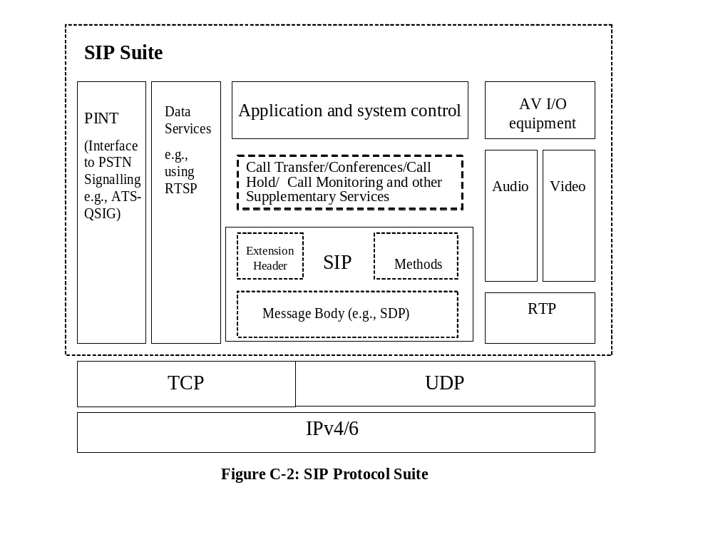
Comparison of H.323 and SIP

Table C-1 describes the differences and similarities between H.323 and SIP functions and services.
Table C-1: Comparison of H.323 and SIP capabilities

Functions/Services | H.323v5 | SIP | Comments
Encoding | Binary Code | Textual | Binary code reduces the size of the transmission and saves bandwidth.  Text is easier to modify and understand these codes, and ports more readily over Internet-enabling protocols, but it increases the size of messages that are sent.
Call Set-up delay | =1.5 * RTT | = 1.5 * RTT | H.323v5 reduced excessive Round Trip Time (RTT) call delay experienced by previous versions of H.323. However, work is still required to make SIP compatible with H.323.
3G (Third Generation) | No | Yes | 3G vendors have settled on a non-standard version of SIP.
Protocol Complexity | High | Simple HTTP-style Protocol | H.323 uses several different protocols (e.g., H.225.0, H.245, H.450.x, H.460.x, H.501, H.510, H.530, and T.120).
Extensibility | Extensions added with vendor-specific non-standard elements | Standards-based extensions to perform new functions

Table C-1: Comparison of H.323 and SIP capabilities (con’t)

Functions/Services | H.323v5 | SIP | Comments
Addressing Support | Host (without username), E.164 phone numbers; gatekeeper resolved alias (arbitrary case-sensitive string) | Accommodates many addressing formats (e.g., URL, E-mail address, H.323, E.164) | H.323 ENUM Service Registration
Firewall Support | Poor | Inadequate | Security in both protocols remains an issue, due to poor interoperability of vendor products (e.g., gateways)
Instant Messaging | No | Yes
Loop Detection | Imperfect | Good | SIP: routing loops detected; “spirals” recognized and permitted.
Transport Protocol | UDP and TCP. Mostly TCP. | UDP and TCP. Mostly UDP. | Usage of TCP results in greater call set-up latency.
Internet Application Integration | Not designed for Internet implementation | Designed to incorporate Internet style text-based applications | SIP is capable of integration with other services (e.g., a caller may send an E-mail to an unreachable callee).
Inter-domain Call Routing | H.225 Annex G | Domain Name System (DNS) | For SIP, DNS is used to find the SIP server, but does not resolve to the addressee level
Service Standardization | Services standardized in detail in the H.450 series | Services not standardized | SIP only standardizes protocols and general interfaces
Supplementary Services | Rigorously defined | Poorly defined | Both standards are upgrading

Table C-1: Comparison of H.323 and SIP capabilities (con’t)

Functions/Services | H.323v5 | SIP | Comments
Internet Compatibility | Low | High | H.323 tries to impose ISDN architecture on IP network
Scalability | Poor | Excellent | SIP is less complex and easy to customize
Type of Services | Only media streams, including voice | No obvious limitations | SIP is almost perfectly general
Vender Interoperability | Limited | Widespread | H.323 Interoperability is virtually non-existent
Quality of Services (e.g., Call Setup delay, packet loss recovery, resource reservation capability) | Supports redundant gatekeepers. Policy Control has limited DiffServ support | Loop detection algorithm using “VIA” header | QoS capabilities are still not mature for H.323 and SIP over IPv4
Interoperability | Compatible with PSTN Signaling; uses Q.931-like messages, which are compatible with ATM-QSIG (Private Network) | Standards are draft | Interfacing between H.323 and SIP, both protocols should translate call set-up and use RTP to communicate with each other.
Mobile/Wireless Capabilities | Add version 5, reference to H.510 draft | Designed for nomadic based services still on going | Compatible
3GPP (Third Generation Partnership Project) | Currently No | Yes

Table C-1: Comparison of H.323 and SIP capabilities (con’t)

Function/Services | H.323v5 | SIP | Comments
Security | Defines security mechanisms and negotiation via H.235; SSL may also be used | Supports authentication via HTTP; confidentiality with SSL/TLS, SSH, S-HTTP, PGP, S/MIME; key exchange with SDP | Compatible
Architecture | H.323 goes beyond basic signaling capabilities to include conference control, registration, capability negotiation, QoS, and service discovery. | Modular: Does only signaling; other functions (e.g., QoS, directory access, service discovery, and session content description) reside in separate, orthogonal protocols
Components | Terminal/Gateway | UA (User Agents)
Components | Gatekeeper | Servers
Multicast Signaling | Yes, with Location Requests (LRQ) and Gatekeeper Request (GRQ) | Yes (e.g., group INVITEs) | H.323 LRQ and GRQ are Registration, Admissions, and Status (RAS) messages for discovery
Conference | Yes | Yes
Click for Dial | Yes | Yes
Large Number of Domains | H.225 Annex G defines communication between administrative domains, address resolution, access authorization, and usage reporting. | Inherent support for wide area addressing. Loop detection, Registrar, and redirect servers support user location with multiple servers.

Features of the latest versions of H.323 and SIP
Some functions that have been included in H.323v5 are the following:

- Tunneling of DSS1/QSIG signaling within H.323 systems
- Use of URL and DNS services within the context of H.323 systems
- Modem relay within H.323 systems
- Camera control for video conferences
- Fault tolerance
- Number portability
- Call priority designation
- Transport of duplicate Q.931 IEs (Single-byte and Multi-byte),
- Fast connect
- Digit maps
- Querying for alternative routes
- QoS monitoring and reporting
- SIP as a support protocol
- Enhanced security

SIP has been chosen as the standard for call set-up in IP-based networks by the 3rd Generation Partnership Project (3GPP), with the following enhancements:

- Address resolution and Name mapping
- Reliability of Provisional Responses
- Call redirection
- Determining the location of the target end point
- Enhanced packet size handover, and RTP header compression
- Enhance end-to-end QoS for terminal
- Additional options, such as wireless and mobile applications
- Support Multipurpose Internet Mail Extensions (MIME) and secure MIME (S/MIME)
- Support unicast and multicast
- Event notification mechanisms
- Capability extension for Instant Messaging

Figure C-3 shown VoIP with SIP.

IP
Network
IP
Network
IP
Network
IP
Network
IP
Network
IP
Network
RTP/UDP
SIP/TCP or UDP
SIP
Signaling
Signaling
Voice
Voice

Figure C-3: VoIP with SIP

Appendix D - Compression of IPv4 and IPv6

Voice communication services are migrating to a common infrastructure approach that provides support for multimedia applications (e.g., voice, video, and data). VoIP is currently using IPv4 technology to support this new approach. However, its limitations in end-to-end security, scalability, addressing, and Quality of Service (QoS) capabilities may hamper the deployment of future Air Traffic Management (ATM) voice services.

The section will focus on IPv6, which provides the networking services found in IPv4, as well as these additional features:

Larger address spaces
More efficient addressing design and handling at the IP network layer
Better QoS support
Imbedded security
Mobility and broadcasting
Increased support for a variety of communication services
Ensure future compatibility with industry, government, and international systems
Airline industry is collaborating on a standard for airborne IPv6.

IPv4 was initially standardized in 1981. As the Internet became more ubiquitous, the inherent IPv4 QoS, security, addressing, and scalability capabilities were pushed to their limit. These deficiencies, as well as new network services, exacerbated the strain placed on IPv4 technology and its quest to accommodate the global needs for Internet services. To continue using IPv4 under this load required that new features and capabilities be developed, standardized, and “bolted on”. This approach would have been costly, risky, and difficult to manage. This resulted in the development of a next generation networking protocol IPv6. Pv6 was designed to overcome the limitations of IPv4 by:

Expanding available IP address space to accommodate future demand
Improving QoS to minimize packet loss/drops
Operating over greater bandwidths for video conferencing and Voice over IP (VoIP) applications
Enhancing end-to-end security, which is critical for the ATM
Providing more robust system management on an enterprise scale
Eliminating the need for network address translation (NAT)
Incorporating a fixed header structure, this expedites packet routing

The following diagrams show IPv4 and IPv6 header formats and field comparisons.

IPv4 and IPv6 Headers

Figure
- IPv4 Header
Version IHL Type of Service Total Length
Identification
Time-to-live Protocol Header Checksum
Source Address
Destination Address
Options Padding
Flags
Fragment Offset
- IPv6 Header
Version
Class
Flow Label
Payload Length
Next Header
Hop Limit
Source Address
Destination Address
Removed in IPv6. IPv6 extension headers replace IPv4 options.
Options
The field is the same except that IPv6 addresses are 128 bits in length.
Destination Address
The field is the same except that IPv6 addresses are 128 bits in length.
Source Address
Removed in IPv6. In IPv6, the link layer performs bit-level error detection for the entire IPv6 packet.
Header Checksum
Replaced by the IPv6 Next Header field.
Protocol
Replaced by the IPv6 Hop Limit field.
Time to Live
Removed in IPv6. Fragmentation information is not included in the IPv6 header. It is contained in a Fragment extension header.
Identification
Fragmentation Flags
Fragment Offset
Replaced by the IPv6 Payload Length field, which only indicates the size of the payload.
Total Length
Replaced by the IPv6 Traffic Class field.
Type of Service
Removed in IPv6. IPv6 does not include a Header Length field because the IPv6 header is always a fixed size of 40 bytes. Each extension header is either a fixed size or indicates its own size.
Internet Header Length
Same field but with different version numbers.
Version
IPv6 Header Field
IPv4 Header Field

Does not require manual configuration or DHCP
Must be configured either manually or through DHCP
Must support a 1280-byte packet size (without fragmentation)
Must support a 578-byte packet size (possibly fragmented)
There are no IPv6 broadcast addresses. Instead, a link-local scope all-nodes multicast address is used
Broadcast addresses are used to send traffic to all nodes on a subnet
ICMP Router Discovery is replaced with ICMPv6 Router Solicitation and Router Advertisement messages and is required
ICMP Router Discovery is used to determine the IPv4 address of the best default gateway and is optional
IGMP is replaced with Multicast Listener Discovery (MLD) messages
Internet Group Management Protocol (IGMP) is used to manage local subnet group membership
ARP Request frames are replaced with multicast Neighbor Solicitation messages
Address Resolution Protocol (ARP) uses broadcast ARP
All optional data is moved to IPv6 extension headers Internet
Header includes options
Header does not include a checksum
Header includes a checksum
Fragmentation is not done by routers, only by the sending host
Fragmentation is done by both routers and the sending host
Packet flow identification for QoS handling by routers is included in the IPv6 header using the Flow Label field
No identification of packet flow for QoS handling by routers is present within the IPv4 header
IPSec support is required
IPSec support is optional
Addresses are 128 bits in length
Addresses are 32 bits in length
IPv6
IPv4

Appendix E - VoIP Security

An important consideration in this regard is the implementation of mechanisms to ensure acceptable security for various ATM functions. In particular, voice communication services must be delivered with acceptable security and availability for controllers. Key requirements are as follows:

- Priority and security service (implemented with RTP and RTCP)
- Secure real-time transport protocol (SRTP)
- Low latency and queuing delays (<75 ms each way)
- Security and encryption for using H.323, H.235, and H.245
- Service availability
- Security services deployment under Quality of Services (QoS) guidelines

To enable these requirements, appropriate security mechanisms may be implemented at the various Open System Architecture layers, as shown in Figure E-1. Selection of these services may be constrained by QoS criteria for the various classes of ATM communications traffic.

The most significant security concerns in a VoIP environment are:

● Denial of Service (DoS) Attacks: Endpoints, such as IP telephones, and VoIP gateways (w/embedded SIP proxies), can be bombarded with rogue packets to disrupt communications
● Call Interception: Unauthorized monitoring of voice packets or Real-Time Transport Protocol (RTP).
● Signal Protocol Tampering: In the same category as call interception, and possibly a DoS attack, a malicious user could monitor and capture the packets that set up the call. By doing this, they can manipulate fields in the data stream and interfere with communications.
● Presence Theft: Impersonation of a legitimate user sending or receiving data.
- Authentication: Mechanisms should be achieved to ensure the integrity of the voice packets, such that what is presented at the destination node is identical to what was issued from the source node.
- Access control: This consists of tools that block unauthorized users from invoking voice services.
- Application Level Gateways (ALG) and firewalls security issues have not been resolved.

Encrypting VoIP traffic will prevent the unauthorized interception of VoIP calls. New capabilities in the two key VoIP protocols, SIP and H.323, are promising end-to-end call encryption in the future.

Presence theft offers a unique challenge. The best countermeasure for presence theft is strong authentication, such as two-factor authentication. Strong authentication at the IP endpoint is another emerging technology, which will be available soon.

Security features built into the SIP and H.323 protocols such as address authentication, Command Sequence (CSeq) and Call-ID headers are recommended. Additional security standards for VoIP are as follows:
Transport Layer Security

Transport Layer Security version 1.0 (TLSv1) are available for authentication and encrypted communication between users. It allows user/server applications to communicate without tampering, or forgery. The TLSv1 protocol is an industry standard that can be used to add security to any protocol that uses TCP. TLS is a modular, scalable protocol, with forward and backward compatibility and supports peer-to-peer communications.

Internet Protocol Security and Virtual Private Network

Internet Protocol Security (IPSec) features are available for IPv4/IPv6, with Internet Control Management Protocol version 6 (ICMPv6). IPSec capabilities include:

- Access control
- Connectionless integrity
- Data origin authentication [i.e., Authentication Header (AH)]
- Protection against replays (partial sequence integrity)
- Confidentiality [i.e., Encapsulating Security Payload (ESP)]
- Security Parameters Index (SPI)
- Security Association (SA)
- Security Gateways (in routers or firewalls)
- Manual SA and key management (e.g., Virtual Private Networks [VPN])
- Automated SA and key management (e.g., Internet Key Exchange (IKE)

Since IPSec for IPv4/6 [5] operates in the network layer, it supports security-enhancing mechanisms, such as authentication and encryption. IPSec may be deployed as native to End Systems (i.e., transport mode for IPv4, see Fig. E-2a, E-2b and for IPv6, see Fig. E-4a, E-4b), or on distinct gateways (i.e., tunnel mode for IPv4, see Fig. E-3 and for IPv6, see Fig.E-5). Multiple layers of security can be implemented across subnetworks by constructing tunnels to delineate each security domain (e.g., Virtual Private Networks (VPN).

IPSec includes the AH, ESP, and ISAKMP services, as follows:

- AH - supports connectionless integrity, data origin authentication (including the immutable and predictable fields in the IP headers), and an optional anti-replay service. It does not provide confidentiality. AH is an appropriate protocol to employ when no confidentiality (i.e., encryption) is required.

- ESP - this protocol may provide confidentiality (encryption), and limited traffic flow confidentiality. It also may provide connectionless integrity, data origin authentication, and an anti-replay service. ESP authentication is appropriate if only the upper layer protocol must be authenticated.

- ISAKMP - provides an application protocol for key management by exchanging information contained in security associations.

Internet Control Message Protocol (ICMP)
Even though ICMP is classified as a separate protocol from IP, it is truly essential to the operation of IP. ICMP coordinates the interaction among systems through neighbor discovery and with group membership messages. It provides a simple way for systems to automatically determine their own IP addresses. It also coordinates a network’s response to potential problems. When IP detects a problem with a data-gram, ICMP reports that error to diagnostic tools (monitored by users and administrators) with its echo request and reply. ICMP messages can be sent using either “transport” mode or “tunnel” mode.

Processing of ICMP messages is discussed in Section 6.0 of [103]. Security considerations for authentication and encryption of ICMPv6 messages are addressed in Section 5.0 of [65], which updates ICMPv4 that is associated with IPv4.

MultiProtocol Label Switching (MPLS)

MPLS emulates Virtual Circuit (VC) connections through an IP network. As shown in Figure E-6, VPNs are supported by MPLS over Asynchronous Transfer Mode, FR, and ISDN. It can work on any IP transport, potentially reducing the complexity of maintaining both IP and ATM networks. Features of MPLS that support these requirements include:

- Link layer VPN
- Distinct path labeling provides security from spoofing and Denial of Services (DoS) attacks
- Transparent to applications and users
- Centralized, dynamic provisioning
- High Scalability
- Traffic engineering/prioritization

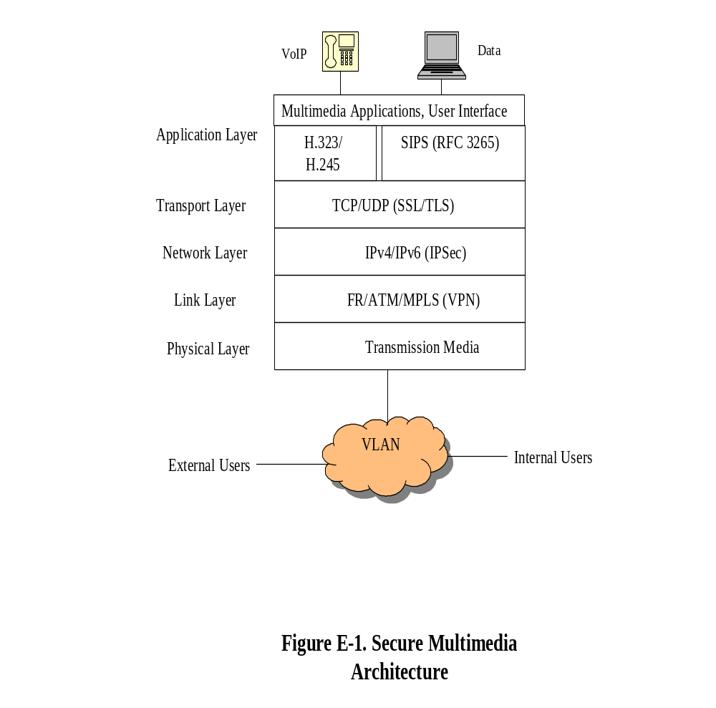

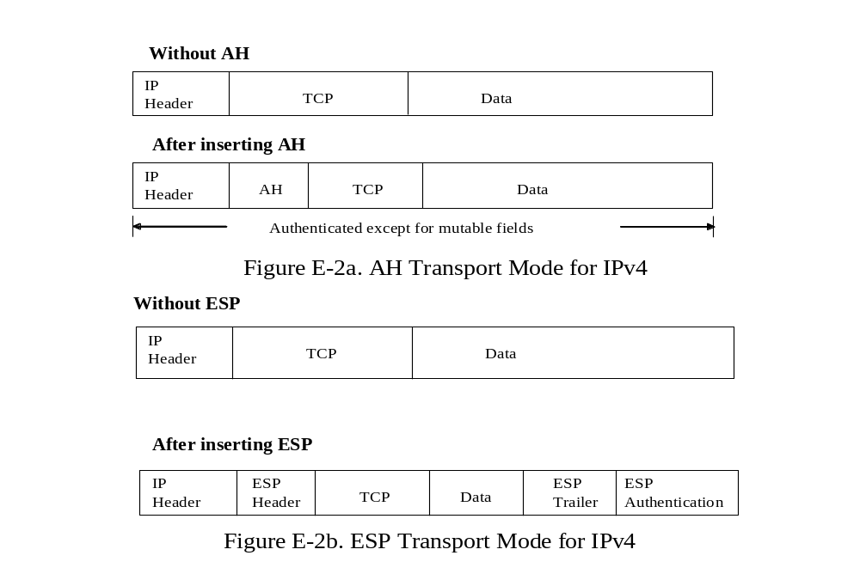
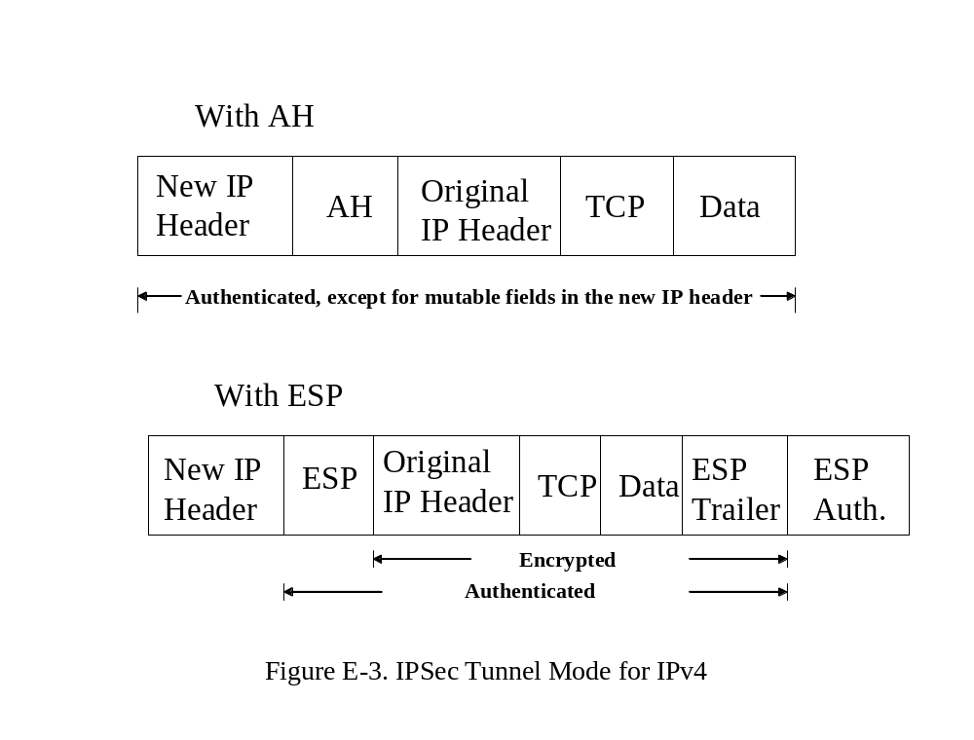

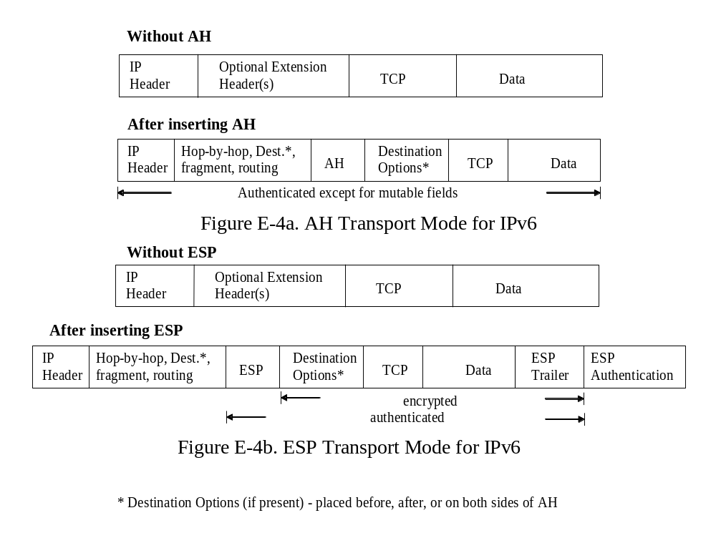
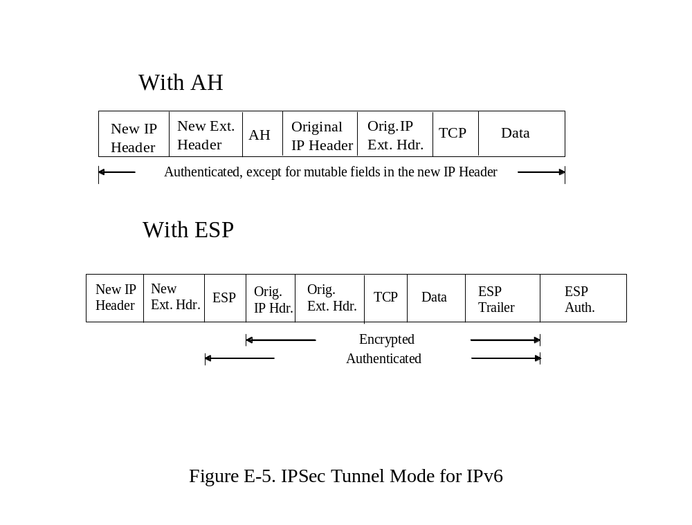

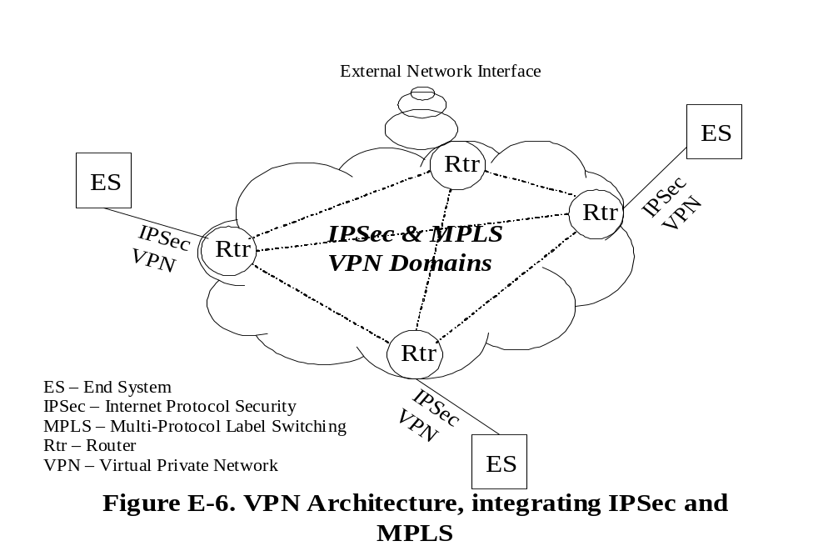

Appendix F- Numbering and Addressing

Addressing plans are of particular importance in the establishment of communications services. There are several currently-deployed voice communications technologies, each associated with a particular addressing structure (e.g., ISDN, ATS-QSIG/PSS-1, and PSTN). To establish network services across the various networking technologies, a common numbering and addressing structure is described below that is based on nationally and internationally approved standards (e.g., ITU-T, ECMA, IETF, and ICAO).

Database Services

Call control databases manage user endpoint mapping, and provides address translation services between disparate domains. Additional features include transaction report generation, and network security.

Eurocontrol R2 addressing

All Air Traffic Control Center switches and switches at international airports are connected by point-to-point dedicated circuits, using the Multi Frequency Code (MCF-R2) signaling protocol [111] as shown below:

A | A | n | n | n | n | P | A | A | n | n | n | n

Calling Exchange and Terminal
Area Code of Originator
Priority
Called Exchange and Terminal
Area Code of Destination

Detailed information is contained in the CCITT Yellow Book Volume IV – Fascicle VI-4 [111] and Annex C of this document.

ICAO Recommended Numbering Plan

ICAO Annex 10, Vol. III, Part II, Chapter 4, ‘Recommendations for ATC Speech Circuit Switching and Signaling’, calls for six-digit addresses for ATC facilities [82], as shown below:

ICAO Format for ATC Speech Circuit Switching and Signaling
A | A | c | c | n | n

Working Position
Control Center
Identification/Area

Up to two additional digits may be added to specify unique positions within the control center.

The field specifications are 2 digits for area identifier (AA), 2 digits for Unit Identifier (CC), and 2 digits for Controller working position (CWP) identifier.

Integrated Services Digital Network (ISDN) Numbers and Addresses

The level 3 protocol on the ISDN D-Channel is configured for user-network signaling for the control of calls, as well as for the control of supplementary services. ITU-T Recommendation Q.931 (I.451) [25] respectively provides these functions. ISDN numbering plan can be found in ITU-T Recommendation E.164.

ISDN Numbering Plan
 | National ISDN Number
International ISDN Number
ISDN Address
Country Code (CC) | National Destination Code (NDC) | Subscriber Number (SN) | Subaddress

Up to 40 digits
Variable
Variable
Up to 3 digits

International Numbering Plans E.164

Recommendation E.164 [97] provides the number structure and functionality for the three categories of numbers used for international public telecommunication:

- National Telephone Services
- Global Telephone Services
- International Networks

All telephone numbers can be dialed up-to 15 digits, made up of a one to three digit country code (CC), and followed by the subscriber number (SN). The first few digits of the subscriber number generally identify the National Destination Code (NDC), which identifies the type of telephone number being called. Relevant ITU Documents for numbering plan are E.123, E.162, E.212, and E.164.

Newly Proposed Schema: Electronic Numbering (ENUM)

ENUM [81] or Enum is a standard adopted by the IETF that uses the Domain Name System (DNS) to map telephone numbers to Uniform Resource Locators (URL). The goal of the ENUM standard is to provide a single number to replace the multiple numbers and addresses for individual phones, faxes, cell phones, and e-mail addresses. Enum is targeted for VoIP use to enable the dialing of existing numbers via the Internet. ENUM also bridges between the PSTN and the Internet, in accordance with RFCs 3761, 3762 [97, 78], and RFC 3764 [80].

Addressing Scheme (Revised iPAX Scheme)

An IPv6 [107] addressing scheme had been developed within the context of the iPAX Task Force and is illustrated in Figure F-1.

The addressing scheme follows on from the RIPE allocation to provide /48 assignments. Indeed, when considering the existing IPv4 addressing schemes, most ANSPs already work with a “Class A” address (e.g., 10.x.y.z), where x and y are 2 octets used to assign sites and subnets. With a /48, ANSPs still have 2 octets to number their sites and subnets and can still make use of IPv6 address auto-configuration. Fortunately, this matches the standard /48 assignments described in the RIPE policies.

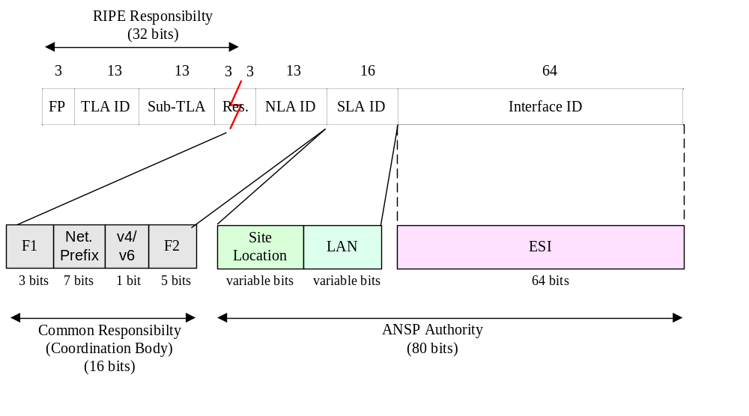
Figure F-1: Proposed IPv6 address structure

To summarise the iPAX addressing scheme:
- The first 32 bits are fixed to 2001:4b50 (RIPE allocation)
- The 3 bits of Field F1 are reserved for future use
- The 7 bits of the fixed “Net. Prefix” field are used to number each ANSP, organisation or infrastructure that can be considered as a single entity; network prefix values have been revised since the iPAX-TF and can be found in Annex A
- The 1 bit of the v4/v6 field is a toggle bit to indicate if IP address translation is required at the network border.
- The 5 bits of F2 field are assigned as described in Annex B and have been revised since the iPAX-TF.

ANSPs assign the remaining 80 bits of the address based on their own policies but should note the advice provided in RFC 3353 (A Flexible Method for Managing the Assignment of Bits of an IPv6 Address Block).

IPv6 Addressing

IPv6 [53, 108 and 110] features a much larger addressing space than IPv4, as shown in Figure F-2. This enables an ISP or enterprise organization to aggregate the prefixes of node or user groups (e.g., customers, or internal users) under a single Network Prefix for advertisement on the IPv6 Internet.

XXXX | XXXX | XXXX | XXXX | XXXX | XXXX | XXXX | XXXX

Network Prefix Interface ID

Figure F-2: IPv6 Addressing Format

XXXX = 0000 through FFFF, while X is a 4-bit hexadecimal value.

The 128-bit IPv6 address is separated into eight 16-bit hexadecimal numbers. In order to alleviate the cumbersome size of these addresses, the IPv6 community has developed the following notational shorthand:
- Leading “0”s can be removed
- 0000 = 0 (compressed form)
- “::” represent one or more groups of 16-bits, “0”can only appear once in an address. For example, 2001:0:13FF:09FF:0:0:0:0001 = 2001:0:13FF:09FF::1
- The lower four 8-bits can use decimal representation of IPv4 address for example, 0:0:0:0:0:0:192.168.0.1

IPv6 [18] addressing encompasses the following types:
- Unicast [118] – used to identify a single interface. Unicast supports the following address types: Global Unicast Address, Site – Local Unicast address, and Link – Local Unicast address as illustrated in Figure F-3
001  (3-bits) | Global routing Prefix  (45 - bits) | Subnet ID  (16 - bits) | Interface ID  (64 - bits)

Global Unicast Address Format

1111111010  or  FE80::10  (10 - bits) | Set value to “0”  (54 – bits) | Interface ID  (64 – bits)

Link – Local Unicast Address Format

1111111011  or  FEC0::10  (10 - bits) | Set value to “0”  (38 – bits) | Subnet ID  Site Link add (16-bits) | Interface ID  (64 – bits)

Site – Local Unicast Address Format

Figure F-3: Type of Unicast Addressing format

Table F-1 illustrates IPv6 main addressing type.

Allocation | Prefix | Function of Address Space
Global Unicast Addresses  Link Local Addresses  Site Local Addresses  Multicast Addresses | 001  1111 1110 10  1111 1110 11  1111 1111 | 1/8  1/1024  1/1024  1/256

Table F-1: IPv6 Main Addressing Type

- Anycast [110] – a global address that is assigned to a set of interfaces belonging to different nodes. Anycast addresses have the following restrictions:
  - An Anycast address must not be used as a source address of an IPv6 packet
  - An Anycast address must not be assigned to an IPv6 host. It may be assigned to an IPv6 router.

Figure F-4 shows the anycast addressing format.

Subnet prefix | 00000000000000000000

128 – Bits

Figure F-4: Anycast Addressing Format

Within each subnet, the highest 128 interface identifier values are reserved for assignment as subnet anycast addresses. The construction of these addresses depends upon the IPv6 address type used in the subnet, as indicated by the format prefix of the address. In particular, IPv6 address types requiring 64 – bit interface identifiers in Extended Unique Identifier-64 (EUI-64) format [112] are constructed as depicted in Figure F-5.

Subnet Prefix  (64 – bits) | 111111X1111….111  (57- bits) | Anycast ID  (7 – bits)

Figure F-5: Reserved subnet anycast address format with EUI-64 interface identifiers

X = “1” if EUI-64 Globally Administrated, and “0” if EUI-64 Locally Administrated.
- An IPv6 Address with Embedded IPv4 Address is used in transition techniques when migrating IPv4 domains to IPv6, as shown in Figure F-6. The 16 “X” bits take a value of “0000” when assigned as a Unicast address to IPv6 nodes in an IPv4 routing infrastructure, and is known as an “IPv4-compatible IPv6 address”. The 16 “X” bits take a value of “FFFF” when used to represent IPv4 nodes in an IPv6 address format, and is known as an “IPv4-mapped IPv6 address” [110].

0000………………………………….0000  (80 – bits) | XXXX  (16-bits) | IPv4 address  (32 – bits)

Figure F-6: IPv6 with Embedded IPv4 Address

- Multicast [110] is assigned to a set of interfaces that may belong to different nodes. A packet sent to a multicast address is delivered to all interfaces identified by that address. Its format is shown in Figure F-7.

11111111 (8-bits) | Flags (4-bits)  and  Scope (4-bits) | Group ID (112 – bits)

Figure F-7: Multicast Addressing Format

The leading 8 bits (“11111111”) identifies the address as being a multicast address. “Flags” is a set of 4 bit, as configured below:

0 | 0 | 0 | T

T = 0 indicates a permanently-assigned address by the Internet Assigned Number Authority (IANA) [119].
T = 1 indicates a non-permanently-assigned (transient) multicast address.

Scope is a 4-bit field, used to limit the scope of the multicast group. The values are:

1 = Interface – local
2 = Link - local
3 = Subnet - local
4 = Admin - local
5 = Site - local
8 = Organization – local
E = Global

Note: Transition of IPv6 Packets over Ethernet or Local are Network (LAN) [117].
Table F-2 illustrates IPv4 concepts and their IPv6 equivalent [17].

IPv4 Address | IPv6 Address
Internet address classes | Not applicable in IPv6
Addresses are 32 bits in length | Addresses are 128 bits in length
Multicast address (224.0.0.0/4) | IPv6 multicast addresses (FF00::/8)
Broadcast addresses | Not applicable in IPv6
Unspecified address is 0.0.0.0 | Unspecified address is ::
Loop-back address is 127.0.0.1 | Loop-back address is ::1
Public IP addresses | Global Unicast addresses
Private IP addresses (10.0.0.0/8, 172.16.0.0/12, and 192.168.0.0/16) | Site-local addresses (FEC0::/10)
Auto-configured address (169.254.0.0/16) | Link-local addresses (FE80::/64)
Text representation: Dotted decimal notation | Text representation: Colon hexadecimal format with suppression of leading zero and zero compression. IPv4-compatible addresses are expressed in dotted decimal notation
Network bits representation: Subnet mask in dotted decimal notation or prefix length | Network bits presentation: Prefix length notation only
IPSec support is optional | IPSec support is required

Table F-2: IPv4 and IPv6 Equivalent

Transition Mechanisms

In order to support migration from IPv4 to IPv6, a number of tools are available for using different addressing scenarios, some of which are described below:

- Dual Stack infrastructures are based upon routers that concurrently, but independently, support IPv4 and IPv6 traffic domains.
- Configured Tunneling – A technique for establishing point-to-point tunnels by encapsulating IPv6 packets within IPv4 headers to carry them over IPv4 routing infrastructures [113].
- 6over 4 – This allows isolated IPv6 hosts, located on a physical link which has no directly connected IPv6 router, to become fully functional IPv6 hosts by using an IPv4 domain that supports IPv4 multicast as their virtual local link. It uses IPv4 multicast as a “virtual Ethernet” [11].
- NAT-PT – provides transparent routing between IPv6-domain and IPv4-domain end systems. This is achieved with IPv6/IPv4 protocol translation (using SIIT, see next bullet) and Network Address Translation (NAT) mechanisms [109 and 114].
- Stateless IP/ICMP Translator (SIIT) – translates between IPv4 and IPv6 packet headers. This algorithm is used as part of the solution for enabling communications between IPv4 and IPv6 nodes [115].
- ISATAP – a simple mechanism that connects IPv6 host/router over IPv4 networks. Intra-Site Automatic Tunnel Addressing Protocol (ISATAP) views the IPv4 network as a link layer for IPv6 and views other nodes on the network as potential IPv6 host/routers [116].
- TRT – an IPv6-to-IPv4 Transport Relay Translator (TRT) enables IPv6-only hosts to exchange TCP and UDP traffic with IPv4-only hosts [120].
- Proxy – this artifact bridges IPv6 and IPv4 domains by overriding network protocol dependencies at the application layer

Future Numbering Plan for VoIP

It is recommended that EUROCAE-67 Subgroup 3 evaluate the various numbering plans below to harmonize legacy and future voice communication system numbering and addressing schemes:

- E.164 - Uniform Resource Identifiers (URI) Dynamic Delegation Discovery System (DDDS) Application (ENUM) [97].
- Telephone Number Mapping (ENUM) Service Registration for H.323.
- ENUM service registration for Session Initiation Protocol (SIP) Addresses-of-Record.
- User-customized Direct dialing-in (DDI) capability, as described in E.164
- ECMA-155 [87] Structure of private numbering plans and network addressing
- IPv6 (RFC 2373) and IPv4 (RFC 791) addressing architecture.
- Notation for National and International Telephone Numbering [121]

It is also recommended that provisions be made for situations where the proposed addressing schema does not cross technological domains (e.g., SIP, H.323, Megaco). Consideration should be given to various approaches, such as address encapsulation, mapping, or conversion, to enable interoperability.

Appendix G - VoIP Components

The following describes VoIP technology components, and their interfaces, in support of an enhanced G-G ATM infrastructure for establishing and managing VoIP services, as shown in Figure G-1.

End system: System that interfaces to users, such as a telephone, audio Personal Computer (PC), Host, or radio (hardware/software)

Terminal Adapter (Modem): Interface between network and various telephones, Fax machines, PCs and satellites

Codec: Implement compression techniques on voice signals to reduce bandwidth requirements from legacy G.711 coding, while preserving voice quality

H.323 Gatekeeper, SIP Proxy: A gatekeeper/proxy provides centralized call management functions; it may also provide call admission control, bandwidth management, address translation, authentication, and user location

Gateway and Media Gateway: Interfaces signaling and communication services among various telephone networks (e.g., between PSTN and VoIP). A Media Gateway is used among multiple users to transfer packet data, signaling information, and various stakeholders’ protocols

Media Gateway Controller, Call Agent: External call control elements that interface and issue commands to Media Gateways

Multipoint-Controller–Unit (MCU): A MCU enables conferencing functions between three or more terminals. Logically, a MCU contains two parts:
- Multipoint controller (MC) that handles the signaling and control messages necessary to setup and manage conferences, and,
- Multipoint processor (MP) that accepts streams from endpoints replicates them and forwards them to the correct participating endpoints.

A MCU can implement both MC and MP functions, in which case it is referred to as a centralized MCU. Alternatively, a decentralized MCU handles only the MC functions, leaving the multipoint processor function to the endpoints.

Private Branch Exchange (PBX): A private telephone network that creates connections for telephones, terminals or other communications equipment either directly attached to PBX or between connected PBXs and which also provides access to the public telephone system

Router: A Router is a layer 3 device for forwarding packets (or message), and for interconnecting two or more nodes across homogeneous or heterogeneous networks. Routing protocols propagate topological relationships among routers and end systems of a network (e.g., IP).

Backbone, Trunk: A Backbone is used for LAN/WAN connectivity between subnets across a high-speed communications network such as Fiber optical cable or fast Ethernet. A Trunk is a circuit that connects two or more switching or routing devices.

Recorder: Device that records voice and data communications on a network

Network Management: Set of procedures, equipment, tools, and operations for monitoring and controlling network faults, configuration, usage accounting, performance, and security

Uninterruptible Power Supply (UPS): Auxiliary power supply back up (e.g., battery, generator) that supplies continuous power in the event of a power outage

Redundancy: Duplicate standby equipment or interface cards that are activated upon device failure to ensure continuous service

Node: (1) Physical equipment (e.g., computers, switches, routers) in a network. (2) In a switched network, the switching points, including PBXs

Network: Collection of switches/routers connected to one another by transmission facilities

Radiotelephony: Communications medium that provides mobile telephone services to users

Wireless: Communications media that does not involve physical connectivity to the network

Hub: A device that interconnects several stations. A hub is basically acting as a repeater; it repeats an incoming signal on an outgoing link. In satellite networks, it is used as a central earth station

SIP/User Agents: A user agent is end system acting on behalf of a user. There are two parts to it: a client and a server. The client portion is called User Agent Client (UAC) while the server portion is called User Agent Server (UAS). The UAC is used to initiate a SIP request while the UAS is used to receive request and return responses on behalf of the user

SIP/Network Servers: There are 3 types of services within a network. A registration server receives updates concerning the current locations of users. A proxy server on receiving request forwards them to the next-hop server, which has more information about the location of the called party. A redirect server on receiving request determines the next-hop server and returns the address of the next-hop server to the client instead of forwarding the request.

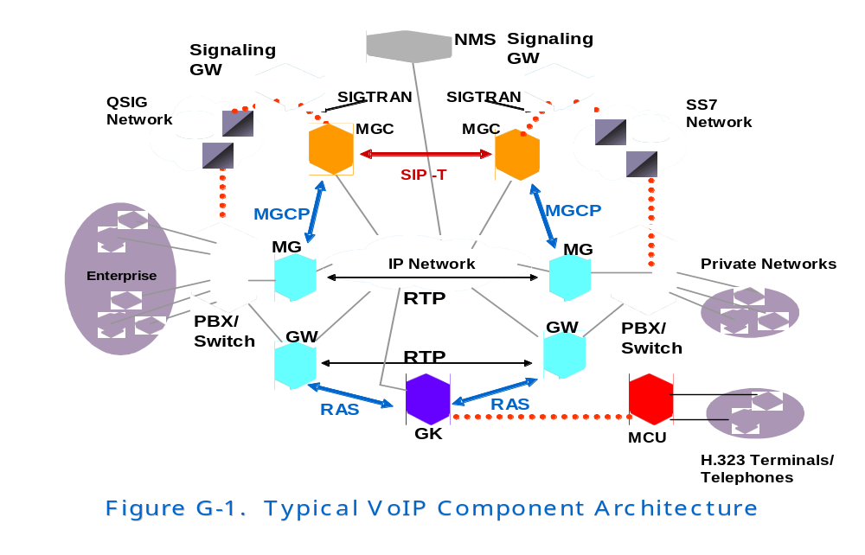

Appendix H - Bandwidth and Performance

Basic concepts

Bandwidth is the plain data transmission capacity of the network, and its design may result of paramount importance in the system because an inadequate bandwidth may cause delay and packet loss.

Bandwidth requirement may increase depending on the kind of codification or compression performed. The following are some commonly ITU-T standards codecs and the amount of one-way delay that they introduce:

- ITU-T G.711 uncompressed 64 Kbps speech adds negligible delay.
- ITU-T G.729 encodes speech at 8 Kbps and adds a one-way delay of about 25 ms.
- ITU-T G.723.1 encodes speech at 6.4 Kbps or 5.3 Kbps and adds a one-way delay of about 67.5 ms.

Calculating Bandwidth Demand

Depending on the type of voice- compression method used, each one-way VoIP transmission requires up to 64 Kbps of bandwidth, as specified in G.711. Some compression methods as G.729 may operate at 8 Kbps. As it can be seen the bandwidth that is required for each VoIP session is relatively low. The goal to achieve is to make the bandwidth available in spite of the network utilization.

In order to calculate the bandwidth needed, it is very important to have into account the IP protocol stack model. For VoIP telephony the following protocols are relevant: RTP (Real Time Protocol), UDP (User-Datagram Protocol), IP (Internet Protocol) and the Network Interface (e.g. Ethernet or Token Ring MAC – Media Access Control. These four activities let to handle the MIBs throughout the SNMP protocol.

The bandwidth demand per call for a specific link is defined by the following formula:

BW (b/s) = (V + I + L) (B/pkt) * 8 (b/B)* P (pkt/s)
Where,
V is the voice payload for each packet, is a function of the code selected (G.711 is 64000 b/s; G.729 is 8000 b/s),
I is the IP/UDP/RTP header overhead per packet, is a constant 40, unless RTP header compression is enabled, and then the resulting overhead is vendor specific.
L is the link-layer overhead for the specific link type, and its value can be very variable owing to there are optional fields and vendor specific capabilities.
P is the number of packets or frames generated per second, expressed in milliseconds – 10ms, 20 ms 30ms.

The results obtained for different compression techniques for one VoIP call is exposed in
Table H-1
Link Type | G.711 (20ms) | G.711 (30ms) | G.729 (20ms) | G.729 (30ms)
802.3 half duplex | 190.4 | 169.6 | 78.4 | 57.6
802.3 full duplex | 95.2 | 84.8 | 39.2 | 28.8
PPP | 83.2 | 76.8 | 27.2 | 20.8

Table H-1: Bandwidth Demand per VoIP Call (kbps)

In this sense, the total Bandwidth demand for a specific call is defined by:

TBW = BW (b/s) * N (calls),
where N is the number of active calls in the link. This result indicates the minimum bandwidth needed per link to have the system working properly.

As it can be seen from the information exposed in the Table H-1 the main goal achieved by speech compression (e.g. G.729) is the reduction of bandwidth requirements end-to-end. However, some other problems may appear. Packet loss has much more serious consequences when high compression codecs are used because more data is lost per packet. So, although G.711 has high bandwidth requirements, it is the most widely codec used.

Some enhancements can be addressed regarding to G.711 by using Voice Activation Detection (VAD). At one specific call, the media path is either active (100 percent bandwidth demand) or is inactive (almost zero percent bandwidth demand). Besides, there is another technique known as Comfort Noise Generator (CNG), that plays background noise instead of no sound at all, which users find preferable to silence. These bandwidth conservation techniques can provide about a 30-50 % bandwidth savings in a 64 Kbps full duplex voice conversation.

Bandwidth Planning for VoIP Applications

Bandwidth for VoIP is dependent upon which compression algorithm is used. Bandwidth consumption for several common VoIP codes is shown in table H-2.

Codec | Bite Rate  (Kbps) | Nominal Ethernet BW  (Kbps)
G.711  G.729  G.723.1  G.726  G.728 | 64  8  6.3/5.3  32/24  16 | 87.2  31.2  21.9/20.8  55.2/47.2  31.5

Table H-2: Bandwidth Requirements for Several Common VoIP Compression Algorithms

Note: Nominal Bandwidth values include packet header protocol and network management overhead; in addition, 10% may be required for traversing over the WAN.

Improving Bandwidth Design

One of the most recognized features from IP network traffic is its irregularity, so a really significant manner to improve the bandwidth performance is the utilization of some kind of prioritization. The most known techniques used to prioritize packets are:

Class of Service (CoS) - A parameter for assigning priority to packets on a LAN. Network devices will be responsible for delivering high priority packets in a predictable manner, by recognizing the three-bit CoS values. If congestion is detected, lower priority packets will be dropped rather than those with higher priority.

Type of Service (ToS) - IPv4 header field defines ToS to provide an indication of abstract parameters of the QoS desired. Specific values are described in RFC 1349 [ ]. These values are examined by routers and can also be used by Level 3 routers. In IPv6, there is a priority field which enables a source to identify the desired delivery priority of the packets called traffic class. Priority values are divided in two ranges: traffic where the source provides congestion control and non-congestion control traffic.

DiffServ - Definition of the Differentiated Services (DS) field in the IPv4 and IPv6 haders defines in RFC 2474 [52]. DiffServ states a set of various set of Per-Hop Behaviors (PHBs) to define packet treatment. PHB is applied to each packet at each node, and the technique is highly scalable, performing classification at the edge.

Internet Services – This is an out-of-band QoS signaling protocol for reserving resources, such as bandwidth for a network path. Each network path is unidirectional and two paths must be set up for each call. RSVP is not easily scalable and DiffServ is expected to eclipse it. RSVP is described in RFC 2205 [42].

Delay or Latency

Delay or Latency is one of the biggest troubles when dealing with Voice over IP applications. ITU-T G.114 defines three bands of one-way delay as it is exposed in Table H-3.

These recommendations are for connections with echo adequately controlled. This implies that echo cancellers are used. Echo cancellers are required when one-way delay exceeds 25 ms, as it is defined in ITU-T G.131

Whatever it is the application in any VoIP system, it will always be positive to make the delay as low as possible. For Air Traffic Management VoIP applications the latency should be between 150 and 200 ms.

Range in milliseconds | Description
0-150 | Acceptable for most user applications
150-400 | Acceptable provided that administrators are aware of the transmission time and the impact it has on the transmission quality of user applications.
Above 400 | Unacceptable for general network planning purposes. However, it is recognized that in some exceptional cases this limit is exceeded.

Table H-3: One-way delay specifications

Sources of Fixed Delay

Sources of delay introduced by the different network components may be split in two main groups: fixed and variable delay components (also known as jitter).

In this paper the main sources of delay will be briefly outlined. This section is focused on fixed delay components, variable delay components will be explained in the next section.

The main fixed delay components are: coder (processing) delay, algorithmic delay, packetization delay, serialization delay, network components delay, propagation delay and De-jitter delay.

Coder Delay - Coder or processing delay is the time to compress a block of PCM samples. This delay varies with the coder used (ADPCM, ACELP, etc…) and processor speed.

Algorithmic Delay - algorithmic delay depends on the codec and the coding algorithm (G.711, G.723, G.729, etc…).

Packetization Delay - this kind of delay is based on the latency caused by the time needed to fill a packet payload with encoded / compressed speech.

Serialization delay - serialization delay is the time taken to clock a frame onto the network interface. It is directly related to the clock rate on the trunk.

Network components delay - It is not recommended to sub-estimate the delay due to the presence in the system of different kind of network devices, such as routers, gateways, etc…

Propagation Delay - propagation delay is the time needed by the information signal to be transmitted in a physical media. This delay can be considered as roughly 4 to 6 microseconds per kilometer. In Geo-stationary satellites this time increases till 260 ms.

De-Jitter Delay - since speech is a constant bit-rate service Jitter from all the variable delays must be removed before the signal leaves the network. Here, it takes a significant importance the de-jitter buffer which must transform the variable delay into a fixed delay.

Jitter

Jitter is the variable delay caused by the irregular latency of the packets in IP networks. When working over IP developments, different groups of packets may follow different routes to reach its end, due to congestion or routing causes.

In order to minimize the effects of jitter, at the receive end a jitter buffer is maintained to contempt all the delayed packets. The main goal to achieve when designing VoIP networks is to size the jitter buffer to capture an optimal portion of the data packets, while keeping the effective latency as low as possible.

There are other two possible sources of variable delay: queuing/buffering delay and network switching. Queuing delay is produced by the random time that any frame must wait in a queue before being transmitted. It depends on the link speed and the state of the queue. As a consequence of the public or private WAN that interconnects the endpoint locations appears Network switching delay, which is one of the most difficult delays to quantify.

Reducing Delay and Jitter

To reduce latency, jitter and keeping delay under some limits is essential to optimizing VoIP systems (approximately 150 ms). Since jitter increases effective latency is really crucial to control this two parameters.

There are two scenarios to have into account to decrease both latency and jitter: at the endpoint system and from end-to-end.

Reducing delay at the endpoint - Several methods can be employed to get the delay reduced at an end point, such as:

  - Optimize jitter buffering
  - Optimize packet size
  - Avoid asynchronous transcoding
  - Use a stable packet size
  - Use a low compression codec such as G.711
  - Ensure that network protocol stacks are efficient and correctly priorized for VoIP traffic.

Reducing End-to-End Delay - The main tool used to reduce end-to-end delay is packets priorization, by using the following techniques:

- Class of Service (CoS) – implemented for Ethernet.
- Type of Service (ToS) – field in the IP header.
- DiffServ - implemented at the router by static provisioning based on ToS bits.
- RSVP for bandwidth reservation – implemented at the router by static provisioning based on the transmitting port.
- Policy-based network management
- Multi-Protocol Label switching.

Packet Loss

Since for IP networks the treatment for voice and data is the same, i.e., the network just transmits packets, if there are frames hit by errors, corrupted during failures or discarded by routers under congestion, these frames will be dropped.

When working with data packets, lost packets can be re-transmitted, but this solution is not acceptable in case of transporting voice packets, which can contains up to 40 or as many as 80 ms of speech information.

Even in case of using G.711, which is considered the most solid coder against packet loss, if just a 1% of packet loss appears, this can result significantly annoying for the user. Other coders (e.g., G.723 and G.729) cause more damaging effects, due to more severe signal compression.

Reducing Packet Loss

There are two main algorithms used to compensate for packet loss at the endpoint: Packet Loss Concealment (PLC) and Packet Loss Recovery (PLR). When using PLC algorithm with G.711 up to a 5% rate of packet loss can be acceptable. Some speech coders based on Codebook Excited Linear Prediction (CELP), such as G.723, G.728 and G.729 have PLC built-in.

One example of Packet Loss Concealment for use with G.711 may be found at ANSI T1.521a-2000 (Annex B) [91] Standard for Packet Loss Concealment. The PLC technique described in this standard uses linear predictive model of speech production to estimate the vocal tract and excitation information from the previously received packets to reconstruct the signal contained in the missing packet; it works with packet sizes of 5-30 ms. This standard uses an algorithm that estimates the spectral characteristics of a missing speech segment and then synthesizes a high-quality approximation of the missing segment using the LPC speech production model. This algorithm is implemented entirely at the receiver side of the transmission channel.

Packet loss may be reduced by means of Payload Redundancy (RFC 2198) [98], as well, but it may result in an increasing bandwidth.

Appendix I - QoS Criteria

It has been shown that there are distinct advantages in adopting an IP-based infrastructure for voice ATM communications. An important consideration in this regard is the implementation of mechanisms to ensure acceptable QoS for various ATM functions. In particular, voice communication services must be delivered with acceptable quality for controllers. Key expectations of such users are described in ITU-T G.114, as follows:

- Prioritized service (implemented with RTP and RTCP)
- Low packet loss (<2%)
- Low latency and queuing delays (<45 ms each way)
- Low Jittering (< 50ms variance)
- Robust call signaling functionality
- Intelligent network features (Distributed architecture, GWs and Switches)
- Echo canceling (for one-way delay > 25 ms)
- Service availability
- Network redundency

A QoS-enabled network will differentiate between different types of traffic, by prioritizing services among those traffic types, as appropriate to the ATM mission. This is achieved using the Differentiated Service Field [previously Type of Service (ToS)] bits in the IP header, as shown in Figure I-1.

8-Bit DS Field
(previously ToS field)
16-Bit Total Length
4-Bit
Version
4-Bit Header Length

6-Bit DSCP
2-Bit ECN

ECN – Explicit Congestion Notification (used to manage congestion in IP networks)

DSCP – Differentiated Services Code Point (used by each DS node to select the PHB for each packet that is forwarded)

Fig I-1: IP DS (Differentiated Services) Field

To satisfy the expectations of QoS in VoIP-based networks, two different approaches are available, Integrated Services (IntServ) and Differentiated Services (DiffServ):

- IntServ: works with the network to define QoS requirements. It is an approach where the endpoints and application can work with the network infrastructure to provide required resources and conditions to enable a quality voice conversation (e.g., use of the Resource Reservation Protocol (RSVP), which is a protocol that allows for the reservation of bandwidth for voice IP transactions).
- DiffServ: configures the network to define QoS requirements. This approach differs from IntServ, because it uses the predefinition of devices and resources for each packet and traffic type and defines the priority of voice and other time dependent traffic higher than non-time dependent traffic to ensure quality voice communications [e.g., Per Hop Behavior]

A new protocol called MPLS provides virtual-circuit-like connections through an IP network, using the header format shown in Figure I-3. By implementing MPLS, IP becomes connection-oriented and establishes virtual-circuits (VCs) between the ingress and egress nodes as shown in Figure I-4. With VCs, problems are more traceable, service levels are guaranteed, the need for routers to perform an address look up for every packet is eliminated, QoS is offered, and Private VPN are supported. MPLS can operate over Asynchronous Transfer Mode, FR, ISDN networks, and can work on any IP transport, potentially reducing the complexity of maintaining both IP and ATM networks.

Voice Quality Characteristics

QoS parameters are used to set voice service performance, affecting digital voice quality, jitter, echo cancellation, silence suppression, background noise (may be significant for wireless and satellite links), and frame losses.

Voice quality is also affected by the implementation of voice compression technologies (i.e., Compression/Decompression (CODEC)), which reduce the required bandwidth for voice services. Candidate CODECs should be selected that preserve an acceptable quality of voice. A Mean Opinion Score (MOS) that ranges from 1.0 to 5.0 commonly measures this; a score of 4.0 is considered Toll Quality, which is the minimally acceptable MOS for ATM applications. Various automated approaches exist that may be used for objectively predicting MOS for VoIP.

Appendix B, table B-2 lists the prevalent CODECs in the United States (US), and their characteristics.

Since IP was initially designed for data, mechanisms have been implemented to provide for the real-time, low-latency, and error-correction demands for voice. Figure I-2 shows the relationship between quality optimization and the factors that affect the call quality over VoIP and IP telephony.

QoS monitoring and reporting can be implemented by using H.460.9.

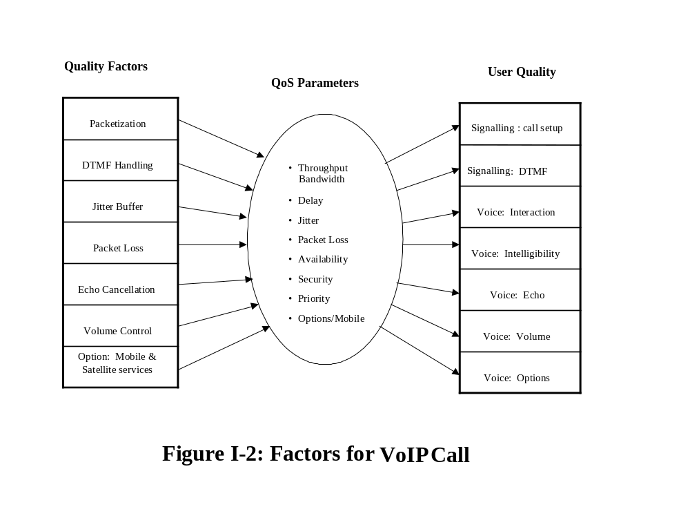

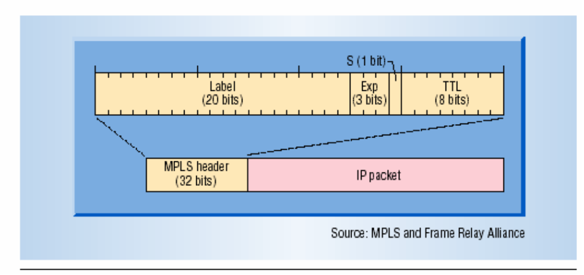

Figure I-3 MPLS uses 32-bit headers divided into four sections. The main label section describes the next hop along a predefined path a packet will take. The experimental section supports various classes of service for data sets with different delivery priorities. The stacking section identifies the last of the multiple labels that can be used with an MPLS data set. The time-to-live (TTL) section represents maximum amount of time a packet can propagate through a network before being discarded.
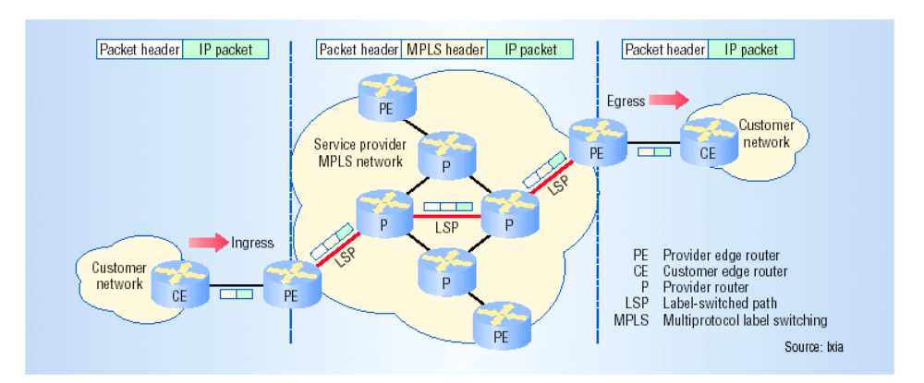

Figure I-4 In traffic passing between user IP networks via an MPLS network, an MPLS-label header is added to data so that routers can send it along an optimal, predefined level switched path. The label tells routers where the packets’ next hop is. At each hop, the router replaces the old header with a new one. Each router removes the MPLS header when traffic leaves the MPLS network and reaches the destination IP network.

Appendix K - Gateway/Gatekeeper

Gateways: In general, a gateway (GW) translates between similar services using different protocols to support interoperation. In the VoIP context, a GW allows H.323 terminals to communicate with non-H.323 terminals. There are different types of GWs such as signaling needed to convert from H.232 or SIP to PSTN, media GW to convert IP media protocols from H.323 or RTP to ISDN. Other types of GW may be used to connect softswitches, or server’s. GWs are optional in the terminals, when the terminals on a network need to communicate with an endpoint in some other network, then they communicate via GWs using the H.245 and Q.931 protocols.

Gatekeepers: Functions often are build in GWs, it perform several functions:
- Address translation
- Admission Control
- Bandwidth Control
- Zone management Call Control Signaling (option)
- Call Control Signaling (option)
- Call Authorization (option)
- Call Management (option)
- Bandwidth Management (option)

Figure K-1 shows main steps in the signaling process and correlates with H-series protocol used.

H.225-RAS Gatekeeper Discovery
Terminal Registration

H.225-RAS Routed Call Signaling
H.225-Q.931 between the Terminals through the Gatekeeper

H.245 Initial Communications and Capability Exchange
- Master Slave diction
- Capability Exchange

Establish Audio Communication
H.245 - Open logical channel

RTP/RTCP Audio Transmission

Figure K-1: Signaling Process

The Figure K-2 illustrates the functional components of GW or terminals that use the H.323 standards.

Speech
Processor

Call
Processing
Network Manage-ment
Speech SNMP

Signaling
Packet
Processor
IP Packet

Figure K-2: Voice Gateway/Terminal Functions

References

1 | ITU-T H.323 Version 5, July 2003 | Packet-based multimedia communications systems
2 | ITU-T H.225.0, July 2003.  ITU-T H.225 Annex G, Sept.1999 | Call Signaling Protocols and media stream packetization for packet-based multimedia communication systems
3 | ITU-T H.235, August 2003 | Security and Encryption for H-Series
4 | ITU-T H.245, July 2003 | Control Protocol for multimedia communication
5 | ITU-T H.246, February 1998 | Interlocking of H-Series multimedia terminal with H-Series multimedia terminals and voice/voiceband terminals on GSTN and ISDN
6 | ITU-T H.248.1, September 2005 | Gateway Control Protocol, version 3
7 | ITU-T H.261, March 1993 | Video Codec for Audiovisual services
8 | ITU-T H.263, February 1998 | Video Coding for Low Bit Rate Communication
9 | ITU-T H.320, (March 2004), H.321 (February 1998), H.324 (March 2002) | Narrow-band visual telephone systems and terminal equipment; Adaptation of H.320 visual telephone terminals to B-ISDN environments; Terminal for low bit-rate multimedia communication
10 | ITU-T H.332, September 1998 | H.323 extended for loosely coupled conferences
11 | ITU-T H.450.1, February 1998 | Generic function protocol for the support of supplementary services in H.323
12 | ITU-T G107, March 2003 | The E-Model, a computational model for use in transmission planning
13 | ITU-T G.114, May 2003 | Guidance on One Way Delay for Voice over IP
14 | ITU-T G.165, March 1993  ITU-T G 168, August 2004 | Echo Cancellers  Digital Network Echo Cancellation
15 | ITU-T G.711, November 1988, Appendixes I and II | Pulse code modulation (PCM) of voice frequencies
16 | ITU-T G.723.1, Annexes A, B, C, Novembre 1996 | Speech Coders: Dual Rate Speech coder for Multimedia Communications Transmitting at 5.3 and 6.3 Kbps.  Silence compression scheme.  Alternative specification based on floating point arithmetic.  Scalable channel coding scheme for wireless applications
17 | ITU-T G.726, December 1990 | 40, 32, 24, 16 Kbps Adaptive Differential Pulse Code Modulation (ADPCM)
18 | ITU-T G.728, September 1992 | Coding of speech at 16 Kbps using low delay code excited linear prediction
19 | ITU-T G.729 and G.729a, March 1996 | Coding of speech at 8 Kbps using conjugate-structure algebraic-code-excited linear-prediction (CS-ACELP)
20 | ITU-T P.800 (August 1996), P.800.1 (March 2003) | Methods for Subjective Determination of Transmission Quality; MOS Terminology
21 | ITU-T P.861, February 1998 | Objective quality measurement of telephone-band (300-3400 Hz) speech codecs
22 | ITU-T P.862 (March 2003), 862.1 (November 2003) | Revised Annex A: Source code for the reference implementation and conformance tests.Mapping function for transforming P.862 raw result scores to MOS-LQO
23 | ITU-T Q.921: June 2000 | ISDN user-network interface – Data link layer specification
24 | ITU-T Q.922: January 2001, and IETF RFC 2427, September 1998 | Implementation Guide for Frame Relay (FR), Multi protocol over FR
25 | ITU-T Q.931: May 1998, with Amendment 1 December 2002, and H.225 | ISDN user-network interface layer 3 specification for basic call control. Extensions for the support of digital multiplexing equipment.
26 | ITU-T.120, July 1996 and Annex C, February 1998 | Data protocol for multimedia conferencing
27 | ITU-T.130, February 1998 | Audio Video and Control for Conferences Multimedia Architecture/General Vision
28 | ITU-T Y.1310, March 2004 | Transport of IP over ATM in Public Networks
29 | ITU-T Y.1540, December 2002, and Amendment 1, August 2003 | Internet Protocol Data Communication Services – IP Packet Transfer and Availability Performance Parameters
30 | ITU-T Rec. Y.1541 (May 2002), Amendment 1 (August 2003), Amendment 2 (February 2004) | Network Performance Objectives for IP-Based Services (including QoS classes and values)
31 | ECMA 312, 3rd Edition, June 2003 | Private Integrated Services Network (PISN) – Profile Standard for the Use of PSSI (QSIG) in Air Traffic Services Networks
32 | Internet Telephony Volume 7 Number 4, 2004 | VoIP Security: Stakes Get High As Deployments Grow
33 | IEEE 802.1p, 1998 | Traffic Class Expediting and Dynamic Multicast Filtering
34 | IEEE 802.1Q, 2003 | Virtual Bridge Local Area Networks
35 | IEEE 802.3, May 2000 | Carrier Sense Multiple Access with Collision Detection (CSMA/CD) Access Method and Physical Layer Specifications Aggregation of Multiple Link Segments
36 | IETF RFC 791, 1981 | Internet Protocol Specification
37 | IETF RFC 793, 1981 | Transmission Control Protocol
38 | IETF RFC 768, 1981 | User Data-gram Protocol
39 | IETF RFC 1680, August 1994  IETF RFC 2225, April 1998 | IPng Support for ATM Services (Info).  Classical IP & ARP over ATM
40 | IETF RFC 1754, January 1995 | IP over ATM Working Group’s Recommendations for the ATM Forum’s Multiprotocol BOF (Informational)
41 | IETF RFC 1771, March 1995 | A Border Gateway Protocol 4 (BGP-4)
42 | IETF RFCs 2205, 2209, and 2750, September 1997.  IETF RFCs 2210, 2211, 2212 (September 1997) | Resource Reservation Protocol (RSVP) standards.  The Use of RSVP with IETF Integrated Services (IntServ); Controlled-Load control services; Guaranteed control services
43 | IETF RFC 2246, 1999 | The TLS Protocol Version 1.0
44 | IETF RFC 2326, April 1998 | Real Time Streaming Protocol (RTSP)
45 | IETF RFC 2327, June 2002 | SDP: Session Description Protocol
46 | IETF RFC 2328, April 1998 | OSPF Version 2
47 | IETF RFC 2402, 1998 | IP Authentication Header (AH)
48 | IETF RFC 2406, 1998 | IP Encapsulating Security Payload (ESP)
49 | IETF RFC 2407, 1998 | The Internet IP Security Domain of Interpretation for ISAKMP
50 | IETF RFC 2408, 1998 | Internet Security Association and Key Management Protocol (ISAKMP)
51 | IETF RFC 2409, 1998 | The Internet Key Exchange (IKE)
52 | IETF RFCs 2474 (December 1998), 3168 (September 2001), 3260 (April 2002) | Differential Services (DiffServ) and Explicit Congestion Notification (ECN) standards
53 | IETF RFC 2460, 1998 | Internet Protocol, Version 6 (IPv6) Specification
54 | IETF RFC 2463, 1998 | Internet Control Message Protocol (ICMPv6) for the Internet Protocol Version 6 (IPv6) Specification
55 | IETF RFC 2484, January 1999 | PPP LCP Internationalization Configuration Option
56 | IETF RFC 2547, March 1999 | BGP/MPLS VPNs (Informational)
57 | IETF RFC 2597, June 1999 | Assured Forwarding Per-Hop-Behavior (PHB) Group
58 | IETF RFC 2764, February 2000 | A Framework for IP Based Virtual Private Network (Informational)
59 | IETF RFC 2824, May 2000 | Call Processing Language Framework and Requirements (Informational)
60 | IETF RFC 2848, June 2000 | The PINT Service Protocol: Extensions to SIP and SDP for IP Access to Telephone Call Services
61 | IETF RFC 2871, June 2000 | A Framework for Telephony Routing over IP
62 | IETF RFC 3031, January 2001 | Multiprotocol Label Switching Architecture (MPLS)
63 | IETF RFC 3168, 2001 | The Addition of Explicit Congestion Notification (ECN) to IP
64 | IETF RFC 3246, March 2002 | An Expedited Forwarding PHB (Per-Hop Behavior)
65 | IETF RFC 3261, June 2002, and  IETF RFC 3853, July 2004 | SIP: Session Initiation Protocol,  S/MIME, Advance Encryption Standard (AES) Requirement for SIP
66 | IETF RFC 3262, June 2002 | Reliability of Provisional Responses in the Session Initiation Protocol (SIP)
67 | IETF RFC 3263, June 2002 | Session Initiation Protocol (SIP): Locating SIP Servers
68 | IETF RFC 3264, June 2002 | An Offer/Answer Model with the Session Description Protocol (SDP)
69 | IETF RFC 3265, June 2002 | Session Initiation Protocol (SIP)-Specific Event Notification
70 | IETF RFC 3266, April 1998 | Support for IPv6 in SDP
71 | IETF RFC 3372, September 2002 | Session Initiation Protocol for Telephones (SIP-T): Context and Architectures
72 | IETF RFC 3525, June 2003 | Gateway Control Protocol Version 1
73 | IETF RFC 3550, July 2003, and  IETF RFC 3551 | RTP: A Transport Protocol for Real-Time Applications (RTCP)
74 | IETF RFC 3711, 2004 | The Secure Real-Time Transport Protocol (SRTP)
75 | EUR 145-05/GT 67-15, April 2005 | Minutes of the 7th Meeting of WG-67 (VoIP for ATM)
76 | IETF RFC 2974, October 2000 | SAP: Session Announcement Protocol
77 | IETF RFC 3435, January 2003,  IETF RFC 3661, December 2003 | Media Gateway Control Protocol V- 1.0.  MGCP Return Code Usage
78 | IETF RFC 3762, 2004 | Telephone Numbering Mapping (ENUM) Service Registration for H.323
79 | IETF RFC 1157, May 1990  IETF RFC 2273, Jan 1998 | Simple Network Management Protocol (SNMP)  SNMP v 3
80 | IETF RFC 3764, 2004 | Enum Service registration for SIP Address-of-Record
81 | IETF RFC 3953, 2005 | Telephone Numbering Mapping (ENUM) Service Registration for Presence Services
82 | ICAO Annex 10, Vol. III, Part II., Chapter 4, 1995, and  Doc 9804, 2002 | Recommended Voice Addressing Plan.  Manual on ATS Ground Voice Switching
83 | ITU-T E.212, 2004 | International Identification Plan for Mobile Terminal and Mobile Users
84 | ITU-T E.160 rev.1, 1993 | Definition Relating to National and International Numbering Plan
85 | ITU-T E.162, 1995 | Capability for 7 digit analysis of International E.164 Numbers
86 | ITU-T E.164, 1997 | International Telephone Numbering Plan
87 | ECMA-155, 1997 | Private Integrated Service Network-Addressing
88 | IETF RFC 2833, May 2000 | RTP Payload for DTMF Digits, Telephony Tones and Telephony Signals
89 | ITU-T.125, April 1994 | Multipoint communication service protocol specification
90 | NIST Spécial Publication 800-58, January 2005 | Security Considerations for VoIP Systems
91 | ANSI T1.521a-2000, June 2000 | Packet Loss Concealment with ITU-T Recommendation G.711 Annex B
92 | ITU G.113 Appendix I, Septembre, 1999 | Provisional Planning Values for the equipment impairment factor Ie
93 | ITU-T E.123, 1988 | Notation for National and International Telephone Numbering
94 | ITU-T G.131 Octobre, 1996 | Control of Talker Echo
95 | ITU-T Q.705, March 1993 | Signaling Network Structure
96 | ITU-T Q.708, March 1999 | Assignment procedures for international signaling point code
97 | IETF RFC 3761, April 2004 | The E.164 to Uniform Resource Identifiers (URI) Dynamic Delegation Discovery System (DDDS) Application (ENUM)
98 | IETF RFC 2198, September 1997 | RTP Payload Redundant Audio Data
99 | ITU-T H.460.x, Novembre 2004 | Document series on the Generic Extensibility Framework for H.323 enhancements
100 | IETF RFC 3611, Novembre 2003 | RTP Control Protocol Extended Reports (RTCP XR)
101 | IETF RFC 3951, December 2004 | Internal Low Bit Rate Codec (iLBC), Experimental
102 | IETF RFC 3952, December 2004 | RTP Payload Format for iLBC speech, Experimental
103 | IETF RFC 2401, 1998 | Security Architecture for the Internet
104 | COMT-31 Working Paper 10, EUROCONTROL, October 2004 | Report on ATS Ground Voice Network Numbering Plan
105 | draft-zimmermann-avt-zrtp-01.txt, Internet-Draft, March 5, 2006 | ZRTP: Extensions to RTP for Diffie-Hellman Key Agreement for SRTP  draft-zimmermann-avt-zrtp-01
106 | IETF RFC 3353, August 2002  Information | Overview of IP Multicasting in a MPLS Environment
107 | E67-IP03-SG1#5-EURO03 | EUROCONTROL IPv6
108 | IETF RFC-1883, December 1995 | IPv6 Specification (changes from IPv4 to IPv6)
109 | IETF RFC-3596, 2003 | DNS Extension to Support IPv6
110 | IETF RFC-3513, April 2003 | IPv6 Addressing Architecture for Unicast, Anycast, Multicast, and an IPv6 node’s required address
111 | ITU-T Rec.,Q.400 and Q.490, November 1988 | Specification of Signalling R2
112 | IETF RFC-2526, 1999 | Reserved IPv6 Subnet Anycast Addressing, using EUI-64 format
113 | IETF RFC-4213, 2005 | Basic Transition Mechanisms for IPv6
114 | IETF RFC-22766, 2000 | Network Address Translation-Protocol (NAT-P)
115 | IETF RFC-2765, 2000 | Stateless IP/ICMP translation Algorithms (SIIT)
116 | IETF RFC-4214, 2005 | Intra-Site Automatic Tunnel Addressing Protocol (ISATAP)
117 | IETF RFC-2464, 1998 | Transmission of IPv6 Packets over Ethernet Networks
118 | IETF RFC-1887, December 1995 | An Architecture for IPv6 Unicast Address Allocation
119 | IETF RFC-3232, January 2002 | Assigned Numbering
120 | IETF RFC-3142, 2001 | An IPv6-tp-IPv4 Transport Relay Translator
121 | ITU-T Rec., E.123, 1988 | Notation for National and International Telepone Numbering

Lexicon

ABR – Available Bit Rate is a Quality of Service category that may attributed to a network traffic class, providing no guarantees regarding cell loss or delay, providing only best-effort service

ADPCM – Adaptive Differential Pulse Code Modulation is an algorithm which encodes analog voice samples into high-quality digital signals at a low bit rate. This is achieved by recording the difference between samples and adjusting the coding scale dynamically to accommodate large and small differences

A-G- Air to Ground

ARP – Address Resolution Protocol used to map an IP address to a MAC address. It is defined in IETF STD 37

ATM – Asynchronous Transfer Mode is a network technology based on transferring data in cells or packets of a fixed size. The small, constant cell size allows ATM equipment to transmit video, audio and computer data over the same network, assuring that no single type of data utilizes excessive bandwidth on the line

ATM – Air Traffic Management provides management, control, and maintenance services for air traffic flow

ATS – Air Traffic Services

Backbone – The main trunk that connects nodes across a LAN or WAN

Bandwidth – The amount of data that can be transmitted in a fixed amount of time. For digital networks, the bandwidth is usually expressed in bits per second (bps) or bytes per second

Broadcast – A packet delivered to all workstation on a network. Broadcasts exist at layer 2 and at layer 3

Broadband – Descriptive term for evolving digital technology that provides consumers a single node offering integrated access to voice, high-speed data service, video-on-demand services, and interactive delivery services

Call – Establishment of voice connection between two endpoints

Call deflection – Call deflection is a feature under H.450.3 call diversion (call forwarding) that allows a called H.323 endpoint to redirect the unanswered call to another H.323 endpoint

CO – Central Office, a local telephony company office which connects to all local loops in a given area and where circuit switching of customer lines occurs

Codec – Coder/Decoder. In telecommunications, it is a device that encodes or decodes a signal. For example, telephone companies use codecs to convert binary signals transmitted on their digital networks to analog signals converted on their analog networks. They are defined by the ITU-T “G.7xx” family of recommendations

Compression – Any technique that reduces the number of digital packets, frames, or cells to lower the bandwidth or space required for transmission or storage

Congestion – The situation in which the traffic presented to the network exceeds available network bandwidth/capacity, resulting rising latency and lower throughput

Class of Services – Class of Services (CoS) is an enterprise network has many different type of traffic flow across it, for voice and data transmissions. There are 3 major technologies that are used to create classes and prioritizing:
- IEEE 802.1p (layer 2 tagging)
- Type of Services (ToS), layer 3 IP header
- Differentiated Services (DiffServ), layer 3

Delay – Amount of time a call spends waiting to be processed. A system performance metric, delay can refer to actual transmission time, the waiting time in buffer, the time it takes for the data to travel between any two network nodes, the processing time (e.g., packetization, depacketization, protocol processing, coding) or to the time for data to be switched through a switch or router

DiffServ - differentiates IP traffic so that the relative priority of each traffic class could be determined on a per-hop basis

DTMF – Dual Tone Multi-Frequency: The set of standardized, superimposed tones used in telephony signaling as generated by a touch tone pad

DSP – Digital Signal Processor is a high-speed processor designed to do real-time signal manipulation

DHCP – Dynamic Host Configuration Protocol provides a mechanism for allocating IP addresses dynamically, enabling their reuse when hosts no longer need them

Echo Cancellation – When transmitting a signal, some of the energy may be reflected back to the transmitter. For full duplex communication, this will interface with a real signal being sent to the transmitter. A full duplex device can eliminate some of this noise in a received signal by applying a correction signal derived from its transmitted signal

Echo Control – The control of reflected signals in a telephone transmission path

E-1 – A wide-area digital transmission scheme: 2,048 Mbits/s; 31 channels, 64 Kbps each

E.164 – The international public telecommunication numbering plan. An E.164 number uniquely identifies a public network termination point and typically consists of three fields, CC (Country Code), NDC (National Destination Code), and SN (Subscriber Number), up to 15 digits in total

Endpoint – SIP or H.323 terminal or gateway

Failed Call – An attempted call that does not elicit a Connect message from the destination host

Firewall – A system designed to prevent unauthorized access to or from a private network

FR – Frame Relay, a packet-switching protocol for connecting devices on a WAN

H.323 – A standard approved by the ITU-T that defines how audiovisual conferencing data is transmitted across networks. It is an umbrella of standards for packet-based multimedia communications systems. This standard defines the different multimedia entities that make up a multimedia system – endpoints, gateways, MCUs, and gatekeepers – and their interaction. This standard is used for many VoIP applications

Hop off – In VoIP, hop off is a point or gateway at which a call moves from an H.323 network to a network that uses some other protocol, typically at a gateway

G-G – Ground to Ground

Gate keeper – A gatekeeper is a management tool for H.323 multimedia networks. A single gatekeeper controls interactions for each zone, which comprises the terminals, MCUs, and gateways within a particular domain. Depending on the demands of the specific network, the gatekeeper oversees authentication, authorization, telephone directory, and PBX services, as well as call control and routing. Other functions may include monitoring the network for load balancing and real-time network management applications, intrusion detection and prevention, and providing interfaces to legacy systems

Gateway – In IP telephony, a network device that converts voice and fax calls, in real time, between the public switched telephone network and IP network

GRP – Generation Partnership Project

GRQ – Gatekeeper Request

ICAO – International Civil Aviation Organization

IEs – Information Elements

IETF – The Internet Engineering Task Force is the body that defines standard Internet operating protocols such as TCP/IP. The IETF is supervised by the Internet Society Internet Architecture Board (IAB). IETF members are drawn from the Internet Society's individual and organization membership. Standards are expressed in the form of Requests for Comments (RFCs) and Standards (STD)

IP – Internet Protocol: A layer 3 (network layer) protocols that contains addressing and control information that allows packets to be routed. Defined in RFC 791 (IPv4) and RFC 2460 (IPv6)

IPSec – IP security, a set of protocols being developed by the IETF to support secure exchange of packets at the IP layer

Internet Telephony – Generic term used to describe various approaches to running voice telephony over IP

ISDN – Integrated Services Digital Network: An international communications standard for sending voice, data, and video over digital telephone lines or normal telephone wires

ISP – Internet Service Provider: A business that enables individuals and companies to connect to the Internet by providing the interface to the backbone

ITU-T – International Telecommunication Union: An international body of member countries whose task is to define recommendations and standards relating to the international telecommunications industry

Jitter – In voice over IP (VoIP), jitter is the variation in the time between packets arriving, caused by network congestion, timing drift, or route changes. A jitter buffer can be used to handle jitter

Latency – In a network, latency, a synonym for delay, is an expression of how much time it takes for a packet of data to get from one designated point to another.

LAN – Local Area Network, a network covering a relative small geographic area

Load Balancing – Distribution of calls among terminating nodes based on the priorities and weights assigned by the switches to optimize quality of service

LRQ – Location Request

MCU – Multipoint Control Unit, a device in videoconferencing that connects two or more audiovisual terminals together into one single videoconference call. The MCU collects information about the capabilities of the systems at each of the videoconference endpoints and sets the conference at the lowest common denominator so that everyone can participate

MGCP – Media Gateway Control Protocol, a protocol complementary to H.323 and SIP, designed to control media gateways from external call control elements in decomposed gateway architectures

MOS – Mean Opinion Score, a system of grading the voice quality of telephone connections. The MOS is a statistical measurement of voice quality, derived from a large number of subscribers judging the quality of the connection

MPLS – Multi-Protocol Label Switching, an IETF initiative that integrates layer 2 information about network links (bandwidth, latency, utilization) into layer 3 (IP) within a particular autonomous system in order to simplify and improve IP packet exchange

Node – Physical equipment such as switch, computer, terminal, router that terminates one or more network segments

Packet – A logical grouping of information that includes a header and user data

Packet Loss Rate – The measured loss of data packets, over a specific time period, as a percentage of the total packet traffic transmitted

PPP – Point-to-Point is a layer 2 protocol which provides router-to-router and computer-to-network connections across a wide area circuit

PBX – Private Branch eXchange is a private telephone network used within an enterprise. Users of the PBX share a certain number of outside lines for making telephone calls external to the PBX

PGP – Pretty Good Privacy

Protocol – A formal description of a set of rules and conventions that govern how devices on a network exchange information

Protocol Stack – Related layers of protocol software that function together to implement particular communications architecture. Example: OSI reference model

PSTN – Public Switched Telephone Network, a general term referring to the variety of telephone networks and services in place worldwide

PINT – PSTN/Internet Networking

PVC – Permanent Virtual Circuit, a virtual circuit that is permanently available

PCM – Pulse Code Modulation, transmission of analog information in digital form through sampling, and encoding the samples with a fixed number of bits

Q.931 – ISDN connection control protocol, roughly comparable to TCP in the TCP/IP stack. Q.931 does not provide flow control or retransmission capabilities, because the underlying layers are assumed to be reliable and the circuit-oriented nature of ISDN allocates bandwidth in fixed increments of 64 Kbps. In H.323 scenario, this protocol is encapsulated in TCP

QoS – Quality of Service. It is a measure of performance for transmission systems that reflects its transmission quality and service availability. Standards-based QoS for VoIP usually involves the implementation of Ethernet standards 802.1p and 802.1q at layer 2 across an Ethernet. At layer 3, the IP standard DiffServ defines bit setting in the IP header which will identify packets as being associated with a specific service

QSIG – Q (point of ISDN model) signaling, system between a PBX and CO, or between PBXs to support enhanced features such as forwarding and follow me

Radio Station – An aeronautical telecommunication station having responsibility for handling communication between ground station(s) and aircraft in given area

RAS – The Registration, Admission and Status channel is used to carry messages used in the gatekeeper discovery and endpoint registration processes which associate an endpoint alias address with its call signaling channel transport address

Router – A networking device for forwarding packets and interconnecting nodes that may belong to homogeneous or non-homogeneous networks. A router is a sophisticated device that operates at the network layer

RSVP – Resource ReSerVation setup Protocol is designed for an integrated services Internet. It is used by a host on behalf of an application data stream to request a specific quality of service from the network for particular data streams or flows. It is also used by routers to deliver QoS control requests to all nodes

RTCP – RTP Control Protocol, a protocol providing support for applications with real-time properties, including timing reconstruction, loss detection, security, and content identification. RTCP provides support for real-time conferencing for large groups within an Internet, including source identification and support for gateways (like audio and video bridges) and multicast-to-unicast translators. Define in RFCs 2205-2209

RTP – Real-Time Transport Protocol, the standard protocol for streaming applications developed within IETF RFC 3550. RTP is designed to provide end-to-end network transport functions for applications transmitting real-time data, such as audio, video, or simulation data over multicast or unicast network services

RTSP – Real-Time Streaming Protocol is a control protocol that initiates and directs delivery of streaming multimedia data from media servers. Its role is to provide the remote control (i.e., signaling); the actual data delivery is done separately, most likely by RTP.

RTT – Round Trip Time it is a measure of the time it takes for a packet to travel from a computer, across a network to another computer, and back.

Server – A computer device on a network that manages network resources

SDP – provides multimedia sessions for the purpose of session announcement, session invitation and other forms of multimedia session initiation.

Signaling – Commands between devices to manage call sessions (e.g., call set up/tear down)

SIP – Session Initiation Protocol, an application layer control, a signaling protocol for Internet Telephony. SIP can establish sessions for audio/videoconferencing, interactive gaming, and call forwarding to be deployed over IP networks. It enables service providers to integrate basic IP telephony services with user authentication, redirect and registration services. SIP servers support traditional telephony features such as personal mobility, time-of-day routing and call forwarding based on the geographical location of the person being called

SNMP – Simple Network Management Protocol, a protocol for managing complex networks. SNMPv1 reports only whether a device is functioning properly. SNMPv3 provides additional information, in a secure fashion

SRTP – The secure Real-time Transport Protocol it integrates with RTP and RTCP as an optional layer of security in the protocol stack

Switch – Electronic device which opens or closes circuits, changes operating parameters, or selects paths either on a frequency or time division basis

SVC – Switched Virtual Circuit, a virtual circuit that is dynamically established on demand and is torn down when transmission is completed. An SVC is used in situations where data transmission is sporadic

T-1 – 1.544-Mbps point-to-point dedicated digital circuit provided by telephone companies consisting of 24 channels

T-3 – The digital signal carried on a North America high-speed facility operating at approximately 45 Mbps

Terminal – a device that enables a person to communicate with a host or network

TCP – Transmission Control Protocol, a connection-oriented transport (layer 4) protocol that provides reliable full-duplex data transmission

TLS – Transport Layer Security, a security protocol based on SSL. TLS uses digital certificates to authenticate the user as well as the network

Trunk – A communications channel between two nodes, typically referring to large bandwidth telephone channels between switches or routers that handle many simultaneous voice and data signals

UDP – User Datagram Protocol is a connection-less protocol that runs on top of IP networks. UDP provides very few error recovery services, offering instead a direct way to send and receive datagram over an IP network. It is used primarily for broadcasting and voice messaging over an IP network

VoIP – Voice over Internet Protocol, the capability to carry normal telephone-style voice over an IP-based internet with acceptable reliability and voice quality. VoIP enables a router to carry voice traffic over an IP network

VPDN – Virtual Private Dial-Up Network, also known as virtual private dial network. A VPDN is a network that extends remote access to a private network using a shared infrastructure. VPDNs use layer 2 tunnel technologies to extend the layer 2 and higher parts of the network connection from a remote user across an ISP network to a private network

VPN – Virtual Private Network enables IP traffic to travel securely over a public TCP/IP network by encrypting all traffic within its domain. A VPN uses “tunneling” to encrypt all information at IP Level

WAN – Wide Area Network, data communications network that serves users across a broad geographic area and often uses transmission devices provided by common carriers

“The Secure Real-time Transport Protocol (SRTP)”, RFC 3711, IETF, March 2004
“SIP: Session Initiation Protocol”, RFC 3261, IETF, June 2002
“The Secure Shell (SSH) Connection Protocol”, RFC 4254, IETF, January 2006
This delay is dependent on the trunk, router, and switch speed.
R is a transmission rating factor, described in ITU-T G.107, which is based upon the E-model for predictive transmission network planning; these figures assume a typical network
ITU-T G.113 Appendix I [92] provides guidelines on the effect of frame loss on voice quality in terms of the Ie (Equipment Impairment) factor, which is a measure of the voice quality degradation as a result of the equipment used (e.g., CODEC performance)
Mean Opinion Score; MOS above 4 is considered “toll quality” by the ITU-T P.800; these figures assume a typical network.
For description of this protocol, see http://www.ilbcfreeware.org/
Refer to: www.globalipsound.com, iLBC white paper – October 2004, Figure1b
Refer to: www.GLOBALIPSOUND.com, GIPS Enhanced G.711 Figure 1b
VPN – logical connections over a public network that provides secure communications with encryption technology

