 | International Civil Aviation Organization  WORKING PAPER | ACP-WGF29/WP11  2013-09-05

AERONAUTICAL COMMUNICATIONS PANEL (ACP)

TWENTY NINETH MEETING OF WORKING GROUP F

Nairobi, Kenya 5 – 12 September 2013

Agenda Item 7: | Development of material for ITU-R meetings

Update on Compatibility Studies between WAIC Systems and Radio Altimeters in the Frequency Band 4 200 – 4 400 MHz

(Presented by Uwe Schwark)

SUMMARY
Initial results on the compatibility between WAIC systems and radio altimeters in the frequency band 4 200 – 4 400 MHz were presented at the most recent ITU-R Working Party 5B meeting in May/June 2013. These studies address the possibility of WAIC systems installed on board one or multiple aircraft to interfere with a radio altimeter onboard another aircraft. Meanwhile, further studies have been undertaken addressing further interference geometries/scenarios and also the potential impact radio altimeters might have onto WAIC systems. All results indicate that both, low and high data rate WAIC systems located within the aircraft structure (LI and HI WAIC systems), are compatible with all types of radio altimeters embraced within Draft New Recommendation ITU-R M.[RadAlt], including pulsed radio altimeters.
Employing maximum power levels and omni-directional antennas is suggested as the default configuration for low and high data rate outside WAIC systems (LO and HO systems) in Draft New Report ITU-R M.[WAIC_CHAR_SPEC]. Initial study results for this configuration of LO and HO systems show that their radiated emissions on one hand lead to an exceedance of the “receiver desensitization” as well as the “false altitude report” protection criteria of all FMCW radio altimeter types embraced in Draft New Recommendation ITU-R M.[RadAlt] (see Document ITU-R 5B/TEMP/121-E). On the other hand radio altimeter emissions may also lead to an exceedance of the protection criteria of WAIC LO and HO systems. For this reason studies are currently ongoing aiming at analyzing the potential for improving the isolation between radio altimeter and outside WAIC systems through application of directive antennas and lowered transmit power levels for these outside WAIC systems. A separate Working Paper has been submitted to the 29th meeting of the ICAO ACP WG-F, which describes the approach and assesses its potential for improvements.
The Annex to this Working Paper provides an update on compatibility studies between inside WAIC systems and radio altimeters in the frequency band 4 200 – 4 400 MHz undertaken since the last ITU-R Working Party 5B meeting. It is intended to make contributions into the upcoming meetings of CEPT ECC CPG PTC and ITU-R Working Party 5B based on these and additional results gathered within the coming weeks.
ACTION
To provide feedback on the proposed scenarios, assumptions and the study methodology, as well as the study results in order to support the development of a solution for WRC-15 agenda item 1.17.

Annex
Radiocommunication Study Groups | 
 | Document 5B/xxx-E
 | xx Oct 2013
 | English only
Working Party 5B
Working document towards a preliminary draft new
Report ITU-R M.[WAIC_SHARING_4 200-4 400MHz]
Sharing and compatibility analyses between Wireless Avionics Intra-Communications (WAIC) systems and systems in the existing services in the band 4 200 - 4 400 MHz
...
ANNEX 1
Wireless Avionics Intra-Communications (WAIC) systems

A-1.1 Technical characteristics of Wireless Avionics Intra-Communications systems
Draft New Report ITU-R M.[WAIC_CHAR_SPEC] provides detailed characteristics for WAIC systems and their potential use. WAIC systems provide radiocommunication over short distances between two or more stations onboard a single aircraft. WAIC will not provide communications, in any direction, between stations installed on one aircraft and those on another aircraft, terrestrial systems, or satellites. Providing sensor information wirelessly is an example of an application of WAIC systems. These sensors will be installed at various locations both within and outside the aircraft and will be used to monitor the health of the aircraft structure and it’s critical systems and to communicate this information within the aircraft to a central onboard entity which can make the best use of such information. WAIC systems are also intended to support data, voice and safety related video surveillance applications such as taxiing cameras and may also include communications systems used by the crew for safe operation of the aircraft.
Points of communication will include avionics components with integrated wireless capabilities and dedicated components of the WAIC system. In all cases communication between two or more stations installed on a single aircraft is assumed to be part of an exclusive network required for the aircraft’s safe operation. WAIC systems are not intended to provide communications with consumer devices, such as radio local area network (RLAN) devices that are brought onboard the aircraft by passengers or for in-flight entertainment applications. The scope of WAIC applications is limited to applications that relate to the safe, reliable and efficient operation of the aircraft as specified by the International Civil Aviation Organization (ICAO). WAIC systems are envisioned to offer aircraft designers and operators many opportunities to improve flight safety and operational efficiency while reducing costs to the aviation industry and the flying public.
There are two types of WAIC systems, “low data rate” and “high data rate”. Additionally, either of these two system types may be installed outside or inside of the aircraft structure; creating four types of WAIC application categories as shown in Figure A-1.1.
Figure A-1.1
Wireless Avionics Intra-Communications system categorization
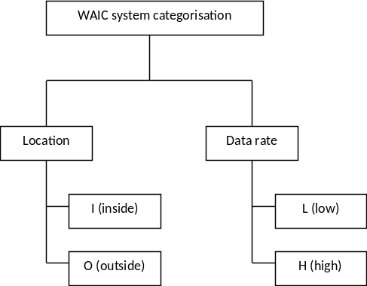

Tables A-1.1 summarizes all WAIC system characteristics used for studies contained in this Report.
Table A-1.1
Technical characteristics for Wireless Avionics Intra-Communications low and high data rate systems
 | Low data rate systems | High data rate systems | Units
Aggregate net average data rates for inside applications | 394 | 18 385 | kbps
Aggregate net average data rates for outside applications | 856 | 12 300 | kbps
Total aggregate net average data rates | 1 250 | 30 685 | kbps
Channelization overhead factor (β) | 1.92 | 1.20 | -
Spectrum requirements per aircraft¹ | 35 | 53 | MHz
number and location of simultaneously active transmitters per channel | 1 | 1 | -
Antenna gain (RX and TX) ² | 0 | 0 | dBi
Max. transmission power ³ | 10 | 50 | mW
3-dB emission bandwidth | 2.6 | 16.6 | MHz
Receiver IF-bandwidth | 2.6 | 20 | MHz
Receiver noise floor | -100 | -91 | dBm
Required signal-to-noise ratio | 9 | 14 | dB
Receiver sensitivity | –91 | –77 | dBm
Protection criterion (I/S) | -9 | -14 | dB
Maximum distance between WAIC transmitter and receiver ³ | 15 | 15 | meter
¹ Values reflect spectrum requirements assuming a single aircraft and no mutual interference with other WAIC system equipped aircraft.
² Directive antennas with gains larger than 0 dBi in the mainbeam direction and consequential negative gains outside the main beam may be applied. In these cases, the antenna main beams are pointed towards the center of the aircraft. This will enable the reduction of the overall emissions of the aircraft.
³ These values are technical upper limits. Lower values are generally possible at the cost of cell size and increased number of required cells to appropriately cover the aircraft.

A-1.2 Definition of channel gain/loss models for various areas of the aircraft
The protection criterion for WAIC systems is based on interference-to-signal power at the WAIC receiver. For determining the signal power it is necessary to take the aircraft-specific propagation conditions into account. Annex 3 of Draft New Report ITU-R M.[WAIC_CHAR_SPEC] provides information on radio-frequency (RF) signal propagation within and around a typical commercial passenger aircraft. Based on analysis of various sets of RF propagation measurements taken in different areas of this aircraft, the grouping of sets of test locations into six groups as summarized in Table A-1.2 below was defined. Each of the groups A to F contains measurements obtained at locations (test points) with similar propagation conditions, e.g. similar shadowing situation. For each of these groups a corresponding channel model was derived.
TABLE A-1.2
Combining datasets into groups with similar propagation characteristics
Group | Group name | Description
A | Intra-Cabin &Intra-Flight Deck | Includes test pairs where both points are in the same cabin area (e.g. business class), or both are in the flight deck
B | Inter-Cabin | Includes test pairs where each point is in a different cabin area. Points are generally separated by cabin monuments (lavatories, galleys, etc.)
C | Inter-Cabin-to-Lower Lobe & Inter-Cabin-to-Flight Deck | Includes test pairs where one point is in the cabin and one is in a lower-lobe area (Electronic Equipment Bay or Cargo area), separated by the main deck floor. Also includes test pairs where one point is in the cabin and one point is in the flight deck, separated by the forward cabin monuments and flight deck door/bulkhead.
D | Inter-Cabin-to-Exterior  (points on wing) | Includes test pairs where one point is in the cabin and one point is on the wing or engine, separated by the fuselage. Note there is some expected LOS or near-LOS component expected through the cabin windows.
E | Inter-Cabin-to-Landing Gear &  Inter-Lower-Lobe to Exterior | Includes test pairs where one point is in the cabin and one point is on the landing gear, or one point is in the lower-lobe and one point is outside the fuselage. In both cases the test points are separated by the fuselage with no expected LOS or NLOS through the cabin windows.
F | Inter-Exterior | Includes test pairs where both points are exterior of the aircraft fuselage.

For the gain/loss prediction a model of the functional form
(A-1.1)
is used, where n and k are the distance and frequency exponents and C₁ is a constant offset. Values for the parameters k, n and C₁ are summarized in Table A-1.3 below.
TABLE A-1.3
Channel gain model parameters for each group of test points
Group | Group name | k  (freq exp) | n  (dist exp) | C_{1,dB}
A | Intra-Cabin & Intra-Flight Deck | 2.45 | 2.00 | 189.8
B | Inter-Cabin | 2.09 | 3.46 | 167.5
C | Inter-Cabin-to-Lower Lobe &  Inter-Cabin-to-Flight Deck | 1.86 | 2.49 | 124.5
D | Inter-Cabin-to-Exterior (points on wing) | 1.86 | 2.12 | 118.2
E | Inter-Cabin-to-Landing Gear &  Inter-Lower-Lobe to Exterior | 1.59 | 1.51 | 77.9
F | Inter-Exterior | 1.95 | 2.31 | 142.5

A-1.3 Wireless Avionics Intra-Communications reference models
This section provides reference models which can be utilized to derive overall emissions of WAIC applications described in Draft New Report ITU-R M.[WAIC_CHAR_SPEC].
A reasonable simplification for determining the aggregate effect of the emissions of all WAIC applications onboard an aircraft is provided in Annex 4 of Draft New Report ITU-R M.[WAIC_CHAR_SPEC]. In this approach first the number of WAIC transmitters required to cope with the expected data rates per aircraft compartment or area is determined. Applying a compartment/area specific duty and structural shielding factor allows performing very detailed studies focusing on specific applications and aircraft compartments or areas. The resulting e.i.r.p values per WAIC application and aircraft compartment/area are provided in Table A-1.4.
TABLE A-1.4
WAIC e.i.r.p. values per aircraft compartment/area and application
Compartment / aircraft area | NTX | Duty factor (%) | Structural shielding (dB) | e.i.r.p. per channel (dBm) | e.i.r.p. density (dBm/MHz)
LI WAIC category
Flight deck | 1 | 0.5 | 35 | -48.3 | -52.4
Cabin compartment | 2 | 55.4 | 35 | -27.6 | -31.7
Avionics compartment | 1 | 1.2 | 35 | -44.3 | -48.4
fwd and aft cargo compartment, center tank, bilge | 1 | 32.1 | 35 | -29.9 | -34.1
Bulk cargo compartment | 1 | 8.5 | 35 | -35.7 | -39.8
Wing fuel tank | 1 | 12.1 | 35 | -34.2 | -38.3
Horizontal stabilizer | 1 | 1.1 | 35 | -44.6 | -48.7
Nacelles | 1 | 50.9 | 35 | -27.9 | -48.7
LI WAIC total e.i.r.p.(dBm) | -21.6
LO WAIC category
Nose | 1 | 36.0 | 0 | 5.6 | 1.4
Center (upper) | 1 | 93.6 | 0 | 9.7 | 5.6
Center (lower) | 2 | 79.3 | 5 | 4.0 | -0.2
Tail | 1 | 47.4 | 0 | 6.8 | 2.6
Left wing | 1 | 68.0 | 5 | 3.3 | -0.8
Right wing | 1 | 68.0 | 5 | 3.3 | -0.8
LO WAIC total e.i.r.p.(dBm) | 14.3
HI WAIC category
Flight deck | 1 | 37.3 | 35 | -22.3 | -34.5
Cabin compartment | 1 | 63.8 | 35 | -19.9 | -32.2
Avionics compartment | 1 | 48.1 | 35 | -21.2 | -33.4
fwd and aft cargo compartment. center tank. bilge | 1 | 80.5 | 35 | -18.9 | -31.1
Nacelles | 1 | 22.1 | 35 | -24.6 | -36.8
HI WAIC total e.i.r.p.(dBm) | -14.0
HO WAIC category
Nose | 1 | 22.7 | 0 | 10.6 | -1.6
Center (upper) | 1 | 38.9 | 0 | 12.9 | 0.7
Center (lower) | 1 | 24.6 | 5 | 5.9 | -6.3
Tail | 1 | 32.6 | 0 | 12.1 | -0.1
Left wing | 1 | 25.0 | 5 | 6.0 | -6.2
Right wing | 1 | 25.0 | 5 | 6.0 | -6.2
HO WAIC total e.i.r.p.(dBm) | 17.7

For coexistence studies on a WAIC application category basis, a simplified reference model described in the following is deemed to be appropriate. The model assumes that the electromagnetic radiation emitted by all inside or outside WAIC applications communicating within a low or high data rate frequency channel can be perceived as single Omni-directional Point Source (OPS), when the aircraft is observed from a large distance. These OPSs are considered to continuously transmit at their corresponding transmit power level (either 10 dBm or 17 dBm for low or high data-rate WAIC systems, respectively). An antenna gain of G_{WAIC}=0dB, as listed in Table A-1.1 is further taken into account. For OPS located inside the aircraft fuselage an additional signal attenuation of L_{Body}=35dB caused by the aircraft body is assumed in reference to the “shielded” aircraft compartment case described in Draft New Report ITU-R M.[WAIC_CHAR_SPEC]

The number of OPSs required to adequately represent all low and high data rate WAIC applications described in Annex 4 of Draft New Report ITU-R M.[WAIC_CHAR_SPEC] is given by the minimum number of radio channels required for communication by a WAIC application category. These numbers are derived from the high and low data-rate WAIC spectrum requirements and the inside and outside WAIC application data-rates, as described by Equation A-1.2. The results for LI, LO, HI and HO channels are listed in Table A-1.5. The corresponding numbers are rounded towards the next integer value in order to provide margin for multiple simultaneous peaks in the application data rates.

(A-1.2)
Table A-1.5
Number of required channels on board a Wireless Avionics Intra-Communications aircraft per category
 | Inside systems | Outside systems
Low data rate systems | 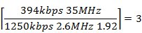 | 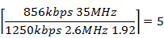
High data rate system | 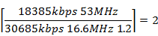 | 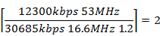

Table A-1.6 summarizes all relevant parameters of the OPS model. The comparison of the total emitted e.i.r.p. values per WAIC application category (see Table A-1.4) with the OPS model (see Table A-1.6) shows that both models are closely related.
Table A-1.6
Omni-directional Point Source reference model parameters
WAIC application category | Transmit Power (dBm) | Aircraft body attenuation L_{Body} (dB) | Required number of OPS | Total OPS e.i.r.p (dBm) | Bandwidth requirements  per OPS/Channel  (MHz)
(LI) | 10 | 35 | 3 | -20.2 | 5
(LO) | 10 | 0 | 5 | 17.0 | 5
(HI) | 17 | 35 | 2 | -15.0 | 20
(HO) | 17 | 0 | 2 | 20.0 | 20

ANNEX 2
Compatibility analysis between Wireless Avionics Intra-Communications systems and radio altimeters in the aeronautical radionavigation service in the band 4 200 – 4 400 MHz

A-2.1. Technical characteristics and protection criteria of frequency modulated continuous wave and pulsed radio altimeters
The basic function of a radio altimeter is to provide accurate height measurements above the Earth surface with a high degree of accuracy and integrity during the approach, landing, and climb phases of aircraft operation. Such information is used for many purposes. The high degree of accuracy and integrity of those measurements must be achieved regardless of the properties of the Earth surface, representing a wide variety of reflectivity. It is also used to determine the particular altitude in which the aircraft can safely land and as an input to the terrain awareness warning system (TAWS), which gives a “pull up” warning at a predetermined altitude and closure rate; and as an input to the collision avoidance equipment and weather radar (predictive windshear system), auto-throttle (navigation), and flight controls (autopilot).
Radio altimeter systems are designed to operate for the entire life of the aircraft in which they are installed. The installed life can exceed 30 years, resulting in a wide range of equipment age, performance and tolerance. Tables A-2.1 and A-2.2 provide technical characteristics of the radio altimeter systems operating in the 4 200 - 4 400 MHz frequency band as contained in Draft New Recommendation ITU-R M.[RadAlt].
The following protection criteria must be considered and need to be met for any new service or application which shall share the band with radio altimeters. These criteria are also contained and described in more detail in subsections 2.3, 2.4 and 2.5 of Draft New Recommendation ITU-R M.[RadAlt].
Due to the fact that radio altimeters provide a safety-of-life service, harmful interference needs to be avoided when the aircraft is in operation. In order to avoid harmful interference the following protection criteria have to be fulfilled in flight critical operating scenarios:
Desensitization: I/N = –6 dB (A-2.1)
Front End Overload: I_{RF} ≤ I_{T,RF} (A-2.2)
where I_{T,RF} is as defined in Tables A-2.1 and A-2.2
False Altitudes (for FMCW Altimeters only):
I_{D} < I_{T,FA}, (A-2.3)
where I_{T,FA} = –143 dBm/100 Hz *
*following the instantaneous altimeter local oscillator
Power Spectral Density:
I_{PSD} < P_{1dBSD} (A-2.4)
with: I_{PSD} = P_{RI} –10log(B_{i})
where: P_{RI} is the received interference power at f_{ci} in dBm;
f_{ci} is the center frequency of the potential interference source and
B_{i} the -40dB bandwidth of the interferer.
with: P_{1dBSD} = P_{T,RF} –10 log(B_{R,IF})
where: P_{T},_{RF} is the input receiver overload threshold
(see Tables A-2.1 & A-2.2) and
B_{R,IF} is the IF-bandwidth of the radio altimeter

The receiver desensitization criterion refers to the interference power level captured by the IF-stage I_{IF} of the RA. Within Draft New Recommendation ITU-R M.[RadAlt] this fact is already considered for FMCW type RAs and is extended here for the case of pulsed RAs. The IF-stage of a pulse RA only captures a fraction of the interfering WAIC OPS signal power if the bandwidth occupied by WAIC OPSs is greater than the IF-bandwidth of the RA. This fraction is determined by the ratio between the pulsed RA IF-bandwidth and the bandwidth occupied by the WAIC system.

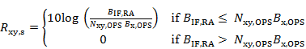 (A-2.x)

where is the IF-stage bandwidth of the RA under consideration, is the bandwidth required by a low or high rate OPS, see Table A-1.6, and is corresponding number of LI, LO, HI or HO OPSs as derived by Equation A-1.2.

Table A-2.1
Analogue radio altimeters
 | Radio altimeter A1 | Radio altimeter A2 | Radio altimeter A3 | Radio altimeter A4 | Radio altimeter A5 | Radio altimeter A6 | Units
Transmitter
Nominal center frequency | 4 300 | 4 300 | 4 300 | 4 300 | 4 300 | 4 300 | MHz
Transmitted power | 0.600 | 1 | 0.1 to 0.25 | 100 | 5 | 40 | W (peak)
Modulation (FMCW or Pulsed) | FMCW | FMCW | FMCW | Pulsed | Pulsed | Pulsed
Chirp bandwidth excluding temperature drift | 104 | 132.8 | 133 | Not applicable | Not applicable | Not applicable | MHz
Typical number of altimeter systems installed on an aircraft | Up to 3 | Up to 3 | Up to 3 | Up to 3 | Up to 3 | Up to 3 | Per aircraft
3 dB emission bandwidth | 110 | 162.8 | 171 | 8 | 7 | 15 | MHz
Receiver
Noise Figure | 10 | 6 | 6 | 10 | 10 | 10 | dB
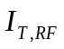 Input Threshold Receiver Overload | –30 | –53 | –56 | –40 | –40 | –40 | dBm
-3 dB Intermediate Frequency (IF) bandwidth | 2 | 0.25 | 0.025 to 2 | 9.2 | 6.0 | 16 | MHz
Antenna
Antenna gain | 10 | 9.5-10 | 10 typical, but different Antenna could be used | 13 | 11 | 11 | dBi
Cable loss (single path) | 6 | 6 | 2 to 7 | 6 | 6 | 6 | dB
-3 dB beam width | 40 to 60 | 55 | 45 to 60 | 35 | 45 | 45 | Degrees

Table A-2.2
Digital radio altimeters
 | Radio altimeter D1 | Radio altimeter D2 | Radio altimeter D3 | Radio altimeter D4 | Units
Transmitter
Nominal center frequency | 4 300 | 4 300 | 4 300 | 4 300 | MHz
Transmitted power (peak) | 0.400 | 0.100 | 0.1 to 1 | 5 | W (peak)
Modulation | FMCW | FMCW | FMCW | Pulsed
Chirp bandwidth excluding temperature drift | 150 | 176.8 | 133 | Not Applicable | MHz
Typical number of systems fitted | 2 or 3 | 2 or 3 | 1 or 2 | 1 or 2 | Per aircraft
3 dB emission bandwidth | 150 | 177 | 175 | 5 or 31 | MHz
Receiver
Noise figure | 8 | 9 | 8 to 12 | 10 | dB
Input Threshold Receiver Overload | –30 | –43 | –53 | –40 | dBm
–3 dB Intermediate Frequency (IF) bandwidth | 0.312 MHz  (LPF – Single sided) | 1.95 MHz | 0.1 to 2.0 | 30 | MHz
Antenna
Antenna gain | 11 | 10 | 8 to 11 | 13 | dBi
Cable Loss (single path) | 6 (10 max) | 0 | 2 to 7 | 0 to 2 | dB
-3 dB beam width | 40 to 60 | 45 to 60 | 45 to 60 | 45 | Degrees

A-2.1.1 Radio altimeter antenna characteristics and installation location
The scope of this section is to describe the model assumptions for the position and the antenna pattern of the radio altimeter on board an aircraft, throughout the following referred to as “RA-aircraft”. The onboard radio altimeter is assumed to be located at the geometrical center of the aircraft, as shown in Figure A-2.1. The radio altimeter antenna is oriented towards the Earth surface with its main beam direction pointing into the direction of the RA-aircraft’s yaw axis.
The radio altimeter antenna pattern a and is circular symmetric parabolic shape is assumed. It is parameterized by φ_{3dB}, the 3dB-beamwidth and G_{RA,dBi}, the isotropic antenna gain as stated in Tables A-2.1 and A-2.2. Because of its symmetry a single incident angle φ, which represents the combination of azimuth and elevation, is required in order to calculate the antenna gain G_{RA,dBi}. Hence the parabolic antenna pattern is described by:
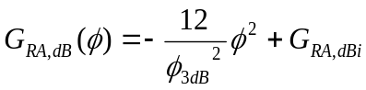. (A-2.5)
Figure A-2.2 shows the antenna patterns of all FMCW and pulsed type radio altimeters considered in this study. Any signal observed at the radio altimeter frontend input is additionally attenuated by a cable loss C_{L} after the antenna output, as defined in Tables A-2.1 and A-2.2.
Figure A-2.1
Radio altimeter antenna position onboard the aircraft
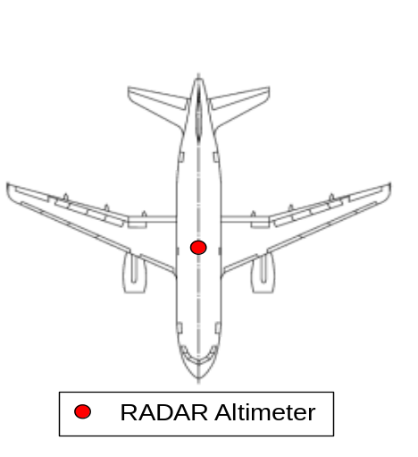

While the maximum gain and beamwidth for the various radio altimeter types are provided in [Preliminary] Draft New Recommendation ITU-R M.[RadAlt], the antenna patterns are not. Therefore, antenna patterns using the given information with the parabolic roll-off described by equation A-2.5 has been assumed. Figure A-2.2 provides a graphical representation of these antenna patters.
Figure A-2.2
Antenna patterns of various radio altimeters types
Radio altimeter A1 | Radio altimeter A3 |  | Radio altimeter D1
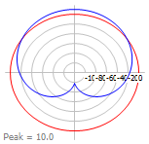 |  |  | 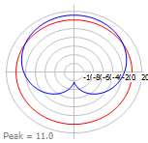
Radio altimeter D2 |  | Radio altimeter D3

A-2.2 Study 1

A-2.2.1 Introduction
The study contained in this section analyzes whether and under which conditions FMCW and pulse type radio altimeters operating in the band of 4 200 MHz – 4 400 MHz (see section A-2.1 of this Annex) and WAIC systems (described in Annex 1) can share the band. The study investigates the potential interference impact of WAIC systems onto radio altimeters as well as the potential interference impact of radio altimeters onto WAIC systems. The radio altimeters and WAIC systems are assumed to be installed at different aircraft. The aircraft equipped with a radio altimeter is hereafter referred to as “RA-aircraft”. Aircraft equipped with WAIC systems are hereafter referred to as “WAIC-aircraft”.
The separation distance between WAIC and RA-aircraft has major influence on the mutual interference impact onto both systems. According to Annex 2 to the Convention on International Civil Aviation (10th Edition) the minimal vertical separation distance between adjacent flight levels is 300 m. According to Doc 4444 “Procedures for Air Navigation Services – Air Traffic Management” of the International Civil Aviation Organization, the minimum horizontal separation distance is much larger than 300 m. Thus the assumed lower bound for the separation distance between two aircraft in flight is 300 m. Separation distances less than 300 m consequentially only occur in the vicinity of airports between a RA-aircraft performing landing or takeoff procedures and WAIC-aircraft on ground. For these cases, however, specific system characteristics such as antenna patterns, aircraft orientation, etc. influencing the interference geometry for these cases have to be taken into account. The mainbeam-to-mainbeam coupling approach taken for the in-flight case does not apply anymore (see section A-2.2.3).
The following study considers both of the scenarios mentioned above. The first part of the study analyzes the mutual interference impact between aircraft in flight. The second part of the study analyzes the interference impact between an RA-aircraft approaching an airport and one or multiple WAIC-aircraft on ground. The results of both scenarios a summarized in section A-2.2.4.

A-2.2.2 In-flight scenario
In flight, the onboard radio altimeter may suffer from harmful interference emitted by WAIC applications on board a WAIC-aircraft flying in proximity of the RA-aircraft and vice versa. In this section the minimal separation distance between aircraft in the air, which is required to protect the RA as well as WAIC systems from harmful interference, is derived. For the analysis it is assumed that the radio altimeter antenna main beam directly points into the direction of the omni-directional WAIC transmit/receive antenna (mainbeam-to-mainbeam coupling). The described worst-case scenario may occur if the RA-aircraft is located above the WAIC-aircraft.

A-2.2.2.1 Analysis of potential impact of Wireless Avionics Intra-Communications systems onto frequency modulated continuous wave and pulsed radio altimeters
The minimal separation distance between a WAIC and RA-aircraft is defined as the distance at which all four RA protection criteria, as described in section A-2.1 are met. These protection criteria are related to the interference power I_{RF} induced at the RA frontend. The highest WAIC interference power level at the RA antenna output is observed when the WAIC-aircraft is flying through the RA antenna main beam below the RA-aircraft. Consequently the worst-case interference power level I_{x,RF} observed at the RA antenna output caused by a LI, LO, HI or HO OPS on board the WAIC-aircraft is given by:

I_{xy,RF}(d_{RA}) = P_{Tx,x} + G_{WAIC} - L_{body} - L(d_{RA}) + G_{RA} - L_{C}, (A-2.6)

where P_{Tx,x} is the maximum transmit power of either the WAIC high or low rate OPS, G_{WAIC} is the maximum gain of the WAIC transmit antenna, L_{body} is fuselage attenuation applied for WAIC applications inside the aircraft fuselage, L(d_{RA}) is the free-space path loss at a vertical separation distance d_{RA}, G_{RA} is the maximum RA antenna gain, L_{C} is the RA cable loss and is corresponding number of LI, LO, HI or HO OPS as derived by Equation A-1.2.
The path loss in dB along the slant range d between an OPS and the RA antenna is calculated in accordance with Recommendation ITU-R P.525 by:

L(d) = 32.4 + 20log f + 20log d, (A-2.7)

In Equation A-2.7 f is the carrier frequency in MHz (in this case a value for f of 4 300 MHz is chosen which is the center frequency of the band), d. is the distance between transmitting and receiving antenna in km.

In the following sections the minimum separation distance required to protect the RA-aircraft from harmful interference is analyzed. For each WAIC application type, the aggregate interference power levels at the RA antenna output induced by the corresponding OPSs are calculated and utilized for comparison against the protection criteria. Table A-2.3 summarizes all WAIC system parameters utilized for the analysis.
TABLE A-2.3
Wireless Avionics Intra-Communications signal propagation parameters
Parameter | Value | Units
Fuselage attenuation L_{body} | 35* | dB
OPS transmit power for high data rate systems P_{Tx,H} | 17 | dBm
OPS transmit power for low data rate systems P_{Tx,L} | 10 | dBm
WAIC carrier frequency | 4 300 | MHz
* “shielded” attenuation scenario described in Draft New Report ITU-R M.[WAIC_CHAR_SPEC]

Radio altimeter frontend overload criterion
In order to avoid overload of the RA receiver frontend, it has to be ensured that the interference power at the frontend input I_{RF} never exceeds the RA-specific overload threshold I_{T,RF} defined in Tables A-2.1 and A-2.2. The results presented in Figure A-2.3 depict the dependence of I_{RF} on the separation distance between the RA and the WAIC-aircraft. Because the threshold I_{T,RF} is specific to the respective RA type, all plots are normalized to the overload threshold I_{T,RF} for the considered radio altimeter types. A violation of the frontend overload criterion occurs if I_{RF}/I_{T,RF} > 0 dB for any radio altimeter type. For WAIC high and low rate inside applications, the separation distance required to protect against a frontend overload is approximately 1 m.

FIGURE A-2.3
Frontend overload protection criterion versus separation distance
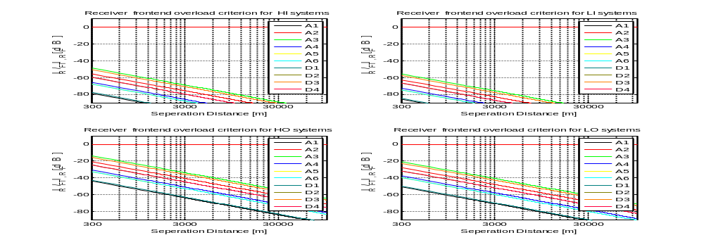

Radio altimeter receiver desensitization criterion
A desensitization of the RA receiver is likely to occur if the ratio of I_{IF} (the interference power in the IF-stage, i.e. the interference power referred to the IF-bandwidth) to N (the noise power referred to the IF bandwidth) exceeds -6 dB. Figure A-2.4 shows the I_{IF}/N ratio versus the separation distance for all RA types and WAIC system categories. In each of the plots shown in Figure A-2.4 a red line marks the -6 dB I_{IF}/N protection threshold. For the inside WAIC application categories this protection threshold is not exceeded for separation distances larger than 150 m.

Figure A-2.4
Receiver desensitization protection criterion versus separation distance
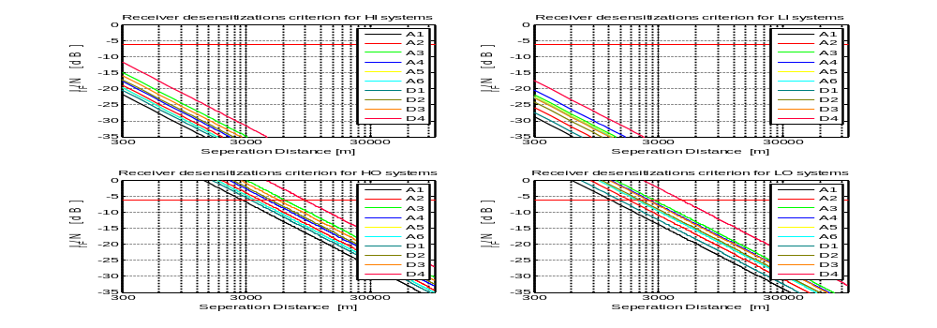

Radio altimeter false altitude report criterion
Interference in the RA detector stage may result in false altitude reports. To prevent false altitude detections caused by interference within the bandwidth of the detector stage the corresponding interference power level I_{D} is to be considered. In this context a detector bandwidth of 100 Hz is assumed for all FMCW RA types (see Draft New Recommendation ITU-R M.[RadAlt]). For that reason the protection threshold, which I_{D} must not exceeded, is defined as I_{T,FA} = -143 dBm/100 Hz. The criterion is not applicable for pulse type RA for that reason Figure A-2.5 only shows the relation between I_{D} and the separation distance for FMCW type RA. In each plot of Figure A-2.5 a red line marks the absolute -143 dBm/100 Hz protection threshold. For the inside WAIC application categories the protection threshold is not exceed for separation distances larger 100 m.

Figure A-2.5
False altitude protection criterion versus separation distance
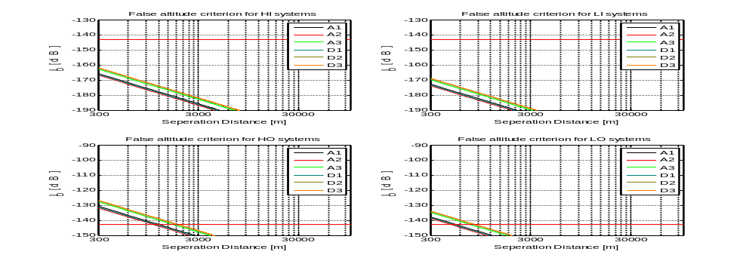

Radio altimeter power spectral density criterion
To ensure that the IF-stage is protected from overload conditions, the average power spectral density of the WAIC interference signal I_{PSD} is not allowed to exceed the protection threshold I_{T,1dBPSD}. Figure A-2.6 depicts the dependency of I_{PSD} on the separation distance. Because the threshold I_{T,1dBPSD} is specific to the respective RA type, all corresponding plots are normalized to protection threshold I_{T,1dBPSD}. A violation of the power spectral density criterion in this representation occurs if I_{PSD}/I_{T,1dBPSD} > 0 dB for any type of RA. For WAIC the inside application category the protection threshold I_{T,1dBPSD} is never exceeded for separation distances larger than 1 m.

Figure A-2.6
1dB power spectral density criterion versus separation distance
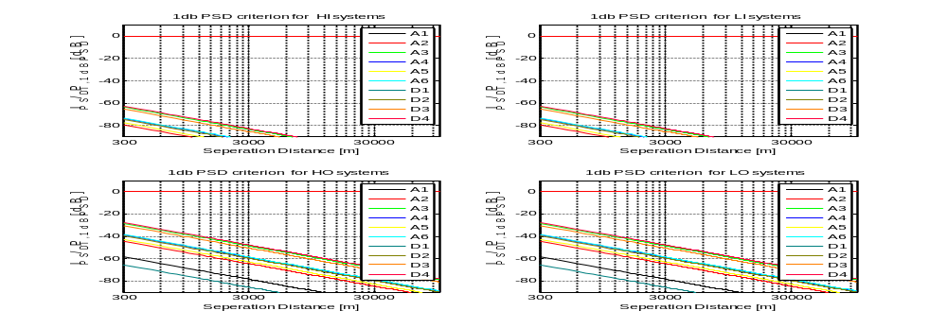

Summary
Analysis of the in-flight scenario shows that a minimal separation distance of 150 m is required to protect the radio altimeter from harmful interference of WAIC high and low rate systems of the inside application category.

A-2.2.2.2 Analysis of potential impact of FMCW and pulsed radio altimeters onto Wireless Avionics Intra-Communications systems
WAIC systems are designed to provide reliable wireless communication between two stations onboard an aircraft. The reliability of a wireless communication link is mainly defined by three parameters: The propagation environment, the distance between the transmitting and receiving WAIC station d_{WAIC} and the transmit power P_{TX,x}, see Figure A-2-7. Depending on the propagation environment, d_{WAIC} and P_{TX,x} of WAIC high or low data rate systems are configured such that a sufficiently high signal power level S, required for reliable communication at the receiver, is always guaranteed.
Draft New Report ITU-R M.[WAIC_CHAR_SPEC] specifies maximum allowable values for d_{WAIC} and P_{TX,x}. The report also provides a set of path loss models for different propagation environments between points inside and outside the aircraft structure. A detailed description of these models can be found in the Draft New Report ITU-R M.[WAIC_CHAR_SPEC]. Consequently S is given by
S(d_{WAIC}) = P_{TX,x} + G_{WAIC} + G_{WAIC} - L_{WAIC,n}(d_{WAIC}), (A-2.8)

where L_{WAIC,n}(d_{WAIC}) is the path loss at distance d_{WAIC} of the n^{th} model listed in Table A-1.3 and G_{WAIC} the transmit and receive antenna gain of the WAIC stations, as depicted in Figure A-2.7.
Figure A-2.7
Graphical representation of the calculation of the Signal-to-Interference power ratio for WAIC systems
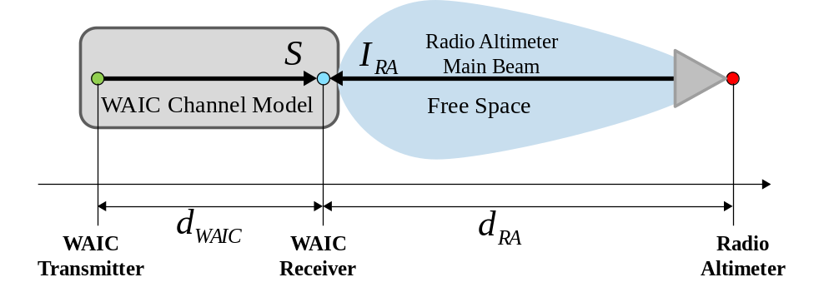

According to Table A-1.1 the maximum distance between two WAIC stations on board an aircraft is 15 m. Given this value, the minimal signal power level observed at a receiving WAIC station for all propagation environments can be derived.
WAIC systems are organized in cellular sub networks on a compartment basis as specified in Draft New Report ITU-R M.[WAIC_CHAR_SPEC]. That implies that there is no communication among WAIC stations located in different aircraft compartments, or between a station internal and another station external to the aircraft structure. For that reason, only the radio channel models A, B and F of Table A-1.3 are deemed applicable for determining the minimum WAIC receive signal power level.
The minimal receive signal power levels resulting from these channel models are listed in Table A-2.4, assuming a WAIC high data rate system transmit power of P_{TX,H} = 17 dBm, a WAIC low data rate system transmit power of P_{TX,L} = 10 dBm and a WAIC transmit/receive antenna gain of G_{WAIC} = 0 dBi as stated in Table A-1.1.
Table A-2.4
Minimal WAIC receive signal power
Group | Group name | Min. WAIC high rate receive signal power | Min. WAIC low rate receive signal power
A | Intra-Cabin & Intra-Flight Deck | S_{A,H} = -52.7dBm | S_{A,L} = -59.7dBm
B | Inter-Cabin | S_{B,H} = -57.5dBm | S_{B,L} = -64.5dBm
F | Inter-Exterior | S_{F,H} = -55.5dBm | S_{F,L} = -62.5dBm

The potential impact of an interfering FMCW or pulsed radio altimeter signal onto WAIC systems is only experienced at receiving WAIC stations. In-flight, the worst-case power level of an interfering RA signal received at a WAIC station is given by

I_{RA}(d_{RA}) = P_{TX,RA} - L(d_{RA}) - L_{body} + G_{RA,dBi} - C_{L} + R_{E.} (A-2.9)

where L(d_{RA}) is the free-space path loss at the distance between the receiving WAIC station and the RA transmit antenna d_{RA}, P_{TX,RA} is the transmit power of the radar altimeter, L_{body} is attenuation applied for WAIC applications inside the aircraft fuselage, G_{RA,dBi} is the maximum RA antenna gain and C_{L} is the RA cable loss.
The bandwidth ratio R_{E} is applied to account for the fact that only a fraction of the energy of an interfering RA signal with a 3dB emission bandwidth B_{RA} larger than the 3dB IF-bandwidth B_{IF,WAIC} of a WAIC station, is observed as interference at a receiving station.
Considering pulse type RAs the bandwidth ratio R_{E} is given by:

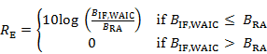. (A-2.10)

The instantaneous signal bandwidth of FMCW type RAs is small compared to B_{IF,WAIC}. Thus the entire energy of an FMCW signal falls into the IF-stage of a receiving WAIC station. Consequently the bandwidth ratio equals one (R_{E} = 0dB) for FMCW type radio altimeters.

Harmful interference from FMCW or pulse type RAs onto WAIC systems does not occur as long as the interference to signal power ratio (I/S) is below the thresholds defined by the WAIC protection criteria described in Draft New Report ITU-R M.[WAIC_CHAR_SPEC]. For WAIC low data rate systems the I/S threshold is given by:

I_{RA}(d_{RA})/S_{x,L} < -9 dB, (A-2.11)

where S_{x,L} is the minimal receive signal power of low data rate systems derived by the use of channel model x (A,B or F).
For WAIC high data rate system the threshold is

I_{RA}(d_{RA})/S_{x,H} < -14 dB, (A-2.12)

where S_{x,H} is the minimal receive signal power of high data rate systems.

Given the dependencies described above, the potential impact of a radio altimeter onto a WAIC system can be analyzed for any given separation distance between a receiving WAIC station and a RA transmit antenna.
The plots in Figure A-2.8 show the corresponding I/S ratios of the radio altimeter interference power level I_{RA} and the WAIC receive signal power level S vs. separation distance for all four WAIC system categories and their associated protections thresholds (red lines). In accordance with section A-1.2 channel models A and B are applied for the WAIC inside application categories.
The analysis shows that a separation distance larger than 270 m will protect all WAIC inside application categories from harmful interference.
Figure A-2.8
I/S observed at a WAIC receiving station vs. separation distance
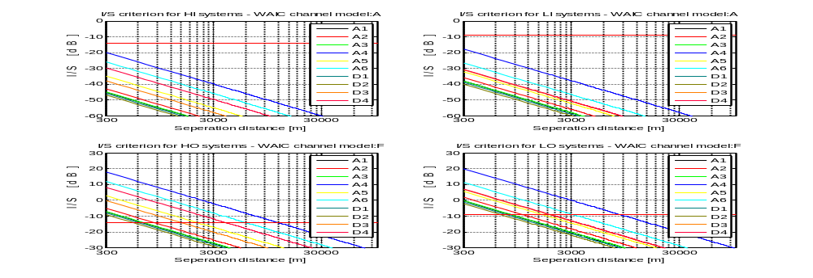
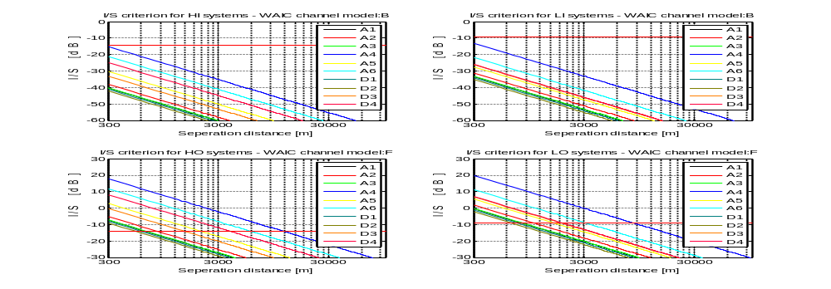

A-2.2.3 Airport scenario
The most critical operational phase for the radio altimeter of the RA-aircraft is during final stage of landing. Consequentially, interference from aircraft equipped with WAIC systems occurring during landing is most critical. Because the distances between aircraft lining up in the air for landing are large (~5 km), interference from WAIC systems is only expected from aircraft on ground at the airport premises. In this case the separation distances between the RA- and WAIC-aircraft can be less than 300 m.
In this case potentially harmful interference is only expected if WAIC-aircraft are located in close vicinity to the volume illuminated by the radio altimeter antenna beam beneath the landing RA-aircraft. Consequentially, situations in which potentially harmful interference may occur are limited to scenarios where WAIC-aircraft are located on taxiways near to the runway approached by the landing RA-aircraft.
For that reason, the following sections investigate two scenarios. The first scenario describes a situation where multiple WAIC-aircraft are taxiing for takeoff next to the runway which the RA-aircraft is approaching for landing. This scenario is hereafter referred to as “airport taxiway scenario”. The second scenario describes a situation in which a WAIC-aircraft is located on a taxiway holding position next to the touchdown zone of the runway which is approached by a landing RA-aircraft. The described scenario is hereafter referred to as “airport holding bay” scenario.

A-2.2.3.1 Airport taxiway scenario description
In this scenario the landing approach of an RA-aircraft is specified by a model with two parameters:
– the RA-aircraft altitude 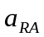, see Figure A-2.10.
– the orthogonal projection of the RA-aircraft’s position on the centerline of the runway in the y-axis direction 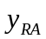, see Figure A-2.9.
Thus, the center point of the RA-aircraft is always assumed to be located above the centerline of the runway.
The scenario considers a configuration with several WAIC-aircraft queuing on a taxiway parallel to the runway dedicated for landing, as shown in Figure A-2.9. A separation distance of d_{Taxi} = 80 m for aircraft on the taxiway is assumed.
The WAIC systems on board the taxiing WAIC-aircraft are model by the OPS concept introduced in section A-1.3. In this model OPSs representing inside WAIC applications are located at the center of the aircraft cabin and OPSs representing outside WAIC applications are located at the wingtip closest to the RA-aircraft, as shown in Figure A-2.11. The selected locations lead to minimal slant ranges between the RA antenna and the OPS representing inside and outside WAIC application categories on board the taxiing WAIC-aircraft. This can be seen as a worst-case scenario regarding the impact of mutual interference. In reality WAIC stations are distributed over the entire aircraft and not concentrated at the locations closest to the RA.
FIgure A-2.9  Airport scenario top view  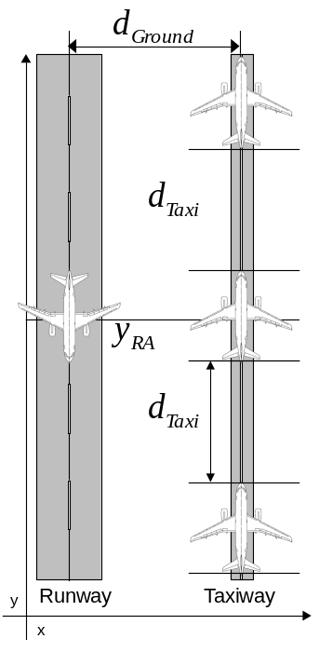 | Figure A-2.10  Airport scenario frontal view  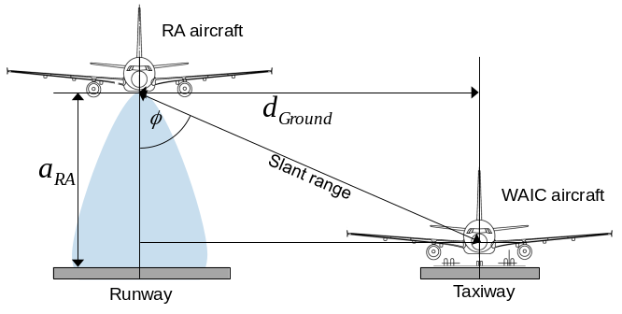
FIGURE A-2.11
WAIC-aircraft OPS distribution
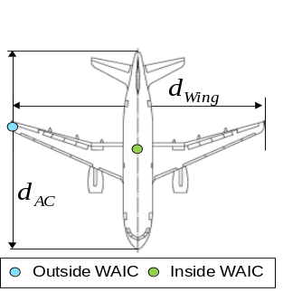

Given the WAIC-aircraft model described above the interference impact of the RA-aircraft onto WAIC-aircraft and vice versa is significantly influenced by two parameters:
– the slant range between the RA antenna position and the WAIC OPS.
– the angle-dependent antenna gain 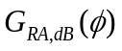.
Both parameters are directly related to , , the distance between the runway and taxiway centerlines 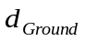. the aircraft dimensions and the location of the OPS on board the WAIC-aircraft.
Annex 14 to the Convention on International Civil Aviation and the IATA Airport Development Reference Manual provide design rules for. Six reference aerodromes (ICAO code letters A-F) and the associated maximum dimensions for aircraft allowed to land on the corresponding runways are introduced. The determining factor in this context is the aircraft wingspan. The reference aerodromes and the associated reference aircraft types are listed in Table A-2.5.
In the following a scenario where a RA-aircraft on ground (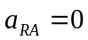) and a single WAIC-aircraft on the taxiway located abreast the position of the RA-aircraft is considered. Regarding this scenario, the slant ranges between radio altimeter antenna and the inside/outside OPS are minimal and depend linearly on . Because the slant ranges are proportional to the path loss of the WAIC signal observed at the radio altimeter antenna, lower values of lead to higher interference power. However, the airport type and the associated WAIC-aircraft size influence the minimum possible slant range, i.e. the maximum possible coupling between WAIC systems and the radio altimeter receive antenna of the RA-aircraft. The corresponding ranges are listed in Table A-2.5.
Table A-2.5
Airport classification with associated aircrafts types
Reference Aerodrome (ICAO Aerodrome Reference Code) | WAIC-aircraft |  |  | Distance between taxiway and runway centerlines d_{Ground} (m) | Distance between outside OPS and runway centerline (m) | Distance between inside OPS and runway centerline (m)
 | Type | Length  (m) | Span  (m)
B | CRJ 200 | 26.76 | 21.21 | 87.00 | 65.79 | 87.00
C | A319 | 33.84 | 34.10 |  | 133.90 | 168.00
 | A320-200 | 37.57 | 34.10 | 168.00 | 133.90 | 168.00
 | B737-800 | 39.50 | 34.30 |  | 133.70 | 168.00
D | A310-300 | 46.66 | 43.90 |  | 132.10 | 176.00
 | B757-200 | 47.33 | 38.06 | 176.00 | 137.94 | 176.00
 | B767-300ER | 57.94 | 47.57 |  | 128.43 | 176.00
E | A340-600 | 75.30 | 63.45 |  | 119.05 | 182.50
 | B777-200 | 63.73 | 60.95 | 182.50 | 121.55 | 182.50
 | B747-400 | 70.67 | 64.94 |  | 117.56 | 182.50
F | A380 | 73.00 | 79.80 | 190.00 | 110.20 | 190.00

Considering an increasing RA-aircraft altitude, the slant ranges remain minimal as long as the RA-aircraft is not moved along the -dimension. Consequently the path loss for any value ofalso remains minimal. But an increasing values of will lead to a decreasing incident angle at the RA antenna, see Figure A-2.10. Therefore it leads to an increase of antenna gain 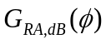. Again the will remain minimal for any value of as long as the RA-aircraft’s position remains unaltered and abreast to the taxiing aircraft. Hence the described scenario leads to maximum impact of a RA-aircraft onto WAIC-aircraft and vice versa for any value of and any given airport type. In this regard, the worst interference impact can be expected for reference aerodrome type B and its associated aircraft type since for this aerodrome type the resulting “on ground” slant ranges are minimal.
Although the maximum interference scenario described above only takes a single WAIC-aircraft into account, corresponding considerations do also apply for multiple taxiing WAIC-aircraft. For that purpose the geometrical center point on the y-axis of all WAIC-aircraft has to be abreast the RA-aircraft position, as shown in Figure A-2.9.
The number of 5 WAIC-aircraft is deemed to be appropriate since any higher number will only cause a deviation smaller than 0.5dB from the results presented in sections A-2.2.3.3 and A-2.2.3.4. The parameters used for the investigation of the airport taxiway scenario are shown in Table A-2.6.
Table A-2.6
Airport taxiway scenario parameters
Parameter | Value
d_{Taxi} | 80 m
d_{Ground} | 87 m
WAIC-aircraft wingspan | 21.21 m
WAIC-aircraft length | 26.76 m
Number of WAIC-aircraft | 5

A-2.2.3.2 Airport holding bay scenario description
In this scenario potential mutual interference between a landing RA-aircraft and a WAIC-aircraft waiting for takeoff at a runway holding bay next to the runway entrance is analyzed. The minimal distance on ground between the RA-aircraft and the WAIC-aircraft is given when the RA-aircraft is located directly above the touchdown zone (see Figures A-2.12 and A-2.13). As a consequence, the mutual interference impact solely depends on the landing RA-aircraft altitude.
The WAIC systems on board the WAIC-aircraft waiting at the runway holding bay are modeled using the OPS concept introduced in section A-1.3. In this model OPSs representing inside and outside WAIC applications are located at the nose tip of the WAIC-aircraft, as shown in Figure A-2.14. The selected locations lead to minimal slant ranges between the RA antenna and the OPS representing inside and outside WAIC application categories on board the WAIC-aircraft. This can be seen as a worst-case scenario regarding the impact of mutual interference. In reality WAIC stations are distributed over the entire aircraft and not concentrated at the locations closest to the RA.

FIGURE A-2.12  Airport holding bay scenario top view  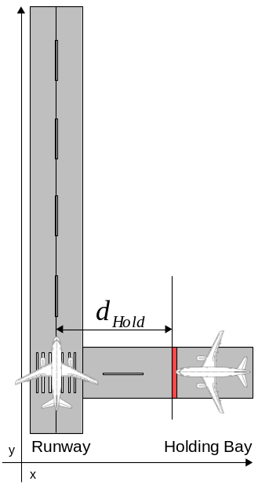 | FIGURE A-2.13  Airport holding bay scenario frontal view  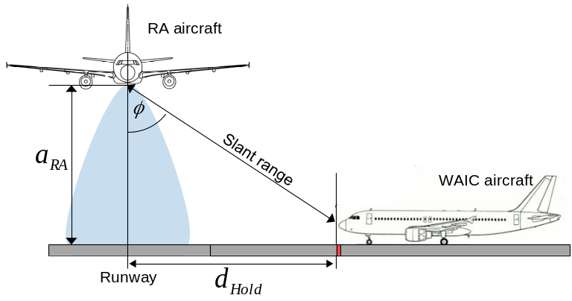
FIGURE A-2.14
WAIC-aircraft OPS distribution
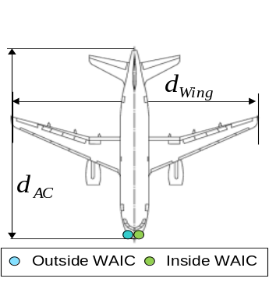

Given the WAIC-aircraft model described above the interference impact of the RA onto WAIC systems and vice versa is significantly influenced by two parameters:
– the slant range between the RA antenna position and the WAIC OPS.
– the angle-dependent antenna gain .
Both parameters directly depend on , the distance between the runway touchdown zone and the runway holding bay position d_{Hold}, the aircraft dimensions and the location of the OPS on board the WAIC-aircraft as shown in Figure A-2.14.
According to the airport design rules described in Annex 14 to the Convention on International Civil Aviation, the separation distance d_{Hold} depends on the length of the associated runway, as shown Table A-2.7. The ICAO reference aircraft type which requires the shortest runway length and hence the lowest separation distance is the Bombardier CRJ 200 (see Table A-2.5). Specifications provided by Bombardier state that the minimal runway length required by the CRJ 200 is 1 479 m, which is a code number 3 type runway (see Table A-2.7). Thus the minimal separation distance which maximizes the impact of mutual interference is d_{Hold} = 75 m. All parameters used for the investigation of the airport holding bay scenario are summarized in Table A-2.8.

TABLE A-2.7
Minimum distance (d_{Hold}). between the runway center line and a runway holding position
 | Code Number
Type of runway | 1 | 2 | 3 | 4
Runway reference length | Less than 800m | 800m up to but not including 1200m | 1200m up to but not including 1800m | 1800m and more
Non-instrument | 30m | 40m | 75m | 75m
Non precision approach | 40m | 40m | 75m | 75m
Precision approach category I | 60m | 60m | 90m | 90m
Precision approach categories II and III | - | - | 90m | 90m
Table A-2.8
Airport holding bay scenario parameters
Parameter | Value
d_{Hold} | 75 m
WAIC-aircraft wingspan | 21.21 m
WAIC-aircraft length | 26.76 m
Number of WAIC-aircraft | 1

A-2.2.3.3 Analysis of potential impact of Wireless Avionics Intra-Communications systems onto FMCW and pulsed radio altimeters
The OPS introduced in section A-1.3 are assumed to transmit with a power of P_{Tx,H} = 17 dBm for high data rate systems and P_{Tx,H} = 10 dBm (see Table A-2.9). The fuselage attenuation is assumed to be constantly 35 dB (‘shielded’ case) as specified in ITU-R PDNR M.[WAIC_CHAR_SPEC]. This results in an attenuation of the signals emitted by inside OPSs of L_{Body} = 35 dB.
TABLE A-2.9
Wireless Avionics Intra-Communications signal propagation parameters
Parameter
Aircraft body attenuation L_{Body} | 35 dB
High rate OPS transmit power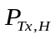 | 17 dBm
Low rate OPS transmit power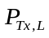 | 10 dBm
WAIC carrier frequency | 4 300 MHz

The four protection criteria described in section A-2.1 all relate to I_{RF} the LI, LO, HI and HO WAIC interference power observed at the RA-frontend input. When taking the impact of the WAIC antenna gain G_{WAIC}, the fuselage attenuation L_{Body}, the signal propagation loss L(d), the RA antenna gain , the cable loss C_{L}, the WAIC transmit signal power P_{TX} and the corresponding number of LI, LO, HI or HO OPSs N_{xy,OPS} as derived by Equation A-1.2 into account, the interference power level observed at the RA-frontend input is described by:
I_{x,RF} = 10log(N_{xy,OPS}) + P_{TX,x} + G_{WAIC} - L_{Body} - L(d) + G_{RA,dB}(φ) - C_{L}. (A-2.13)
The results of the airport taxiway and airport holding bay scenarios presented throughout the following are depicted in a common format. For each protection criterion four plots are presented per each WAIC system category. Each of these plots shows an evaluation of a parameter specific to the considered protection criterion vs. the RA-aircraft’s altitude.

Frontend overload criterion
In order to avoid overload of the RA receiver frontend, it has to be ensured that the interference power at the frontend input I_{RF} never exceeds the RA-specific overload threshold I_{T,RF} defined in Tables A-2.1 and A-2.2. The results presented in Figures A-2.15 and A-2.16 depict the dependence of I_{RF} on the RA-aircraft’s altitude in the airport taxiway and airport holding bay scenarios. Because the threshold I_{T,RF} is RA-specific, all plots are normalized to the overload threshold I_{T,RF} for the considered RA types. A violation of the frontend overload criterion occurs if I_{RF}/I_{T,RF} > 0 dB for any type of RA. The results show that the frontend overload criterion is not exceeded for any of the analyzed RA types in both scenarios.
Figure A-2.15
Airport taxiway scenario: frontend overload protection criterion
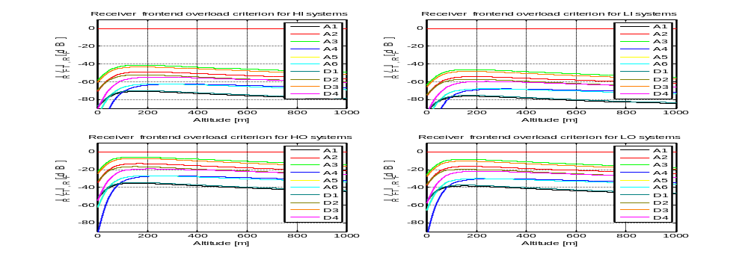

Figure A-2.16
Airport holding bay scenario: frontend overload protection criterion
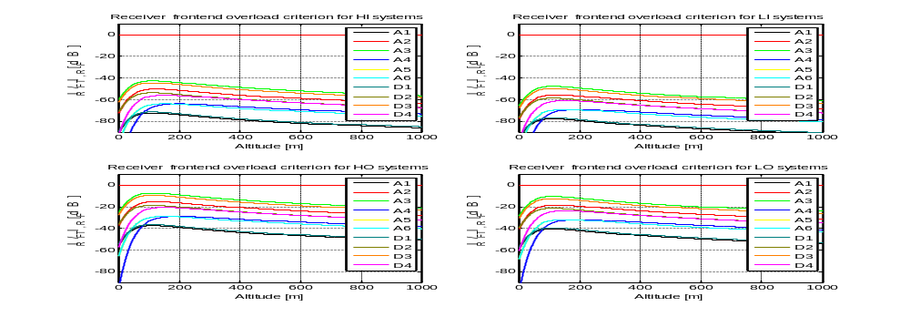

Receiver desensitization
A desensitization of the RA receiver is likely to occur if the ratio of I_{IF} (the interference power in the IF-stage, i.e. the interference power referred to the IF-bandwidth) to N (the noise power referred to the IF-bandwidth) exceeds -6 dB for any of the considered RA types. Figures A-2.17 and A-2.18 show the evaluation of the I_{IF}/N ratio versus the RA-aircraft’s altitude for all considerer RA types and WAIC system categories in the airport taxiway and airport holding bay scenarios. In each of the plots shown in Figures A-2.17 and A-2.18 a red line marks the -6 dB I_{IF}/N protection threshold. For the inside WAIC application categories the protection threshold is never exceeded for all RA types in both scenarios.

Figure A-2.17
Airport taxiway scenario: receiver desensitization protection criterion
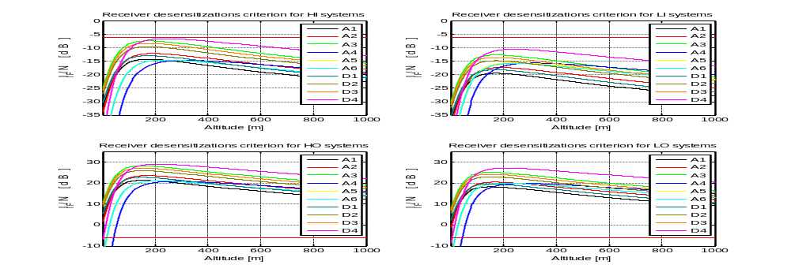

Figure A-2.18
Airport holding bay scenario: receiver desensitization protection criterion
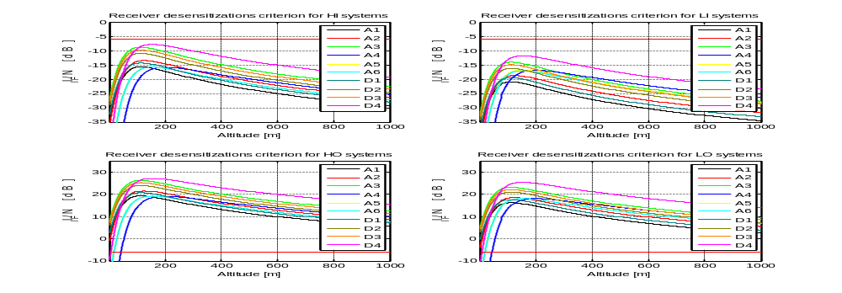

False altitude report
Interference in the RA detector stage may result in false altitude reports. To prevent false altitude detections caused by interference within the bandwidth of the detector stage the corresponding interference power I_{D} is considered. In this context a detector bandwidth of 100 Hz is assumed for all FMCW RA types. For that reason the protection threshold, which should not be exceeded by I_{D}, is defined to be I_{T,FA} = -143 dBm/100 Hz. Figures A-2.19 and A-2.20 show the relation between I_{D} and the RA-aircraft’s altitude for all considered RA types and WAIC system categories in the airport taxiway and airport holding bay scenario. In each plot of Figures A-2.19 and A-2.20 a red line marks the absolute -143 dBm/100 Hz protection threshold. For the inside WAIC application categories the protection threshold is never exceeded.

Figure A-2.19
Airport taxiway scenario: false altitude report protection criterion
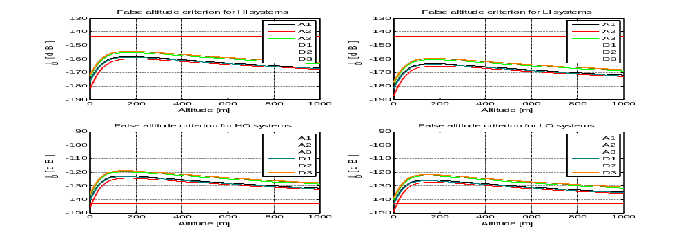

Figure A-2.20
Airport holding bay scenario: false altitude report protection criterion
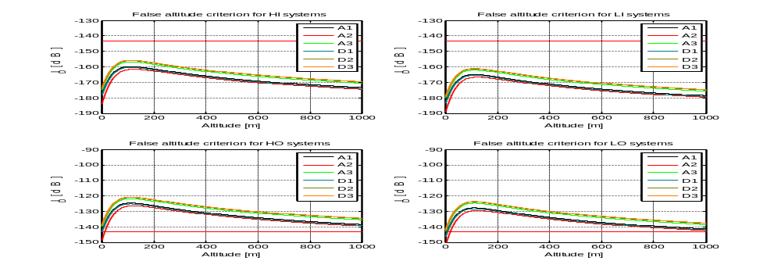

Power spectral density
To ensure that the IF-stage is protected from overload conditions the average power spectral density of the WAIC interference signal I_{PSD} is not allowed to exceed the protection threshold I_{T,1dBPSD}. The results presented in Figures A-2.21 and A-2.22 depict I_{PSD} vs. the RA-aircraft’s altitude in the airport taxiway and airport holding bay scenarios. Because the threshold I_{T,1dBPSD} is RA-specific, all corresponding plots are normalized to the protection threshold I_{T,1dBPSD} for all considered FMCW RA types. A violation of the power spectral density criterion in this representation occurs if I_{PSD} /I_{T,1dBPSD} > 0 dB for any type of RA. The power spectral density criterion is not exceeded for any of the RA types in both airport scenarios.

Figure A-2.21
Airport taxiway scenario: power spectral density protection criterion
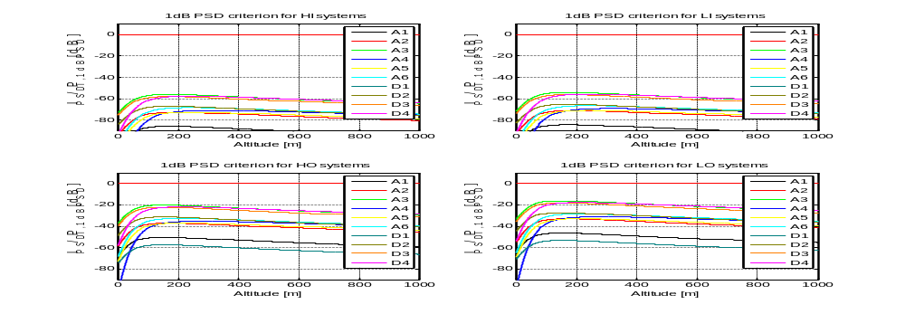

Figure A-2.22
Airport holding bay scenario: power spectral density protection criterion
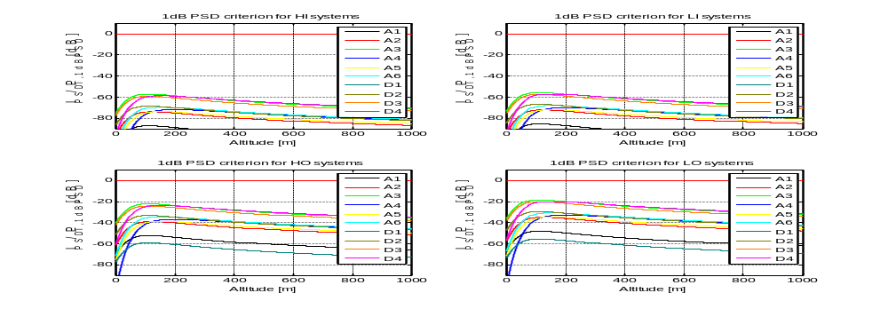

A-2.2.3.4 Analysis of potential impact of FMCW and pulsed radio altimeters onto Wireless Avionics Intra-Communications systems
The signal propagation model utilized to investigate the I/S protection criterion of WAIC systems is similar to the model described in section A-2.2.2.2. Moreover, the interference impact of the RA onto WAIC systems may vary at different locations inside the WAIC-aircraft due to the close distance between RA and WAIC-aircraft. For that reason different positions for receiving WAIC stations representing the WAIC inside and outside application categories at which the RA interference signal is evaluated, are evaluated. These positions are the same as the positions of the WAIC OPS described in sections A-2.2.3.1 and A-2.2.3.2.
Furthermore, due to the close distances between RA and WAIC-aircraft in the airport scenario the pattern of the radio altimeter transmit antenna has to be taken into account in the evaluation of the I/S ratio. Therefore, static RA mainbeam equation A-2.9 is modified in order to reflect the incident angle between the receiving WAIC station and the RA antenna as described in sections A-2.2.3.1 and A-2.2.3.2. Thus the interference power level at the receiving WAIC station at a distance d_{RA} to the RA antenna is given by:
I_{RA}(d_{RA}) = P_{TX,RA} - L(d_{RA}) - L_{Body} + G_{RA,dB}(φ) - C_{L} + R_{E}. (A-2.14)
The WAIC receive signal power levels S_{y,x} at the receiving WAIC stations are listed in Table A-2.4.
In the airport taxiway scenario the interference impact of the RA-aircraft onto WAIC is analyzed at the taxiing WAIC-aircraft abreast the RA-aircraft. The interference impact onto the other taxiing WAIC-aircraft is not considered since it will always be lower due to the larger separation distances.

Results
The investigation of the I/S ratio protection criteria for the airport taxiway and airport holding bay scenarios are presented in a common format. Each of the plots depicted in Figures A-2.23 and A-2.24 shows an evaluation of the I/S ratio vs. the RA-aircraft’s altitude. The four plots of each figure depict the results for the inside WAIC application categories for the relevant radio channel models A and B.
The results show that in both scenarios the I/S ratio protection criterion for inside WAIC high and low data rate applications is never exceeded. For WAIC outside applications the results show an exceedance of the protection criteria of up to 31 dB (e.g. for the HO WAIC application category, RA type A4 and the airport taxiway scenario).

FIGURE A-2.23
Airport taxiway scenario: scenario: I/S protection criterion
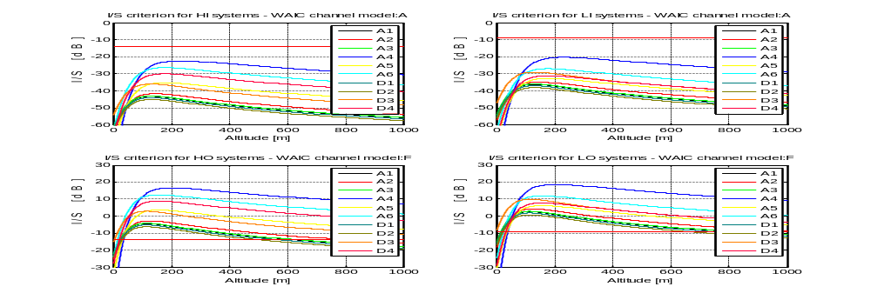
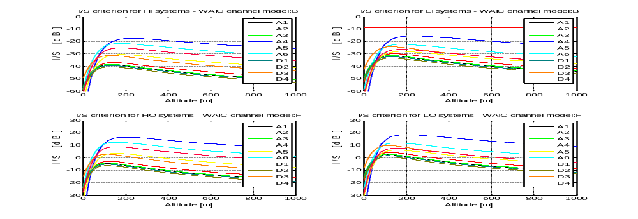

FIGURE A-2.24
Airport holding bay scenario: I/S protection criterion
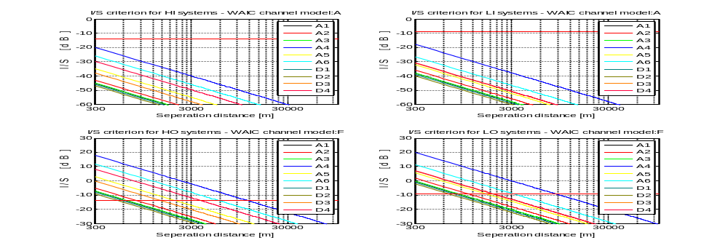
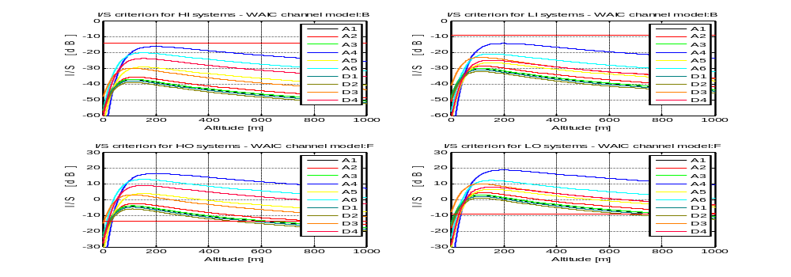

A-2.2.4 Conclusions
TBD
______________

