SECOND WORKING GROUP MEETING OF THE
FREQUENCY SPECTRUM MANGEMENT PANEL (FSMP)

(FSMP-WG/2)

Montreal, Canada, 15-19 February 2016

Agenda Item 2a: Outcome of WRC-15 (General)

NEW METHODOLOGY FOR THE PROTECTION OF AERONATUCAL SYSTEMS

(John Mettrop)

SUMMARY
This paper identifies, that as a result of the 2015 World Radiocommunication Conference, the need of finding a new methodology for ensuring the protection of aeronautical systems has become more urgent. The paper therefore recommends that the feasibility of using an approach first proposed at the 31st Meeting be further investigated.

- INTRODUCTION
  - The provision of air traffic control is generally regarded as a safety of life service and that the air ground radio systems used for it’s provision require the appropriate level of protection. This has traditionally been provided by operating those system in frequency bands allocated to an appropriate aeronautical safety service and applying a safety margin in all compatibility studies. In Recommendation 1/12, ANC-12 supported such an approach by requesting the development and implementation of a comprehensive aviation frequency spectrum strategy … which includes the following objectives: … clearly state in the strategy the need for aeronautical systems to operate in spectrum allocated to an appropriate aeronautical safety service.
- DISCUSSION
  - As spectrum has become an apparently more scarce resource so aviation has been increasingly challenged to justify the level of protection required and why an additional safety margin should be included in compatibility studies. Additionally those seeking to gain access to spectrum allocated to aeronautical services have employed relevant aeronautical system experts to help build their case and undermine the arguments of aviation.
  - The method provisionally adopted by WRC-15 to resolve agenda item 1.5 further undermines the civil aviation position by using allocations to a non-aeronautical safety service for an aeronautical safety critical system. Where it to be adopted then it sets a precedence that aviation are prepared to operate a safety critical air ground radio system operating in an allocation to a non-safety service and furthermore that at least one element of that safety critical system operate on a secondary basis, a precedence for an aeronautical radio system. The fact ICAO whilst noting some reservations appeared to endorse the method and certainly made no reference to needing to be judge in the light of the need to operate aeronautical safety systems in frequency bands allocated to an appropriate aeronautical safety service, in the minds of many was effectively accepting the precedent.
  - Having reviewed the ICAO statement the CAA could only agree with the view that a precedent has been set and hence we have decided that we will be neutral on the inclusion of safety margins in future compatibility/sharing studies until the WRC-15 agenda item 1.5 has been finally concluded. We will then make a decision at that point whether will then press for or object to the inclusion of a safety margin.
  - Given all of the above it is my belief that we need to review how we protect our own systems and develop a methodology that can be applied consistently to all of those systems based on the required performance of that system noting that a system may consist of one or more individual radio links. Noting that if we agree to develop a new mehod then it will eventually need to be incorporated into an ITU-R Recommendation or even a Radio Regulatory provision, the FSMP must ensure that the work has reached a reasonable level of maturity before submitting into the ITU process
  - A method was proposed at the 31st meeting of ACP working Group F (see annex 1) but unfortunately I have had little time to develop the proposal further. Whilst I am still willing to develop the concept futher it would be useful if the working group could provide some guidance on the following issues:-

Information source: What source should be used for information on the performance requirements of the various systems (accuracy, percentage of time etc) and how should those performance requirements be divided between equipment factors and the radio link itself? I presume the first source should be ICAO SARPs or handbook material but what should be used in the absence of definitive information?

Distribution of tolerances: Should the worst case be used in each case or should it be some form of probability distribution model where in cases the average value would be zero and then some form of standard deviation applied?

Distribution model: Assuming the answer to the previous case is to use a probability distribution model then which distribution model should be used?
  - Whilst I am not expecting answers to the above questions at this meeting it would be helpful if members would be prepared to provide advice subsequent to this meeting in such a time frame as to allow work to be done in time for the next meeting.
- ACTION BY THE MEETING
  - The meeting is invited to:
- note and review the contents of this working paper;
- support the development of a new methodolgy for ensuring that aeronautical systems are given suitable protect during compatibility/sharing studies.
- To provide guidance either during or after the meeting on the following points as eloborated in paragraph 2.6:
- Information source
- Distribution of tolerances.
- Distribution model

Annex 1
 | International Civil Aviation Organization  WORKING PAPER
  ACP-WGF31/WP-26

AERONAUTICAL COMMUNICATIONS PANEL (ACP)

31st MEETING OF WORKING GROUP F

Seattle, Washington October 6-10, 2014

Agenda Item 3: | Aviation Safety Margins

Protection of aeronautical systems

(Presented by John Mettrop)

SUMMARY
This paper revisits the working paper 10 from the 29th meeting of ACP-WG-F with a view to moving the work on the development of justified protection criteria for aeronautical systems further forward.
ACTION
The meeting is invited to take the following action:-
- Note the information used within the document
- Agree to work, in conjunction with the other relevant groups within ICAO to identify the performance required from various aeronautical systems approached on the approached outlined in this paper or some other method.
- Continue to using worst case analysis and the addition of a safety margin in studies within the International Telecommunication Union until work on the previous bullet point has been completed.

- INTRODUCTION
  - The provision of air traffic management and the required supporting radiocommunication system infrastructure are generally recognised as a safety of life system. In recognition of this the aeronautical mobile (R), aeronautical mobile satellite (R), aeronautical radionavigation and aeronautical radionavigation satellite services are regarded within the International Telecommunication Union as safety of life services. As a result there are a number of special provisions within the Radio Regulations in order to facilitate the protection of systems operating under allocations to those services
  - In carrying out sharing studies aviation traditionally has used a worst case analysis and added a 6dB margin to cover factors that may be present in reality but could not be covered in a theoretical study. However the realism of scenarios being considered, especially the percentage of time, and the use of a safety margin are increasingly being questioned by those who would for various reasons prefer to see a less stringent sharing condition.
- discussion
  - If aviation as an industry is to remain credible within the radio regulatory environment, especially in the perceived spectral congestion believed to exist, it has to be able to justify not only its needs in terms of spectrum but also the levels of protection it requires in a traceable manner.
  - If aviation is to be able to able to provide a credible argument for how compatibility should be analysed it must be able to justify not only the scenario proposed but also the various factors included in that scenario such as time percentage and any margins that should be included. The final part of the argument required is the impact of a factor being exceeded.
  - Drawing on some work done in another part of the CAA it might be reasonable to assume that what we are looking at is that for every aircraft there will be a bubble of uncertainty around the location of that aircraft. The size of that bubble being determined by the navigational accuracy of the ground/airborne systems including the update rates of those systems and the ability of the aircraft and/or ground system to detect a deviation from the location 3 dimensional location.
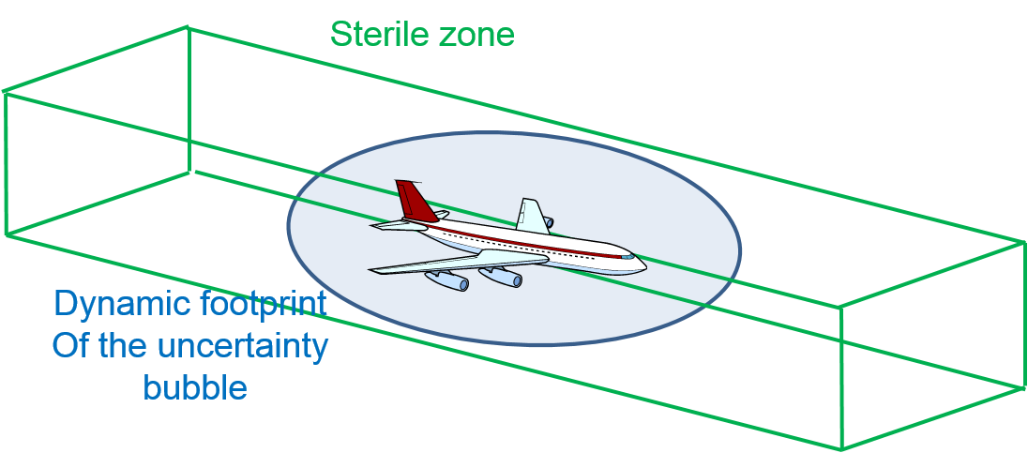
  - The aim of the air traffic management system is then to ensure that the bubbles of location uncertainty for 2 aircraft do not overlap more than a certain percentage of time which is ideally zero. In order to achieve this the separation standards are designed to place a sterile zone around an aircraft and its bubble of location uncertainty such that the probability of 2 aircraft bubbles overlapping is kept to an acceptable level determined by a hazard analysis carried in accordance with ICAO Document 9859. An extract of the UK CAA publication CAP 670 is contained in the annex to this document giving an example of a Risk/Severity/Probability Matrix and definitions. The size of the sterile zone will depend on a number of factors such as:-
- Accuracy of surveillance systems
- Reaction time of controller/pilot
- Communication delay
- Performance constraints of the aircraft
- etc
  - Whilst the identification of a sterile zone would not be an easy process and involve a number of factors which if included in the diagram below would make it hard to understand, the simplified example below I hope helps understand this concept.
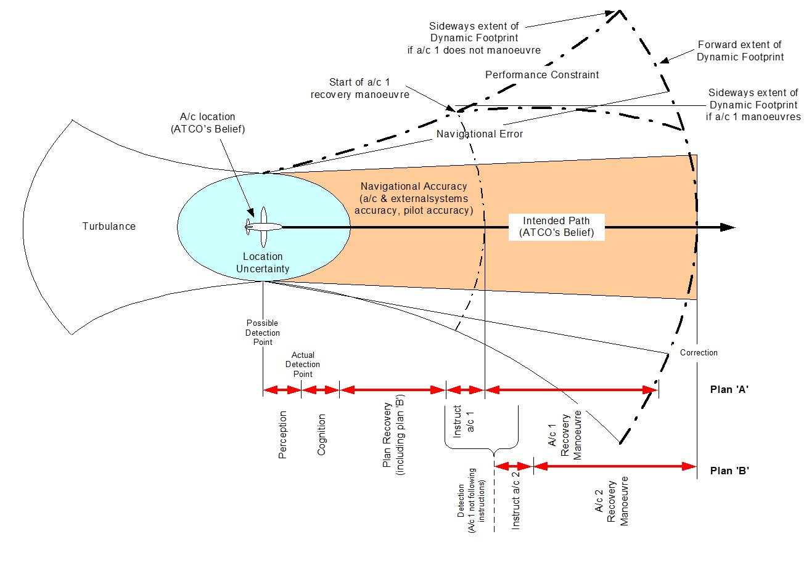
  - The exact determination of the sterile zone will depend on the identifications of the various hazards, their causes and potential mitigations as well as the impact of such a hazard if uncorrected as illustrated by the following diagram.
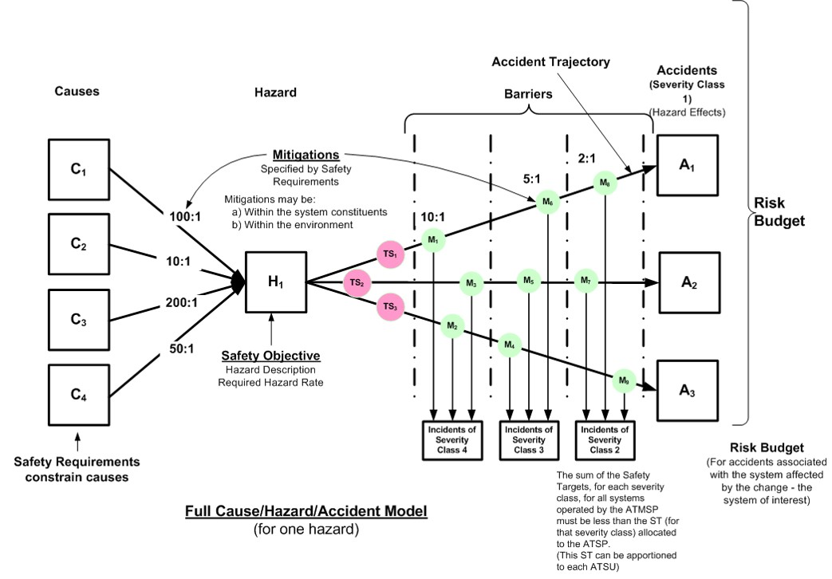
  - In spectrum management terms what we as spectrum engineers need to understand are the critical scenarios, the acceptable level of risk associated with those scenarios and the amount of that acceptable risk can be associated with the availability of the radio link alone.
- Conclusion
  - Aviation needs to improve the way in which it justifies its arguments. However until we can follow an approach such as the one described above we have no alternative but to continue using the approach current used based on worst case scenarios and use of a safety margin.
  - It is therefore suggested that WG-F work in conjunction with other relevant groups to try and define a model that would allow the identification of the size of the sterile zone, and allowable apportionment of the various factors that go into the determination of the sterile zone that can be attributed to the performance of the radio link.
- ACTION BY THE MEETING
  - The ACP WGW is invited to:
- Note the information used within the document
- Agree to work, in conjunction with the other relevant groups within ICAO to identify the performance required from various aeronautical systems approached on the approached outlined in this paper or some other method.
- Continue to using worst case analysis and the addition of a safety margin in studies within the International Telecommunication Union until work on the previous bullet point has been completed.
ANNEX
Example Risk/Severity/Probability Matrix
and Definitions

The requirements of a safety case are globally defined in ICAO Document 9859 “Safety Management Manual” as implemented through regional/national legislation requiring the production of a safety case. In Europe this has been done through the 4th part of Eurocontrol Safety Regulatory Requirement (ESARR4) brought into legislation by the European Commission Implementing Rule (EU) No 1035/2011. The information below however is taken from CAP 670 but is based on the ICAO and EASA requirements
.
Accident | an occurrence associated with the operation of an aircraft which, in the case of a manned aircraft, takes place between the time any person boards the aircraft with the intention of flight until such time as all such persons have disembarked, or in the case of an unmanned aircraft, takes place between the time the aircraft is ready to move with the purpose of flight until such time it comes to rest at the end of the flight and the primary propulsion system is shut down, in which:  ● a person is fatally or seriously injured as a result of:  – being in the aircraft, or,  – direct contact with any part of the aircraft, including parts which have become detached from the aircraft, or,  – direct exposure to jet blast, except when the injuries are from natural causes, self- inflicted or inflicted by other persons, or when the injuries are to stowaways hiding outside the areas normally available to the passengers and crew; or  ● the aircraft sustains damage or structural failure which adversely affects the structural strength, performance or flight characteristics of the aircraft, and would normally require major repair or replacement of the affected component, except for engine failure or damage, when the damage is limited to a single engine, (including its cowlings or accessories), to propellers, wing tips, antennas, probes, vanes, tires, brakes, wheels, fairings, panels, landing gear doors, windscreens, the aircraft skin (such as small dents or puncture holes) or minor damages to main rotor blades, tail rotor blades, landing gear, and those resulting from hail or bird strike, (including holes in the radome); or  ● the aircraft is missing or is completely inaccessible;
Serious Incident | an incident involving circumstances indicating that there was a high probability of an accident and is associated with the operation of an aircraft, which in the case of a manned aircraft, takes place between the time any person boards the aircraft with the intention of flight until such time as all such persons have disembarked, or in the case of an unmanned aircraft, takes place between the time the aircraft is ready to move with the purpose of flight until such time it comes to rest at the end of the flight and the primary propulsion system is shut down.
Major Incident | An incident associated with the operation of an aircraft, in which the safety of the aircraft may have been compromised, having led to a near collision between aircrafts, with ground or obstacles.
Significant Incident | An incident involving circumstances indicating that an accident, a serious or major incident could have occurred, if the risk had not been managed within safety margins, or if another aircraft had been in the vicinity
No Effect Immediately | An incident where there is no immediate effect on safety
Table 1: Example Severity Classification Scheme
  - The tolerability of any particular is then assessed in accordance with a risk classification/tolerability matrix an example of which is provided below.
ESARR 4  Severity | Probability of Occurrence
ESARR 4  Severity | Extremely improbable | Extremely remote | Remote | Reasonably probable | Frequency
ESARR 4  Severity | <10⁻⁹ per hour | 10⁻⁷ to 10⁻⁹  per hour | 10⁻⁵ to 10⁻⁷  per hour | 10⁻³ to 10⁻⁵  per hour | 1 to 10⁻³  per hour
Accidents | Review | Unacceptable | Unacceptable | Unacceptable | Unacceptable
Serious incident | Acceptable | Review | Unacceptable | Unacceptable | Unacceptable
Major incident | Acceptable | Acceptable | Review | Unacceptable | Unacceptable
Significant incident | Acceptable | Acceptable | Acceptable | Review | Unacceptable
No immediate effect | Acceptable | Acceptable | Acceptable | Acceptable | Review
Table 2: Example Risk Classification/Tolerability Matrix
  - The tolerability of a risk being defined as follows:-
Acceptable - the consequence is so unlikely or not severe enough to be of concern. The risk is tolerable and the Safety Objective has been met. However, consideration should be given to reducing the risk further to as low as reasonably practical in order to further minimise the risk of an accident or incident.
Review - the consequence and/or likelihood is of concern; measures to mitigate the risk to as low as reasonably possible should be sought. Where the risk still lies within the 'Review' region after as low as reasonably possible risk reduction has been undertaken, then the risk may be accepted provided that the risk is understood and has the endorsement of the individual ultimately accountable for safety within the organisation.
Unacceptable - the likelihood and/or severity of the consequence is intolerable. Major mitigation or redesign of the system may be necessary to reduce the likelihood or severity of the consequences associated with the hazard.

— END —

