FREQUENCY SPECTRUM MANAGEMENT PANEL (FSMP)

Sixteenth Working Group meeting

Bangkok, Thailand, 15 – 24 February 2023

Agenda Item 3b): Development of Material for ITU-R Studies on WRC-23 AI1.7 VHF AMS(R)S

Frequency assignment planning and coordination exercises on AI 1.7 VHF ASMS(R)S. Further considerations on regulatory affairs

(Presented by: Manuel Garcia)
(Prepared by: ENAIRE, Indra)

SUMMARY

Studies on WRC-23 agenda item 1.7 towards defining a new allocation of the band 117.975-137 MHz to the aeronautical mobile satellite (route) service (AMS(R)S) are quite advanced and close to completion by ITU-R Working Party 5B (WP 5B). A specific report has been developed by WP 5B including technical compatibility analysis when using several technologies (voice, datalink) for aeronautical mobile satellite (route) services and covering the band 117.975-137 MHz with the aim of supporting WRC23 decision on new AMS(R)S allocation. Also, draft CPM text (regulatory text to assist the work of the WRC 23) has been developed.

ICAO has already responded to ITU-R WP 5B on certain elements regarding the regulatory framework where AMS(R)S would be developed. The technical and compatibility analysis of future AMS(R)S networks and other services operating in adjacent band above 137 MHz have been addressed via static and dynamic studies, although still with some ongoing discussions about the methodology or protection criteria to be applied. Despite the reasonable understanding of the interference scenario between future AMS(R)S and other adjacent band services, the compatibility of in band operations of AMS(R)S and AM(R)S falls directly within the competence or possibilities of ICAO for solving such coexistence.

This document aims also at serving to further develop the ICAO position versus Agenda Item 1.7 WRC-23.

Action by the meeting: Take note of these further considerations on frequency assignment planning exercises and regulatory framework, to confirm ITU-R that ICAO can certainly continue managing the shared use of the AMS(R)S, AM(R)S and AM(OR)S by continuing the application of frequency assignment exercises, development of allotment plan when necessary and apply coordination procedures, as appropriate.

- INTRODUCTION
  - The ITU context (Radio Regulations)
ITU is addressing the compatibility studies following the WRC-23 AI 1.7 “to consider a new aeronautical mobile-satellite (R) service (AMS(R)S) allocation in accordance with Resolution 428 (WRC-19) for both the Earth-to-space and space-to-Earth directions of aeronautical VHF communications in all or part of the frequency band 117.975-137 MHz, while preventing any undue constraints on existing VHF systems operating in the AM(R)S, the ARNS, and in adjacent frequency bands”
The key setting the regulatory procedures to be applicable is the Radio Regulations (RR) document body. The RR establishes the definition of services, the allotment of frequencies, the protection criteria and special provisions in our case, for the aeronautical mobile services.
It is very important to differentiate between allocation, allotment and assignment as defined on RR 1.16 - 1.17 and 1.18. ITU R RR is currently studying the feasibility of new allocation to AMS(R)S while the subsequent studies on allotments and assignments will be likely conducted by ICAO and national civilian aviation and spectrum management administrations, likely at later stages once the conditions to use the new allocation would be defined by the future WRC-23. Certainly, ICAO can develop preliminary planning exercises or conduct studies towards anticipating potential options regarding the allotment, assignment and coordination procedures which will have to be conducted once the ITU WRC23 will have decided on the conditions to operate AMS(R)S.
It is also important to bring here the definition provided by RR for the aeronautical mobile services, AMS (RR 1.32), AM(R)S (RR 1.33), AM(OR)S (RR 1.34) and AMS(R)S (RR 1.36).
In this point it is important to note that RR defines rules for the assignment and use of the frequencies in its article 4. It introduces the fundamental principle that individual administrations can use the spectrum in any way they wish, provided interference is not caused to services operating in conformity with the agreements in the RR and which are registered in the Master International Frequency Register (MIFR). But also establishes that the safety services require special measures to ensure their freedom from harmful interference; it is necessary therefore to take this factor into account in the assignment and use of frequencies (RR 4.10). Note the difference between interference, which always exists in the radioelectric spectrum and harmful interference when such interference has the potential to harm the victim services.
The more important chapter of the RR related with Aeronautical Services is Chapter VIII (Articles 35 to 45) – Aeronautical Services that deals exclusively with aeronautical matters and addresses licensing and regulatory aspects of allocations as well as service operational matters. These matters are applicable to all aircraft operations, whether for civil, national governmental purposes. Special note to article 43 (Special rules relating to the use of frequencies).
Definitions of the boundaries of the major world air routes areas (WMARAs) and definitions of the regional and domestic air routes areas (RDARAs) combined with a footprint space systems characteristics definition could be used to establish a frequency allotment plan to help the Nationals Administration for the assignment of frequencies in an international coordination context.
Specific tools or upgraded versions of Safire/Manif or Frequency Finder tools could be developed to help the coordination procedures between Administrations combining the current AM(R)S global allotment and national assigned frequencies with the new AMS(R)S allotment and assignment frequencies.
  - ICAO – SARPS
ICAO has developed a set of documents related to the procedures to use by the aeronautical services in the allocated frequency bands.
Those documents address both, the technical requirements, the frequency allotment and assignment and the operational coordination.
The following documents are key references on this matter:
- Annex 10 – Volume V - Aeronautical Radio Frequency Spectrum Utilization.
- ICAO Handbook on Radio Frequency Spectrum Requirements for Civil Aviation including statement of approved ICAO policies (Doc 9718).
- Annex 10 – Volume III – Communications Systems
- ICAO Doc. 9776 – Manual on VHF Data Link (VDL) Mode 2
- Manual on the Aeronautical Mobile Satellite (Route) Service (Doc 9925)
- Global Operational Data Link (GOLD) Manual (Doc 10037)
Using the comprehensive set of procedures included in the above documents, it can be easily understood that ICAO has procedures to carry out the coordination between AMS(R)S, AM(R) and AM(OR) and can be used as a basis for developing any further required procedures once the allocation of the AMS(R)S service in the band 117.975-137MHz is decided by ITU WRC23.
Emphasis is made on the fact that ITU-R defines the conditions for use of a new allocation to the AMS(R)S without concluding on any allotment or assignment of the frequencies. The ITU-R processes to agree on a new allocation are mostly based on compatibility with other services using adjacent bands. Once the new allocation is defined by ITU-R, ICAO will conduct the subsequent stages on allotment, if required, or assignment of frequencies consistently with the conditions specified by ITU-R for the use of the new allocation as well as frequency assignments coordination procedures. Before ITU-R decides on the new allocation, ICAO can certainly conduct examples of exercises on frequency planning just to evidence that there would be tools to ensure the subsequent studies on allotment and/or assignments while protecting other aeronautical mobile services can be certainly undertaken.
Difference may be made with respect to the technologies being planned for new AMS(R)S: voice or data communications. While voice communications are mostly based on the assignment of a dedicated channel, the data communication has the potential to share the frequency channel between different links, including AM(R)S and AMS(R)S.

- Current tools for frequency assignment coordination
There is not a unique tool to coordinate the frequencies assignment. Some ICAO regions use the Frequency Finder tool while other uses SAFIRE or their own solution. These tools are usual mechanisms both for frequency planning exercise as well as for assisting on the sharing studies. As an example, SAFIRE is intensively used in Europe due to the congestion of frequencies and necessary reuse of frequencies: the coordination process is already defined and known by the ICAO European Administration using the tool on a daily basis.
The coordination inside ICAO EUR area is efficient but the coordination with other ICAO Regional neighbours is not processed in an automated way and, so far, an Administration-to-Administration coordination process could be more practical process than a regular coordination between ICAO Regionals Offices.

3 Current global statistic frequency assignments review
This section provides statistical analysis on the usage of the frequency assignments to preliminary identify possible saturation of the available spectrum or whether there may be heterogeneous or unbalanced usage of certain frequency assignments.
Despite the different tools and process followed by the ICAO Regional Offices, a first approach was done to analyse the usage of VHF 117.975-137MHz channels worldwide. Several statistical analyses were performed in order to study potential scenarios that could help to develop a worldwide coordination process for frequency assignments. The outcome of this first analysis indicates that defining a coordination process on a Regional basis could be an easy and practical way to establish the frequency assignment criteria for the AMS(R)S.
From such study, it can be derived several key facts:
- There are more than 35 channels used lest than 10 times worldwide, in contrast with other channels which are used more than 500 times.
- The more saturated sub-bands are:
  - 129-132MHz due to the AOC ground stations worldwide
  - 136-137MHz due to the VDL-Mode 2 ground stations in Europe.
- Less usage is done for the sub-band is 117.975-129MHz.
- There are also more than 40 channels not used so far in a global basis with the exception of some countries.
- 5 channels are no used worldwide.
- The coordination processes should be done on a Regional basis, as a more practical mechanism.

4 Timeline for ITU-R and ICAO developments on new allocation to AMS(R)S and subsequent frequency assignment phases
Assuming that a new AMS(R)S allocation is adopted by the ITU-R WRC-23, and that ICAO will develop the associated standards, there is a huge potential benefit for the aeronautical sector exploiting this new allocation, which can be implemented in the short, medium or even longer terms.
ITU-R defines the conditions for use of a new allocation to the AMS(R)S without concluding/constraining on any future allotment or assignment of the frequencies. The ITU-R process to agree on a new allocation is mostly based on compatibility with other services using adjacent bands. It should be borne in mind that in the band 117.975-137 MHz, there are only aeronautical services, therefore, ITU-R may not need defining specific conditions for assigning frequencies to aeronautical services. Once the new allocation is defined by ITU-R, ICAO would conduct the subsequent stages on allotment or assignment of frequencies consistently with the conditions specified by ITU-R for the use of the new allocation. Before ITU-R decides on the new allocation, ICAO can certainly conduct examples of exercises on frequency planning just to evidence that there would be tools to ensure the subsequent studies on allotment and/or assignments while protecting other aeronautical mobile services.
Consequently, ICAO can start its internal studies and considerations related to AMS(R)S by developing the relevant Standards and Recommended Practices (SARPs) in the whole VHF aeronautical frequency band 117.975-137 MHz with the aim to make them available after the WRC-23 and continue/complete the studies on frequency assignment planning and coordination once the conditions of use of the new AMS(R)S allocation are defined by ITU-R WRC-23.
It is important to clarify the different timelines of ICAO and ITU. Each Organization has different responsibilities and competences and carry out their work under different rules and timelines.
The following picture provides a summary of the typical timeline:
Two main documents are the vehicles to record all activities of the scope of this agenda item:
- The Preliminary Draft New Report (PDNR) which is elaborated by the competent ITU-R Working Party 5B who has the responsibility to conduct the technical compatibility studies.
- The Conference Preparatory Meeting (CPM) Report which includes the regulatory conditions and summary of studies to help WRC-23 to take decisions.
The resulting decisions of the WRC-23 would require modifications to the Table of frequency Allocations included in the Article 5 of the Radio Regulations. The CPM includes methods to satisfy the mandate of the agenda item. The draft CPM text regarding agenda item 1.7 has been already provided by the Director of the ITU BR and will be discussed at the CPM meeting early 2023.
ICAO has created two main working groups to collect and discuss the contributions related to this agenda item and to study the necessary review of the current ICAO SARPS, these groups are the FVSG (Future VHF Sub Group) reporting to ICAO-PT-T and collecting all the activities and studies to review the SARPS and the CG-SV (Coordination Group – Satellite VHF) reporting to ICAO-FSMP and collecting all the Questions and Answers related to the Space-Based VHF and related to the future AMS(R)S operating in the VHF frequency band.
Independently of next FSMP meetings, February 2023 and by August-September 2023, there are other two keys important meetings at ICAO to set the ICAO position for the WRC-23, one is the at Air Navigation Commission level by March-April 2023 and at Council level by May-June 2023.
It is necessary to bear in mind the correct order of international procedures to use a frequency assignment, that is, a portion of frequency spectrum for a service. The first step is the allocation of this service in the Table of frequency Allocation in Article 5 of the Radio Regulations. If there is not a service allocation, there is not possible use by that service, particularly if safety communications are addressed. This allocation will set the conditions for operation of the aeronautical mobile-satellite (R) service, which will be based mostly on requirements to ensure the compatibility with other services.
Therefore, the first step is to adopt the new allocation to the aeronautical mobile-satellite (R) service in the frequency band 117.975-137 MHz in order to support aeronautical VHF communications in the Earth-to-space and space-to-Earth directions. This first crucial stage is currently in elaboration in the ITU domain when a definitive CPM text will be approved in March-April 2023 by ITU R.
Once the allocation is in place, the second step is to define an allotment and/or assignment of frequencies and the procedures for coordination, which could be implemented at a worldwide and/or on a regional basis. This Coordination Plan and Procedure could be defined by a worldwide entity as ICAO in coordination with the ICAO Regional Offices. The plan or criteria for frequency assignment and coordination procedures should be established once the allocation is decided by ITU-R and conditions associated to the usage of such allocation be identified by ITU-R, likely on the basis of requirements to ensure technical compatibility with other adjacent band services.
The possibilities to undertake the frequency planning exercise and the subsequent coordination procedures are preliminary evidence showing that it would be feasible to carry out such exercises and the necessary coordination procedures even using tools currently in place and regularly used by ICAO and ICAO Regional Offices while observing the technical requirements, the conditions identified so far in the feasibility studies, and the operational compatibility studies provided by this and other documents and further documented in the PDNR of the ITU-R WP5B. All this material and studies provide evidence that there is room for several mechanisms to undertake the frequency planning exercises and procedures for international and national coordination of the frequency assignments.
At it is mentioned in section 5.3 of Attachment E, Volume II of ICAO Handbook on Radio Frequency Spectrum Requirements for Civil Aviation including statement of approved ICAO policies (Doc 9718), the economic value of spectrum allocated to certain applications can exceed by far the economic value of aeronautical applications of the same spectrum. This has recently been demonstrated by the results of the “spectrum auctions” conducted in several countries to support future commercial mobile multimedia systems. This situation requires aviation to clearly identify the need and economic value of required spectrum in certain bands and to consider innovative approaches to guarantee the required level of safety-service availability.
That is, in order to ensure that ICAO can access to suitable spectrum for the ICAO safety communications needs in the future, any opportunity to allocate aeronautical services should be used by ICAO to provide the aeronautical community with alternative solutions, not only for the short term, but also with a longer-term perspective. Technology would evolve over time and different mechanisms of assignment of frequencies or coordination or SARPs may be developed by using the WRC-23 allocation to the aeronautical mobile-satellite (R) service.
Note should be taken that ITU-R allocations are decided only at WRC. WRCs are held every 4 years. Including agenda items for possible new allocations is not a fast process and require many years of studies. ICAO should not dismiss the opportunity offered by WRC-23 to obtain a new allocation for aeronautical mobile satellite (route) service which would be available for ICAO during decades. ICAO can develop the standards for use of the new AMS(R)S allocation when convenient for ICAO as well as conduct the necessary frequency planning exercises at its own pace, provided ITU WRC-23 would have concluded on the new allocation to AMS(R)S.
Considering the different timelines of ICAO and ITU where each Organization has different responsibilities and carry out their work under different rules and timelines and considering the current process status at ITU and ICAO related with the WRC-23 AI 1.7, ICAO should continue supporting the efforts of the ITU-R WP 5B and CPM to help deciding on a new allocation to AMS(R)S in the band 117.975-137 MHz. Similarly, ICAO can conduct its own preliminary internal studies to analyze the operational compatibility of AMS(R)S with AM(R)S, the necessary update of SARPs if needed and preliminary exercises on frequency planning and coordination options.

5 AMS(R)S, AM(R)S and AM(OR)S sharing and coordination
Although the final exercises on frequency planning and coordination among AMS(R)S, AM(R)S and AM(OR)S should be completed once the ITU R would have decided on the conditions for use of new allocation to AMS(R)S, initial considerations can be made:
- AMS(R)S and AM(R)S as defined in RR 1.36 and RR 1.33 respectively, are considered for safety-of-life.
- AM(OR)S as defined in RR 1.34 is not appropriate for safety-of-life operations.
- The RR 44 gives the order of priority of communications and RR 43.1 “§ 1: Frequencies in any band allocated to the aeronautical mobile (R) service and the aeronautical mobile-satellite (R) service are reserved for communications relating to safety and regularity of flight between any aircraft and those aeronautical stations and aeronautical earth stations primarily concerned with flight along national or international civil air routes.
- The RR foot notes 5.201 and 5.202 provide additional allocation to AM(OR)S in the band 132-137MHz for certain countries, these footnotes state that “In assigning frequencies to stations of the aeronautical mobile (OR) service, the administration shall take account of the frequencies assigned to stations in the aeronautical mobile (R) service” and therefore, the current AM(OR)S services operating in this band have to be also protected to the same level they are protected versus AM(R)S.
- The RR 4.10 Member States recognize that the safety aspects of radionavigation and other safety services require special measures to ensure their freedom from harmful interference; it is necessary therefore to take this factor into account in the assignment and use of frequencies.
- Under RR 6.3 Member States may, under the provisions for special arrangements in the Constitution, conclude, on a worldwide basis, and as a result of a conference to which all Member States have been invited, special agreements concerning the assignment of frequencies to those of their stations participating in a specific service, on condition that such assignments are within the frequency bands allocated exclusively to that service in Article 5.
- The RR 9 establishes the Procedure of effecting coordination with or obtaining agreement of other administrations.
- That the protection criteria defined for AM(R)S in co-frequency and adjacent frequency shall apply in the AMS(R)S and AM(R)S planning assignment and coordination but also same criteria can be applied for AMS(R)S and AM(OR)S planning assignment and coordination. However, AM(OR)S systems operate in channels within national assignments, which themselves are managed by the followings ICAO members: regional organizations and national regulators. Therefore, the compatibility between AMS(R)S and AM(OR)S assignments should be resolved through their conventional frequency planning exercise, as ICAO has already informed to ITU-R WP 5B. In the event that a new allocation is made to AMS(R)S in this band, the corresponding responsible organization will develop a corresponding channel plan for use of AMS(R)S frequencies to ensure compatibility between the satellite and terrestrial uses of the band. By protecting existing terrestrial assignments, this plan should protect any existing assignments to AM(OR)S.
- Regarding protection of AMS(R)S space station, some countries are proposing the regulatory provision that AMS(R)S space station would not be entitled to claim protection. While the interference risks from other adjacent band satellite services into AMS(R)S space station are negligible (as indicated in the latest version of the ITU-R PDNR ITU-R M.[SPACE-VHF], it is understood that a safety related service should be able to be protected from harmful interference generated by other services operating in the adjacent band above 137 MHz. In a detailed review of satellite networks operating above 137 MHz, it can be noted that the frequency assignments associated to those other networks are generally narrow band with assigned bandwidths of 25 kHz, 50 kHz and few other larger bandwidths, which means that the large majority of emissions from those networks will fall under the category of spurious emissions and consequently AMS(R)S space station would be protected under Appendix 3 provisions. However, there are some theoretical assignments of those networks operating in the edge of the band, at 137.0-137.050 kHz which would fall under out of band emissions. A worst-case dynamic study is reported in the ITU-R WP 5B PDNR ITU-R M.[SPACE-VHF], by which a aggregated interference generated by ALL those other satellite networks either operational or notified would be negligible.
- An allotment plan and frequency coordination procedures could be developed on a worldwide and/or on a regional basis. This Coordination Plan and Procedure could be defined by a worldwide entity as ICAO in coordination with the ICAO Regional Offices.
- Once the Coordination Plan and Procedure is defined, the National Administration could assign frequencies to AMS(R)S; this assignment could be in a worldwide coordination, in a regional coordination basis or could be between Administrations coordination following the RR Art. 9.
Based on the above considerations, it can be concluded that the coordination between AMS(R)S, AM(R)S and AM(OR)S can be conducted following similar principles and procedures as applicable so far for AM(R)S and AM(OR)S.

6 REGULATORY FRAMEWORK DEFINED BY ARTICLES 9 AND 11 OF THE RADIO REGULATIONS
The options of applicable procedures for coordination of AMS(R)S and aeronautical mobile (route) services (AM(R)S) discussed in this contribution take also into account the ICAO’s view on the requirement for an overall regulatory framework for the frequency planning and coordination process, as provided in Document 5B/652 from ICAO.
Working Party (WP) 5B draft new Report ITU-R M.[SPACE-VHF], in its Chapter 8.1, reads: "ICAO is of the position that if there is any potential interference between AM(R)S and AMS(R)S, it would be resolved by the ICAO through conventional frequency planning exercise, assigning frequencies to the satellite system over interested regions, to ensure compatibility between ground and satellite facilities. Therefore, from an ICAO perspective there is no need to perform a comprehensive compatibility study within ITU-R between these two different services, that cover the same system on-board the aircraft. Both are technically similar services as the same on-board cockpit avionics system (for VHF communications) would be used for ground and satellite communications". This ICAO advice to WP 5B is logical from the point of view of the interest of ICAO to control and manage any future assignment to AMS(R)S, while protecting AM(R)S.
At the light of the above two considerations (request from ICAO for an overall regulatory framework to be established by ITU and frequency planning process expected to be undertaken by ICAO), several procedural options are identified from provisions of the Radio Regulations which may be applicable to future AMS(R)S networks.

6.1 Background
The decision to allocate this band for the AMS(R)S by WRC-23 will require the appropriate identification of procedures which will have to be applied by the new AMS(R)S networks sharing this frequency band.
Satellite networks, for several satellite services, use the provisions of Articles 9 and 11 of the Radio Regulations to ensure a mechanism which avoid harmful interference between satellite networks sharing the same spectrum. When RR Articles 9 and 11 are applicable, the corresponding allocation include a footnote addressing the applicability of Article 9, usually by calling to the whole set of provisions or a subset of them, depending on the sharing scenario for each band. While ICAO may further take responsibility on defining specific frequency assignments suitable for the operation of AMS(R)S, the existing coordination procedure at ITU level may be necessary prior to any ICAO action or anticipating/complementing it.
The provisions of RR Articles 9 and 11 are further complemented by other rules of procedures which provide clarification on the application of specific provisions or establishing additional practical procedures.
A summary of some relevant provisions for the case of coordination procedures affecting satellite networks with respect to other satellite networks are here below further analyzed.

6.2 Articles 9 and 11 Radio Regulations
Radio Regulations Article 9 addresses procedures for effecting coordination with or obtaining agreement of other administrations. It contains several sections on advance publication and procedure to effect coordination. RR Article 11 addresses the procedures for notification and recording of frequency assignments.
A review of some relevant provisions of RR Article 9 regarding coordination of satellite networks is here summarized.

Provision | Requirement to effect coordination | Satellite scenario for the AMS(R)S
9.3 | Advance publication of information on satellite networks or satellite systems that are not subject to coordination procedure | Only API is required and no coordination, although administrations can request the assistance of the ITU BR
9.11A | e) for a station for which the requirement to coordinate is included in a footnote to the Table of Frequency Allocations referring to this provision, the provisions of RR Nos. 9.12 to 9.16 are applicable | General requirement to coordinate
9.12 | f) for a station in a satellite network using a non-geostationary satellite orbit, for which the requirement to coordinate is included in a footnote to the Table of Frequency Allocations referring to this provision or to RR No. 9.11A, in respect of any other satellite network using a non-geostationary-satellite orbit, with the exception of coordination between earth stations operating in the opposite direction of transmission | Non-GSO / non-GSO  (same direction)
9.12A | g) for a station in a satellite network using a non-geostationary-satellite orbit, for which the requirement to coordinate is included in a footnote to the Table of Frequency Allocations referring to this provision or to (RR No. 9.11A, in respect of any other satellite network using a non-geostationary satellite orbit, with the exception of coordination between earth stations operating in the opposite direction of transmission | Non-GSO / GSO  (not applicable for assumptions on AI 1.7)
9.13 | h) far a station in a satellite network using the geostationary-satellite orbit, for which the requirement to coordinate is included in a footnote to the Table of Frequency Allocations referring to this provision or to No. 9.11A, in respect of any other satellite network) using a non-geostationary-satellite orbit, with the exception of coordination between earth stations operating in the opposite direction of transmission | GSO / non-GSO  (Not applicable for assumptions on AI 1.7, only addressing non-GSO for AMS(R)S)
9.14 | for a transmitting space station of a satellite network for which the requirement to coordinate is included in a footnote to the Table of Frequency Allocations referring to this provision or to RR No. 9.11A in respect of receiving stations of terrestrial services where the threshold value is exceeded | GSO or non-GSO space-to-Earth vs terrestrial services
9.15 | for either a specific earth station or typical earth station of a non-geostationary satellite network for which the requirement to coordinate is included in a footnote to the Table of Frequency Allocations referring to RR No. 9.11A, in respect of terrestrial stations in frequency bands allocated with equal rights to space and terrestrial services and where the coordination area of the earth station includes the territory of another country | Non-GSO earth stations vs terrestrial services
9.26 | Coordination may be affected for a satellite network using the information relating to the space station, including its service area, and the parameters of one or more typical earth stations located in all or part of the service area of the space station. Coordination may also be affected far terrestrial stations using the information relating to typical earth stations, except for those mentioned in RR Nos. 11.18 to 11.23 | Coordination effect for the specific characteristics of the non-GSO network (typical earth stations)

As it can be seen the table above, the requirement for coordination between AMS(R)S networks would relay on the provisions mandated by RR Nos. 9.11A and 9.12, assuming that the AMS(R)S network will be based only on non-geostationary satellite networks. Coordination would have to be affected or agreement sought with those administrations identified through the application of Appendix 5 of the Radio Regulations as indicated below:

Article 9  Reference | Threshold / Condition | Calculation method
RR No. 9.12  Non-GSO / non-GSO | Bandwidths overlap for the frequency bands for which a footnote refers to RR No. 9.11A or No. 9.12 | Check by using the assigned frequencies and bandwidths

In addition to the above provisions, the provision RR No. 9.21 is also called for when specific circumstances require the coordination with administrations in general. This is the case when allocations to AMS(R)S require coordination of AMS(R)S and radionavigation by satellite for the band 5 000-5 030 MHz as there would be scenarios of sharing spectrum which cannot be anticipated via limits or specific sharing conditions. Therefore, it is considered that this article would not be strictly required when addressing coordination between AMS(R)S systems or networks and when specific sharing or technical compatibility conditions are identified. This preliminary conclusion is also endorsed by discussions held so far at the WP 5B, in response to considerations contributed by the ITU BR on regulatory procedures.

6.3 Notification procedures – Article 11 of the Radio Regulations
Article 11 of the RR sets the procedures applicable for the notification of frequency assignments to the ITU BR in order the BR to record those frequency assignments in the Master international Frequency Registry (MIFR). Such requirement is set in provision RR No. 11.2: "Any frequency assignment to a transmitting station and to its associated receiving stations except for those mentioned in Nos. 11.13 and 11.14 shall be notified to the Bureau".

6.4 Considerations on the combined regulatory framework ITU / ICAO
Although the above procedures (articles 9 and 11) would be applicable for the case of coordination of satellite networks under the ITU context, it should be borne in mind that the effective operation of AMS(R)S networks will require the endorsement or compliance against the ICAO SARPs and ICAO frequency assignment procedures. Therefore, there are several possible options for an overall regulatory framework where the involvement of ITU and ICAO is envisaged.
Option 1 – ITU coordination process
The procedures applicable for AMS(R)S will follow the ITU R articles 9.11 A (notably 9.12, 9.14, 9.15) as a whole (Sections I, II Art. 9 RR), including the application of relevant provisions of Article 11, thus concluding on the notification of frequency assignments by notifying administrations to the ITU BR and ITU BR recording those frequency assignments in the MIFR.
This process would end with AMS(R)S satellite network having recorded several frequency assignments within the band 117.975 -137 MHz. These recorded frequency assignments would be defined as a result of the coordination procedure following Radio Regulations. Notifying administrations of the future AMS(R)S satellite networks will have to select appropriate frequency assignments within the 117.975-137 MHz and define their network characteristics in connection with the foreseen technology (voice, data). This process would implicitly assume some voluntary interaction from those notifying administrations and ICAO, ICAO Regional Offices and/or National Aviation Authorities.
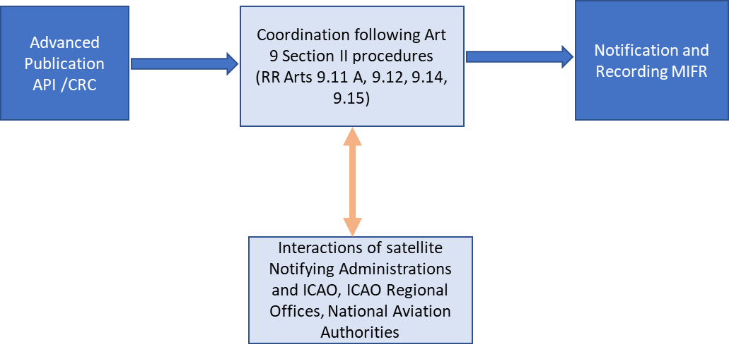
This option would provide an overall comprehensive procedure chain of coordination. However, it would require AMS(R)S systems to conduct the coordination of their frequency assignments for a much larger set of candidate frequency assignments within the band 117.975-137 MHz (in theory, more than 750 frequency assignments). The coordinated frequency assignments may have Global or Hemispheric or Regional or sub-Regional service areas.

Option 2. Combined ITU procedure and ICAO frequency assignment
This regulatory framework would apply similar procedures of Section II Art 9 for the Radio Regulations, as for option 1 although it is assumed that the procedure.
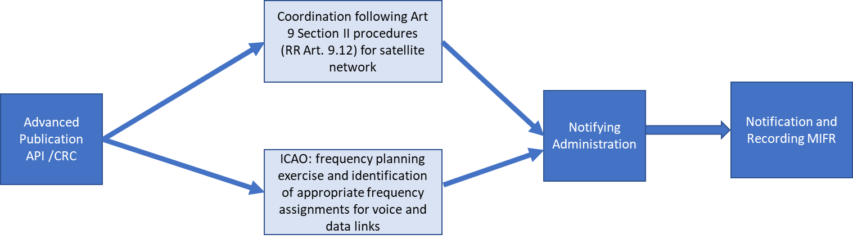
When referring to ICAO in the above picture, it should be understood as including ICAO, ICAO Regional Offices and/or National Aviation Authorities
This option 2 would provide a combined mechanism to be undertaken simultaneously within ITU and ICAO avoiding unnecessary coordination processes for theoretical AMS(R)S frequency assignments which ultimately ICAO would not recommend or would not be able to be used in its frequency planning exercises. The mandatory use (regulatory requirement) of only the frequency assignments identified by ICAO should be implemented via inclusion of the ICAO identified frequency assignments suitable for AMS(R)S in the corresponding SARPs.

Option 3. Simplified coordination procedure
This option 3 is based on a simplified approach under which ICAO would conduct the necessary frequency planning and frequency coordination for both satellite and terrestrial links and will identify the suitable frequency assignments which future AMS(R)S systems would have to implement.
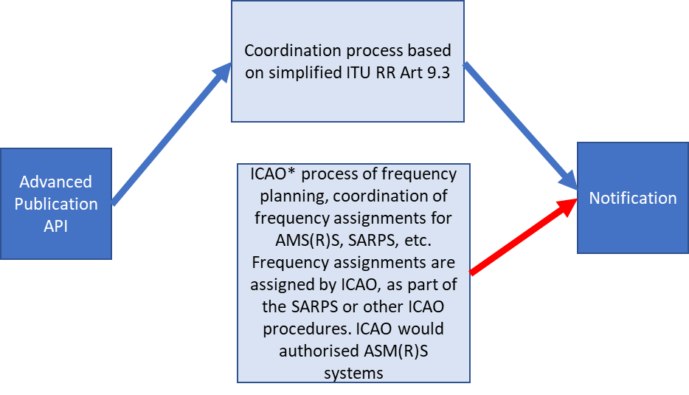
* When referring to ICAO, it should be understood as including ICAO, ICAO Regional Offices and/or National Aviation Authorities

This option 3 has the advantage of simplification of the procedure under ITU Art 9 and although several ASM(R)s satellite networks could be notified to the ITU, the only valid and effective registrations would be for those frequency assignments notified by Notifying Administrations which are in conformity with ICAO frequency planning. This procedure assumes full control of the future AMS(R)S systems under ICAO. The SARPs should include the authorized frequency assignments and the AMS(R)S systems approved by ICAO.

6.5 Considerations on the earth station / aircraft stations
When a satellite network is considered, it is usual to assume that the link is established between a space station and an earth station. Therefore, it would be expected that the space station of the AMS(R)S would communicate with an aircraft earth station located in the aircraft.
However, under WRC-23 agenda item 1.7 it is pursued that the operations under the new allocation for AMS(R)S would not require modification to the aircraft equipment, as the space segment would be able to receive and transmit to standard VHF radios already installed on board aircraft, thus relaying standard VHF communications operating under the AM(R)S, and complementing terrestrial infrastructures over oceanic and remote areas. To map this scenario into the existing definitions of stations defined in Article 1 of the RR, the relevant definitions for these types of stations are worth to be remembered:
“1.83 aircraft station: A mobile station in the aeronautical mobile service, other than a survival craft station, located on board an aircraft.
1.84 aircraft earth station: A mobile earth station in the aeronautical mobile-satellite service located on board an aircraft.ˮ
The following picture depicts all these types of stations and associated services.
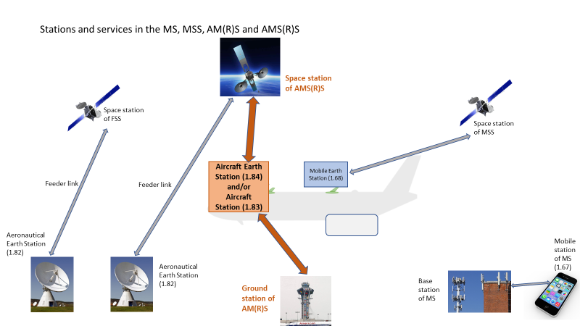
By considering which station should be borne in mind for the association to the satellite network of the AMS(R)S, two options emerge.
– Option A on aircraft stations:
Consider that the aircraft station which currently communicates in the AM(R)S will also communicate with the AMS(R)S.
In this case, RR Appendix 7 (coordination of earth stations with other terrestrial services) would not apply and reference may be developed for the coordination distances between two aircraft stations, resulting from the combined frequency planning of AM(R)S and AMS(R)S. A provision should be added to ensure a minimum coordination distance between aircraft stations and territory of administrations, for example, similarly as RR Appendix 7 predetermined distance of 1 000 km between two aircraft stations.
– Option B on aircraft earth stations:
Consider that the aircraft station which currently communicates in the AM(R)S will operate simultaneously as an aircraft earth station in the AMS(R)S, even both stations being the same equipment and only distinguished for regulatory purposes.
In this case, RR Appendix 7 (coordination of earth stations with other terrestrial services) would rely on the requirements for predetermined coordination distance between aircraft earth station and aircraft station specified by RR Appendix 7 as 1 000 km.
Note should be taken that aircraft operate in skies beyond the jurisdiction of administrations. The procedures to protect operation of aircraft flying over extended skies (Flight Information Region (FIR) areas in ICAO terminology) should be part of the ICAO frequency planning exercise, as protection of operation of AM(R)S or AMS(R)S in FIR areas, beyond jurisdictional areas of an administration, is managed by ICAO frequency planning and coordination procedures. Therefore, protection of operation of aircraft stations in FIR areas would not be covered by ITU procedures, but by ICAO procedures.

7 ACTION BY THE MEETING
The meeting is invited to:
- note and review the contents of this working paper.
- take note of the considerations on frequency assignment planning exercise.
- use conclusions of this working paper to:
c.1) to refrain from any future frequency assignment process to future AMS(R)S and rely on the ITU article 9 coordination procedures, which will be applied to coordinate satellite networks as well as protection of AM(R)S. This scenario corresponds to Option 1.
c.2) or to combine coordination of satellite networks at ITU level (application of RR 9.12) and coordination of frequency assignments for ASM(R)S by ICAO to ensure protection of AM(R)S. This scenario corresponds to Option 2.
c.3) or to confirm to ITU R that ICAO can continue managing the shared use of the AMS(R)S, AM(R)S and AM(OR)S by continuing the application of frequency assignment exercises, development of allotment plan when necessary and apply coordination procedures, as appropriate, within ICAO. This scenario corresponds to Option 3.
c.4) decide on which consideration should be given to the equipment on board aircraft when communicating with AMS(R)S space stations: either as aircraft equipment communicating with space station of AMS(R)S or converting, only for regulatory purposes, the current aircraft station into an artificial aircraft earth station.
- take note on the appropriateness for ICAO to support the new allocation to aeronautical mobile-satellite (R) service in the band 117.975-137 MHz, as a crucial first step to allow subsequent frequency planning exercises and establish coordination procedures for AMS(R)S, AM(R)S and AM(OR)S.

— END —

ATTACHMENT 1
ICAO liaison to ITU-R WP 5B november 2022
Document 5B/652-E
12 September 2022

ICAO thanks Working Party (WP) 5B for the recent liaisons regarding the progress of work being performed related to studies under WRC-23 agenda item 1.7 on space-based aeronautical VHF communications system within the 117.975-137 MHz frequency band.
The work to develop the AMS(R)S SARPs and Technical Manual has been initiated within ICAO and the decisions from WRC-23 will significantly impact the outcome of this work. These documents, and planning criteria between systems operating in the aeronautical mobile (route) service (AM(R)S) and the aeronautical mobile satellite (route) service will be further developed.
ICAO has the following views of the frequency planning and coordination process if WRC-23 under agenda item 1.7 were to make an allocation to AMS(R)S in all or part of the 117.975-137 MHz frequency band.
ICAO’s view on the overall regulatory framework for the frequency planning and coordination process
ICAO is of the view that the overall regulatory framework, including associated provisions contained in footnote(s) and or Resolution(s), would:
• enable participating States to perform, through the ICAO framework and in line with ITU coordination principles, the management of aeronautical satellite frequency assignments in all or part of the frequency band 117.975-137 MHz;
• require that only systems complying with ICAO standards and recommended practices could operate under the new allocation to the AMS(R)S;
• ensure that the satellite systems operating in the frequency band under an allocation to the AMS(R)S will be appropriately coordinated in accordance with the ITU Radio Regulations taking into account that:
○ Nos. 9.15/9.17, in conjunction with Table 10 of Appendix 7, results in a 1000 km pre-determined coordination distance from the service area of the AMS(R)S satellite to the border and/or territorial seas of an administration, and that this distance may be insufficient to ensure protection of an aircraft station operating in the AM(R)S located at the edge of the operational coverage of those services (which may extend hundreds of kilometres beyond that border/territorial sea);
○ there may be a need to define coordination thresholds; and
• prevent any undue constraints on systems operating in the AM(R)S in the 117.975-137 MHz frequency band.
ICAO’s view on its role in the regulatory framework for the frequency planning and coordination process
ICAO considers that its responsibilities within the overall process for system operating in the AM(R)S and AMS(R)S would include:
• Extension of its current frequency management responsibilities (including coordination of frequency assignments) with respect to aeronautical VHF systems to include systems operating under AMS(R)S.
• Development and maintenance of:
○ international aviation technical standards and recommended practices;
○ technical manuals;
○ frequency planning criteria and coordination procedures to be used in the first bullet point noting that these will have to be in line with current ITU procedures; and
○ procedures for the implementation of terrestrial and satellite systems.
• ICAO frequency planning / management, which is also known as the “ICAO coordination” process, to allow recommendation of appropriate channel(s) for AM(R)S and AMS(R)S uses over the coverage areas requested, that would comply with the ICAO regulatory framework.
○ This process includes the possibility that existing AM(R)S or AMS(R)S assignments may be requested to change for frequency management reasons (e.g., new entrants, RFI resolution); and
○ those channels will be formally assigned for use of the AM(R)S or AMS(R)S operators by the appropriate Administration, while also protecting assignments in the frequency band that may not be in the scope of “ICAO coordination”.
ICAO’s understanding of the ITU regulatory framework
ICAO understands that the ITU is considering the applicability of the provisions of RR Articles 9 and 11 in carrying out coordination, notification, and recording within the ITU. Changes may be needed to relevant RR Appendices (e.g. RR Appendix 4, 5 and 7) if WRC-23 introduces a new AMS(R)S allocation.
ICAO would appreciate any comments on this material and being kept apprised of WP 5B efforts on WRC-23 agenda item 1.7.

When referring to ICAO, it should be understood as including ICAO, ICAO Regional Offices and/or National Aviation Authorities

