FREQUENCY SPECTRUM MANGEMENT PANEL (FSMP)

Eighth Working Group Meeting

Montreal, Canada, 21 to 29 January 2019

Agenda Item 3 & 7..: Radio Altimeter and Wireless Aircraft Intra-Communications (WAIC) issues
Interference from Non-Aeronautical Sources

Inconsistency in Recommendation ITU-R SM.1541

(Presented by John Mettrop)

SUMMARY
This paper provides information on an inconsistency in Recommendation ITU-R SM.1541 with the Radio Regulations and ICAO SARPs and seeks the meetings view on how best to address the issue.

- INTRODUCTION
  - 1.1 Recommendation ITU-R SM.1541 provides information on the recommended spectral mask unwanted emission limits for various systems, including aeronautical mobile, telemetry and radar, in the out-of-band domain. Those emission limits are then generally implemented into the relevant global, regional and national standards.
  - 1.2 Whilst addressing an issue within the European Telecommunication Standards Institute (ETSI) I had cause to reference ITU-R SM.1541 and noticed an apparent anomaly between the out-of-band limits for aeronautical mobile and maritime mobile services defined in this Recommendation and the Radio Regulations, ICAO SARPs material and RTCA/Eurocae MOPs .
  - 1.3 This document is intended to highlight where I believe there to be an inconsistency and seek the meetings view as to whether they agree there is an anomaly and how best to address that anomaly given the sensitivities around Annex 8 of the Recommendation that addresses unwanted emissions from radar.
- DISCUSSION
  - 2.1 Overview
  - 2.1.1 The Radio Regulations govern the international use of the radio spectrum and geostationary orbits. They form the baseline against which all other radio regulatory standard should be based, however it appears that for aeronautical mobile and maritime services Recommednation ITU-R SM.1541 is not consistent with the Radio Regulations, ICAO SARPs and RTCA/Eurocae Minimum operational performance standards.
  - 2.2 Radio Regulatory Requirememts

2.2.1 Article 3.6 requires that transmitting stations shall conform to the maximum permitted power levels for unwanted emissions in the spurious domain specified in Appendix 3. Additionally, Article 3.9 requires that the bandwidths of emissions shall be such as to ensure the most efficient utilization of the spectrum with Appendix 1 providing guidance for the determination of the necessary bandwidth with Appendix 1 incorporating Recommendation ITU-R SM.1138-2 as guidance on formulae to use for the determination of the necessary bandwidth.

2.2.2 For 8.33 kHz DSB-AM, ITU-R SM.1138-2 recommends that the necessary bandwidth, normally assumed to be the 3dB points for communication systems, is twice the maximum modulation frequency (2.5 kHz) or 5 kHz. Appendix 3 of the Radio Regulations then defines that the maximum permitted spurious domain emission power for aeronautical mobile services as 43+10log(P) or 70 dBc whichever is the less stringent at 250% of the necessary bandwidth which, for a 25 Watt transmitter, would be 57 dBc at 12.5 kHz.

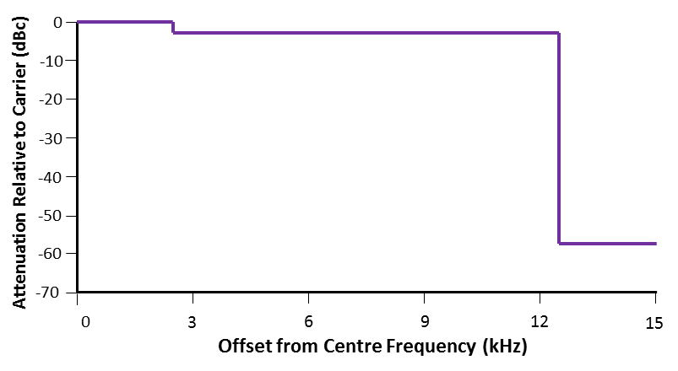

Figure 1: 8.33 kHz Radio Spectral Mask as defined by ITU Radio Regulations

2.2.3 Recommendation ITU-R SM.1541

2.2.3.1 Within Recommendation ITU-R M.1541 Annex 10 defines the spectral mask for aeronautical mobile services as 50-150% of the necessary bandwidth -25 dBc and 150-250% of the necessary bandwidth -35 dBc as illustrated below

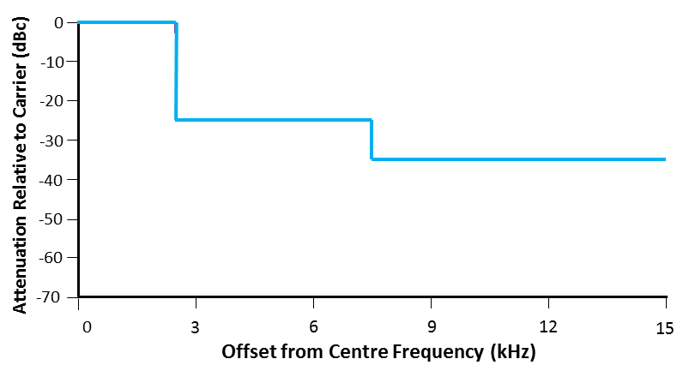

Figure 2: 8.33 kHz Radio Spectral Mask as defined by ITU-R SM.1541

2.2.4 ICAO Standards and Recommended Practices
    - 2.2.4.1 ICAO in Annex 1o, Volume III, Part 2 to the International Convention on Civil Aviation only define the need for the power under all operating conditions when measured over a 7 kHz channel bandwidth centred on the first 8.33 kHz adjacent channel to not exceed -45 dB below the transmitter carrier power as illustrated below.

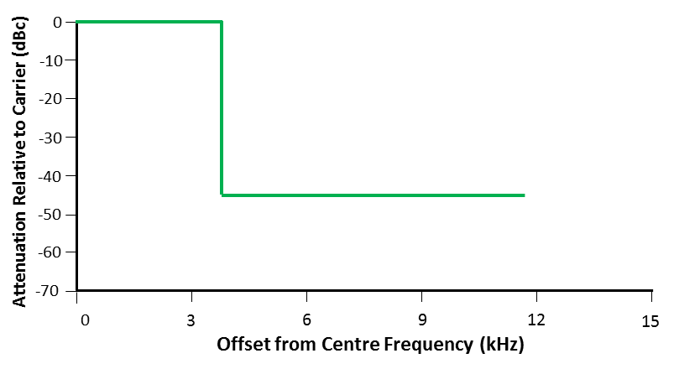

Figure 3: 8.33 kHz Radio Spectral Mask as defined by ICAO SARPs

2.2.5 RTCA/Eurocae Minimum Operating Performance Standards
    - 2.2.5.1 The spectral mask for an 8.33 kHz airborne transmitter is defined by the following mask.

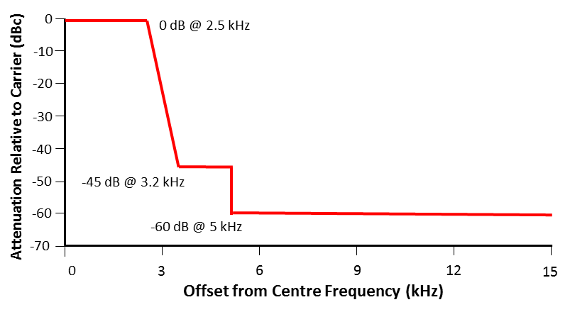

Figure 4: 8.33 kHz Radio Spectral Mask as defined by RTCA\Eurocae MOPS

3 CONCLUSION
    - 3.1 Comparing the spectral masks (see below) indicates that the masks defined by the ICAO SARPs and RTCA\Eurocae MOPs comply with the Radio Regulations, especially if you did not use a step function but assumed straight lines between the defined points. However, the mask as defined by Recommendation ITU-R SM.1541 does not conform to the Radio Regulations.

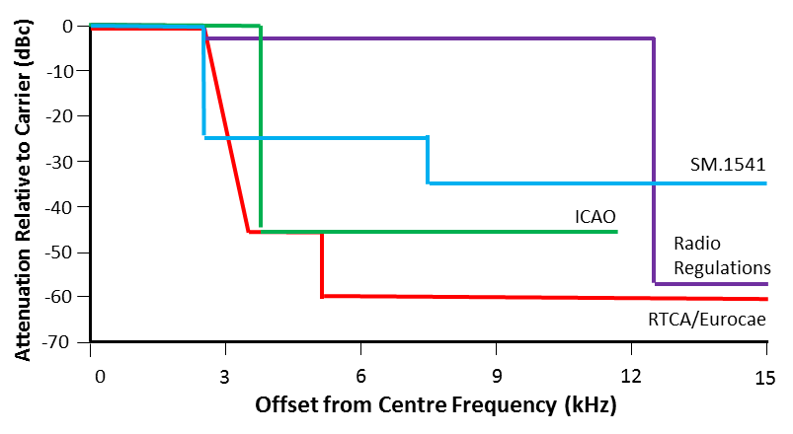

Figure 5: Comparison of Spectral Masks as Defined by the Various Documents

    - 3.1 Further more, if Recommendation ITU-R SM.1541 is to correct then that defines the necessary bandwidth for an aeronautical communication system as being the -25dB bandwidth as opposed to the normal assumption of it being the -3 dB bandwidth. This would have potentially serious implications for other aeronautical communication systems. Fortunately Recommendation ITU-R SM.1541 is not incorporated by reference into the Radio Regulations and hence has no mandatory status however, it is used as the basis for regional standards at least within Europe.

4 POTENTIAL ACTION
    - 4.1 The following potential course of action have been identified:
- Accept that Recommendation ITU-R SM.1541is not appropriate with respect to aeronautical communication systems and take no further action.
- Accept the principle that for aeronautical communication systems the necessary bandwidth equals the -25 dB and not the -3dB bandwidth.
- Seek a revision of the Recommendation to bring it in line with our understanding of necessary bandwidth

- ACTION BY THE MEETING
  - 5.1 The meeting is invited to:
- note and review the contents of this working paper;
- provide feedback as to whether the issue needs to be addressed and if so how best to proceed.

— END —

