 |  | ECC PT1(20)xyz
ECC PT1 #66
Web meeting, 1-3 and 9-11 September 2020
Date issued: | TBD
Source: | International Civil Aviation Organization (ICAO)
Subject: | IMT emissions and Radio Altimeters in the frequency band 4200 – 4400 MHz
Group membership required to read? (Y/N)
N
Summary:
In accordance with the guidance of ECC, ICAO would like to bring to the attention of ECC PT1 the following material:
- Information on radio altimeter characteristics and its application (based on Recommendation ITU-R M.2059),
- Usage scenarios to consider for assessing the impact of IMT unwanted emissions to the Radioaltimeters operating in the frequency band 4200-4400 MHz.

Proposal:
invites ECC PT 1 to
Consider the information in this document, as needed, when performing studies regarding the co-existence of IMT and Radioaltimeters operating in the 4200-4400 MHz frequency band.

Background:
During the last ECC meeting, ICAO raised its concerns about the issue of potential interference to aeronautical Radio Altimeters operating in the 4200 - 4400 MHz frequency band, caused by IMT (sometimes referred as 5G) systems currently operating or planned to operate in the frequency band 3400 - 3800 MHz. This issue is raising concerns within aviation due to the possible large impact which could occur to the operation of aeronautical Radio Altimeters, systems which provide a function critical to the safety of aircraft.

The discussion was summarised in the ECC minutes as follows:

Document ECC(20)INFO 06 from ICAO was introduced by France. This highlighted concerns about potential interference from 5G MFCN unwanted emissions to Radio Altimeters in the frequency band 4200 – 4400 MHz. It was generally considered that this issue should be looked at in ECC PT1 to see if any action is needed.
It was noted that ICAO was not able to find all the information about channel bandwidth of MFCN systems in 3400-3800 MHz and has assumed that the limit in block edge mask in ECC Decision (11)06 and Decision (EU) 2019/235 applies in the 4200 – 4400 MHz band. Participants noted that depending on the channel bandwidth of the MFCN system, the lower spurious emission limits in ERC Recommendation 74-01 may apply. It was also noted that it could be useful for ICAO to provide further information on radio altimeter characteristics and usage scenarios.

ICAO was invited to contribute to the next ECC PT1 on this issue; ECC PT1 should then consider if there is an issue and report back to ECC. It was suggested that it could be beneficial to update the ECC(20)INFO 06 with complete information.

Introduction
During the last ECC meeting, ICAO informed ECC about the issue of potential interference to aeronautical radio altimeters operating in the frequency band 4200 - 4400 MHz, caused by IMT systems currently operating or planned to operate in the frequency band 3400 - 3800 MHz in Europe. In response to this liaison statement, ICAO was invited to contribute to the next ECC PT1 on this issue; ECC PT1 should then consider if there is an issue and report back to ECC. It was suggested that it could be beneficial to update the ECC(20)INFO 06 with complete information, and this document can be considered as that update.
Aviation is currently conducting radio altimeter studies in a number of different fora. Those studies are not yet complete, so the information – and in particular the scenarios – provided below should be considered as preliminary. ICAO will provide updated information as it becomes available.
Finally, to facilitate update of the preliminary studies reported on in our liaison to the ECC (ECC(20) INFO 06), ICAO would request that the actual parameters applicable for IMT operating within the frequency band 3400-3800 MHz including unwanted emissions (in particular within the frequency band 4200-4400 MHz) be provided.

Information on radio altimeter characteristics (based on ITU-R M.2059)
All technical characteristics for radio altimeters operating within the frequency band 4200-4400 MHz can be found in Recommendation ITU-R M.2059. In particular Table 1 & and Table 2 give the technical parameters of each radio altimeter type.
Radio altimeters are operating within the frequency band 4200-4400 MHz under the aeronautical radionavigation service (ARNS).
The basic function of a radio altimeter is to provide accurate, independent height measurements above the Earth surface with a high degree of accuracy and integrity during the approach, landing, and climb phases of aircraft operation representing a wide variety of surface reflectivity. Such information is used for many purposes and the high degree of accuracy and integrity of those measurements must be achieved regardless of the Earth surface, such as during final approach and flare guidance, i.e. to raise the aircraft nose, in the last stages of automated approach to land. It is also used to determine the particular altitude in which the aircraft can safely land and as an input to the terrain awareness warning system (TAWS), which gives a “pull up” warning at a predetermined altitude and closure rate; and as an input to the collision avoidance equipment and weather radar (predictive wind shear system), auto-throttle (navigation), and flight controls (autopilot). As a result, radio altimeters remain active for all phases of flight. Radio altimeter systems are designed to operate for the entire life of the aircraft in which they are installed. The installed life can exceed 30 years, resulting in a wide range of equipment age, performance and tolerance.
It is important to note that there are two types of radar waveform modulation methods for Radio altimeters:
- Continuous wave of LFMCW (Linear Frequency Modulation Continuous Wave) or FMCW Radio altimeters (Frequency Modulated Carrier Wave); and
- Pulsed modulation.

FMCW Radio altimeters
FMCW radio altimeters operate by a Tx/Rx working in conjunction with separate transmit/receive antennas. Operation requires a signal from the transmit antenna to be directed to the ground. When the signal hits the ground it is reflected back to the receive antenna. The system then performs a time calculation to determine the distance between the aircraft and ground, as the altitude of the aircraft is proportional to the time required for the transmitted signal to make the round trip.
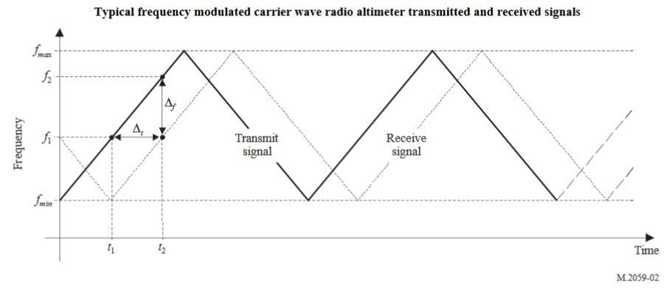
It is important to note that FMCW radio altimeters do not have a fixed frequency. One can find the chirp bandwidth of each FMCW radio altimeter type in Table 1 of Recommendation ITU-R M.2059.

Pulsed Radio Altimeters
The pulsed-type radio altimeter uses a series of pulses of radio frequency energy transmitted towards the earth to measure the absolute height above the terrain immediately underneath the aircraft. The time difference between the transmitted pulse and the received pulse is measured, and that time is proportional to the height of the aircraft.
One can note that pulsed radio altimeters are emitting at a fixed frequency (generally 4300 MHz). However, the emission bandwidth could vary (see for example D4 within the Table 1 from ITU-R M.2059).

Antenna PATTERN for RADIO ALTIMETERS
There is no antenna pattern defined within Recommendation ITU-R M.2059. However, ICAO recommends using the antenna pattern formula available in Report ITU-R M.2319 (§A-3.1.1) when performing compatibility studies. It should be noted that this pattern only applies for the frequency band 4200-4400 MHz.
$G_{RA\left(dB\right)}($φ$)=-\frac{12}{{φ_{3dB}}^{2}}φ^{2}+G_{RA,dBi}$
Where:
$φ_{3dB}$: = –3 dB beam width;
$G_{RA,dBi}$: = The maximum antenna gain;
$G_{RA\left(dB\right)}($φ$)$: = The antenna Gain value at φ degrees;
φ, = The angle formed with the interferer and the vertical axis;
Recommendation ITU-R M.2059 tables 1 & 2 define these values of G_{RA} &ϕ_{3dB} as follows:
Radio Altimeter | A1 | A2 | A3 | A4 | A5 | A6 | D1 | D2 | D3 | D4
G_{RA} (dBi) | 10 | 10 | 10 | 13 | 11 | 11 | 11 | 10 | 11 | 13
ϕ_{3dB} (degrees) | 60 | 55 | 60 | 35 | 45 | 45 | 90 | 60 | 60 | 45

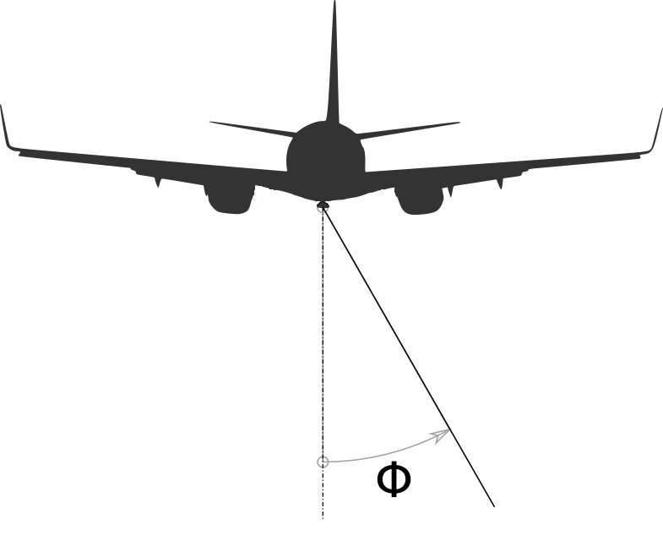
ICAO recommends using this formula only for -90°<Φ<90°.

Interference threshold to be considered for Radio Altimeters

Protection CRITERIA
Recommendation ITU-R M.2059 explains three primary electromagnetic interference coupling mechanisms between radio altimeters and interfering signals from other transmitters: receiver overload, desensitization, and false altitude generation.
Any compatibility analysis between radio altimeters and other systems must utilize those protection criteria for the maximum acceptable degradation for a radio altimeter.
Those three criteria are defined as followed:
- Receiver front-end overload where the value depends on each radio altimeters type
- Receiver desensitization which is the common I/N protection criteria of -6dB,
- And the False altitude reports which is defined by -143 dBm/100 Hz (–143 dBm considering 100 Hz detector bandwidth following the instantaneous altimeter local oscillator (LO) frequency).
For studies focused on emissions into the frequency band 4200-4400 MHz, only the false altitude reports and the receiver desensitization are applicable.

Receiver desensitization
According to ITU-R Recommendation M.2059 Receiver Desensitization I_{T,RF}, the limit for aggregate interference at the receiver input is given for radio altimeters by:
$I_{T,RF}=I_{T,IF}-10log⁡\left(R_{S}\right)$ dBm/RF or dBm/B_{S}
Or
$I_{I,RF}=I_{T,IF}-10\log\left(R_{S}\right)-10log\left(B_{S}\right)$ dBm/MHz
And for pulsed radio altimeters:
$I_{I,RF}=I_{T,IF}$ dBm
Or
$I_{I,RF}=I_{T,IF}-10log\left(B_{S}\right)$ dBm/MHz

Where:
I_{T,IF} = Interference power threshold
$≥N-I/N\text{ dB}$
N $=-114dBm/MHz+10\log{(}B_{R,IF})+N_{F}$
B_{R,IF} = IF bandwidth of the radio altimeter (MHz)
N_{F} =Noise figure at receiver input (dB)
I/N = Interference to noise ratio (assumed to be -6 dB)
R_{S} $=\frac{2B_{R,IF}}{B_{S}}$
B_{S} = Chirp Bandwidth (MHz) or RF Bandwidth radar
One can note that Rs is only applicable for FMCW radio altimeters.
It has to be noted, that the interference power threshold (I_{T,RF}) is considered within the RF bandwidth of the received. Therefore, to get the interference power threshold in dBm/MHz, the following formula should be applied:
$I_{T,RF}(dBm/MHz)=I_{T,RF}(dBm/B_{S})-10\log_{10}{B_{SF}}$.

FalsE altitude report
ITU-R M.2059 defines the false altitude criteria as -143 dBm/100 Hz (or -103 dBm/MHz) for all FMCW radio altimeters as:
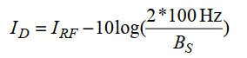
Where a 100 Hz detection bandwidth is considered representative:
- ID: Interference power at the detector,
- BS: Chirp bandwidth.
If the magnitude of the spectral components caused by the interference signal rises above the detection threshold of the altimeter (IT,FA), then they may falsely be regarded as valid altitudes by the altimeter and there will be no means to exclude them from the altitude calculation. In practice, ID (the interference power at the detector) would cause false target spectral components within the FMCW receiver signal processing chain if it exceeds the protection threshold IT,FA.
IT,FA = –143 dBm considering 100 Hz detector bandwidth following the instantaneous altimeter LO frequency.

Application of ITU-R M.2059 for the interference threshold
Type of radio altimeter |  | A1 | A2 | A3 | A4 | A5 | A6 | D1 | D2 | D3 | D4
Antenna Gain (dBi) |  | 10 | 10 | 10 | 13 | 11 | 11 | 11 | 10 | 11 | 13
Feeder Loss (dB) |  | 6 | 6 | 2 | 6 | 6 | 6 | 6 | 0 | 2 | 0
Protection Criteria (I/N) (dB) |  | -6 | -6 | -6 | -6 | -6 | -6 | -6 | -6 | -6 | -6
Receiving Bandwidth (MHz) |  | 2 | 0,25 | 2 | 9,2 | 6 | 16 | 0,31 | 1,95 | 2 | 30
Noise Figure (dB) |  | 10 | 6 | 6 | 10 | 10 | 10 | 8 | 9 | 8 | 10
Chirp Bandwidth (MHz) |  | 104 | 132,8 | 133 | - | - | - | 150 | 176,8 | 133 | -
R_{S} (dB) |  | -14,15 | -24,24 | -15,22 | 0,00 | 0,00 | 0,00 | -23,84 | -16,56 | -15,22 | 0,00
Interference Threshold (I/N) at the receiver P_{R} | dBm | -92.84 | -95.78 | -95.78 | -100.36 | -102.22 | -97.96 | -93.25 | -91.54 | -93.77 | -95.23
Interference Threshold (I/N) at the receiver P_{R} | dBm/MHz | -112,94 | -116,94 | -116,94 | -109,93 | -109,93 | -109,93 | -114,94 | -113,94 | -114,94 | -109,93
False Altitude criteria (dBm/MHz) |  | -103,00 | -103,00 | -103,00 | - | - | - | -103,00 | -103,00 | -103,00 | -

Application of the Safety margin
Radio altimeters are used for safety aeronautical application. ICAO (DOC 9718) defines an aeronautical safety margin and recommends including it into any study as followed:
“Aeronautical safety applications are required to have continued operation through worst case interference, so all factors which contribute to harmful interference should be considered in analyses involving those applications. An aviation safety margin is included to address the risk that some such factors cannot be foreseen (for example impacts of differing modulation schemes). This margin is applied to the system protection criteria to increase the operational assurances to the required level. Traditionally for aviation systems/scenarios an aviation safety margin of 6–10 dB is applied. Until established on the basis of further study on a case-by-case basis, an aviation safety margin of not less than 6 dB should be applied.”
As a result, given the safety implications, ICAO recommends using the aeronautical safety margin when assessing impacts to the radio altimeter.

Relevant scenario to consider
For each of the scenarios that follow, ICAO recommends the following parameters be taken into account when performing studies:
- The aircraft can have a maximum roll of up to +/-30 degrees from the horizontal in all directions,
- The air to ground propagation model (Recommendation ITU-R P.528-4) with a minimum time percentage should be used. It should be noted that Rule of Procedure on RR 5.441B was adopted by the ITU Radio Regulatory Board and proposes to use this Recommendation with a time percentage of 1% for calculation of IMT interference into non-safety aircraft applications. As a result, for safety applications such as radio altimeters a percentage value less than 1% should be considered. If the Recommendation is not capable of calculating path losses with time percentage less than 1%, then 1% should be used and appropriate margins added.

Base Station Scenario
There is not a single scenario that provides all the necessary parameters and protection for radio altimeters, especially given the variation of aviation operations and aircraft types. While more work is ongoing to develop these scenarios, ICAO recommends the below preliminary scenarios should be considered.

General Aircraft Scenario
A simple scenario can be considered as an initial step. A single base station is considered, and it is checked whether the protection criteria are met for an airplane flying at different heights (50, 200 and 2000 ft (15, 61 and 610 meters)) above the base station. The figure below shows the geometry of the scenario.
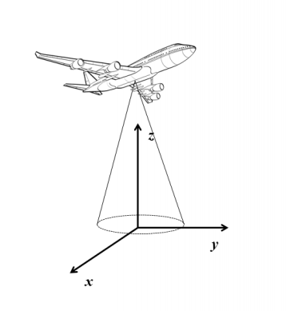
With reference to the coordinate systems in this figure:
- The base station is located at (0,0,0);
- The aircraft is flying along a horizontal path defined by the coordinates (0,ya,ha). The altitude ha of the aircraft is fixed, so that his position varies along the axis y only;
- The radio-altimeter antenna beam is modelled with §2.3.
The rationale of initially considering one single base station is to make a sanity check to verify whether this scenario can pose a threat to the aeronautical systems in the band (for simplicity the aircraft can have zero roll and pitch); If a single base station is predicted to not cause interference, the analysis should be expanded to consider the aggregation of multiple interferers and the roll and pitch of the aircraft.

Commercial Aircraft Landing Scenario
This is a commercial aircraft landing scenario at an airport with an IMT network active at the same location.
To simulate an assumed worst case scenario, a model was produced of an aircraft on final approach in a Cat III landing. The approach path passes directly overhead of a Base station (BS). This would present the minimum possible distance between the aircraft and base station while the altimeter is providing height information to the autopilot during landing.
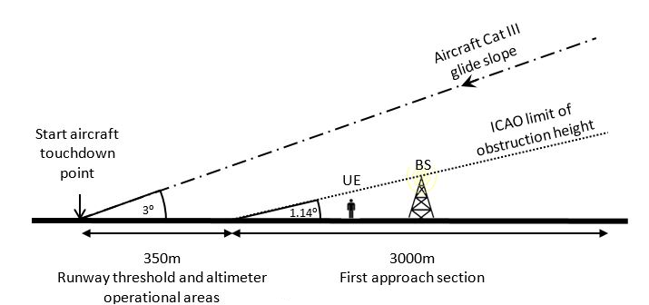

A base station (BS) is set at the minimum distance within the ICAO limit of obstruction height for the height of the BS. For the macro suburban case this is 1600 m from the touchdown point, and for the small cell case this is 650 m from the touchdown point.
An aircraft on approach is set to a 3-degree glideslope, with a 2-degree pitch, and a roll of up to +/-30 degrees.
For the study, it is assumed that the aircraft approaches to land directly over the BS. This may not necessarily represent the worst-case geometry for potential interference but it is a straightforward analyze.

Helicopter Landing Scenario
A helicopter (e.g., medevac) landing on a rooftop helipad in close proximity to IMT towers on neighboring buildings. The aircraft parameters for this scenario are under development and will be provided as soon as they are defined

USER EQUIPMENT SCENARIO

General Aircraft Scenario
The same aircraft parameters should be used as the general aircraft scenario for base stations (section 4.1.2), and user equipment numbers should be spaced consistent with applicable IMT deployments under worst-case conditions.

Inside the cabin of an aircraft
A number of user equipment is expected to be transmitting inside the cabin of an aircraft while the radio altimeter is operational. In order to help ECC PT1, ICAO notes that experiments on an A321 aircraft have measured a minimum Interference Path Loss (IPL) of 74.4 dB for signals from inside the cabin coupling into the radio altimeter receive antenna. Recent preliminary measurements by an ICAO member state indicated an IPL of 72.8 dB for a Beechcraft B300 (King Air B350). Finally, measurements reported to an aviation standards organization have indicated IPLs on the order of 57 dB for smaller aircraft such as helicopters, but this is subject to further confirmation.
ICAO would ask this information to be considered in the ECC studies.
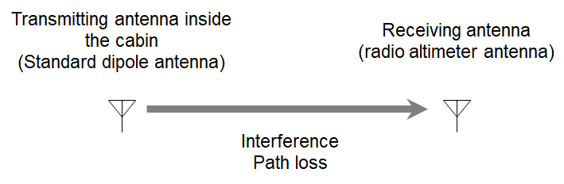
It should be noted that in all cases the interference path loss measurement took into account the antenna gain of an assumed standard dipole transmit antenna, the fuselage attenuation of the aircraft, the path loss attenuation (between the transmitter and the receiver) and finally the antenna gain of the radio altimeter receiver. No additional losses should be added to these parameters to ensure an accurate worst case model.

However, see section 4 on possible changes in orientation of aircraft.
Software to compute the P.528-4 model can be found at https://github.com/NTIA/p528-gui/releases
Medical Evacuation

