FREQUENCY SPECTRUM MANAGEMENT PANEL (FSMP)

Twentieth Working Group Meeting

Meeting, 19 Feb – 7 March 2025

Agenda Item 4: Radio Altimeter issues

Radio Altimeter filter definition in ITU-R M.2059

Prepared by Ivan Martin (THALES), Guillaume Novella (DSNA) and Christian FLEURY (DSNA)
Presented by Christian FLEURY

SUMMARY
This paper provides elements to clarify the Radio Frequency filtering in Recommendation ITU-R M.2059.

- INTRODUCTION
In the scope of WRC27 agenda Item 1.7, some compatibility studies are presented as input contributions to ITU-R WP 5D in Feb 2025. These contributions are using the RF filtering characteristics of the recommendation ITU-R M.2059 for compatibility studies between IMT (as interferer) and radio altimeter (as victim).
This “RF selectivity for radio altimeters” characteristic presented in Table 3 of ITU-R M.2059 is used to assess the potential impact of 4400 – 4800 MHz IMT emissions into the radio altimeter system.

The purpose of this WP is to clarify the filtering values that shall be used for compatibility studies.

- OVERVIEW OF THE FILTERING INFORMATION AVAILABLE in REC M.2059
Recommendation ITU-R M.2059 “Operational and technical characteristics and protection criteria of radio altimeters utilizing the band 4 200-4 400 MHz” defines the frequency selectivity of the receiver with a roll off of 24 dB per octave from 4 200 MHz (respectively 4 400 MHz on the other edge of the band) to a maximum value of 40dB.
To clarify the lecture of the REC M.2059, we should use both the Table 3 “RF selectivity for radio altimeter” and the explanation indicated in §2.1 “Receiver front-end overload” in this recommendation.
In ITU-R REC M.2059, in the Radio Altimeter protection criteria “Receiver front-end overload” paragraph, the TABLE 3 shows the “RF selectivity for radio altimeters”.
The first column indicated the “interference frequency”, and the second one, the corresponding “RF filter attenuation” as showed in the hereunder table:
Interference frequency  (MHz) | RF filter attenuation  (dB)
≤ 4 200 | Attenuated at 24 dB per octave  to a maximum of 40 dB
4 200 | 0
4 300 | 0
4 400 | 0
≥ 4 400 | Attenuated at 24 dB per octave  to a maximum of 40 dB

It should be noted that all interference frequency and associated attenuation is referring to radio frequency.
The band-pass RF filter only passes frequencies within certain range. Above and below the cut-off frequencies, the RF signals are attenuated.
In the table 3, the two band-pass cut off frequencies are respectively 4200 and 4400 MHz.
The RF filter attenuation is a factor by which the signal is changed, namely the Gain and the Phase shift. Both the gain G and the phase shift θ are dependent upon the radio frequency (meaning they are functions of radio frequency), they can be expressed as follows:
Gain =G (f)
Phase shift = θ (f)

The RF filter attenuation varies with the slope of the gain G(f) outside of the pass-band domain.
Analog filters are characterized with at least 3 parameters
- filter type (low pass, high pass or band pass)
- cutoff frequency
- filter order (first second third etc.)
For each order of an analog RF filter, the slope of the attenuation increases by 6 dB/Octave (or equivalently, by 20 dB/Decade) as shown in the figure below.
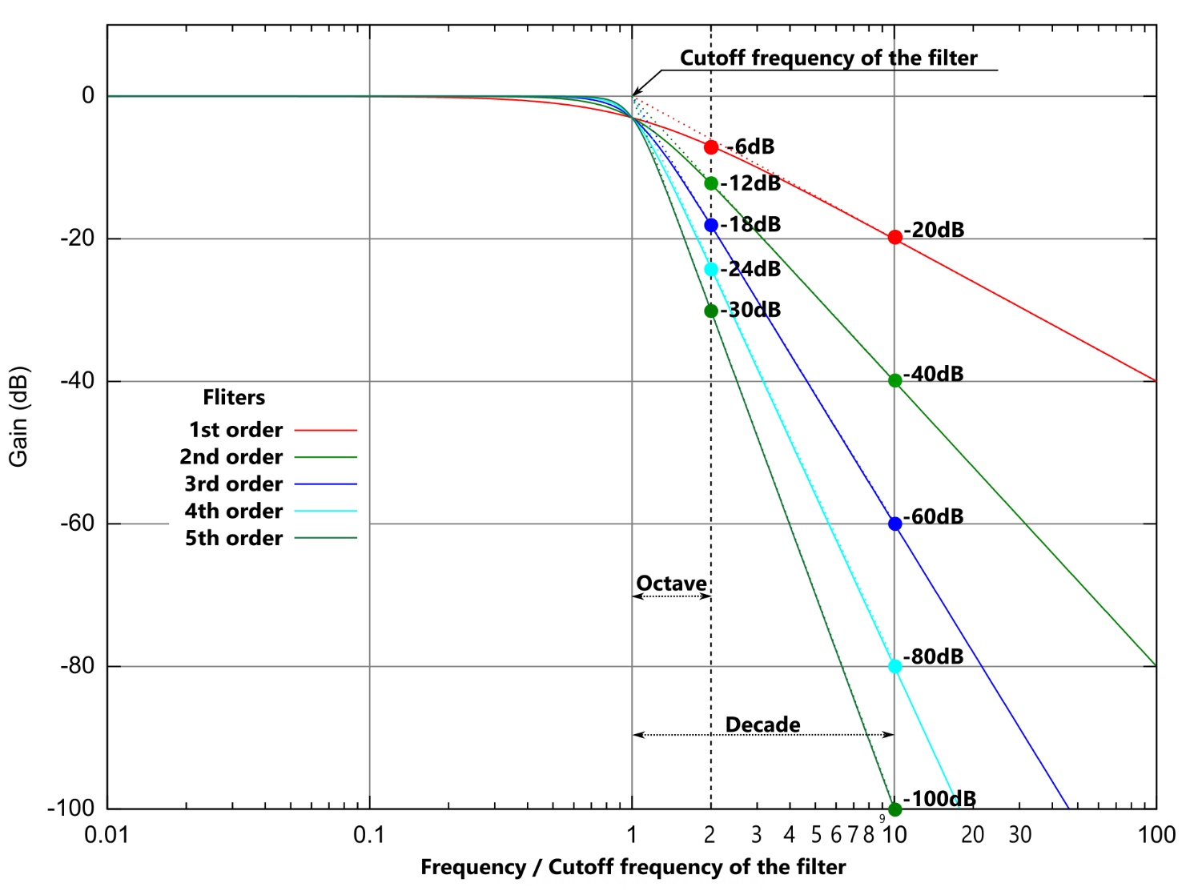
The slope of attenuation is given as dB/decade or in dB/octave. A decade corresponds to a ratio of 10 between two numbers, an octave corresponds to a ratio of 2 between two numbers. That means an octave frequency is the half or the double of a reference radio frequency (often used in music).Indeed, some administrations in some studies misinterpret the term “octave” in the table 3 by considering that it corresponds to twice the 200 MHz bandwidth (4.2-4.4 GHz).
In fact, even if it is obvious for filter definition, it is clear in the table that the line refers to the frequency and not to a bandwidth.
An attenuation slope of 24 dB/octave (which corresponds to a 4th order filter), means that for each octave (doubling of radio frequency for the upper cut off radio frequency edge or dividing by 2 for the lower cut off radio frequency edge), the gain, G (f), will be diminished by 24 dB.
The associated RF filter attenuation curve, from table 3 of ITU-R REC M.2059, is therefore presented in the figure below :
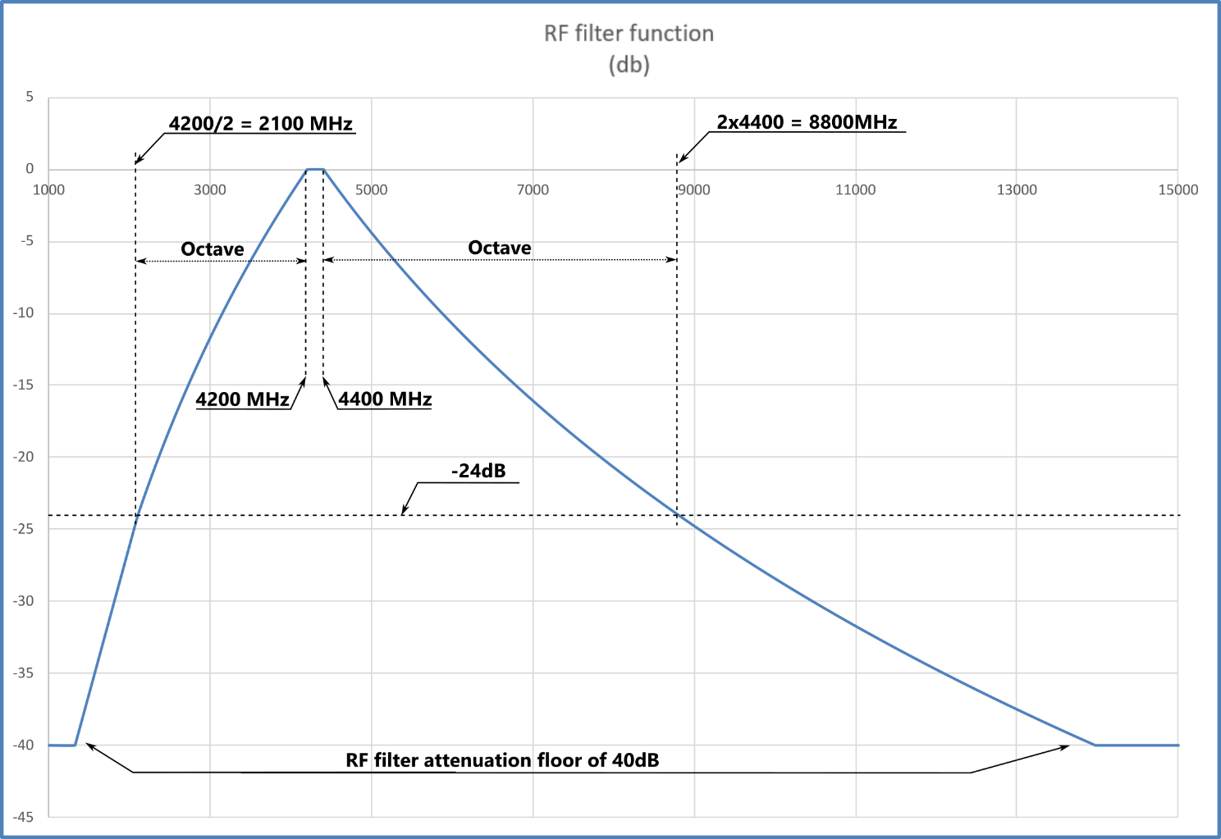

Most of the time, to represent the filtering gain, a bode diagram is used (logarithm scale), in which the attenuation slope is a linear (that will decrease in our case, at a rate of 24 dB par octave).
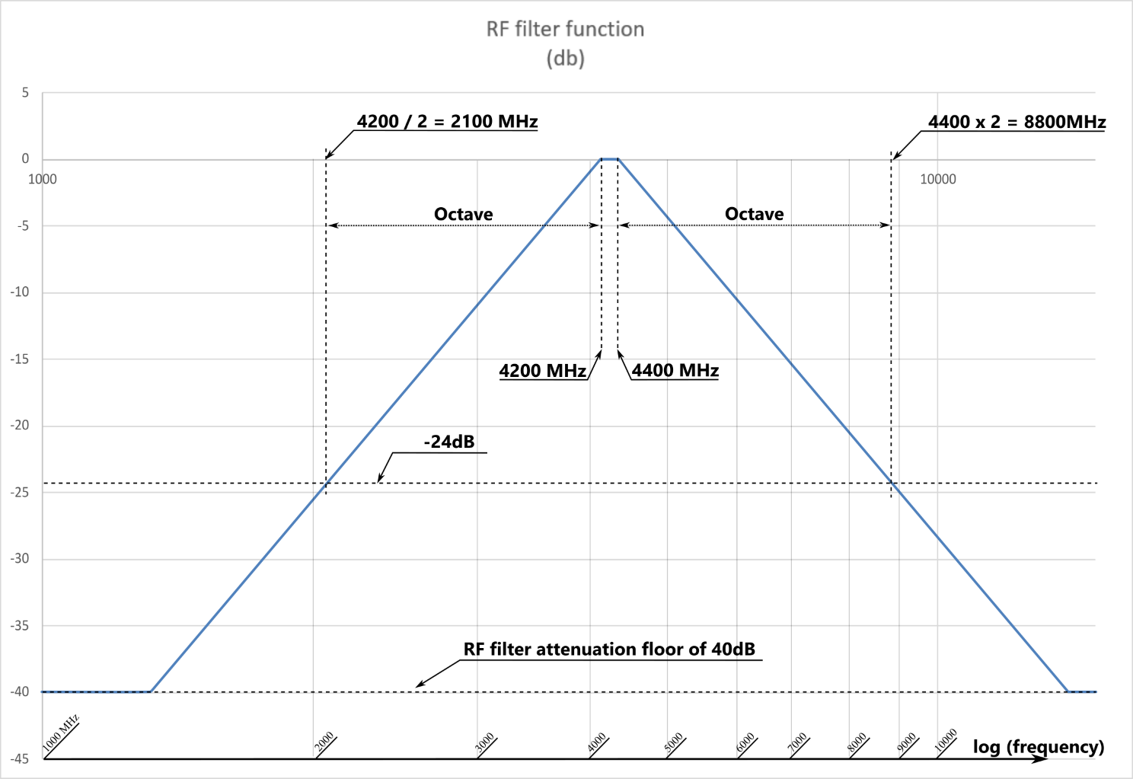

Some will say that this rejection value is extremely low and will argue our interpretation is therefore erroneous, but they are referring to what is done today with digital filtering. It is important to have in mind that most Radio altimeters in service were designed at a time when digital filtering either did not exist or could not be used with very high frequency, and at that time, stable 4th-order analog filtering was considered to be efficient.
This is confirmed, in the introduction of the “Receiver front end overload” section in the ITU-R M.2059, that indicates that “A radio altimeter front-end generally has modest selectivity (gradual RF-filter roll-off)”.

- ACTION BY THE MEETING
  - The FSMP meeting is invited to:
    - Note the information presented in this working paper.
    - Update, as appropriate, the ITU-R compatibility studies performed especially in the frame of WRC-27 Agenda Item 1.7 based on the values of RF filtering presented in this FSMP WP.
— END —

