FREQUENCY SPECTRUM MANGEMENT PANEL (FSMP)

Fourth Working Group meeting

Bangkok, Thailand, 29 March – 7 April 2017

Agenda Item 9: Interference from non-aeronautical sources

Programme Making and Special Event (PMSE) in the 960 – 1164 MHz frequency band

Presented by Claude Pichavant - ICCAIA

SUMMARY and ACTION
The CEPT Electronics Communications Committee (ECC) Working Group FM (WGFM) is currently undertaking studies whether low power audio applications (Wireless microphones and In-Ear monitors) for Programme Making and Special Event (PMSE) can be accommodated in the 960 – 1164 MHz frequency band which is currently used mainly for safety Aviation services.

Action: FSMP WG/4 is invited to review the attached, and develop material which can be submitted as a contribution to the next meeting of WGFM.

- INTRODUCTION
  - General Information

The Electronic Communications Committee (ECC) which develops common policies and regulations in electronic communications for Europe and which is a focal point on spectrum use, conducts the work of the European Conference of Postal and Telecommunications Administrations (CEPT).

One piece of this work is about additional spectrum for low power audio (Wireless microphones and In-Ear monitors) for Programme Making and Special Event (PMSE) and its possible usage in the band 960-1164 MHz which is currently used mainly for safety Aviation services.

ECC is working on identifying and scoping out the requirements for possible compatibility and sharing studies and also carrying out preliminary investigations on regulatory and legal issues and on the feasibility of introducing PMSE in this 960-1164 MHz band.

The conclusions of the preliminary findings should be presented to the next WG FM which will take place mid-May in Dublin (Ireland).

  - Background
A Letter from CEPT Electronics Communications Committee - Working Group FM, titled Request for information on aeronautical, regulatory, legal and technical matters related to the possible sharing the frequency band 960-1164 MHz with wireless microphones was sent to ICAO.
In this letter, WGFM invites ICAO to participate in their meetings to assist and contribute to the on-going ECC studies, by confirming relevant compatibility assumptions (parameters, scenarios, systems,…), and contributing specific aeronautical issues (regulatory, legal, operational,…) and on the feasibility of introducing PMSE into the 960 – 1164 MHz band.

- DISCUSSION
By this WP, Airbus would like to raise awareness and concerns as Airframer regarding the potential introduction of PMSE in Europe into the 960 – 1164 MHz band.

The 960 - 1164 MHz band is allocated to ARNS (Aeronautical Radio Navigation Service) and is used by a various number of aeronautical safety systems, including; Distance Measuring Equipment (DME), Secondary Surveillance Radar (SSR), Traffic Computer Collision Avoidance System (TCAS), Airborne Collision Avoidance System-X (ACAS-X), Automatic Dependent Surveillance – Broadcast out (ADS-B), and Universal Access Transceiver (UAT).
Adjacent Band impact shall also be considered for GNSS (Global Navigation Satellites Systems), in this case Galileo L5 Band may be concerned.

This 960 - 1164 MHz band is also allocated to AM(R)S and is planned to be used by the L-band Digital Aeronautical Communication System (LDACS), currently being standardized within ICAO and RTCA /Eurocae standardization bodies.

Any decision to allow sharing in this frequency band which is globally harmonized for aeronautical Air Transport use will raise potential risks of harmful interferences to Air Traffic Services on Communication, Navigation and Surveillance systems, that are currently operating in this spectrum and a risk to future aviation access and developments in this frequency band.

As airframer, we would like to draw the global picture at Aircraft level in order to properly capture the associated potential threats.

  - GNSS
Because of low power levels of GNSS signals, such as GPS (Global Positioning System), SBAS (Satellite Based Augmented System) and Galileo, the satellite navigation receivers are susceptible to interference - non intentional or intentional jamming threats. Aforementioned disturbances have already occurred and may impact aeronautical navigation services based on GNSS and its augmentations.
In the context of an increased reliance on GNSS in C.N.S./Air Traffic Management., to provide gate to gate operations and services, it is necessary to ensure that GNSS based solutions have adequate and sufficient robustness but also that at system of systems level, resilience of the airspace users against interference is enhanced.

Indeed, the robust solution cannot be limited solely to a solution based on a GNSS receiver but rather should be assuming all available independent barriers e.g.; aircraft architectures using other sensors such as inertial systems, VOR, DME, ILS; law enforcement measures; regulations and state policies.
This approach is absolutely necessary to take full benefits of the advantages provided by GNSS technology in terms of safety enhancement, absorption of the increased traffic, fuel consumption and noise and emissions reduction, while ensuring public safety. As stated in “GNSS Radio frequency Interference Mitigation Plan: GNSS Manual Update Proposal”, ICAO NSP/3 Flimsy 12, December 2016, in section “5.3.2 Preventing adverse impact”, the recommendation for Air Navigation Service Providers is to rely on alternate conventional radio-navigation means to ensure safety: “If Radio frequency Interference cannot be prevented, its adverse impact can be prevented at two levels. The first level involves hardening GNSS receivers to make them more resistant to RFI. However, this is only a long-term possibility, which would only be applicable to new equipment to be standardized. The second level involves further integration of GNSS using redundant systems and capabilities. Alternate navigation capabilities such as VOR, DME and IRS are important to ensure that safety and, if possible, continuity of operations can be maintained even in the presence of RFI. Similar principles apply to other avionics uses of GNSS. Therefore, ANS providers should take into account the local risks of GNSS RFI when undertaking rationalization of the conventional navigation and surveillance infrastructure.”

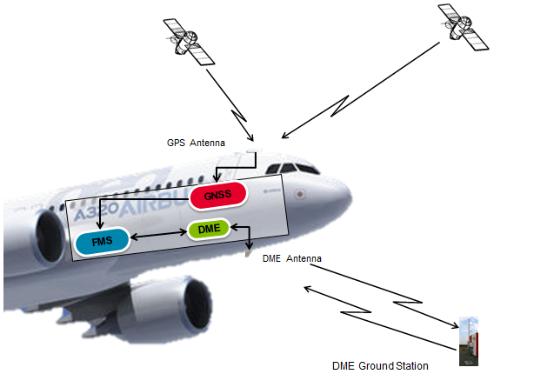

Typical Aircraft architecture using GNSS, DME and FMS

  - DME Principle

The DME system, which uses the most widely the 960 - 1164 MHz band, measures the distance in a straight line to the ground beacon.
As described in §2.1, among its core function, the DME system can be used as a backup of GNSS for aircraft Radio navigation position (DME/DME) in case of GNSS unavailability/outage. It is also used for display on Primary Flight Displays and Navigation Displays.

DME system operates the 252 available channels which are contained between 960 and 1215 MHz. Channels are numbered from 1 to 126 and each channel number is further divided into two channels ‘X’ and ‘Y ’.

The ‘X’ channels are separated from the ‘Y’ channels by varying the pulse separation time.
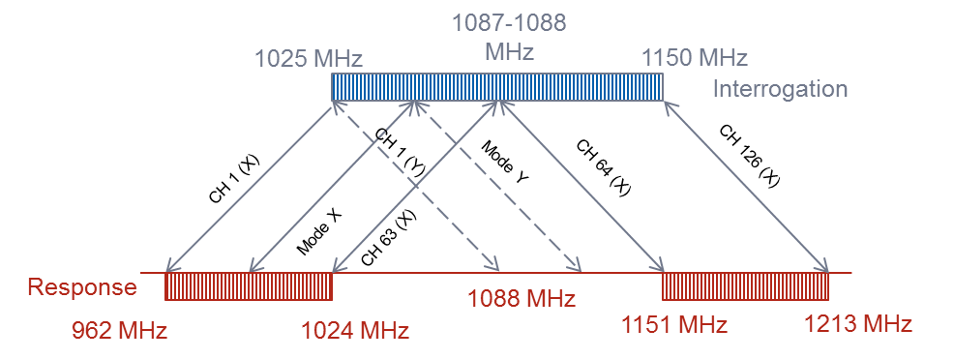
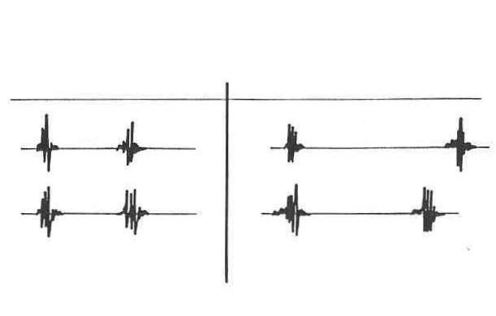
X/Y Pulse pairs characteristic spacing
X coding
Y coding
12μs
12μs
30μs
36μs
Interrog.
Response

The DME measurement concept is based on the measurement of the amount of time elapsed between the transmission of pulse pairs by an airborne transceiver and their reception further to re-emission by a ground station after a fixed delay (50µs for X channels or 56µs for Y channels).

  - Potential DME impact in case of PMSE perturbation
1st Hypothesis: PMSE transmitter is jamming only one DME ground station.
The DME on board receiver will transmit NCD (Non Computed Data) data to the aircraft systems for this Ground Station .
DME distance and Ident if displayed on Navigation Displays, will then disappear and be replaced by dashes.

That DME ground station then cannot be used anymore by the FMS for Radio position computation.
If no other adequate ground station(s) is available, this will lead to the loss of aircraft radio position .

2nd Hypothesis: PMSE transmitter is jamming on-board DME receiver.

The DME on board receiver will transmit NCD (Non Computed Data) data to the aircraft systems, including FMS, for all DME Ground Stations then the radio aircraft position will be lost.
DME distance(s) and Ident if displayed on Navigation Displays, will then disappear and be replaced by dashes .

In summary PMSE effect on DME band could create noise on DME aircraft receivers, leading to the loss of the Aircraft radio position and to a degradation of aircraft operational performances (loss of DME distances display). Obviously these performances can become critical in case of difficult conditions such as bad weather, low flight altitude…where we still need to ensure and maintain Safety of Flight.

  - Other aircraft systems potential impact
Same exercise shall be performed for each aircraft system such as TCAS, ACAS-X, ADS-B, SSR, UAT .. to assess the potential overall impact at Aircraft level.
As a reminder each aircraft is equipped with : 2 DMEs; 2 Transponders and 2 TCAS.

Concerning LDACS which is still under study and not deployed, it shall be necessary to clarify also potential impact on the expected performances, both at ground and board levels.

Current cohabitation in this frequency band is already considered as delicate and challenging . Considering all existing aeronautical systems (Spectrum, usage, Noise, Occupancy, Guard channels ) some complex mitigation means like suppression pulse are necessary at Aircraft level to avoid systems cross talking.
Therefore in an increasingly dense aircraft traffic environment , it will be really difficult to anticipate global behavior in this band especially with the introduction of a new Service which for sure will create additional noise, interferences and which will have an undesirable and not manageable impact on the so called “Cumulative effect”.

Radio navigation receivers performances are covered by high level qualification standards defined by Eurocae/RTCA standardization bodies, currently 27700 air transport civil aircraft are in service, so we cannot imagine to modify current receiver performances without a huge impact on associated costs which will affect the full Aeronautical community (Suppliers, Airlines, Airframers, ANSP...).

Finally it shall be necessary to conduct General Non Interferences tests at Aircraft level to assess the potential impact of such PMSE in various environments knowing that we will not be able, as Aeronautical sector to control, neither master the development of this new kind of equipment in Europe.
- CONCLUSION
As Airframer , Airbus considers that the introduction of PMSE in 960 – 1164 MHz band will definitely create new constraints in this band which is already heavily used for civil air transport by Navigation, Surveillance and Communication Safety of life systems.
This band is also used by military community for operating safety-of-life radionavigation services.

For all reasons described in this WP, the intent to introduce PMSE in 960 – 1164 MHz band is not desirable if aeronautical community want to maintain and continue to rely on safety of flight Navigation, Surveillance and Communication operations for short and long terms.
- ACTION BY THE MEETING
The group is invited to note the information provided and, where appropriate, use the information in preparing and submitting formal contributions to the next meetings of WGFM., ECC, CEPT and FM51.

