FREQUENCY SPECTRUM MANAGEMENT PANEL (FSMP)

Eleventh Working Group meeting

Web Meeting, 1 – 12 March 2021

Agenda Item 3.: Radio Altimeter and Wireless Aircraft Intra-Communications (WAIC) Issues
- National efforts to implement broadband mobile near 4200-4400 MHz

UK Deployment of Mobile Systems in the Frequency Range 3.6-4.2 GHz and the Theoretical Impact on Radio Altimeters

(Presented by .John Mettrop)

SUMMARY
This document provides a study into the potential interference from 5G base stations operating in the frequency range 3.6-4.2 GHz into radio altimeters under various scenarios as defined by the information contained in International Telecommunication Union, European Commission and UK regulations/documents.

- INTRODUCTION
  - Since the introduction of mobile phones in 1985, the public demand for mobile communication has increased significantly as the capabilities of phones has increased to the point where many families no longer own/use a fixed line handset. At the same time other new and innovative ways of using spectrum have been discovered whilst traditional users have looked to take advantage of these innovations to broaden the services they can offer. The increase in demand and its finite nature has made spectrum a valuable commodity that governments are keen to exploit to the extent possible.
  - The desire to exploit spectrum to the maximum extent possible has meant that every frequency band has come under increasing scrutiny with any spare capacity being liberated to meet the increasing demand. The frequency band 3.4-4.2 GHz, traditionally used by the fixed and fixed satellite services, where mobile services can be accommodated by re-farming where necessary existing users into suitable alternative frequency bands. However, this will change the adjacent band environment for radio altimeters that operate in the frequency band 4.2-4.4 MHz.
  - Within the UK the frequency band 3.6-4.2 GHz has been split in two with the 3.6-3.8 GHz currently being auctioned off for mobile services and 3.8-4.2 GHz to be made available through co-ordinated local licences to meet local wireless connectivity needs and innovation. This document provides a theoretical study into the potential inference for various scenarios based on International Telecommunication Union, European Commission and UK regulations/documents.
  - This study does not consider the impact of active antenna system due to modelling difficulties and user equipment as the power levels are significantly lower and therefore presumed not to be a threat.
- METHODOLOGY
  - Receiver Overload Threshold
    - Baseline
      - For each of the two frequency bands the study considers the separation distance relative to the mobile base station antenna required between a rural mobile base station and an aircraft in level flight, as illustrated below:

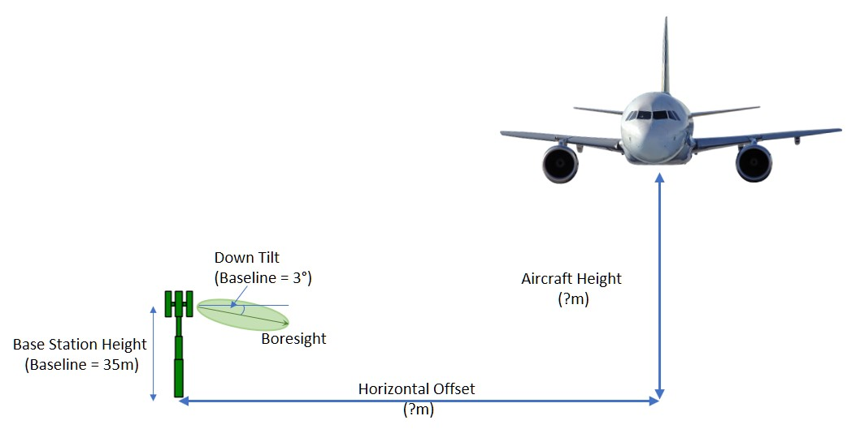

Figure 1: Scenario Considered
      - For each angle the required separation distance is calculated using the following formula assuming free space path loss, radio altimeter information taken from the ITU and that aircraft shielding is sufficient additional protection once the aircraft is below the mobile base station antenna.

Where:

P_{Rx} = Power received (assumed to be the receiver overload threshold)

P_{Tx} = Mobile base station power supplied to the antenna port

G_{Tx} = Gain of the mobile base station antenna in the direction of the aircraft

AF_{Tx} = Transmitter activity factor

FSPL = Free space path loss (=32.4+20log(F_{MHz})+20Log(D_{km})

F_{MHz} = Frequency

D_{km} = Separation distance

G_{Rx} = Gain of the radio altimeter antenna in the direction of the mobile base station

Rx_{Rej} = Adjacent channel rejection of the radio altimeter receiver

FL_{Rx} = Feeder loss in the radio altimeter

SM = Safety margin (assumed to be 6dB)
      - Combining the equations And re-arranging to make the separation distance the subject of the formula gives:
      - Knowing the angle from the horizontal being considered the horizontal and vertical separation can then be calculated and a vertical slice through the interference volume can be generated.
    - Variations in the Baseline Scenario
      - Having established the baseline scenario, the following variations in the baseline scenario are investigated for radio altimeters A1 and A3 taken from Recommendation ITU-R M.2059:

Pitch/Roll: The impact of the aircraft pitching/rolling by 15°, 30°, 45° towards the mobile base station antenna

Mobile Antenna Heigh & Tilt: Variations in the height and down tilt angle of the mobile base station for urban (25m & 6°) and suburban masts (20m & 10°)

Aggregate Effects: The level of aggregate interference that should be applied assuming a standard rural macro deployment scenario taken from Recommendation ITU-R M.2101 &Report ITU-R M.2292

Radio Altimeter Receiver Frequency Dependent Rejection: Use the frequency dependent rejection at 3.75 GHz based on ITU-R M.2059 assuming the octave is based on the size of the frequency band & band edge frequency, radio regulatory guidance, RTCA worst case measured results.
    - Reasonable Worst Case Scenario
      - Based on the information obtained through the investigations into the variations of the baseline solution a reasonable worst case scenario will be assessed.
- RESULTS
  - Baseline
    - Assumptions:
      - The following assumptions were made for the baseline study for 3.6-3.8 GHz and 3.8-4.2 GHz.
 |  | 3.6 - 3.8 GHz | 3.8 - 4.2 GHz | Units

Mobile Base Station Transmitter
Power supplied to antenna port (P_{Tx}) |  | 60 | 31 | dBm
Activity factor (AF_{Tx}) |  | 40 |  | %
Maximum transmitter bandwidth |  | 100 |  | MHz

Mobile Base Station Antenna
Antenna gain (G_{Tx}) |  | 18 |  | dBi
Mechanical down tilt | Urban  Suburban  Rural | 10  6  3 |  | degrees
Antenna height | Urban  Suburban  Rural | 20  25  35 |  | metres
Antenna Pattern |  | ITU-R F.1336-5 Equation 2b3  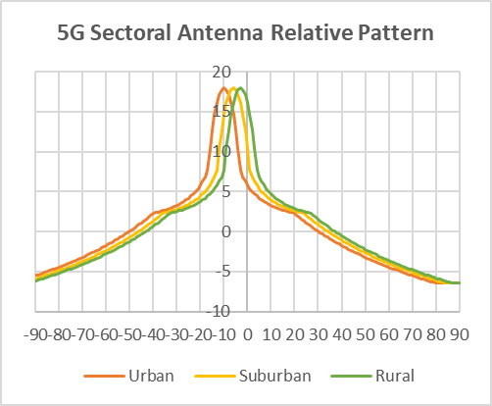  See annex 1 for derevation

Radio Altimeter Receiver | See annex 2
Radio Altimeter Antenna Pattern | 3.6 – 3.8 GHz  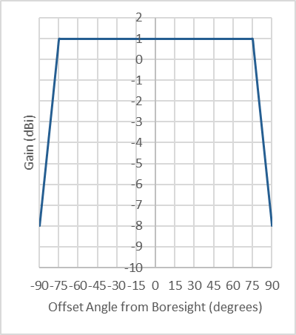  Based on RTCA measured data for 3 750 MHz see annex 2 for a comparision of this mask and the measured mask | 3.8 – 4.2 GHz  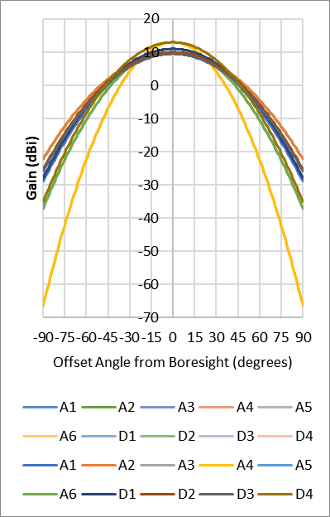  See annex 2 for derivation

General
Propagation Model | Recommendation ITU-R P.525 Free space path loss
Safety Margin | 6dB
Airframe Shielding | Once the angle from the boresight of the radio altimeter is greater than 90 degrees then airframe shielding will be sufficient to protect the receiver
      - The results for the baseline cases are shown below for all of the radio altimeters included in Recommendation ITU-R M.

Figure 2: Minimum Separation Distance from a 5G Base Station
Operating in the Frequency Band 3.6-3.8 GHz

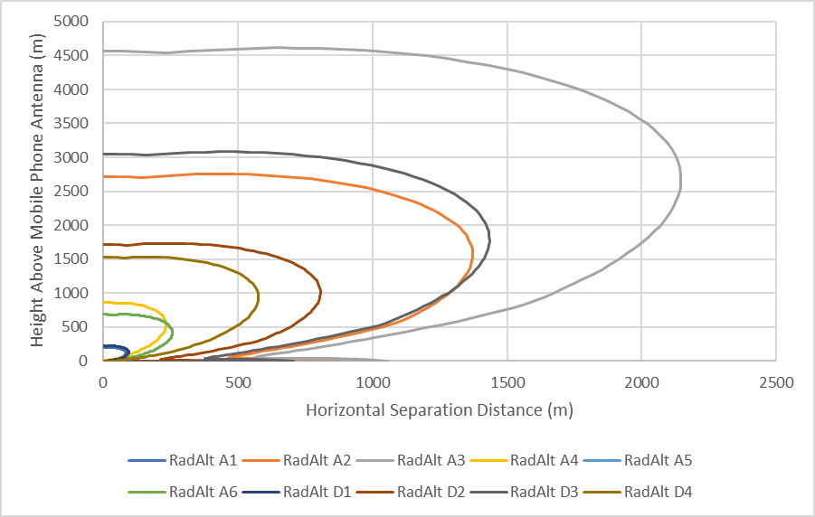

Figure 3: Minimum Separation Distance from a Local Fixed Wireless Access Base Station
Operating in the Frequency Band 3.8-4.2 GHz

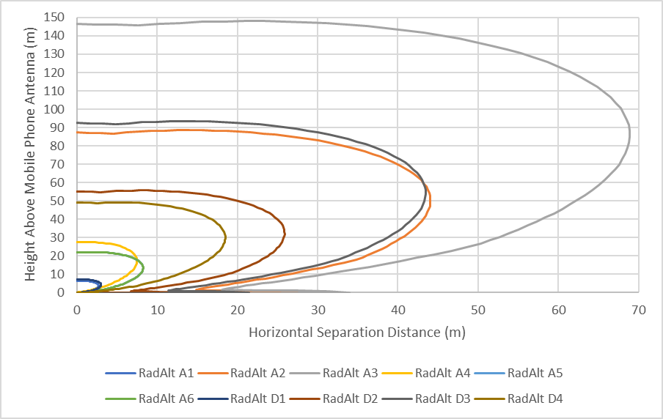
      - Both baseline cases indicate the need for a horizontal and or vertical separation distance that is not consistent with either an aircraft on an approach to a runway or a helicopter landing at a helipad or some other convenient point on the ground.
  - Variations in Pitch/Roll
    - Assumptions:
      - The same assumptions as for the baseline are applied in each of the two frequency bands under consideration for radio altimeters A1 & A3 except that instead of just considering level flight the aircraft pitched/rolled at 15°, 30° & 45° have also been considered

Figure 4: Minimum Separation Distance from a 5G Base Station
Operating in the Frequency Band 3.6-3.8 GHz
Figure 4a: Radio Altimeter A1  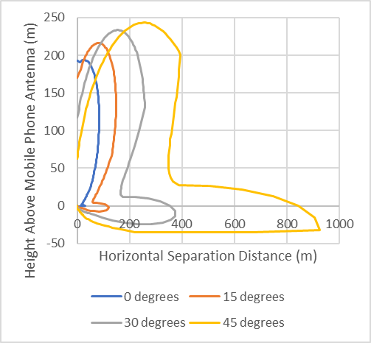 | Figure 4b: Radio Altimeter A3  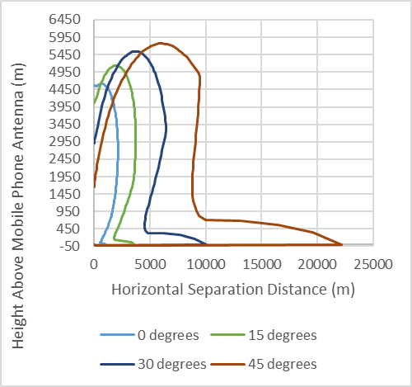

Figure 5: Minimum Separation Distance from a Local Fixed Wireless Access Base Station
Operating in the Frequency Band 3.8-4.2 GHz
Figure 5a: Radio Altimeter A1  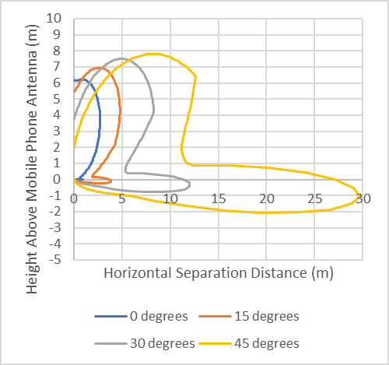 | Figure 5b: Radio Altimeter A3  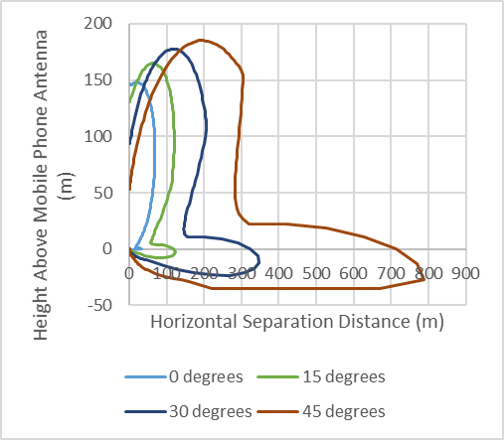
      - The results as would be expected indicate a clear increase in the required separation distance but more surprising a delineation between the effect of the radio altimeter antenna (vertical plain) and the base station antenna (horizontal plane).

  - Variations in Height & Tilt
    - Assumptions:
      - The same assumptions as for the baseline are applied in each of the two frequency bands under consideration for radio altimeters A1 & A3 however this time considering variations in height and tilt combinations (rural 35m & -3°, suburban 25m & -6° and urban 20m & -10°
Figure 6: Minimum Separation Distance from a 5G Base Station
Operating in the Frequency Band 3.6-3.8 GHz
Figure 6a: Radio Altimeter A1  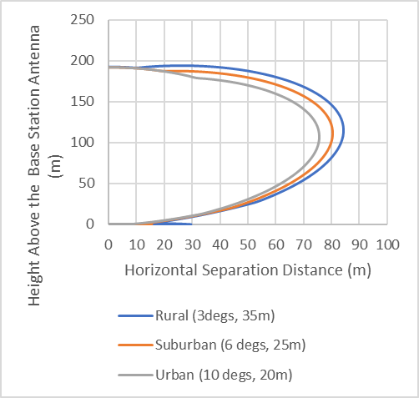 | Figure 6b: Radio Altimeter A3  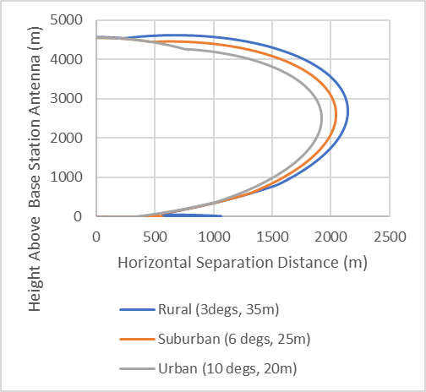

Figure 7: Minimum Separation Distance from a Local Fixed Wireless Access Base Station
Operating in the Frequency Band 3.8-4.2 GHz
Figure 7a:Radio Altimeter A1  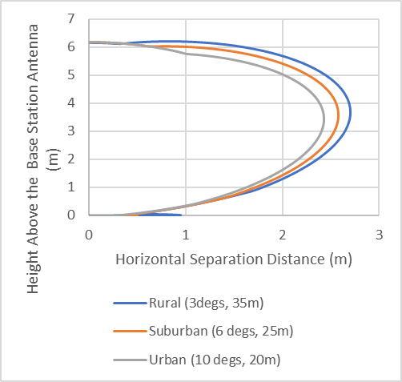 | Figure 7b:Radio Altimeter A3  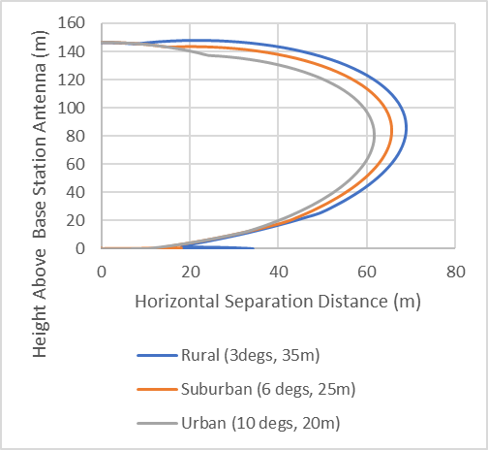
  - Aggregate Effect
    - Assumptions:
      - The same assumptions as for the baseline are applied in each of the two frequency bands under consideration for radio altimeters A1 & A3. However, in this section the level of aggregation that should be applied is considered.
      - Recommendation ITU-R M.2101 and Report ITU-R M.2292 describe how to model IMT networks for use in sharing and compatibility studies at the frequencies under consideration it is suggested that a cell radius of 4km should be used for a rural deployments illustrated in Figure 8 below. The calculations are therefore done for 4km and then 3km, 2km & 1km to show the influence of the cell size and consider the impact of using smaller cells as would typically be deployed in suburban or urban environments

Figure 8: Relationship between two Adjacent Cells used in the Study

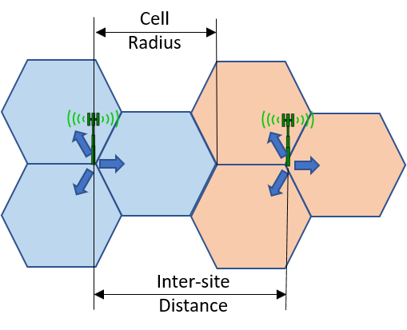
      - To study the aggregation of signal strength from surrounding cells the following cell pattern was studied assuming all cells radiate the same signal level with the results taken for the indicated calculation area.
Figure 9: Relationship between two Adjacent Cells used in the Study

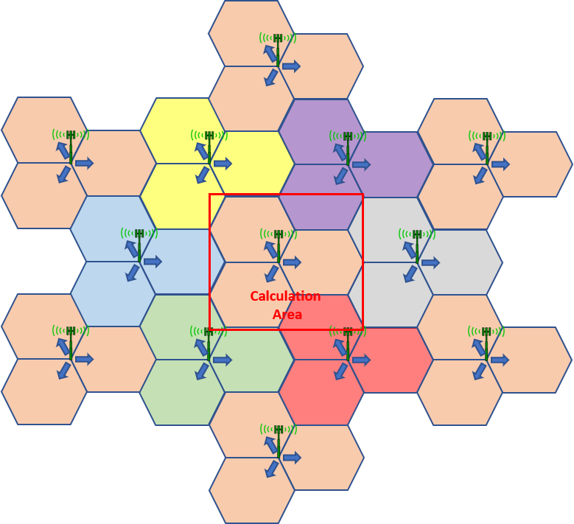
      - The results for 1km, 2km, 3km & 4km are shown below:

Figure 10: Aggregate Interference for Various Cell Sizes
Figure 10a: 1km  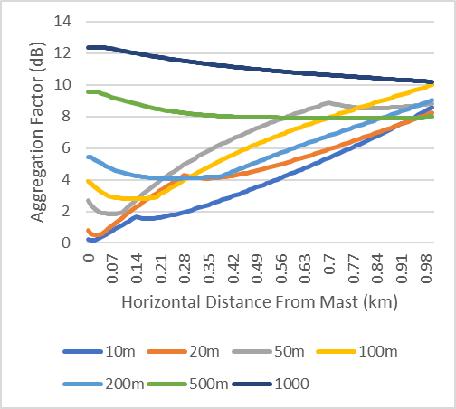 | Figure 10b: 2km  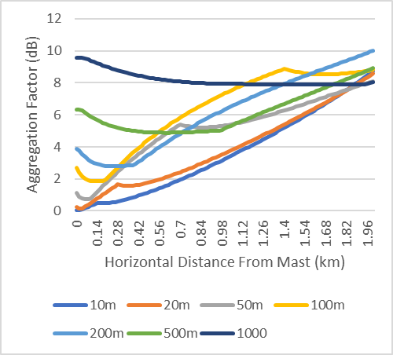
Figure 10c: 3km  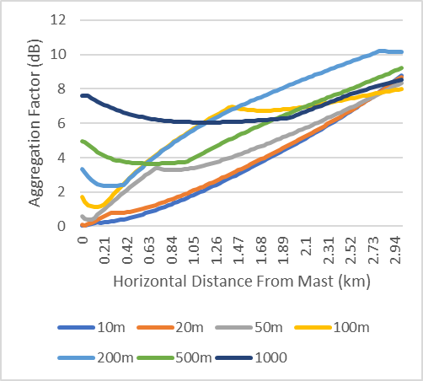 | Figure 10d: 4km  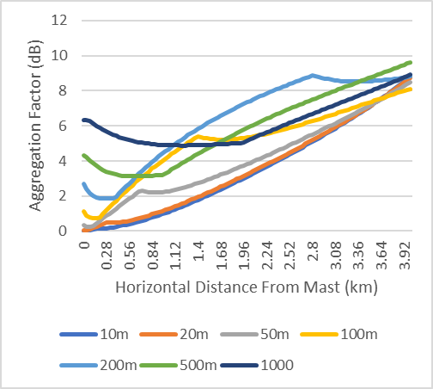
      - The results of the simulation clearly indicate he variation in the level of aggregation effects dependant on the cell radius and the height of the aircraft.

  - Receiver Frequency Dependant Rejection
    - Assumptions:
      - To study the effect that receiver frequency dependant rejection has on the required horizontal and vertical separation distances necessary to ensure the protection of radio altimeter A1 & A3 the following scenarios have been considered:
- Recommendation ITU-R M.2059 24dB/Octave:
  - Based on allocated bandwidth (200 MHz)
  - Based on centre lower frequency (4 200 MHz)

It should be noted that Recommendation ITU-R M.2059 is unclear as to what frequency an octave is based and hence two interpretations have been considered although a third has been suggested which would be to base it on the centre of the radio altimeter frequency band (4 300 MHz). However, if the third option where to be used then that would be inconsistent with have 0 dB at 4 200 MHz)
- Radio Regulatory guidance material
- RTCA envelope
- Recommendation ITU-R M.2059 24dB/Octave to 40dB
  - Based on Allocated bandwidth (200MHz)

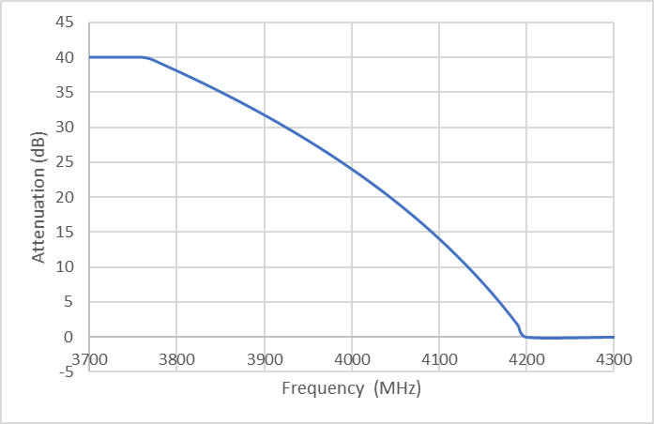
  - Based on the lower frequency band edge (4200 MHz)

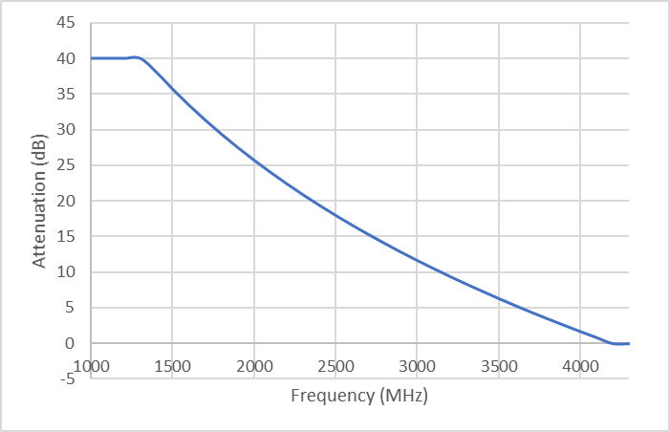
- Radio Regulations Guidance Material

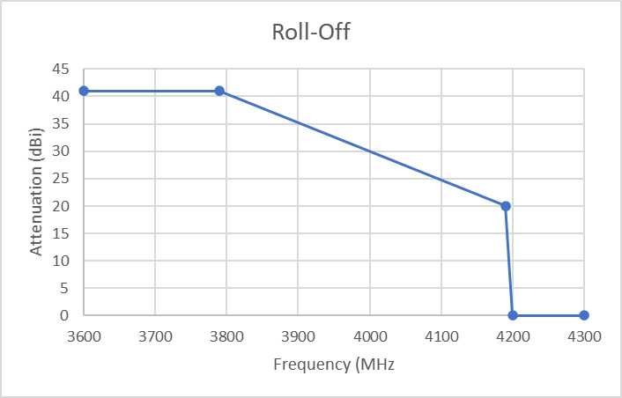
- RTCA Envelope Mask
      - The values assumed at the centre frequency of the first adjacent channel are:
- 5G (3.6–3.8 GHz)
  - 40dB (24dB/Octave 200 MHz),
  - 3.92dB (24dB/Octave 4200 MHz),
  - 40dB (RR guidance)
  - 10dB (RTCA mask)
- Local Fixed Wireless Access (3.8-4.2 GHz)
  - 7.73 (24dB/Octave 200 MHz),
  - 0.4 dB (24dB/Octave 4200 MHz),
  - 22 dB (RR guidance)
  - 0dB (RTCA mask)
      - The results are shown below where the line represents the point :
Figure 11: Minimum Separation Distance from a 5G Base Station
Operating in the Frequency Band 3.6-3.8 GHz
Radio Altimeter A1  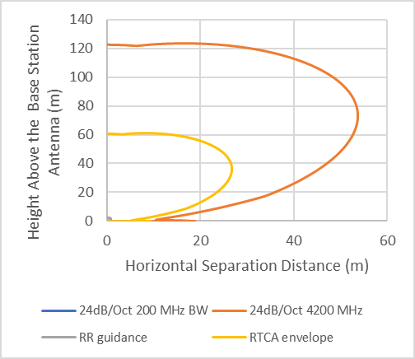 | Radio Altimeter A3  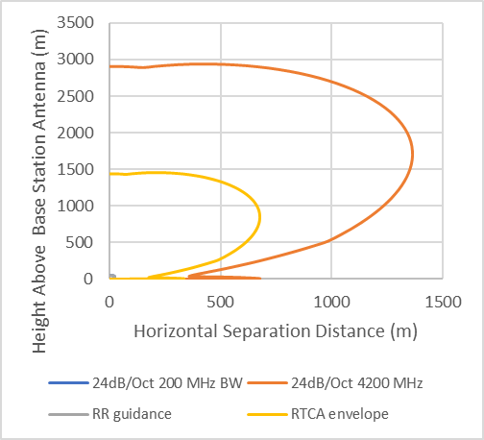

Figure 12: Minimum Separation Distance from a Local Fixed Wireless Access Base Station
Operating in the Frequency Band 3.8-4.2 GHz
Radio Altimeter A1  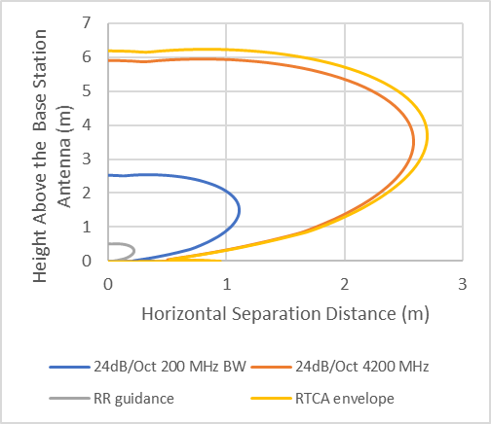 | Radio Altimeter A3  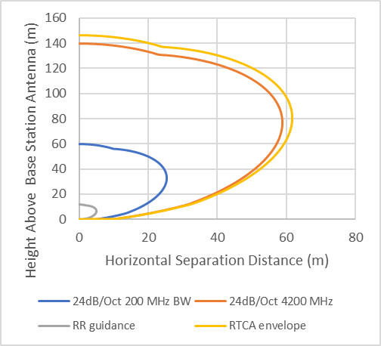
      - The impact of receiver front end filtering is clearly demonstrated
  - Reasonable Worst case
    - Assumptions:
      - The following assumptions based on the baseline assumptions contained in the table below for 5G at 3.6-3.8 GHz and local fixed wireless access at 3.8-4.2 GHz with the following additional assumptions based on the results of the various variations investigated:

Aircraft Pitch/Roll: Noting that in accordance with Recommendation ITU-R M.2059 45° is the absolute worst case to consider and that below a height of 30 metres a pilot would be more worried about hitting the ground a value of 30° has been assumed

Base Station Antenna Height/Tilt: A rural situation has been assumed (35 metres and -3°) given that in practice suburban and urban antenna will be using lower power base stations given the smaller coverage area and the reduction in power will be greater than the increase due to additional aggregation

Aggregation: Given that a rural situation has been assumed then a cell radius of 4km should be used. If it is then assumed that any effect beyond 500m in height would be unacceptable then a maximum aggregation factor of 4dB should be used taken from figure 10d.

Frequency Dependent Rejection: Given that the results of the RTCA indicate that there is a variation in the frequency dependent reject rejection performance between the various radio altimeters tests the worst case (24dB/Octave based on 4200 MHz) and the best (RR guidance with linear interpolation) have been calculated
 | 3.6 – 3.8 GHz | 3.8 – 4.2 GHz | Units

Mobile Base Station Transmitter
Power supplied to antenna port (P_{Tx}) | 60 | 31 | dBm
Activity factor (AF_{Tx}) | 40 |  | %
Maximum transmitter bandwidth | 100 |  | MHz

Mobile Base Station Antenna
Antenna gain (G_{Tx}) | 18 |  | dBi
Mechanical down tilt (Rural) | 3 |  | degrees
Antenna height (Rural) | 35 |  | metres
Cell Size | 4 |  | km
Antenna Pattern | ITU-R F.1336-5 Equation 2b3  See annex 1 for derevation

Radio Altimeter Receiver
Radio Altimeter Antenna Pattern | 3.6 – 3.8 GHz  Based on RTCA measured data for 3 750 MHz see annex 2 for a comparision of this mask and the measured mask | 3.8 – 4.2 GHz  See annex 2 for derivation

General
Aircraft Tilt/Roll | 30 degrees
Propagation Model | Recommendation ITU-R P.525 Free space path loss
Aggregation Factor | 4dB
Safety Margin | 6dB
Airframe Shielding | Once the angle from the boresight of the radio altimeter is greater than 90 degrees then airframe shielding will be sufficient to protect the receiver

      - Using the above assumptions the following minimum separation distances can be calculated for the various radio altimeters characteristics given in Recommendation ITU-R M.2059
Figure 13: Minimum Separation Distance from a 5G Base Station Operating
in the Frequency Band 3.6-3.8 GHz

Figure 13a: Assuming a Frequency Dependant Rejection of 3.92 dB (24dB/Octave 4200 MHz)

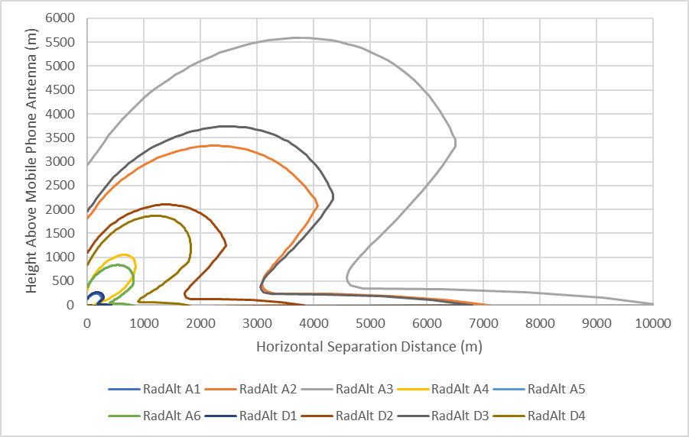

Figure 13b: Assuming a Frequency Dependant Rejection of 40 dB (24dB/Octave 200 MHz)

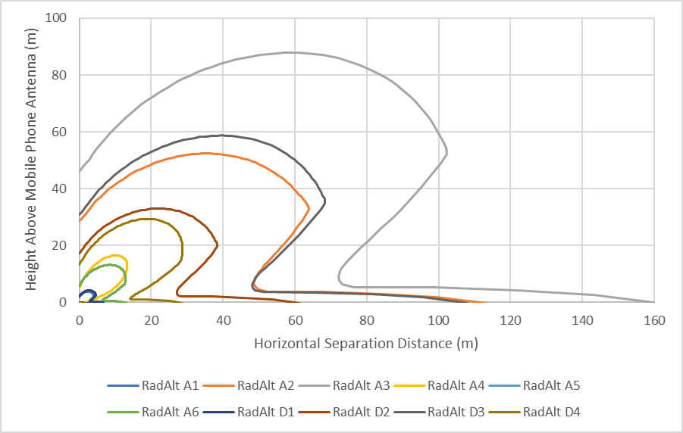
Figure 14: Minimum Separation Distance from a Local Fixed Wireless Access
Base Station Operating in the Frequency Band 3.8-4.2 GHz

Figure 14a: Assuming a Frequency Dependant Rejection of 0.04 dB (24dB/Octave 4200 MHz)

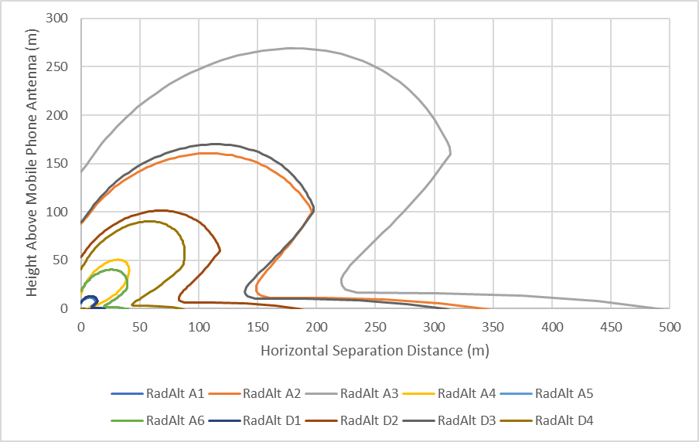

Figure 14b: Assuming a Frequency Dependant Rejection of 7.73 dB dB (24dB/Octave 200 MHz)

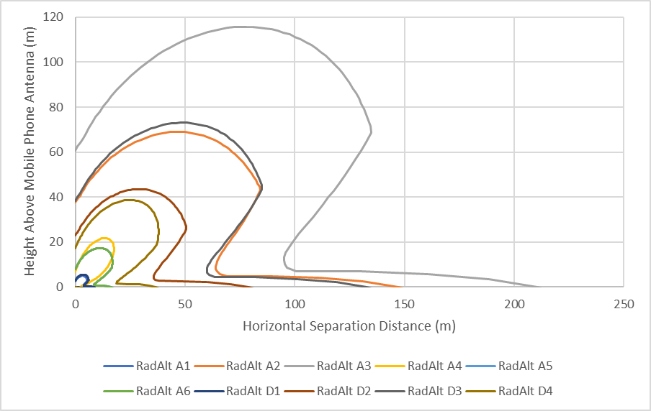

- CONCLUSIONS
  - This study would indicate that 5G mobile base stations operating below 3.8 GHz, especially if they use active antenna systems, which have not been considered in this study, pose a viable interference threat. However, due to the anonymisation of the data provided in the RTCA study, which is the only one currently available, the number of radio altimeters affected and the degree to which they are affected cannot be assessed
  - For the UK situation with respect to local fixed wireless access systems operating in the frequency band 3.8-4.2 GHz, especially given the restriction to rural areas and considering practical separation distances it is unlikely to be a problem for aircraft landing at an airfield. However there may be an issue for helicopters, especially those used by the emergency services that could land closer to a mobile mask than would occur for fixed wing aircraft.
  - In order to quantify the extent of the problem results are required for individual radio altimeters. Once quantified then a solution(s) can be determined.
  - Given the size of the issue at 3.6-3.8 GHz in comparison to that at 3.8-4.2 GHz it would be reasonable to assume that any solution for the 3.6-3.8 GHz will also resolve the issue at 3.8-4.2 GHz
  - Noting that 5G or other similar systems, including one deployed at London Heathrow, have apparently been operating without interference being detected then the reason why there has not been any interference detected needs to be investigated in light of the results of this study.

- ACTION BY THE MEETING
  - The meeting is invited to:
- note and review the contents of this working paper;
- Encourage radio altimeter manufacturers to declare the susceptibility f their equipment to 5G mobile signals
- Support action to explain why interference has not been detected from 5G and other systems that have or are currently operating in these frequency bands

ANNEX 1
MOBILE BASE STATION ANTENNA PATTERN
Antenna Pattern |  | ITU-R F.1336-5 Equation 2b3
Peak Antenna Gain |  | 18 dBi
Horizontal 3dB Beamwidth |  | 65 degrees
Vertical Beamwidth |  | 7.56 degrees
Mechanical Down Tilt | Urban  Suburban  Rural | 10  6  3
Mast Height | Urban  Suburban  Rural | 10  6  3
K_{a} |  | 0.7
K_{p} |  | 0.7
K_{h} |  | 0.7
K_{v} |  | 0.3

Equations for the Antenna Pattern
Where:
_{Xv} =
X_{k} = |  | = 0.944458
C = | 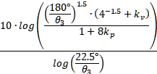 | = 18.45142
ƛ_{Kv} = |  | = 4.607252
G₁₈₀ = | -15 | = -24.4558

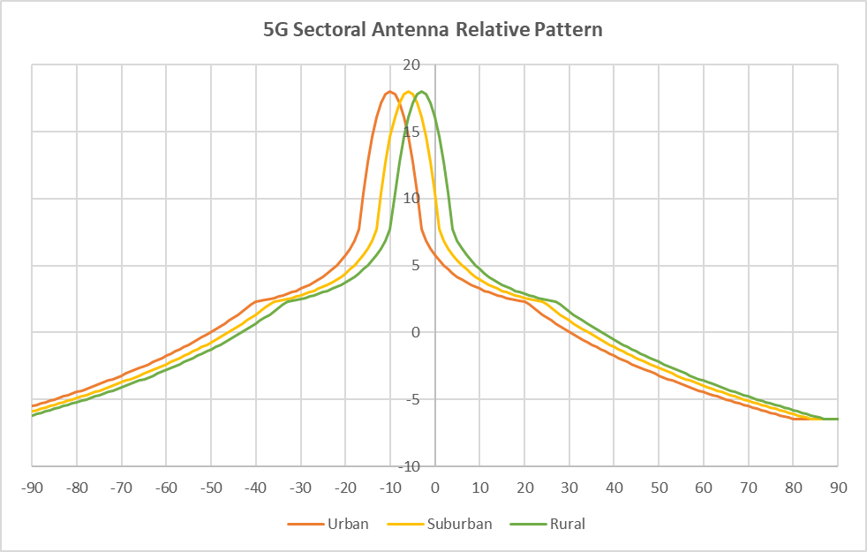

ANNEX 2
RADIO ALTIMETER INFORMATION USED IN THIS STUDY

A2.1 Technical Parameters
 | A1 | A2 | A3 | A4 | A5 | A6 | D1 | D2 | D3 | D4 | Units
Nominal centre frequency | 4,300 | 4,300 | 4,300 | 4,300 | 4,300 | 4,300 | 4,300 | 4,300 | 4,300 | 4,300 | MHz
Chirp bandwidth B_{S} | 104 | 133 | 133 | N/A | N/A | N/A | 150 | 177 | 133 | N/A | MHz
Sensitivity* | -120 | -113 | -120 | -95 | -95 | -95 | -114 | -125 | -120 | -95 | dBm
Noise Figure | 10 | 6 | 6 | 10 | 10 | 10 | 8 | 9 | 8 | 10 | dB
Rx front-end overload P_{T,RF} | -30 | -53 | -56 | -40 | -40 | -40 | -30 | -43 | -53 | -40 | dBm
IF bandwidth B_{R,IF} | 2 | 0 | 2 | 9 | 6 | 16 | 0 | 2 | 1 | 30 | MHz
Necessary Bandwidth (B₋₂₀) | 120 | 170 | 181 | 44 | 29 | 51 | 153 | 180 | 185 | 105 | MHz
Antenna
Antenna gain | 10 | 10 | 10 | 13 | 11 | 11 | 11 | 10 | 9.5 | 13 | dBi
Cable loss (single path) | 6 | 6 | 4.5 | 6 | 6 | 6 | 6 | 0 | 5 | 1 | dB
–3 dB beam width | 50 | 55 | 52.5 | 35 | 45 | 45 | 50 | 52.5 | 52.5 | 45 | degrees
Note the numbers highlighted in yellow are where a range of values has been quoted and the average value has been taken
A2.2 Antenna Patterns
A2.2.1 4.2-4.4 GHz – In-Band
The following antenna patterns were derived from the information above using the following formula taken from Report ITU-R M.2319-0
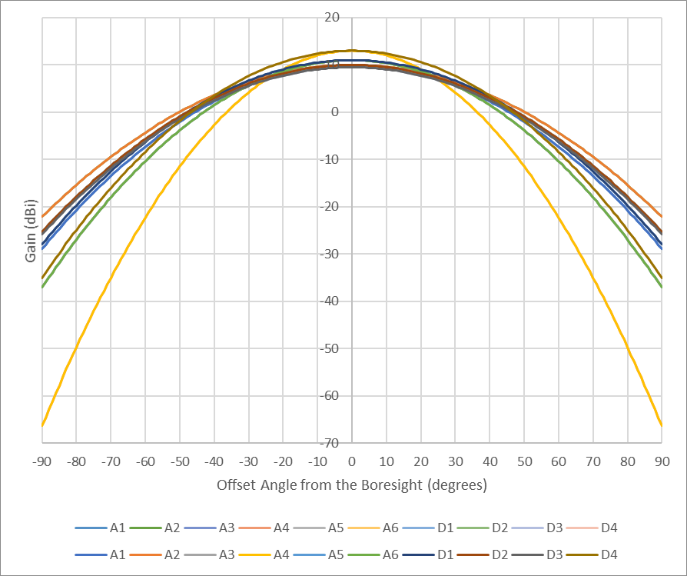
A2.2.1 RTCA Reference Antenna Pattern in the Frequency Band 3.7 – 3.98 GHz
The RTCA reference antenna patter nis shown in red and the assumed patter in blue
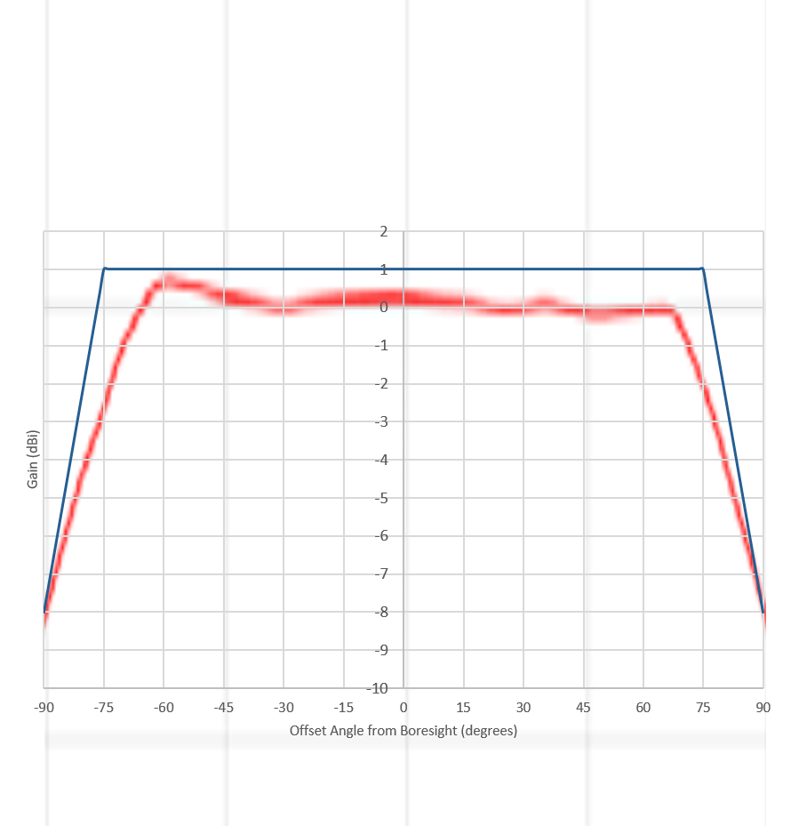
A.2.3 Radio Altimeter Frequency Dependant Rejection
A.2.3.1. ITU-Recommendation 2059: “Operational and technical characteristics and protection criteria of radio altimeters utilizing the band 4 200-4 400 MHz” defines that the receive will roll off at 24 dB per octave from 4 200 MHz to a maximum value of 40dB. However, what the octave is referenced too is not defined and can be interpreted in more than one. The following two interpretations are considered in this document:
A.2.3.1.1 Referenced to the size of the frequency band
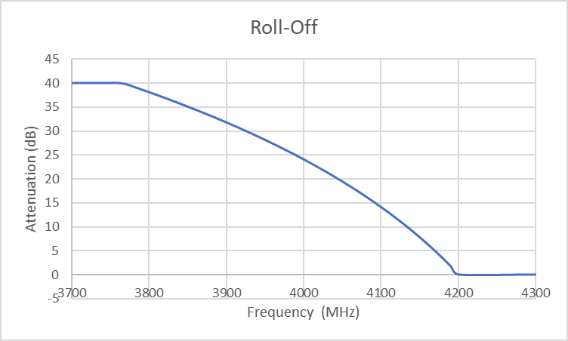
A.2.3.1.2 Referenced to the edge of the radio altimeter frequency band
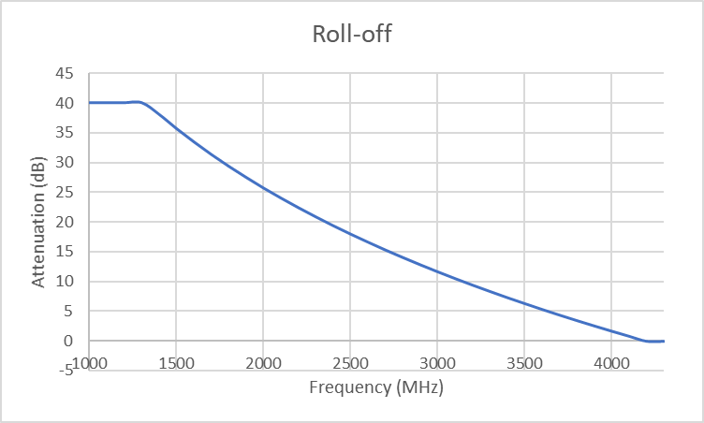
A.2.3.2 Radio Regulatory guidance: Receivers should comply as far as possible with the frequency tolerances of the transmitters with due regard being paid to the Doppler effect where appropriate and that the selectivity should be appropriate for the bandwidths of emission. For a primary radar such as a radio altimeter the necessary bandwidth is defined as the -20 dB Bandwidth. If we assume that the necessary bandwidth equates to the allocated bandwidth (e.g. the -20db points fall at the band edges) then in accordance with the Radio Regulations the boundary between the centre frequency (4.3 GHz MHz) and the spurious domain is defined as 2.5*necessary bandwidth (500 MHz or 3.8 GHz). Further the Radio Regulations require that the signal should be 43+10Log(PEP) below the fundamental. Taking into account that the frequency tolerance as defined by Appendix 2 of the Radio Regulations (1 259 parts in 10⁶ or 5.375 MHz) and twice the Doppler shift 10 kHz then the transmit mask would need to be broadened by 5.385 MHz. Allowing some additional margin it is assumed that the tolerance to be included is 10 MHz which would result in the mask shown below for radio altimeter A1 which is the mask used in the study.
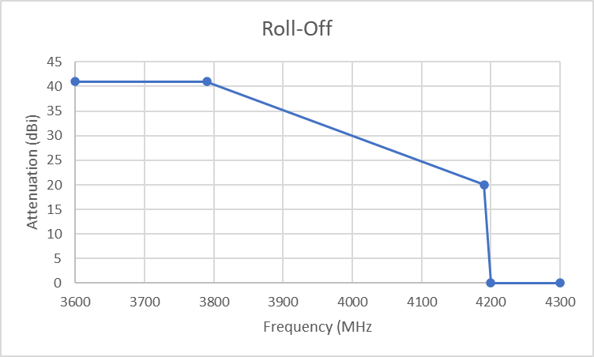

Recommendation ITU-R M.2059 - Operational and technical characteristics and protection criteria of radio altimeters utilizing the band 4 200-4 400 MHz
Recommendation ITU-R M.2102 - Modelling and simulation of IMT networks and systems for use in sharing and compatibility studies
Report ITU-R M.2292 - Characteristics of terrestrial IMT-Advanced systems for frequency sharing/interference analyses
3.4.1.2 Recommendation ITU-R M.2101 Modelling and simulation of IMT networks and systems for use in sharing and compatibility studies
Report ITU-R M.2292 Characteristics of terrestrial IMT-Advanced systems for frequency sharing/interference analyses
ITU-R M.2319 Compatibility analysis between wireless avionics intra-communication systems and systems in the existing services in the frequency band 4 200-4 400 MHz
Table 1 of Annex 1 to Appendix 3 of the Radio Regulations
Table 1 to Appendix 3 of the Radio Regulations
Based on an aircraft travelling at the speed of light

