FREQUENCY SPECTRUM MANAGEMENT PANEL (FSMP)

Eleventh Working Group meeting

On-line, 1-12 March 2021

Agenda Item 3(b): 5G basestation issues

The compatibility study between 5G base stations and radio altimeters in Japan and update of the result of measurement campaign

Naruto Yonemoto,
Akiko Kohmura, Shunichi Futatsumori, and Kazuyuki Morioka
Electronic Navigation Research Institute,
National institute of Maritime, Port and Aviation Technology
(ENRI/MPAT), JAPAN

SUMMARY
This WP presents the results of the discussion on the co-existence between 5G and Radio Altimeters (RAs) in Japan. It also introduces the result of laboratory tests for 5G new radio (NR) format.

- INTRODUCTION
  - Since 2018, the Ministry of Internal Affairs and Communications started the discussion on the new allocation of the frequency band for 5G mobile communications in Japan [1]. ENRI has also joined the activities to discuss the adjacent band of RAs (4200-4400MHz) from the former generation of mobile communications (LTE-Advanced)
  - The first compatibility study has been conducted from 2012 using LTE-Advanced systems. During the study, some laboratory tests were conducted by the mobile operators, and we have already reported in FSMP-WG7/IP08[2] for the evaluation of the behavior of the radio altimeters collocated with the LTE-Advanced base stations in the adjacent band. The test results indicated that the vulnerability of pulsed RAs is weaker than that of FMCW RAs.
  - We also have reported in FSMP-WG7/IP06 [3] in 2018 on the compatibility study between the RAs and the base stations. The simulation results indicated to require to improve the suppression of interference signals.
  - The further study has also conducted using the signal of 5G base stations (5G BS). The validity of the former compatibility study has also been confirmed in the numerical analysis. And we have also conducted experiments to check the vulnerability of the active RAs if the bandwidth of the interferer was larger than that of the former generation of mobile base stations.
  - This paper presents the activities after the last reports in Japan. We update the results of the lab tests and report the conclusion of the discussion on the regulation for 5G BS in Japan.
- DISCUSSION
  - Theoretical analysis has been conducted by using the parameters described in Recommendation ITU-R M.2059 [4]. Table 1 shows the parameters extracted from the reference [4] to calculate the in-band (unwanted emission interference)/out-of-band (blocking) tolerance for RA.

Table 1 Receiving characteristics of radio altimeters described in the Recommendation ITU-R M.2059

(Extracted from Recommendation ITU-R M.2059 Annex 2 Table 1)
 | Radio altimeter technical characteristics
 | A1 | A2 | A3 | A4 | A5 | A6 | D1 | D2 | D3 | D4
Modulation | FMCW | FMCW | FMCW | Pulsed | Pulsed | Pulsed | FMCW | FMCW | FMCW | Pulsed
Sensitivity (dBm) | -120 | <-113 | ≤-120 | -95 | -95 | -95 | <-114 | <-125 | ≤-120 | <-95
Noise Figure (dB) | 10 | 6 | 6 | 10 | 10 | 10 | 8 | 9 | 8 to 12 | 10
Input Power Threshold Receiver Overload (dBm) | -30 | -53 | -56 | -40 | -40 | -40 | -30 | -43 | -53 | -40
-3 dB Intermediate Frequency (IF) Bandwidth (MHz) | 2 | 0.25 | 0.025 to 2 | 9.2 | 6.0 | 16 | 0.312 | 1.95 | 0.1 to 2.0 | 30
Antenna Gain (dBi) | 10 | 10 (Typ.) 9.5 (min.) | 10 (Typ.) | 13 | 11 | 11 | 11 | 10 | 8 to 11 | 13
Cable Loss (dB) | 6 | 6 | 2 to 7 | 6 | 6 | 6 | 6 (10 max) | 0 | 2 to 7 | 0 to 2
-3 dB Beam Width (degrees) | 40 to 60 | 55 | 45 to 60 | 35 | 45 | 45 | 40 to 60 | 45 to 60 | 45 to 60 | 45
  - In section 3 of annex 3 of the reference [4], the protection criteria for unwanted emission interference and blocking are also described. In the case of unwanted emission interference, the interferer causes desensitization if the level of interferer exceeds -6 dB to the noise floor of the receivers (I/N = -6dB). On the other hand, the interferer causes the front-end overload if the level of interferer exceeds the saturation input level of the receivers in case of blocking. According to the theoretical calculations, the threshold interference values for each radio altimeter are obtained as shown in Table 2. There, the power spectral density of the aggregated interferer is used for the unwanted emission interference analysis, and aggregated power of the interferer is used for the blocking analysis.

Table 2 Calculated threshold value of unwanted emission interference/blocking levels for each radio altimeter described in Recommendation ITU-R M.2059
Types of Interference | Types of Altimeters
Types of Interference | A1 | A2 | A3 | A4 | A5 | A6 | D1 | D2 | D3 | D4
Unwanted emission interference (dBm/MHz) | -104 | -108 | -112 | -111 | -111 | -111 | -106 | -111 | -110 | -117
Blocking (dBm) | -24 | -47 | -54 | -34 | -34 | -34 | -24 | -43 | -51 | -40

  - Concerning the worst-case scenario, we extracted the most stringent value from Table 2. The compatibility study was considered not to exceed the levels described in Table 3.

Table 3 Most stringent value of unwanted emission interference/blocking level in Table 2
Type of Interference | Threshold Value
Unwanted emission interference | -117 dBm/MHz
Blocking | -54 dBm

  - In order to estimate the aggregated interference level, scenario-based simulations were conducted as shown in the reference [3]. We assumed two types of 5G BS. One is the macro-cell BS (with the higher power radiation and higher antenna height) and another is the small-cell (with the lower power radiation and lower antenna height). We briefly summarize the scheme of the simulations. The specifications of the 5G BS are described in Table 4.
Table 4 The specifications of two types of 5G BS for the simulations [1]
 | Small-cell BS | Macro-cell BS
Maximum EIRP (dBm/MHz) | 25 | 48
Maximum Antenna Gain (dBi) | 23 | 23
Ohmic loss of Active Antenna System (AAS) (dB) | 3 | 3
Mechanical tilt (degrees) | 10 | 6
Antenna Height (m) | 10 | 40
Adjacent Channel leakage Level | -16 dBm/MHz | -4 dBm/MHz
Spurious Level | -4 dBm/MHz | -4 dBm/MHz

  - The deployment scenario is set as shown in Table 5. The BS deployment model is divided into 4 types of areas that have different densities and ratios of the 5G BSs. In the simulation, the range of the considerations for aggregation calculation is modeled as shown in Figure 1. The angle of the range for aggregation is 170 degrees downward. And the area on the surface is calculated by the flight altitude. The maximum radius of the dense urban area model is 564m (1km²). The urban area model is placed surrounding the dense urban area model if the radius of the range of considerations is exceeding the maximum radius of the dense urban area model according to the flight altitude. The 5G BSs are randomly and equally distributed on the land. The aggregated power of the 5G BS is numerically calculated and the calculation is repeated. As a result, the distribution of the aggregated interferer level is obtained. The calculation results are described in the reference [3, 5].

Table 5 BS deployment scenarios for the simulation of the aggregated interference level
BS deployment model | BS density characteristics | Value of BS density | Ratio between Small/Macro-cell BS
Dense urban | Ultra-High  (ex. Central Tokyo) | 100 BS/km² | 100:0
Urban area | High  (Average of TOKYO) | 300 BS/100km² | 90:10
Sub-Urban | Medium  (average of KANTO region) | 6,300 BS/10,000km²  (63 BS/100km²) | 70:30
Nationwide | Low  (average of nationwide) | 15,000 BS/100,000km² (15 BS/100km²) | 0:100
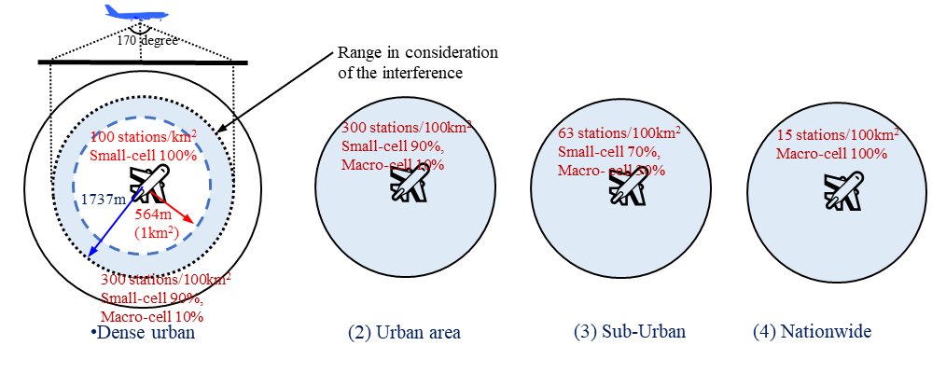

Figure 1. BS deployment models
  - The simple estimation of the required suppression of the interference level is calculated in comparison to the simulated distribution and threshold value as shown in Table 6 without any restriction of the location of the 5G BS.

Table 6 Calculated required suppression level of interference level in each scenario and altitude for unwanted emission interference
Flight Altitide (m) | Required Suppression for Unwanted Emission Interference Level (dB)
Flight Altitide (m) | Averaged Patterns of Base Station Antennas considering AAS beam-forming |  |  |  | Maximum Patterns of Base Station Antennas considering AAS beam-forming
Flight Altitide (m) | Dense Urban | Urban | Sub-Urban | Nation-Wide | Dense Urban | Urban | Sub-Urban | Nation-Wide
17 | 31.2 | 32.2 | 32.3 | 25.4 | 58.2 | 59.0 | 59.0 | 36.7
50 | 22.5 | 45.0 | 45.0 | 45.0 | 47.2 | 72.1 | 72.1 | 72.1
94.2 | 19.4 | 31.5 | 31.5 | 31.5 | 43.3 | 58.1 | 58.1 | 58.1
146.2 | 18.4 | 26.6 | 26.5 | 26.4 | 42.6 | 52.9 | 52.9 | 52.8

  - Concerning the RF selectivity of RA receivers (-24dB/200MHz in out-of-band) described in Table 3 of Annex 3 of Recommendation ITU-R M.2059[4], the selectivity decreases the interferer level intruding to the RA receiver. Table 7 summarizes the calculated frequency separations to reduce the interferer level to be equal to the threshold level of blocking.

Table 7 Calculated frequency separation to avoid blocking
Flight Altitude (m) | Frequency Separation to avoid blocking (MHz)
Flight Altitude (m) | Averaged Patterns of Base Station Antennas considering AAS beam-forming |  |  |  | Maximum Patterns of Base Station Antennas considering AAS beam-forming
Flight Altitude (m) | Dense Urban | Urban | Sub-Urban | Nation-Wide | Dense Urban | Urban | Sub-Urban | Nation-Wide
17 | 0 | 34 | 34 | 34 | 220 | 220 | 223 | 128
50 | 0 | 197 | 197 | 197 | 124 | >400 | >400 | >400
94.2 | 0 | 84 | 84 | 84 | 96 | 306 | 306 | 306
146.2 | 0 | 43 | 43 | 43 | 87 | 262 | 262 | 262

  - In the last evaluation of we need at least 60MHz of GB to avoid the blocking to the radio altimeters as we reported in [2]. Therefore, we search the condition of the regulation of physical distance under 100MHz GB condition. The calculation result of the required suppression of interferer is shown in Figure 3. In the case of blocking, 100m separation distance might be considered to make the compatibility in the case of the averaged pattern analysis. 400m of separation distance from the point beneath the aircraft might be needed to make the compatibility in case of the maximum envelope pattern. In case of the unwanted emission interference, the required separation distance is larger than that of the blocking case without any insertion of the filters which reduced the unwanted emission in the RA band. To reduce the separation, reduction of the unwanted emission interference of 5G BS is required.

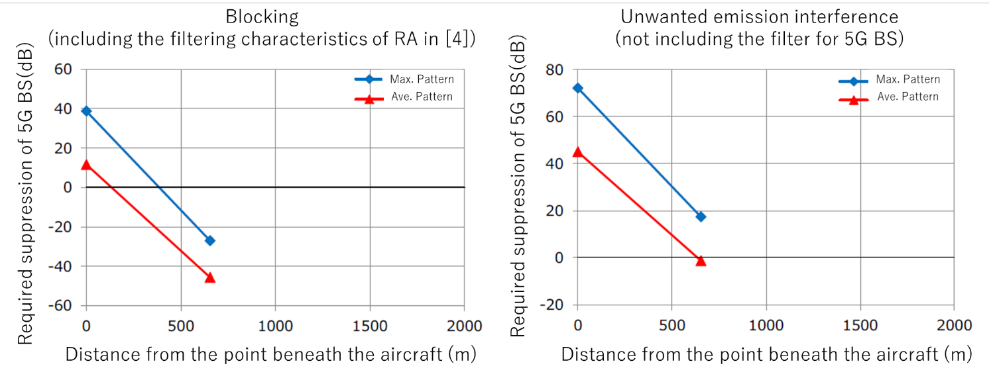

Figure 2 Improvement by the blanking of 5G BS at the beneath of aircraft
  - In order to reduce the upward level of the maximum envelope pattern of the antenna, the limit of the scanning range of directivity is set for the evaluation. A schematic diagram of the limit of directivity is illustrated in Figure 3. If the mobile station locates near the 5G BS, the directivity of the antenna is directed down from the horizon. The sidelobe level of the antenna patterns is degraded upward side robe level when the tilt angle is getting deeper.

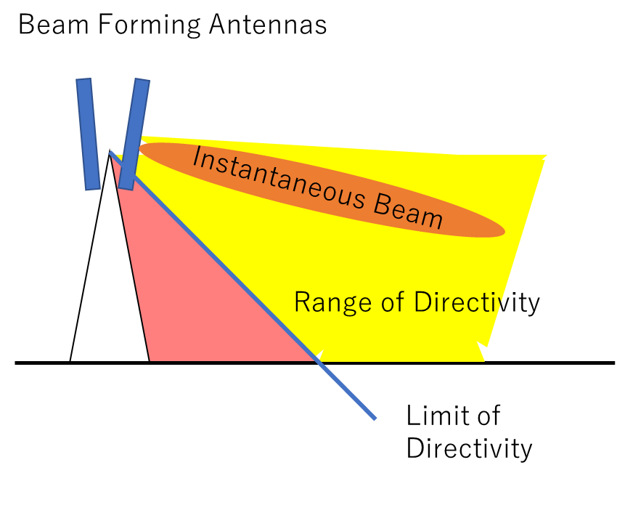

Figure 3 Conceptual figure of the limit of directivity (tilt angle)
  - The effects of the limit of directivity are shown in Figure 4. The tilt angle is limited from -45 degrees to 0 degrees (horizontal). Calculated envelopes show the reduced upward gain by the limit of directivity.
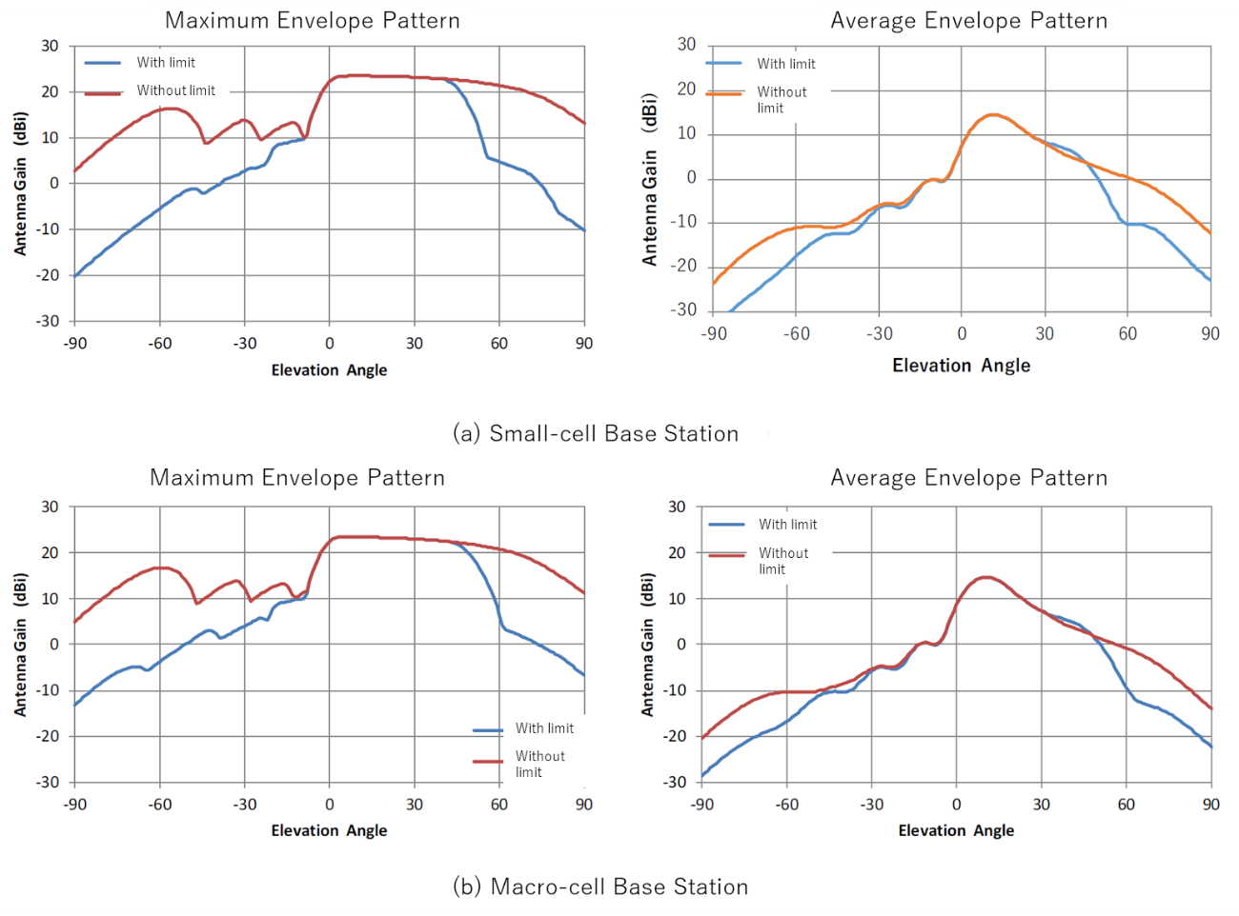

Figure 4. The envelope patterns for the maximum and average pattern
  - The improvement by blanking of 5G BS is also recalculated considering the antenna patterns with the limit of directivity. The calculated required suppression level is reduced and the distance for the blanking is also reduced by the installation of the limit of directivity. In the case of blocking, the effect of the limit of directivity is effective to reduce the separation distance. 200m of the separation distance should be needed to suppress the blocking.
  - The required suppression for unwanted emission interference still remains more than 30 dB after the installation of the limit of directivity.

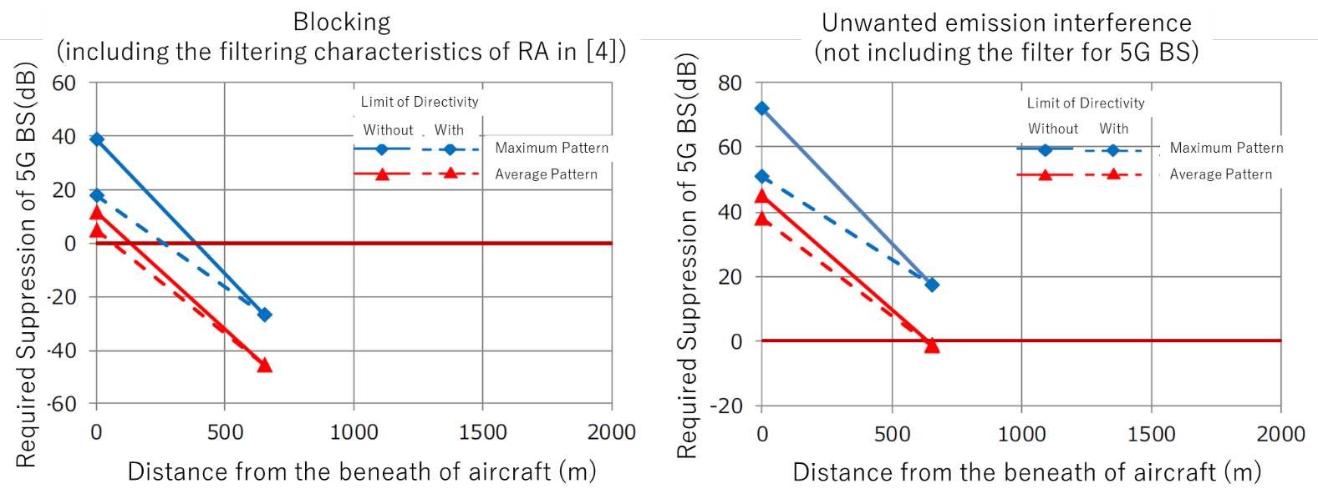

Figure 5 Improvement by the blanking of 5G BS at the beneath of aircraft with/without the limit of directivity
  - The scenarios for the landing of the helicopters were also considered. The required suppression levels of 5G BS are summarized in Table 8 for unwanted emission interference and Table 9 for blocking interference. The required suppression for 5GBS in case of unwanted emission interference is higher than that of blocking. It also indicates the requirement of the filters to suppress the unwanted emission of 5G BS in the RA band. In order to realize the mitigation criteria for the blocking, the physical separation should be needed 20 m for the small-cell and 50m for the macro-cell BS to achieve the suppression. And there is the restriction to put the 5G BS in the same/adjacent place where the helicopters will depart/land. The details on the theoretical calculations are published in the report [3, 5].
Table 8 Required suppression for heliport scenario in case of unwanted emission interference
Altitude (m) | Horizontal Separation Distance (m) | Frequency Separation (MHz) | Required suppression for small-cell BS |  | Required suppression for macro-cell BS
Altitude (m) | Horizontal Separation Distance (m) | Frequency Separation (MHz) | Average Patterns | Maximum Patterns | Average Patterns | Maximum Patterns
0 to 100 | 20 | 0 | 29.1 | 48.7 | 41.9 | 61.3
0 to 100 | 40 | 0 | 23.2 | 42.6 | 35.8 | 54.7
0 to 100 | 50 | 0 | 21.3 | 40.8 | 33.9 | 49.1
0 to 100 | 60 | 0 | 19.7 | 39.1 | 32.3 | 45.3
0 to 100 | 80 | 0 | 17.2 | 33.3 | 29.8 | 42.8

Table 9 Required suppression for heliport scenario in case of blocking with 100 MHz guard band
Altitude (m) | Horizontal Separation Distance (m) | Frequency Separation (MHz) | Required suppression for small-cell BS (dB) |  | Required suppression for macro-cell BS (dB)
Altitude (m) | Horizontal Separation Distance (m) | Frequency Separation (MHz) | Average Patterns | Maximum Patterns | Average Patterns | Maximum Patterns
0 to 100 | 20 | 100 | - < < 0 | 11.0 | 15.2 | 34.6
0 to 100 | 40 | 100 | - < < 0 | 5.0 | 9.2 | 28.1
0 to 100 | 50 | 100 | - < < 0 | 3.1 | 7.3 | 22.5
0 to 100 | 60 | 100 | - < < 0 | 1.5 | 5.7 | 18.6
0 to 100 | 80 | 100 | - < < 0 | < 0 | 3.2 | 16.2

  - We conclude the regulation to 5G BS to realize the compatibility between the RAs and 5G BS as following:
- To avoid harmful interference to the RAs, 100 MHz of the GB should be installed.

Additional requirement for the compatibility to the RAs near the aerodromes:
- To avoid unwanted emission interference, unwanted emission of the 5G BS into the RA band should be reduced.
- To avoid the blocking of radio altimeters, the location of the high-power 5G base station should be avoided within 200 m from the approaching route of aircraft.
- For the aerodromes for helicopters, the 5G BS should be kept the physical separation more than 50 m for macro-cell and 20m for small-cell.

  - To confirm the actual behavior of the RA interference caused by the 5G BS, the lab tests were also conducted to check the vulnerability of the RA using a wider base-band signal emulating the 5G NR signal format. The details of the tests are described in the Appendix. We confirmed that the conditions which are expected to installation the LTE-Advanced technologies are still effective for 5G BS.
  - The risk of interference after the deployment of 5G BS must be considered. We confirmed that some types of aircraft are using pulsed RAs. They include not only old types of aircraft but also relatively new types of aircraft. We have to keep the survey for the interference to the RA, but there are quite a few places to serve the 5G connectivity in Japan now.
- ACTION BY THE MEETING
  - The meeting is invited to review the contents of the paper.

Appendix: Interference test for radio altimeters

Introduction
We also checked the behavior of RA when the 5G signal is collocated in the field. The results of laboratory tests are described in the report [6]. The aim of this WP is the explanation of the result of the compatibility study in Japan.

Test Setup

The laboratory tests have been conducted by a mobile operator in the maintenance center of an aircraft operator. The tested RAs are shown in Table 1. A pulsed RA and Three FMCW RAs were tested.

Table 1. Tested radio altimeters
Type | RT-300 | KRA-405 | KRA-405B | ALT-50
Manufacturer | Honeywell | Honeywell | Honeywell | Rockwell Collins
Modulation | Pulsed | FMCW | FMCW | FMCW
Center Frequency | 4300MHz | 4300MHz | 4300MHz | 4300MHz
Transmission | 5W | 150mW | 160mW | 210mW
Classes of Emission | 100MP0N | 100MF3N | 100MF3N | 100MF3N

The configuration of interference tests is shown in Figure 1. A conformal test system of RA designed to check the validity of the radio altimeters following the RTCA DO-155 [7] was used for the test. The delay line makes the actual propagation time delays and the variable attenuator emulates attenuation of the propagation following to the External Loop Loss diagram in Appendix B of DO-155. The interfering signal was generated by the signal generator by changing the level of the interferer by the variable attenuator. Details of the test setup are shown in Figure 2. The prober connects to measure the induced voltage to drive the indicator.
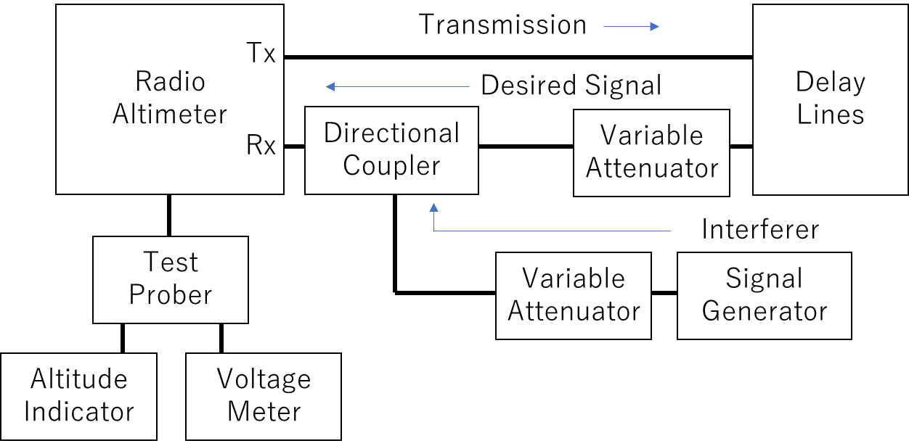
Figure 1 Interference test setup

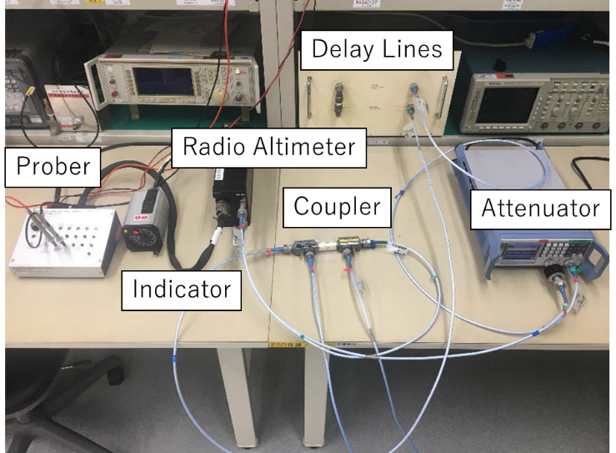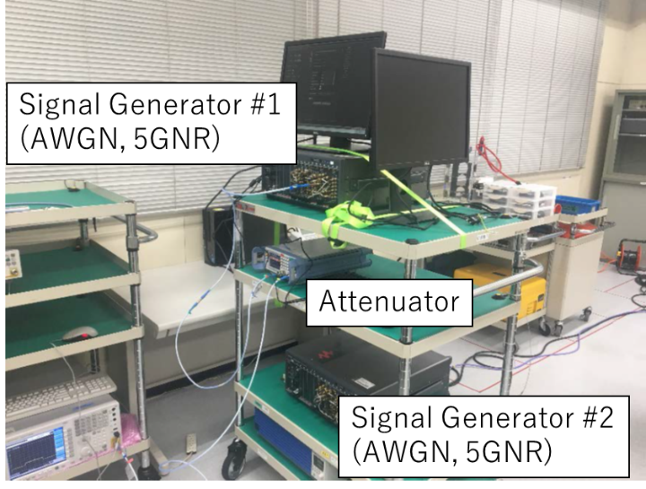
Figure 2. Details of RA interference test system

Types of interference
The interference tests are divided into two coupling scenarios. A scenario is “Unwanted emission Interference” which is caused by the unwanted emission of the 5G BS in the RA band. Another Scenario is “Blocking” which is caused by the transmission of 5G BS for communications out of the RA band. We explain the results of each interference case as follows.

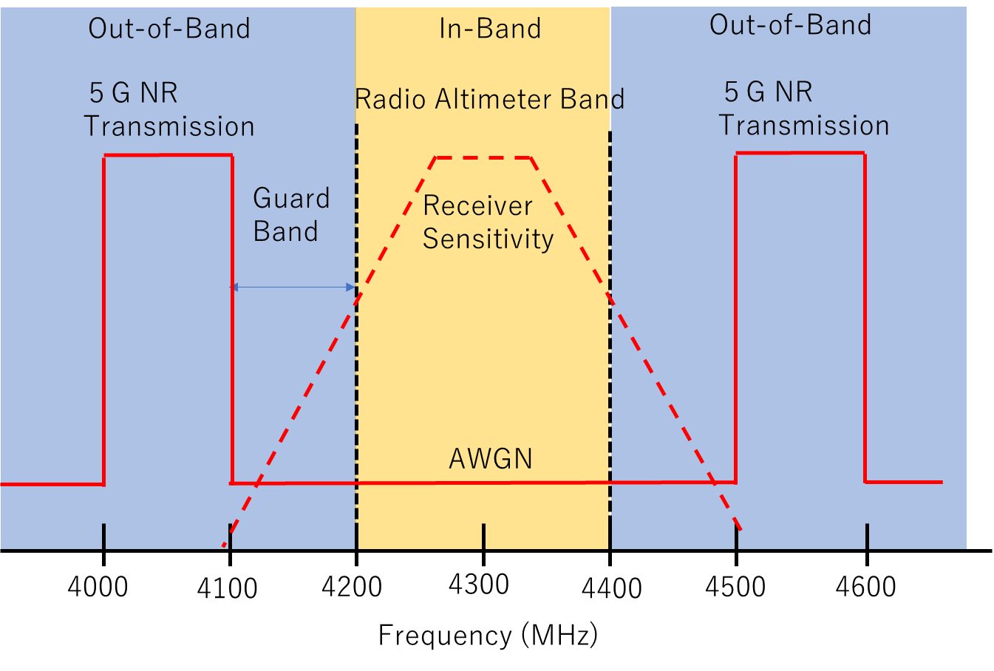
Figure 3 Frequency diagram of in-band (unwanted emission interference)/out-of-band (blocking) test

Unwanted emission interference test
A white noise signal (AWGN: Additive White Gaussian Noise) was used for the unwanted emission interference test. The test conditions are summarized in Table 2.

Table 2 Specifications of interferer for unwanted emission interference test
Waveform | AWGN
Power Spectral Density of Interferer (dBm/MHz) | -130 to -55
Tested Altitude | 50 ft (15.2m)
Tested Altitude | 100 ft (30.5m)
Tested Altitude | 500 ft (152.4 m)

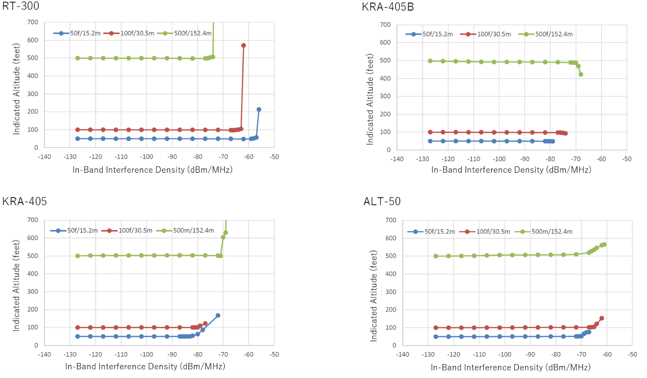
Figure 4 Measured Altimeter with unwanted emission interferer

The measured results for each RA are plotted in Figure 4. The indication of altitude seems to be almost stable when the interferer level is low. After the level of interferer exceeds the certain threshold values, the indicated altitude is rapidly apart from the set altitude values. The threshold values tend to decrease in high altitudes in the case of pulsed altimeters. In order to analyze the behavior of the RA, the ratio of the indicated altitude is calculated as shown in Figure 5.

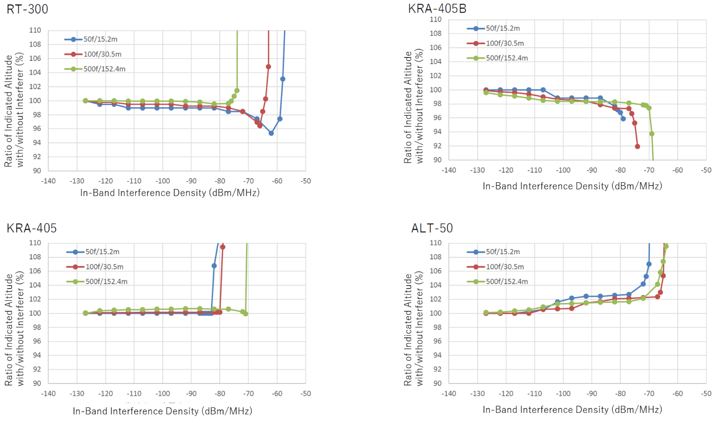
Figure 5 Calculated radio of indicated altitude with unwanted emission interferer

One-hundred percent implies the original indication without interferer. The characteristics of the error of indication is depends on the RA structure. The threshold values exceeding the certain percent of errors are summarized in the Table 3. In comparison to the worst case of Recommendation ITU-R M.2059[4], the measured threshold values are higher than -117dBm/MHz.

Table 3 Threshold values of the measured error in case of unwanted emission interference
Error | Altitude | RT-300 | KRA-405 | KRA-405B | ALT-50
1 % | 15.2 | -82 | -83 | -87 | -107
1 % | 30.5 | -77 | -80 | -97 | -92
1 % | 152.4 | -74 | -71 | -112 | -92
3% | 15.2 | -67 | -83 | -80 | -77
3% | 30.5 | -67 | -80 | -76 | -66
3% | 152.4 | -74 | -71 | -70 | -72
10% | 15.2 | -56 | -80 | -78 | -69
10% | 30.5 | -62 | -77 | -74 | -64
10% | 152.4 | -73 | -70 | -67 | -62

Blocking

The transmissions of 5G NR signal located at the adjacent of RA were also tested. The test conditions are summarized in Table 4. Snapshots of the frequency spectra of the RA receiver is shown in Figure 6 (RT-300), and Figure 7 (KRA-150B). The desired signal of the pulsed RA appears quite a low level in comparison to the 5G transmission interferer because the resolution bandwidth of the signal analyzer is narrower than the bandwidth of frequency spread of the transmitting pulse. We can see the clear spectra of the desired and interfering signals in the case of FMCW RAs. Measured indicated altitude with blocking is plotted on Figure 8(RT-300), Figure 9 (KRA-405), Figure 10 (KRA-405B), and Figure 11(ALT-50), respectively.

Table 4 Specifications of Blocking Test
Waveform | Base Station Transmission on 5G NR (OFDM)
Bandwidth | 100 MHz
Number of the Transmission | 2 (Both sides of RA channel)
Guard Band | 100, 200, 300 MHz
Aggregated power (summation of 2 transmission) | -70 to -10dBm
Tested Altitude | 50 ft (15.2m)
Tested Altitude | 100 ft (30.5m)
Tested Altitude | 500 ft (152.4 m)
Figure 6 Measured Frequency Spectra reception signal without/with the interferer for RT-300 at 50 ft altitude case

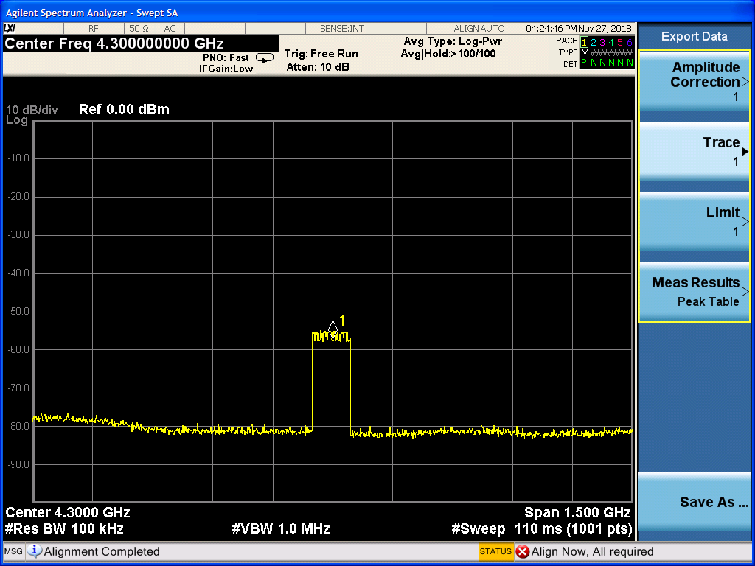
Figure 7 Measured spectra of received signal without/with the interferer for KRA-405B at 50 ft altitude case
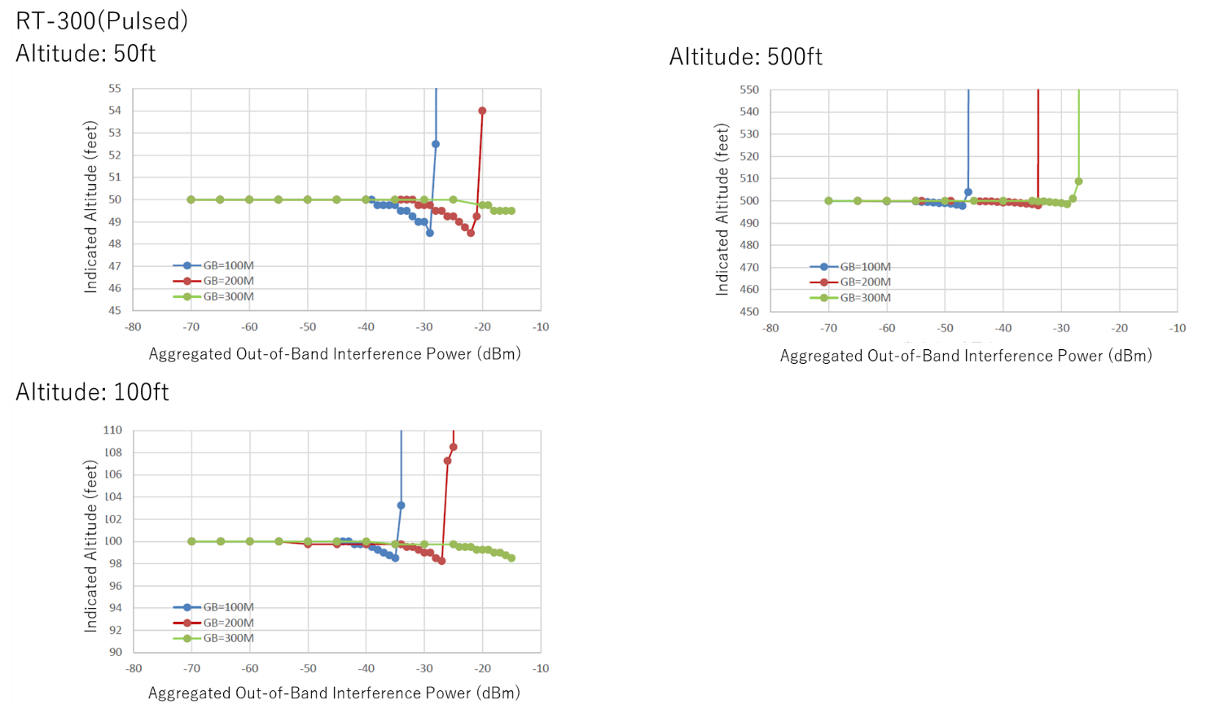
Figure 8 Measured altitude with blocking interferer for RT-300

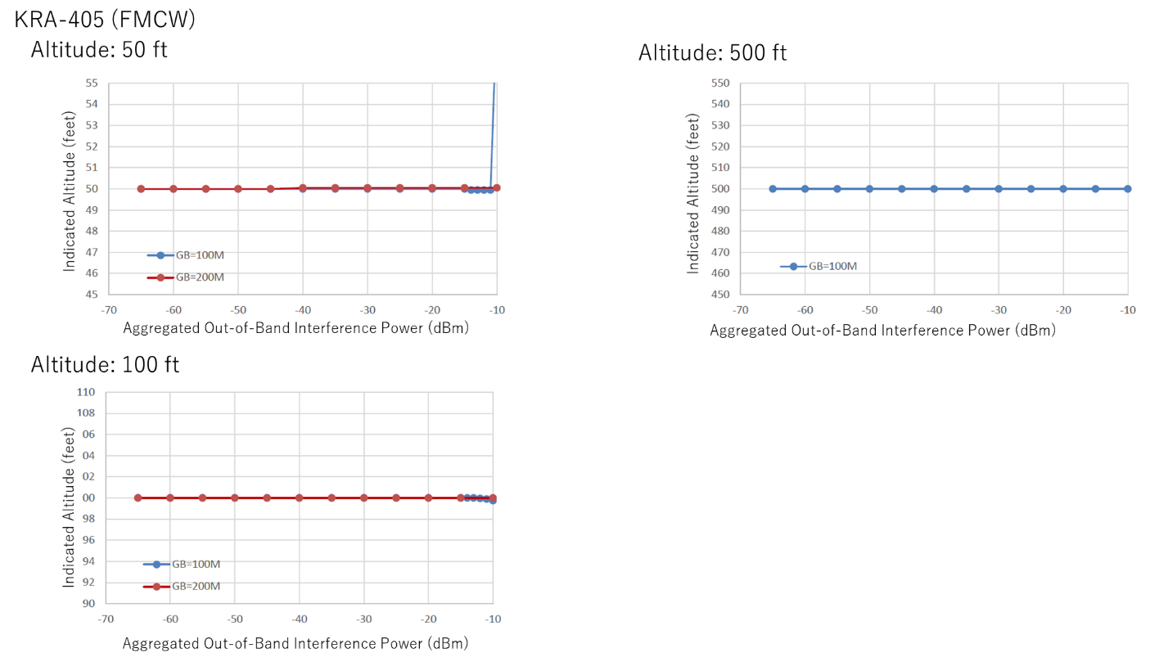
Figure 9 Measured altitude with blocking interferer for KRA-405

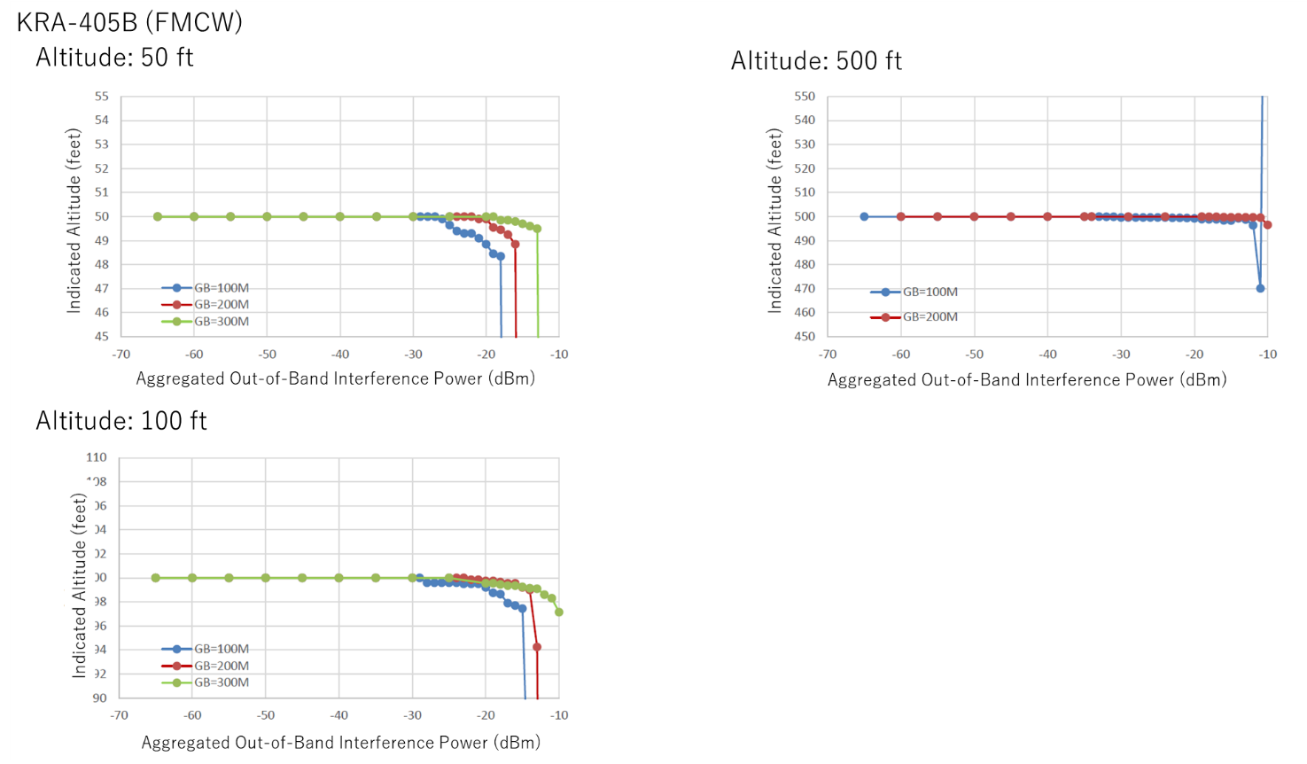
Figure 10 Measured altitude with blocking interferer for KRA-405B

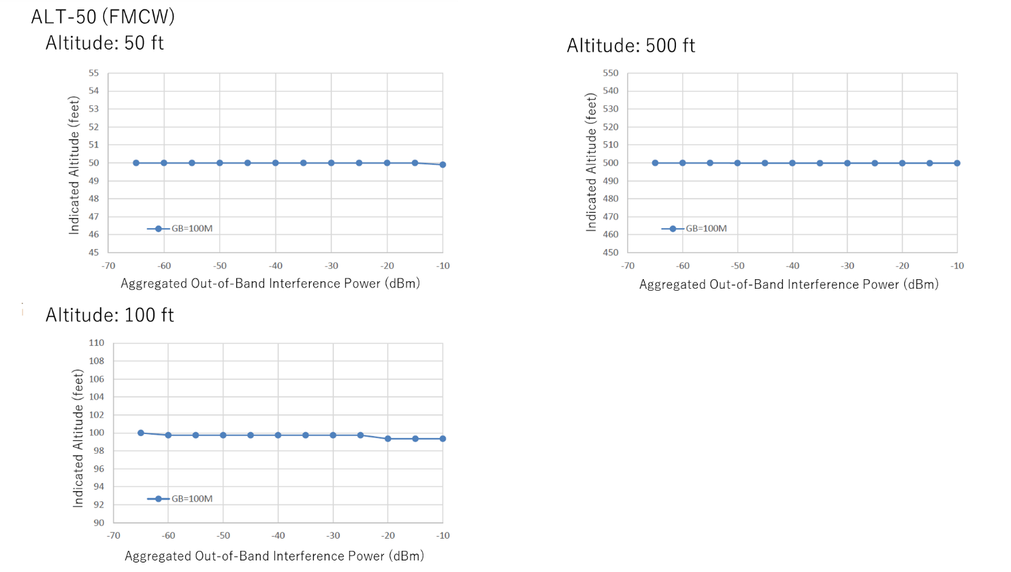
Figure 11 Measured altitude with blocking interferer for ALT-50

In order to analyze the behavior of the RA, the curves of the ratio of the indicated altitude in case of blocking are calculated as shown in Figure 12 (RT-300), Figure 13 (KRA-405), Figure 14 (KRA-405B), and Figure 15(ALT-50), respectively. We also summarize the threshold values to exceeds a certain percentage of the errors as shown in Table 5. The threshold values of the pulsed RA are lower than that of FMCW RAs. In comparison to the worst case of the reference[4], the measured threshold values are higher than -54dBm.

Table 5 Threshold values of the measured altitude error in case of blocking with 100 MHz Guard Band
Error | Altitude | RT-300 | KRA-405 | KRA-405B | ALT-50
1 % | 15.2 | -33 | -11 | -25 | >-10
1 % | 30.5 | -37 | -10 | -18 | >-10
1 % | 152.4 | -47 | -10 | -12 | >-10
3% | 15.2 | -30 | -11 | -20 | >-10
3% | 30.5 | -35 | -10 | -15 | >-10
3% | 152.4 | -47 | -10 | -12 | >-10
10% | 15.2 | -27 | -10 | -17 | >-10
10% | 30.5 | -33 | >-10 | >-10 | >-10
10% | 152.4 | -45 | >-10 | >-10 | >-10

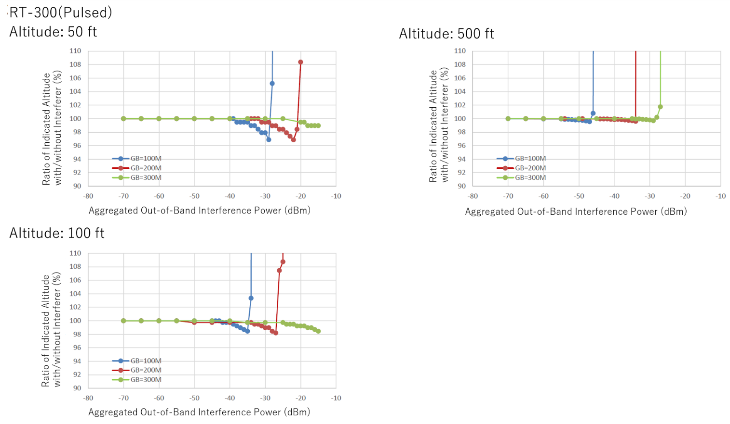
Figure 12 Calculated radio of indicated altitude with blocking interferer for RT-300
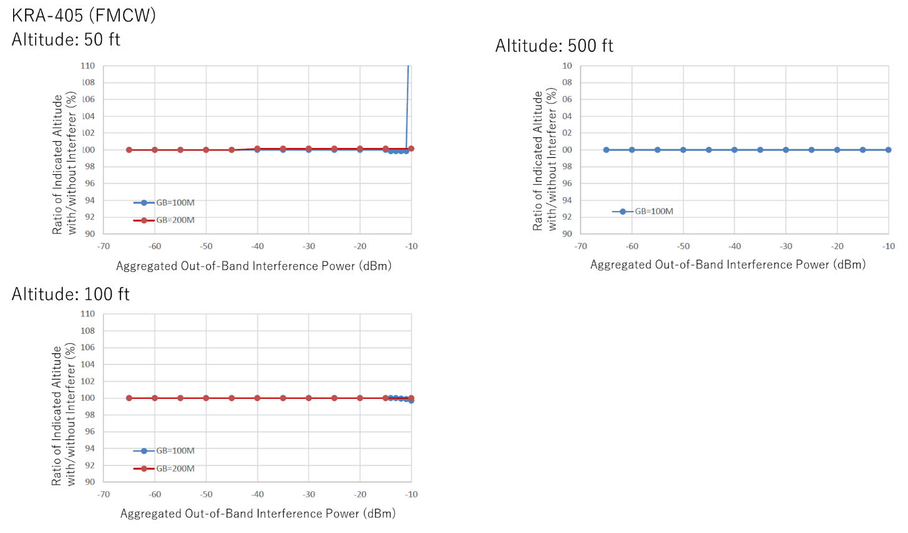
Figure 13 Calculated radio of indicated altitude with blocking interferer for KRA-405

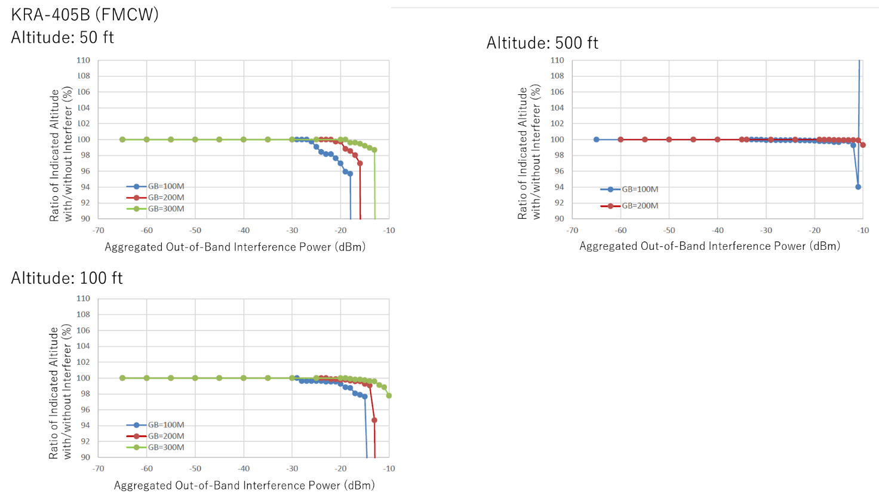
Figure 14 Calculated radio of indicated altitude with blocking interferer for KRA-405B

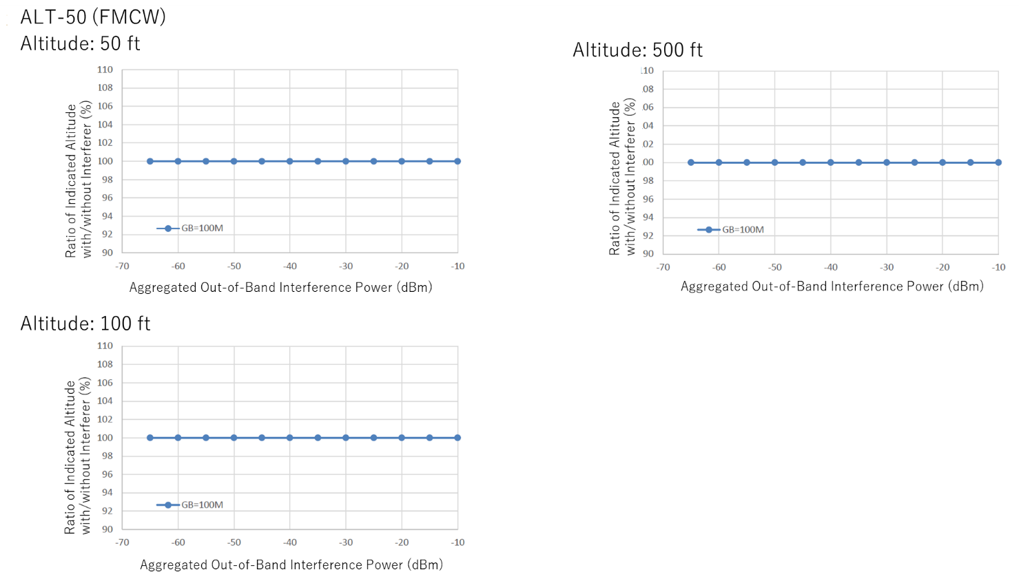
Figure 15 Calculated radio of indicated altitude with blocking interferer for ALT-50

Conclusion
We checked the behavior of the RAs with interference from 5G NR signals. The results of the interference tests indicated a similar tendency as the results which have been reported before. We also confirmed the measured results, which measured less than 500 ft, are in the worst-case of ITU-R M.2059 assumptions.

References
[1] MIC, Japan, Activities of Technical Study Group of new generation mobile communication committee, information and communication council, (All in Japanese)
https://www.soumu.go.jp/main_sosiki/joho_tsusin/policyreports/joho_tsusin/5th_generation/technical/index.html
[2] Naruto Yonemoto et. al., “Experimental investigation of adjacent-band interference into radio altimeter due to LTE-Advanced base stations” , ICAO FSMP-WG7/IP08, September, 2018
[3] Hiroshi Watanabe, “The study of frequency sharing compatibility between aircraft radio altimeter and 5G mobile communication systems”, ICAO FSMP-WG7/IP06, September, 2018
[4] ITU-R, “Operational and technical characteristics and protection criteria of radio altimeters utilizing the band 4 200-4 400 MHz”, ITU-R M.2059, April 10, 2014
[5] New generation mobile communication systems committee, “Report of New Generation Mobile Communication System Committee for Information and Communication
Technology Section of Information and Communications Council” (in Japanese), July, 2018
https://www.soumu.go.jp/main_content/000556418.pdf
[6] ARIB, “Report on Compatibility Study to install 5G mobile communication system to 3.7 GHz, 4.5 GHz, and 28 GHz bands”(not public, in Japanese), March 2019
[7] RTCA, “Minimum Performance Standards Airborne Low-Range Radar Altimeters”, RTCA DO-155, November, 1974
—END—

