FREQUENCY SPECTRUM MANAGEMENT PANEL (FSMP)

Fourteenth Working Group meeting

Web Meeting, 25 – 29 April 2022

Agenda Item 4a : National efforts to implement broadband mobile near 4200-4400 MHz
- Report from correspondence group on radio altimeters (CG-RA)

The update of the CG-RA Report FSMP-WG/13 IP03 are highlited in yellow

(Presented by Christian Fleury)

SUMMARY
In June 2020, ICAO secretary brought to the attention of FSMP members, a Liaison Statement informing ECC about the issue of potential interference to aeronautical Radio Altimeters operating in the frequency band 4200 - 4400 MHz, caused by IMT systems currently operating or planned to operate in the frequency band 3400 - 3800 MHz in Europe. This Liaison Statement explained that there is no specific limit of unwanted emissions from IMT base stations within the frequency band 4200-4400 MHz.
The recent RTCA Report SC-239 raised another risk from MFCN (5G in the band 3.7-3.98 GHz) into some radio altimeters.

This IP compiles all the information on the subject since the publication of the RTCA Report.

INTRODUCTION

The aim of this information paper is to give a “full” picture of the issue and provide some guidance examples that could minimise the impact on Radio-Altimeter for all stakeholders.

A presentation published by Honeywell provides an overview of operation, design, and performance of Radar Altimeters.

History

WRC15
Aviation used the analyses contained in working papers 14 & 17 to the 29th meeting of the Aeronautical Communication Panel, Working Group-F to help defend against late proposals to implement IMT in frequency bands near 4000-4200 MHz in response to WRC-15 agenda item 1.1. After that successful effort, aviation recognized the need for additional information on radio altimeters, and a job card was instituted for FSMP to develop minimal SARPS for those systems, including receiver selectivity limits. Data was collected under the auspices of the WAIC standardization work that would form the basis for those altimeter SARPS. Results were briefed to FSMP starting in January 2019.

February 2020
The United States Federal Communications Commission (FCC) approvals a final Report and Order allocating 3.7-3.98 GHz to ‘Flexible Use Licensees’ that will include 5G services. This includes limits of up to 85 dBm EIRP from 5G towers and with minimal restrictions on antenna placement or their respective beams with respect to aircraft. The FCC decision concluded the power and emission limits set for the 3.7 GHz Service and the spectral separation of 220 megahertz should offer all due protection to services in the 4.2-4.4 GHz band. However, it did agree that further analysis is warranted on why there may even be a potential for some interference given the measure it had put in place and encouraged an industry multi-stakeholder group to assess the issue. The FCC also expected the aviation industry to take account of the RF environment that is evolving below the 3980 MHz band edge starting in Dec 2021 and take appropriate action, if necessary, to ensure protection of such devices. Under this direction, RTCA SC-239 took the initiative formed a multi-stakeholder group to do the analysis.

June 2020
ICAO secretary brought to the attention of FSMP members, a Liaison Statement informing ECC about the issue of potential interference to aeronautical Radio Altimeters operating in the frequency band 4200 - 4400 MHz, caused by IMT systems currently operating or planned to operate in the frequency band 3400 - 3800 MHz in Europe. This Liaison Statement mainly focused on the fact that there is no specific limit of unwanted emissions from IMT base stations within the frequency band 4200-4400 MHz.

October 2020
RTCA published Report SC-239 on the “Assessment of C-Band Mobile Telecommunications Interference Impact on Low Range Radar Altimeter Operations” highlighted the following issues with the operation of mobile/fixed communications network using 5G technology in the frequency band 3.7-3.98 GHz.

- That “5G base stations present a risk of harmful interference to radar altimeters across all aircraft types, with far-reaching consequences and impacts to aviation operations”
- That fundamental emission (3,7 - 3.98 GHz signals) from 5G Base Station using active antenna systems could cause harmful interference to Usage Category 1 (Commercial Air transport Aircraft) in certain circumstances. Noting that fundamental emission creates effects on Radio-Altimeter like blocking, saturation, intermodulation....
- For Usage category 2 (Regional Business Aviation and General Aviation) and Usage Category 3 (Helicopter) every 5G base station configuration will result in harmful interference, from both fundamental and spurious emissions, being present in virtually all operating scenarios and geometries
- That 5G User Equipment (UE) operating on the ground are not expected to cause harmful interference to radio altimeters
- That 5G UE operating on board Usage Category 2 & 3aircraft could cause harmful interference to radar altimeters.

November 2020
In France, 5G was authorised and the first base stations were activated. Considering the RTCA SC-239 report, France has taken immediate action to mitigate possible interference with radio altimeters.

Documents published on the subject in 2021

CEPT PT1

ECC PT1 #67 January 2021 ECC
There were 3 contributions on the subject:

Airbus ECC PT1(21)022 The airframer wanted to make the PT1 aware of the radio altimeter issue, of the existence of the RTCA report SC-239 and of the planned tests.

France ECC PT1(21)006 Protection of radio altimeters from MFCN in 3.4-3.8 GHz.

France invites ECC/PT1 to study, as a matter of urgency and taking into account the safety aspect, the risk of interference from 5G in the 3.5 GHz band into radio altimeters. France also presented immediate measures for the protection of radio altimeters .

Bouygues Telecom, Orange ECC PT1(21)027

C-band 5G networks have been deployed in different parts of the world, and there was no interference case reported. The source of problem suggested by the RTCA report was Radio-Altimeter receiver out of band blocking (…) There is no evidence this RTCA report represents the real situation in Europe or elsewhere (…) If some Radio-Altimeter models have receiver blocking problems, a replacement or repair plan must be set up as an urgent matter.

PT1 agreed on a new work Item (PT1_40): “Compatibility between MFCN operating in frequency band 3400-3800 MHz and Radio Altimeters operating in the frequency band 4200-4400 MHz”
The scope of this work item is the following: Assessment of susceptibility of deployed receivers operating in 4200-4400 MHz, while taking into account any civil aviation initiatives on Radio-Altimeter receivers, in order to study the following compatibility scenarios:
- Unwanted emissions from MFCN operating in 3400-3800 MHz into 4200-4400 MHz radio altimeters band
- Impact of blocking of radio altimeters from 3400-3800 MHz MFCN in-band emissions

ECC PT1 #68 April 2021 - There were 3 contributions on the subject:

GSA ECC PT1(21)122 MFCN characteristics for WI on Radio Altimeters. GSA invites ECC PT1 to take the MFCN characteristics (as in Annex) into account for the studies of radio altimeters while noting that final information will be provided for the September meeting of ECC PT1.

France ECC PT1(21)117 WI 5G radio altimeters. France invites ECC PT1 to consider the attached draft skeleton for an ECC report on “Compatibility between MFCN operating in 3400-3800 MHz and Radio Altimeters (RA) operating in 4200-4400 MHz”. This proposal was accepted by ECC PT1.

Eurocontrol ECC PT1(21)115 EUROCONTROL ICAO State Letter on Potential safety concerns regarding interference to radio altimeters. Eurocontrol invites Administration to consider as a priority, public and aviation safety when deciding how to enable MFCN (5G) services in radio frequency bands near the bands used by radio altimeters.

ECC PT1 #69 September 2021 - There were 3 contributions on the subject:

France ECC PT1(21)192 Outcome from preliminary trial on one type of radio altimeter fitted on helicopter.

GSA ECC PT1(21)188 MFCN characteristics for WI on Radio Altimeters .

Norway ECC PT1(21)184 - Results of the preliminary test of compatibility between MFCN operating in 3400-3800 MHz and Radio Altimeters operating in 4200-4400 MHz.

ECC PT1 #70 January 2022 - There were 7 contributions on the subject:

EUROCAE and RTCA ECC PT1(22)017 LS response to ECC on radio altimeters parameters.

EASA and Eurocontrol ECC PT1(22)020 Input to ECC Report on MFCN-RA compatibility

France ECC PT1(22)041 ECC Report on Compatibility between MFCN operating in 3400-3800 MHz and Radio Altimeters (RA) operating in 4200-4400 MHz .

France ECC PT1(22)048 Preliminary outcome of second de-risking trial on the second type of radio altimeter fitted on helicopter of the French gendarmerie.

GSA ECC PT1(22)058 Comments on altimeter characteristics for coexistence

FAA ECC PT1(22)INFO01 request for radio altimeter parameters

ECC ECC PT1(22)INFO02 LS to aviation bodies and DGs of Commission

Two virtual meetings were held for the PT_CG_Radio_Altimeters_4.2-4.4GHz on March 23 and April 13, 2022. Discussions focused on the aviation community's response to questions from the Mobile community.

For the short term, the main questions from the Mobile community were on the Worst-Case Landing Scenario and the loop loss. For the Worst-Case Landing Scenario aviation explained that it is a real operational case (Go Around or Missed APproach) and that it is a negligible factor for Usage category 1 (UC 1). For the loop loss aviation recommended wireless to study the paper from Honeywell on the topic to better understand how a radar loop loss is built. Discussion on the UC1, 2, 3. Mobile community questioned the relevancy of those Usage Categorization because there are various RF performance amongst this categorization.
For the long term, RTCA/EUROCAE presented the top down plan for the delivery of the "DO/ED Technical standard on RF Environment for RA" which consists for the RADALT manufacturers to define the maximum tolerable RF performance and then to infer some examples of compatibility with current 5G deployment.
Mobile community has still not communicated the elements requested by the Aeronautical community

ICAO

ICAO FSMP

FSMP WG11 – March 2021
There were 3 contributions on the subject
- FSMP-WG11-WP27_Mobile vs Radalt REv.1 UK Deployment of Mobile Systems in the Frequency Range 3.6-4.2 GHz and the Theoretical Impact on Radio Altimeters
- FSMP-WG11-WP30_5G Japan: The compatibility study between 5G base stations and radio altimeters in Japan and update of the result of measurement campaign.
- FSMP-WG11-WP19 ICCAIA Working Paper on radio altimeters to Encourage ICAO and Panel Member Participation in Country Regulatory Activities that Could Cause Interference to Radio Altimeters
- Elements for a proposed State Letter on possible interference to radio altimeters were drafted (see Section 2.2)

FSMP WG12 – October 2021
There were several contributions on the subject
- FSMP-WG12-WP17_ICCAIA_5GLRRA Input ICCAIA presents “an updates on Industry Assessment of 5G Cellular Compatibility with Radio Altimeters» and asks to provide feedback for a new update.
- FSMP-WG12-IP05_Status on replanning the 3700–4200 MHz band in Australia. Australia presents the current status of activity in Australia to address the potential impact of deployment of wireless broadband services in the 3.4-4.0 GHz band on Aviation safety.
- FSMP-WG12-IP07_Interference Susceptibility Evaluations of Pulsed Radio Altimeters Due to 5G Mobile Base Station Signal_rev1 Enri (JAPAN) presents laboratory tests on “Interference Susceptibility Evaluations of Pulsed Radio Altimeters Due to 5G Mobile Base Station Signal” on two Honeywell RT300
- FSMP-WG12-IP12 - Brazil 5G Auction provides information on 5G auction in Brazil and technical parameters.

ICAO High Level Conference On COVID-19 (HLCC 2021)
One WP30 co-signed by Air Transport Association (IATA), the International Business Aviation Council (IBAC), the International Coordinating Council of Aerospace Industries Associations (ICCAIA), the International Federation of Air Line Pilots’ Associations (IFALPA) and RTCA was presented on “Safety concerns regarding interference to aircraft radio altimeters”. This Working Paper asked that States mitigate the risk of 5G implementation to safety-critical radio altimeter functions.
The HLCC agreed to the following Recommendation.
Recommendation 5/5 — Mitigating the risk of 5G implementation to safety-critical radio altimeter functions That States:
a) consider, as a priority, public and aviation safety when deciding how to enable cellular broadband/5G services;
b) consult with aviation safety regulators, subject matter experts and airspace users, to provide all necessary considerations and regulatory measures to ensure that incumbent aviation systems and services are free from harmful interference;
and That ICAO:
c) continue coordinated aviation efforts, particularly at the International Telecommunication Union (ITU), to protect radio frequency spectrum used by aeronautical safety systems.

Information and Frequencies bands used for 5G around 4.2-4.4GHz worldwide.

European Union law
Commission Implementing Decision (EU) 2019/235 of 24 January 2019 on amending Decision 2008/411/EC as regards an update of relevant technical conditions applicable to the 3400-3800 MHz frequency band.
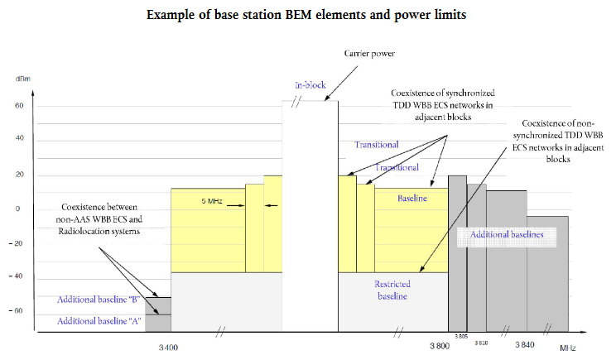
Definition of Block Edge Mask (BEM) elements
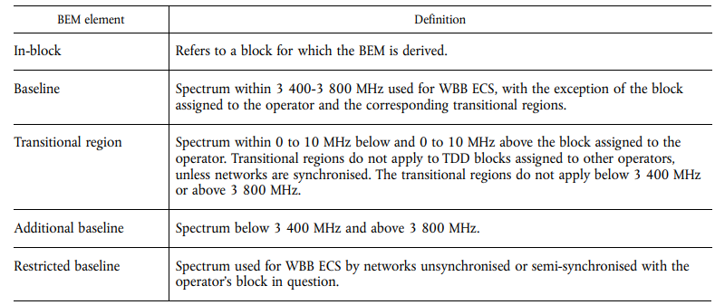

No Power limitation In-block assigned to the operator for non-AAS and AAS base stations

France
The power spectral density (PSD) of the base stations varies according to the operators between 62.44dBm/5MHz to 67.34 dBm/5MHz.
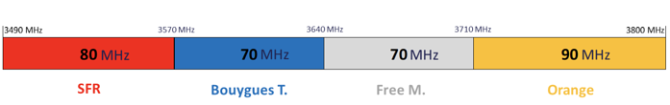

Canada
This figure bellow shows the 3500 MHz band deployment in Canada as of Dec 2021, which includes the frequency range of 3400 to 3650 MHz. The frequency range of 3400 to 3450 MHz is allocated for radiolocation. The frequency range of 3450 to 3650 MHz is divided into 20 unpaired blocks of 10 MHz each and allocated for fixed and mobile (flexible use).
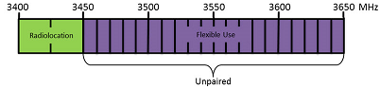

USA
The USA has allocated 3.7-3.98 GHz to services including 5G in Feb 2020 in 20 MHz license blocks that can be aggregated by the same operator up to 100 MHz. The FCC limited the power to 65 dBm/MHz maximum EIRP for rural areas, and 62 dBm/MHz in urban areas, though no limits were placed on antenna positioning or direction. 5G operators won the subsequent auction in Dec 2020 for over $80 bn USD with additional money going to the SATCOM operators fund satellite migration and ground station filtering. Given the need to migrate existing SATCOM users over time, the first 100 MHZ (3.7-3.8 GHz) was planned for implementation in Dec 2021, and the remaining 3.80-3.98 GHz in Dec 2023. Licensees are also only in certain Partial Economic Areas (PEAs) in the US, not nationwide.

Worldwide actions

Japan
At the last FSMP, Japan presented measures for the deployment of 5G base stations around runway. These measures were put in place a long time before the French mitigation measures were implemented. Both measures are similar.
Apart from the fact that Japan uses a different frequency band than Europe (closer to the radio altimeter frequency band), in time when Japan implemented these mitigation measures, AAS antennas were not allowed. The maximum EIRP (macro cells 68dBm or small cells 48dBm) was therefore much lower than EIRP (with AAS antennas) allowed in Europe and in the U.S. For these reasons, Japan requires smaller separation distances while being closer to the radio altimeter frequency band.

New Zealand
In November 17th 2020, CAA published a safety message that require to “Do not use 5G devices inflight if you have a radar altimeter”.

United Arab Emirate
United Arab Emirate also published a Safety Alert at the attention of United Arab Emirate Aircraft Operator, informing them about the likelihood of 5G interferences on aircraft system. This safety alert also recommends to monitor and report any 5G interference events.

France
France published a Safety info leaflet while mitigation measures are still in place around Airports where ILS CAT III are implemented.
Extensive tests were planned but the mobile operator involved left the table after few weeks of preparation. This test is still on hold.
France conducted and provided the preliminary outcome of de-risking trials, performed by test pilots, on two type of radio altimeter one fitted on an AS350 helicopter of the French gendarmerie. (ECC PT1(22)048) and another fitted on an EC 135 helicopter also of French gendarmerie (ECC PT1(21)192). It has been observed that there was no unexpected behaviour of the type of radio altimeters fitted onboard helicopters of the French gendarmerie during the retained trial, which gives reasonable level of confidence on the resilience of these type of radio altimeters.
This two de-risking trials on radio altimeters embedded on helicopters of the French gendarmerie lead France to consider that all the different types of radio altimeters used by helicopters of the French gendarmerie and civil protection in France are now covered where the emissions characteristics of 5G base stations are similar. Indeed, the tests were performed with a base station whose 5G antenna tilt was negative. Therefore, although the tests provide a representative scenario, the absence of unexpected behaviour cannot alone guarantee that the radio altimeter will remain free from harmful interference from 5G NR emissions in all configurations.
It has also to be noted that, subject to confirmation by the radio altimeter manufacturers, the two types of radio altimeters fitting helicopters of the French gendarmerie are in conformity with the blocking level of Usage Category -1 radio altimeters as assumed in the RTCA report. Therefore, the results of these trials cannot be used to address the cases of other type of radio altimeters much more sensitive to interferences and which have been considered under the Usage Category -3 of the RTCA report.
Additional trials may be envisaged with other types of radio altimeters.
.
France also started consultation with mobile operator in order to define the roadmap of 5G in order to have the deployment perspective of 5G in order to have baseline for future MOPS for radio altimeter offering resilience to IMT 5G and other applications. Indeed, France considers that it is the highest priority task to conduct in close cooperation with all the stakeholders within ECC PT1.

Australia
The Australian spectrum regulator (the ACMA) has formed a technical liaison group (TLG) to review/develop spectrum and apparatus licence technical frameworks for the 3400-4000 MHz band. Public consultation on the proposed rules that are informed by the TLG are expected in March / April 2022. The Australian Civil Aviation Safety Authority (CASA) published an Airworthiness Bulletin asking to report any Radio-Altimeter interference that occurs below 2500 feet.
In late December 2021 CASA issued an exclusion from the Operation of Airworthiness Directives FAA AD 2021-23-12 and FAA AD 2021-23-13. This Exclusion applies to any Australian registered aircraft when it as operated outside the airspace of the United States of America.

In March 2022 the ACMA opened two consultations for proposals that cover the band of interest.
IFC 10/2022 - Proposed spectrum re-allocation declaration for the 3.4 GHz and 3.7 GHz bands:
IFC 10/2022 has no proposed restrictions or controls to protect radio-altimeters.

IFC 11/2022 -
Allocation of AWLs in the 3.4–4.0 GHz band in remote Australia - IFC 11/2022:
IFC 11/2022 includes proposals for compatibility with radio-altimeters when the transmitter is operating above 3700 MHz. This proposal is an option only and is square bracketed in the draft RALI (Radiocommunications Assignment and Licensing Instruction). The proposals for compatibility include an “exclusion zone” defined as 910 metres laterally either side of a runway edge of an identified runway and 2100 metres beyond the runway thresholds; and a restricted zone defined, the same width as the exclusion zone, but extending another 2100m beyond the ends of the exclusion zone.
The proposal also restricts transmitters where:
- The transmitter is located in an exclusion zone.
- The transmitter is located in a restricted zone, is a non-AAS transmitter and its peak EIRP is more than 41 dBm/MHz.
- The transmitter is located in a restricted zone, is a non-AAS transmitter and is not operating its antenna system/s at a negative angle with reference to the horizon.
- The transmitter is located in a restricted zone, is a non-AAS transmitter and its peak total EIRP of unwanted emissions is more than -3 dBm/MHz in the 4200-4400 MHz range.
- The transmitter is located in a restricted zone, is a AAS transmitter and its peak EIRP is more than 58 dBm/MHz.
- The transmitter is located in a restricted zone, is a AAS transmitter and is directing its highest gain above the horizontal plane when forming beams.
- The transmitter exceeds a PFD of -16 dBm/m2/MHz on the primary surface of a helipad associated with an identified heliport.
- The transmitter is not located in an exclusion or restricted zone, is a non-AAS transmitter and its peak EIRP is more than 53 dBm/MHz.
- The transmitter is not located in an exclusion or restricted zone, is a AAS transmitter and its peak EIRP is more than 62 dBm/MHz.

Canada
Innovation, Science and Economic Development Canada (ISED) is the spectrum regulator in Canada. ISED allows Flexible Use networks and technology (including 5G) in the frequency band 3450-3650 MHz (auctioned in June 2021 and deployed in Dec 2021) and has decided to allow Flexible Use wireless systems to operate in the frequency band 3650-3980 MHz starting in 2023.

Transport Canada Civil Aviation (TCCA) has published a Civil Aviation Safety Alert (CASA) (2021-08) Potential Risk of Interference of 5G Signals on Radio Altimeters (June 2021 and Dec 2021) to raise awareness of the potential risk of 5G interference worldwide and to recommend precautionary operational measures before confirmation of the impact of 5G to Radio Altimeters. It also recommends switching off all 5G passenger/flight crew devices and in case of interference, to report the event to the Air Traffic Service as soon as possible and to file a Radio Altimeter disturbance/interference report on a provided form.

In August 2021, ISED consulted the telecom and aviation industry on the interim technical mitigations to protect Radio Altimeters from 5G interference in the 3450-3650 MHz band. On Nov 18th, ISED established temporary restrictions to 5G based on available information and mitigations taken in France and Japan. ISED protection measures include:
- exclusion and protection zones to mitigate interference to aircraft around certain airport runways where automated landing is authorized
- a national antenna down-tilt requirement to protect aircraft used in low altitude military operations, search and rescue operations and medical evacuations all over the country.
- Outdoor non-AAS and AAS fixed point-to-point and multipoint stations with a positive angle with reference to the horizon with limiting power.
- Airborne operations (e.g. drones) are not permitted in the 3450-3650 MHz band.
- Active antenna system (AAS), Non time division duplexing (TDD) systems, fixed point-point stations restriction.
- Frequency divided into 20 unpaired blocks of 10 MHz each.
- Maximum power is 68 dBm/5 MHz up to 305 metres and 61 dBm/MHz for channel bandwidth less than 5 MHz. Antenna above 305 m need to calculate the maximum power emission

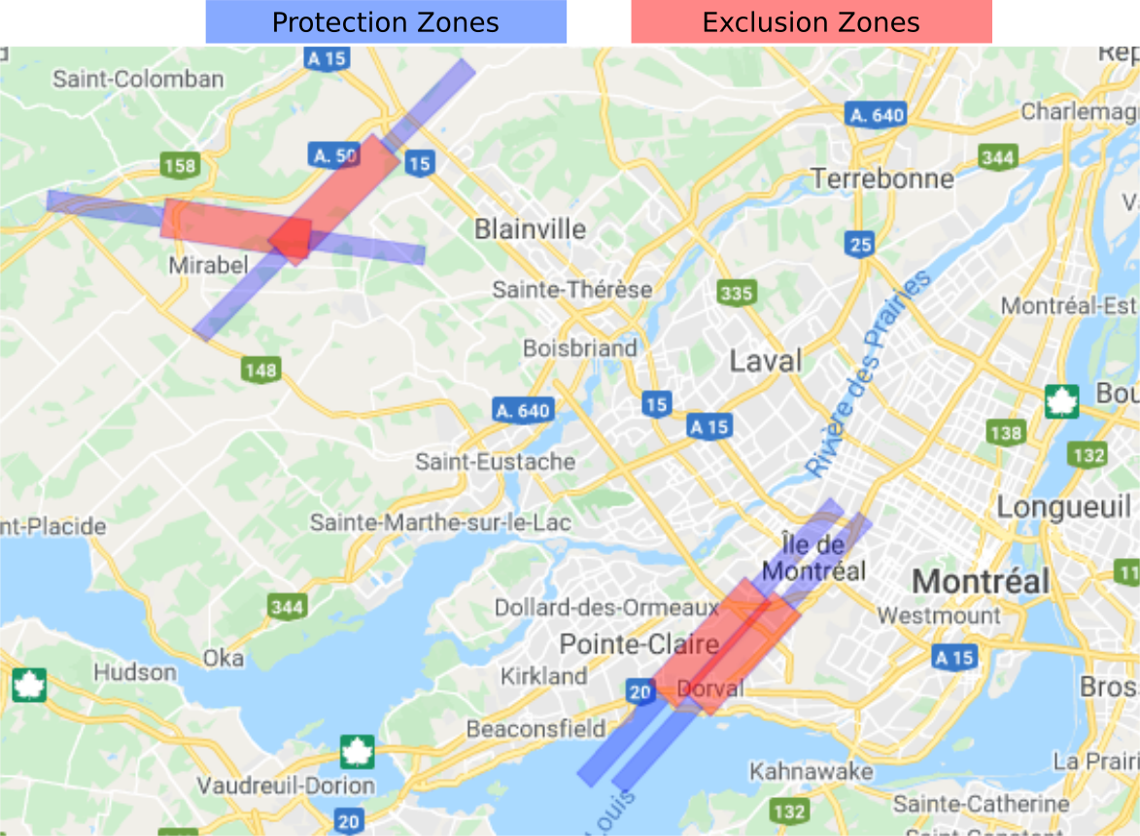
Montreal example

Thailand
CAA Thailand issue the document "Continued Airworthiness Notification" to Thailand's Aircraft Operators to provide recommendations on the issue. The document could be found in the attachment or could be reached by this address with reference number CAAT-CAN-2021-02
CAA Thailand issue an official letter to NBTC-Thailand's Spectrum Regulator to raise their awareness on the potential interference from 5G to Radio altimeter issue. As of now, Thailand is in the auction process on the C-band spectrum (3 400 - 3 700 MHz) while still have a discussion of the suitable guard band between IMT and FSS.

Sultanate of Oman
Sultanate of Oman published an Aeronautical Information Circular (AIC). The purpose of this Civil Aviation Safety Alert is to raise awareness of the potential risk of 5G interference and to recommend precautionary operational measures before confirmation of impact of 5G radio waves on radio altimeters.

Czech Republic
November 2021, Czech Republic in their Safety Brief inform that “Prague Airport respects the safety zones and precaution zones specified by the French Civil Aviation Authority DGAC and keeps them free of any 5G transmitters. And kindly asked to the pilots to report any radio altimeter issues.

USA
The United States Federal Aviation Administration (FAA) on 23 December 2021 issued a Special Airworthiness Information Bulletin (SAIB) on the Risk of Potential Adverse Effects on Radio Altimeters and also two Airworthiness Directives (ADs): Airworthiness Directive on altimeter interference and airplanes, and an Airworthiness Directive on altimeter interference and helicopters. The FAA has also facilitated data sharing between avionics manufacturers and wireless companies, and recent dialogue has helped to establish information sharing between aviation and telecommunications sectors and newly agreed measures to reduce the risk of disruption, but these issues are ongoing and will not be resolved overnight.

DISCUSSION
The problem of radio altimeters is not specific to 5G but rather to high field susceptibility. We can take the example given by ATR in its presentation to the FSMP. But of course, since 5G is being deployed massively and globally around the radio altimeter frequency band 4.2-4.4 GHz, it makes 5G the main part of the problem.
The mid-band frequencies ranges discussed here have become central to 5G operators plans to rollout new technologies, balancing capacity and coverage. The priority the 5G operators place in this spectrum range is reflected by the multiple billions offered in different national auctions. This is contrasted by radar altimeters being a highly sensitive system, needed to achieve the necessary performance and accuracy, reacting to a dramatic change in the RF environment. Radar altimeters are deployed on most aircraft for many essential air safety functions of modern aircraft given its capability and years of interference free performance. Therefore, both industries are highly invested in the outcome, but also use different standards and metrics to assess the risk of interference. Combined with the significant sums of money and political interests, this creates a source of friction that appears difficult to solve.

Why C-band 5G networks have been deployed in different parts of the world, and there was no interference case reported?
This question is often asked, but the risk cannot be generalised. The risk of interference to a Radio Altimeter depends on many parameters such as:
- Maximum Effective Isotropic Radiated Power (E.I.R.P = power of the 5G base station (xxx) + antenna gain (yy))
  - Power of the 5G base station (xxx dBm) call TRP (True Radiated Power)
  - Antenna gain (yy dBi) depending on the type of antenna.
- the location of the Base station antenna
- the antenna tilts.
- The vertical scan (Scan angle)
- the rate of use of a base station
- The ground scattering and altitude
- the frequency band used.
- aggregated unwanted emission level
From one country to another, all these parameters are different even in CEPT countries.

E.I.R.P
The tests carried out by Norway are interesting.
If we consider the power parameter (EIRP) as a parameter and estimate the "zone de sécurité" (safety zone) as defined in the French mitigation measures.
If we use the power of 60.68dBm EIRP from Norway: the “zone de securité” is in red (123m each part of the runway);
If we use the power of 78dBm EIRP from France: “zone de sécurité” is in green (910m each part of the runway).
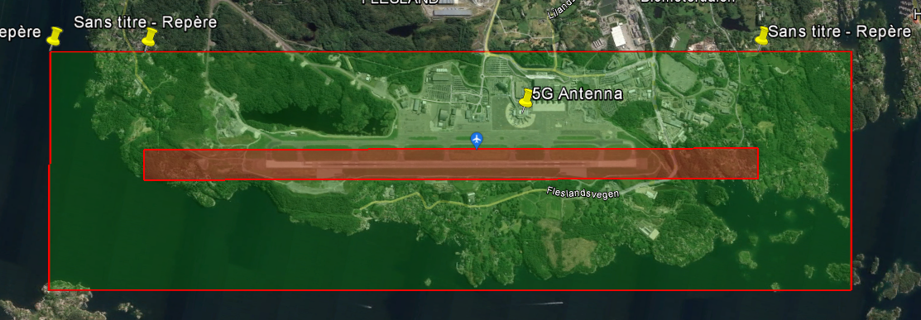
As we can see, using an EIRP of 60.68dBm for the 5G Base station, the runway easements are sufficient to protect radio altimeters, using an EIRP of 75dBm for the 5G Base station: implementing 5G antenna on the air terminal would be problematic.
E.I.R.P is the main problem, but within the regulations, there is no limit of EIRP! Because there are not limit on the antenna Gain, only the TRP is limited (E.I.R.P = TRP +.Antenna Gain). AAS antennas are a huge problem, because in theory there is no limit to the antenna gain and therefore no regulation on the limit to the EIRP. Without EIRP limits, we will never be able to develop standards that allow radio altimeters to be resilient!

Type of antennas used
Two different technology are available for 5G antennas with different antenna gain and therefore acts directly on E.I.RP

AAS antenna (advanced antenna systems) is the general term used to describe antenna using adaptive beamforming. Depending on the information available, the gain can exceed 25dBi

Non AAS antennas are antennas with a fixed beam, usually 120° where the gain where the gain is constant around 15dBi.

Antenna tilt
In some countries, the tilt must always be below the horizon, and therefore the maximum gain towards the aircraft is lower (about 5dB) than the maximum gain of the antenna. But for example, in France, this constraint has been removed by a ministerial decision. Negative tilt is only imposed in the precautionary and safety zones around aerodromes with CAT III approaches (there is no CAT II in France).
The desire to use the 5G for the UTM will question the limitation of negative tilt in other countries.

The vertical scan (Scan angle)
The vertical scan of an AAS Antenna has the ability to steer the main beam of the AAS antenna upward toward an aircraft above the horizon. There are no restrictions on the vertical scan angle in the Telecommunication regulations. The main beam is steered above the horizon depending on User Equipment demand in the vicinity and network management policy of the operators and the antenna manufacturers. RTCA report details the consequences on radio Altimeters in such cases (refer to §10.1.3). Also, high negative vertical scan angles can also create significant grating lobes upward.

The rate of use of a base station
The power radiated by a base station depends on the data traffic passing through it. According to the information available: in France, data transmitted in 5G represents less than 1.5% of mobile data. This can be explained by the price of 5G subscriptions, which is tending to fall. At the same time, the rate of 5G compatible phones that will be available for the population is going to increase, knowing that but the average renewal period for a phone is 2 years. This means that, within 2 years, most of the phones will be 5G capable and the 5G mobile data traffic will be higher.

The ground scattering and altitude.
The susceptibility of radio altimeters also depends on the ratio of the 5G signal to the radio altimeter return signal. The higher the ground scattering is, the more resistant the radio altimeter is. But this coefficient is not constant, it depends on the type of soil (sand, pure water or sea, agricultural land, vegetation…) and the soil moisture content. A very interesting document produced by Honeywell (page 33 to 40) deals with this complex subject and helps to understand the issue.

The altitude of the aircraft increases the path loss of the Radio altimeter signal, and therefore makes its receiver more sensitive, but at the same time the altitude of the aircraft moves it away from the 5G base stations and increase 5G the path loss. Studies and simulations have shown that the most unfavourable altitude is around 200ft.

Aggregated unwanted emission level
RTCA report indicated that the conducted PSD (Power Spectral Density) of Spurious Emissions from a 5G Base Station is -20 dBm/MHz. It also indicates that the peak output PSD of this spurious level at the output of the antenna (EIRP) corresponds to a conducted PSD through a single element of an AAS antenna. So the Peak Output PSD spurious (EIRP) can reach -12.9 dBm/MHz. RTCA Report relies on data provided by Telecommunication community (as per Appendix B)

The frequency band used
The new uses of 5G worldwide are concentrated in the frequency band 3-5 GHz. A wide guard band does not make it safe, but it is part of the equation to protect radio altimeters. That is why the availability of data on the susceptibility for all type of Radio-Altimeter over the whole frequency band 3-5 GHz, will allow us to establish specific rules for each 5G frequency band.

Stakeholder organisation

ICAO

FSMP
ICAO sent a state letter (drafted by FSMP) to raise awareness in the aviation community.
During FSMP WG11, a correspondence group on radio altimeters (CG-RA) was formed to collect information on a number of topics related to 5G/altimeter compatibility (FSMP WG11 Report Appendix H).

Flight Operations Panel (FLTOPSP)
During FLTOPSP/8 an information paper 6 updated the position on interference by 5G communications in the aircraft radio altimeters (FLTOPSP/7 Decision 5/2).
The panel were informed that the original statement had been presented to the frequency spectrum management panel (FSMP), and that the FSMP had requested any specific examples of interference to be shared
with them.
Regarding updating of the industry standards for radio altimeters, the panel noted that work was underway with RTCA to develop more robust systems, but that this would be a long term fix as the new standards
would not be completed until Q4 2022 and would then need to be adopted by equipment manufacturers to be implemented. Reports from the 5G industry suggested there was considerable interest in looking at improvements and mitigations to allow 5G development to continue without impacting on aircraft safety.

FMG Europe
The European FMG is following the issue and invites its members to express ICAO's concerns to their respective frequency regulator.

EASA
Following the CARI (Continuing Airworthiness Review Item) sent by EASA to all aviation stakeholders on the subject, the partial data received until now by EASA (initial deadline in February 2021) did not allow to conclude on a risk assessment for all possible combinations of radalt/aircraft models. Further data are still expected .
During ECC PT1 #68 Meeting (April 2021), EASA has taken the lead in the collection, compilation and anonymisation of radio altimeter data from the different manufacturers. These data are needed to be implemented into the draft ECC Report (CEPT PT1 SWG C TEMP 13 / ANNEX VIII-13) for conducting studies, and only EASA (within Europe) has the authority/legitimacy to request this data from manufacturers.
EASA did not contribute nor participate in the following ECC PT1 #69 meeting (sept 2021).

EASA / EC DG MOVE / EUROCONTROL
On 25 February 2021, a joint workshop was hosted by EASA, the European Commission and EUROCONTROL for aviation stakeholders. Presentations were given by EASA, RTCA / EUROCAE, Airbus, Thales, DGAC and EUROCONTROL. The presentations were made available to all registered participants.

EUROCONTROL
On 2 October 2020, the EUROCONTROL Airport Operations Team was informed about the 5G and RADALT issue. The airports community was requested to be vigilant about 5G deployments near aerodromes and to ensure caution when deploying 5G infrastructure themselves.

On 23 February 2021, EUROCONTROL presented the potential for RFI to RADALT from 5G emissions to the 4th meeting of SAFOPS, which is part of the network manager working arrangements. It also published a safety bulletin with an information message to operators. The bulletin is to make sure that if events related to RADALT are reported, that they are made available to EVAIR, the EUROCONTROL Voluntary ATM Incident Reporting System, for further analysis. As of end September 2021, no such reports have been received.

On 12 March 2021, an action paper on Possible 5G Interference to Radio Altimeters was presented to the NDTECH meeting, the Network Directors of Technology Working Group (agenda item 4.6). The paper summarizes the issue and associated developments and calls for cooperation between airport operators, ANSP, aviation and radio regulatory authorities, military and all airspace user organizations to cooperate on the matter. It establishes three priorities for such activities, which are to 1) maintain safety, 2) limit the economic impact to the aviation industry and 3) engage with the 5G industry to facilitate 5G developments as far as possible while maintaining safety and a viable transition to operations with equipment built to improved RADALT standards. NDTECH continues to be informed on this matter through the “matters arising” agenda item.

CEPT PT1
At the beginning of the year 2021, when the issue was brought to the attention of PT1, there was a lot of tension. But since the ITM community has realised that the aeronautical community is not able to provide technical characteristics, they are more confident. Some of them asked to put the subject on hold, others said that if EASA doesn't react then there are no problems, and therefore the work item must be closed…
The ECC PT1 report on the Radio-Altimeter topic was planned to be delivered for March 2022
Important involvement of the aviation industry at the PT1 meeting of 11-12 and 17-21 January 2022. Base on documents (cf. §1.1.5.1 CEPT PT1 /ECC PT1 #70 January 2022), the meeting agreed to establish a Correspondence Group (CG), chaired by Mr Alexander Deder (Germany), until the next ECC PT1 meeting (with the Terms of Reference in ECC PT1(22)074 ANNEX VIII-28). The CG convener should provide an update to ECC PT1 chairman on the progress of CG activity one week prior upcoming ECC meeting in order for PT1 chairman to inform ECC accordingly.
The CG continued developing the draft ECC Report on compatibility between MFCN operating in 3400-3800 MHz and Radio Altimeters operating in 4200-4400 MHz (ECC PT1(22)074 ANNEX VIII-27).
Material from relevant input documents was included in appropriate places into the working document but there was not sufficient time to discuss it, so it was inserted with square brackets and further considerations are required. Questions by the mobile industry were raised on whether received parameters for Radio-Altimeter were the most appropriate and a list of clarifying questions was drafted. ASRI kindly agreed to work on responses to these questions. Recognising that there is a range of Radio-Altimeter performance, participants stressed the need to agree first on realistic assumptions and scenarios before starting any compatibility studies. It was also highlighted that assumptions should represent the CEPT situation.
During the discussions it was pointed out that there are still missing parameters required for the simulations. AVSI informed the meeting that additional parameters are intended to be published in March this year. It was highlighted that a reply to Eurocae/RTCA on received Radio-Altimeter parameters and questions regarding 5G performance would be essential.
The draft ECC Report had been scheduled to be finalised for submission to ECC for approval for public consultation from this ECC PT1 meeting but this was the first time the group received information regarding radio altimeter characteristics, therefore more time is needed to progress the work and an extension to the deadline by 3 additional ECC PT1 meetings to work item PT1_40 will be requested from ECC (draft report for public consultation to be approved at ECC PT1 #73 in January 2023 for submission to ECC #61 in March 2023; resolution of public consultation comments at ECC PT1 #74 in April/May 2023 and final approval at ECC #62 in June/July 2023).

The PT1 website has opened a forum dedicated to "CG Radio altimeters 4.2-4.4 GHz" on which a lot of information and exchanges between the different stakeholders are available.

April 2022 ,AVSI has published it's third and final volume of the AFE 76s2 Project Report. The three volumes of the report include:
- Volume I - contains the introduction, AVSI test procedures, and test results from out-of-band interference representative of 5G fundamental signals in the 3700-3980 MHz frequency band. Volume I can be downloaded here: AVSI AFE 76s2 Project Report - Volume I
- Volume II - contains the AVSI test results from in-band interference representative of 5G spurious signals in the 4200-4400 MHz frequency band and identifies changes to the test conditions and analysis for spurious tests. Volume II can be downloaded here: AVSI AFE 76s2 Project Report - Volume II
- Volume III - contains manufacturer-provided test results, including additional altimeter models, additional interference signal frequencies, and investigation of additional experimental conditions. Volume III is attached and can be downloaded here: AVSI AFE 76s2 Project Report - Volume III

FAA (Federal Aviation Administration U.S.A)
See Section 1.3.10[TBC]

RTCA-EUROCAE
Following the US national regulator’s decision to allow 5G services in the 3.7-3.98 GHz, additional study was encouraged given the questions raised by the aviation community. From this, RTCA created a public multi-stakeholder group under its SC-239 committee that conducted an extensive theoretical study of the simulated 5G interference, assessing it against radar altimeter performance data from the major manufacturers in common and real-world scenarios. With the regulatory limits defined by the US national regulator for base stations and handsets, combined with data from the 5G interests, the RTCA SC-239 Report found that all aircraft types and multiple operations received interference from both simulated fundamental and spurious 5G emissions. The RTCA Report concluded that “5G base stations present a risk of harmful interference to radar altimeters across all aircraft types, with far-reaching consequences and impacts to aviation operations”. Although they did not participate in the public RTCA work, 5G interests have challenged the findings stating it is overly conservative and there is no interference potential. Since publication of the RTCA Report, no decision has been yet made by the U.S national regulatory.

In December 2020, RTCA made an interesting Youtube presentation of the Radio Alitmeter issue.

RTCA and EUROCAE (SC-239/WG-119) have jointly initiated the drafting of new Mops for the Radio Altimeter, the completion of the work is planeded for the end 2023.

Arab Civil Aviation Organization (ACAO)
Air Navigation committee meeting No 45 on 30-31 March 2022. The committee endorsed the following recommendation (English Translation):
- Urge the member states of the organization to take appropriate measures to reduce the impact of the installation of 5G cellular networks on the movement of aircraft in coordination with the concerned authorities of each country (national telecommunications regulatory bodies) to ensure that the levels of use of 5G cellular networks near airports and their future plans.
- Task the General Administration of ACAO in coordination with the recently established 5 G Working Group by ICAO Middle East Regional Office to work on the development of a mechanism at the national and regional levels to report and analyse interference reports resulting from the use of 5G networks
- Urge member states to support ICAO's position during the 2023 World Telecommunications Conference WRC-23 meeting to be held on 2023 through coordination with the nation

Conclusion
Radio altimeters were developed at a time when:
- mobile telecommunication industry didn’t exist.
- coexistence with systems in adjacent frequency bands had little or no impact.

The increase demand for wireless technology to enable connectivity has come to surround of some aeronautical frequency bands, including the Radio Altimeter frequency band 4.2-4.4GHz. It was clearly never anticipated by the Radio altimeters industry in 1980s.

Although the aviation community is developing new standards as fast as possible, but States shall ensure the safety of life during this transitional period. The aeronautical community must make “the best effort” but can do it only if the limits of RF environment are perfectly known and stable for decades.

– END –
- Arab Civil Aviation Organization (ACAO) Air Navigation committee meeting No 45 on 30-31 March 2022. The committee endorsed the following recommendation (English Translation):

- A. Urge the member states of the organization to take appropriate measures to reduce the impact of the installation of 5G cellular networks on the movement of aircraft in coordination with the concerned authorities of each country (national telecommunications regulatory bodies) to ensure that the levels of use of 5G cellular networks near airports and their future plans.
- B. Task the General Administration of ACAO in coordination with the recently established 5 G Working Group by ICAO Middle East Regional Office to work on the development of a mechanism at the national and regional levels to report and analyze interference reports resulting from the use of 5G networks
C. Urge member states to support ICAO's position during the 2023 World Telecommunications Conference WRC-23 meeting to be held on 2023 through coordination with the nation

https://avsi.aero/wp-content/uploads/2021/12/Radar-Altimeter-Overview-of-Design-and-Performance.pdf
https://www.icao.int/safety/acp/ACPWGF/ACP-WG-F-30/ACP-WGF30-WP14%20Radio%20Altimeter%20Adjacent%20Bands%20Compatibility%20Study%20with%20IMT-FINAL%20Rev1.docx
https://www.icao.int/safety/acp/ACPWGF/ACP-WG-F-30/ACP-WGF30-WP17_radio%20altimeter%20analysis.doc
https://www.icao.int/safety/FSMP/Documents/Job%20Cards/FSMP_JobCard.07.01.pdf
https://www.fcc.gov/ecfs/filing/0303046335999, paragraphs 390-395, dated 28 Feb 2020
The FCC does have generic limits on tower and antenna placement in its CFR 14 - Part 17 rules that apply to all services.
https://www.fcc.gov/ecfs/filing/104202099224796, dated 20 Apr 2020
https://www.icao.int/safety/FSMP/MeetingDocs/FSMP%20WG10/WP/FSMP-WG10-WP13-Annex%202%20-%20ECC_PT1_66th_meeting%20-%20ICAO%20Input%20on%20Radioaltimeters%20vs%205G.docx
https://www.rtca.org/wp-content/uploads/2020/10/SC-239-5G-Interference-Assessment-Report_274-20-PMC-2073_accepted_changes.pdf
US 5G operators and manufacturers were openly invited to participate in the group, but voluntarily withdraw after the first few meetings without explanation. 5G parameters were instead provided via another forum that allowed for some data exchange on 5G and radar altimeter parameters (see RTCA report Appendix B - TWG-3 Information Exchange). Representatives of 5G operators did provide feedback to the final draft report during the public comment process and disagreed with the conclusions made (see RTCA report Appendix C – Public Comments), but were unable to provide any technical information to support their opinion. However, they did provide a correction to the 5G base station parameters they had originally provided (see RTCA report Appendix D – Additional Analysis).
https://portal.icao.int/FMG/Documents/FMG%20CM%202021%20-%20RAFT19/FMGCM2021%20RAFT19%20IP07.pdf
https://cept.org/Documents/ecc-pt1/62425/ecc-pt1-21-022_airbus-radio-altimeters-interference-from-5gmfcn-in-34-38-ghz
https://cept.org/Documents/ecc-pt1/62166/ecc-pt1-21-006_france-protection-of-radio-altimeters-from-mfcn-in-34-38-ghz
https://cept.org/Documents/ecc-pt1/62432/ecc-pt1-21-027_bouygues-telecom-orange-mfcn-and-radio-altimeters-co-existence
http://eccwp.cept.org/WI_Detail.aspx?wiid=775
https://cept.org/Documents/ecc-pt1/64077/ecc-pt1-21-122_gsa-mfcn-characteristics-for-wi-on-radio-altimeters
https://cept.org/Documents/ecc-pt1/64066/ecc-pt1-21-117_france-wi-5g-radioaltimeters
https://cept.org/Documents/ecc-pt1/64064/ecc-pt1-21-115_eurocontrol-icao-state-letter-on-potential-safety-concerns-regarding-interference-to-radio-altimeters
https://cept.org/Documents/ecc-pt1/65970/ecc-pt1-21-192_france-radioaltimeter
https://cept.org/Documents/ecc-pt1/65959/ecc-pt1-21-188_gsa-mfcn-characteristics-for-wi-on-radio-altimeters
https://cept.org/Documents/ecc-pt1/65941/ecc-pt1-21-184_norway-results-of-the-preliminary-test-of-compatibility-between-mfcn-operating-in-3400-3800-mhz-and-radio-altimeters-operating-in-4200-4400-mhz
https://www.icao.int/Meetings/HLCC2021/Documents/WP/EN/SAF/wp_030_en.pdf
https://eur-lex.europa.eu/legal-content/EN/TXT/?uri=CELEX:32019D0235
https://www.arcep.fr/la-regulation/grands-dossiers-reseaux-mobiles/la-5g/frequences-5g-procedure-dattribution-de-la-bande-34-38-ghz-en-metropole.html
https://www.gcaa.gov.ae/en/epublication/admin/Library%20Pdf/Safety%20Alerts/SAFETY%20ALERT%202021-03%20-%20REQUIREMENTS%20TO%20MITIGATE%205G%20INTERFERENCE%20OPERATIONAL%20RISKS%20-%20ISSUE%2001.pdf
https://www.ecologie.gouv.fr/sites/default/files/Safety_Info_Leaflet_2021_01_5G_interferences.pdf
https://www.casa.gov.au/search-centre/airworthiness-bulletins/potential-5g-interference-radio-altimeter-systems
https://tc.canada.ca/en/aviation/reference-centre/civil-aviation-safety-alerts/potential-risk-interference-5g-signals-radio-altimeter-civil-aviation-safety-alert-casa-no-2021-08
https://www.caat.or.th/en/archives/56597
https://www.caa.gov.om/upload/files/AIC%2004-21.pdf
https://www.prg.aero/sites/default/files/obsah/O-letisti/O%20spole%C4%8Dnosti/Bezpecnost%20na%20letisti/Safety/Safety%20Brief/SAFETY%20BRIEF%20LKPR%2093%20Interference%20of%205G%20networks%20with%20radio%20altimeters.pdf
https://www.faa.gov/5g
https://www.icao.int/safety/FSMP/MeetingDocs/FSMP%20WG11/IP/FSMP-WG11-IP06_RA_interference.pdf
https://avsi.aero/wp-content/uploads/2021/12/Radar-Altimeter-Overview-of-Design-and-Performance.pdf
https://www.icao.int/safety/FSMP/MeetingDocs/Forms/AllItems.aspx?RootFolder=%2fsafety%2fFSMP%2fMeetingDocs%2fFSMP%20WG11%2fReport&FolderCTID=0x012000556AC038F4589F4281B27ABB7E901CAE
https://www.cept.org/ecc/groups/ecc/ecc-pt1/client/forum/topic/619
https://www.rtca.org/wp-content/uploads/2020/10/SC-239-5G-Interference-Assessment-Report_274-20-PMC-2073_accepted_changes.pdf
https://www.youtube.com/watch?v=OpYhjK2MDqM

