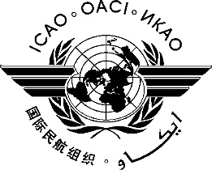 | International Civil Aviation Organization  WORKING PAPER
  FSMP-WG3/WP-05
  2016-08-25
FREQUENCY SPECTRUM MANGEMENT PANEL (FSMP)

Third Working Group meeting

Montreal, Canada, 6 to 14 September 2016

Agenda Item 3 | Updates to the ICAO Frequency Spectrum Policy (Doc 9718 Vol I, Chapter 7)

proposed modifications to Doc 9718, Vol I, Chapter 7

Mike Biggs

SUMMARY
FSMP has been updating Doc 9718, the Handbook on Radio Frequency Spectrum Requirements for Civil Aviation. Volume I, chapter 7 of that document contains a band by band Statement of Frequency Allocations, Technical Details and ICAO Policy. The annex to this paper contains proposed revisions to that material.

ACTION
Review the proposed modifications contained in the Annex, and take action as necessary.

