 | International Civil Aviation Organization  WORKING PAPER
  FSMP-WG/03 WP/09
  2016-08-29
FREQUENCY SPECTRUM MANGEMENT PANEL (FSMP)

Third Working Group meeting

Montreal, Canada, 6 to 14 September 2016

Agenda Item 10: Any other Business

RADAR – SPECTRAL MASK

(Presented by John Mettrop)

SUMMARY
This working paper presents a comparision of the spectral mask derived in accordance with Recommendations ITU-R SM.853, SM.1138 & 1541 for Primary (2700-2900 MHz) and secondary surveillance radar as well as ICAO SARPs for secondary surveillance radar.

1. INTRODUCTION
1.1 The Radio Regulations, a United Nations treaty level document, govern the global use of spectrum and are administered and published by the International Telecommunication Union. They define, for a number of defined services, the frequency bands that can be used, the spectral mask of those transmissions, any restrictions that apply to the use of that service in order to ensure compatibility with other co or adjacent frequency services and the co-ordination procedures to be applied. Within Europe spectrum use is co-ordinated through the European Conference of Postal and Telecommunication Administrations and for the 28 member States the European Union.
1.2 In May 2014 the Radio Equipment Directive (RED) (2014/53/EU) was published in the Official Journal of the European Union which superseded the Radio and Telecommunications Terminal Equipment (R&TTE) Directive. All equipment placed on the market after June 2017 within the European Union must comply with the directive.
1.3 As part of the work associated with the introduction of the RED the the Radar group of the Aeronautical Task Group of the European Telecommunications Standards Institute (ETSI) EMC & Radio Spectrum Matters Technical Committee has been tasked with developing standards for ground based aeronautical primary and secondary surveillance radar operating in the L, S and X frequency bands.
1.4 This paper provides an analysis of the findings of the Radar group with respect to the minimum Radar spectral mask requirements as defined by the Radio Regulations and compares these with additional material that can be found in various ITU-R Recommendations. For primary radar the document uses the characteristics of S-band radar contained in Recommendation ITU-R M.1464-2 to illustrate the implications of the findings whilst for secondary surveillance radar a comparison is undertaken to the specifications contained in ICAO Annex 10 volume IV.
2. DISCUSSION
2.1 As previously pointed out the Radio Regulations are the basis for the regulation of all radio systems. Within those regulations Article 1 provides the following definitions of radar:
1.100 radar: A radiodetermination system based on the comparison of reference signals with radio signals reflected, or retransmitted, from the position to be determined.
1.101 primary radar: A radiodetermination system based on the comparison of reference signals with radio signals reflected from the position to be determined.
1.102 secondary radar: A radiodetermination system based on the comparison of reference signals with radio signals retransmitted from the position to be determined.
With radiodetermination being defined as:
1.9 radiodetermination: The determination of the position, velocity and/or other characteristics of an object, or the obtaining of information relating to these parameters, by means of the propagation properties of radio waves
Note: Radiodetermination can also be a radio service defined under Article 1.40 as a radiocommunication service for the purposes of radiodetermination.
2.2 Radiodetermination, as a service, is then further broken down into the various radionavigation and radiolocation services that are defined in Article 1 as shown below.
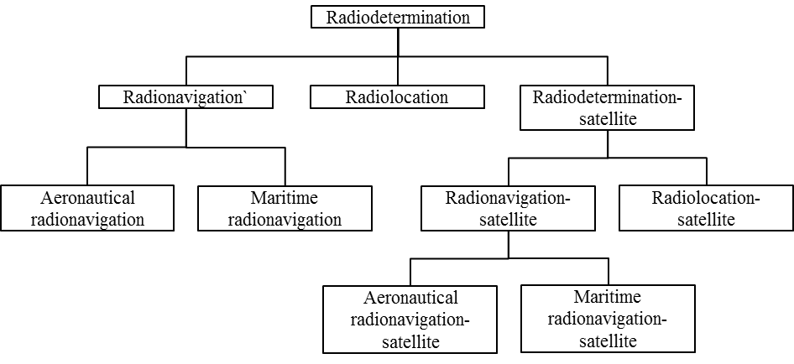
2.3 However, in terms of necessary bandwidth, frequency tolerance and unwanted emissions the Radio Regulations do not differentiate between those services other than the inclusion of a number of provisions that relate to primary radar.
2.1 Radio Regulatory Requirements
2.1.1 Frequency Tolerance
2.1.1.1 Article 3.5 of the Radio Regulations specifies that all transmitting stations shall conform to the frequency tolerances specified in Appendix 2. Within Appendix 2 the following frequency tolerances are specified for radiodetermination stations

Frequency band | Tolerance applicable to the transmitter
9 kHz to 535 kHz  1 606.5 kHz to 4 000 kHz  Power 200W or less  Power above 200W  29.7 MHz to 100 MHz  470 MHz to 2 450 MHz  2 450 MHz to 10 500 MHz  10.5 GHz to 40 GHz | 100 parts in 10⁶  20 parts in 10⁶  10 parts in 10⁶  50 parts in 10⁶  500 parts in 10⁶  1 250 parts in 10⁶  5 000 parts in 10⁶
Note: Where specific frequencies are not assigned to radar stations, the bandwidth occupied by the emissions of such stations shall be maintained wholly within the band allocated to the service and the indicated tolerance does not apply.
2.1.1.2 The following derived values illustrate the maximum frequency tolerance applicable for a number of standard primary radar frequencies:
1 300 MHz 515 kHz
2 800 MHz 3.5 MHz
3 000 MHz 3.75 MHz
9 100 MHz 11.375 MHz
9 400 MHz 11.75 MHz
2.1.2 Unwanted Emissions
2.1.2.1 Definition
2.1.2.1.1 Article 3.6 of the Radio Regulations specify that transmitting stations shall conform to the maximum permitted power levels for unwanted emissions in the spurious domain specified in Appendix 3. The emission limits of this Appendix apply to all emissions, including harmonic emissions, intermodulation products, frequency conversion products and parasitic emissions, at frequencies in the spurious domain as illustrated below:
2.1.2.2 Necessary Bandwidth
2.1.2.2.1 Appendix 1, Section I of the Radio Regulations defines the following three methods for determining the necessary bandwidth.
- use of the formulae and examples of necessary bandwidths and designation of corresponding emissions given in Recommendation ITU-R SM.1138-2
- computation, in accordance with other ITU-R Recommendations;
- measurement, in cases not covered by the above.
2.1.2.2.2 Given that the only ITU Recommendation related to the calculation of the necessary bandwidth for a radiodetermination service that is incorporated by reference in the Radio Regulations is Recommendation ITU-R SM.1138-2 it can be assumed that only the first bullet point has any regulatory standing. Whilst the other two methods are both possibilities, the second bullet would require the Recommendation to be incorporated by reference for it to have any form of regulatory standing and the third method is radar type specific and therefore is not suitable for a generic standard:
2.1.2.2.3 Within Recommendation ITU-R SM.1138-2 the only formula provided for radiodetermination systems is the following one for radars with un-modulated pulse emissions
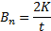 | (1)
Where B_{n} = Necessary bandwidth
K = an overall numerical factor which varies according to the emission and which depends upon the allowable signal distortion. It depends upon the ratio of pulse duration to pulse rise time. Its value usually falls between 1 and 10 and in many cases it does not need to exceed 6
t = pulse duration at half amplitude
2.1.2.2.4 However, how K should be calculated has not been defined within the Radio Regulations nor can any definitive guidance be found in other regulatory texts.
2.1.3 Maximum Permitted Spurious Domain Emission Levels
2.1.3.1 Table I of Appendix 3 to the Radio Regulations specifies that for a Radiodetermination service transmission the minimum attenuation below the power supplied to the antenna transmission line is either 43 + 10 log (Peak Envelope Power), or 60 dB, whichever is less stringent. In general, for radars used for aeronautical purposes this will result in the use of the 60dB figure.
2.1.4 Boundary Between the Out-of-Band and Spurious Domains
2.1.4.1 General
2.1.4.1.1 Appendix 3, Table 1 (shown below) of the Radio Regulations defines, for the generic case, the frequency separation between the centre frequency and the boundary of the spurious domain which should be applied unless specifically defined elsewhere.
Table 1 Boundary Between the Out-of-Band and Spurious Domain
Frequency  range | Narrow-band case |  | Normal  separation | Wideband case
Frequency  range | for B_{N} < | Separation | Normal  separation | for B_{N} > | Separation
9 kHz < f_{c} ≤ 150 kHz | 250 Hz | 625 Hz | 2.5 B_{N} | 10 kHz | 1.5 B_{N} + 10 kHz
150 kHz < f_{c} ≤ 30 MHz | 4 kHz | 10 kHz | 2.5 B_{N} | 100 kHz | 1.5 B_{N} + 100 kHz
30 MHz < f_{c} ≤ 1 GHz | 25 kHz | 62.5 kHz | 2.5 B_{N} | 10 MHz | 1.5 B_{N} + 10 MHz
1 GHz < f_{c} ≤ 3 GHz | 100 kHz | 250 kHz | 2.5 B_{N} | 50 MHz | 1.5 B_{N} + 50 MHz
3 GHz < f_{c} ≤ 10 GHz | 100 kHz | 250 kHz | 2.5 B_{N} | 100 MHz | 1.5 B_{N} + 100 MHz
10 GHz < f_{c} ≤ 15 GHz | 300 kHz | 750 kHz | 2.5 B_{N} | 250 MHz | 1.5 B_{N} + 250 MHz
15 GHz < f_{c} ≤ 26 GHz | 500 kHz | 1.25 MHz | 2.5 B_{N} | 500 MHz | 1.5 B_{N} + 500 MHz
f_{c} > 26 GHz | 1 MHz | 2.5 MHz | 2.5 B_{N} | 500 MHz | 1.5 B_{N} + 500 MHz
NOTE – In Table 1, f_{c} is the centre frequency of the emission and B_{N} is the necessary bandwidth. If the assigned frequency band of the emissions extends across two frequency ranges, then the values corresponding to the higher frequency range shall be used for determining the boundary.
2.1.4.2 Primary radar
2.1.4.2.1 For primary radar, the boundary between the out-of-band and spurious domains is defined as the frequency at which the out-of-band domain limits specified in the applicable ITU-R Recommendation are equal to the spurious domain limit defined in Table 1 of this Appendix. Further guidance on the boundary between the out-of-band and spurious domains for primary radar is provided in the most recent version of Recommendation ITU-R SM.1541. (see section 3.2.4 for the defined spurious domain limit for radio determination systems)
2.2 ITU Guidance Material
2.2.1 Introduction
2.2.1.1 All of the above information has been drawn from either the Radio Regulations or ITU-R Recommendations incorporated by reference however there is additional guidance material contained in Recommendation ITU-R SM.853 & SM.1541. The following section looks at the relevant material contained in these 2 ITU-R Recommendations and how that information compares with the regulatory requirements derived above from the Radio Regulations
2.2.2 Necessary Bandwidth
2.2.2.1 Recommendation ITU-R SM.853-1 provides the following additional formulae for determining the necessary bandwidth which for primary radar is assumed to be the 20 dB Bandwidth:
Rectangular/Trapezoidal pulses  Smaller of:  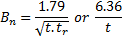 | (2)
Frequency modulated pulses  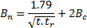 | (3)
Frequency Hopping  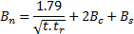 | (4)
Carrier Wave | (5)
Where B_{n} = necessary bandwidth
B_{c} = frequency deviation
B_{s} = maximum frequency range over which the carrier will be shifted
B_{d} = maximum frequency deviation
t = pulse duration at half amplitude
t_{r} = pulse duration at half amplitude
2.2.2.2 The above formulae are also contained in Recommendation ITU-R SM.1541-6 in annex 8 that addresses primary radar, where it is confirmed that they relate to the 20 dB bandwidth.

2.2.3 Formulas for the B₋₄₀ dB bandwidth
2.2.3.1 Recommendation ITU-R SM.1541-6 also provide formulae for determining the 40 dB Bandwidth (B₋₄₀) for primary radar, on the basis that the ratio of the B₋₄₀ and necessary bandwidth is not in general a constant
Non-FM pulse  Smaller of:  where the coefficient K is 6.2 for radars with output power greater than 100 kW and 7.6 for lower-power radars and radars operating in the radionavigation service in the 2 900-3 100 MHz and 9 200-9 500 MHz bands. The latter expression applies if the rise time t_{r} is less than about 0.0094t when K is 6.2, or about 0.014t when K is 7.6 | (6)
FM pulsed  where:  to account for the rise time  to account for the fall time  to account for both the rise and fall times combination  τ : pulse length including rise and fall times  t_{r} : pulse rise time  t_{f} : pulse fall time  B_{c} : bandwidth of the frequency deviation (total frequency shift during the pulse generation)  B_{S} : the maximum range over which the carrier frequency will be shifted, B_{s} equals zero for non-frequency hopping cases.  Equation (7) is valid only when the following conditions are met:  1. the product is greater than or equal to 0.10; and  2. that the product of or compression ratio must be greater than 10. | (7)
Otherwise  where A is 0.105 when K  6.2, and 0.065 when K  7.6 | (8)
Carrier Wave  where F_{C} is the carrier frequency. | (9)
Frequency modulated carrier wave  where B_{R} is the total frequency deviation and T is the chirp period. | (10)

2.2.3.2 Recommendation ITU-R SM.1541-6 then defines a roll off to 60 dBc point of either 20 (CW/FMCW/Phase Coded) or 30 dB per decade with a design objective of 40 dB per decade.
2.3 Comparison of the Regulatory and Guidance Material
2.3.1 Introduction
2.3.1.1 The following section investigates the consistency between the regulatory/guidance provisions highlighted above based on the aeronautical radars operation in the frequency band 2 700-3 100 MHz as contained in Recommendation ITU-R SM.1464-2. The technical characteristics of aeronautical radar used in this document are contained in Annex 1, noting that a number of radars have been excluded either because there were insufficient details available or they are not used for air traffic control purposes.
2.3.2 Primary Radar
2.3.2.1 Comparison
2.3.2.1.1 The following Out of Band frequency masks have been derived from the information contained in Recommendations ITU-R SM.853-1, SM.1138-2 & SM.1541-6. . In reviewing the frequency masks, the following points should be noted:
- Recommendation ITU-R SM.1138-2 is the only Recommendation that is incorporated by reference
- The K factor is not defined for any of the systems and has been derived from the quoted 20 dB bandwidth
More detailed information on how these graphs were derived is contained in the embedded excel spreadsheet contained in Annex 2
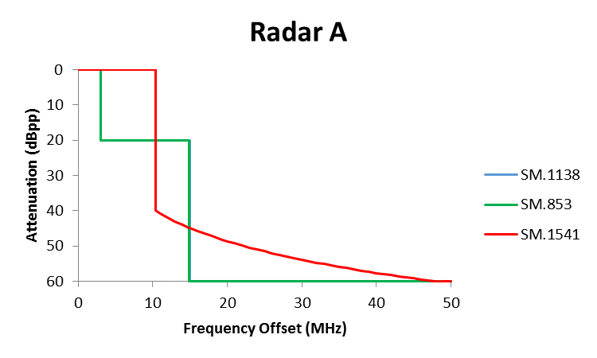
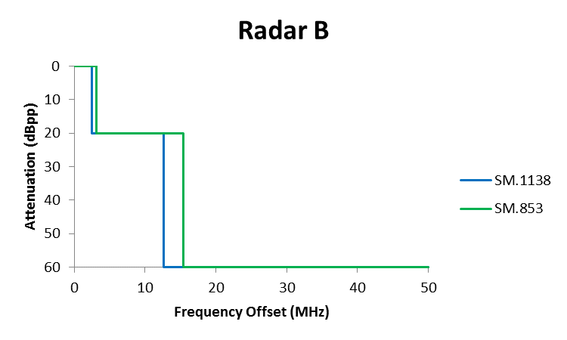
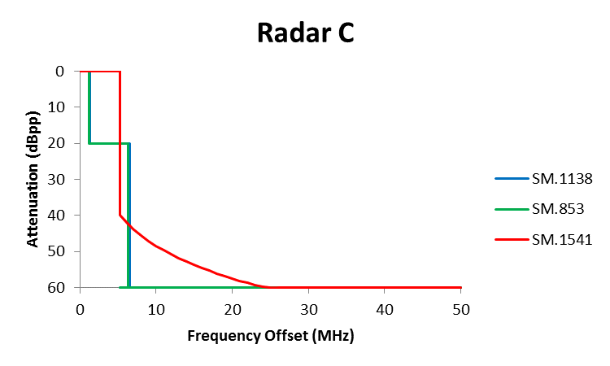
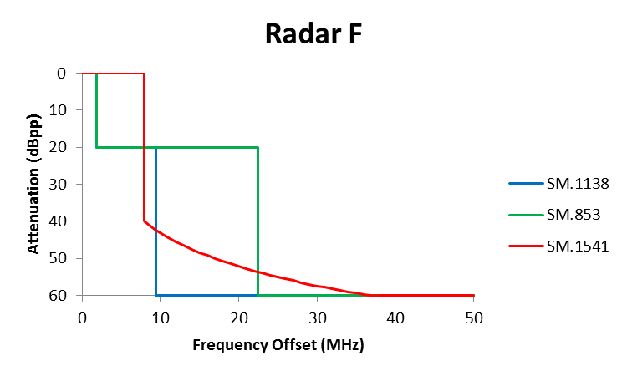
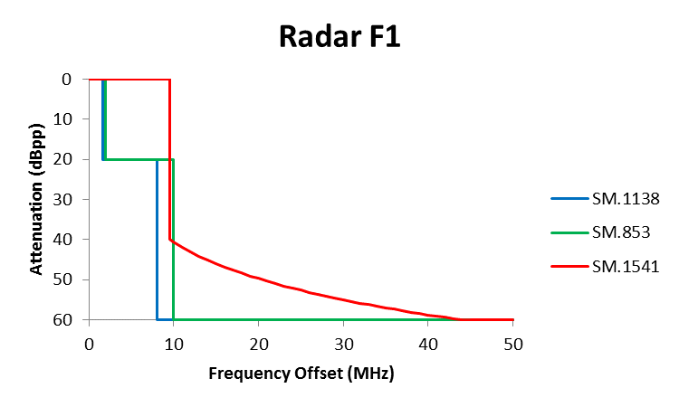
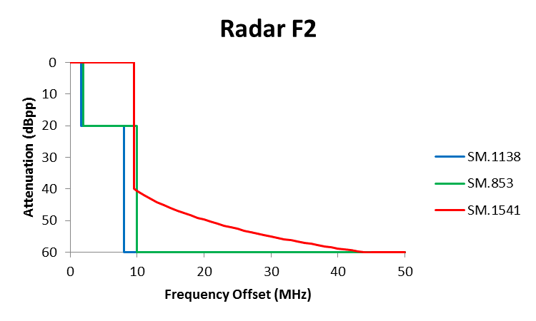
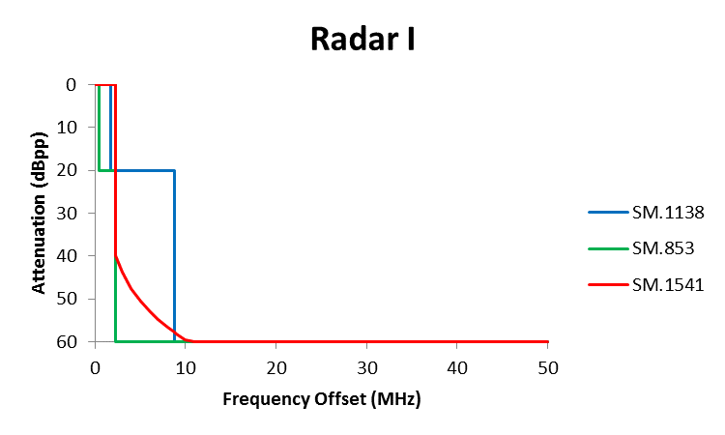
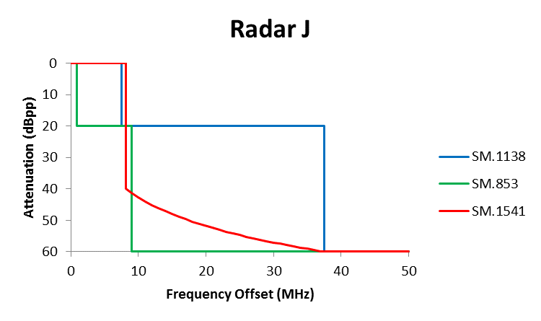
2.3.2.2 Conclusions for Primary Radar
- There is a disconnect between the masks produced in accordance with the formulae provided by the 3 ITU-R Recommendations for the various radar
- The K factor is not mathematically defined and hence there is some uncertainty with respect to the results produced by Recommendation ITU-R SM.1138
- In each case what could be regarded as the regulatory mask limit (e.g. SM.1138) does not necessarily encompass the masks that result from the application of the other two Recommendations
- Compliance with Recommendation ITU-R SM.1541-6, which is used in most Regions as the basis of their regional regulations, does not necessarily ensure compliance with the requirements contained in the Radio Regulations (assumed to be SM.1138)
2.3.3 Secondary Surveillance Radar
2.3.3.1 Comparison
The following Out of Band frequency masks have been derived from the information contained in Recommendations ITU-R SM.853-1, SM.1138-2, SM.1541-6 and ICAO Annex 10 volume III. In reviewing the frequency masks, the following points should be noted:
- Recommendation ITU-R SM.1138-2 is the only Recommendation that is incorporated by reference
- The K factor is not defined for any of the systems and has been derived from the quoted 20 dB bandwidth
- Recommendation SM.1541-6 is formally only applicable to primary radar
More detailed information on how these graphs were derived is contained in the embedded excel spreadsheet contained in Annex 3
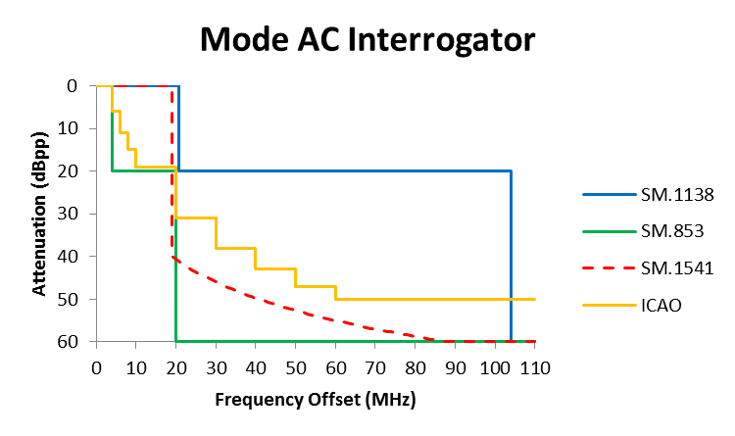
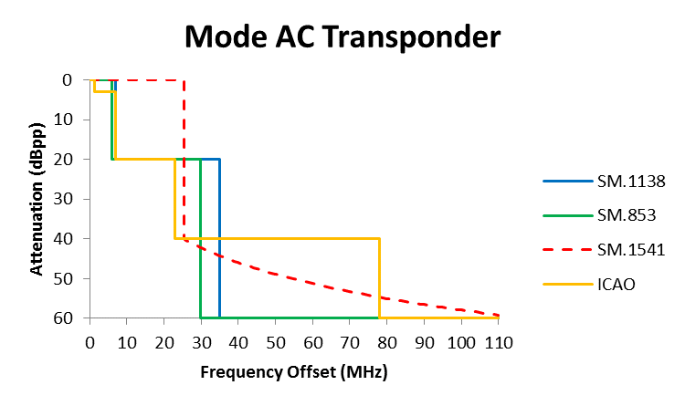
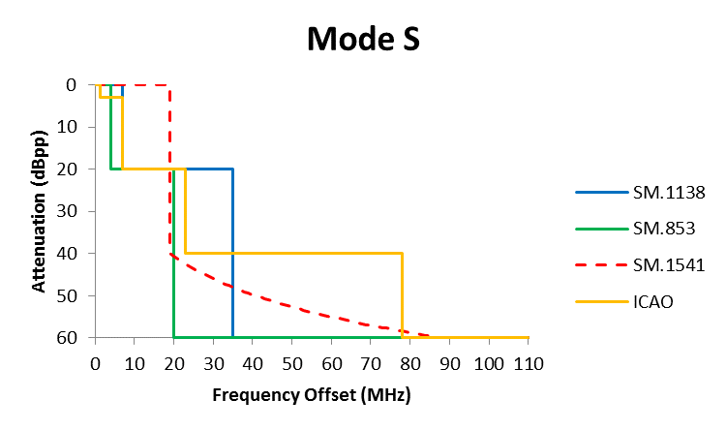
2.3.2.2 Conclusions for Secondary Surveillance Radar
- There is a disconnect between the masks produced in accordance with the formulae provided by the 3 ITU-R Recommendations
- The K factor is not mathematically defined and hence there is some uncertainty with respect to the results produced by Recommendation ITU-R SM.1138
- The spectral mask defined by ICAO is not consistent with the masks derived using the 3 ITU-R Recommendations
- Recommendation ITU-R SM.1541-6 should not be used as it does not apply to secondary surveillance radar.
3 Overall Conclusions
- For primary Radar what could be regarded as the regulatory mask limit (e.g. SM.1138) does not encompass the masks that result from the application of the other two Recommendations
- There is some consistency between the spectral mask produced using Recommendations SM.853 and SM.1138
- The K factor is not mathematically defined and hence there is some uncertainty with respect to the results produced by Recommendation ITU-R SM.1138
- The spectral mask defined by ICAO for secondary surveillance radar is not consistent with the masks derived using the 3 ITU-R Recommendations
- That the content of the 3 ITU-R Recommendations with respect to radar considered in this document does not reflect current waveforms.
- There appears to be an assumption in the ITU documentation that radiodetermination including radionavigation relates to radar and little consideration is given to other radiodetermination systems
- ACTION BY THE MEETING
  - The meeting is invited to:
- note and review the contents of this working paper;
- agree that action needs to be taken within the ITU to
- resolve the inconsistencies between the various ITU-R Recommendations
- Update the formulae used for defining the spectral mask for radiodetermination systems to reflect current systems and waveforms
- develop a strategy and supporting contributions to the ITU to address b)
- establish a correspondence group to address c)
— END —

ANNEX 1
S-Band Aeronautical Radar Characteristics

Characteristics | Units | Radar A | Radar B | Radar C | Radar F | Radar F1 | Radar F2 | Radar I | Radar J | Radar K
Modulation |  | P0N | P0N | P0N, Q3N | P0N, Q3N | P0N, Q3N | P0N, Q3N | Non-linear FM  P0N, Q3N | Non-linear FM  P0N, Q3N | Non-linear FM Q3N
Pulse width | μs | 0.6 | 1.03 | 1.0, 89⁽³⁾ | 0.4, 20  0.5, 27⁽⁴⁾ | 1.0 (SP)  60.0 (LP) | 1.0 (SP)  ≤ 250.0 (LP) | 0.4⁽¹⁾ to 40 | 0.1⁽¹⁾ to 200 | > 100
Pulse rise/fall time | μs | 0.15-0.2 |  | 0.5/0.32  (short pulse)  0.7/1  (long pulse) | 0.1 (typical) | 0.2 (SP), 3 (LP) | 0.2 (SP), 3 (LP) | 10 to 30 typical | 10 to 30 typical | Not given
Pulse repetition rate | pps | 973-1 040 (selectable | 1 059-1 172 | 722-935  (short impulse)  788-1 050  (long impulse) | 1 100  840⁽³⁾ | 320-6 100 (SP)  320-1 300 (LP)  ⁽⁸⁾ | 320-4 300 (SP)  320-1 500 (LP)  ⁽⁸⁾ | 550 to 1 100 Hz | 300 Hz to  10 kHz | < 300 Hz
Duty cycle | % | 0.07 maximum | 0.14 maximum | 9.34  maximum | 2  (typical) | 0.2⁽⁹⁾ -0.6 (SP)  ≤ 12.0⁽¹⁰⁾ (LP) | 0.2⁽⁹⁾ -0.4 (SP)  ≤ 12.0⁽¹⁰⁾ (LP) | 2.5 maximum | 10 maximum | Up to 3
Chirp bandwidth | MHz | Not applicable | Not Applicable | 2 | 2 | 3 | 3 | 2.5 | Up to 10 | > 100
Phase-coded sub-pulse width |  | Not applicable |  |  |  | Not applicable | Not applicable
Compression ratio |  | Not applicable | Not applicable | 89 | 40:1  55:1 | 180 | ≤ 750 | Up to 100 | Up to 300 | Not applicable
RF emission bandwidth:  –20 dB  3 dB | MHz | 6 | 5  0.6 | 2.6  (short impulse)  5.6  (long impulse)  1.9 | 3  (valeur type)  2 | 3.2 (SP) / 5.0 (LP)  0.6 (SP) / 1.2(LP)  ⁽¹¹⁾ | 3.2 (SP) / 5.0 (LP)  0.6 (SP) / 1.2 (LP)  ⁽¹¹⁾ | 3.5  2.5 | 15  10 | > 100

Source: Recommendation ITU-R SM.1464-2

Annex 2
Primary Radar Mask - Supporting Calculations

Annex 3
SSR Mask - Supporting Calculations

A service involves the transmission, emission and/or reception of radio waves for specific telecommunication purposes
No.1.152 of the Radio Regulations defines necessary bandwidth: “For a given class of emission, the width of the frequency band which is just sufficient to ensure the transmission of information at the rate and with the quality required under specified conditions”. It is assumed that this does not include frequency tolerance of a signal.
These coefficients, K = 6.2 or 7.6 and 64, are related to theoretical values that would prevail in the case of constant frequency trapezoidal and rectangular pulses, respectively. Also, in the case of the trapezoidal pulses, the coefficient K has been increased somewhat to allow for implementing output device characteristics. For ideal rectangular pulses, the spectrum falls off at 20 dB per decade leading to a 20 dB bandwidth of 6.4/t and a B₋₄₀ dB bandwidth ten times as large, i.e. 64/t. To discourage the use of pulses with abrupt rise and fall times, no margin is allowed. The spectra of trapezoidal pulses fall off firstly at 20 dB per decade and then ultimately at 40 dB per decade. If the ratio of rise time to pulse width exceeds 0.008 the 40 dB points will fall on the 40 dB per decade slope, in which case the B–40 would be: Allowance for unavoidable imperfections in implementation requires that the mask be based on values of at least: depending upon the category of radar.
The term A/tr adjusts the value of B₋₄₀ to account for the influence of the rise time, which is substantial when the time-bandwidth product Bct, is small or moderate and the rise time is short.

