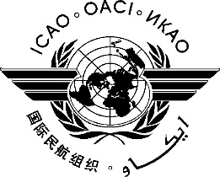 | International Civil Aviation Organization  WORKING PAPER
  FSMP-WG3/WP-13
  2016-08-29
FREQUENCY SPECTRUM MANGEMENT PANEL (FSMP)

Third Working Group meeting

Montreal, Canada, 6 to 14 September 2016

Agenda Item 8 | 5 GHz Band Planning

RTCA MOPS for Unmanned Aircraft Systems (UAS) Control and Non-Payload Communications (CNPC)

Don Nellis

SUMMARY
This briefing provides information on the work being performed in RTCA regarding terrestrial systems for unmanned aircraft control links.

ACTION
The meeting is invited to note the information and provide comment as necessary.

