FREQUENCY SPECTRUM MANAGEMENT PANEL (FSMP)

EIGHTEENTH working Group Meeting

Meeting, 6 – 16 February 2024

Information Note

Measures to address potential blocking of MES operating in frequency bands 1 525-1 559 MHz on the ground at airports from terrestrial IMT systems planned in the frequency band below 1518 MHz

1. Introduction
This Information Note is intended to provide guidance to National Civil Aviation Authorities to assist them in responding to the requests from their national radio regulators in assessing the technical measures to facilitate the deployment of terrestrial IMT systems in the frequency band below 1 518 MHz in a manner that is compatible with the operation of aeronautical L-band mobile earth-station receivers (‘aeronautical L-band MES’).

The aeronautical L-band MES that are potentially affected by interference include those that support AMS(R)S communications within the frequency bands 1 525-1 544 and 1545-1 559 MHz (which encompasses the frequency range 1 545-1 555 MHz worldwide and additionally 1 555-1 559 MHz in the US) where AMS(R)S systems have priority access and immediate availability over other mobile-satellite communications operating within a network.

Studies have shown that the potential blocking of aeronautical L-band MES could occur when the MES is on the ground. Such interference does not pose a direct threat to safety of flight. Indeed, the MES usage on the ground is to verify the correct functioning of the satcom communication link as part of the operational procedures for aircraft prior to departure from airports or during device maintenance. Studies also show the potential for interference is negligible when aircraft are in-flight. Since the impact of interference on MES may result in the disruption of departures, delays and cost overruns for airlines, there is a need for National Civil Aviation Authorities to identify which area(s) of airports are used for the operation of aeronautical L-band MES for pre-flight system checks to ensure that the aeronautical MES will be operational during flight, and to identify the area(s) of airports that are used for device maintenance. There may also be a need to identify other areas of airports where aeronautical L-band MES may operate, such as when the aircraft is on the apron, on runways or at taxi areas.

L-band aeronautical MES are deployed on aircraft in use in most countries. The frequency band 1 492-1 518 MHz is part of a wider frequency band (1 427-1 518 MHz) identified for IMT systems in the Radio Regulations. Some administrations are considering making available all, or a part, of this wider frequency band for terrestrial IMT systems (including use for 4G and 5G terrestrial mobile systems). The use of the frequency band up to 1 518 MHz by IMT has a potential to cause “blocking” of aeronautical L-band MES receivers operating within the frequency range 1 525-1 559 MHz. Consequently, compatibility measures would be necessary to ensure the operation of L-band aeronautical MES at airports where needed.

A common approach to avoid blocking of aeronautical L-band MES is by the application of power flux density (PFD) limits around these specific areas or locations (see CEPT and ITU-R deliverables below). This information note provides guidance on how to identify these specific areas or locations generally inside airport and maintenance areas which would require the application of a PFD limit to be fulfilled by mobile operators with authorisation to operate IMT within the frequency band 1 492-1 518 MHz.

This note also provides information on the steps taken to encourage the aeronautical industry to improve the resilience of aeronautical L-band MES receivers to tolerate a -30dBm blocking level for MES operating above 1520 MHz. In Europe, this new blocking level has been taken as the reference to determine the protection measures for resilient aeronautical L-band MES resulting in less stringent PFD limits on IMT transmissions around airports. See section 4 for more details.

Relevant CEPT and ITU deliverables

Several technical studies have been conducted both within the CEPT and the ITU-R to examine the compatibility between MSS operating in frequency bands above 1 518 MHz and IMT operating in the frequency bands below 1 518 MHz.

The results of the CEPT studies are available in ECC Report 299 on: “Measures to address potential blocking of MES operating in bands adjacent to 1518 MHz (including 1525-1559 MHz) at sea ports and airports” and ECC Report 263 on: “Adjacent band compatibility studies between IMT operating in the frequency band 1492-1518 MHz and the MSS operating in the frequency band 1518-1525 MHz”. The analysis conducted by the CEPT on this issue (contained in ECC Report 299) also addresses the timing of the provisions on compatibility.

ITU-R published in the end of 2023 Report ITU-R M.2529-0 on “Adjacent band compatibility studies of IMT systems in the mobile service in the band 1 492-1 518 MHz with respect to systems in the mobile-satellite service in the frequency band 1 518-1 525 MHz” and Recommendation ITU-R M.2159-0 on “Technical and regulatory measures to provide compatibility between IMT and MSS, with respect to MSS operations in the frequency band 1 518-1 525 MHz for administrations wishing to implement IMT in the frequency band 1 492-1 518 MHz”. It is noted that “While the Recommendation is based on studies requested by Resolution 223 (Rev.WRC-19) relating to coexistence between IMT in the band 1 492-1 518 MHz and MSS in the band 1 518-1 525 MHz, the technical requirements and regulatory measures recommended are also effective and may be applicable to MESs operating in the band 1 525-1 559 MHz.”.
The Recommendation also recommends “that administrations should consider further regulatory measures for IMT BSs, to provide for compatibility with ship earth stations and aircraft earth stations in selected areas, as described in Annex 3;” extracted from the recommend 3.

2. Identification of airports requiring the application of protection measures

There is a need for National Civil Aviation Authorities to identify on its territory the airports requiring the application of PFD limits, taking into account the requirements for functional tests to be performed by aeronautical L-band MES on the ground before flight. Those operational applications may include ADS-C EPP for Continuous Climb/Continuous Descent operations; CPDLC; AOC ACARS; D-ATIS; IP for AISD and ACD applications; and crew satcom voice communication. Some of these AMS(R)S applications may be used when the aircraft is on the ground.

Additionally, there are existing operational requirements for flights between Europe and North America, and specific requirements that are being developed as part of the SESAR Iris project. These are described below.

2.1 Flights between Europe and North America

In the North Atlantic region (used for flights from Europe to/from North America), aircraft are required by ICAO from 29th of March 2018 to have FANS 1/A capability if they wish to use the preferred aircraft tracks and altitudes between 35,000ft and 39,000ft (see ICAO EUR NAT Doc 007). From 2020, this satcom mandate has been expanded to cover all airspace above 29,000ft in the North Atlantic Region. According to these procedures, “If a flight experiences an equipment failure prior to departure which renders the aircraft non-DLM (Data Link Mandate) compliant, the flight should re-submit a flight plan so as to remain clear of the NAT DLM airspace". Aircraft without FANS 1/A capability would have to use tracks and altitudes, which might require additional fuel burn.

2.2 The Iris programme within the European Union

The Iris programme was initiated by the European Space Agency (ESA) with the aim of making aviation safer by developing a new satellite-based air-ground communication system for air traffic management (ATM).

Iris is a part of a much broader push to modernise how air traffic control is managed in collaboration with the Single European Sky ATM Research (SESAR) joint undertaking launched in 2006 by EUROCONTROL and the European Union. Iris (as a part of the SESAR project) is designed to improve air traffic management over continental and transoceanic airspace and, in its context, new terminals for aircraft should meet the new standards and new blocking requirements. It is noted that Iris MES terminals would require protection from the Phase 2 PFD limits.

Iris service deployment has comprised of upgrades to ground infrastructure serving the Inmarsat-4 series, Alphasat and Inmarsat-6F1 satellites, and requires the installation of Iris capable satcom equipment on commercial flights operating within the European airspace and supporting air traffic control communication. The first Iris commercial flights started in January 2024. The potential impact of interference on aircraft using MSS services could lead to disruption of departure/dispatch procedures and normal FANS operational procedures at the airport.

3. Area within the airport for the operation of aeronautical L-band MES or pre-flight checks

Measures could be implemented to address potential blocking of L-band aeronautical MES receivers in specific areas or locations.

One of the global recommended approaches, as implemented in Europe, to avoid blocking of aeronautical L-band MES is through the application of PFD limits around airports. The geographic areas to be protected should be defined on an airport-by-airport basis, taking into account the operational requirements described in the preceding section or the pre-flight checks areas. An example of an airport protection area for the Brussels airport is shown in Figure 1, that includes runways, taxiways, aprons and stands. Another example for the Charles de Gaulle airport protection area is shown in Figure 2, which includes only the areas where pre-flight tests are conducted and maintenance areas.

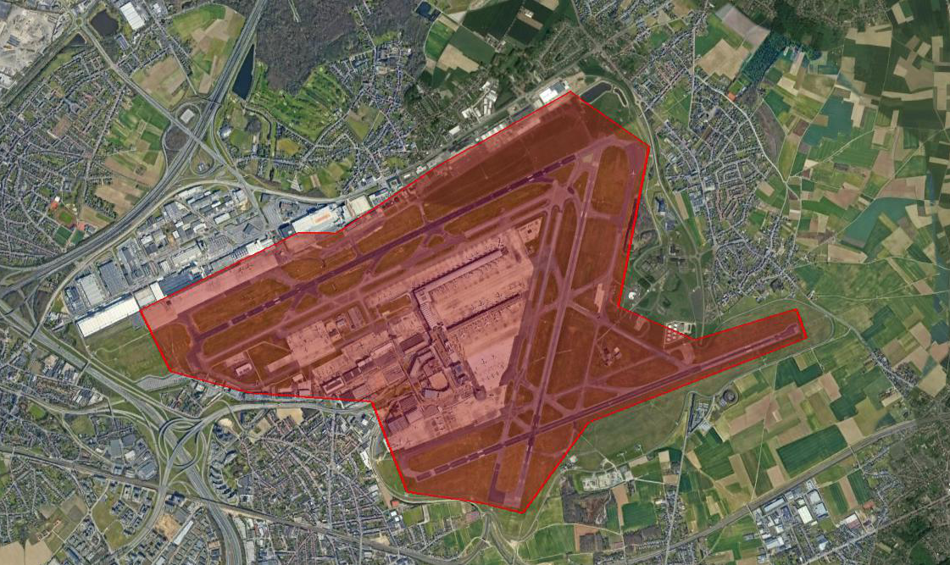
Figures 1. Example of defined airport protected area considering operation of aeronautical L-band MES

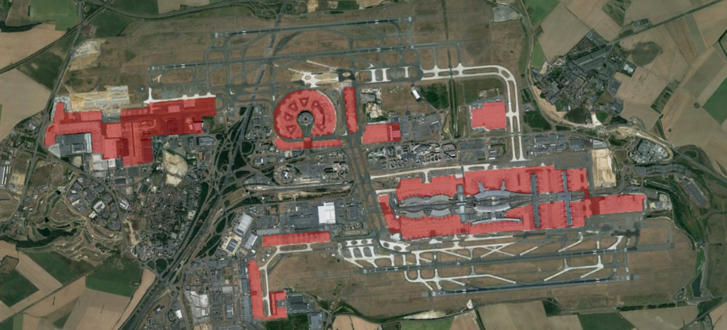
Figure 2. Examples of defined airport considering pre-flight checks and maintenance areas of aeronautical L-band MES

The PFD produced by IMT base stations must be kept below the maximum PFD limit value at the boundary of the area and at any point inside the area (for example, the area shaded red in Figures 1 and 2).

It is expected that the national spectrum licensing authorities ensure that the airport protected areas and associated maximum PFD limits are defined and included in the IMT operator’s licence conditions. The concerned airports and areas should be identified in consultation with the relevant national aviation safety representatives and/or with the airport operator. The information on areas where the limit applies has to be available when national spectrum licensing authorities start the IMT authorisation process.

The identification of the appropriate level of the PFD limit as well as the compliance of the licensed IMT operator to fulfil its obligations to respect the required level of PFD in the identified areas of airport is the responsibility of national spectrum regulator.

4. Explanation on a need for a two-phased approach to the application of PFD limits

Given the time required to set and agree equipment standards, build and deploy new terminals in the aeronautical markets, it is expected that measures, determined by administrations in order to protect aeronautical MES terminals at airports, could be implemented in a two-phased approach. The initial measures, Phase 1, are to protect currently operating terminals which are sensitive to blocking. Phase 1 would be time limited and to be followed by Phase 2, which would be without time limit. Phase 2 would be based on future implementation of terminals having a blocking resilience of -30 dBm at the input of the MES receiver. Phase 2 provides a permanent PFD limit for IMT coverage in the same locations as Phase 1. The time limitation of Phase 1 should be taken into account by aeronautical community.

PFD limits are already implemented by some national spectrum regulators. Two example sets of PFD limits are provided in ECC Report 299. Similar PFD limits with 2 options are contained in the Annex 3 of the Recommendation ITU-R M.2159-0.

In the case of Europe:
Mobile communications Supplemental Downlink (SDL) below 1 518 MHz are authorised within the EU with harmonized technical conditions (see Commission Implementing Decision (EU) 2015/750, modified by Commission Implementing Decision (EU) 2018/661 of 26 April 2018). The same harmonised technical conditions has been implemented within CEPT (see ECC DEC/(13)03 (1452-1492 MHz) and ECC/DEC/(17)06 (1427-1452 MHz and 1492-1518 MHz). CEPT also developed guidance to administrations in the ECC Report 299 to address potential blocking of L-band aeronautical MES receivers.

In ECC Report 263, CEPT concluded that an acceptable minimum in-band blocking characteristic for aeronautical mobile earth station receivers from a 5 MHz broadband signal interferer (LTE) operating below 1518 MHz shall not exceed −30 dBm, when the MES operates above 1520 MHz and noting that the IMT block ends at 1517 MHz. This limit is assumed to be supported by MES receivers to minimise any potential blocking situation and is the reference for the PFD limit with resilient MES receivers in CEPT countries (see liaison statement from ECC PT1 to ICAO FSMP-WG9-WP05 introduced in August 2019). The Annex 2 of the Recommendation ITU-R M.2159-0 provides the receiver blocking levels in MES equipment.
In ECC Report 299, CEPT concluded that an acceptable minimum in-band blocking characteristic for aeronautical mobile earth station receivers from a 5 MHz broadband signal interferer (LTE) operating below 1517 MHz shall be −30 dBm for MES operating above 1520 MHz. This limit is assumed to be supported by future MES receivers to minimise any potential blocking situation to be considered for the Phase 2 PFD limits for resilient MES receivers in CEPT countries. Also in January 2017, CEPT invited standardization organizations in Europe to update the MES standards accordingly to reach -30 dBm blocking level. It is noted that some national spectrum administrations in Europe have indicated their intent to apply Phase 2 PFD limit for future deployment of IMT base stations, either bypassing Phase 1 or with a very short duration for Phase 1. This should be taken into consideration by the aeronautical community.

5. Required actions toward a fully updated fleet with resilient aeronautical MES

Currently deployed MES terminals are not all able to meet the level of receiver blocking but the resilient MES terminals are expected to be designed to meet the relevant standards applicable for aeronautical terminals.

This spectrum regulation based on the availability of resilient aeronautical system would benefit from an international roadmap in order for aeronautical industries to carry out all the necessary actions to improve the blocking resilience of MES receivers and thereby reduce the duration of phase 1.

The identified necessary actions to proceed with resilient aeronautical L-band MES receivers, are summarised as follows:

- Updates of the applicable satcom performance standards procedures, regulations and guidelines which govern air transport in accordance with the recommended blocking level;
- MES receivers complying to the update standards must be developed, tested and certified as safe for use by a competent authority and non-regression demonstration shall also be performed.
- Once equipment has been validated and certified for all types of aircraft in all possible configurations, it can be offered to customers who requested it for new aircraft as line-fit delivery, or mandated for installation and made available to the aftermarket; and
- For retrofit installations, test and certification for the modification needs to be validated, and documentation needs to be elaborated. Possible supplementary type certificate (STC)may be requested and in that situation, they must be obtained from EASA/FAA for each type and variant of aircraft.
Further information on the processes and the current status is provided in Annex 3.

6. IMT unwanted emission limits

The Annex 1 of the Recommendation ITU-R M.2159-0 contains various options that administrations should consider for their application of emission levels from IMT equipment operating in the band 1 492-1 518 MHz (see Annex 2). Among the various options in the ITU-R Recommendation M.2159-0, one option is corresponding to the mandatory regulation in the European Union for the unwanted emissions from IMT base stations which is contained in EC Decision (EU)2018/661(see Annex 3).

7. IMT channel arrangements at airports
Recommendation ITU-R M.1036-7 contains several different channel arrangements for IMT operation in the 1 427-1 518 MHz frequency band. Among these IMT channel arrangements, it is assumed in Recommendation ITU-R M.2159-0 and in ECC Report 299 that only IMT BS are able to transmit in the upper edge of the frequency band (e.g. supplementary downlink (SDL) or frequency division duplex (FDD)). This avoids the need to consider the potential interference from IMT user terminals (e.g. time division duplex (TDD)), which can't be prevented from transmitting close to the aircraft.

Annex 1. Examples of PFD limits based on blocking measurements from CEPT ECC Report 299 and Recommendation ITU-R M.2159-0

Alternative approach 1: See CEPT ECC Report 299 annex 1 A2.1 tables 10 and 11 and Option B of Annex 3 of the Recommendation ITU-R M.2159-0

Pfd limits for IMT BSs transmitting a single or multiple channels
Phase | Phase 1 |  |  | Phase 2
 | pfd limits for BS emissions in the band 1 492-1 502 MHz (dBW/m²) | pfd limit for BS emissions in the band 1 502-1 512 MHz (dBW/m²) | pfd limit for BS emissions in the band 1 512-1 517 MHz (dBW/m²) | pfd limit for BS emissions in the band 1 492-1 502 MHz (dBW/m²) | pfd limit for BS emissions in the band 1 502-1 512 MHz (dBW/m²) | pfd limit for BS emissions in the band 1 512-1 517 MHz (dBW/m²)
Airports | −42.9 | −42.9 | −57.9 | No limit required provided that the BS e.i.r.p. does not exceed 68 dBm | −27.9 | −37.9

Alternative approach 2: See Option A of Annex 3 of the Recommendation ITU-R M.2159-0

Table A3-1
Pfd limits for IMT BS transmitting a single channel
Phase |  | Phase 1 |  |  | Phase 2
 | MES terminal antenna gain (dBi) | pfd limit  for BS emissions in the band 1 492-1 502 MHz (dBW/m²) | pfd limit  for BS emissions in the band 1 502-1 512 MHz (dBW/m²) | pfd limit  for BS emissions in the band 1 512-1 517 MHz (dBW/m²) | pfd limit  for BS emissions in the band 1 492-1 502 MHz (dBW/m²) | pfd limit  for BS emissions in the band 1 502-1 512 MHz (dBW/m²) | pfd limit  for BS emissions in the band 1 512-1 517 MHz (dBW/m²)
Airports | 3 | −28.9 | −42.9 | −58.2 | No limit required provided that the BS e.i.r.p. does not exceed 68 dBm | −27.9 | −37.9
Airports | 3-17  (see Note 1) | −28.9 to −42.9 | −42.9 to −56.9 | −58.2 to −72.2 | No limit required provided that the BS e.i.r.p. does not exceed 68 dBm | −27.9 to −41.9 | −37.9 to −51.9
Note 1: The pfd values based on 3 dBi MES antenna gain apply in most situations, but there are locations in the world where the antenna gain towards the horizon can exceed 3 dBi (up to 19 dBi or 17 dBi). This is where there is a low elevation angle for the MES and where an IMT BS could be deployed in the direction of the MSS satellite as seen from the MES. For these cases, the actual angles to the satellite and the IMT deployment should be taken into consideration and the pfd adjusted to a value within the ranges shown.

Table A3-2
Pfd limits for IMT BS transmitting multiple channels
Phase | MES terminal antenna gain (dBi) | Phase 1 |  | Phase 2
 | MES terminal antenna gain (dBi) | pfd limit for BS emissions in the band 1 492-1 512 MHz (dBW/m²) | pfd limit for BS emissions in the band 1 512-1 517 MHz (dBW/m²) | pfd limit for BS emissions in the band 1 492-1 512 MHz (dBW/m²) | pfd limit for BS emissions in the band 1 512-1 517 MHz (dBW/m²)
Airports | 3 | −53.5 | −63.4 | −30.9 | −40.9
Airports | 3-17  (see Note 1) | −53.5 to −67.5 | −63.4 to −77.4 | −30.9 to −44.9 | −40.9 to −54.9
Note 1: The pfd values based on 3 dBi MES antenna gain apply in most situations, but there are locations in the world where the antenna gain towards the horizon can exceed 3 dBi (up to 19 dBi or 17 dBi). This is where there is a low elevation angle for the MES and where an IMT BS could be deployed in the direction of the MSS satellite as seen from the MES. For these cases, the actual angles to the satellite and the IMT deployment should be taken into consideration and the pfd adjusted to a value within the ranges shown.

– For Phase 1, the pfd values are based on the blocking measurements of the currently operating terminals performed by some manufacturers. Those measurements determined that, with respect to IMT emissions in the band 1 512-1 517 MHz, blocking occurs at a level of −76 dBm for currently operating maritime terminals and −50.3 dBm for currently operating aeronautical terminals. For IMT emissions in the band 1 502-1 512 MHz, blocking occurs at levels of −68 dBm and −35 dBm for maritime and aeronautical terminals respectively. For IMT emissions in the band 1 492-1 502 MHz, blocking occurs at levels of −53 dBm and −21 dBm for maritime and aeronautical terminals respectively.
– The pfd limits applied during Phase 2 are based on assumed blocking performance for next generation MESs. For Phase 2, the pfd limits in Table A3-1 are based on −20 dBm and −30 dBm blocking levels resulting from the band 1 502-1 512 MHz and the band 1 512-1 517 MHz respectively; and the pfd values in Table A3-2 are based on −23 dBm and −33 dBm blocking levels resulting from the band 1 492-1 512 MHz and the band 1 512-1 517 MHz respectively.

Annex 2: Options of unwanted emissions for IMT unwanted emissions from Recommendation ITU-R M.2159-0

Options for IMT base stations unwanted emission limits
Option | MSS operations in the band 1 518-1 525 MHz (Y/N) | Maximum unwanted emissions (e.i.r.p.)  (Δf is the frequency relative to and above 1 518 MHz)
1 ⁽¹⁾ | Y | −0.8 dBm/MHz (0 MHz ≤ Δf ≤ 2 MHz),  −30 dBm/MHz (2 MHz < Δf ≤ 41 MHz)
2 | N | No additional requirement (0 ≤ Δf ≤ 7 MHz),  −30 dBm/MHz (7 MHz < Δf ≤ 41 MHz)
3 | Y | −41 dBm/MHz (0 MHz < Δf ≤ 41 MHz)
4 | N | No additional requirement (0 ≤ Δf ≤ 7 MHz),  −41 dBm/MHz (7 MHz < Δf ≤ 41 MHz)
5 | Y | −30 dBm/MHz (0 MHz ≤ Δf ≤ 2 MHz),  −41 dBm/MHz (2 MHz < Δf ≤ 7 MHz),  −52 dBm/MHz (7 MHz < Δf ≤ 41 MHz)
6 | N | No additional requirement (0 ≤ Δf ≤ 7 MHz),  −52 dBm/MHz (7 MHz < Δf ≤ 41 MHz)
⁽¹⁾ This option assumes an upper edge of the IMT frequency block at 1 517 MHz with a maximum of 58 dBm/5 MHz in-band e.i.r.p. for the band 1 512-1 517 MHz. The result of applying the unwanted emission level of −0.8 dBm/MHz is that in 1 518-1 520 MHz, MSS will not be able to operate in this portion of the band in the same geographical area as IMT.

Options for IMT user equipment unwanted emission limits
Option | Application | Maximum unwanted emissions  (Δf is the frequency relative to and greater than 1 518 MHz)
1 ^{(1), (2)} | IMT TDD | −70 dBm/MHz (0 MHz < Δf ≤ 41 MHz)
2 ⁽³⁾ | IMT TDD | −20 dBm/MHz (2 MHz < Δf ≤ 41 MHz)
3 | IMT SDL or FDD | None, noting that there are no UE transmitting in the band 1 492-1 518 MHz
⁽¹⁾ This option is to be applied with an additional regulatory requirement that the UE should not be used within 10 m of a ship earth station.
⁽²⁾ The option employing the lower unwanted emission limit for IMT user equipment would lower the risk of harmful interference to MSS operations in the frequency band above 1 518 MHz. However, complying with the lower unwanted emission limit would make it more difficult to implement IMT user equipment.
⁽³⁾ Employing the higher unwanted emission limits for IMT user equipment would increase the risk of harmful interference to MSS operations in the frequency band above 1 518 MHz, while complying with the higher unwanted emission limit is easier to implement in IMT user equipment. Therefore, this option would make it more difficult to operate MSS systems. In addition, this option does not provide any unwanted emission level for MSS band in the range of 1 518-1 520 MHz.

Annex 3: Extract of the unwanted emissions provisions on IMT from EC Decision (EU) 2018/661

Within EU member States the following requirements apply to all licensees’ mobile operators (see table 4 DECISION (EU) 2018/661)

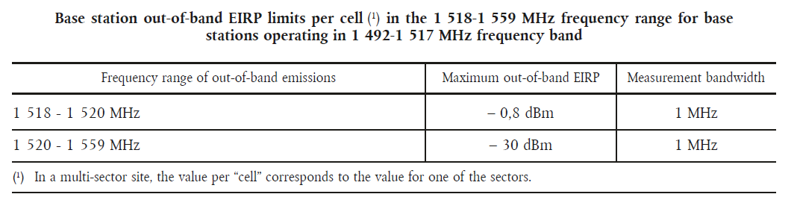

These requirements are intended to provide appropriate protection of mobile satellite services operating in the 1 518-1 559 MHz frequency band, in particular at sea ports, airports and search and rescue ground stations of the mobile satellite service, from mobile systems (IMT) operating in the 1 492-1 517 MHz frequency band, including when only a portion of this frequency band is assigned for IMT. Further national measures may be needed to improve protection of mobile satellite services in the band 1 518-1 559 MHz (see sections on pf limits)

The maximum OOB emissions limit, when combined with the geographical separation expected between the aircraft and base stations, would ensure the MES receiver degradation due to IMT unwanted emissions is kept to acceptable levels.

Additionally, the European Union provided a framework requiring a maximum e.i.r.p for the frequency block 1512-1517 MHz (see table below):
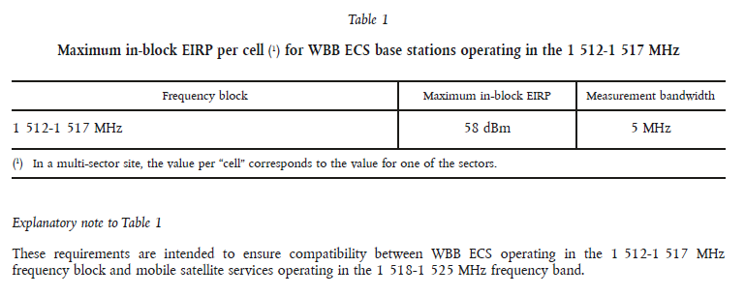

Annex 4: Process example for an aviation information notice

This annex contains an example for inclusion of the following elements in the scope of an aviation notice to inform civil aviation entities about the risk of receiver blocking of MES:
- Description of the issue;
- Reference to the current report;
- Information needed from the spectrum regulator on the strategy of introduction of IMT in the L band;
- Information gathered on the list of aircraft equipped with satcom and the associated blocking level;
- Information on the Recommended blocking level;
- Information on the airports using L-Band satcom;
- Information on the relevant areas of these airports and maintenance sites;
- Definition of the level of blocking used as a reference to the PFD limit required for each airport and identification of areas where the limit(s) apply;
- Sharing of relevant information (issue, protected area(s), risk in case of non-compliance with the blocking level in respect with the PFD limit for the affected areas) with airlines and aircraft operators;

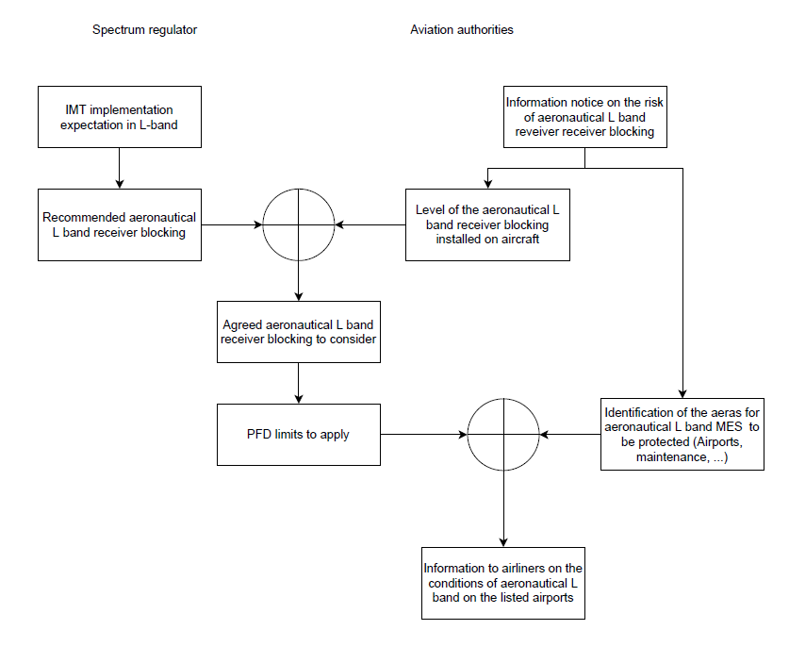
Figure: simplified process for aeronautical L band use
Annex 5: Updated aeronautical L-band MES standards and equipment

This Annex describes the elements related to the deployment of next generation aeronautical L-band MESs, to meet the new receiver blocking requirements.

A5.1 Revision of standards for aeronautical L-band MES receiver operating 1525-1559 MHz requiring -30 dBm blocking compliance

It is important that resilient equipment, based on updated standards which take into account the new required blocking performance, is available on the market. Aeronautical Standards which include performance requirements in relation with L-band terminal satcom are identified below:

Standard | Summary | Elements related to IMT interference
ARINC 741P1-15  “Aviation Satellite Communication System, Part 1, Aircraft Installation Provisions” | This ARINC Standard defines the installation characteristics of first generation L-band satellite communication systems. It provides the traditional form, fit, function, and interfaces for the installation of satcom equipment for use in all types of aircraft. Description of avionics equipment (e.g., Satellite Data Unit (SDU), Antennas, etc.) are included. | Supplement 15 adds references to new Diplexer/Low Noise Amplifiers (DLNAs) defined in Supplement 8 to ARINC Characteristic 781: Mark 3 Aviation Satellite Communication Systems. The five new DLNAs are intended to protect Inmarsat Classic Aero and SwiftBroadband (SBB) satcom equipment from ground-based cellular sources, such as cellular Long Term Evolution (LTE) and Ancillary Terrestrial Component (ATCt). The DLNAs are categorized by desired features and service (e.g., new DLNA versus drop-in replacement, LTE and/or ATCt protection, Classic Aero and/or SBB service).
ARINC 761-6  “Second Generation Aviation Satellite Communication Systems, Aircraft Installation Provisions” | This ARINC Standard defines the installation characteristics of second generation L-band satellite communication systems. It provides the traditional form, fit, function, and interfaces for the installation of satcom equipment for use in all types of aircraft. Description of avionics equipment (e.g., Satellite Data Unit (SDU), Antennas, etc.) are included | Supplement 6 adds references to new Diplexer/Low Noise Amplifiers (DLNAs) defined in Supplement 8 to ARINC Characteristic 781: Mark 3 Aviation Satellite Communication Systems. The five new DLNAs are intended to protect Inmarsat Classic Aero and SwiftBroadband (SBB) satcom equipment from ground-based cellular sources, such as cellular Long Term Evolution (LTE) and Ancillary Terrestrial Component (ATCt). The DLNAs are categorized by desired features and service (e.g., new DLNA versus drop-in replacement, LTE and/or ATCt protection, Classic Aero and/or SBB service).
ARINC 781-8  “Mark 3 Aviation Satellite Communication Systems” | This document sets forth the desired characteristics of an aviation satellite communication (satcom) system intended for installation in all types of commercial transport and business aircraft. The intent of this document is to provide general and specific guidance on the form factor and pin assignments for the installation of the avionics primarily for airline use. It also describes the desired operational capability of the equipment to provide data and voice communications, as well as additional standards necessary to ensure interchangeability. This Characteristic specifies equipment using Inmarsat satellites operating in L-band. Ku-band and Ka-band equipment is specified in ARINC Characteristic 791. | Supplement 8 adds new Diplexer Low Noise Amplifiers (DLNA) to protect Inmarsat’s Classic Aero and SwiftBroadband (SBB) satcom equipment from possible ground-based LTE and ATCt (Ligado) interference.
RTCA DO-210  “Minimum Operational Performance Standards For Geosynchronous Orbit Aeronautical Mobile Satellite Services (AMSS) Avionics” | This document contains minimum operational performance standards (MOPS) for  Aeronautical Mobile Satellite Services (AMSS) operating in the frequency bands 1.5 and  1.6 GHz. These standards specify system characteristics that should be useful to  designers, manufacturers, installers and users of the AMSS system and equipment. | Change 5 to DO-210D (26 March 2020) introduces requirements for blocking immunity from International Mobile Telecommunication (IMT) base stations in the band 1 492 to 1 517 MHz and 1526 to 1 536 MHz.
RTCA - DO262F  “Minimum Operational Performance Standards for Avionics Supporting Next Generation Satellite Systems (NGSS)” | This document contains minimum operational performance standards (MOPS) for avionics that provide Aeronautical Mobile Satellite (R) Services (AMS(R)S) by means of satellite communications technologies scheduled to become operational in context of the global and regional ATM and CNS modernization (e.g. ICAO/Global Air Navigation Plan, Europe/SESAR, US/NextGen). Each of these technologies is individually and collectively referred to as a "Next Generation Satellite System" (NGSS), and the NGSS nomenclature will be used throughout this document. This document does not apply to avionics that provide AMS(R)S in accordance with the Standards and Recommended Practices defined in ICAO Annex 10, Part I, Volume III, Chapter 4 (Chapter 4 SARPS). Such equipment is specified in the current version of RTCA DO-210D. | Version E dated 26 March 2020, includes the -30 dBm receiver blocking requirement
EUROCAE ED-243  “MOPS for Avionics Supporting Next Generation Satellite Systems (NGSS)” | This document contains minimum operational performance standards (MOPS) for avionics that provide Aeronautical Mobile Satellite (R) Services (AMS(R)S) by means of satellite communications technologies scheduled to become operational in context of the global and regional ATM and CNS modernization (e.g. ICAO/Global Air Navigation Plan, Europe/SESAR, US/NextGen). | ED-243c dated 01 June 2021, includes the -30 dBm receiver blocking requirement
RTCA DO-343  “Minimum Aviation System Performance Standard for AMS(R)S Data and Voice Communications Supporting Required Communications Performance (RCP) and Required Surveillance Performance (RSP)” | This document contains Minimum Aviation System Performance Standards (MASPS) for Aeronautical Mobile Satellite (Route) Services (AMS(R)S) that provide safety communications to aircraft in airspace where 1) procedural separation is applied or 2) ATS surveillance services are provided. | This document is related to system performance requirements, and hence does not address equipment RF performance
EUROCAE ED-242C  “MASPS FOR AMS(R)S Data and Voice Communications supporting RCP and RSP” | This document contains Minimum Aviation System Performance Standards (MASPS) for Aeronautical Mobile Satellite (Route) Services (AMS(R)S) that provide safety communications to aircraft in airspace where 1) procedural separation is applied or 2) ATS surveillance services are provided. | This document is related to system performance requirements, and hence does not address equipment RF performance

The necessary revision of these standards, taking into account requirements for aeronautical L-band MES, is already achieved.

A5.2 Certified aeronautical MES receiver operating 1525-1559 MHz compliant with receiver blocking requirements of -30dBm

Currently, as of begining-2024, some aeronautical L-band MES satcom manufacturers are in the process of designing MESs that comply with the revised blocking requirement. A Type H DLNA for use with classic aero systems that is compliant with the new receiver blocking requirement of -30 dBm from mobile-base station transmissions at 1 512-1 517 MHz has received a Technical Standards Order (TSO) from the FAA. A Type J DLNA for use on SBB and Classic Aero terminals has also been granted a TSO and a small number of orders have been received. An airframer Light Cockpit Satcom (LCS) programme for SBB has been certified to the revised blocking requirement and is in service on a handful of aircraft.

A5.3 Production of new aircraft for line-fit delivery

This phase requires time for adaptation of the manufacturing production and also manufacturing processes in place. This phase can only start when products are available and aeronautical certification has been initiated.

A5.4 Retrofit process

If the modification is not performed by the airframer which also includes validation and certification of the modification, a supplementary type certificate (STC) may be required for each type and variant of aircraft. This is in addition to the type certificate for the satcom terminal itself. To inform airlines on the availability of the modification, service bulletins have to be issued.

The service bulletin is a communication toward airlines to inform them on the availability of some of the system modifications including the relevant information to explain the purpose of the upgrade. Depending on the rational of the modification and, especially, if the modification is required by the regulation, the airline could choose whether to proceed with the retrofit or not.

The position of airlines and operators has been to accommodate updates to aircraft systems as part of the natural lifecycle of airframes and avionics (generally between 20-30 years). On the other perspective, the position of some spectrum authorities on the recommended minimum timing for the replacement of satcom equipment for the transition from Phase 1 to Phase 2 PFD limits, in order to facilitate satellite operators preparing retrofit operations for terminals/users requiring protection, is based on inter-alia on Inmarsat's public service obligations for the closure of obsolete services, which is typically a minimum period of 5-7 years. In that perspective, administrations may need to decide on the appropriate timelines and protection measures.

For today, notwithstanding with the current situation, one possible approach to accelerate the process to move ahead is to take advantage of new ATM projects which could encourage the update of satcom terminal usage (e.g Iris project).

Automatic dependent surveillance — contract Extended Projected Profile
Controller Pilot Data Link Communications
Airline Operational Control - Aircraft Communications, Addressing and Reporting System
Digital-Automatic Terminal Information Service
Internet Protocol – Airline Information Services Domain and Aircraft Control Domain

