FREQUENCY SPECTRUM MANAGEMENT PANEL (FSMP)

Ninth Working Group meeting

Montreal, Canada, 22-30 August 2019

Agenda Item 7: New Provisions to Support Aeronautical Radiocommunications
d) Wideband HF communications

SYSTEM DESCRIPTION AND PLANNED TECHNICAL CHARACTERISTICS FOR MODERNIZED HF AERONAUTICAL COMMUNICATIONS SYSTEM

(Presented by Sai Kalyanaraman, Collins Aerospace)

SUMMARY
Proposal to modernize HF aeronautical communications via application of standard waveforms and channel bandwidths proven in State aircraft applications to significantly improve HF data rate, voice clarity, and link availability. This paper provides information to the Panel regarding approach to develop the system and how it could be used within industry.

- INTRODUCTION

  - Historically, HF Radio communications have been the primary long range communication system for safe, efficient air travel over long range routes beyond the range of ground-based VHF radios. However, modern technology now provides alternate solutions, namely aeronautical mobile (R) service (AMS(R)S) satellite communications (SATCOM) which are now authorized by regulatory authorities for use in long range aeronautical communications.

  - Terrestrial and space-based systems work well together in a complementary and synergistic fashion to offer better performance, reliability and availability than either system alone. Having both space-based and terrestrial means of long-range communication, termed “link diversity,” mitigates single point of failure concerns associated with vulnerabilities which differ for each system (e.g. solar events, rain fade, jamming, hardware failures, etc.).

  - A next generation wideband HF radio system is currently under development that will address the limitations of today’s HF radio communications systems, namely intelligibility of analog voice communications and slow throughput of data over the existing High Frequency DataLink (HFDL) system. In order to accomplish these performance improvements, the radio regulations governing the allocation and use of HF aeronautical spectrum need to be updated.

  - At the Eighth Working Group Meeting of the FSMP, a proposal to support a future agenda item to modernize the HF AM(R)S allocations in the ITU-R Radio Regulations Appendix 27 was approved for inclusion in the ICAO WRC-19 position. The objective of these rewrites would be to allow for use of multiple 3 kHz channel assignments as a single, wideband channel, and to allow for advanced modulations that would provide greater throughput of information and maintain a robust, link-diverse communications architecture.

- DISCUSSION
System Operation:
  - The system is intended to work as seamlessly as possible and maintain backward compatibility with analog voice and legacy HFDL. Software-Defined Radio (SDR) technology will be utilized to improve the airborne HF equipment. The HF transceiver and coupler will be combined into single remote-mounted Line-Replaceable Unit (LRU). This will result in significant avionics size, weight, power, and cost reductions, with corresponding reductions in fuel consumption and carbon emissions. SDR technology will also enable multi-channel receive capability, allowing a single airborne LRU to provide simultaneous, robust voice and data link functionality, along with continuous background signal propagation soundings. The system will provide for “ruthless pre-emption” that will ensure priority of voice transmissions over data. The new airborne equipment will continue to support legacy HF voice and HFDL functionality.

  - The System will utilize separate uplink and downlink frequencies for communication exchanges between the ground and air, rather than transmitting and receiving on the same frequency as is done with the legacy HF. Thus, all air/ground traffic on a given frequency will be one way: either uplinks or downlinks. This Frequency Division Duplex (FDD) system is anticipated to be asymmetric with a large uplink channel broadcasting to many aircraft over a high power transmission, while the downlink channels will be more numerous but narrow in bandwidth and lower in power transmission.

  - Each ground station will operate with this split transmit and receive site architecture (including separate antennas), enabling the ground station to transmit and receive simultaneously. Each ground station will have multiple receivers, enabling it to receive data from multiple aircraft at the same time on different HF channels. This will ensure fewer data collisions and thus less need to retransmit.

  - A Frequency Management Function will determine the best uplink transmission frequency for each ground station. Airborne radios will use an associated set of HF frequencies in the same band for downlinks. This approach is depicted in Figure 1, which shows aircraft using 3 different HF frequencies for downlink data. Available downlink frequencies will be provided by each ground station via uplink squitters. The system will control the number of simultaneous users allowed to connect to each ground station, to avoid saturation of the links.
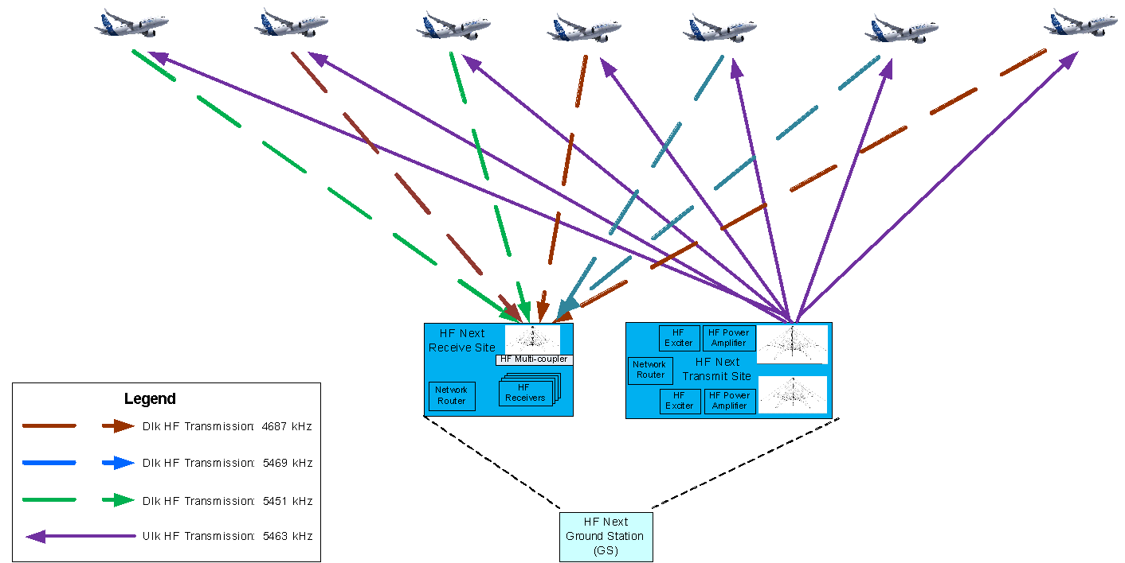
Figure 1 - Multiple Downlink Frequencies per Uplink Channel
  - In order to ease aircraft retrofit/forward fit, the airborne radio is being designed to function without requiring changes to the (Communications Management Unit) CMU, Tuning Panels, or other avionics systems, at least in the first phase. As a result, the CMU will treat the airborne radio as a legacy HFDL radio, with no changes to the existing Williamsburg Protocol interface between the avionics (the higher data rate will be transparent to the CMU). In the future, CMUs may be updated to support a new media type to allow optimized timers, more sophisticated QoS-based routing, and dedicated flight crew selections and status indications.
Aircraft Equipage
  - One avionics manufacturer has begun development of the new radio as a forward fit product line to address obsolescence in the current HF radio product line. That product line, set to enter into service in 2022, will have the size, weight, and power savings described previously and will be mounted remotely in the aircraft tail section in the equipment mount previously used by the antenna coupler. The radio will also be multi-mode, performing the functions of today’s HF radio suite – analog single sideband HF voice and HFDL – with a 61 kg savings in weight and 60% reduction in power consumption.

  - Development of the HF “advanced features” will continue until entry into service in 2024. During this timeframe the architecture will be developed, ground stations will be deployed to serve an initial system launch area, and an update to the avionics will be developed and certified. The system will then launch in a limited geographic region with a beta customer to begin operational test and evaluation. Ground stations will continue deployment and the system will achieve global coverage in approximately 4-5 years.

Spectrum Needs
  - In order to meet RCP-240 performance requirements in the interim, the new HF system will need additional HF frequency authorizations in parallel with the wideband regulatory effort. Engineering analysis shows that the advanced modulations (used in compliance with existing emission designators or under experimental license), when used on the existing 3 kHz allocations, can achieve a modest increase in performance over today’s HFDL. 6-8 kilobits per second is a reasonable expectation for this scenario. This performance would be enough to support a single digital voice calls as well as pass data to meet the RCP-240 performance standard with a very limited load on the system. This scenario would be an interim proof of concept step while pursuing approval to conduct wideband operations. Since the engineering and deployment efforts culminate in an initial operational capability in 2024, it ideally lines up with WRC-23 approval of the proposed Appendix 27 updates needed for full implementation. It is therefore essential that the needed changes are accomplished in one WRC cycle.

  - As the Radio Regulation updates are in-progress, potential areas of the spectrum that would be ideally suited for wideband operations will be identified. The strategy is to add the construct of wideband channel bonding and use of advanced modulations to the regulations in the ITU, but then address use of individual channels at the regional ICAO level. Negotiations for obtaining adjacent channels that could someday be bonded would ideally occur in regional meetings of ICAO planning groups rather than the ITU. Once Radio Regulations are updated, the initial rollout of wideband HF would likely be with a limited number of channels. Additional channels would then be added to the system over time, particularly as HF voice traffic continues to decline and HF operations around the world have a decreasing need to maintain multiple voice channels within each band. By adding channels over time, the effort to transition analogue channels to wideband data would be gradual and transparent to voice channel users. This construct would support the strategy of starting small and growing over time rather than disrupting the allocation table and introducing many wideband assignments all at once through the ITU.

Benefits to Industry:
  - HF oceanic communications can be managed as a provided service rather than a national asset, bringing economies of scale to utilization of RF spectrum. Just as ANSPs use AMS(R)S SATCOM service providers for communications within their airspace as an alternative to operating their own constellation, managing HF communications for aeronautics can be approached in the same way. HF frequencies can be consolidated and used more efficiently in groups that provide benefit to many nations, more so than they can be used individually by specific ANSPs or CSPs. Changes to the radio regulations to allow wideband use of consecutive channels will further increase the utility of HF radio in aviation.
- CONCLUSION:
  - Utilizing multiple 3 kHz HF frequency assignments and advanced modulation techniques for the purposes of fielding a wide-band HF communications system benefits industry and provides a complementary system for use in conjunction with satellite based systems to provide a long range communications solution that:

- Offers improved voice quality, higher data rates, and automated operation.
- Ensures polar coverage
- Provides link-diverse long range communication paths that can be used simultaneously
- Eliminates single point of failure in a dual L-Band solution
  - The described modernized HF terrestrial based system, working in synergy with a space-based SATCOM system, offers aeronautical communications safety services with optimal performance and availability.
- ACTION BY THE MEETING
  - The meeting is invited to:

    - Comment on the development and deployment strategy as proposed above.
— END —

