FREQUENCY SPECTRUM MANAGEMENT PANEL (FSMP)

Eighteenth Working Group Meeting

Montreal, Canada, 06 to 16 February 2024

Agenda Item 9: Any other business

IMPACT OF LEO PNT SYSTEMS ON RADIO NAVIGATION SYSTEMS USED FOR CIVIL AVIATION PURPOSE

(Presented by Guillaume Novella
Prepared by Guillaume Novella, Christophe Macabiau, Philippe Estival, Christian Fleury)

SUMMARY
To ensure the safe use of GNSS for civil aviation purpose, the worst-case interference environement of GNSS receivers and the capability of aeronautical GNSS receivers to safely operate in a reference interference environment is assessed in Annex 10 of ICAO convention as well as in RTCA DO-235 and DO-292. These RF environments are then used to formulate the requirements, as well as the corresponding testing procedures on GNSS receivers to safely operate in that reference interference environment, as for example in DO229 and ED259/DO401.
This reference interference environment takes into account the interference sources known at the date at which these standards have been developed. It is therefore important, when a new interference source appears, to verify its impact on aeronautical GNSS receivers.
This WP analyses the impact of a new interference source, L-band LEO PNT constellations, on aeronautical GNSS receivers.

Action by the meeting is in paragraph ‎3.

- INTRODUCTION
  - To ensure the safe use of GNSS for civil aviation purpose, the worst-case interference environement of GNSS receivers and the capability of aeronautical GNSS receivers to safely operate in a reference interference environment is assessed in Annex 10 of ICAO conventionas well as in RTCA DO-235 and DO-292. These RF environments are then used to formulate the requirements, as well as the corresponding testing procedures on GNSS receivers to safely operate in that reference interference environment, as for example in DO229 and ED259/DO401.
  - This reference interference environment takes into account the interference sources known at the time these standards have been developed. For the L5/E5a frequency band surrounding 1176.45 MHz, defined as at least 1176.45 +/- 12 MHz (contained in ITU ARNS band 960-1215 MHz and in ITU RNSS band 1164-1215 MHz), the reference interference environment of DO-292A is illustrated in Figure 1.
Figure 1: Reference interference environment in the L5/E5a frequency band
  - Inter/intra system RFI refers to interference caused by GNSS signals different from the signal of interest victim of that interference. The list of GNSS systems taken into account to derive the reference interference environment of DO-292A and ED-259A is given in Appendix A.
  - The idea to develop Low Earth Orbit (LEO) Positioning, Navigation and Timing (PNT) services has been growing since a few years. As a result, some administrations has submitted some filings at the ITU to launch LEO systems proposing PNT services under RNSS allocation, some of them declaring emissions within the L-band. These LEO PNT systems are not taken into account into the reference interference environment, it is therefore important to analyze the impact of this new interference source on the capacity of aeronautical GNSS receiver to meet its minimum required performance.
  - This WP focuses on the LEO PNT systems operating in the L5/E5a frequency band. The LEO PNT systems which are considered in this WP are:
- SATNET
- Xona
- NSAT01
- Synchrocube
- DISCUSSION

This section is divided in three parts. First, the methodology for assessing the impact of an RNSS system interfering with another victim RNSS system is briefly described. Second, relevant information on LEO PNT systems are given. Third, the impact of each LEO PNT systems addressed in this WP on RNSS system used by civil aviation is computed.
  - Characterisation of the impact of RNSS interference on aeronautical GNSS receiver
    - The characterisation of the impact of an interfering RNSS system on another victim RNSS system is described in ITU Recommendation M.1831.
    - Typically, the post-correlator effective carrier-to-noise density ratio, $C/N_{0,eff}$, is used to measure the impact of the interference from various sources on the operational performance of the intended receivers. $C/N_{0,eff}$ is dependent on the receiver, antenna and external noise from non-RNSS sources. However, it is used in assessing inter-system interference of RNSS systems.
 | $$C/N_{0,eff}=\frac{C_{min}}{\frac{N_{0}}{1-BDC}\left(1+\frac{I_{0,WB}}{N_{0}}+R_{I}\right)}$$ | (Eq 1)
- $C_{min}$ is the post-correlator received desired-signal power from the satellite in the reference constellation including any relevant processing losses.
- $N_{0}$ is the thermal noise level in dB W/Hz
- $BDC$ is the blanker duty cycle.
- $R_{I}$ characterizes the impact of below blanker pulsed interference.
- $I_{0,WB}$ is the aggregate equivalent noise from all continuous interference sources, including inter system interference sources. It can be identified by (Eq 2).
 | $$I_{0,WB}=\frac{1}{β_{0}}\sum_{k=1}^{K}{I_{0,k}}$$ | (Eq 2)
- $β_{0}$ characterizes the impact of filtering on carrier to noise density ratio.
- $I_{0,k}$ is the contribution of the continuous interference source $k$.
- $K$ is the number of continuous interference sources hitting the GNSS receiver.
    - A LEO PNT system acts as a continuous interference source on other RNSS systems. At a given instant and a given position, the contribution $I_{0,k}$ of a given LEO PNT system on a victim RNSS system $j$ can be modeled as in (Eq 3).
 | $$I_{0,k}\left(t\right)=\sum_{i=1}^{M_{k}}{P_{k}G_{Rx}\left(e_{i}\left(t\right)\right)P_{norm}\left(e_{i}\left(t\right)\right)SSC\left(i,j\right)}$$  $$SSC\left(i,j\right)=\int_{-∞}^{+∞}{{\left|H_{RF,BB}\left(f\right)\right|}^{2}S_{i}\left(f\right)S_{j}\left(f\right)df}$$ | (Eq 3)
- $M_{k}$ is the number of SV is the interfering RNSS system $k$.
- $P_{k}$ is the maximum received power at Earth surface from one SV.
- $e_{i}\left(t\right)$ is the elevation angle of SV $i$ from the receiver location.
- $G_{Rx}$ is the GNSS receiver antenna gain. The pattern used in this WP is taken from ITU Recommendation M.1831. This pattern is also used in DO-292A and DO-235C.
- $P_{norm}$ is the normalized received power at Earth surface to take into account difference of propagation losses between zenith and horizon and the satellite antenna gain pattern.
- $SSC\left(i,j\right)$ is the spectral separation coefficient between the victim RNSS system $j$ and the interfering signal $i$.
- $S_{x}$ is the power spectral density of signal $x$.
- $H_{RF,BB}$ is the RF front-end filter at baseband of the GNSS receiver.
    - The objective of the methodology followed in ITU Recommendation M.1831 is to find an upper bound of $I_{0,k}\left(t\right)$. Considering that since all interfering signals $i$ have the same power spectral density (long PRN code approximation), then the SSC is the same for all the interfering signal of the RNSS system $k$ and can be denoted $SSC(k,j)$. $I_{0,k}\left(t\right)$ can therefore be bounded by (Eq 4).
 | $$I_{0,k}\left(t\right)=P_{k}SSC\left(k,j\right)\sum_{i=1}^{M_{k}}{G_{Rx}\left(e_{i}\left(t\right)\right)P_{norm}\left(e_{i}\left(t\right)\right)}≤P_{k}SSC\left(k,j\right)G^{agg}$$  $$G^{agg}=\max_{t}{\sum_{i=1}^{M_{k}}{G_{Rx}\left(e_{i}\left(t\right)\right)P_{norm}\left(e_{i}\left(t\right)\right)}}$$ | (Eq 4)
    - Eventually, the contribution $I_{0,k}$ of the interfering RNSS system $k$ is bounded by:

$$I_{0,k}=P_{k}SSC\left(k,j\right)G_{agg}$$

It depends on:
- The maximum received power at Earth surface of the interfering signal $P_{k}$.
- The spectral separation coefficient which characterizes the frequency overlap between the interfering signal and the victim receiver $SSC\left(k,j\right)$.
- The aggregate gain which characterizes the worst geometry of the interfering RNSS constellation $G_{agg}$.

These three parameters of further discussed in this WP.
  - Description of LEO PNT systems
    - General characteristics
    - 4 LEO PNT systems are invesigated in this WP and their characteristics related to power are given in Table 1. These data are deduced from information provided in filings and from information communicated as part of Resolution 609 consultation meeting. Note that at this stage of development, Xona and Satnet leave several open options en terms of characteristics of the system (power, power spectral density, bandwidth).
 | Xona Pulsar | Satnet | Synchrocube | NSAT01+NSAT01.001
Altitude (km) | 1080 | 1145 | 550 | 800 (NSAT01)  500 (NSAT01.001)
Number of satellites | 258 | 504 | 25 | 96 (NSAT01)  1 (NSAT01.001)
Max transmitted power from filing (dBW) | 18,6 (Mode 1)  14,5 (Mode 2) | 1  -2  -4 | 8,2 | 5 (NSAT01)  -4.55 (NSAT01.001)
Max received power (dBW) | -136  -140,1 | -154,1  -157,1  -159,1 | -140,6 | -147 (NSAT01)  -152.4 (NSAT01.001)
Frequency (MHz) | 1190,4 | 1191,5 | 1184 | 1176,45 (L5T)  1191,975 (E5T)
Bandwidth (MHz) | 20 | 51  24  4 | 58 | 16
Table 1: Power characteristics of considered L-band LEO PNT systems around L5/E5a.
    - Spectrum characteristics
      - The spectrum characteristics, as given in Resolution 609 consultation meeting, are illustrated in Figure 2 for Satnet and Xona.

Figure 2: Considered L-band LEO PNT spectral characteristics around L5/E5a.
      - These spectral characteristics allows to compute the spectral separation coefficient, considering the 20 MHz RF front-end rejection specified in DO-292. The SSC values are given in Table 2.
Xona Pulsar | Satnet | Synchrocube | NSAT01
-90,96 (Mode 1)  -92,25 (Mode 2) | -70,9 (1174 MHz)  -70,91 (1178 MHz)  -98,14 (1202 MHz) | -75,90 | -71,26 (L5T)  -87,88 (E5T)
Table 2: SSC for considered L-band LEO PNT systems around L5/E5a.

    - Aggregate gain calculation
      - As expressed in (Eq 4), the aggregate gain depends on the patterns of the receiver antenna gain and the normalized received power for each LEO PNT systems. These patterns are represented in Figure 3. Further information on how LEO PNT systems’ normalized received power pattern are derived is given in Annex A.
Figure 3: GNSS receiver antenna pattern and normalized received power of considered L-band LEO PNT systems around L5/E5a.

      - The aggregate gain for the different LEO PNT systems are then computed running the constellations over 1 day. The results are illustrated in Figure 4. The contribution of Satnet to the Resoultion 609 consultation meeting indicates that:
- For the near polar orbit space station of the China SATNET LEO Augmentation Navigation System, all 72 satellites transmit signals at central frequencies of 1174.404 MHz at the same time, or transmit signals at central frequencies of 1178.496 MHz at the same time. Each satellite uses only one frequency to transmit signals.
- For the inclined orbit space station of the China SATNET LEO Augmentation Navigation System, 216 satellites transmit signals at central frequencies of 1174.404 MHz at the same time, or transmit signals at central frequencies of 1178.496 MHz at the same time, each satellite uses only one frequency to transmit signals. The other 216 satellites of the inclined orbit transmit signal at central frequencies of 1202.025 MHz at the same time.

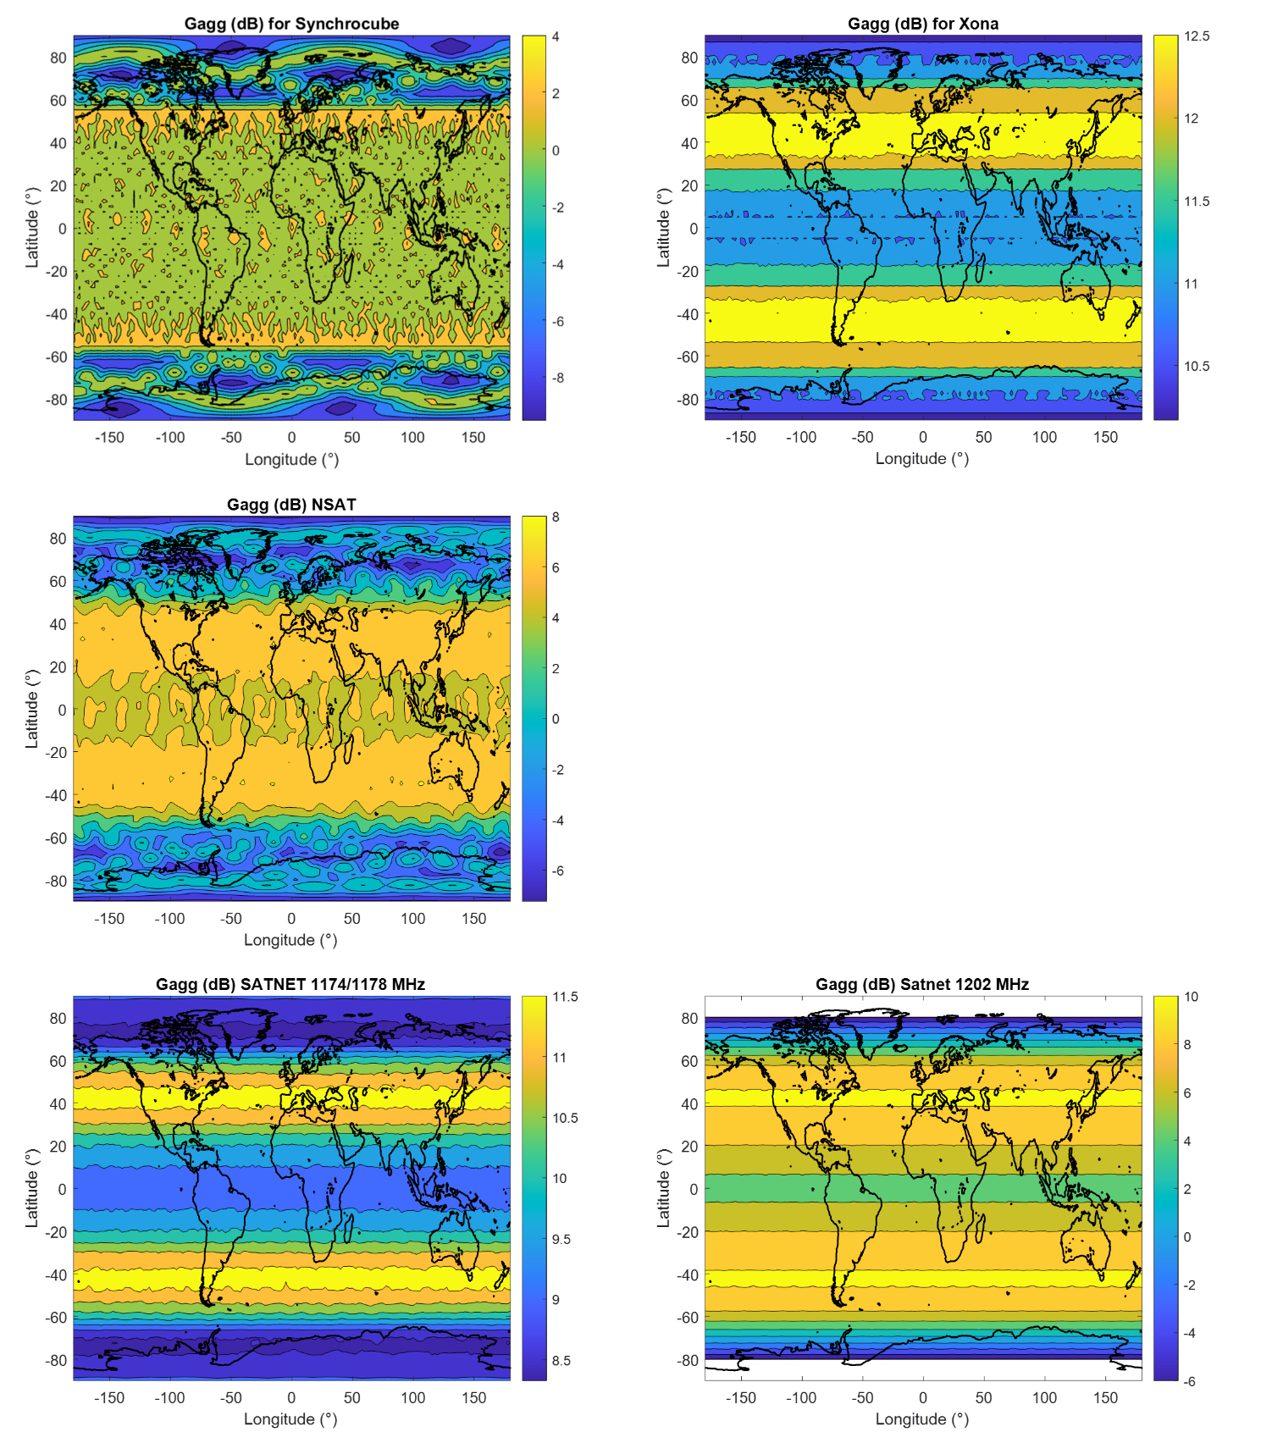
Figure 4: Aggregate gain for the different LEO PNT systems

      - The maximum worldwide aggregate gains $G_{agg}$ for the different L-band LEO PNT systems are recapped in Table 3.
 | Xona | Synchrocube | Satnet 1174/1178 MHz | Satnet 1202 MHz | NSAT
$$G^{agg} (dB)$$ | 12.8 | 5.2 | 11.8 | 10.2 | 7.2
Table 3: Maximum worldwide $G_{agg}$ value for the different L-band LEO PNT systems
  - Impact of L-band LEO PNT systems on aeronautical GNSS receiver performance
    - The maximum worldwide contribution $I_{0,k}$ of each LEO PNT system can then be computed from the inputs of section 2.2. $I_{0,k}$ figures are given in Table 4 to Table 7, and the $I/N$ ratios are also presented.
 | $$I_{0,Xona} (dBW/Hz)$$ | $$I_{0,Xona}/N_{0} (dB)$$
Mode 1 | -214.16 | -14.16
Mode 2 | -218.26 | -18.26
Table 4: Max worldwide interference equivalent noise caused by Xona
 | $$P_{Tx}=1 dBW$$ |  | $$P_{Tx}=-2 dBW$$ |  | $$P_{Tx}=-4 dBW$$
 | $$I_{0,Satnet}$$  $$(dBW/Hz)$$ | $$I/N (dB)$$ | $$I_{0,Satnet}$$  $$(dBW/Hz)$$ | $$I/N (dB)$$ | $$I_{0,Satnet}$$  $$(dBW/Hz)$$ | $$I/N (dB)$$
1174 MHz | -213.2 | -13.2 | -216.2 | -16.2 | -218.2 | -18.2
1178 MHz | -213.2 | -13.2 | -216.2 | -16.2 | -218.2 | -18.2
1202 MHz | -242 | -42 | -245 | -45 | -247 | -47
Table 5: Max worldwide interference equivalent noise caused by Satnet
$$I_{0,Synchrocube} (dBW/Hz)$$ | $$\frac{I_{0,Synchrocube}}{N_{0}} (dB)$$
-211.3 | -11.3
Table 6: Max worldwide interference equivalent noise caused by Synchrocube
 | $$I_{0,NSAT} (dBW/Hz)$$ | $$\frac{I_{0,NSAT}}{N_{0}} (dB)$$
L5T | -210.7 | -10.7
E5T | -227.3 | -27.3
Table 7: Max worldwide interference equivalent noise caused by NSAT
    - The aggregate impact should also be investigated. The aggregate equivalent noise is plotted in Figure 5. Note that in order to elaborate this figure, the maximum $I_{0}$ per latitude for each constellation is taken in order to take into account the Earth rotation, and this is the reason why the aggregate equivalent noise $I_{0, LEO}$ only varies whith respect to latitude and not to longitude. In addition, some hypothesis assumed in this exercise are :
- Xona mode 1
- Satnet satellites of near polar orbit and half of the satellites of the inclined orbit are transmitting at 1174 MHz, with 1 dBW EIRP. The other transmits at 1202 MHz.

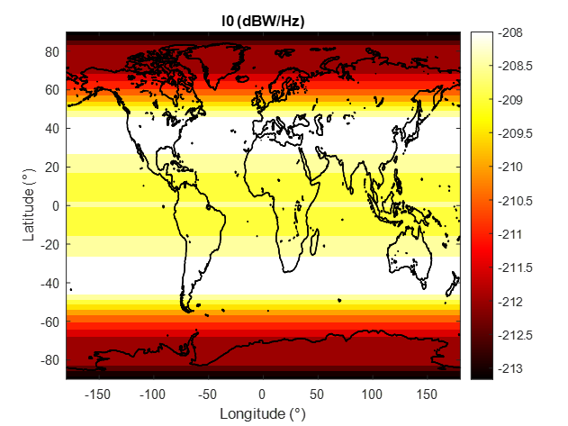
Figure 5: Aggregate equivalent noise induced by LEO PNT systems
    - The maximum worldwide aggregate equivalent noise from LEO PNT is $I_{0,LEO}$ is -207.5 dBW/Hz. This value grows to -201.5 dBW/Hz if a 6 dB safety margin applies in order to cover for all unknowns. This value should be interpreted with respect to relevant thresholds.
      - ITU threshold
        - ITU Recommendation M.1905 indicates that the maximum tolerable level from non-aeronautical interference source is -204.8 dBW/Hz for aeronautical GNSS receiver in tracking mode. Therefore, this threshold is exceeded if the 6 dB safety margin is applied.
        - ICAO threshold
          - The ICAO GNSS interference reference is the interference mask. The GNSS interference mask, in the frequency band surrounding L5/E5a, has been derived considering a maximum non-aeronautical equivalent noise of -201.58 dBW/Hz. This value is issued from a C/N0 link budget analysis for SBAS demodulation at high altitude (FL400), and the location at which it has been derived is (41°N, 75.5°W) (US pulsed interference hot spot). This location does not correspond to the latitude where the aggregate impact of $I_{0,LEO}$ is maximum. At the 41° latitude, the bounding equivalent wide-band noise level due to the 4 L-band LEO PNT constellations at L5/E5a is $I_{0,LEO}=-207.6 dBW/Hz$. Applying the 6 dB safety margin covering all unknowns, this value grows to -201.6 dBW/Hz and it eats all the remaining margin left for all non-aeronautical interference sources. It is important to note that GNSS standards have already identified non-aeronautical sources and their estimated equivalent noise (including 6 dB safety margin) can be up to -202.5 dBW/Hz.
- ACTION BY THE MEETING
  - The meeting is invited to:
- Discuss the coordination process in each administration for the introduction of a new RNSS system, and if the civil aviation authority is part of this process;
- Provide more information, if possible, on the technical characteristics of these new LEO PNT systems, and feedback on the assumptions considered in this WP; and
- Pay attention to the result of coordination process for new LEO PNT systems.

ANNEX A: NORMALIZED RECEIVED POWER
This annex presents how the normalized received power patterns of Figure 3 are computed.

A.1 Satnet and Synchrocube

Contributions from Satnet and Synchrocube to the Resolution 609 consultation meeting directly indicate the power flux density at Earth surface as a function of the elevation angle. The normalized received power is therefore deduced from this input.

A.2 Case of NSAT01, NSAT01.001 and Xona

This powed flux density as a function of elevation is not available for NSAT and Xona. Instead, the satellite antenna patterns are known.

In addition, the normalized received power takes into account the difference of propagation losses depending on the elevation angle. The ratio of the propagation losses when the SV is at elevation $e$ compared to when it is at the zenith is given by (Eq 5).
 | $$ΔFSL={\left(\frac{D\left(e\right)}{H_{s}}\right)}^{2}={\left(\frac{-R_{T}\sin\left(e\right)+\sqrt{R_{T}^{2}\sin^{2}\left(e\right)+H_{s}\left(H_{s}+2*R_{T}\right)}}{H_{s}}\right)}^{2}$$ | (Eq 5)
- $H_{s}$ is the satellite altitude
- $R_{T}$ is the Earth radius
- $D(e)$ is the distance between the Earth surface and the satellite when the elevation angle is $e$.
$ΔFSL$ is illustrated in Figure 5 for Xona, NSAT01 and NSAT01.001.
Figure 7: $ΔFSL$ for Xona and NSAT

The normalized received power is then deduced by combining the transmitting antenna gain and the delta of propagation losses, and after normalizing. Note that the relation between the boresight angle $b$ and the elevation angle is given in (Eq 6).
 | $$\cos\left(e\right)=\frac{H_{s}+R_{T}}{R_{T}}sin⁡(b)$$ | (Eq 6)
— END —

