FREQUENCY SPECTRUM MANAGEMENT PANEL (FSMP)

Eighteenth Working Group meeting

Montreal, 6 - 16 February 2024

Agenda Item 8 Revision of ICAO Frequency Spectrum Handbook (Doc 9718/New Volume-B)

Subject: Material for Doc 9718/New Volume B

(Prepared by NAV CANADA-TCCA, Canada)

SUMMARY
This paper proposes some material for Volume B (Spectrum Management for ICAO) of the restructured handbook Doc 9718/ Volume1 and seeks comments as to the proposed structure and content. This working paper uses the existing Doc 9718/ Volume1, ITU constitution & Convention, and the RR as the source.

- INTRODUCTION

It should be mentioned that the Correspondence Sub-Group of FSMP is presently revising the current Doc 9718 ICAO Spectrum Handbook (Vol. I and Vol. II). The proposal is to publish this document in 4 separate volumes (provisionally labelled as Volume A, B, C and D).

This working paper aims to revise doc 9718 edition 2 by making improvements to the new document. It worth noting that the new structure of the handbook proposed in the FSMP-WG/9-WP/17 is different from the previous one; therefore, rearrangements of paragraphs are recommended. This review addresses the first three chapters. This document also proposes materials for attachments C, E and F. All changes and proposals are written in blue colour and the original text in black colour (see annex 1).

- Discussion

Attachment D “Approach for Establishing and Promoting the ICAO Position for Future ITU World Radiocommunication Conferences” should demonstrate the strategic character of ICAO Position for Future ITU-WRC, hence, it is proposed to move this attachment D to volume A: “ICAO spectrum strategy, policy and strategy”.

It takes more than three years for any preparatory activities for World Radio Conferences to be finalized. Generally, ICAO declares its position a few months in advance of the conference which does not leave enough time for the ICAO to publish it in a new version of DOC 9718 in which other aeronautical concerns and agenda items would have already been established for the next WRC.
- For that purpose, it is proposed to exclude the ICAO position on WRC agenda items from DOC 9718 and publish them in an independent document or in an annex to Document 9718 that will be easy to update, avoiding the need to revise the entirety of Doc 9718; and
- The handbook will only contain a section explaining mainly the ICAO policy and strategy on WRC agenda items and how the process is followed to get the ICAO Position on them.

- ACTION BY THE MEETING

The meeting is invited to:

- consider and review the contents of this working paper.
- include the materials in the relevant updated Volume B of the ICAO Spectrum Handbook.

Annex 1

Handbook on Radio Frequency Spectrum Requirements
for Civil Aviation
Volume B – Spectrum Management

Chapter 1
Introduction
(Source : Chapter 1/ Volume 1/ Doc 9718)

The radio frequency spectrum is a scarce natural resource with finite capacity limits and for which demand is constantly increasing. Predictions of future demand for spectrum indicate a continuing rate of increase for all users and radio services and facilities that utilize radio waves as the world economies progressively expand. The competition among all users to acquire available spectrum available is hence expected to intensify further in the years ahead. In this competitive situation, even a user holding a spectrum allocation will not have an automatic right to retain that radio frequency spectrum, as a decision by an International Telecommunication Union (ITU) conference may require that spectrum be removed from any radio service to meet a superior justified demand for other radio services. Aviation is only one of many such competitors, albeit with the significant benefit of a worldwide cooperative forum, namely the International Civil Aviation Organization (ICAO), to coordinate and support its case.

Aeronautical services are recognized internationally to be prime users of radio frequencies without which aircraft operations would not be capable of meeting the global demand for safe, efficient and cost-effective transport. The prominent safety-of-life element, present during all phases of an aircraft’s flight, is accorded special treatment internationally and is granted protection from harmful interference through agreed measures. Spectrum allocated to aeronautical services in the main frequency bands is divided into two main functions: air-ground communications and radionavigation. The gradual introduction of satellite-based services in accordance with the communications, navigation and surveillance/air traffic management (CNS/ATM) policies agreed at the Tenth Air Navigation Conference (1991) and approved by the ICAO Council is progressing.

Radio frequency spectrum congestion imposes on all users the duty of spectrum-efficient operation. The process of channel splitting, as employed in some aeronautical communication and navigation frequency bands, is an example of technological development helping to achieve spectrum-efficient operation and meeting future requirements without requiring additional spectrum. Modern sophisticated systems employing complex modulation techniques are another facet of efficient spectrum use when transmitting more information within the same bandwidth. Extending radio services and systems into higher frequency bands is yet another. These measures need to continue for the foreseeable future.

The ever-increasing demand for commercial aviation has led to rapid expansion of unmanned aircraft (UA). The safe integration of UAs into airspace shared with conventional commercial aircraft requires new spectrum. For the safe integration of UA into in both the LOS (Line of Sight) and BLOS (Beyond Line of Sight), the aviation community and the ICAO plead for a protected aviation spectrum to operate UAS using the CNPC link. the CNPC links operate in the Aeronautical Mobile (Route) Service (AM(R)S) and Aeronautical Mobile Satellite (Route) involving the responsibility of under International Telecommunications Union (ITU).

The process of international competition between expanding radio services obliges all existing users (i.e. aeronautical and non-aeronautical) to continually defend and justify the retention of frequency bands or the addition of new bands to those already allocated to their service, subject to the same conditions as apply in other services. Civil aviation operations are expanding globally, requiring more navigation and communication facilities and thus creating additional pressures on the already stressed and limited spectrum availability. The civil aviation community must accordingly develop and present, as necessary, its agreed policies and its quantified and qualified statements of requirement for radio frequency spectrum so as to ensure the continuing availability of adequate radio spectrum and, ultimately, the ongoing viability of air navigation services throughout the world.

Aeronautical systems utilize frequency bands that are attractive to many users due to their propagation characteristics, their generally worldwide allocations and resultant benefits in equipment design. Many of these users are global industries delivering significant economic benefits that are well understood by governments. The potential revenues for such sectors are often directly quantifiable in terms of their overall spectrum bandwidth allocation. However, unlike other spectrum users, the amount of spectrum used by aeronautical safety systems is not directly related to revenue and thus the quantification of the cost benefit of aviation spectrum bandwidth can become challenging.

Competition among spectrum users is becoming more severe and each ITU/WRC cycle sees increasing demand for new allocations to meet industry and societal demands for improved communications and new applications. Spectrum availability is now a key issue, and potentially a critical constraint, to delivering innovation and growth in all sectors. This has resulted in significant economic pressure on radio regulators and governments to ensure spectrum can be managed in a way that can adapt to meeting these changing needs.

This document contains a balanced and justified presentation of aviation needs, and it will be made available to all aviation interests involved in the frequency management process. It will be updated through regular amendments based on technological developments in communication, navigation and surveillance systems for aviation and changing operational requirements on the utilization of these systems. These updates also consider the decisions in the ITU, including amendments to the ITU Radio Regulations and the development of relevant ITU-R Recommendations and reports.

Chapter 2
Objectives and PURPOSE
Source Chapter 2/ Volume 1/ Doc 9718)

  - The ITU is the specialized agency of the United Nations for telecommunication matters where international agreements are made on the use of the radio frequency spectrum. At World Radiocommunication Conferences (WRCs), convened about every four years, changes are made to the ITU Radio Regulations, including the Table of Frequency Allocations (Article 5 of the ITU Radio Regulations), on the basis of proposals made by States. This mechanism was introduced in 1992 in order to better adapt the Table of Frequency Allocations to rapid technological developments and spectrum requirements for all users of the radio frequency spectrum.
  - A consequence of this process is that a coordinated aeronautical position (the ICAO Position) must be established for every ITU WRC and finalized well in advance of the ITU conference itself, in order to be of maximum use to aviation authorities. The ICAO Position is intended to be used by civil aviation authorities in their national discussions with the radio regulatory authorities when developing proposals for submission by their administrations to meetings of regional telecommunication organizations which prepare regional positions for ITU conferences as well as to the ITU conferences themselves and to brief the delegations at these meetings. In addition, it is to be used by aviation experts at these conferences and is submitted by ICAO to the ITU conferences in the form of an information paper. The ICAO Position contains the agreed radio frequency allocation requirements for aeronautical radio services, including the necessary protection from harmful interference, that are provided to support safety critical aeronautical communication, navigation and surveillance systems, including Control and Non-Payload Communications (CNPC) links for UAS. the ICAO policy statement and the spectrum strategy on WRCs and how the process is followed to get the ICAO Position on WRCs The ICAO Position, the ICAO spectrum strategy and the ICAO policy statements in this handbook are developed by the Air Navigation Commission, with the assistance of the Frequency Spectrum Management Panel (FSMP), and approved by the ICAO Council. In developing the ICAO Position, all ICAO Member States and relevant international organizations are consulted. Aeronautical aspects on the Agenda Items for next WRCs are published separately in the ICAO document …….
  - With this background, the prime objectives of this document are:
- to provide a consolidated and up-to-date statement of agreed spectrum requirements for aeronautical services and the ICAO policy in the frequency bands used by international civil aviation for the communication, navigation and surveillance systems that are to be provided for air traffic purposes, taking into account all future needs;
- to provide background information on the international spectrum management institutional framework and the main ITU elements;
b) to provide a source of reference for relevant ITU regulations, resolutions, recommendations and associated ITU-Radiocommunication Sector (ITUR) material; and
c) to provide a convenient record for important frequency management material, such as the criteria applied in the planning of radio frequency assignments, and the protection from interference. and
d) to provide background information on the international spectrum management institutional framework and the main ITU elements.

Chapter 3
Spectrum Management
- OVERVIEW

      - GENERAL ASPECTS OF THE SPECTRUM MANAGEMENT PROCESS
[Source: section 6.1. Doc 9718_vol_1_2ed]

Civil aviation use of the radio frequency spectrum accounts for less than 14 per cent of the total, comparable to maritime use, but considerably less than other uses such as broadcast or national defence. The spectrum management process is designed to make the optimum use of this scarce spectrum resource. One of its main objectives is to create a universally agreed framework in which the demands for radio frequencies from individual countries are balanced with the interests of different service users to produce a planned radio environment incorporating an effective and efficient spectrum use. It has a necessary international dimension, which must be flexible and responsive to changing patterns of demand or to new technology, having scope for additional forms of transmissions and modulation methods.

With new technology, the useable spectrum expands over time, particularly in the higher frequency region, creating new possibilities and options. Spectrum expansion has limitations of scale and scope, however. Demand for spectrum continues to increase at a much faster rate than the frequency availability created from either extended spectrum boundaries or improved efficient use of the spectrum that is available (e.g. through reduced channel spacing). In its essentials, spectrum management combines separate disciplines, such as regulatory and control measures and technical (frequency assignment) planning, to achieve a reasonable compromise in dealing with the increasing demand for more spectrum. The current decade is expected to see this increase in demand rise sharply, particularly for broadband mobile applications and spectrum management problems will hence increase in complexity and scale.

In the context of this handbook, the management of the spectrum may be characterized by four main domains or areas of activity: the regulatory domain, the technical domain, the licensing domain and the registration domain, which are described below.

The regulatory domain

In this domain, the international agreements made within the ITU lay down a set of principles, rights and procedures, together with an institutional framework for their effective operation, which create the basis for an orderly international use of radio frequencies. The mechanism of the ITU (periodic radiocommunication conferences, the Radio Regulations Board and the Radiocommunication Bureau) maintains the permanent documents responsive to, and in line with, modern conditions.

The Radio Regulations, which have treaty status, are the cornerstone of the process. They contain the internationally agreed Table of Frequency Allocations and the agreed rules for its implementation, as well as the important international obligations for the operation of radio stations, licensing and other control measures for ensuring an effective regime of operation within the framework of the Radio Regulations.

The Radio Regulations primarily address regulatory aspects; technical material, usually of a more volatile character, is relegated to the Appendices to the Radio Regulations or to ITU-R Recommendations. Amendments to the Radio Regulations can only be made through a WRC, the Final Acts of which are agreed and signed at the conference, with the instrument of ratification to be deposited within the given time as specified in the Final Acts themselves. This regulatory basis, as contained in the ITU Constitution, Convention and Radio Regulations, is the starting point for the existence of a framework of stable international order and practical utility which is adhered to by all countries of the world.

The technical domain

In the final analysis, the effective use of the radio frequency spectrum is dependent on the expert technical planning of the frequency assignments used by the various services and systems. The main technical tools at the disposal of the spectrum manager are those in the hierarchical order of allocation planning, service sharing planning and, at the station level, the planning of assignments to particular locations.

The processes here are quantitative and exact, requiring careful examination and agreement between countries and service users. The concepts of acceptable interference and harmful interference, as contained in the regulatory rules, must be translated into practical limits and applied to achieve a service which meets all of its operational requirements. Different services require different amounts of bandwidth and can tolerate different levels of interference. Also, propagation conditions vary widely throughout the useable spectrum. Careful assessment and balancing of these degrees of freedom have to be applied to achieve optimum results. The ITU-R is the focus for the studies which lead to refined and workable criteria for sharing among services and for the development of international and national frequency plans.

Due to safety implications, however, civil aviation is, through ICAO, developing and planning most of the use of worldwide exclusive aeronautical frequency bands within its organizational structures, utilizing technical standards that have been adopted or approved within ICAO.

The licensing domain

Implementation of the basic ITU obligations for certification of system and personnel, licensing of stations, monitoring the observance of licence conditions and clearing interference are functions carried out at the national level under national law. These duties are normally exercised by national telecommunication administrations, which also provide the spectrum management expertise for national frequency planning and participate in international discussions on spectrum matters. Coordination among administrations is the usual mechanism for bilateral and multilateral discussions. The licensing actions generally also include equipment type approval against national or other specifications. The parameters checked include those having an effect on other users, such as frequency stability and spurious emissions, and system interoperability features. In the case of aviation equipment, conformity with Annex 10 may also be a licensing condition.

The licensing process is the controlling mechanism for the use and change of use of frequency bands, or for the exercise of sanctions in the case of licence infringements. It also provides the opportunity to levy such charges as are necessary to support the spectrum management and regulation activity or to control demand.

Article 18 of the Radio Regulations requires that all stations be licensed by the government having authority over their operations. For aircraft, dispensations are granted in 18.8 for the specific instance of first delivery, and in 18.11 for wet and dry lease. Article 39 requires the station licence to be available for inspection on demand at any time. Article 37 addresses operators’ certificates for personnel in the aeronautical services. These basic telecommunications requirements have been included in Articles 29, 30 and 32 of the ICAO Convention.
The registration domain

The registration by countries of their assignments in an internationally agreed database is fundamental to the ITU principle of prior rights gained by earlier registration (first come, first served), and the important obligation not to derogate the protection of existing registered assignments of other countries. The procedural rules are laid down in the Radio Regulations and the process of consultation and recording in the Master International Frequency Register (MIFR) is administered by the Radiocommunication Bureau. A comprehensive procedure for coordination, especially for space services, is a particular feature of these important provisions which have been developed and refined over many years.

The MIFR thus serves the dual purpose of a formal record and a planning guide for new assignments.

The predominant emphasis in all of these processes is that of the freedom of countries to use frequencies as they wish, provided they do not affect other existing services and uses of other countries, which have been established in accordance with the Radio Regulations and registered in the MIFR. In keeping with these liberal principles, the ITU Convention contains no provisions for arbitration or for the referral of disputes to international adjudication. The settling of problems is hence treated as a matter for bilateral or multilateral resolution in the first instance, calling on informal assistance from the permanent organs of the ITU should this fail. Cases of failure, however, remain an insignificant proportion of the millions of operating radio services.

For the role of ICAO in frequency coordination and registration (in ICAO) see Chapter 4, 4.5, and Chapter 5.

- The Involved Parties

ITU Radiocommunication Sector (ITU-R)
      - The ITU Radiocommunication Sector (IUT-R) is one of the tree main areas of the International Telecommunication Union (ITU). Under the responsibility of ITU, ITU-R plays a vital role in global spectrum management, as noted in lines 11 and 12 (Article 1) of the ITU Constitution. Hence, the article 12 of the ITU constitution states that the ITU-R ensures the rational, equitable, efficient, and economical use of the radio frequency spectrum by all radiocommunication services, whether terrestrial or satellite. The line 80 of the constitution establishes the structure of the ITU-R.
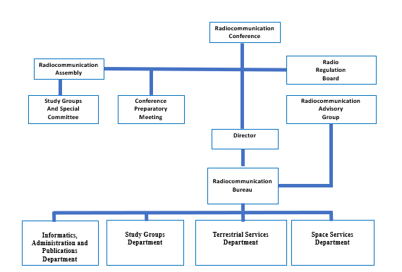
Fig xy : Radiocommunication Sector Organization (Source ITU)

      - The Radiocommunication Sector performs its regulatory and political functions by working, among others, with the World and Regional Radiocommunication Conferences; and Radiocommunication Assemblies supported by Study Groups, and of right, the administrations of all Member States; any entity or organization which becomes a Sector Member, and UN agencies, such as the International Civil Aviation Organization. (Source Doc 9718)
      - The technical work is performed on an ongoing basis by the ITU Radiocommunication Sector (ITU-R) and the ITU Radiocommunication study groups (ITU-R SG). The ITU-R study groups support this technical work through the development of relevant ITU-R Recommendations, or reports and handbooks. Most aviation related issues are addressed by ITU-R Study Group 5 which deals with terrestrial services including mobile and radiodetermination. ITU-R Study Group 4 deals with satellite services including those used for aeronautical purposes. This work is important to aviation, particularly in relation to the development of ITU-R Recommendations addressing compatibility between aeronautical and non-aeronautical services for the purpose of preventing harmful interference to aeronautical use of radio frequency spectrum. In addition, the detailed technical preparations for the WRCs which are undertaken under the auspices of the Radiocommunication Bureau by the Conference Preparatory Meeting (CPM) are delegated to these Study Groups. The CPM functions as a permanent body using material developed by the ITU-R study groups and presented by administrations in developing the CPM Report to the WRC. The CPM Report provides information on the technical, operational and regulatory/procedural issues relevant to the WRC agenda items. (Source 3.7/ Doc 9718/Volume1)
      - In order to coordinate frequency use and spectrum requirements within specific regions of the world, a number of regional bodies have been set up in a cooperative arrangement between telecommunication administrations. These are: the European Conference of Postal and Telecommunications Administrations (CEPT) for Europe, the Asia-Pacific Telecommunity (APT) for the Asia-Pacific region, the Comisión Interamericana de Telecomunicaciones (CITEL) for the Americas region, the African Telecommunications Union (ATU) for Africa, the Regional Commonwealth in the field of Communications (RCC) for Eastern Europe and Asian countries belonging to ITU Region 1, and the Arab Spectrum Management Group (ASMG) for the countries in the Middle East and North Africa. These regional bodies have the capability, where agreed and necessary, to present common proposals to ITU conferences, which would include, where appropriate, proposals addressing aeronautical allocations. A trend is appearing also where these bodies exercise joint influence on policies to promote their regional interest, often with a strong commercial motivation. (Source 3.9/ Doc 9718/Volume1)

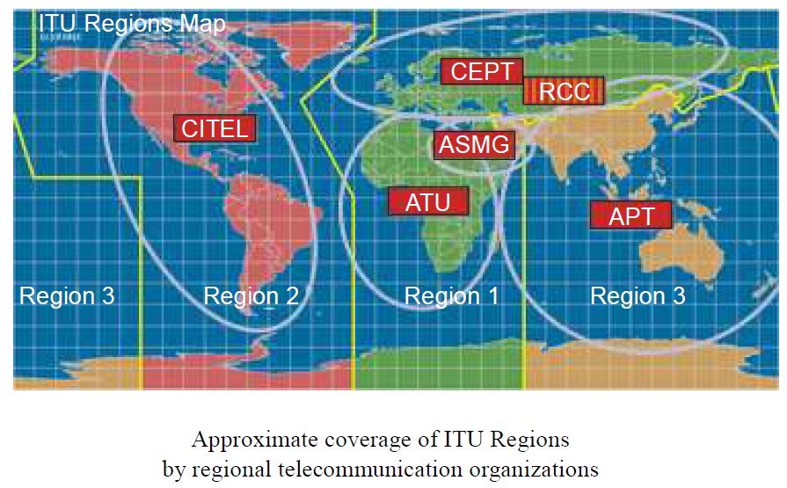
Figure xz. Map of ITU world Regions

      - In response to its specialized responsibility and competence in civil aviation, ICAO has been accorded observer status (“Observer in an advisory capacity”, see Section 7-III.2) at all conferences and meetings held under ITU auspices, including ITU-R meetings. This enables ICAO to submit its internationally agreed statements on telecommunication policies and frequency use and ensures that the ICAO Position and policy is propagated at these conferences and meetings and, to the maximum extent possible, to ensure that aeronautical allocations and frequency use, including future requirements, are safeguarded. (Source 3.8 / Doc 9718/Volume1)
      - The ITU forum is of great importance to civil aviation interests and is increasing in importance with the emergence of new philosophies on spectrum sharing between different services and on jointly operated services, such as mobile satellite services. In order to secure adequate spectrum for aviation, it is essential that the aviation position be rational, well considered and well presented in discussions that are becoming increasingly diverse, complex and commercial in their character and scope. The ITU is expected to give due consideration to the globally coordinated civil aviation requirements and positions submitted by ICAO, and to act accordingly in order to ensure the continued safety of the air transport operations worldwide. (Source 3.10 / Doc 9718/Volume1)

ITU Member States
      - The ITU is an UN agency made up of 193 member states and sector members from some 900 companies, universities, research institutes and international and regional organizations. Within the ITU, Member States and sector members have well-defined rights and obligations, cooperating for the achievement of the Union's objectives.
      - Within the ITU-R sector, Member States play a dual role, on the one hand by contributing to the improvement of international spectrum management during plenipotentiary conferences and WRCs, and in the BR and the Radio Regulations Board works, and on the other hand by applying ITU-R policy at the national level and ensuring proper use of the spectrum. National policies take into account all of the competing interests of radio frequency spectrum users to determine the States’ proposals to the conference. It is essential that aeronautical participation in these national and regional activities be ensured in order to support and defend aviation requirements. (Source 3.4 Doc 9718)
      - As per of Article 44 of the ITU constitution on the use of the Radio-Frequency Spectrum and of the Geostationary-Satellite and Other Satellite Orbits, Member States shall optimise the use of frequencies and the spectrum to provide in a satisfactory manner the necessary services. Recourse to the latest technical advances is recommended. Member States must demonstrate rationality, efficiency, and economy in the use of radio frequencies and all associated orbits, including the orbit of geostationary satellites, given the scarcity of the latter.
      - As per of Article 45 of the ITU Constitution on harmful interference, the responsibility of Member States in the use of radio stations is recalled so as not to cause harmful interference to radio services or communications of other Member States and which operate in accordance with the provisions of the Radio Regulations.
      - As per of Article 46 of the ITU constitution on Distress, Urgency, Safety or Identification Signals, Member States agree to take the necessary measures to protect the integrity of distress, emergency, security or identification signals and to provide the necessary means for the location and identification of stations under their jurisdiction transmitting these signals.

- The International Civil Aviation Organization ( source: Chapter 5/ Volume 1& convention/ Doc 7300-9 )

The International Civil Aviation Organization (ICAO) was created by The Convention on International Civil Aviation, drawn up in 1944 by 54 countries, more commonly known today as the “Chicago Convention”. The Article 43 of the convention states:
“An organization to be named the International Civil Aviation Organization is formed by the Convention. It is made up of an Assembly, a Council, and such other bodies as may necessary.”

ICAO is the United Nations specialized agency with recognized competence in matters related to aviation safety. Under Article 37 of the Convention on International Civil Aviation, ICAO is empowered to adopt and amend international SARPs for all aviation matters including aeronautical communications systems and air navigation aids. Under Article 37, the highest practicable degree of uniformity is seen as essential to facilitate and improve the safety of air navigation. Characteristics for aeronautical radio communication and navigation systems are laid down in Annex 10 to the ICAO Convention, and the requirement for interoperability of systems on a global basis demands that frequency allocations be available worldwide and, preferably, also exclusive. ( Source: 5.1/ Doc 9718/ Volume 1)

ICAO coordinates the input to ITU discussions on aeronautical radio frequency spectrum matters. In pursuance of this role, ICAO is accorded observer status at relevant ITU WRCs and also participates at meetings of the ITU-R study groups, including the Conference Preparatory Meetings (CPMs) which prepare the technical and regulatory basis for WRCs. The range of this involvement includes aspects of common system technical standards, maximum levels of tolerable interference and measures to control and resolve interference incidents, frequency planning criteria, the preparation of frequency plans, and distress and safety procedures. The outcome of these discussions normally results in material being incorporated in the ITU Radio Regulations or in ITU-R Recommendations and subsequently being applied through national regulation by national telecommunication authorities. ( Source: 5.2/ Doc 9718/ Volume 1)

Within ICAO, the necessary activity to support these ITU-generated functions exists at two levels:

at the worldwide level, through the work of the Air Navigation Commission, with the assistance of the FSMP (and communication divisional meetings or air navigation conferences, as required), to prepare the coordinated ICAO policies, spectrum estimates and technical inputs for ITU conferences and ITU-R study groups. The ICAO spectrum strategy, policy statements and the ICAO Position for WRCs are approved by the Council; and
- b) at the regional level, by the ICAO Regional Offices, through coordination of frequency assignment plans with States, using agreed ICAO planning criteria. This activity is supported by the Regional Planning and Implementation Groups (PIRGs). ( Source: 5.3/ Doc 9718/ Volume 1)

Aviation representatives are generally included in States’ delegations to ITU conferences where they have the important role of safeguarding the aviation position during the conference discussions. States’ cooperation in this supporting role is an essential factor in securing the aviation requirements. ( Source: 5.3/ Doc 9718/ Volume 1)

The repetitive (now three to four-year) cycle for ITU WRCs means that the ICAO Position on the conference agenda must be prepared within the same time frame as national/regional inputs to the conference. This process is described in Attachment D to this handbook. ( Source: 5.3/ Doc 9718/ Volume 1)

This handbook, which is updated through a rolling system of amendment action, provides the record of agreed ICAO policies, including the ICAO spectrum strategy and the ICAO policy statements. ( Source: 5.3/ Doc 9718/ Volume 1)

The relationship between the radio regulatory activities and those of ICAO and civil aviation authorities (CAAs) is given in Figure 5-1. ( Source: 5.3/ Doc 9718/ Volume 1)

The approach to improve States’ support of the ICAO Position at WRCs has been approved by the ICAO Council. This approach is in Attachment E. ( Source: 5.3/ Doc 9718/ Volume 1)

The ICAO Position for WRC-27, as approved by the Council, is in Attachment F. ………….( Source: 5.3/ Doc 9718/ Volume 1)

International Telecommunication Union Radio

Regulatory Framework

Introduction
(Source: 7-III.1 GENERAL/ doc 9718/ Volume1 & Constitution &Convention )

The ITU, which is governed by its Constitution and Convention, is an important forum for aeronautical radio services, and ultimately, for the continued operation of aviation. The principal areas where the ITU organization exercises its influence are:
a) the radio frequency bands needed to sustain the radio services; these may only be obtained through agreements made at ITU World Radiocommunication Conferences (WRCs);
b) standardization of systems and equipment with other services, to the degree necessary, which are often only achievable within the technical organs of the ITU;
c) problems of radio interference;
d) important regulations relating to frequencies and procedures for distress and safety communications which also affect the maritime and land mobile services; these can only be agreed and formalized within a common international forum; and
e) provisions dealing with licensing of radio stations and personnel.

Through the exercise of its authority and competence over the full telecommunications field, the ITU provides a focus for discussion and agreement. For example, in the use of satellite navigation and communication services which usually is multinational, multi-purpose and commercial in character, the full range of representative interests may only be addressed in a common telecommunications forum such as the ITU.

The ITU Radio Regulations contain authoritative treaty provisions representing worldwide agreement on the telecommunications matters within the ITU areas of interest.

The ITU deals with all telecommunications matters, both for radio and for line transmission purposes, and is supported by its technical agencies ITU-R and ITU-T for study and research in radio and line transmission, respectively. Their output is normally in the form of Recommendations for worldwide publication and dissemination. A small proportion of ITU-R Recommendations are validated to the same treaty status as that in the Radio Regulations through incorporation of such Recommendations in the RR by means of a linked reference.

Section from 3.3.2. through 3.3.7 below highlights Regulations of special importance to aviation indicating their context and scope in relation to aeronautical use of the spectrum.

ITU Constitution and Convention

(Source: 7-III.2 ITU CONSTITUTION AND CONVENTION / doc 9718/ Volume1)

States fully benefit from their sovereign right in the management of international telecommunications, dispose of the Constitution and the Convention of the International Telecommunications Union.

The ITU is governed by the agreements contained in its Constitution, which defines the objectives, composition and basic structure of the organization. The ITU Convention lays down the personnel procedures, working methods and other matters of a procedural character. The present Constitution and Convention were last amended at the Plenipotentiary Conference in 201022 (GuadalajaraBucharest, MexicoRomania) (PP-1022). Some amendments were introduced as a consequence of extending participation of Observers and Sector Members of the ITU-R Sector to WRCs.

The need to ensure the safety of life is covered in Article 1 of the ITU Convention which states that one of the purposes of the Union is to “promote the adoption of measures for ensuring the safety of life through the cooperation of telecommunication services”. Additionally, Article 40 of the ITU Constitution on the priority of telecommunications concerning safety of life states that “International telecommunication services must give absolute priority to all telecommunications concerning safety of life at sea, on land, in the air or in outer space, as well as to epidemiological telecommunications of exceptional urgency of the World Health Organization”.

Of special importance is Article 50 of the Constitution, which deals with relations with other international organizations, and stipulates that “In furtherance of complete international coordination on matters affecting telecommunication, the Union shall cooperate with international organizations having related interests and activities”.

ICAO, as a specialized agency of the United Nations, shall be admitted as an observer to:
- plenipotentiary conferences to participate in an advisory capacity, as regulated in Article 23 of the Convention; (Source: 7-III.2.4 / Volume/ Doc 9718)
- radiocommunication conferences to participate in an advisory capacity, as regulated in Article 24 of the Convention; and (Source: 7-III.2.5 / Volume/ Doc 9718)
- radiocommunication assemblies to participate in an advisory capacity, as regulated in Article 24 of the Convention. (Source: 7-III.2.6 / Volume/ Doc 9718)

The Plenipotentiary Conference in 2002 (Marrakech, Morocco) (PP-02) considered the situation of observers in ITU conferences and meetings. Particular attention was given to the situation of observers from organizations and agencies within the United Nations system, several of which play an important role in relation to the use of the radio frequency spectrum and satellite orbits.

Therefore, “the Plenipotentiary Conference decided to confirm at future radiocommunication conferences that observers referred to in Nos. 259 (269A) and 262 (269D) of the Convention will be able to submit to these conferences information documents relevant to their mandate, which will be taken into account by Member States. These information documents will continue to be distributed at the conference as they become available. according to past practice and should be referenced for information on relevant daily agendas. In addition, the observers mentioned in numbers 259 (269A) and 262 (269D) may, with the authorization of the President and in accordance with the rules of procedure (i.e. RP 16 and 17) (GR 44), provide opinions on relevant points. to their mandates. Information materials and advice should not contain or be treated as proposals. The right to make proposals, written or oral, to such conferences is clearly reserved to Member States.
3.3.2.1. Important to note here is that the ITU-R Sector Members are admitted as observers to radiocommunication conferences on the basis of provision No. 280 contained in Article 24 of the Convention, thus identifying a different status between a Sector Member and a specialized agency of the United Nations, such as ICAO. Pursuant to Annex 3 of Resolution 145 of PP-06, ITU-R Sector Members at radiocommunication conferences are admitted to attend plenary meetings and committees, and may be asked by the chairman during the course of a meeting to provide relevant information in order to assist the proceedings or to make a statement, but shall not be authorized to participate in the debates.

ITU Radio Regulations
(Source 7-III.3& Chapter 3/ Volume 1/Doc 9718 & RR (Articles))

The Radio Regulations are the principal ITU document (with a treaty status) for radio matters. Parts of the Radio Regulations are discussed, agreed and embodied in the Final Acts of WRCs. WRCs are now held every four years in a rolling sequence in which each conference drafts the agenda for the next, and the provisional agenda for the second sequential WRC. The agenda for a WRC is approved by the ITU Council.

The Radio Regulations lay down the framework for international spectrum management and contain the Table of Frequency Allocations, which is effectively the worldwide agreement on the deployment and conditions of use of all radio frequencies in the radio frequency spectrum. The set of Radio Regulations documents (RR) is composed of Articles, Appendices, Resolutions, and Recommendations and ITU-R Recommendations incorporated by reference.

The Radio Regulations also regulate the prevention and removal of interference, whether between services, countries or regions, between frequency assignments, or from other sources of radiation such as industrial or medical equipment. The ITU Radio Regulations (RR) state in ITU RR No. 4.4:

“Administrations of the Member States shall not assign to a station any frequency in derogation of either the Table of Frequency Allocations in this Chapter or the other provisions of these Regulations, except on the express condition that such a station, when using such a frequency assignment, shall not cause harmful interference to, and shall not claim protection from harmful interference caused by, a station operating in accordance with the provisions of the Constitution, the Convention and these Regulations.”

Particular attention is accorded to services that have a predominant critical safety-of-life function, such as aeronautical and radionavigation services. This is reflected in special measures for rapid elimination of interference by national telecommunication authorities or, in case interference is affecting two or more States, through bilateral negotiations with authorities in these States. Other special measures such as the use of radio in distress and emergency situations or for search and rescue operations, in collaboration with maritime and land services as necessary, are also given prominent treatment. The ITU Radio Regulations (RR) state in ITU RR No. 4.10:
“Member States recognize that the safety aspects of radionavigation and other safety services require special measures to ensure their freedom from harmful interference; it is necessary therefore to take this factor into account in the assignment and use of frequencies”, and in
ITU RR No. 1.169:
“Interference which endangers the functioning of a radionavigation service or of other safety services or seriously degrades, obstructs, or repeatedly interrupts a radiocommunication service operating in accordance with Radio Regulations (CS)”

ICAO develops its material (e.g. SARPs) for radiocommunication and radionavigation systems within the framework set by the Radio Regulations. This section of the handbook reproduces Radio Regulations of particular importance to aeronautical services, and presents them with background comments which highlight their context and significance. The ITU Radio Regulations state in ITU RR No. 43.1:
“Frequencies in any band allocated to the aeronautical mobile (R) service and the aeronautical mobile-satellite (R) service are reserved for communications relating to safety and regularity of flight between any aircraft and those aeronautical stations and aeronautical earth stations primarily concerned with flight along national or international civil air routes.”

Rules of Procedure (Number 95/ Article 14/ CS : Radio Regulations Board & itu.int )

Rules of Procedure (ROP) are updated and approved by the Radio Regulation Board. The ROP serve Member States and the Radiocommunication Bureau in the application of the provisions of the Radio Regulations, Regional Agreements, Resolutions and Recommendations of World and Regional Radiocommunication Conferences. The Rules of Procedure are presented in three Parts:
Part A: the Rules that relate to one or a limited number of Radio Regulatory provisions;
Part B: the Rules that relate to a process i.e. a technical examination; and

Part C: internal arrangements and working methods of the Board (source ITU)

As per paragraphs 94 & 95/ Article 14 of the constitution, the duties of the Radio Regulations Board shall consist of :
“the approval of Rules of Procedure, which include technical criteria, in accordance with the Radio Regulations and with any decision which may be taken by competent radiocommunication conferences. These Rules of Procedure shall be used by the Director and the Bureau in the application of the Radio Regulations to register frequency assignments made by Member States. These Rules shall be developed in a transparent manner and shall be open to comment by administrations and, in case of continuing disagreement, the matter shall be submitted to the next world radiocommunication conference;” (Rules of Procedure 2021 edition (+ rev.2)

The Rule of Procedure 27/19 – concerning the APPENDIX 27 to the RR mentions:
“This provision specifies the role of the ICAO in performing voluntary coordination (“should”) in the operational use of the frequencies. The Board considers such a coordination as an internal ICAO activity, intended to conclude operational agreements between the international operators (e.g. time sharing arrangement). Therefore, the Bureau will not take into account such agreements between operators, unless they are communicated to the Bureau by their national telecommunication administrations.”
(Rules of Procedure 2021 edition (+ rev.2)

Aeronautical Services

[Source: Section # & 6.4 / doc no. 9718_vol_1_2ed].

Aviation services are recognized important users of radio spectrum to create safe and expeditious conditions to support air operations. The aeronautical mobile (route) service (AM(R)S), the aeronautical radionavigation service (ARNS) and their satellite service counterparts are important components in the mobile and radiodetermination families of users (see Figure 3-3) with (normally) exclusive allocations made on a worldwide basis to ensure global harmonization. A summary overview of the use of spectrum by aviation is in (Figure xx.: Radio services). Worldwide allocations enable international standardization of equipment and systems to support safe and global air traffic. The Radio Regulations are used as the framework for the relevant ICAO Annexes and the Standards and Recommended Practices (SARPs) contained therein. (Source 3.5 chapter 3/ Volume? Doc 9718)

Aeronautical services are subject to all of the processes described above in this handbook the same general way as any other radio service. The allocations to the aeronautical mobile and aeronautical radionavigation services are part of the common spectrum resource for aviation and are required to be justified on a continuous basis, requesting additions when necessary and releasing frequencies which are no longer required.

The areas where the special role of radio in air operations is fully recognized, as noted above in this handbook, are:
  - the technical control and management of the exclusive allocations to aeronautical services is carried out by aeronautical experts, both internationally and nationally, in a majority of countries. In these activities, ICAO performs a central coordinating function, providing the international forum for the review of needs for spectrum, the development of technical planning standards and the registration of global use. National aviation experts participate fully in these activities;
  - equipment and system approval by aviation authorities, recognizing that ground systems must meet operational standards based on safety, and aircraft equipment must obtain type approval and airworthiness certification also based on safety requirements under national responsibilities emanating from the ICAO Convention; and
  - cases of interference to aeronautical radio services are treated in the Radio Regulations as requiring special measures. National telecommunications administrations are required to take particular care in the licensing and operation of other services and industrial processes using radio waves which have the potential to endanger safety-of-life functions. In cases where harmful interference is experienced, ICAO can offer assistance in eliminating the interference.
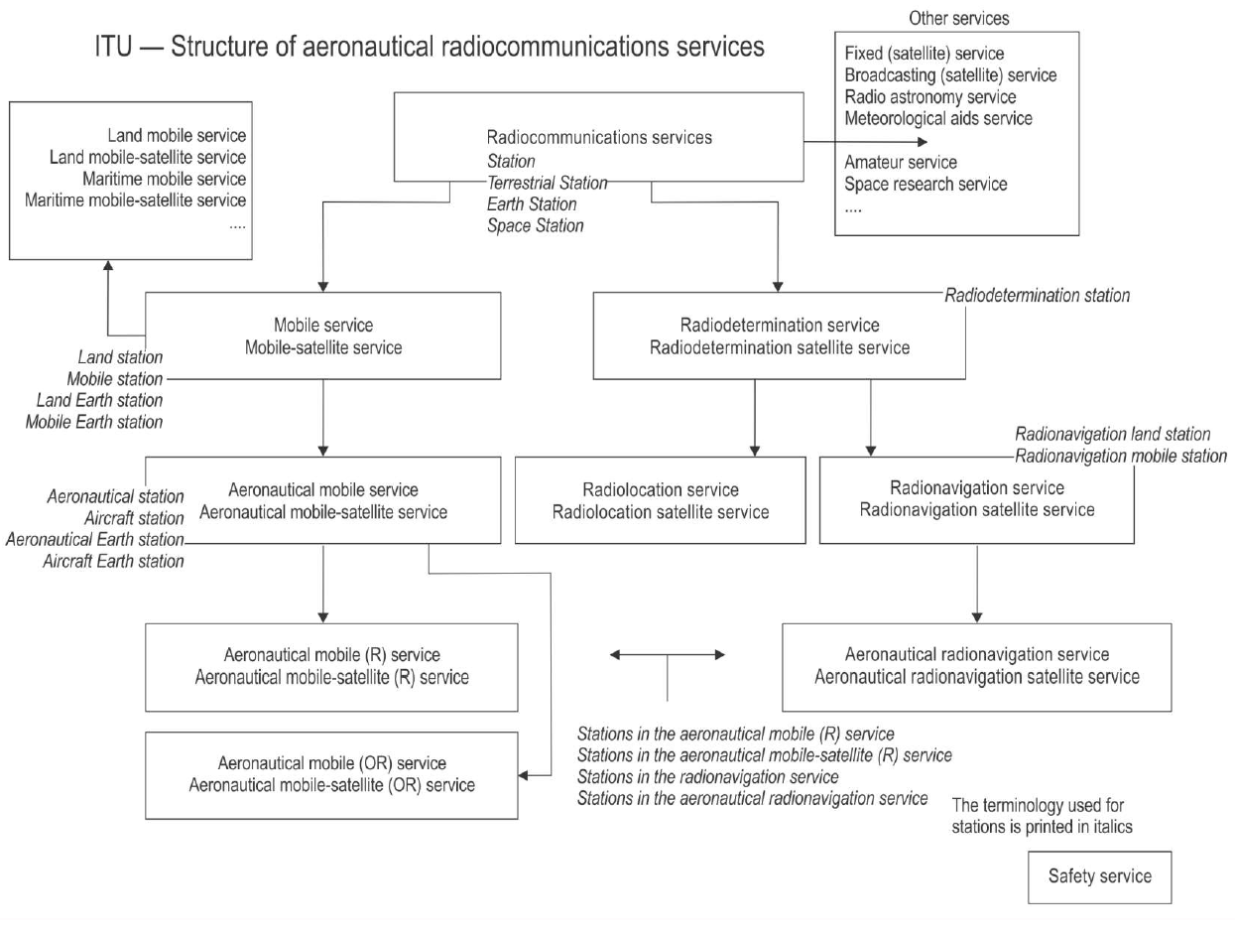
Figure xx.: Radio services

Aeronautical Spectrum Allocations

[source: Section I./ Chapter 7/ ICAO doc 9718_Vol_1 & Recommendation ITU-R SM.1131-0]

Spectrum allocation refers to the process of assigning specific frequencies or bands to different wireless services and technologies. This process begins at the end of each WRC, where the ITU-R Bureau updates the frequency range between 9 kHz and 275 GHz in the Table of Frequency Allocations / Radio Regulations, Vol 1, Art 5, Sect IV. This update is then reflected in the frequency band allocation table at the national level by regulatory bodies to ensure efficient and interference-free communication. on a national level.

The Recommendation ITU-R SM.1131-0 stipulates factors to consider in allocating spectrum on a worldwide basis to facilitate activities that depend on internationally operable equipment (i.e. flight traffic control), namely: technical factors, operational factors, economic factors, and might be other factors. (Recommendation ITU-R SM.1131-0)

List of frequency bands allocated to aeronautical services 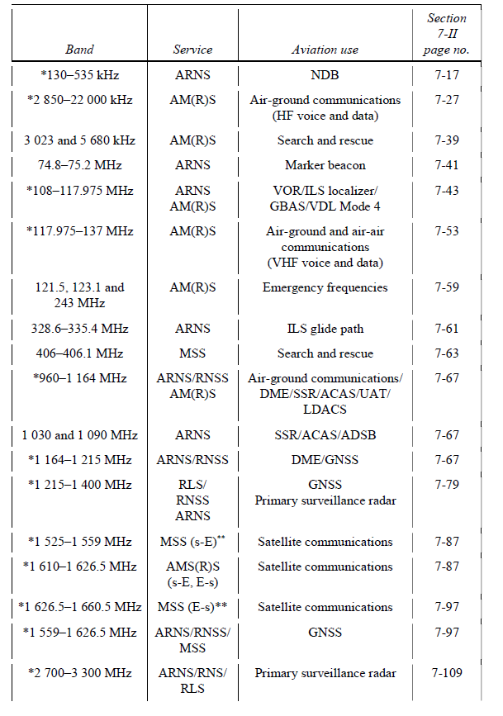

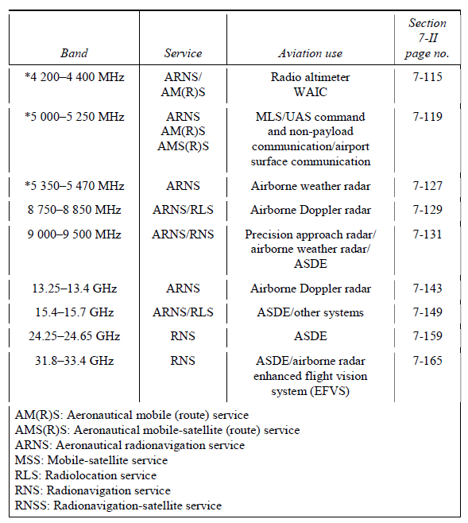

* A graphical presentation of the allocations of the aeronautical services, together with other services and relevant footnotes to which these bands are also allocated, is in Figures 7-1 to 7-7.
** In the frequency bands 1 545–1 555 MHz and 1 646.5–1 656.5 MHz (and also in the band 1 555-1 559 MHz and 1 656.5-1 660.5 MHz in the United States under RR 5.362A), priority is to be given to accommodating the spectrum requirements of the aeronautical mobile-satellite (R) service providing transmission of messages with priority 1 to 6, as defined in Article 44 of the Radio Regulations; no allocation to AMS(R)S has been made
in this frequency band.

International Telecommunication Union Resolutions and Recommendations
(Source: section 4.7/ Volume1/Doc 9718 & ITU Convention)

ITU WRC Resolutions, included in Volume 3 and referenced in Volumes 1 (Articles)and 2 (Appendices) of the Radio Regulations using mandatory language, form part of the Radio Regulations and express a mandatory agreement among all of the ITU members to follow a particular course of action. ITU Recommendations, which are also part of the Radio Regulations, have no mandatory force and usually address matters of limited concern.

TU_R disposes of a set of recommendations establishing international technical standards which have been developed by study groups, in association of experts from administrations, operators, industries and other organizations dealing with the radiocommunications industry and approved by ITU Member States. Among these recommendations, it is worth mentioning some of which address the aeronautical frequency bands; See the Attachment F. As per Alinea 149A/ ITU Convention :
“ The radiocommunication study groups shall also study topics identified in resolutions and recommendations of world radiocommunication conferences. The results of such studies shall be included in recommendations or in the reports prepared in accordance with No. 156 below.”

Relationship between the ITU Regualtory Material including the Radio Regulations and ICAO SARPs
[Source: 4.4.1, 4.4.2, 4,4,3, 4.4.4 of doc no. 9718_vol_1]

Under its Constitution and Convention, the ITU is recognized as the authoritative international body for telecommunications. The Radio Regulations are the instrument through which this specialization is expressed in internationally agreed terms for radio matters. These Radio Regulations, as presently constituted, lay down the agreed apportionment of the radio frequency spectrum to the various user services, including the aeronautical services. The Radio Regulations also define maximum radiation limits (e.g. for spurious or unwanted emissions) to support an interference-free radio environment. When necessary, this material is supplemented by ITU-R Recommendations. These, together with a broad regulatory framework covering, in particular, licensing of radio stations, personnel, provisions for inspection on demand, and procedures for safety, distress, resolving harmful interference, coordination and notification of frequency assignments, create the basis for a universal system of order in the use of radio frequencies.

4.4.2 The Radio Regulations have treaty status, and there is an inherent obligation on States to comply, unless an exception is stated and embodied in the Final Acts of the Conference which created the regulation. Such statements appear in the published version of the Final Acts. Aeronautical services are obliged to operate within the framework established by the Radio Regulations.

4.4.3 The ICAO SARPs in Annex 10 are developed in accordance with Article 37 of the ICAO Convention for the purpose of ensuring the safety and regularity of air navigation. In addition to the Radio Regulations, the SARPs specify interface and performance standards for internationally agreed aeronautical systems which have been developed by aviation to meet the specific operational requirements of aeronautical services. ICAO is recognized internationally as the competent international body to carry out this work and to coordinate a worldwide policy for the operational use of the specified systems. Furthermore, the ICAO Annexes contain procedures for regular and emergency communications that are specifically developed for aviation purposes, taking account of the operational conditions. These procedures supplement the basic requirements of the Radio Regulations for procedures in aeronautical communications.

4.4.4 The Radio Regulations and ICAO SARPs together thus form a complementary set of regulatory provisions without any overlap. The Radio Regulations must evolve within the general telecommunications environment with its many and diverse users of the radio frequency spectrum, while the ICAO SARPs respond to the operational safety aspects of air navigation and are developed and agreed by aviation within the ICAO organizational framework.

Attachments

- Definitions and Terms Used in the ITU Radio Regulations Relevant to Aviation
- Acronyms and Abbreviations
- The Regulation of Radio Equipment in Aircraft

- Approach for Establishing and Promoting the ICAO Position for Future ITU World Radiocommunication Conferences
- ICAO Position for the International Telecommunication Union (ITU) World Radiocommunication

- ITU Resolutions and Recommendations

