FREQUENCY SPECTRUM MANAGEMENT PANEL (FSMP)
Nineteenth Working Group meeting
Montréal, Canada, 15 to 26 July 2024

Agenda Item 5 Aeronautical Band Planning – FSMP.005.03
b) 960 – 1215 MHz
characteristics and protection criteria for International civil aviation systems in the frequency band 960 – 1215 MHz

Prepared by Michael Tran

Presented by Chris Tourigny

SUMMARY
This working paper provides characteristics and protection criteria for aviation systems in the frequency band 960 – 1215 MHz for discussion by the FSMP.

1. Introduction

The frequency band 960-1215 MHz is allocated to the aeronautical radionavigation service (ARNS) and the band 960-1 164 MHz is allocated to the aeronautical mobile (route) service (AM(R)S). These bands are limited to systems that operate in accordance with recognized international aeronautical standards and with Resolution 417 (Rev. WRC-15). The allocations are heavily used by several aeronautical Communications, Navigation and Surveillance (CNS) systems.
The ICAO standardized systems include the L-band Digital Aeronautical Communication System (LDACS), Distance Measuring Equipment (DME), Automatic Dependent Surveillance - Broadcast (ADS-B), Secondary Surveillance Radar (SSR), Multilateration systems (MLAT), including Wide-Area Multilateration (WAM), and the Airborne Collision Avoidance System (ACAS).
The frequency bands 1 164-1 215 MHz, 1 215-1 300 MHz, and 1 559-1 610 MHz are allocated to the radionavigation satellite service (RNSS) (space-to-Earth) (space-to-space). Aviation systems use these RNSS frequency bands for global navigation. Some RNSS frequency bands are augmented to support regional precision navigation with enhanced accuracy and integrity. There are several ITU-R Recommendations and reports that cover RNSS systems.
This working paper covers the ICAO standardized systems for which it is difficult to find characteristics and protection criteria in the ITU-R. The following sources contain information that might be useful to provide to ITU-R Study Groups for use to investigate compatibility with the systems in the 960 – 1215 MHz frequency band:

1. CEPT Electronic Communications Committee (ECC) Report 306: CEPT investigation on possible usage of low power audio PMSE in the band 960-1164 MHz.
2. ICAO Annex 10 Volume 1 - Chapter 3 Section 3.5 and Attachment C section 7: These sections contain information for the DME systems in the frequency band 960-1 215 MHz.
3. ICAO Annex 10 Volume 3, Chapter 5: This chapter contains information for the SSR Mode S air-ground data link using 1 090 MHz.
4. ICAO Annex 10 Volume 3, Part I - Chapter 12: This chapter contains information for the Universal Access Transceiver (UAT) operating at the frequency 978 MHz.
5. ICAO Annex 10 Volume 4 - Chapters 2 and 3: These chapters contain information for the SSR systems operating at the frequencies 1030 MHz (ground-to-air) and 1090 MHz (air-to-ground).
6. ICAO Annex 10 Volume 4 – Chapter 5 section 5.2: This chapter contains information for the 1090 MHz ADS-B systems.
7. ICAO Annex 10 Volume 4 - Chapter 4: This chapter contains information for the airborne collision avoidance system (ACAS) operating at the frequencies 1030 MHz and 1090 MHz.
8. ICAO Annex 10 Volume 5, Chapter 4 Section 4.3: Frequency planning for DME.

2. Characteristics and protection criteria of ICAO systems in 960-1 215 MHz

DME
DME utilizes channels throughout the frequency band 960-1 215 MHz. An aircraft determines its slant range from the ground-based transponder at the DME station by interrogating the transponder on a frequency channel and receiving a reply from the transponder on a different frequency channel separated by 63 MHz.
For many larger aircraft, navigation applications use multiple DME ground stations for position determination (DME-DME navigation). The slant range provided by DME is also an essential element of the Instrument Landing System (ILS) by augmenting or replacing marker beacons as the check on distance to the runway threshold.
ICAO has defined the Performance Based Navigation (PBN) concept which specifies aircraft area navigation system performance requirements, defined in terms of accuracy, integrity, continuity and functionality, needed within a particular airspace for precise routing. DME-DME can meet the performance requirements for area navigation (RNAV 1, 2 and 5) and the required navigation performance (Basic RNP 1) as specified in ICAO Doc 4444.
DME system characteristics:
- Frequency range 962-1213 MHz
- Airborne interrogators, 126 frequencies with 1 MHz spacing (1025-1150 MHz)
- Ground transponders, 126 frequencies in 962-1024 MHz and 1151-1213 MHz.
- 4 operating modes (W, X, Y, Z)
- Azimuth coverage, 360 degrees
- Pulse pair with 3.5 µs pulse width, measured at the 50% pulse amplitude and 12 µs apart
- Pulse repetition frequency: DME (max 2700 pps)
- Coverage area (DOC) of a DME ground station is 120 NM and 35,000 feet.
The following figures contain some pulse characteristics, a ground station antenna pattern, and a real deployment scenario.

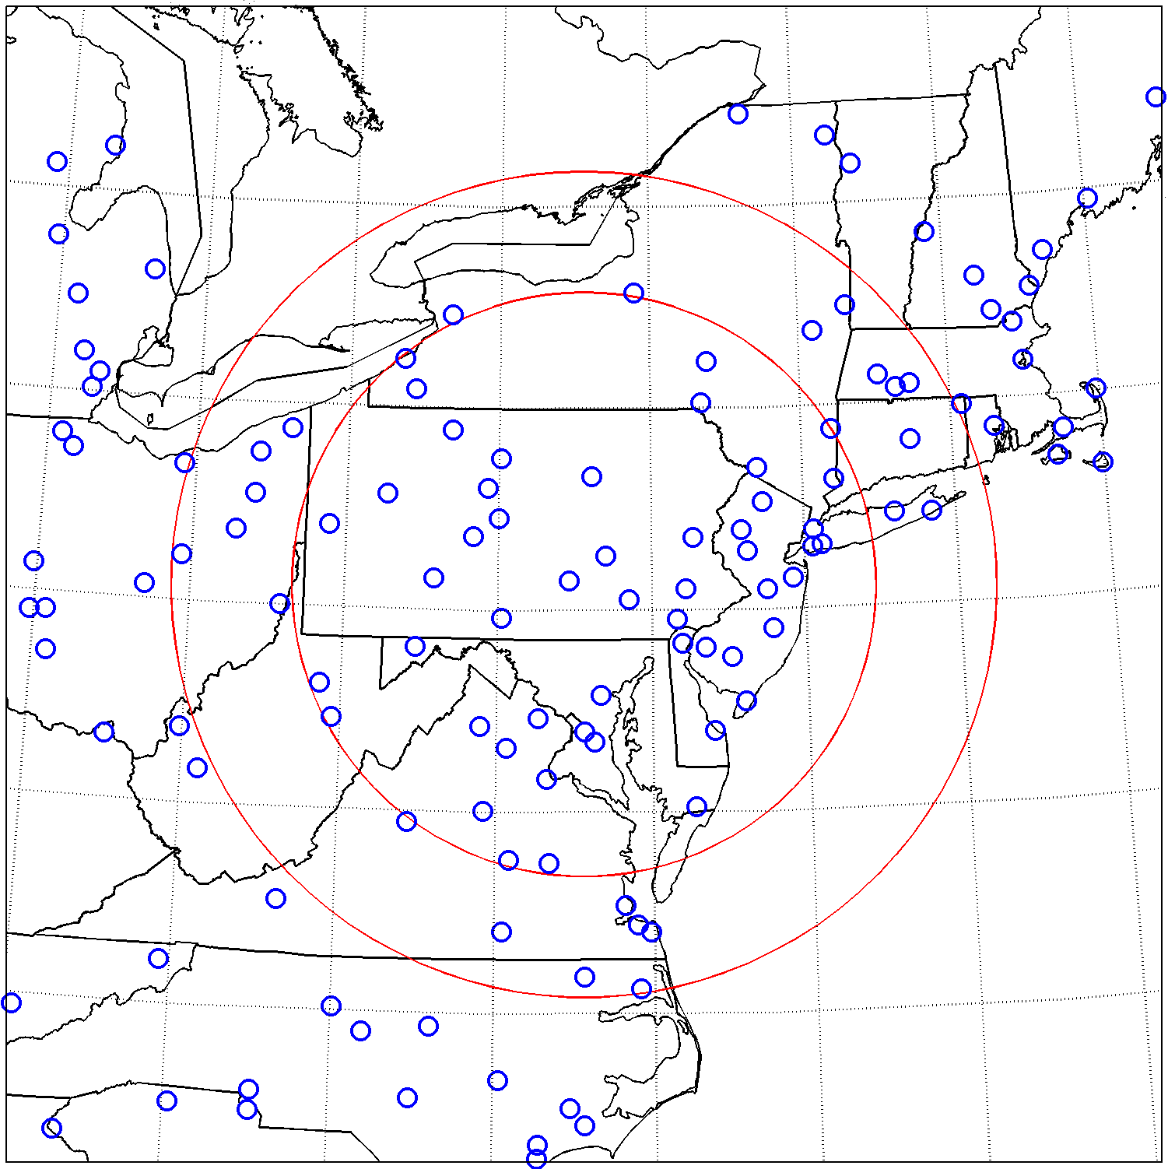

Many airport ILS/DME installations have been certified at the highest level of precision approach procedures (CAT III) and are authorised to be used for auto-landing operations. ICAO Annex 10 places an integrity/continuity requirement on DME/N at 1 – 1e-5. For Category I instrument landing systems, integrity is quoted as 1 – 1e-7, for Category II and III landing systems, integrity is quoted as 1 – 1e-9. For those systems, continuity is quoted as 1 – 2x10-6. (ref ICAO Annex 10 Vol I, table C-2). Such high availability and integrity is achieved by ensuring there is no harmful interference to the various components of the ILS from other systems. Further, extreme propagation anomalies must be taken into account. The following table contains characteristics and protection criteria extracted from the references that follow. An aviation safety margin should also be considered in accordance with ICAO Doc. 9718.

Parameters | DME/N ground | DME/N airborne | DME/P ground | DME/P airborne
Transmitter
Frequency range, MHz | 962-1213 | 1025-1150 | 962-1213 | 1025-1150
Bandwidth, MHz | 3.5 | 3.5 | 3.5 | 3.5
Max EIRP, dBW | 44 | 38 | 45 | 38
Antenna height, m | 40, 25, 2.1 | 100, 1000, 10000 | 40, 25, 2.1 | 100, 1000, 10000
Antenna polarization | Vertical | Vertical | Vertical | Vertical
Mask, attenuation (dB) @ freq offset (MHz) | 0 @ 0  23 @ 0.8  25.5 @ 1  38 @ 2  80 @ 3 | 0 @ 0  6 @ 0.9  15.3 @ 1  40 @ 1.3  60 @ 1.5  63.3 @ 2  70 @ 3 | 0 @ 0  23 @ 0.8  25.5 @ 1  38 @ 2  80 @ 3 | 0 @ 0  6 @ 0.9  15.3 @ 1  40 @ 1.3  60 @ 1.5  63.3 @ 2  70 @ 3
Receiver
Frequency range, MHz | 1025-1150 | 962-1213 | 1025-1150 | 962-1213
Bandwidth, MHz | 3.5 | 3.5 | 3.5 | 3.5
Antenna gain, dBi | 16 (directional), 12 (10?) (omni-directional) | 5.4 | 16 | 5.4
Noise figure, dB | 4 | 4 | 4 | 4
Cable loss, dB | 1 | 1 | 1 | 1
Protection criteria (I/N), dB | -10/-20 | -10/-20 | -10/-20 | -10/-20

References:
1. CEPT Electronic Communications Committee (ECC) Report 306: CEPT investigation on possible usage of low power audio PMSE in the band 960-1164 MHz.
2. ICAO Annex 10 Volume 1 - Chapter 3 Section 3.5 and Attachment C section 7: These sections contain information of the DME systems in the frequency band 960-1 215 MHz.
3. ICAO Annex 10 Volume 5, Chapter 4 Section 4.3: Frequency planning utilization for DME.

SSR

Secondary Surveillance Radar (SSR) systems interrogate an aircraft transponder on 1030 MHz and receive replies from the aircraft transponder on 1090 MHz. The radar is able to determine the range and bearing of the aircraft from replies, which can also contain additional data such as aircraft identity, altitude, and speed. Different SSR Modes (A, C, and S) have different additional capabilities with different signal structures including a data channel. Mode A codes aircraft identity and Mode C codes the aircraft-derived barometric altitude. Mode S includes the same capabilities as Mode A/C, but with the additional ability to selectively call specific aircraft and request more advanced aircraft data. The following table contains characteristics and protection criteria extracted from the references that follow the table. Further, ICAO has determined ICAO-standardized aeronautical surveillance and collision avoidance systems using the 1030/1090 MHz frequency pair must be able to tolerate an I/N of -10 dB, so this value is recommended for the protection criteria to use until ITU-R determines one in a Recommendation. An aviation safety margin should also be considered in accordance with ICAO Doc. 9718.

Parameters | SSR airborne transponder | SSR ground interrogator
Transmitter
Centre frequency, MHz | 1090 | 1030
Bandwidth, MHz | 4.5 (Mode A and C)  2.3 (Mode S) | 8
Antenna height, m | 100, 1000, 10000 | 40, 25, 2.1
Power (peak), dBW | 27 | 32
Cable loss, dB | 1 | 1
Antenna gain, dBi | 2.8 | 27 (max)
OOB mask | See below | See below
Receiver
Centre frequency, MHz | 1030 | 1090
Bandwidth, MHz | 6 | 4.5 (Mode A and C)  2.3 (Mode S)
Antenna gain, dBi | 2.8 / 5.4 | 27
Antenna polarization | Vertical | Vertical
Sensitivity, dBW | -107 | -120
Cable loss, dB | 1 | 1
Selectivity, attenuation (dB) @ freq offset (MHz) | 3 @ 3  24.6 @ 10  40 @ 15  60 @ 25 | 3 @ 3  24.6 @ 10  40 @ 15  60 @ 25
Noise figure, dB | 5 | 5
Protection criteria (I/N), dB | -10 | -10

OOB mask of SSR airborne transponder:

OOB mask of SSR ground interrogator:
References:
1. CEPT Electronic Communications Committee (ECC) Report 306: CEPT investigation on possible usage of low power audio PMSE in the band 960-1164 MHz.
2. ICAO Annex 10 Volume 4 - Chapters 2 and 3: These chapters contain information of the SSR systems operating at the frequencies 1030 MHz (ground-to-air) and 1090 MHz (air-to-ground).
3. ICAO Annex 10 Volume 3, Chapter 5: This chapter contains information of the SSR Mode S air-ground data link using 1 090 MHz.

ADS-B 1090ES
Automatic dependent surveillance – broadcast (ADS-B) 1090 MHz extended squitter (1090ES) provides air-to-air, air-to-ground, air-to-space datalink capabilities. ADS-B provides aircraft identity, aircraft derived position and other aircraft data. The following table contains characteristics and protection criteria extracted from the references that follow the table. Further, ICAO has determined ICAO-standardized aeronautical surveillance and collision avoidance systems using the 1030/1090 MHz frequency pair must be able to tolerate an I/N of -10 dB, so this value is recommended for the protection criteria to use until ITU-R determines one in a Recommendation. An aviation safety margin should also be considered in accordance with ICAO Doc. 9718. ADS-B transmitter system characteristics will be needed WG/19 decides to bring this paper to the ITU.

Parameters | ADS-B
Transmitter
Centre frequency, MHz
Bandwidth, MHz
Antenna height, m
Power (peak), dBW
Cable loss, dB
Antenna gain, dBi
OOB mask
Receiver
Centre frequency, MHz | 1090
Bandwidth, MHz | 11
Antenna gain, dBi | 2 - 5
Antenna polarization | Vertical
Cable loss, dB | 1
Selectivity, attenuation (dB) @ freq offset (MHz) | 0 @ 0  3 @ 5.5  20 @ 10  40 @ 15  60 @ 25
Noise figure, dB | 5
Protection criteria (I/N), dB | -10

References:
1. CEPT Electronic Communications Committee (ECC) Report 306: CEPT investigation on possible usage of low power audio PMSE in the band 960-1164 MHz.
2. ICAO Annex 10 Volume 4 – Chapter 5 section 5.2: This chapter contains information of the ADS-B systems.

UAT

Universal Access Transceiver (UAT) is an ICAO-standardised ADS-B broadcast data link operating on 978 MHz. UAT supports multiple broadcast services, including flight information services (FIS-B) and traffic information services (TIS-B), in addition to automatic dependent surveillance - broadcast (ADS-B). The following table contains characteristics and protection criteria extracted from the references that follow the table. An aviation safety margin should also be considered in accordance with ICAO Doc. 9718.

Parameters | UAT
Transmitter
Centre frequency, MHz | 978
Bandwidth, MHz | 1.3 MHz
EIRP, dBW | 28
OOB mask, attenuation (dB) @ freq offset (MHz) | 0 @ 0  0 @ 0.5  18 @ 1  50 @ 2.25  60 @ 3.25
Receiver
Centre frequency, MHz | 978
Antenna gain, dBi | 0 - 4
Cable loss, dB | 1-3
Bandwidth, MHz | 1.3 (-3 dB)
Noise figure, dB | 6
Selectivity, attenuation (dB) @ freq offset (MHz) | 0 @ 0  3 @ 0.625  15 @ 1  50 @ 2  60 @ 10
Protection criteria, dB | -6/-10

References:
1. CEPT Electronic Communications Committee (ECC) Report 306: CEPT investigation on possible usage of low power audio PMSE in the band 960-1164 MHz.
2. ICAO Annex 10 Volume 3, Part I - Chapter 12: This chapter contains information of the Universal Access Transceiver (UAT) operating at the frequency 978 MHz.

CNPC characteristics and protection criteria

The following table contains characteristics and protection criteria extracted from the reference that follow the table. An aviation safety margin should also be considered in accordance with ICAO Doc. 9817.
Parameters | UAV CNPC airborne
Transmitter
Frequency range, MHz | 960-1164
Bandwidth, MHz | 0.5 MHz
EIRP, dBW | -15 to 0 with directional antenna  -15 to 7 with omni-directional antenna
OOB mask, max PSD (dBm/kHz) @ freq offset (kHz) from channel edge | -36 @ 0.5  -61 @ 1.0  -71 @ 1.75
Receiver
Frequency range, MHz | 960-1164
Antenna gain, dBi | 3 (omni-directional)
Cable loss, dB | 1
Bandwidth, MHz | 0.5
Noise figure, dB | 4
Selectivity, attenuation (dB) @ freq offset (MHz) | 3 @ 0  19 @ 0.25  54 @ 1.75
Protection criteria, dB | -6/-10
Safety margin, dB | 6

References:
1. CEPT Electronic Communications Committee (ECC) Report 306: CEPT investigation on possible usage of low power audio PMSE in the band 960-1164 MHz.

LDACS characteristics and protection criteria

L-Band Digital Aeronautical Communication System (LDACS) operating in 960-1164 MHz is envisaged to use a cellular point-to-multipoint concept, which means that the airspace is segmented into cells. In each cell, all aircraft are connected to a centralised ground station which controls the entire air/ground communication within the cell. It is designed as a frequency-division duplex system, preferably deployed using an inlay approach, interleaving with DME. The following table contains characteristics and protection criteria extracted from the references that follow the table with some updates that have been made since the publishing of the reference. An aviation safety margin should also be considered in accordance with ICAO Doc. 9718.

Parameters | LDACS airborne
Transmitter
Frequency range, MHz | 960-1010
Bandwidth, MHz | 0.5
EIRP, dBW | 12
OOB mask | 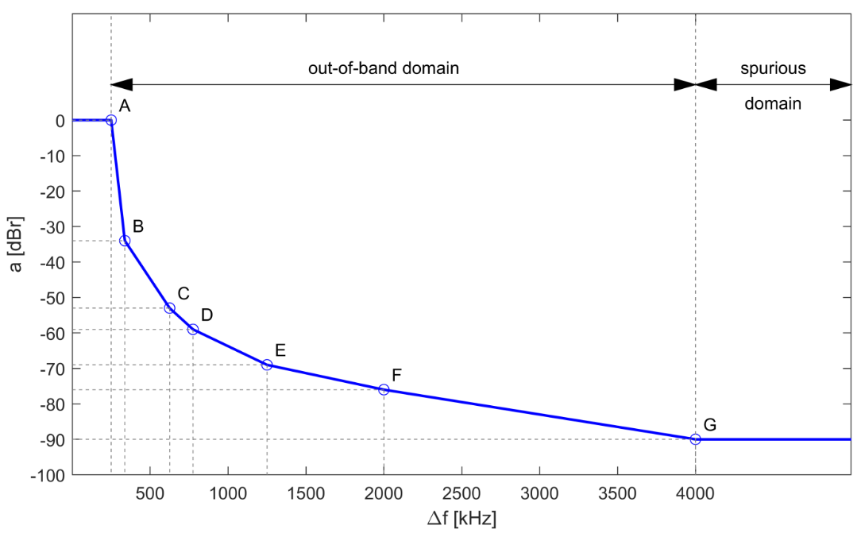
Receiver
Frequency range, MHz | 1110-1156
Antenna gain, dBi | 3
Cable loss, dB | 3
Duplexer loss, dB | 1
Bandwidth, MHz | 0.5
Noise figure, dB | 6
Selectivity, attenuation (dB) @ freq offset (MHz) | 0 @ 0.25  6 @ 0.3  40 @ 0.4  70 @ 0.5  80 @ 0.6  90 @ 1
Protection criteria, dB | -6/-10

References:
1. CEPT Electronic Communications Committee (ECC) Report 306: CEPT investigation on possible usage of low power audio PMSE in the band 960-1164 MHz.

ACAS

The airborne collision avoidance system (ACAS) is an aircraft collision avoidance system using both 1030 MHz and 1090 MHz operating independently of ground-based equipment and air traffic control to warn pilots of the presence of other aircraft that may present a threat of collision. If the risk of collision is imminent, a manoeuvre is directed to the pilot to reduce the risk of collision.

ACAS characteristics and protection criteria are very complex and many times require numerical methods to determine compatibility. For the purpose of spectrum compatibility with the ACAS receiver, see the ADS-B 1090ES airborne receiver characteristics and the SSR transponder receiver for the aircraft receiving the ACAS interrogation until further analysis provides more detailed information.

References:
1. CEPT Electronic Communications Committee (ECC) Report 306: CEPT investigation on possible usage of low power audio PMSE in the band 960-1164 MHz.
2. ICAO Annex 10 Volume 4 - Chapter 4: This chapter contains information of the airborne collision avoidance system (ACAS) operating at the frequencies 1030 MHz and 1090 MHz.

MLAT/WAM

Multilateration systems (MLAT) may use 1030 MHz, 1090 MHz, and 978 MHz. MLAT is intended to be a passive network of ground receivers (of order of 40 to 50 for a large airport) to enable an independent determination of aircraft (and suitably equipped ground vehicles) position on or near an airport using difference in time of arrival techniques. Active interrogations are used when passive receiving is inadequate for system performance. When using active interrogations, MLAT systems have several ground based 1030 MHz emitters to elicit replies from aircraft transponders and 1090 MHz emitters to provide constant confirmation of correct system operation. Wide-area multilateration (WAM) is similar to MLAT, but over a wider geographic area.

MLAT is a distributed network of sensors that are tailored to the specific service area and representative characteristics and protection criteria would be very complex to determine. For the purpose of spectrum compatibility with the MLAT receiver on the ground, see the ADS-B 1090ES and UAT airborne receiver characteristics (on the ground) and the SSR transponder receiver for the aircraft receiving the MLAT interrogation until further analysis provides more detailed information.

References:
1. CEPT Electronic Communications Committee (ECC) Report 306: CEPT investigation on possible usage of low power audio PMSE in the band 960-1164 MHz.
2. ICAO Annex 10 Volume 4 - Chapter 6: This chapter contains information of the multi-lateration systems.

