FREQUENCY SPECTRUM MANAGEMENT PANEL (FSMP)

Nineteenth Working Group Meeting

Montréal, Canada, 15 to 26 July 2024

Agenda Item 2: Development of ICAO position for WRC-27 – FSMP.002.02

Radioaltimeter permanent functioning

(Presented by Laurent Azoulai, ICCAIA)

SUMMARY

During FSMP/18, while discussing the ICAO position on WRC-27 Agenda Item 1.19, it was suggested, that in order to limit interference from Radioaltimeter to Sea Surface Temperature (SST) satellite measurement systems operating in 4200 - 4400 MHz, to envisage interrupting or modifying radioaltimeter functioning above 20000 ft for instance where it is not utilized.

This proposal was strongly rejected by Airborne industry who has been tasked to provide more details on the rationale for this position. This paper reminds the utilization of radio altimeter on-board aircraft and explains why this proposal to interrupt or to modify the radioaltimeter function should not be considered.

The meeting is invited to:
- note and review the content of this working paper;
- agree to discard the various options proposed, on Radio altimeters, to introduce a “stop function,” reduce signal strength or modify duty cycle to allow EEES to also use the 4200 – 4400 MHz frequency band as proposed by WRC27 Agenda Item 1.19.
- consider the following text for the ICAO position with regard to WRC-27 agenda item 1.19: “ICAO recognizes the benefit of providing sea surface temperature measurements for weather forecasting used by aviation. However, any action taken should not impose technical or operational constraints on radio altimeters or wireless avionics intra-communications systems”.
- INTRODUCTION
  - During FSMP/18, it was suggested, during the discussion about ICAO positions with regard to WRC-27 Agenda Item 1.19, that in order to limit interference from Radioaltimeter to other new potential services such as EEES (Earth Exploration Satellite Service) willing to operate in the 4200 - 4400 MHz frequency band, it could be possible to interrupt the radioaltimeter functioning above 20000 ft for instance, where it is not operationally utilized. Aviation community has been informed that radio altimeters over oceans and seas may cause a loss of about 2% of the measured data from satellites planned to be used to measure sea surface temperature (SST) and parameters which are utilized to predict hurricanes.

  - This proposal was rejected by the Airborne Industry and it was requested to provide more details on the associated rationales. This paper reminds the utilization of radio altimeter on board aircraft and explains why this proposal should not be considered.

- DISCUSSION
  - Radio altimeters system users
    - Radio altimeters provide a very accurate, independent, and absolute measurement of the minimum distance to the Earth’s surface below an aircraft. Radio altimeters are integrated into several safety critical aircraft systems as shown in Figure 1. Such systems include, but are not limited to, fly-by-wire flight control systems, automatic flight guidance and control systems, which perform automatic landing flare and rollout in zero visibility conditions, terrain awareness warning systems, traffic alert and collision avoidance systems, airborne collision avoidance systems, and wind shear detection systems. Additional propulsion and surveillance systems (preventing runway overruns for instance), also use the height above terrain provided by the radio altimeter. The measurements from the radio altimeters are also displayed to the flight crew, and below 2500 ft the system provides aural callouts to the flight crew of the height above terrain.
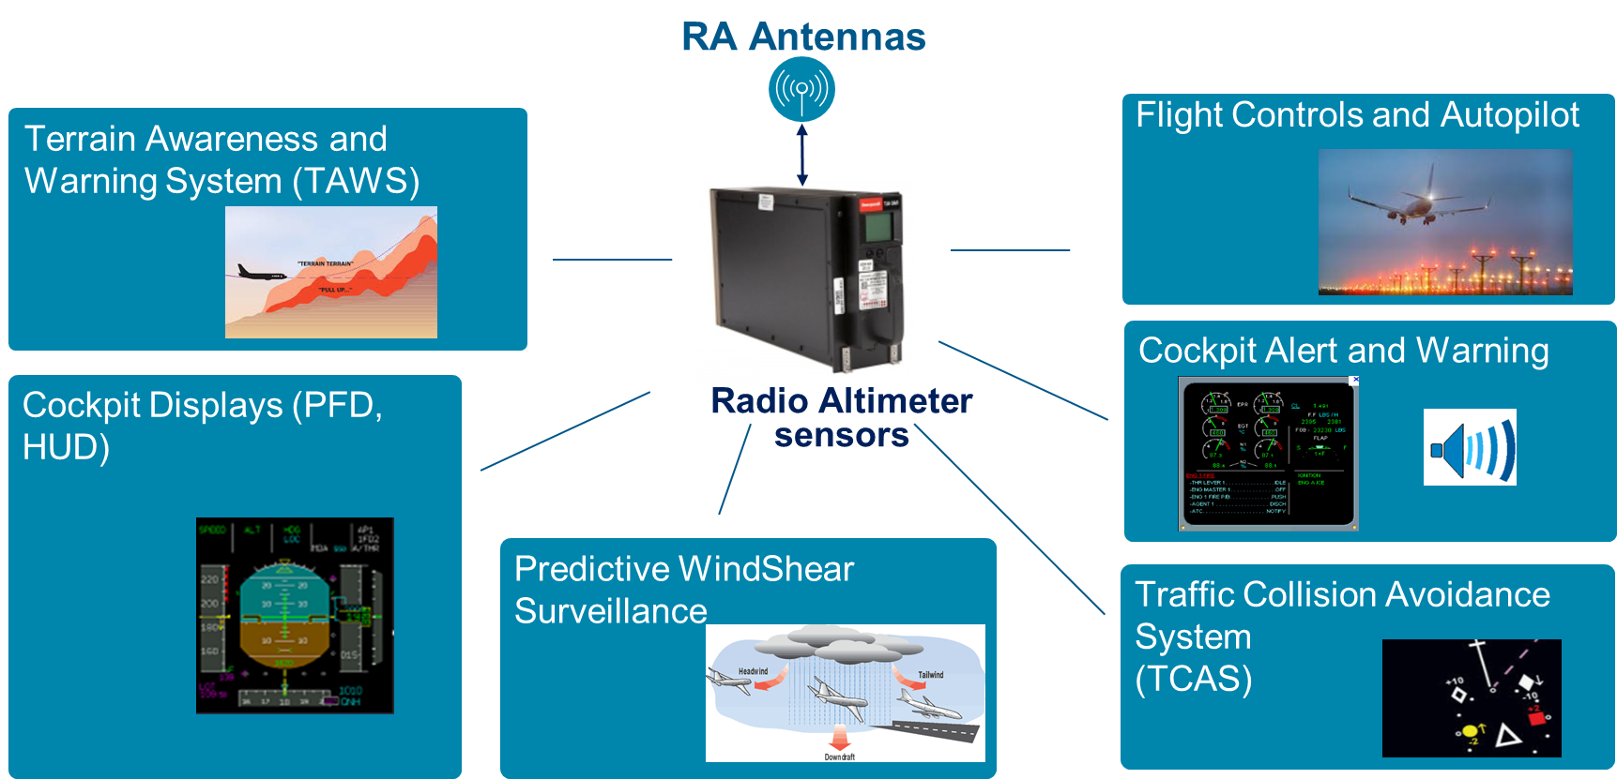
Figure 1: System users of Radio Altimeters
  - Why stopping the radio altimeter functioning above a certain altitude cannot be supported ?
    - What can be the consequences in case the radio altimeter stops its functioning ? The radio altimeter has ARINC digital outputs and in nominal conditions provides height from below 2500 ft down to the ground and even sometimes starts providing height from below 5000 ft down to the ground while always emitting at any altitude because it doesn’t have any indication of its altitude without sensing the return from the Earth. Above these heights, the ARINC digital output status of the height data is Non Computed Data (NCD). This NCD conditions provides the indication that the radio altimeter is alive, i.e. not in fault, but is unable to compute a height. Any other output such as no refresh (NR) meaning no data output at all or Functional Test (FT) or Failure Warning (FW) will indicate a failure condition or a functional test such that the users cannot expect the availability of radio altimeter height.
      - In case there is a command to the radio altimeter to stop its intended function (which is to emit a signal, sense the return from the terrain and output a height), would the output need to be NCD or would it need to be something else to distinguish the mode of the radio altimeter ? Indeed, the users are designed to receive the above mentioned status and would therefore need to be modified to account for the new mode or receive the same external input than the radio altimeter to know that the stop functioning is active. Indeed, the radio altimeter when not emitting, cannot determine its height without an external aid such as a barometric altitude input, and thus cannot determine when it is supposed to stop and reactivate its emission. This would drive the modification of thousands of equipments on more than 20 000 aircraft, which cannot be reasonably envisaged. Obviously, associated thorough Safety Analysis will have to be performed on this “Command” function to assess its impact
  - Another proposal was suggested to instead of stopping the radio altimeter functioning above a certain height, to reduce the signal strength emitted according to the altitude or to reduce the duty cycle. The reduction of signal strength is not desirable because at higher altitude, the signal strength could be higher to promptly detect the terrain below upon descent of the aircraft while the radio altimeter would have no clue that it flies above the terrain or the sea surface without an external input. The reduction of the duty cycle is also not desirable because the radio altimeter must always emit in order to provide timely warnings of terrain detection or provide timely predictive windshear alerts. Indeed, the radio altimeter cannot guess it is flying over oceans or terrains, thus must always emit to sense the return signal from Earth.

  - The radio altimeter being a sensor used in critical functions with safety classification that can be as high as CAT per EASA CS25.1309, any introduction of external inputs from independant sensors, (to determine at which height or altitude the radio altimeter is), will create a dependency to a lower Design Assurance Level and a lower performance sensor with different failure modes. Indeed, a sensor is often considered as “dumb” to really “sense” the physical phenomena that will enable its intended function. If the radio altimeter stops its functioning, it cannot determine its height and thus cannot determine when it is supposed to reactivate its emission. Any introduction of some sort of “intelligence” such as, “where it is supposed to be” or “when it is supposed to work”, requires to embed a functionality or monitoring that will be able to determine when these inputs will be faulty and when they can be trusted. This will add complexity, exposing more potential failure conditions, and would require significant verification and validation with all the possible sensors that could be involved. Adding these dependencies, in case of failure of these external inputs, could prevent the availability of height or interrupt the output of the height at a critical phase of the flight, leading to potentially unsafe conditions.

- ACTION BY THE MEETING
  - The meeting is invited to:
- note and review the content of this working paper;
- agree to discard the various options proposed, on Radio altimeters, to introduce a “stop function” , reduce signal strength or modify duty cycle to allow EEES to use also the 4200 – 4400 MHz frequency band as proposed by WRC27 Agenda Item 1.19.
- consider the following text for the ICAO position with regard to WRC-27 agenda item 1.19: “ICAO recognizes the benefit of sea surface temperature measurements for weather forecasting used by aviation. However, any action taken should not impose technical or operational constraints on radio altimeters or wireless avionics intra-communications systems”.
— END —

