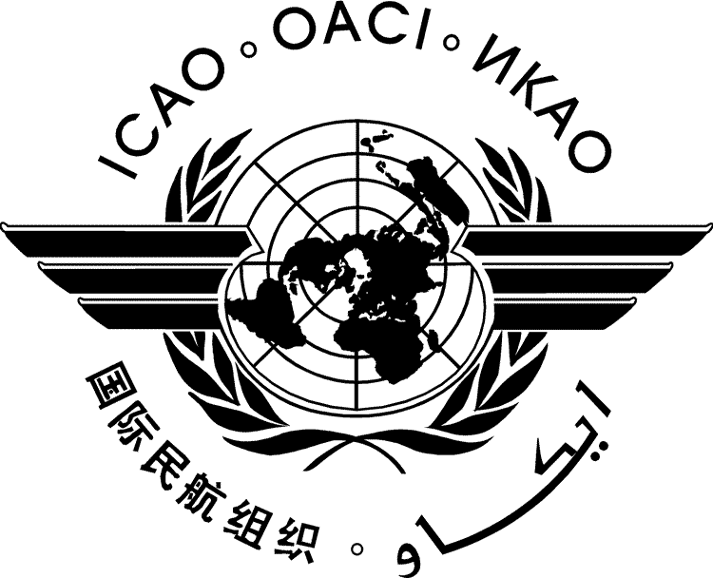 | International Civil Aviation Organization  WORKING PAPER
  FSMP-WG/13-WP/11
FREQUENCY SPECTRUM MANAGEMENT PANEL
WORKING GROUP

thirteenth MEETING

Virtual,21 to 25 February 2022

Agenda Item 2 ICAO WRC-23 Position:
c) WRC-23 AI 1.8 FSS for UAS

Support for Maintaining the Position as Currently Stated and Concerns as to Whether Current Proposals Resolve the Issues of Concern

(Presented by John Mettrop)

SUMMARY
This paper supports the retention of the current ICAO position on WRC-23 agenda item 1.8 and highlights some concerns as to whether proposals made so far resolve the issues of concern.

ACTION
The FSMP-WG is invited to:
  - Review the content of this paper.
  - Agree to maintain the ICAO position as it stands
  - Seek solutions to the concerns raised .

- INTRODUCTION
  - The issue of how to allow the fixed satellite service to be used for the provision of an aeronautical mobile satellite service has been challenging the minds of the spectrum managers involved for the last 15 years without much success. This appears to be the last chance to solve the problem or else aviation will have to make use of existing allocations that are appropriately allocated to a service that in its definition covers all elements of the Unmanned Aircraft (UA) Command and Non-Payload Communication (CNPC) link and can provide the quality of service required.

- discussion
  - Whilst the current ICAO position identifies what needs to be achieved through this agenda item to allow the Fixed Satellite Service (FSS) to be used for the provision of UA CNPC the proposals made to date appear to fail to address the following concerns.

Need for a Primary Allocation: Although two (Satellite Station & aeronautical earth station) of the three elements of the UA CNPC link falling within the definition of the FSS the third element (aircraft earth station) does not. Proposals so far have suggested wording such as “may communicate with” or “are an application of” but neither of these formulations of words makes the aircraft earth station, by definition, part of the FSS. What is required is either an additional allocation to a service that incorporates aircraft earth stations within it’s definition and then limitations are applied or the definition of FSS needs to be changed to include aircraft earth stations used for UA CNPC.

Differentiation from Earth Station in Motion: Resolutions 156 & 169 address the use of the FSS by earth stations in motion and for the bands to which those Resolutions apply they clearly indicate that they cannot be used for safety of life purposes. By definition, aircraft earth stations are earth stations in motion and therefore at least in the frequency bands where there is overlap between Resolution 155 and Resolutions 156/169 either the restriction on the use for safety of life needs to be removed or some mechanism needs to be found that recognises that aircraft earth stations in motion used for UA CNPC are a specific sub-set of earth station in motion where the restriction does not apply.

Responsibility for Operation: Whilst an administration may well authorise the use of a CNPC link it cannot guarantee the interference environment that may exist in another administration especially given that UAS CNPC links cannot claim protection and in frequency bands where other services that take priority may not be recorded in the MIFR. Also the administration providing an air traffic service may for operational reasons need to divert the UA flight over the territory of another country but may not know what the situation is within that State with respect to potential interference. All responsible parties and their administrations need to be clearly identified.

Protection of UA CNPC links: Several proposals have suggested various ways in which UA CNPC links should be protected by administrations but given that UA CNPC systems will be operating on a non-interference, non-protection basis trying to arrange protection international goes against the principle behind the non-interference/non-protect basis. Unless the earth station on the UA and the link with the satellite is given primary status how can measures be taken to provide the protection proposed.
- Conclusions
  - That none of the solutions proposed so far provide a suitable solution to the concerns raised
  - Support that the ICAO position should not be changed.
  - Solutions should be found that address the concerns raised
  - That whilst a solution for UA CNPC using FSS should be the priority aviation should not be afraid to reject a solution that does not address the concerns as there are alternatives.

- ACTION BY THE MEETING
  - The FSMP is invited to:
  - Review the content of this paper.
  - Agree to maintain the ICAO position as it stands
  - Seek solutions to the concerns raised

